Python2  
dice simulator 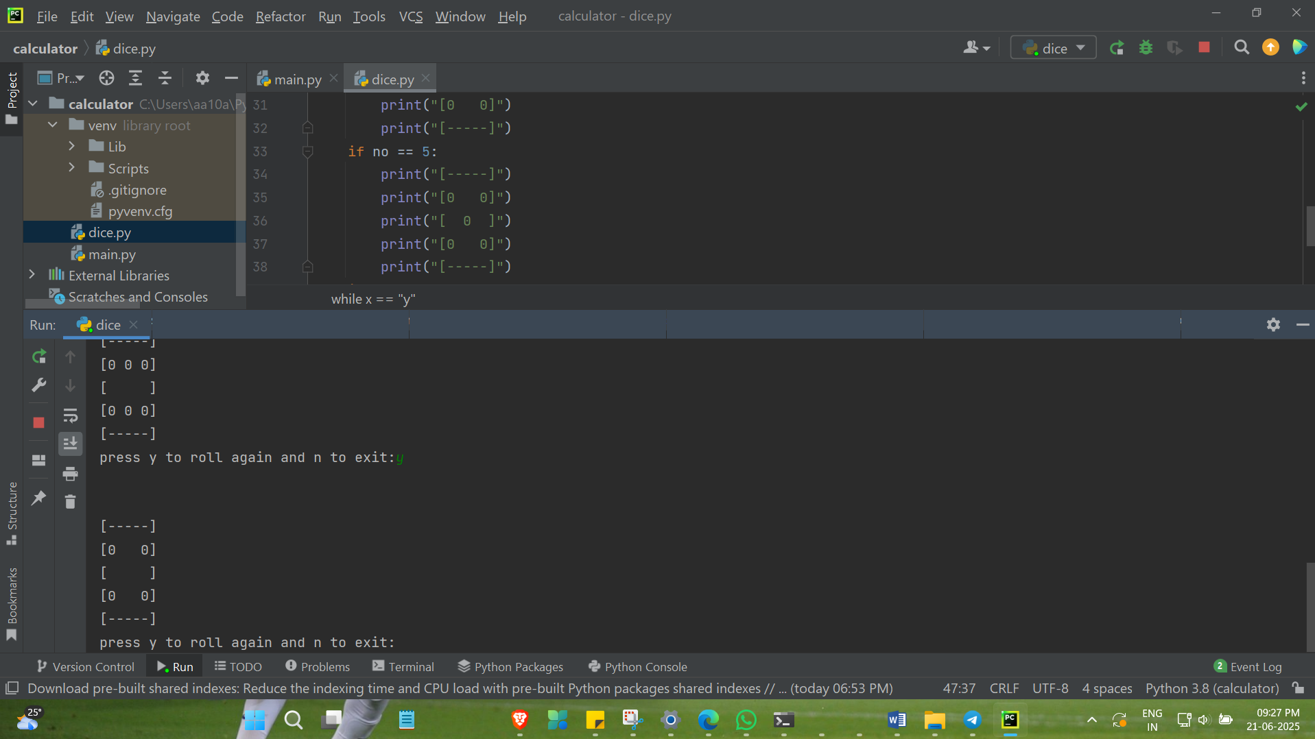

import random  
  
x = "y"  
  
while x == "y":  
  
 no = random.randint(1, 6)  
  
 if no == 1:  
 print("[-----]")  
 print("[ ]")  
 print("[ 0 ]")  
 print("[ ]")  
 print("[-----]")  
 if no == 2:  
 print("[-----]")  
 print("[ 0 ]")  
 print("[ ]")  
 print("[ 0 ]")  
 print("[-----]")  
 if no == 3:  
 print("[-----]")  
 print("[ ]")  
 print("[0 0 0]")  
 print("[ ]")  
 print("[-----]")  
 if no == 4:  
 print("[-----]")  
 print("[0 0]")  
 print("[ ]")  
 print("[0 0]")  
 print("[-----]")  
 if no == 5:  
 print("[-----]")  
 print("[0 0]")  
 print("[ 0 ]")  
 print("[0 0]")  
 print("[-----]")  
 if no == 6:  
 print("[-----]")  
 print("[0 0 0]")  
 print("[ ]")  
 print("[0 0 0]")  
 print("[-----]")  
  
 x = input("press y to roll again and n to exit:")  
 print("\n")