VELLORE INSTITUTE OF TECHNOLOGY, CHENNAI
FALL SEMESTER 2026–2027
BACSE202 – DATABASE MANAGEMENT SYSTEMS
Digital Assignment – Technical Report
RideGraph
A Graph-Database Ride-Hailing Platform using Neo4j, Flask and React
Name | Register Number
Akhil Gokul | 25BCE5009
Praveen Sakthi S | 25BCE1605
Prakash V | 25BCE1769

Faculty: Dr. S. Geetha
Slot: D1 + TD1 Class: CH202670101707
GitHub: https://github.com/akhilax/ridegraph
Demo video: https://drive.google.com/file/d/11rI7FD1uJiBr3lQKsv9nnGIfxgUtdqhg/view

Abstract
Ride-hailing services depend on relationships between data: which rider requested which ride, which driver in which zone accepted it, where it started and ended, and how it was paid and rated. In a relational database each of these questions becomes a chain of joins. RideGraph is a working ride-hailing web application for Chennai that stores this domain as a property graph in Neo4j, so the core operations become short graph traversals.
The system supports three roles. A rider registers, gets a fare estimate, requests a ride, pays by cash, card or UPI, and rates the driver. A driver sees open requests only in their own zone, accepts and completes rides, and tracks earnings. An admin views revenue, rides per zone, top drivers and cancellations. The data model was designed as an ER diagram with 13 entities and relationships. It was converted to a relational schema, normalized to 3NF, and then mapped to 11 node labels and 12 relationship types. The application uses a Python Flask REST API with parameterised Cypher queries, uniqueness constraints on every key, salted password hashing and conditional updates that prevent double booking. The interface is a React single-page app. An automated test script exercises the full ride life cycle, along with error cases such as duplicate registration, invalid input, wrong zone and repeated actions.
Keywords: Graph database, Neo4j, Cypher, ride-hailing, ER modelling, normalization, property graph, Flask REST API, React, data integrity

Table of Contents

(If the page numbers are not shown, right-click the table in Word and choose Update Field.)

1. Introduction
Ride-hailing apps such as Uber, Ola and Rapido match a rider who needs a trip with a nearby driver who is free, price the trip, track it through its life cycle and settle payment and feedback afterwards. Every step reads or changes connections between records: rider → ride → driver → vehicle, ride → pickup/dropoff location → zone, ride → payment/rating/promo/cancellation.
RideGraph implements this workflow as a complete database-backed web application. The data is held in Neo4j, a native graph database, where these connections are stored as first-class relationships. The project covers the full database life cycle: requirements analysis, ER modelling, relational schema design with keys and constraints, normalization, implementation, application connectivity, testing and documentation.

1.1 Problem Statement
Design and build a ride-hailing system in which riders can book rides and drivers can find and serve requests in their area, and in which the platform keeps a consistent record of every ride, payment, rating and cancellation. The system must answer location- and relationship-heavy questions efficiently. Examples are "which available drivers are in this pickup zone?", "which open requests can this driver accept?" and "how much has this driver earned?". It must also enforce integrity rules such as one driver per ride, one payment and one rating per ride, and no double booking.

1.2 Intended Users
- Riders: book rides, apply promo codes, pay, rate and view their history.
- Drivers: see and accept requests in their zone, complete rides, and view their earnings and rating.
- Administrator: monitors platform statistics (rides, revenue, zones, drivers, cancellations).

1.3 Objectives
- Model the ride-hailing domain with an ER diagram and derive a relational schema with primary, foreign and candidate keys.
- Normalize the relations to Third Normal Form and justify any deliberate denormalization.
- Implement the database in Neo4j with uniqueness constraints and indexes, and load realistic synthetic data.
- Build a three-tier web application (React → Flask → Neo4j) with at least five complete end-to-end features.
- Validate all input and handle invalid operations, duplicates, missing records and constraint violations with clear error messages.
- Test the system with documented test cases and automated end-to-end tests.

1.4 Scope
In scope: registration and login for riders and drivers; fare estimation with ride types and promo codes; ride request, zone-based matching, acceptance, completion and cancellation; payment recording; ratings with automatic driver-rating recalculation; ride history and driver earnings; an admin statistics dashboard; six Chennai zones with fifteen named locations.
Out of scope: live GPS tracking and maps, road-network routing (distances are straight-line), real payment gateways, token-based authentication, surge pricing and push notifications. These are listed as future enhancements.

2. Existing Systems
Three widely used ride-hailing platforms in India were studied to identify the features RideGraph should include.

2.1 Uber
URL: https://www.uber.com/in/en/
A global ride-hailing platform offering cars and autos across multiple categories (e.g., Uber Go, Premier, Auto, Moto). Riders get an upfront fare, driver details and live tracking, and pay in-app or in cash. Riders and drivers rate each other after every trip.
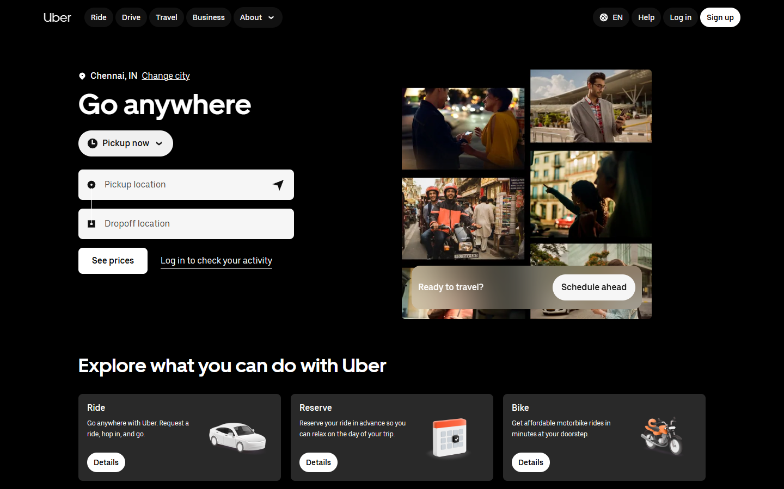
Figure 2.1: Uber – home page (https://www.uber.com/in/en/, captured 01-11-2026)

2.2 Ola
URL: https://www.olacabs.com/
An Indian ride-hailing platform with Mini, Prime Sedan, Auto and Bike categories, coupon codes, multiple payment options (cash, UPI, Ola Money) and trip history.
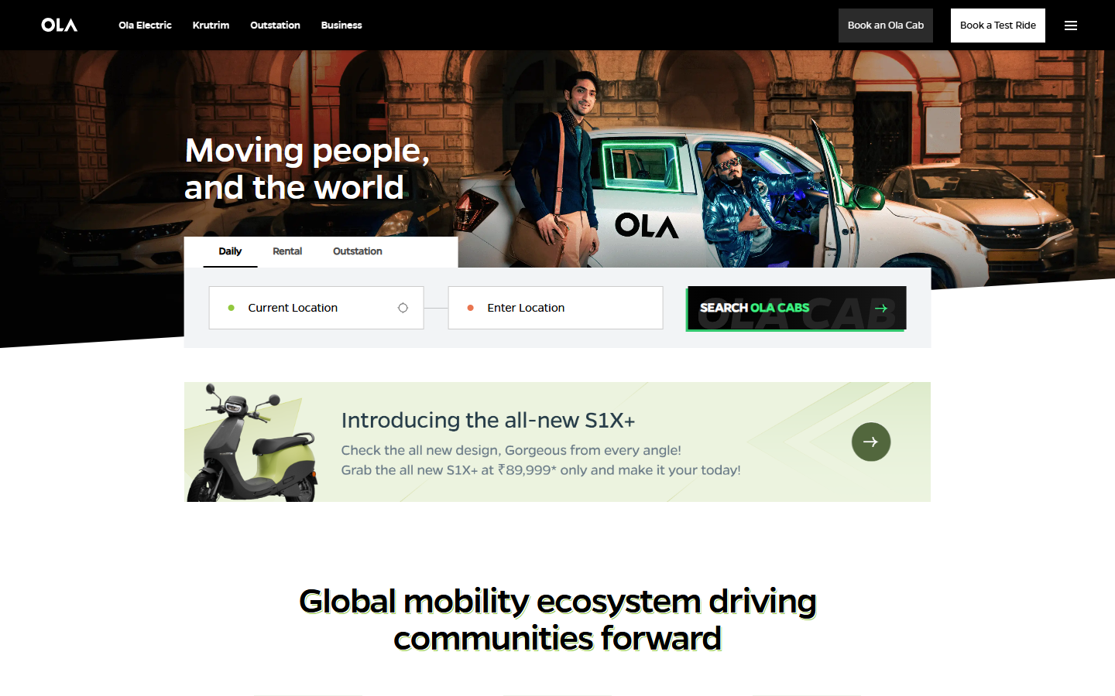
Figure 2.2: Ola – home page (https://www.olacabs.com/, captured 01-11-2026)

2.3 Rapido
URL: https://www.rapido.bike/
A platform focused on bike taxis and autos, with low per-km fares, zone-based captain availability and a simple booking flow.
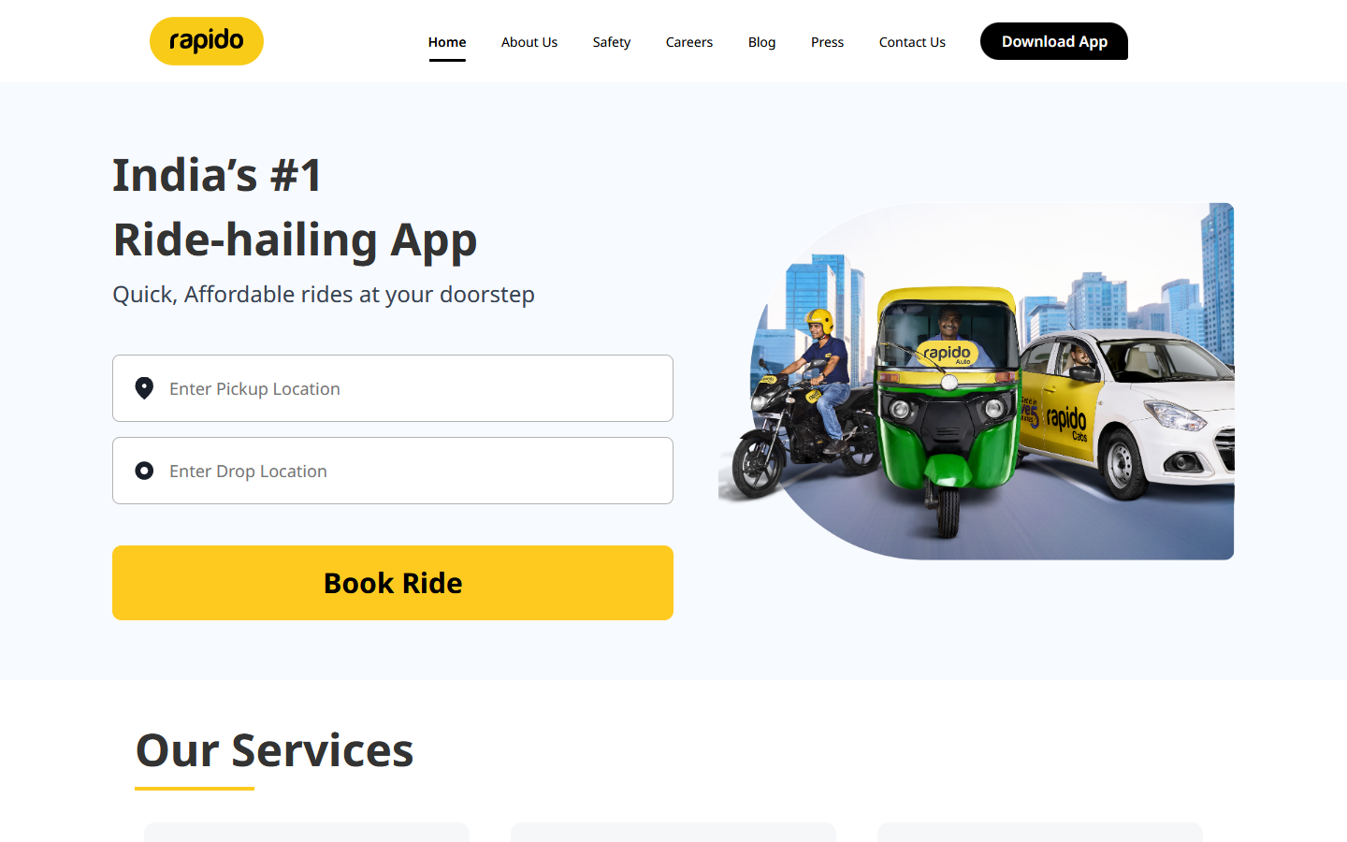
Figure 2.3: Rapido – home page (https://www.rapido.bike/, captured 01-11-2026)

2.4 Comparison and Gap
Feature | Uber | Ola | Rapido | RideGraph
Multiple ride types | Yes | Yes | Yes | Yes (Economy, Premium, Auto, Bike)
Fare estimate before booking | Yes | Yes | Yes | Yes (base + per-km, haversine)
Promo codes | Yes | Yes | Yes | Yes
Nearby-driver matching | Yes (GPS) | Yes (GPS) | Yes (GPS) | Yes (zone graph traversal)
Ratings | Two-way | Two-way | Two-way | Rider → driver, avg. recalculated
Admin analytics | Internal | Internal | Internal | Yes (dashboard)
Data model open for study | No | No | No | Yes – documented graph model
Table 2.1: Feature comparison with existing systems
Commercial platforms are closed systems whose data design cannot be studied. RideGraph reproduces their core workflow on a small scale with a fully documented database design. This shows how a graph database models the relationship-heavy parts of the problem (matching, history, statistics) more directly than a chain of relational joins.

3. Requirements and Proposed System Architecture

3.1 Functional Requirements
ID | Requirement
FR1 | Riders register with name, email, phone and password (≥ 6 characters); email must be unique.
FR2 | Drivers register with name, phone, licence number, password, zone and vehicle (plate, model, colour); phone and licence must be unique.
FR3 | Riders, drivers and the admin log in; a wrong login returns one generic message.
FR4 | A rider gets a fare estimate for pickup, dropoff, ride type and optional promo code.
FR5 | A rider requests a ride; the system stores it with status requested.
FR6 | The system lists available drivers in the pickup zone, best rated first.
FR7 | A driver sees open requests whose pickup lies in their zone, and can accept one if available.
FR8 | The accepting driver completes the ride; a pending payment is created.
FR9 | The rider pays (cash / card / UPI) once and rates the ride (1–5) once.
FR10 | Rider or driver can cancel a requested/accepted ride with a reason.
FR11 | Riders view ride history; drivers view their rides and total earnings.
FR12 | The admin views totals, revenue, rides per zone, top drivers and cancellations.
Table 3.1: Functional requirements

3.2 Non-Functional Requirements
- Integrity: unique keys on every entity; one payment, one rating and at most one cancellation per ride; no double acceptance.
- Security: passwords stored only as salted hashes; all queries parameterised (no Cypher injection); database password kept in an untracked .env file.
- Usability: clear validation messages and correct HTTP status codes (400, 401, 403, 404, 409, 503).
- Portability: one-click run scripts for Windows and macOS; the pre-built frontend means Node.js is not required to run the app.
- Re-runnable setup: seed script uses MERGE so it can be run repeatedly without duplicating data.

3.3 Hardware and Software Requirements
Item | Requirement
Processor / RAM | Any modern x64 CPU, 8 GB RAM recommended (Neo4j + browser)
Operating system | Windows 10/11 or macOS
Database | Neo4j 5.x via Neo4j Desktop 2.x (Community features)
Backend | Python 3.10+, Flask, neo4j driver, python-dotenv, flask-cors, Werkzeug
Frontend | React 19, Vite, React Router, Tailwind CSS, shadcn/ui, Motion (Node.js only to rebuild)
Client | Any modern web browser
Table 3.2: Hardware and software requirements

3.4 Proposed System Architecture
RideGraph follows a three-tier architecture. The browser never connects to the database directly. All reads and writes pass through the Flask API, which validates input, applies the business rules and runs parameterised Cypher over the Bolt protocol.
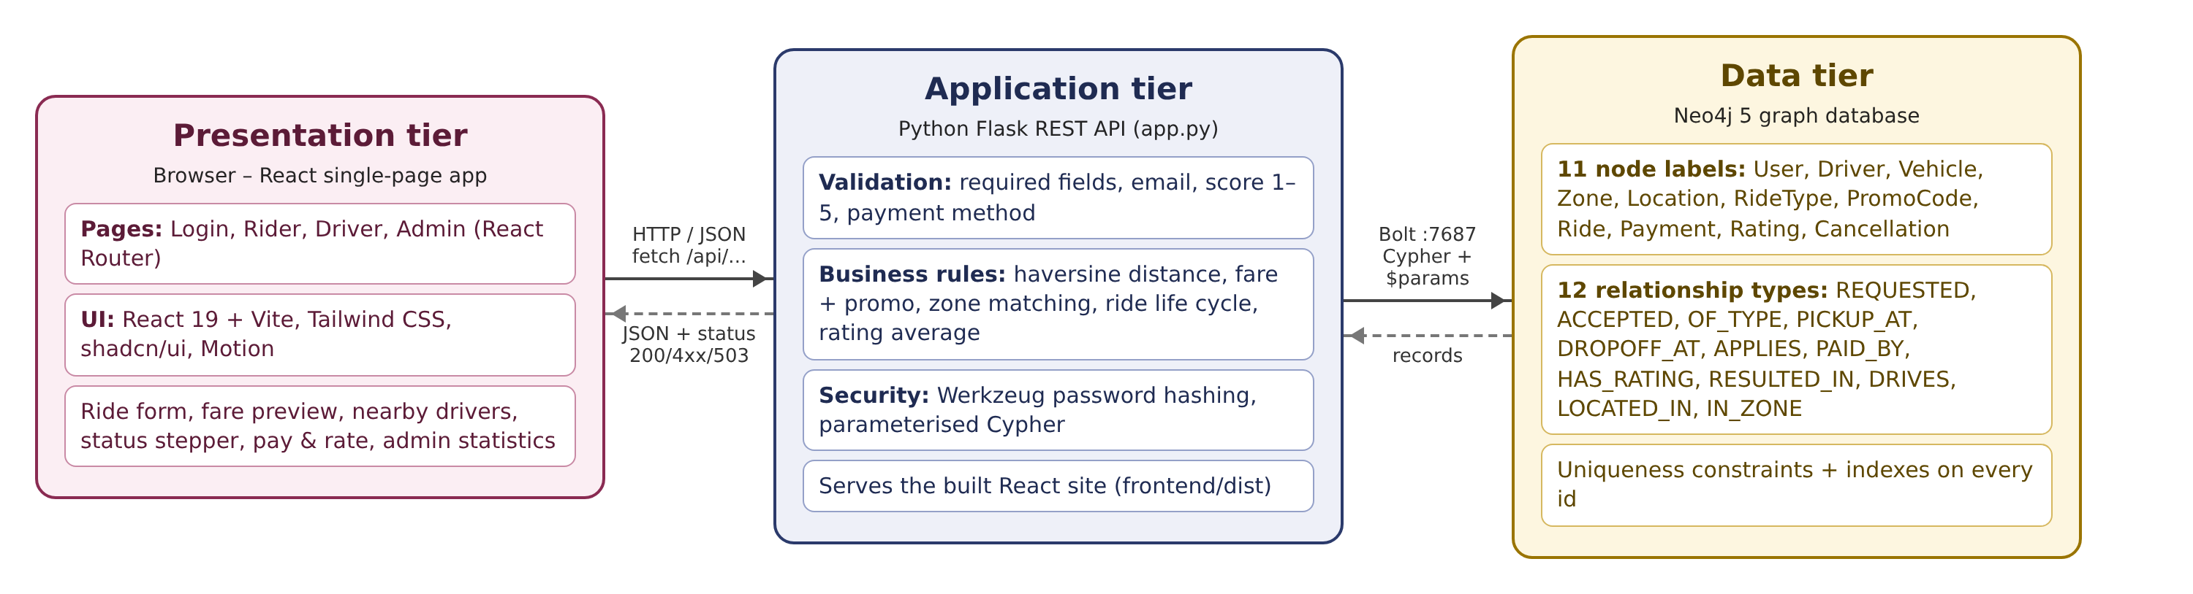
Figure 3.1: Three-tier architecture of RideGraph
- Presentation tier: a React single-page application with Login, Rider, Driver and Admin pages. Vite builds it into static files, which Flask serves.
- Application tier: a Flask REST API (app.py). It computes distance and fare, enforces who may accept, complete, cancel, pay or rate, and returns JSON with proper status codes.
- Data tier: a Neo4j graph database accessed through the official Python driver (db.py). All Cypher statements are kept in queries.py.

4. ER Diagram and Relational Schema

4.1 ER Diagram
The ER diagram has thirteen entity types centred on RIDES. A user requests many rides. A driver accepts many rides, drives one vehicle and is located in one zone. Each ride has one ride type, one pickup and one dropoff location, and optionally one promo code. A ride has at most one payment, one rating and one cancellation.
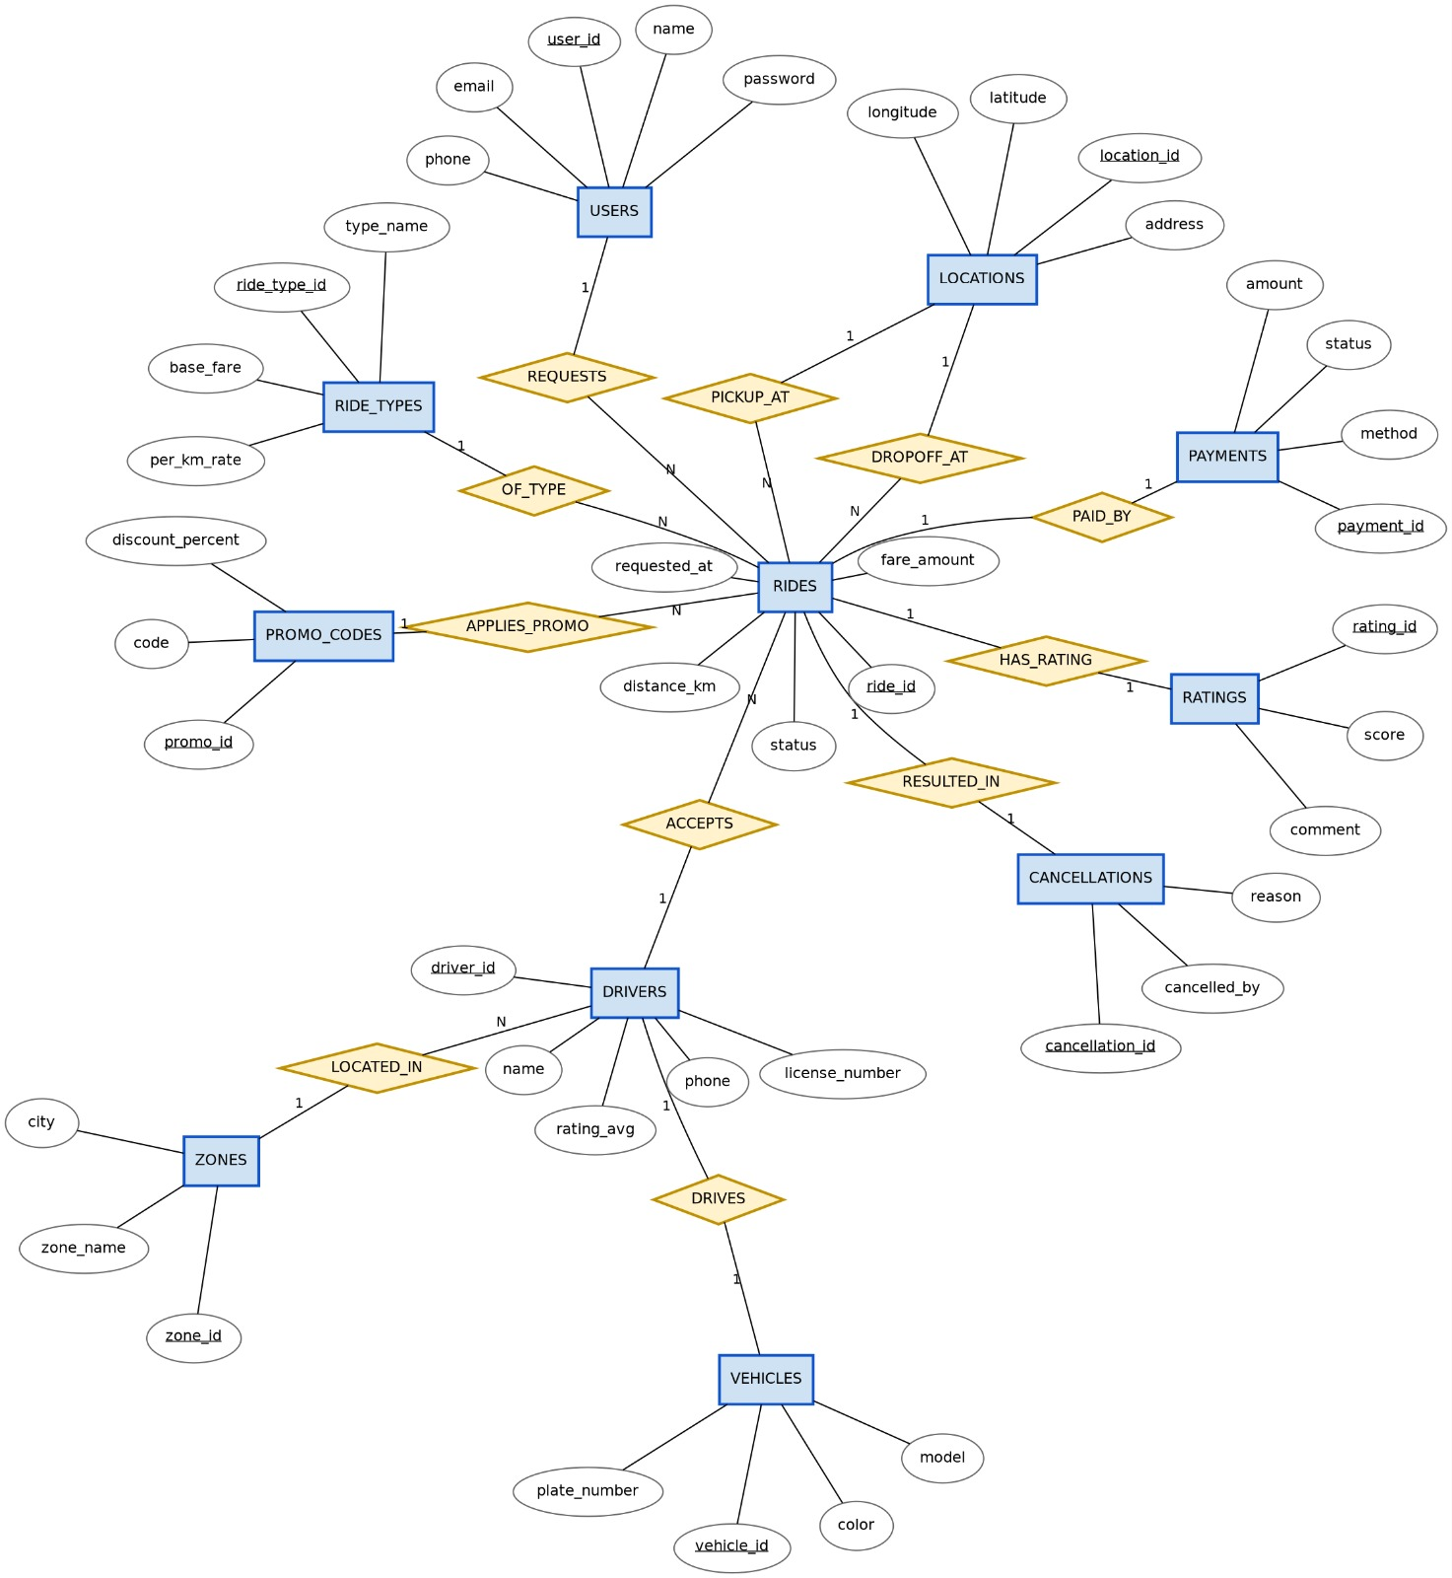
Figure 4.1: ER diagram of RideGraph

4.2 Entities and Relationships
Relationship | Entities | Cardinality | Participation
REQUESTS | USERS – RIDES | 1 : N | Every ride must have a user (total on RIDES)
ACCEPTS | DRIVERS – RIDES | 1 : N | Partial – a requested ride has no driver yet
OF_TYPE | RIDE_TYPES – RIDES | 1 : N | Total on RIDES
PICKUP_AT | LOCATIONS – RIDES | 1 : N | Total on RIDES
DROPOFF_AT | LOCATIONS – RIDES | 1 : N | Total on RIDES
APPLIES_PROMO | PROMO_CODES – RIDES | 1 : N | Partial (promo is optional)
PAID_BY | RIDES – PAYMENTS | 1 : 1 | Total on PAYMENTS
HAS_RATING | RIDES – RATINGS | 1 : 1 | Total on RATINGS
RESULTED_IN | RIDES – CANCELLATIONS | 1 : 1 | Total on CANCELLATIONS
DRIVES | DRIVERS – VEHICLES | 1 : 1 | Total on both
LOCATED_IN | ZONES – DRIVERS | 1 : N | Total on DRIVERS
IN_ZONE* | ZONES – LOCATIONS | 1 : N | Total on LOCATIONS
Table 4.1: Relationship sets (*IN_ZONE links each location to its zone and is used for zone matching)

4.3 Relational Schema
The ER diagram converts to the following relations. Primary keys are bold, and FK marks a foreign key. In the 1:1 relationships PAID_BY, HAS_RATING and RESULTED_IN, the foreign key goes on the dependent side (Payment, Rating, Cancellation) with a UNIQUE constraint. For DRIVES it goes on Vehicles.
Relation | Attributes
ZONES | zone_id, zone_name, city
LOCATIONS | location_id, address, latitude, longitude, zone_id (FK → ZONES)
USERS | user_id, name, email (UNIQUE), phone, password_hash
DRIVERS | driver_id, name, phone (UNIQUE), license_number (UNIQUE), rating_avg, status, zone_id (FK → ZONES)
VEHICLES | vehicle_id, plate_number (UNIQUE), model, color, driver_id (FK → DRIVERS, UNIQUE)
RIDE_TYPES | ride_type_id, type_name (UNIQUE), base_fare, per_km_rate
PROMO_CODES | promo_id, code (UNIQUE), discount_percent
RIDES | ride_id, requested_at, status, distance_km, fare_amount, user_id (FK → USERS), driver_id (FK → DRIVERS, NULL until accepted), ride_type_id (FK), pickup_location_id (FK → LOCATIONS), dropoff_location_id (FK → LOCATIONS), promo_id (FK, NULL)
PAYMENTS | payment_id, ride_id (FK → RIDES, UNIQUE), amount, method, status
RATINGS | rating_id, ride_id (FK → RIDES, UNIQUE), score, comment
CANCELLATIONS | cancellation_id, ride_id (FK → RIDES, UNIQUE), reason, cancelled_by
Table 4.2: Relational schema

4.4 Mapping the Schema to the Neo4j Graph
The relational schema is implemented as a property graph using the standard mapping. Each relation becomes a node label, and each tuple becomes a node whose attributes are its properties. Each foreign key becomes a relationship, so the join it would require is stored directly. Foreign-key columns therefore disappear from the nodes. For example, RIDES.user_id becomes (:User)-[:REQUESTED]->(:Ride), and RIDES.pickup_location_id becomes (:Ride)-[:PICKUP_AT]->(:Location).
Relational foreign key | Graph relationship
RIDES.user_id → USERS | (:User)-[:REQUESTED]->(:Ride)
RIDES.driver_id → DRIVERS | (:Driver)-[:ACCEPTED]->(:Ride)
RIDES.ride_type_id → RIDE_TYPES | (:Ride)-[:OF_TYPE]->(:RideType)
RIDES.pickup_location_id / dropoff_location_id | (:Ride)-[:PICKUP_AT]->(:Location), (:Ride)-[:DROPOFF_AT]->(:Location)
RIDES.promo_id → PROMO_CODES | (:Ride)-[:APPLIES]->(:PromoCode)
PAYMENTS.ride_id / RATINGS.ride_id / CANCELLATIONS.ride_id | (:Ride)-[:PAID_BY]->(:Payment), -[:HAS_RATING]->(:Rating), -[:RESULTED_IN]->(:Cancellation)
VEHICLES.driver_id → DRIVERS | (:Driver)-[:DRIVES]->(:Vehicle)
DRIVERS.zone_id, LOCATIONS.zone_id → ZONES | (:Driver)-[:LOCATED_IN]->(:Zone), (:Location)-[:IN_ZONE]->(:Zone)
Table 4.3: Foreign keys mapped to graph relationships

5. Keys, Constraints, Functional Dependencies and Normalization

5.1 Keys
Relation | Primary key | Candidate / unique keys | Foreign keys
USERS | user_id | email | –
DRIVERS | driver_id | phone, license_number | zone_id
VEHICLES | vehicle_id | plate_number, driver_id | driver_id
ZONES | zone_id | – | –
LOCATIONS | location_id | – | zone_id
RIDE_TYPES | ride_type_id | type_name | –
PROMO_CODES | promo_id | code | –
RIDES | ride_id | – | user_id, driver_id, ride_type_id, pickup_location_id, dropoff_location_id, promo_id
PAYMENTS | payment_id | ride_id | ride_id
RATINGS | rating_id | ride_id | ride_id
CANCELLATIONS | cancellation_id | ride_id | ride_id
Table 5.1: Primary, candidate and foreign keys

5.2 Integrity Constraints
- Entity integrity: every *_id is unique and non-null. In Neo4j this is a uniqueness constraint per label, which also creates an index.
- Referential integrity: a ride can only be created by MATCHing an existing user, ride type and both locations. If any of them is missing, nothing is created and the API returns 404. A driver can only register in an existing zone.
- Domain constraints: Ride.status ∈ {requested, accepted, completed, cancelled}; Driver.status ∈ {available, busy}; Payment.method ∈ {cash, card, upi}; Payment.status ∈ {pending, paid}; Rating.score is an integer from 1 to 5; Cancellation.cancelled_by ∈ {rider, driver}; pickup ≠ dropoff; password length ≥ 6.
- Cardinality / business constraints: at most one rating per ride (WHERE NOT (r)-[:HAS_RATING]->()); a ride can only be paid once; a ride can only be accepted while it is still requested and the driver is available in the same zone.
Neo4j Community Edition supports uniqueness constraints but not property-existence or property-type constraints. The domain rules are therefore enforced in the Flask API before any write, and they are also written into the Cypher patterns so that an invalid update matches nothing.

5.3 Initial Relation
Normalization starts from the single unnormalized record that a ride receipt would produce, with the rider's rides as a repeating group:
RIDE_RECORD( user_id, user_name, email, phone,
{ ride_id, requested_at, status, distance_km, fare_amount,
driver_id, driver_name, driver_phone, license_number, rating_avg, driver_status,
vehicle_id, plate_number, model, color, driver_zone_id, driver_zone_name, city,
ride_type_id, type_name, base_fare, per_km_rate,
pickup_location_id, pickup_address, pickup_lat, pickup_lon, pickup_zone_id, pickup_zone_name,
dropoff_location_id, dropoff_address, dropoff_lat, dropoff_lon, dropoff_zone_id,
promo_id, code, discount_percent,
payment_id, amount, method, payment_status,
rating_id, score, comment,
cancellation_id, reason, cancelled_by } )

5.4 Functional Dependencies
# | Functional dependency
FD1 | user_id → user_name, email, phone, password_hash
FD2 | email → user_id (candidate key)
FD3 | ride_id → requested_at, status, distance_km, fare_amount, user_id, driver_id, ride_type_id, pickup_location_id, dropoff_location_id, promo_id
FD4 | driver_id → driver_name, driver_phone, license_number, rating_avg, driver_status, zone_id, vehicle_id
FD5 | license_number → driver_id; driver_phone → driver_id (candidate keys)
FD6 | vehicle_id → plate_number, model, color; plate_number → vehicle_id
FD7 | zone_id → zone_name, city
FD8 | location_id → address, latitude, longitude, zone_id
FD9 | ride_type_id → type_name, base_fare, per_km_rate
FD10 | promo_id → code, discount_percent; code → promo_id
FD11 | payment_id → ride_id, amount, method, payment_status; ride_id → payment_id
FD12 | rating_id → ride_id, score, comment; ride_id → rating_id
FD13 | cancellation_id → ride_id, reason, cancelled_by; ride_id → cancellation_id
Table 5.2: Functional dependencies

5.5 First Normal Form (1NF)
RIDE_RECORD is not in 1NF because the ride details form a repeating group: one user has many rides. The group is removed by repeating the user attributes on every ride row, so every attribute holds a single atomic value. The key of the flattened relation is the composite (user_id, ride_id).
R1( user_id, ride_id, user_name, email, phone, requested_at, status, ...all ride,
driver, vehicle, zone, type, location, promo, payment, rating, cancellation attributes )
R1 is in 1NF but has redundancy. A user's name and email are repeated on every ride, and a ride type's fare rates are repeated on every ride of that type. This causes update, insertion and deletion anomalies. For example, a new ride type cannot be stored until somebody books it.

5.6 Second Normal Form (2NF)
2NF forbids non-key attributes that depend on only part of the composite key. In R1, user_name, email, phone depend on user_id alone (FD1). Every ride attribute depends on ride_id alone (FD3), and ride_id also determines user_id. These partial dependencies are removed by decomposition:
USERS( user_id, user_name, email, phone, password_hash )
R2( ride_id, user_id, requested_at, status, distance_km, fare_amount, driver_id, driver_name, ...,
ride_type_id, type_name, base_fare, ..., pickup_location_id, pickup_address, ...,
promo_id, code, ..., payment_id, amount, ..., rating_id, score, ..., cancellation_id, reason, ... )
USERS has a single-attribute key, so it is in 2NF. R2 now has the single-attribute key ride_id, so no partial dependency is possible and R2 is in 2NF.

5.7 Third Normal Form (3NF)
3NF forbids transitive dependencies, where a non-key attribute depends on another non-key attribute. R2 has several, all through foreign-key attributes:
- ride_id → driver_id → driver_name, license_number, rating_avg, zone_id, vehicle_id (FD4), and further vehicle_id → plate_number, model, color (FD6) and zone_id → zone_name, city (FD7)
- ride_id → ride_type_id → type_name, base_fare, per_km_rate (FD9)
- ride_id → pickup_location_id / dropoff_location_id → address, latitude, longitude, zone_id (FD8) → zone_name (FD7)
- ride_id → promo_id → code, discount_percent (FD10)
- ride_id → payment_id / rating_id / cancellation_id → their attributes (FD11–FD13)
Each determinant is moved into its own relation, and only its key is kept as a foreign key. This gives the final 3NF relations:
Relation | Key | Dependencies it holds
USERS(user_id, name, email, phone, password_hash) | user_id (alt: email) | FD1, FD2
ZONES(zone_id, zone_name, city) | zone_id | FD7
LOCATIONS(location_id, address, latitude, longitude, zone_id) | location_id | FD8
DRIVERS(driver_id, name, phone, license_number, rating_avg, status, zone_id) | driver_id (alt: phone, license_number) | FD4, FD5
VEHICLES(vehicle_id, plate_number, model, color, driver_id) | vehicle_id (alt: plate_number, driver_id) | FD6
RIDE_TYPES(ride_type_id, type_name, base_fare, per_km_rate) | ride_type_id | FD9
PROMO_CODES(promo_id, code, discount_percent) | promo_id (alt: code) | FD10
RIDES(ride_id, requested_at, status, distance_km, fare_amount, user_id, driver_id, ride_type_id, pickup_location_id, dropoff_location_id, promo_id) | ride_id | FD3
PAYMENTS(payment_id, ride_id, amount, method, status) | payment_id (alt: ride_id) | FD11
RATINGS(rating_id, ride_id, score, comment) | rating_id (alt: ride_id) | FD12
CANCELLATIONS(cancellation_id, ride_id, reason, cancelled_by) | cancellation_id (alt: ride_id) | FD13
Table 5.3: Final relations in 3NF
In every final relation, each non-trivial dependency has a candidate key on its left-hand side, so the relations are in 3NF and also in BCNF. The decomposition is lossless, because every split shares a key with the relation it came from. It is also dependency-preserving, because every FD is contained in one relation. These eleven relations are exactly the eleven node labels in the Neo4j implementation.

5.8 Justified Denormalization
Four stored attributes can be derived from other data. They are kept deliberately:
- RIDES.distance_km can be derived from the two locations' coordinates. It is stored so that history and statistics do not recompute the haversine formula on every read.
- RIDES.fare_amount is a price snapshot taken at booking time. If base_fare, per_km_rate or a promo changes later, past rides must keep the price that was actually charged. Recomputing it would rewrite history.
- PAYMENTS.amount copies the fare when the payment is created, as a separate financial record that is independent of later edits to the ride.
- DRIVERS.rating_avg is the average of the driver's ratings. It is stored so that "nearby drivers, best rated first" can sort without aggregating every rating. It is recalculated by UPDATE_DRIVER_RATING each time a rating is added, so it cannot drift.

6. Implementation Details

6.1 Database Management System
The database is Neo4j 5, run locally through Neo4j Desktop 2.x as the instance ridegraph-db. Neo4j was chosen, with the faculty's approval, because the core operations of a ride-hailing system are traversals over relationships. Neo4j stores relationships as direct pointers between nodes (index-free adjacency). So finding the drivers in a pickup zone follows a few links instead of computing joins over whole tables, and the cost depends on the size of the neighbourhood rather than the size of the database.
Constraints and indexes are created by src/backend/seed.py and by database/schema.cypher. There is one uniqueness constraint per label on its id, plus unique constraints on email, phone, licence, plate and promo code, and indexes on the frequently filtered properties Ride.status, Ride.requested_at and Driver.status.
CREATE CONSTRAINT ride_ride_id IF NOT EXISTS FOR (n:Ride) REQUIRE n.ride_id IS UNIQUE;
CREATE CONSTRAINT user_email_unique IF NOT EXISTS FOR (u:User) REQUIRE u.email IS UNIQUE;
CREATE INDEX ride_status_idx IF NOT EXISTS FOR (r:Ride) ON (r.status);

6.2 Application Technologies
Component | Technology | Role
Backend API | Python 3, Flask, flask-cors | REST endpoints, validation, business rules, serving the frontend
Database driver | neo4j (official Python driver) | Bolt connection pool, transactions
Configuration | python-dotenv | Reads NEO4J_URI / USER / PASSWORD from .env
Security | Werkzeug | Salted password hashing (scrypt)
Frontend | React 19, React Router, Vite | Single-page app: Login, Rider, Driver, Admin pages
UI | Tailwind CSS, shadcn/ui, Motion | Components, theming (light/dark), animations
Table 6.1: Application technology stack

6.3 Database Connectivity
db.py creates one driver object for the whole application, which manages a pool of Bolt connections. It exposes two helper functions, run_read and run_write. Each call runs in its own transaction, routed as a read or a write.
load_dotenv(os.path.join(os.path.dirname(os.path.abspath(__file__)), ".env"))
URI = os.getenv("NEO4J_URI", "bolt://localhost:7687")
USER = os.getenv("NEO4J_USER", "neo4j")
PASSWORD = os.getenv("NEO4J_PASSWORD", "")
DATABASE = os.getenv("NEO4J_DATABASE", "neo4j")
driver = GraphDatabase.driver(URI, auth=(USER, PASSWORD))

def run_read(query, **params):
records, _, _ = driver.execute_query(
query, parameters_=params, database_=DATABASE, routing_="r")
return [r.data() for r in records]

def run_write(query, **params):
records, _, _ = driver.execute_query(
query, parameters_=params, database_=DATABASE, routing_="w")
return [r.data() for r in records]
Every query passes user input as $parameters and never joins it into the query text, which prevents Cypher injection. If Neo4j is stopped or the password is wrong, the driver raises ServiceUnavailable or AuthError. Flask turns this into a 503 response with a clear message.

6.4 Project Structure
RideGraph/
├── README.md
├── database/ schema.cypher, sample_data.cypher, queries.cypher
├── src/backend/ app.py (API), db.py (connection), queries.py (all Cypher),
│ seed.py (constraints + demo data), utils.py (haversine, fare)
├── src/frontend/ React source (src/) and built site (dist/)
├── tests/ test_api.py, TEST_CASES.md
├── screenshots/, report/, presentation/, docs/
└── run_windows.bat, run_mac.command, requirements.txt

6.5 Sample Data
All data is synthetic and covers Chennai: 6 zones, 15 named locations, 4 ride types (Economy ₹40 + ₹12/km, Premium ₹80 + ₹20/km, Auto ₹30 + ₹10/km, Bike ₹20 + ₹6/km), 3 promo codes (WELCOME20, RIDE10, SAVE15), 10 riders, 11 drivers with vehicles, and 24 historical rides: 21 completed with payments and ratings, and 3 cancelled. The demo accounts use fixed demo passwords that are stored only as hashes.

7. Important Queries and Implemented Features
The application has more than five complete end-to-end features. Each one goes from a React screen, through a Flask endpoint, to one or more Cypher queries and back. The key queries are shown below. All of the application's queries are in src/backend/queries.py, and runnable versions are in database/queries.cypher.

7.1 Feature 1 – Registration and Login
POST /api/register checks the required fields, the email format and the password length, rejects a duplicate email, phone or licence with 409, hashes the password and creates the node. A driver is created together with their vehicle and zone link in a single query:
MATCH (z:Zone {zone_id: $zone_id})
CREATE (d:Driver {driver_id: $driver_id, name: $name, license_number: $license_number,
phone: $phone, rating_avg: 0.0, status: 'available', password_hash: $password_hash})
CREATE (v:Vehicle {vehicle_id: $vehicle_id, plate_number: $plate_number, model: $model, color: $color})
CREATE (d)-[:DRIVES]->(v)
CREATE (d)-[:LOCATED_IN]->(z)
POST /api/login looks the account up by email (rider) or phone (driver) and checks the hash with check_password_hash. It returns the same message for an unknown user and for a wrong password, so that it never reveals which accounts exist.

7.2 Feature 2 – Fare Estimate and Ride Request (INSERT)
The API reads the two locations' coordinates, computes the haversine distance, and calculates the fare as base_fare + per_km_rate × distance, less the promo percentage. For example, Pondy Bazaar → Kapaleeshwarar Temple is 3.96 km. With Economy that costs 40 + 12 × 3.96 = ₹87.52, or ₹70.02 with WELCOME20. The ride and its four links are created together:
MATCH (u:User {user_id: $user_id})
MATCH (t:RideType {ride_type_id: $ride_type_id})
MATCH (pl:Location {location_id: $pickup_id})
MATCH (dl:Location {location_id: $dropoff_id})
CREATE (r:Ride {ride_id: $ride_id, requested_at: $requested_at, status: 'requested',
distance_km: $distance_km, fare_amount: $fare_amount})
CREATE (u)-[:REQUESTED]->(r)
CREATE (r)-[:OF_TYPE]->(t)
CREATE (r)-[:PICKUP_AT]->(pl)
CREATE (r)-[:DROPOFF_AT]->(dl)

7.3 Feature 3 – Nearby Drivers and Open Requests (traversal / JOIN)
Finding the available drivers for a ride takes four hops: Ride → pickup Location → Zone ← Driver → Vehicle. In SQL this would join RIDES, LOCATIONS, ZONES, DRIVERS and VEHICLES.
MATCH (:Ride {ride_id: $ride_id})-[:PICKUP_AT]->(:Location)-[:IN_ZONE]->(z:Zone)
<-[:LOCATED_IN]-(d:Driver {status: 'available'})
MATCH (d)-[:DRIVES]->(v:Vehicle)
RETURN d.driver_id, d.name, d.rating_avg, v.model, v.plate_number, z.zone_name
ORDER BY d.rating_avg DESC
The driver's request list walks the same path in reverse: (Driver)-[:LOCATED_IN]->(Zone)<-[:IN_ZONE]-(Location)<-[:PICKUP_AT]-(Ride {status:'requested'}).

7.4 Feature 4 – Accept, Complete, Pay (UPDATE, concurrency-safe)
Acceptance is a single conditional update. The pattern only matches if the ride is still requested, the driver is available, and both are in the same zone. The zone variable z is reused to enforce this. If two drivers press Accept at the same time, the second query finds no match and changes nothing, and the API returns 409 Conflict. This prevents double booking.
MATCH (d:Driver {driver_id: $driver_id, status: 'available'})-[:LOCATED_IN]->(z:Zone)
MATCH (r:Ride {ride_id: $ride_id, status: 'requested'})-[:PICKUP_AT]->(:Location)-[:IN_ZONE]->(z)
SET r.status = 'accepted', d.status = 'busy'
CREATE (d)-[:ACCEPTED]->(r)
Completing a ride sets it to completed, frees the driver and creates a pending Payment in the same transaction. Paying matches only a pending payment on the rider's own completed ride, so a ride cannot be paid twice.
MATCH (d:Driver {driver_id: $driver_id})-[:ACCEPTED]->(r:Ride {ride_id: $ride_id, status: 'accepted'})
SET r.status = 'completed', d.status = 'available'
CREATE (p:Payment {payment_id: $payment_id, amount: r.fare_amount, method: 'unpaid', status: 'pending'})
CREATE (r)-[:PAID_BY]->(p)

7.5 Feature 5 – Rating with Automatic Average
MATCH (:User {user_id: $user_id})-[:REQUESTED]->(r:Ride {ride_id: $ride_id, status: 'completed'})
WHERE NOT (r)-[:HAS_RATING]->(:Rating)
CREATE (rt:Rating {rating_id: $rating_id, score: $score, comment: $comment})
CREATE (r)-[:HAS_RATING]->(rt)

MATCH (d:Driver {driver_id: $driver_id})-[:ACCEPTED]->(:Ride)-[:HAS_RATING]->(rt:Rating)
WITH d, avg(rt.score) AS average
SET d.rating_avg = round(average * 100) / 100.0

7.6 Feature 6 – Cancellation
A requested or accepted ride can be cancelled by its rider or by its driver. OPTIONAL MATCH (the graph form of a LEFT JOIN) finds the driver if there is one, and FOREACH makes that driver available again only if they exist:
MATCH (r:Ride {ride_id: $ride_id}) WHERE r.status IN ['requested', 'accepted']
OPTIONAL MATCH (d:Driver)-[:ACCEPTED]->(r)
SET r.status = 'cancelled'
FOREACH (x IN CASE WHEN d IS NULL THEN [] ELSE [d] END | SET x.status = 'available')
CREATE (c:Cancellation {cancellation_id: $cancellation_id, reason: $reason, cancelled_by: $cancelled_by})
CREATE (r)-[:RESULTED_IN]->(c)

7.7 Feature 7 – Admin Statistics (aggregation / GROUP BY)
Cypher groups automatically by the non-aggregated columns. Using OPTIONAL MATCH keeps zones with zero rides in the result, just like a LEFT JOIN … GROUP BY.
MATCH (r:Ride)
RETURN count(r) AS total_rides,
sum(CASE WHEN r.status = 'completed' THEN 1 ELSE 0 END) AS completed_rides,
sum(CASE WHEN r.status = 'completed' THEN r.fare_amount ELSE 0 END) AS revenue

MATCH (z:Zone)
OPTIONAL MATCH (z)<-[:IN_ZONE]-(:Location)<-[:PICKUP_AT]-(r:Ride)
RETURN z.zone_name AS zone_name, count(r) AS rides ORDER BY rides DESC

7.8 Subqueries, Views, Transactions and DELETE
- Subqueries: EXISTS { }, COUNT { } and CALL { }, for example rides whose fare is above the overall average (database/queries.cypher, section D).
- View: Neo4j has no CREATE VIEW. Instead, the reusable RIDE_DETAIL query fragment in queries.py acts as a view, and every ride query (single ride, rider history, driver history, open requests) appends it.
- Transactions: every API call runs in a single transaction through execute_query. Multi-step operations such as complete-and-create-payment therefore either commit completely or not at all. database/queries.cypher also shows explicit :begin / :commit / :rollback and CALL { } IN TRANSACTIONS.
- DELETE: DETACH DELETE, which works like ON DELETE CASCADE, is used by the test clean-up and by seed.py --reset.
Operation | Where used
INSERT (CREATE / MERGE) | register, request ride, complete (payment), rate, cancel, seed data
SELECT (MATCH … RETURN) | login, lookups, ride detail, history, nearby drivers, open requests, stats
UPDATE (SET) | accept, complete, pay, cancel (driver freed), rating average
DELETE (DETACH DELETE) | test clean-up, seed --reset, queries.cypher A9
JOIN (multi-hop MATCH) | nearby drivers, open requests, RIDE_DETAIL
GROUP BY / aggregates | admin stats, earnings, rating average
LEFT JOIN (OPTIONAL MATCH) | RIDE_DETAIL, rides per zone, cancel
Table 7.1: Database operations and where they are used

8. Testing, Results and Discussion

8.1 Testing Approach
- Automated end-to-end tests: tests/test_api.py calls the running API through a complete ride life cycle (register → login → estimate → request → accept → complete → pay → rate → cancel → history → admin) and checks every response. It prints PASS or FAIL for each check and a total, and it deletes the data it created at the end.
- Negative tests: duplicate values, missing fields, invalid values, missing records, unauthorised actions, repeated actions and a database outage.
- Manual UI testing: the full flow in two browser windows (rider and driver), with the results checked in Neo4j Browser.

8.2 Test Cases
The table below lists the main test cases. All forty are in tests/TEST_CASES.md. The automated script ran 73 checks on 01-11-2026 and all 73 passed (Figure 8.9). TC39 was observed when the Neo4j instance was stopped: every API call returned 503 with the message "Cannot connect to the Neo4j database". TC40 was run against the database, which rejected the duplicate user_id with Neo.ClientError.Schema.ConstraintValidationFailed. All three database scripts (schema.cypher, sample_data.cypher, queries.cypher; 156 statements) also ran without errors.
ID | Feature | Input | Expected | Actual
TC01 | Lookup data | GET locations, zones, ride types | 15, 6 and 4 records | Pass
TC04 | Register rider | Valid new rider | 201 Created | Pass
TC05 | Duplicate email | Same email again | 409 Conflict | Pass
TC06 | Missing fields | Only a name | 400 "'email' is required" | Pass
TC09 | Wrong password | Valid email, wrong password | 401, generic message | Pass
TC10 | Unknown user | Unknown email | 401, same message | Pass
TC13 | Fare estimate | L1 → L4, Economy | base + per_km × distance | Pass
TC14 | Promo code | Same + WELCOME20 | Exactly 20% less | Pass
TC15 | Same pickup and dropoff | pickup = dropoff | 400 | Pass
TC16 | Missing record | Unknown user_id | 404 Not found | Pass
TC17 | Request ride | Valid request | 201, status requested | Pass
TC19 | Zone matching | Driver in other zone | Ride not visible | Pass
TC20 | Wrong-zone accept | Other-zone driver accepts | 403 | Pass
TC21 | Accept ride | Same-zone driver | 200, driver busy | Pass
TC22 | Double accept | Accept again | 409 | Pass
TC24 | Complete ride | Accepting driver | Pending payment created | Pass
TC25 | Invalid input | Payment method "bitcoin" | 400 | Pass
TC27 | Double payment | Pay again | 409 | Pass
TC29 | Double rating | Rate again | 409 | Pass
TC30 | Invalid score | score = 9 | 400 | Pass
TC33 | Cancel ride | Rider cancels accepted ride | Cancelled, driver freed | Pass
TC38 | Admin stats | GET /api/admin/stats | Totals, revenue, 6 zones | Pass
TC39 | Database down | Neo4j stopped | 503 with message | Pass
TC40 | Constraint violation | Duplicate user_id in Neo4j | ConstraintValidationFailed | Pass
Table 8.1: Test cases with expected and actual outcomes

8.3 Results on the Sample Data
On a freshly seeded database, the admin dashboard and the queries in Section 7 return the following values. They can be checked with database/queries.cypher, section C. The screenshots in Section 8.4 were taken on the team's working database, which also contains a few rides created while testing, so the dashboard there shows slightly higher totals.
Measure | Value
Total rides / completed / cancelled | 24 / 21 / 3
Revenue from completed rides | ₹1,973.40
Rides per pickup zone | T. Nagar 9, Mylapore 4, Anna Nagar 3, Velachery 3, Chennai Central 3, Guindy 2
Revenue by ride type | Premium ₹954.86 (6), Economy ₹757.20 (9), Auto ₹202.50 (4), Bike ₹58.84 (2)
Payment methods | UPI 10, Cash 6, Card 5
Demo driver Praveen (D11) | 4 completed rides, ₹553.56 earned, rating 4.75
Table 8.2: Results on the seeded data

8.4 Screenshots
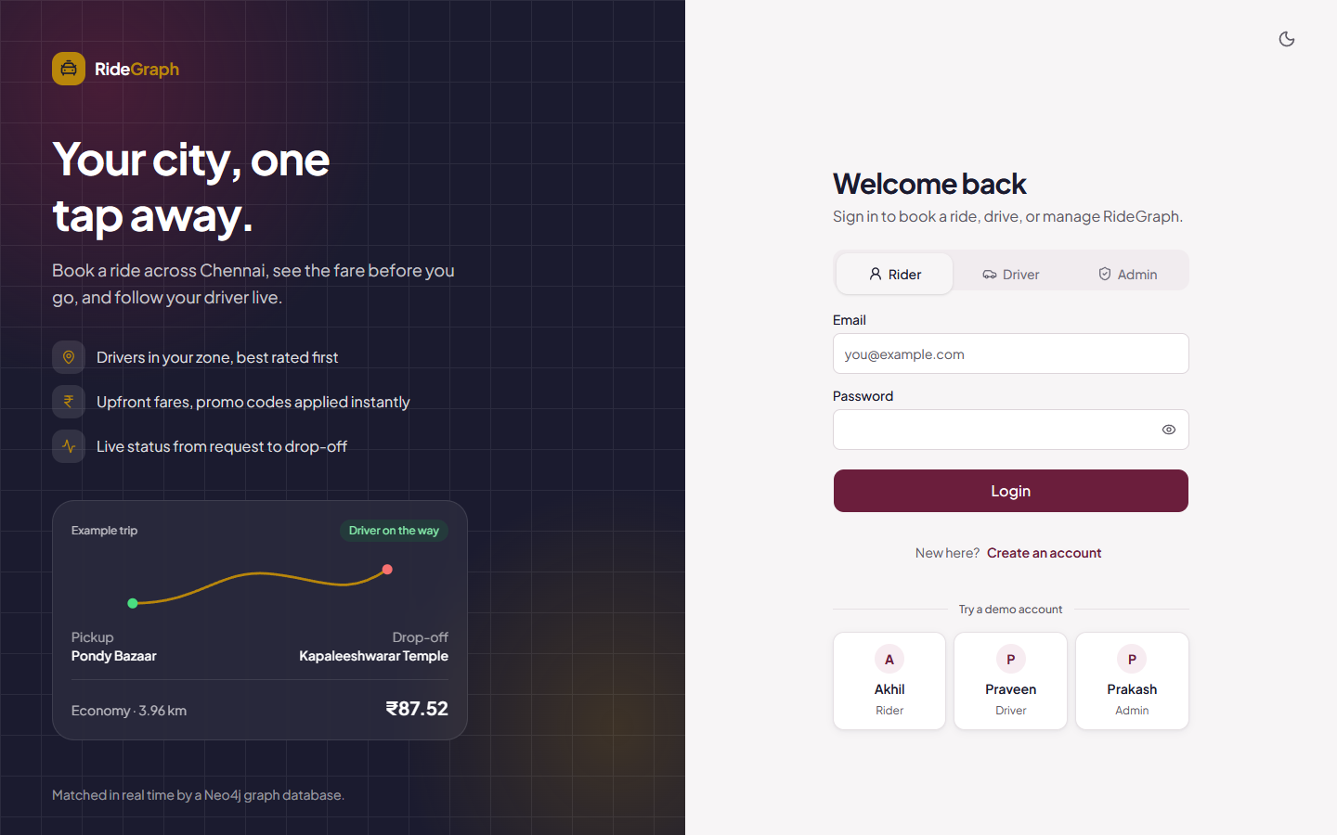
Figure 8.1: Login page with Rider / Driver / Admin tabs and demo accounts
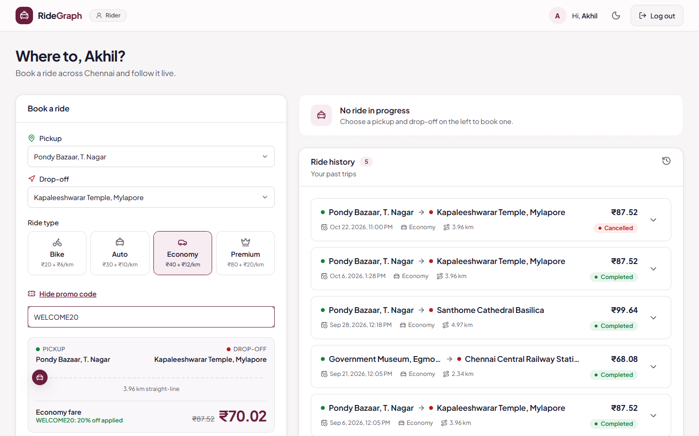
Figure 8.2: Fare estimate – Pondy Bazaar → Kapaleeshwarar Temple, Economy, WELCOME20: ₹87.52 → ₹70.02
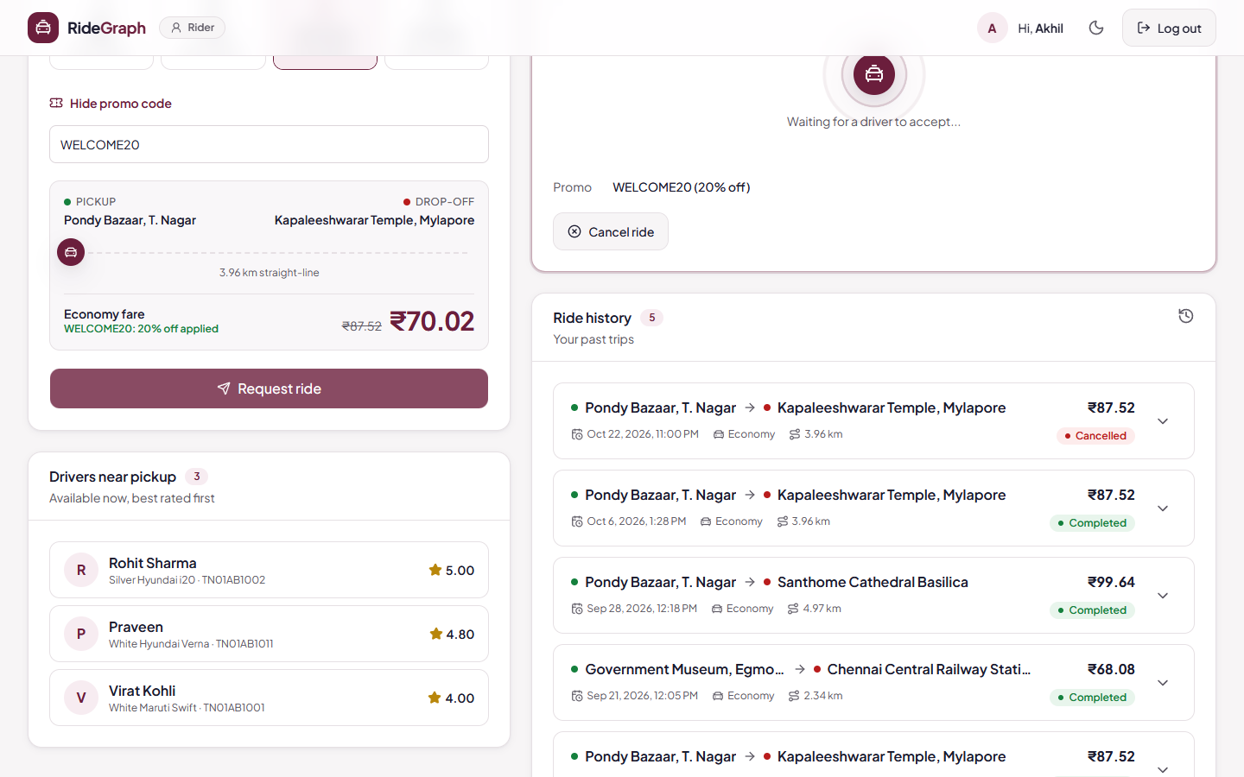
Figure 8.3: Ride requested – available drivers in the pickup zone, best rated first
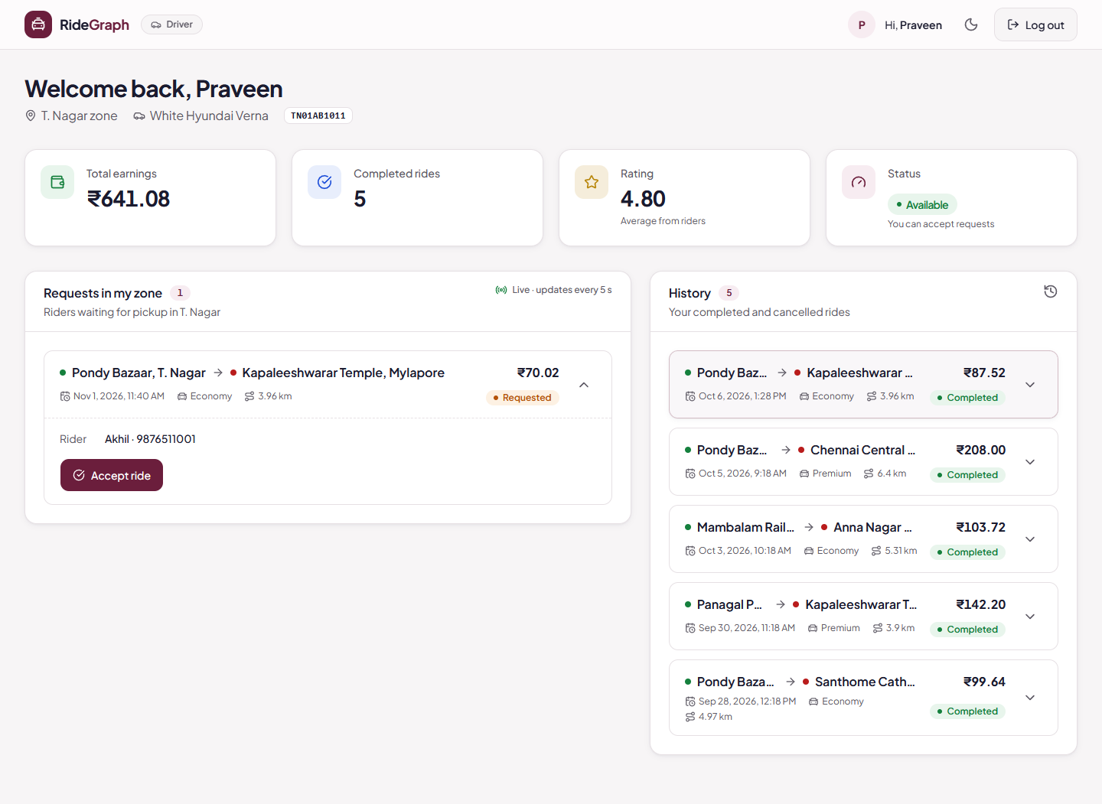
Figure 8.4: Driver Praveen sees the open request in his zone (T. Nagar)
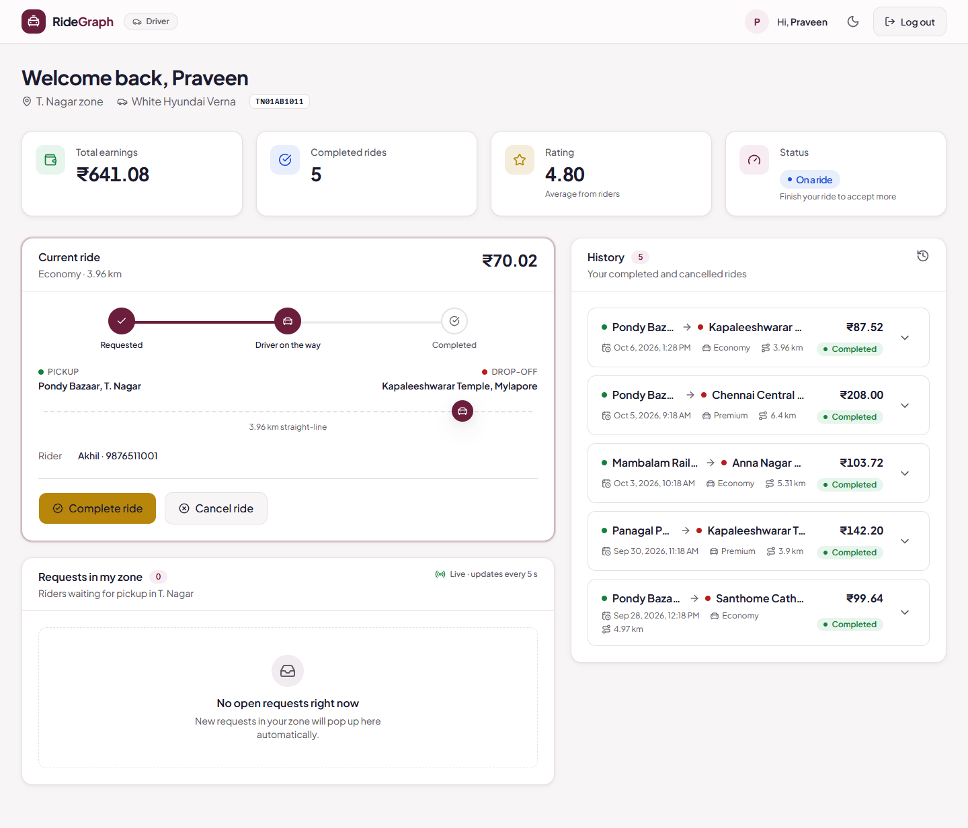
Figure 8.5: After Accept – driver status On a ride, ride stepper at Driver on the way
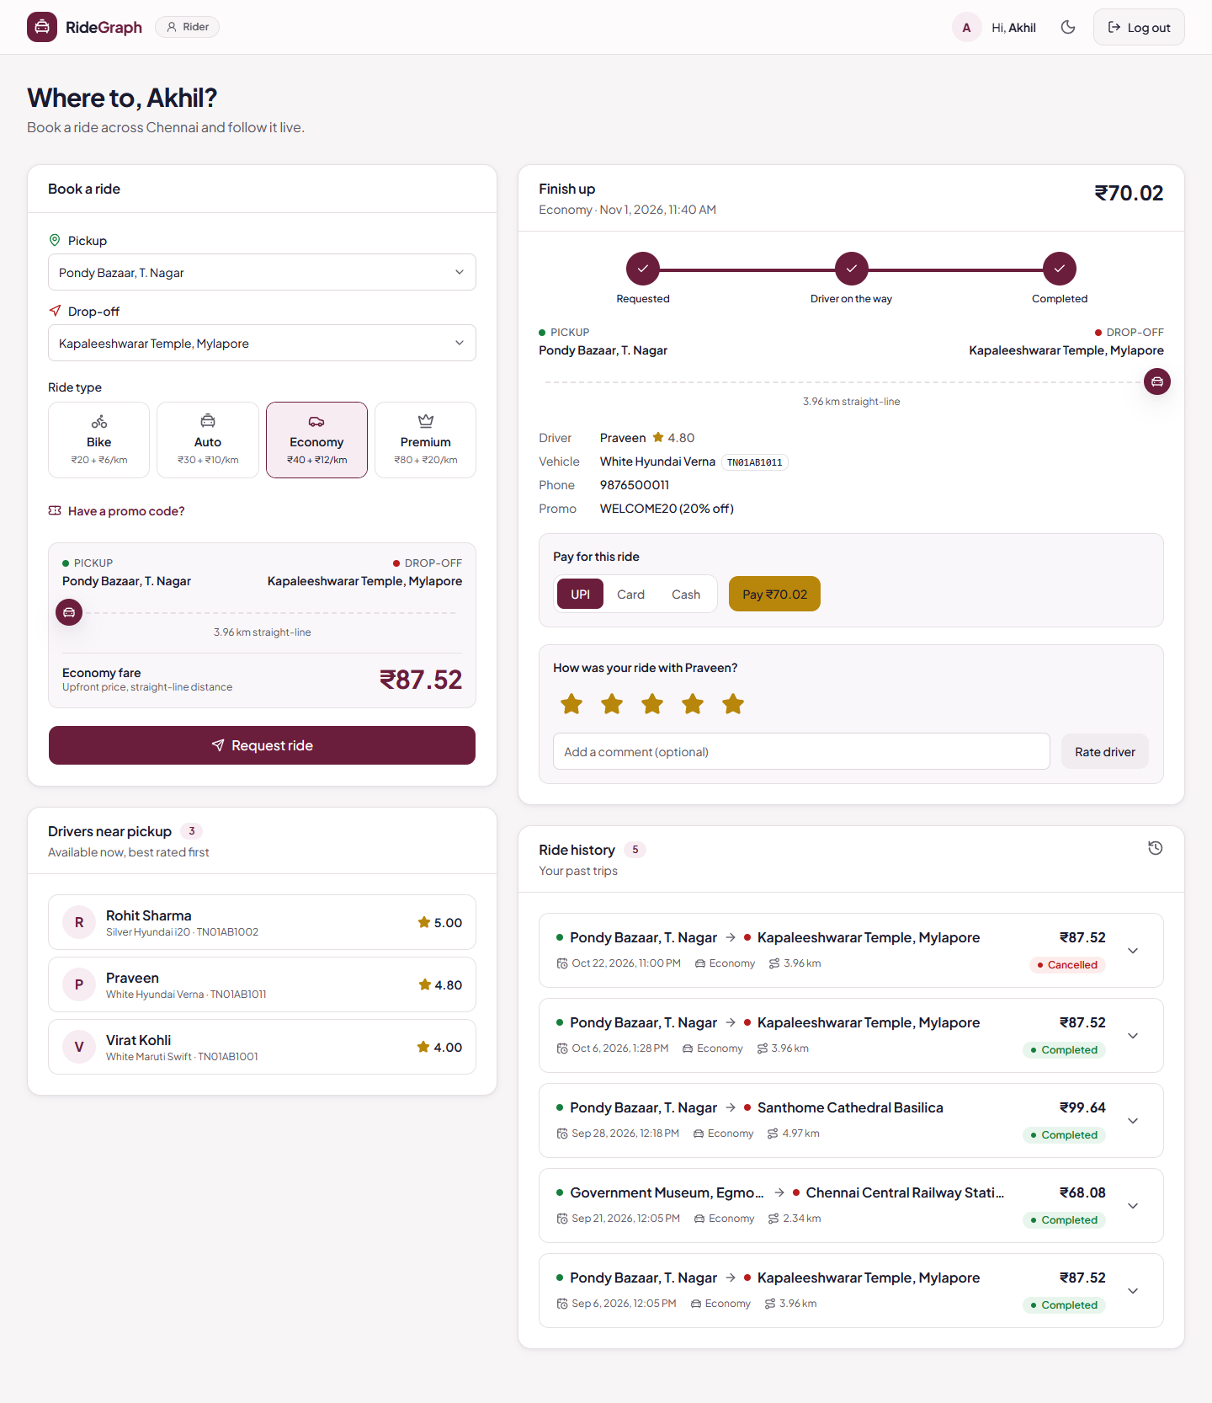
Figure 8.6: Ride completed – rider pays (UPI / Card / Cash) and rates the driver
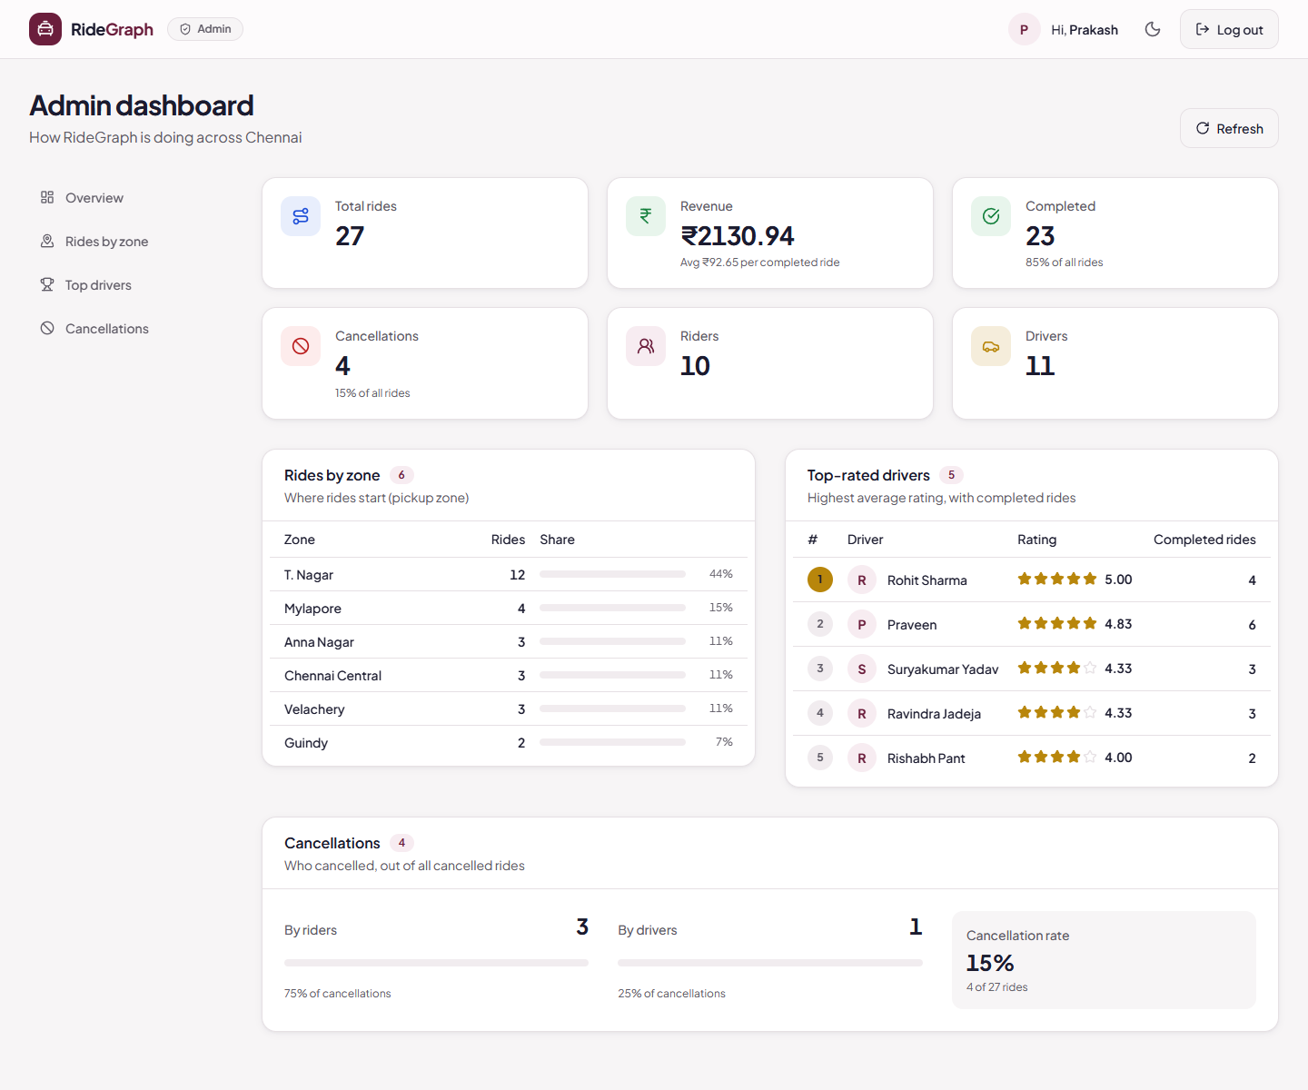
Figure 8.7: Admin dashboard – totals, revenue, rides by zone, top drivers, cancellations
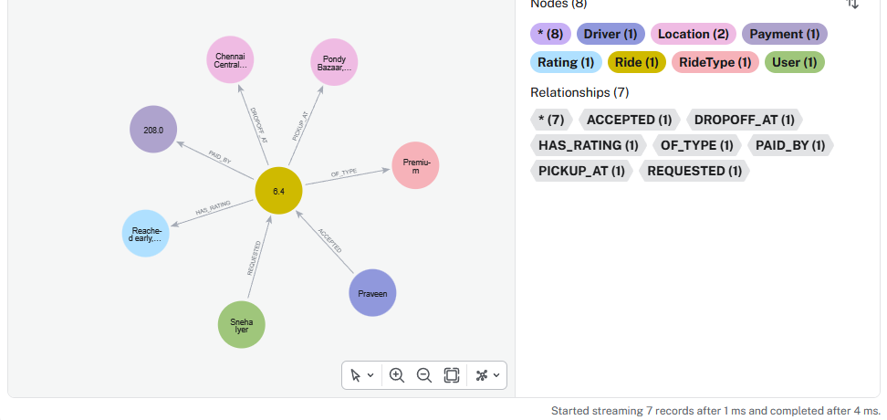
Figure 8.8: Neo4j Browser – ride R24 with its rider, driver, type, locations, payment and rating
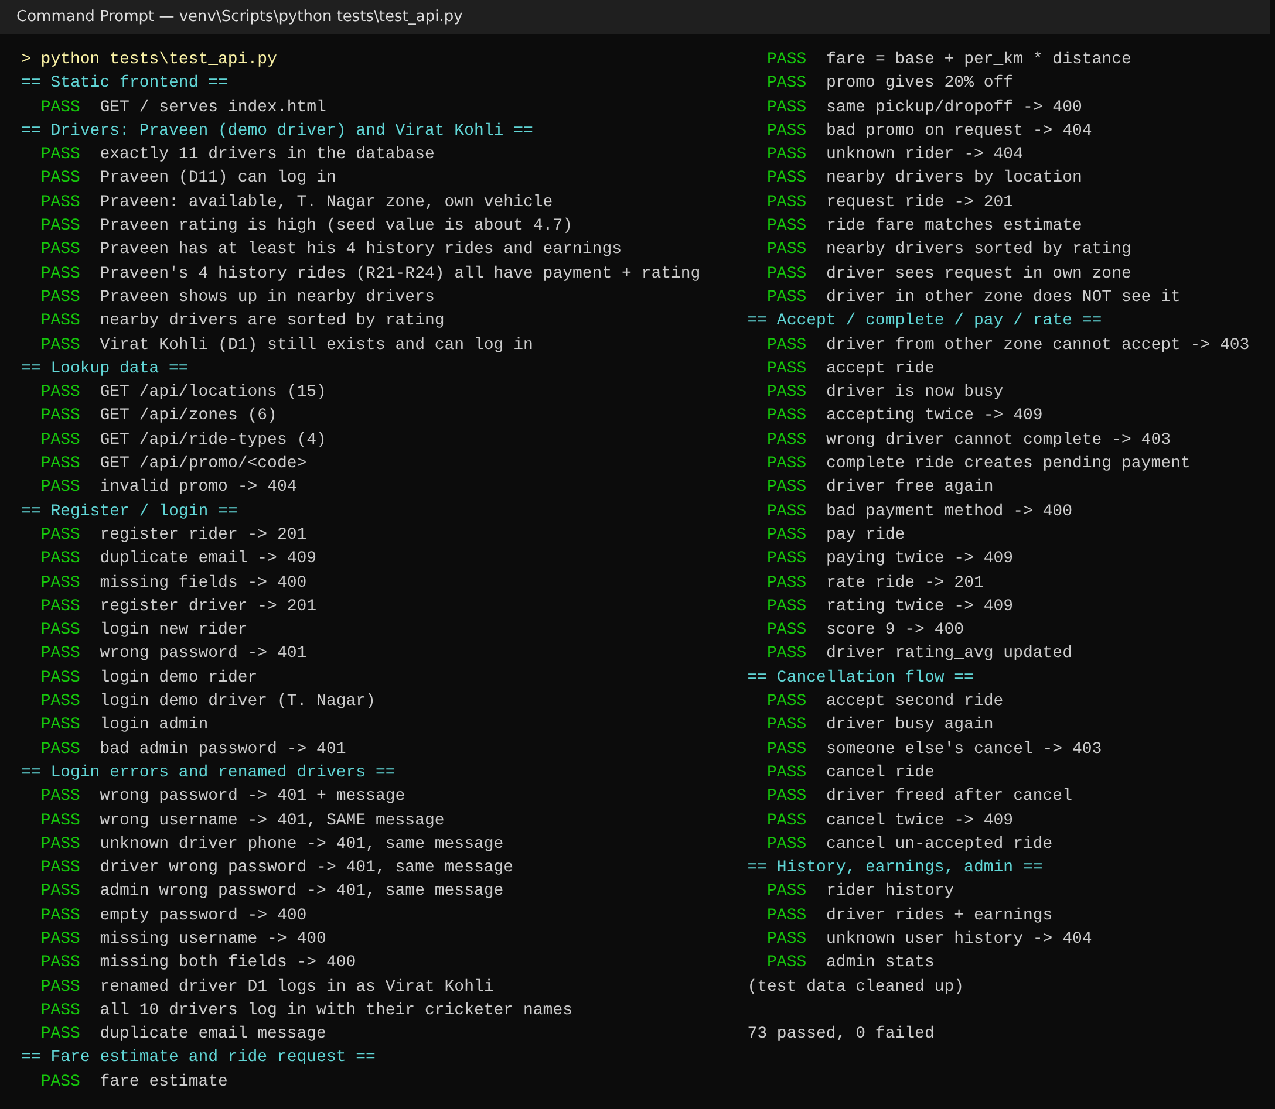
Figure 8.9: Output of tests/test_api.py – 73 passed, 0 failed
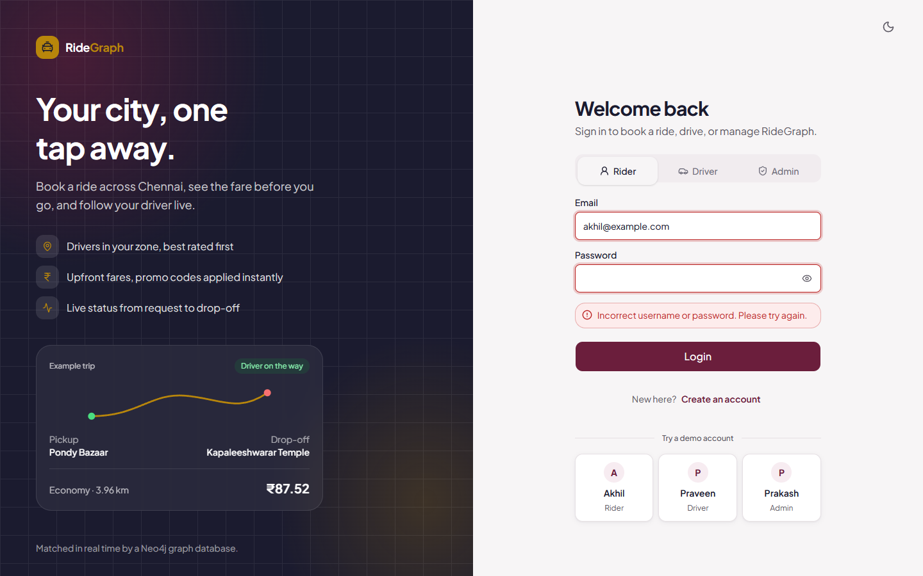
Figure 8.10: Wrong password – one generic message
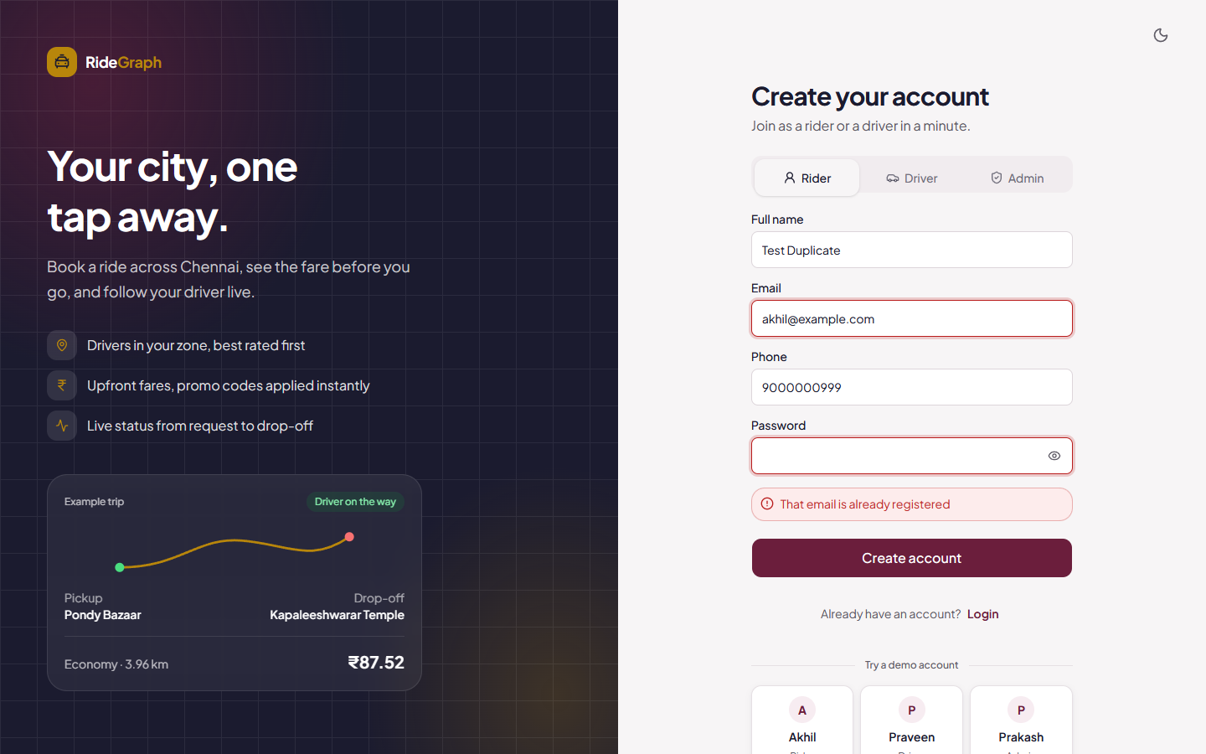
Figure 8.11: Registering an existing email – 409 "That email is already registered"

8.5 Discussion
The graph model made the relationship-heavy features short and readable. Nearby drivers, open requests and ride details are each one MATCH pattern instead of a chain of joins. The conditional-update pattern turned out to be the simplest way to enforce business rules such as no double acceptance, pay once and rate once: if the pre-condition no longer holds, the pattern matches nothing and the API reports a conflict, without separate locking code.
There were also trade-offs. Neo4j Community does not support property-existence or type constraints, so domain rules had to move into the API layer. Aggregate reports such as revenue or rides per zone are equally easy in SQL. The graph approach gives the biggest advantage for multi-hop questions such as repeat drivers for a rider, and for extending the model with new relationship types without changing the schema.

9. Conclusion, Limitations and Future Enhancements

9.1 Conclusion
RideGraph shows a complete database project carried from requirements to a working application. The ER design was converted to a relational schema, normalized to 3NF/BCNF with deliberate and justified denormalization, and implemented as a Neo4j property graph with uniqueness constraints and indexes. A three-tier React–Flask–Neo4j application provides seven end-to-end features covering every CRUD operation, multi-hop traversals, aggregation and subqueries. The application validates input, returns clear errors for duplicates, missing records and rule violations, and was checked with documented and automated tests.

9.2 Limitations
- Authentication is session-less. The API trusts the user and driver ids sent by the browser, and the admin endpoint has no token check.
- Distances are straight-line (haversine), not road distances, and there is no live GPS or map. A driver's position is their zone.
- Payments are simulated, with no payment gateway.
- Property-existence and type constraints need Neo4j Enterprise, so domain rules are enforced in the API.
- Ratings go one way only, from rider to driver.

9.3 Future Enhancements
- JWT-based authentication with role checks on every endpoint.
- Live driver locations using Neo4j point() and distance indexes, shown on a map, with road distances from a routing API.
- Shortest-path and route queries with Neo4j Graph Data Science, and surge pricing based on demand per zone.
- Two-way ratings, ride scheduling, carpooling (a new SHARES relationship) and notifications.
- Integration with a real payment gateway (UPI/card) and deployment to Neo4j AuraDB.

References
[1] R. Elmasri and S. B. Navathe, Fundamentals of Database Systems, 7th ed. Boston, MA, USA: Pearson, 2016.
[2] A. Silberschatz, H. F. Korth, and S. Sudarshan, Database System Concepts, 7th ed. New York, NY, USA: McGraw-Hill, 2020.
[3] I. Robinson, J. Webber, and E. Eifrem, Graph Databases: New Opportunities for Connected Data, 2nd ed. Sebastopol, CA, USA: O'Reilly Media, 2015.
[4] R. Angles and C. Gutierrez, "Survey of graph database models," ACM Computing Surveys, vol. 40, no. 1, pp. 1–39, Feb. 2008.
[5] N. Francis et al., "Cypher: An evolving query language for property graphs," in Proc. ACM SIGMOD Int. Conf. Management of Data, Houston, TX, USA, 2018, pp. 1433–1445.
[6] Neo4j, Inc., "Neo4j Cypher Manual." [Online]. Available: https://neo4j.com/docs/cypher-manual/current/
[7] Neo4j, Inc., "Neo4j Python Driver Manual." [Online]. Available: https://neo4j.com/docs/python-manual/current/
[8] Neo4j, Inc., "Constraints – Cypher Manual." [Online]. Available: https://neo4j.com/docs/cypher-manual/current/constraints/
[9] Pallets Projects, "Flask Documentation." [Online]. Available: https://flask.palletsprojects.com/
[10] Pallets Projects, "Werkzeug – Utilities: Password hashing." [Online]. Available: https://werkzeug.palletsprojects.com/
[11] Meta Platforms, Inc., "React Documentation." [Online]. Available: https://react.dev/
[12] Vite, "Vite Documentation." [Online]. Available: https://vite.dev/
[13] R. W. Sinnott, "Virtues of the Haversine," Sky and Telescope, vol. 68, no. 2, p. 159, 1984.
[14] Uber Technologies, Inc. [Online]. Available: https://www.uber.com/in/en/
[15] ANI Technologies Pvt. Ltd. (Ola). [Online]. Available: https://www.olacabs.com/
[16] Roppen Transportation Services Pvt. Ltd. (Rapido). [Online]. Available: https://www.rapido.bike/

