<!DOCTYPE html>

<html>

<head>

<title>

SonyAlpha

</title>

</head>

<body>

<style>

body{

background-color: black;

}

h1{text-align: center;

background-color: cornsilk;}

a{color: darkgrey;}

</style>

<h1>Professional Sony Cameras</h1>

<b><i><p style="color: blanchedalmond;" style="text-align: right;"> Sony A7R IV<img src="https://www.sony.ca/image/c8a930c97af5746b7120d4b639cfe813?fmt=png-alpha&wid=440&hei=440"></p></i></b>

<h2>

<p style="color: darkgrey;"> Specifications</p>

<table>

<th style="color: darkgrey;"> 4k video 30 FPS</th><br>

<td style="color: darkgrey;"> 1080 P 120FPS</td>

</table>

<a href="file:///C:/Users/5266758/Desktop/Scripting/Potraits.html">Sample images</a> <Br></Br>

<a href="https://www.dpreview.com/samples/3383580260/sony-a7r-iv-sample-gallery">Dppreview</a>

</h2>

<b><h3 style="color: darkgrey;">Compatibility</h3></b>

<a href="https://www.sony.ca/image/e648cced002ba9b3478f98dfbf1a858a?fmt=pjpeg&wid=1014&hei=396&bgcolor=F1F5F9&bgc=F1F5F9">24-70 MM lens</a>

<b><i><p style="color: blanchedalmond;" style="text-align: right;"> Sony A7R III <br><img style="background-color: black;" src="https://www.bhphotovideo.com/images/images2500x2500/sony_ilce_7m3_alpha_a7_iii_mirrorless_1394217.jpg" width="400" height="400"></p></i></b>

<h2>

<p style="color: darkgrey;"> Specifications</p>

<table>

<th style="color: darkgrey;"> 4k video 30 FPS</th><br>

<td style="color: darkgrey;"> 1080 P 120FPS</td>

</table>

<a href="file:///C:/Users/5266758/Desktop/Scripting/Potraits.html">Sample images</a> <Br></Br>

<a href="https://www.dpreview.com/samples/3383580260/sony-a7r-iv-sample-gallery">Dppreview</a>

</h2>

<b><h3 style="color: darkgrey;">Compatibility</h3></b>

<a href="https://www.sony.ca/image/e648cced002ba9b3478f98dfbf1a858a?fmt=pjpeg&wid=1014&hei=396&bgcolor=F1F5F9&bgc=F1F5F9">24-70 MM lens</a>

<a href="file:///C:/Users/5266758/Desktop/Scripting/lenses.html">COMPATIBILITY</a>

</body>

</html>

HTML Page

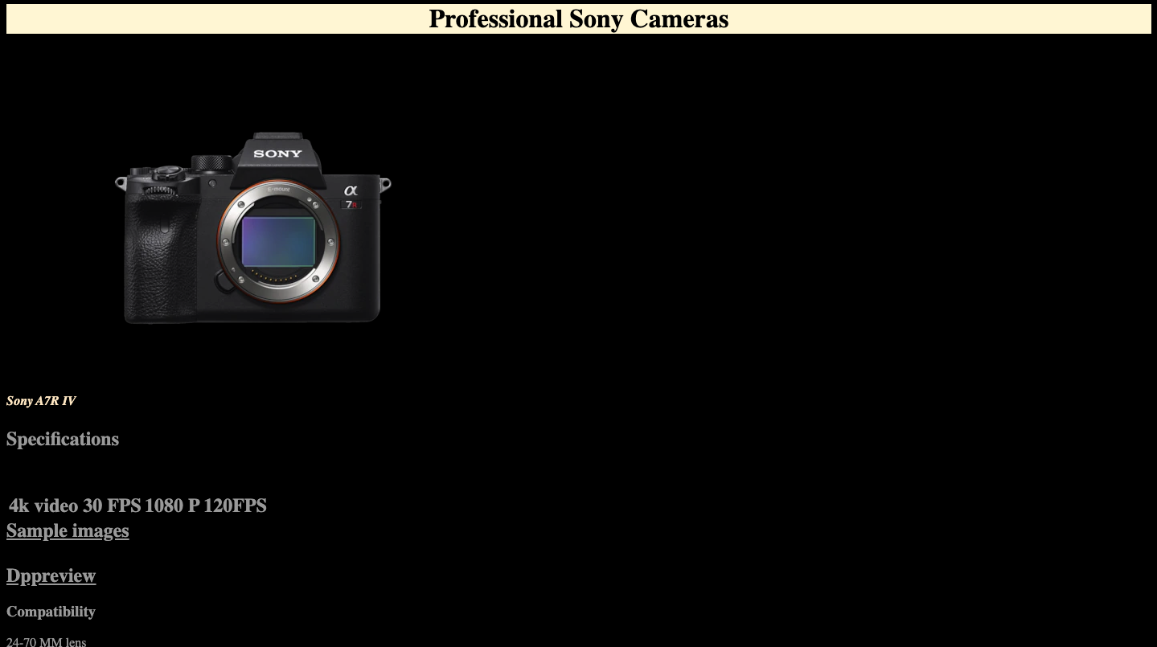

<!DOCTYPE HTML>

<html>

<head>

<title>Page Title</title>

</head>

<body>

<img style="text-align: right;;" src="/Users/bingis/Desktop/download.jpeg">

<h1 style="font-style:italic;">This is Web program class</h1>

<p>Following are the list of topics in html</p>

<ul>

<li style="background-color: lemonchiffon;">first topic is the bascis</li>

<li>second topic is elements</li>

</ul>

<ol>

<li>first topic is the bascis</li>

<li>second topic is elements</li>

</ol>

<a href="/Users/bingis/Downloads/Web Programing/Potraits.PNG"> This is link for the Potraits </a>

<br>

<b>this is bold</b>

<br>

<strong>this is strong</strong>

<p style="text-align: center;">align</p>

</body>

</html>

HTML page

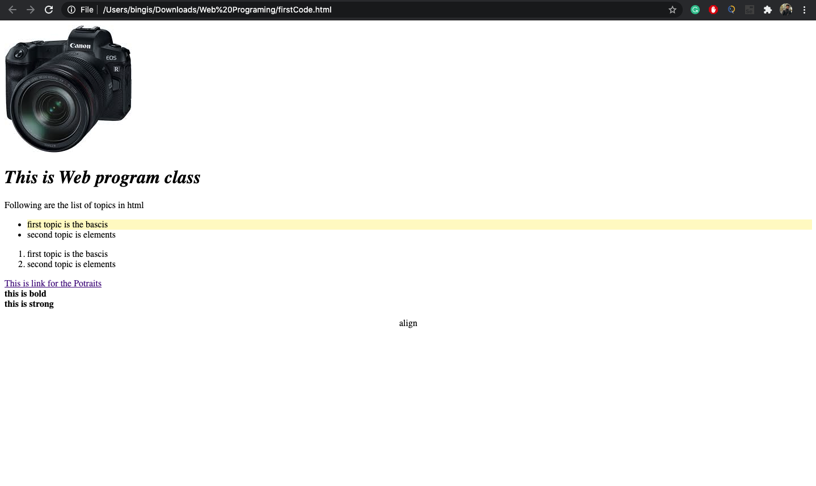

<!DOCTYPE html>

<html>

<head>

<title>

lenses

</title>

</head>

<body>

<style>

body{background-color: black;}

</style>

<h1 style="background-color: blanchedalmond;" align="middle">Sony lenses</h1>

<br>

<br>

<b><p style="color: blanchedalmond;"> SONY 20MM F1.8</p> <br></b>

<img src="https://www.sony.ca/image/5644db5dd0891fd98328a52d1eebb283?fmt=pjpeg&wid=1014&hei=396&bgcolor=F1F5F9&bgc=F1F5F9" alt="">

<b><p style="color: blanchedalmond;"> SONY 16-55 F2.8</p> <br></b>

<img src="https://www.sony.ca/image/c4cd155b3984159ac8050fd24aef8281?fmt=pjpeg&wid=1014&hei=396&bgcolor=F1F5F9&bgc=F1F5F9" alt="">

<b><p style="color: blanchedalmond;"> SONY FE 200–600 mm F5.6–6.3 G OSS/p> <br></b>

<img src="https://www.sony.ca/image/aa4c806667bb613cd7fbc9fa6ed7c6a3?fmt=pjpeg&wid=1014&hei=396&bgcolor=F1F5F9&bgc=F1F5F9" alt="">

</body>

</html>

HTML Page

