**1.Javascript Features**

JavaScript is one of the most popular programming languages which includes numerous features when it comes to web development. It's amongst the top programming languages as per Github and as per StackOverflow's Developer survey. So you must learn JavaScript and you should know the features of JavaScript properly to understand what it is capable of.

* Light Weight Scripting language
* Dynamic Typing
* Object-oriented programming support
* Functional Style
* Platform Independent
* Prototype-based
* Interpreted Language
* Single-threaded
* Async Processing
* Web Workers
* Client-Side Validation
* More control in the browser
* Speed
* Reduces load on the server
* Ease of use
* Rich Interface
* Versatility
* Extended functionality
* Interoperability
* Popularity
* Platform independence
* Powerful frameworks
* Procedural programming features
* Response to user activity
* Updates

### **2.What are the main Advantages of JS?**

### **Speed**

JavaScript is an “interpreted” language, so it cuts down on the time needed for compilation in other languages like [Java](https://codeinstitute.net/global/blog/what-is-java). Additionally, it is a [client-side](https://codeinstitute.net/global/blog/client-side-vs-server-side) script that shortens the time required to establish a server connection, which speeds up program execution.

### **Reduces Load on the Server**

The language runs on the **client side** rather than the server. Thus, the server doesn’t have to deal with the stress of executing JavaScript. Once this burden is reduced, the server will function more quickly and concentrate on other tasks like data management.

### **Ease of Use**

JavaScript is one of the simplest languages to learn, particularly for web programming. It has been designed to be simple for [web developers](https://codeinstitute.net/global/blog/web-developer) to understand and use. Since difficult languages have fewer engineers and demand a higher budget, this helps web companies save a lot of money on development.

### **Rich Interface**

JavaScript offers developers a variety of interfaces to build engaging websites. Websites with drag-and-drop elements or sliders may have a more robust user experience. This increases user interaction with the website.

### **Versatile**

The versatility of JavaScript is its most valuable quality. There are many different ways to integrate it into your website. Since [Node.js](https://codeinstitute.net/global/blog/a-guide-to-node-js) integrates effectively with [MongoDB](https://codeinstitute.net/global/blog/mongodb-explained) and MySQL, it can not only build and finish the [front end](https://codeinstitute.net/global/blog/front-end-development-coding) of the website but also handle its [back end](https://codeinstitute.net/global/blog/what-is-back-end-development).

### **Extended Functionality**

To save time and money, third-party add-ons such as Greasemonkey (a Mozilla Firefox extension) enable developers to incorporate small sections of prefabricated code into their code. These add-ons make it easier and faster for developers to create JavaScript applications than they could with other coding languages.

### **Interoperability**

JavaScript seamlessly integrates with other programming languages, so many developers favour using it to create various apps. Any webpage or script of another computer language can incorporate it.

### **Popularity**

JavaScript is one of the most popular languages for web development. It is an important factor for every working website. Even the most popular websites worldwide, including Amazon and Google, use JavaScript since it is regarded as a very powerful technology. Due to its steadily growing popularity, it is now simpler than ever to learn this language online through [various courses](https://codeinstitute.net/global/full-stack-software-development-diploma).

### **Independent Platform**

Most browsers support JavaScript, making it simple for any browser to comprehend and recognise JavaScript code. You don’t need to go through any installation or setup procedures because it is an easily available technology. Simply use your browser to create several webpage editing zones.

### **JavaScript Has Powerful Frameworks**

Around JavaScript, many commanding [frameworks](https://codeinstitute.net/global/blog/javascript-framework) display ready-to-use codes. Such codes are all easy to comprehend and troubleshoot. Depending on the structure in question, you will have access to several additional capabilities that will exponentially increase your efficiency.

### **JavaScript Provides Procedural Programming Features**

Despite being easy to learn, the language has all the characteristics that make it a popular and significant programming language. JavaScript allows you to create branches, start conditional checking, start loops, and much more, making using your website a lot more fun.

### **JavaScript Codes Are Activated in Response to User Activity**

JavaScript is an Event-Based coding language. This means that various code segments are run after a user clicks a button. As a result, when the website loads, none of the code is initialised. By doing this, you can be certain that your website’s load time won’t be at risk as you load it with high-end features.

### **Updates**

Since the release of ECMAScript 5, the scripting specification on which JavaScript is based, ECMA International has prioritised updating JavaScript annually. 13 editions of features have been released since 1997. The JavaScript family now includes the ES2022 features that have passed stage 4 verification.

**2.What javascript used for?**

JavaScript is used in every industry to create all types of applications. Let’s take a closer look at its uses in [web development](https://www.codecademy.com/catalog/subject/web-development?utm_source=ccblog&utm_medium=ccblog&utm_campaign=ccblog&utm_content=what_is_javascript_used_for_blog), mobile development, game development, and more.

### Front-end web development

[Front-end developers](https://www.codecademy.com/resources/blog/what-does-a-front-end-developer-do/?utm_source=ccblog&utm_medium=ccblog&utm_campaign=ccblog&utm_content=what_is_javascript_used_for_blog) use JavaScript (along with [HTML](https://www.codecademy.com/resources/blog/what-is-html/?utm_source=ccblog&utm_medium=ccblog&utm_campaign=ccblog&utm_content=what_is_javascript_used_for_blog) and [CSS](https://www.codecademy.com/learn/learn-css?utm_source=ccblog&utm_medium=ccblog&utm_campaign=ccblog&utm_content=what_is_javascript_used_for_blog)) to create the parts of a web page that users see and interact with in their browsers.

Before JavaScript, web pages only served static content. JavaScript gave developers the ability to provide their users with a dynamic web experience, adding animations and other interactive elements. When you click a button on a website, and a side panel opens or a modal slowly comes into view, that’s JavaScript at work.

But JavaScript does more than that on the web. You can also use it to create single-page applications (or SPAs) that run on one HTML page to give users a smooth navigational experience.

### Back-end web development

JavaScript is also popular with back-end developers. [Back-end web development](https://www.codecademy.com/resources/blog/what-does-a-back-end-developer-do/?utm_source=ccblog&utm_medium=ccblog&utm_campaign=ccblog&utm_content=what_is_javascript_used_for_blog) (also known as server-side development) involves creating the code that runs on a web server. When a browser loads a web page, it makes a call to a remote server. Server-side code then parses the page’s URL to determine what the user is requesting before retrieving and transforming the required data to serve back to the browser.

[Node.js](https://www.codecademy.com/learn/learn-node-js?utm_source=ccblog&utm_medium=ccblog&utm_campaign=ccblog&utm_content=what_is_javascript_used_for_blog) is a JavaScript framework commonly used for back-end development — so much so that many back-end JavaScript developers refer to themselves as Node.js developers.

Wanna try it for yourself? Take your first steps into back-end development by learning how to [create a back-end app with JavaScript](https://www.codecademy.com/learn/paths/create-a-back-end-app-with-javascript?utm_source=ccblog&utm_medium=ccblog&utm_campaign=ccblog&utm_content=what_is_javascript_used_for_blog).

### Game development

You can also use JavaScript to create 2D and 3D video games that run in web browsers. As browsers get more powerful, web-based video games are evolving beyond simple platformers. Now, JavaScript frameworks like [Phaser.js](https://www.codecademy.com/learn/paths/create-video-games-with-phaser?utm_source=ccblog&utm_medium=ccblog&utm_campaign=ccblog&utm_content=what_is_javascript_used_for_blog) allow you to create more advanced games quickly and easily right from your browser.

### Mobile development

For years, mobile developers had to commit themselves to either Android or iOS, as each platform uses different programming languages. Android developers would learn [Java](https://www.codecademy.com/learn/paths/introduction-to-android-with-java?utm_source=ccblog&utm_medium=ccblog&utm_campaign=ccblog&utm_content=what_is_javascript_used_for_blog) or [Kotlin](https://www.codecademy.com/learn/learn-kotlin?utm_source=ccblog&utm_medium=ccblog&utm_campaign=ccblog&utm_content=what_is_javascript_used_for_blog), while iOS devs preferred [Swift](https://www.codecademy.com/learn/learn-swift?utm_source=ccblog&utm_medium=ccblog&utm_campaign=ccblog&utm_content=what_is_javascript_used_for_blog) or Objective-C.

Now, with the rise of mobile development frameworks like [React Native](https://www.codecademy.com/learn/learn-react-native?utm_source=ccblog&utm_medium=ccblog&utm_campaign=ccblog&utm_content=what_is_javascript_used_for_blog) and Ionic, you can use JavaScript to create apps that run on both platforms.

### Virtual reality (VR)

Virtual reality is a thing again, as devices like the Oculus Rift and Valve Index have made it more generally accessible. Now, you can use JavaScript to create applications for both of them.

A-Frame is a popular JavaScript framework used to build virtual reality experiences in web browsers. If you’re interested in building your own VR applications, start by [Learning A-Frame](https://www.codecademy.com/learn/learn-a-frame?utm_source=ccblog&utm_medium=ccblog&utm_campaign=ccblog&utm_content=what_is_javascript_used_for_blog).

### Artificial intelligence (AI)

JavaScript is also used to develop artificial intelligence, as libraries like [TensorFlow](https://www.codecademy.com/learn/paths/build-deep-learning-models-with-tensorflow?utm_source=ccblog&utm_medium=ccblog&utm_campaign=ccblog&utm_content=what_is_javascript_used_for_blog) bring the power of machine learning to JavaScript developers. Developers can use these libraries to create machine learning models that predict future events based on past data and categorize data and images.

**4. what is the difference between var, let, const**

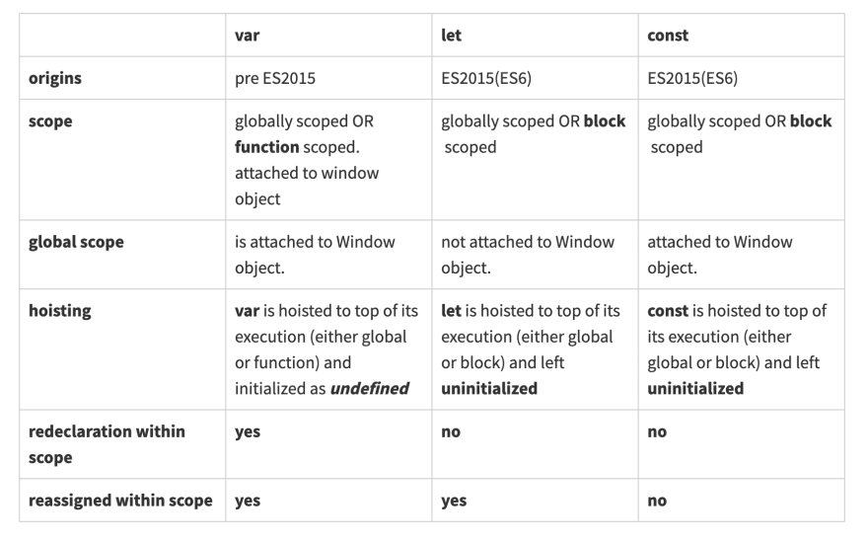

## **What are most popular JS library?**

## **Sencha**



Sencha Ext JS is one of the best JavaScript libraries for [creating enterprise-grade web apps](https://www.sencha.com/blog/10-compelling-reasons-why-you-need-javascript-grid-library/). It provides a wide range of pre-built JS components for building user interfaces. It also comes with an Automation testing tool called Sencha Test.

[Try Ext JS Community Edition and test its impressive features today.](https://www.sencha.com/products/extjs/communityedition/)

## **DOJO Toolkit**

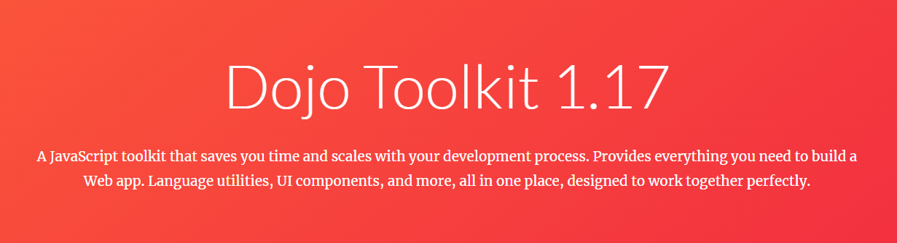

Dojo Toolkit is an open-source JavaScript library that lets you build cross-platform, JS, and Ajax-based websites quickly.

## **jQuery**

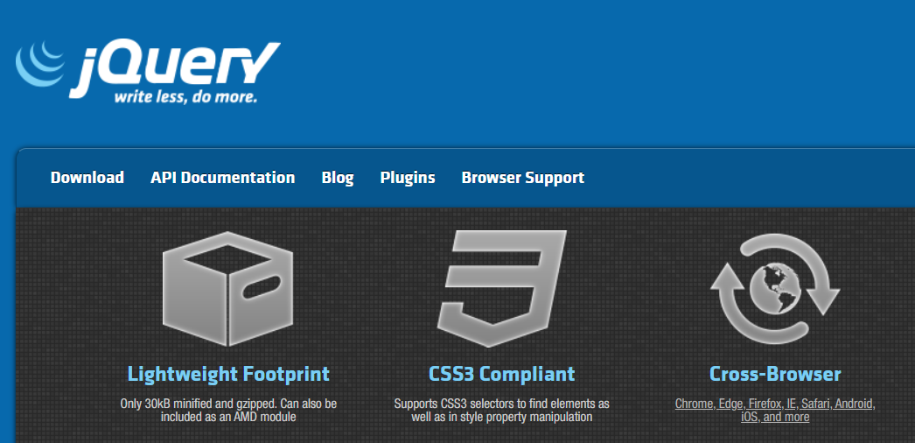

Next on the list of [best JavaScript libraries](https://www.sencha.com/blog/how-to-get-more-results-out-of-the-best-javascript-libraries/) is jQuery. jQuery is a lightweight JS library that dramatically simplifies JavaScript programming language. jQuery library wraps common UI tasks that involve long JS code into methods that JavaScript programmers can easily call with only a few lines of code.

### **Features**

* Makes AJAX calls, event handling, and DOM (Document Object Model) manipulation super easy
* Highly extensible
* Comes with an easy-to-use API that works across multiple browsers
* Platform-independent
* Supports all modern browsers

## **Angular**

## Angular previously known as Angular JS is a single web development framework developed by Google for both desktop and mobile web applications.

Angular aims at creating progressive web apps by offering dependency injection that helps in data service assembly for applications while an HTML template is used for composing templates.

Angular also has a powerful ecosystem that includes four data libraries and support in IDEs. If you want to learn Angular then [**Angular — The Complete Guide**](https://click.linksynergy.com/fs-bin/click?id=JVFxdTr9V80&subid=0&offerid=634352.1&type=10&tmpid=14538&RD_PARM1=https%3A%2F%2Fwww.udemy.com%2Fthe-complete-guide-to-angular-2%2F) is a good place to start with.

[[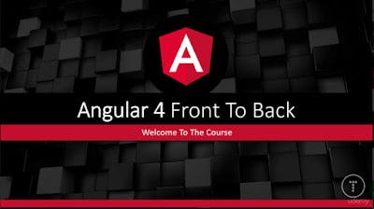](https://click.linksynergy.com/fs-bin/click?id=JVFxdTr9V80&subid=0&offerid=634352.1&type=10&tmpid=14538&RD_PARM1=https%3A%2F%2Fwww.udemy.com%2Fthe-complete-guide-to-angular-2%2F)](https://click.linksynergy.com/fs-bin/click?id=JVFxdTr9V80&subid=0&offerid=634352.1&type=10&tmpid=14538&RD_PARM1=https%3A%2F%2Fwww.udemy.com%2Fthe-complete-guide-to-angular-2%2F)

## **JavaScript InfoVis toolkit**

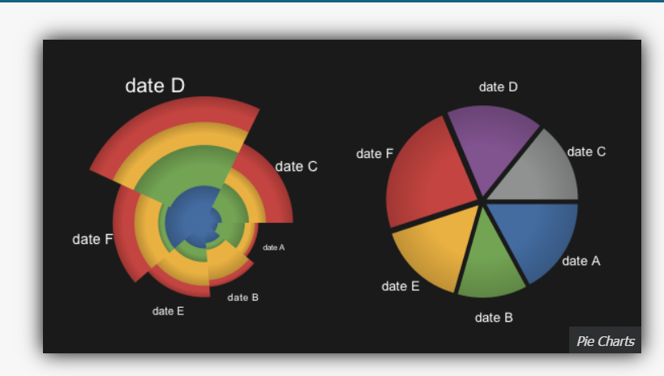

If you’re looking to create interactive data visualizations for your web apps, InfoVis is the right tool.

### **Features**

* Supports a number of data visualizations, such as pie charts, area charts, bar charts, and many more
* Supports TreeMaps, SpaceTree and HyperTree
* Offers several graph manipulation features

## **D3.js**

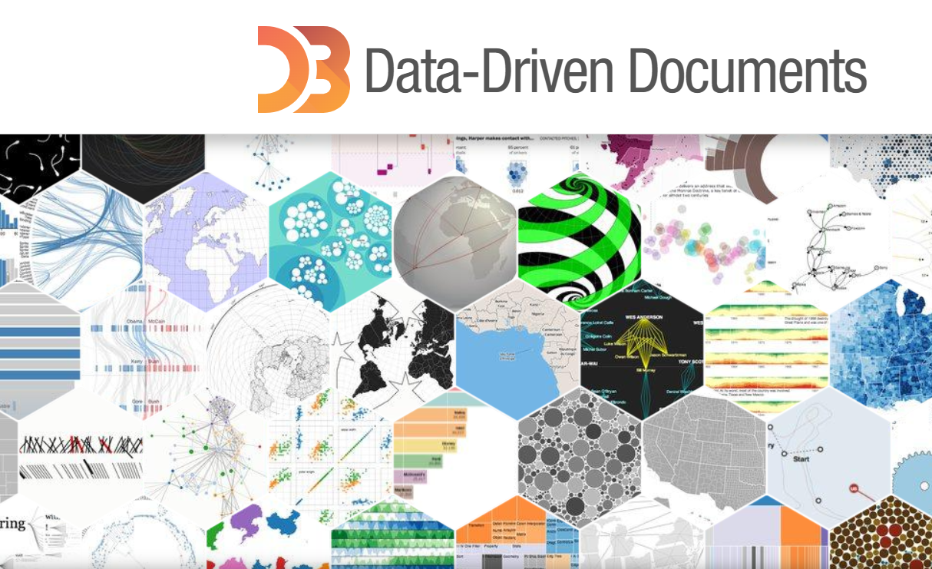

D3 stands for Data-Driven Documents. D3.js allows you to apply data-driven transformations to DOM objects.

### **Features**

* Enables developers to bind arbitrary data to a DOM and apply data-driven transformations to it
* Allows developers to create dynamic and interactive data visualizations
* Comes with several built-in, reusable functions
* Supports CSS, SVG, and HTML

## **Ember.js**

## Ember.js is another popular, open-source JavaScript web framework that is based on the Model and View pattern.

It allows developers to create scalable single-page web applications by incorporating common idioms and best practices into the framework itself.

It has integrated features like templates also known as handlebars that helps in writing less code and have the ability to update themselves with a change in data. Ember.js can be installed via NPM.

If you want to learn more then [**Build Web Apps Using EmberJS: The Complete Course**](https://click.linksynergy.com/fs-bin/click?id=JVFxdTr9V80&subid=0&offerid=634352.1&type=10&tmpid=14538&RD_PARM1=https%3A%2F%2Fwww.udemy.com%2Fbuild-web-apps-using-emberjs-the-complete-course%2F) is a good resource.

[[](https://click.linksynergy.com/fs-bin/click?id=JVFxdTr9V80&subid=0&offerid=634352.1&type=10&tmpid=14538&RD_PARM1=https%3A%2F%2Fwww.udemy.com%2Fbuild-web-apps-using-emberjs-the-complete-course%2F)](https://click.linksynergy.com/fs-bin/click?id=JVFxdTr9V80&subid=0&offerid=634352.1&type=10&tmpid=14538&RD_PARM1=https%3A%2F%2Fwww.udemy.com%2Fbuild-web-apps-using-emberjs-the-complete-course%2F)

## **Pixi.js**



Next on the list of best JavaScript libraries is Pixi.js, an open-source, cross-platform JavaScript library for creating stunning digital content.

### **Features**

* Helps create games and interactive, animation-based websites
* Supports multiple platforms, such as mobile and desktop
* Renders beautiful anti-aliased text
* Comes with advanced support for features like rotational packing and trimming

## **SWFObject**

SWFObject is a simple yet powerful JS library mainly used to embed Adobe Flash SWF files in HTML documents.

### **Features**

* Make it super easy to embed Flash movies
* Can efficiently detect the Adobe Flash Player plug-in
* Supports all major web browsers

## **Three.js**

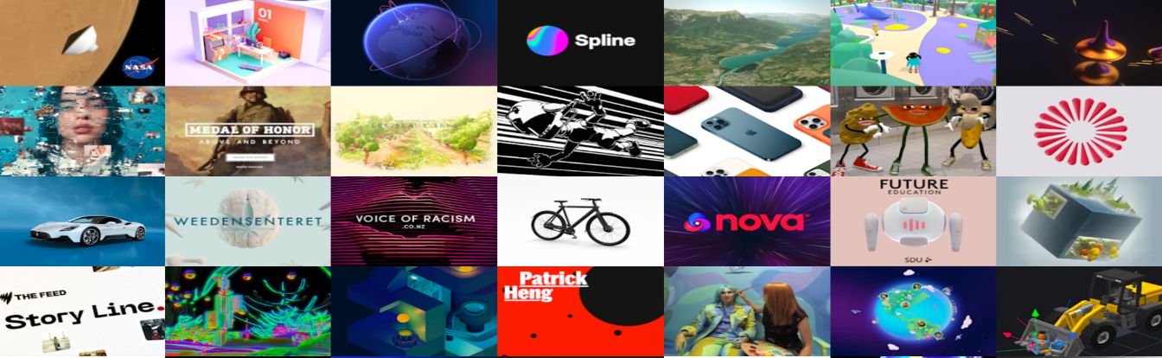Three.js is a cross-browser library and API that allows for the creation of beautiful animations. It offers several useful features for creating 3D scenes in your web browser.

### **Features**

* Relies on WebGL rather than conventional browser-plugins
* Can efficiently display graphics and 3D animations in a web browser
* Comes with useful features like scenes, effects, cameras, materials, lights, sky, meshes, animations, shades, and 3D objects

## **Voca**



Voca is also an efficient JavaScript string library. The idea behind creating Voca is to ease the pain while working with JavaScript strings.

### **Features**

* Comes with several helpful functions for easy string manipulations, such as slugify, change case, trim, pad, latinise, truncate, escape, and more
* Modular design – so you can load the entire

## **QUnit**

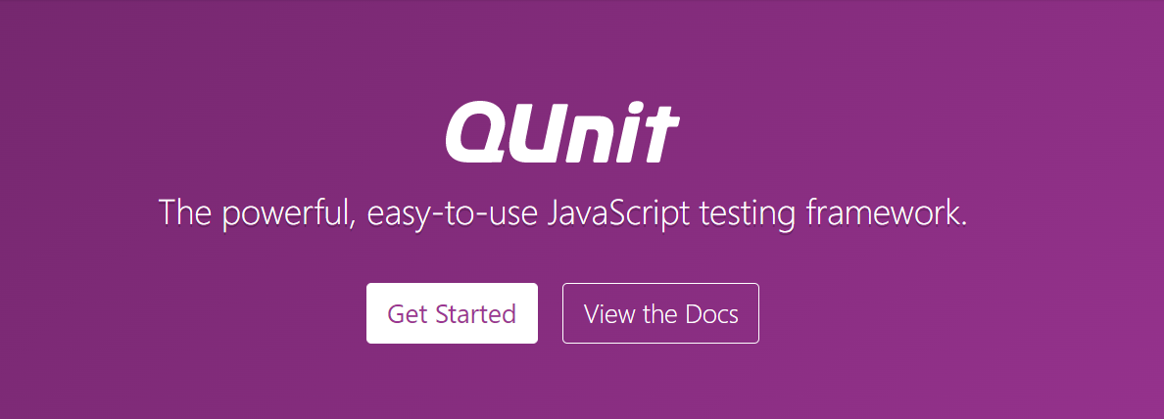

It is also possible to test any generic JavaScript code using the unit testing tool (or framework) QUnit.

### **Features**

* Particularly used in jQuery projects
* Extensible
* Allows developers to test code anywhere

## **MathJX**

MathJAX, true to its name, is another efficient JavaScript library that can display math notations in web browsers.

### **Features**

* Uses markups like LaTeX, ASCIIMathML, and also MathML
* Allows users to copy equations into LaTeX, Office, wikis, and other tools
* Uses CSS with web fonts instead of bitmap images

## **React.js**

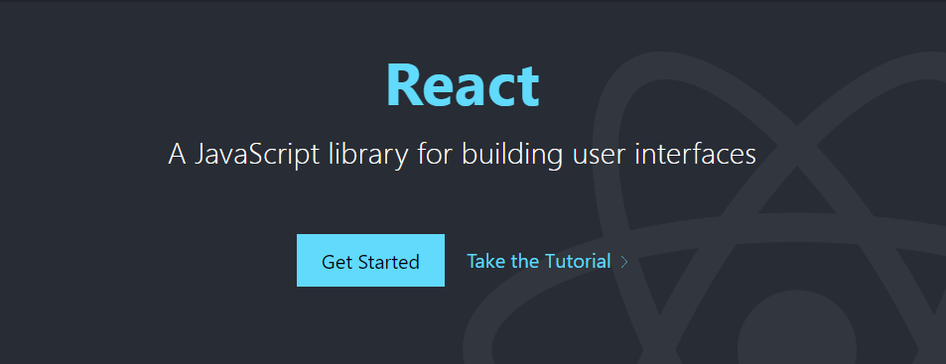

React is undoubtedly one of the most used JavaScript libraries that allows you to build stunning and responsive user interfaces for your web applications. It is built by Facebook and is also open-source.

## **Vue.js**

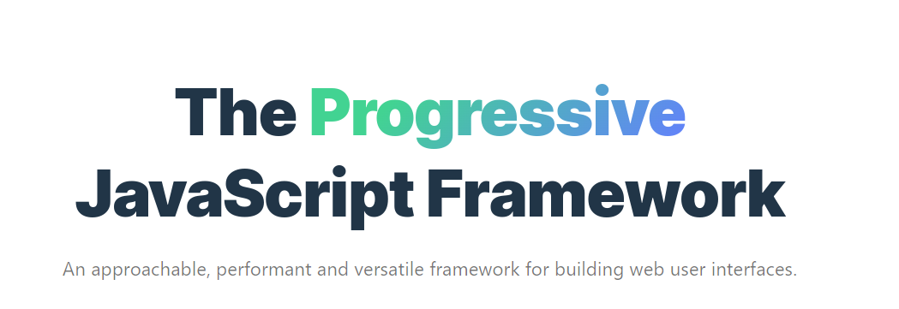

Released in 2014, Vue is markedly one of the most used JavaScript libraries. Like React, Vue.js is similarly based on the Virtual DOM model.

### **Features**

* Firstly, it allows you to create efficient cross-platform single-page applications (SPA)
* Uses virtual DOM
* Component-based architecture