Arduino is a microcontroller-based open source electronic prototyping board which can be programmed with an easy-to-use Arduino IDE.

Other boards like Arduino Lilypad, Arduino Mini, Arduino Mega, and Arduino Nano. However, the Arduino UNO board became more popular than other boards in the family because it has documentation that is much more detailed. This led to its increased adoption for electronic prototyping, creating a vast community of electronic geeks and hobbyists.In recent times, the UNO board has become synonymous with Arduino.

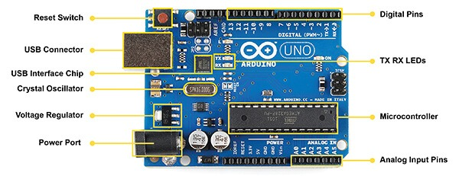

The major components of Arduino UNO board are as follows:

* USB connector
* Power port
* Microcontroller
* Analog input pins
* Digital pins

**USB connector**:

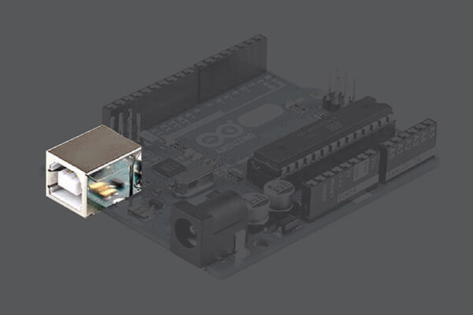

This is a printer USB port used to load a program from the Arduino IDE onto the Arduino board. The board can also be powered through this port.

**Power port**:

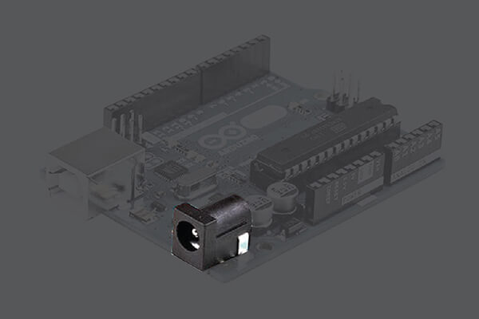

The Arduino board can be powered through an AC-to-DC adapter or a battery. The power source can be connected by plugging in a 2.1mm center-positive plug into the power jack of the board. The Arduino UNO board operates at a voltage of 5 volts, but it can withstand a maximum voltage of 20 volts. If the board is supplied with a higher voltage, there is a voltage regulator (it sits between the power port and USB connector) that protects the board from burning out.

**Microcontroller**:

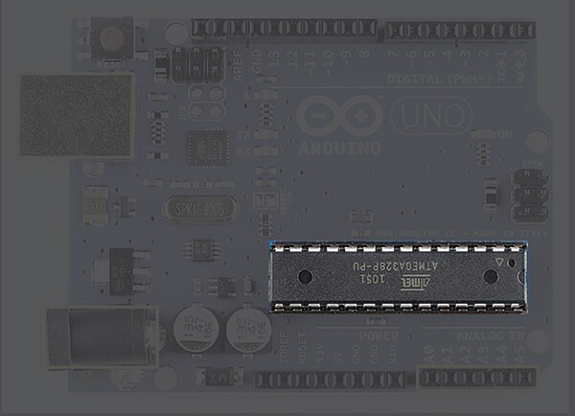

It is the most prominent black rectangular chip with 28 pins. Think of it as the brains of your Arduino. The microcontroller used on the UNO board is Atmega328P by Atmel ( a major microcontroller manufacturer). Atmega328P has the following components in it:

* **Flash memory** of 32KB. The program loaded from Arduino IDE is stored here.
* **RAM** of 2KB. This is a runtime memory.
* **CPU**: It controls everything that goes on within the device. It fetches the program instructions from flash memory and runs them with the help of RAM.
* **Electrically Erasable Programmable Read Only Memory (EEPROM)** of 1KB. This is a type of nonvolatile memory, and it keeps the data even after device restart and reset.

Atmega328P is pre-programmed with bootloader. This allows you to directly upload a new Arduino program into the device, without using any external hardware programmer, making the Arduino UNO board easy to use.

**Analog input pins:**

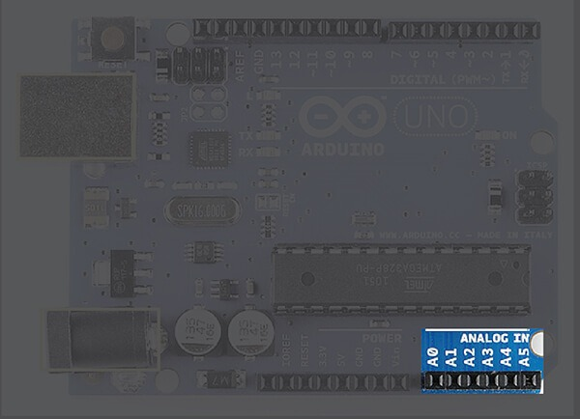

The Arduino UNO board has 6 analog input pins, labeled “Analog 0 to 5.” These pins can read the signal from an analog sensor like a temperature sensor and convert it into a digital value so that the system understands. These pins just measure voltage and not the current because they have very high internal resistance. Hence, only a small amount of current flows through these pins.Although these pins are labeled analog and are analog input by default, these pins can also be used for digital input or output.

**Digital pins**:

These pins are labeled “Digital 0 to 13.” These pins can be used as either input or output pins. When used as output, these pins act as a power supply source for the components connected to them. When used as input pins, they read the signals from the component connected to them.When digital pins are used as output pins, they supply 40 milliamps of current at 5 volts, which is more than enough to light an LED.

A light Emitting Diode (LED) is an optical semiconductor device that emits light when [voltage](https://www.physics-and-radio-electronics.com/electromagnetics/electrostatics/potential-difference.html)is applied. In other words, LED is an optical semiconductor device that converts electrical energy into light energy.

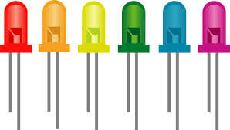

When Light Emitting Diode (LED) is forward biased, [free electrons](https://www.physics-and-radio-electronics.com/electronic-devices-and-circuits/introduction/free-electrons.html) in the conduction band recombines with the [holes](https://www.physics-and-radio-electronics.com/electronic-devices-and-circuits/semiconductor/hole.html)in the valence band and releases energy in the form of light.

The process of emitting light in response to the strong [electric field](https://www.physics-and-radio-electronics.com/electromagnetics/electrostatics/electric-field.html) or flow of electric current is called electroluminescence.

A normal [p-n junction diode](https://www.physics-and-radio-electronics.com/electronic-devices-and-circuits/semiconductor-diodes/pnjunctionsemiconductordiode.html) allows electric current only in one direction. It allows electric current when forward biased and does not allow electric current when reverse biased. Thus, normal p-n junction diode operates only in forward bias condition.

Like the normal p-n junction diodes, LEDs also operates only in forward bias condition. To create an LED, the n-type material should be connected to the negative terminal of the battery and p-type material should be connected to the positive terminal of the battery. In other words, the n-type material should be negatively charged and the p-type material should be positively charged.

The construction of LED is similar to the normal p-n junction diode except that gallium, phosphorus and arsenic materials are used for construction instead of silicon or germanium materials.

How Light Emitting Diode (LED) works?

Light Emitting Diode (LED) works only in forward bias condition. When Light Emitting Diode (LED) is forward biased, the free electrons from n-side and the holes from p-side are pushed towards the junction.

When free electrons reach the junction or depletion region, some of the free electrons recombine with the holes in the positive ions. We know that positive ions have less number of electrons than protons. Therefore, they are ready to accept electrons. Thus, free electrons recombine with holes in the depletion region. In the similar way, holes from p-side recombine with electrons in the depletion region.

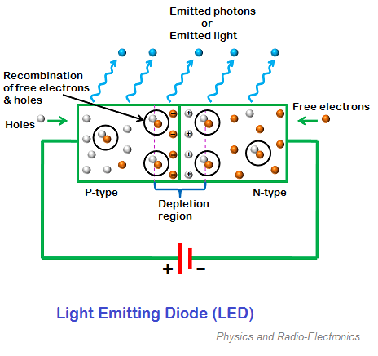

Because of the recombination of free electrons and holes in the depletion region, the [width of depletion region](https://www.physics-and-radio-electronics.com/electronic-devices-and-circuits/semiconductor-diodes/widthofdepletionregion.html) decreases. As a result, more charge carriers will cross the [p-n junction](https://www.physics-and-radio-electronics.com/electronic-devices-and-circuits/semiconductor-diodes/p-n-junction-introduction.html).

Some of the charge carriers from p-side and n-side will cross the p-n junction before they recombine in the depletion region. For example, some free electrons from n-type semiconductor cross the p-n junction and recombines with holes in p-type semiconductor. In the similar way, holes from p-type semiconductor cross the p-n junction and recombines with free electrons in the n-type semiconductor.

Thus, recombination takes place in depletion region as well as in p-type and n-type semiconductor.

The free electrons in the conduction band releases energy in the form of light before they recombine with holes in the valence band.

How LED emits light?

When external voltage is applied to the [valence electrons](https://www.physics-and-radio-electronics.com/electronic-devices-and-circuits/introduction/valence-electrons.html), they gain sufficient energy and breaks the bonding with the parent atom. The valence electrons which breaks bonding with the parent atom are called free electrons.

When the valence electron left the parent atom, they leave an empty space in the valence shell at which valence electron left. This empty space in the valence shell is called a hole.

The energy level of all the valence electrons is almost same. Grouping the range of energy levels of all the valence electrons is called valence band.

In the similar way, energy level of all the free electrons is almost same. Grouping the range of energy levels of all the free electrons is called conduction band.

The energy level of free electrons in the conduction band is high compared to the energy level of valence electrons or holes in the valence band. Therefore, free electrons in the conduction band need to lose energy in order to recombine with the holes in the valence band.

The free electrons in the conduction band do not stay for long period. After a short period, the free electrons lose energy in the form of light and recombine with the holes in the valence band. Each recombination of charge carrier will emit some light energy.

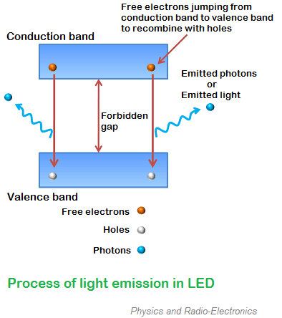

The energy lose of free electrons or the intensity of emitted light is depends on the forbidden gap or energy gap between conduction band and valence band.

The semiconductor device with large forbidden gap emits high intensity light whereas the semiconductor device with small forbidden gap emits low intensity light.

In other words, the brightness of the emitted light is depends on the material used for constructing LED and forward current flow through the LED.

In normal silicon diodes, the energy gap between conduction band and valence band is less. Hence, the electrons fall only a short distance. As a result, low energy photons are released. These low energy photons have low frequency which is invisible to human eye.

In LEDs, the energy gap between conduction band and valence band is very large so the free electrons in LEDs have greater energy than the free electrons in silicon diodes. Hence, the free electrons fall to a large distance. As a result, high energy photons are released. These high energy photons have high frequency which is visible to human eye.

The efficiency of generation of light in LED increases with increase in injected current and with a decrease in temperature.

In light emitting diodes, light is produced due to recombination process. Recombination of charge carriers takes place only under forward bias condition. Hence, LEDs operate only in forward bias condition.

When light emitting diode is reverse biased, the free electrons (majority carriers) from n-side and holes (majority carriers) from p-side moves away from the junction. As a result, the width of depletion region increases and no recombination of charge carriers occur. Thus, no light is produced.

If the reverse bias voltage applied to the LED is highly increased, the device may also be damaged.

All diodes emit photons or light but not all diodes emit visible light. The material in an LED is selected in such a way that the wavelength of the released photons falls within the visible portion of the light spectrum.

Light emitting diodes can be switched ON and OFF at a very fast speed of 1 ns.

Light emitting diode (LED) symbol

The symbol of LED is similar to the normal p-n junction diode except that it contains arrows pointing away from the diode indicating that light is being emitted by the diode.

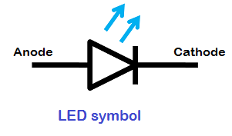

LEDs are available in different colors. The most common colors of LEDs are orange, yellow, green and red.

The schematic symbol of LED does not represent the color of light. The schematic symbol is same for all colors of LEDs. Hence, it is not possible to identify the color of LED by seeing its symbol.

LED construction

One of the methods used to construct LED is to deposit three semiconductor layers on the substrate. The three semiconductor layers deposited on the substrate are n-type semiconductor, p-type semiconductor and active region. Active region is present in between the n-type and p-type semiconductor layers.

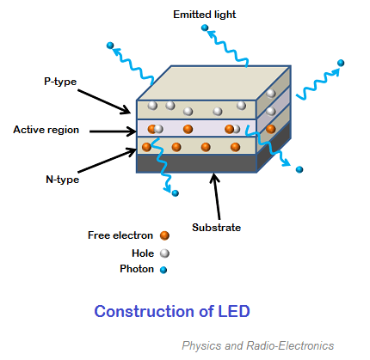

When LED is forward biased, free electrons from n-type semiconductor and holes from p-type semiconductor are pushed towards the active region.

When free electrons from n-side and holes from p-side recombine with the opposite charge carriers (free electrons with holes or holes with free electrons) in active region, an invisible or visible light is emitted.

In LED, most of the charge carriers recombine at active region. Therefore, most of the light is emitted by the active region. The active region is also called as depletion region.

Biasing of LED

The safe forward voltage ratings of most LEDs is from 1V to 3 V and forward current ratings is from 200 mA to 100 mA.

If the voltage applied to LED is in between 1V to 3V, LED works perfectly because the current flow for the applied voltage is in the operating range. However, if the voltage applied to LED is increased to a value greater than 3 volts. The depletion region in the LED breaks down and the electric current suddenly rises. This sudden rise in current may destroy the device.

To avoid this we need to place a [resistor](https://www.physics-and-radio-electronics.com/electronic-devices-and-circuits/passive-components/resistors/resistors.html)(Rs) in series with the LED. The resistor (Rs ) must be placed in between voltage source (Vs) and LED.

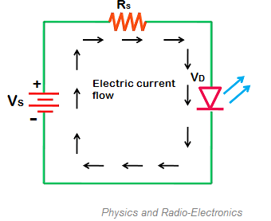

The resistor placed between LED and voltage source is called current limiting resistor. This resistor restricts extra current which may destroy the LED. Thus, current limiting resistor protects LED from damage.

## Advantages of LED

1. The brightness of light emitted by LED is depends on the current flowing through the LED. Hence, the brightness of LED can be easily controlled by varying the current. This makes possible to operate LED displays under different ambient lighting conditions.
2. Light emitting diodes consume low energy.
3. LEDs are very cheap and readily available.
4. LEDs are light in weight.
5. Smaller size.
6. LEDs have longer lifetime.
7. LEDs operates very fast. They can be turned on and off in very less time.
8. LEDs do not contain toxic material like mercury which is used in fluorescent lamps.
9. LEDs can emit different colors of light.

## Disadvantages of LED

1. LEDs need more power to operate than normal p-n junction diodes.
2. Luminous efficiency of LEDs is low.

Expected Outcome:

The power of a LED Lamp is 170 Wh.

So it consumes 1360 Wh in 8 hours i.e from 10 PM – 6 AM

1360 Wh = 1.360 KWh = 1.360 unit

1 unit costs around Rs 5.75

So 1.36 unit costs = 1.36 x 5.75

= Rs 7.82

When a person passes by PIR sensor it glows for 5 seconds. Let us take that 30 persons cross by that sensor from 10 PM – 6 AM.

So it glows for 30 x 5 = 150 seconds

For 1 hour i.e 3600 seconds it consumes 170 Wh

Therefore, For 150 second it consumes 7.0834 Wh

= 0.0070834 KWh

= 0.0070834 unit

So 0.0070834 unit costs = 0.0070834 x 5.75

= Rs 0.04072

Profit = Rs (7.82 – 0.04072)

= Rs 7.77928