IoT SMART WASTE MONITORING AND ALERING SYSTEM

ABSTRACT
Waste management is a critical aspect of urban sustainability, requiring efficient monitoring and disposal mechanisms. This project presents a Smart Waste Management System utilizing two ultrasonic sensors, an Arduino Uno, a GSM module, GPS, Wi-Fi connectivity, and an LCD display to enhance waste collection efficiency.
One ultrasonic sensor continuously monitors the waste bin’s fill level, while the second ultrasonic sensor is used to detect object presence near the bin opening for monitoring usage activity. The system updates real-time bin status using Wi-Fi, enabling remote monitoring through an IoT platform.
When the bin reaches a predefined threshold level, an alert message containing the bin’s GPS location is sent via the GSM module to municipal authorities, ensuring timely waste collection and preventing overflow. The LCD display provides on-site status updates, showing bin level information and system alerts for maintenance personnel.
By integrating IoT, sensing technology, and wireless communication, this project improves waste collection efficiency, optimizes collection routes, and minimizes manual inspection. The system supports smarter urban waste management by enabling real-time monitoring, reducing overflow issues, and improving overall cleanliness in urban environments.

CHAPTER 1
INTRODUCTION
Waste management is a crucial aspect of urban sustainability, ensuring cleanliness, environmental protection, and efficient resource utilization. With rapid urbanization and population growth, cities generate an increasing amount of waste, posing challenges for collection, disposal, and recycling. Traditional waste management systems often rely on fixed schedules for waste collection, leading to inefficiencies such as unnecessary trips, overflowing bins, and increased operational costs. A smart and automated approach is necessary to address these inefficiencies and enhance urban waste management.
The Internet of Things (IoT) has revolutionized various sectors, including waste management, by enabling real-time monitoring, automation, and data-driven decision-making. This project proposes a Solar-Powered Smart Waste Management System that leverages IoT technologies, including ultrasonic sensors, an Arduino Uno, a GSM module, GPS, and solar energy, to optimize waste collection and disposal processes.
The system employs two ultrasonic sensors—one to monitor the fill level of the bin and another to detect lid movement. A servo motor automates the lid’s opening and closing, ensuring hygiene and controlled access to the bin. This not only prevents unauthorized usage but also minimizes direct human contact with waste, reducing health risks. A solar panel powers the entire system, making it energy-efficient and sustainable by reducing dependency on conventional power sources.
Real-time bin status updates are transmitted via Wi-Fi, allowing municipal authorities to remotely monitor waste levels. When a bin reaches a predefined threshold, an automated alert message containing its GPS location is sent via the GSM module to the authorities. This ensures timely waste collection, reducing instances of overflowing bins that lead to environmental pollution and public health concerns. Additionally, an LCD display provides real-time status updates locally, enabling immediate awareness of bin conditions. The system also helps optimize waste collection routes by directing collection vehicles only to the bins that require immediate attention, reducing fuel consumption and operational costs.
By integrating IoT, automation, and solar power, this project significantly improves waste management efficiency. It promotes a cleaner urban environment by reducing uncollected waste and preventing unnecessary collection trips. Furthermore, the system enhances sustainability by ensuring timely waste disposal, minimizing environmental impact, and improving the allocation of waste management resources. The use of GPS tracking also facilitates better planning of waste collection routes, reducing congestion and fuel consumption while improving service efficiency.
Smart waste management solutions like this play a vital role in modern urban planning, aligning with the principles of smart cities. By implementing intelligent monitoring, solar power, and automated alert mechanisms, municipal authorities can manage waste more effectively, leading to improved public health, reduced pollution, and enhanced resource utilization. This project demonstrates how IoT-driven and solar-powered solutions can transform traditional waste management into a smarter, more efficient, and environmentally friendly system, contributing to the development of sustainable urban environments.
OBJECTIVE:
The objective of this solar power Smart Waste Management System is to enhance waste collection efficiency using IoT technology. The system aims to monitor bin fill levels in real-time using ultrasonic sensors and automate lid operation via a servo motor for hygiene and controlled access. By integrating a GSM module and GPS, it provides instant alerts with location details when bins reach a predefined threshold, ensuring timely waste collection. Additionally, it optimizes collection routes, reduces overflow issues, and minimizes operational costs. This project contributes to sustainable urban waste management by promoting automation, efficient resource utilization, and a cleaner, smarter environment.
CHAPTER 2
LITERATURE SURVEY
2.1 Waste management 2.0 leveraging internet of things for an efficient and eco-friendly smart city solution
https://pmc.ncbi.nlm.nih.gov/articles/PMC11290616/?utm_source=chatgpt.com
ABSTRACT: Waste management poses a major challenge for cities worldwide, with significant environmental, economic, and social impacts. This paper proposes a novel waste management system leveraging recent advances in the Internet of Things (IoT), algorithms, and cloud analytics to enable more efficient, sustainable, and eco-friendly waste collection and processing in smart cities. An ultrasonic sensor prototype is tailored for reliable fill-level monitoring. A LoRaWAN and cellular network architecture provides city-wide connectivity. A cloud platform handles sensor data storage, processing, and analytics. Dynamic route optimization algorithms minimize time, distance, and fuel use based on real-time bin data. Extensive pilot studies in 10 different locations across Lahore, Pakistan, validated the system, processing over 200 million data points. The results showed a 32% improvement in route efficiency, a 29% decrease in fuel consumption and emissions, a 33% increase in waste processing throughput, and 18% vehicle maintenance savings versus conventional practices. This demonstrates quantifiable benefits across operational, economic, and sustainability dimensions. The proposed IoT-enabled waste management system represents a significant advancement towards sustainable and ecologically responsible waste practices in smart cities worldwide. This research provides a replicable model for holistic smart city solutions integrating sensing, algorithms, and analytics to transition civic operations towards data-driven, efficient paradigms. It represents a significant advancement in sustainable waste practices for smart cities worldwide. Further work could apply emerging technologies like automation and artificial intelligence to create waste management 3.0.
2.2 IoT-based intelligent waste management system
https://link.springer.com/article/10.1007/s00521-023-08970-7?utm_source=chatgpt.com
ABSTRACT: Recently, the population density in cities has increased at a higher pace, so waste generation is on the rise in most societies due to population growth. Given this concern, it would be highly important to manage waste generation. Intelligent city planning is necessary to improve the quality of city life and make cities more livable. This paper presents an intelligent waste management system (IWMS) in smart cities based on Internet of Things components like sensors, detectors, and actuators. IWMS contains three main phases. The first phase of the system is to adapt the low energy adaptive clustering hierarchy approach as an optimization process to better balance the energy consumption of smart waste bins (SBs), thus leading to extending the life of the smart waste network. The second phase is handling the missing values which are retrieved from SBs using an improved version of the k-nearest neighbor algorithm based on artificial hummingbird optimization (AHA), while the third phase presents an optimal energy-efficient route process for the routing of waste trucks that improves fuel efficiency and reduces the time to get an appropriate SB. According to the experimental results, the proposed system has achieved energy savings of 34% for the smart waste bin network. Moreover, compared to other systems, it has a lower mean error rate when generating missing values, and the results related to convergence and running time validate its superiority compared with other metaheuristic algorithms.
2.3 IoT-Enabled Smart Waste Management Systems for Smart Cities: A Systematic Review
https://acris.aalto.fi/ws/portalfiles/portal/92138468/IoT_Enabled_Smart_Waste_Management_Systems_for_Smart_Cities_A_Systematic_Review.pdf
ABSTRACT: With urbanization, rising income and consumption, the production of waste increases. One of the most important directions in the field of sustainable development is the design and implementation of monitoring and management systems for waste collection and removal. Smart waste management (SWM) involves for example collection and analytics of data from sensors on smart garbage bins (SGBs), management of waste trucks and urban infrastructure; planning and optimization of waste truck routes; etc. The purpose of this paper is to provide a comprehensive overview of the existing research in the field of systems, applications, and approaches vis-à-vis the collection and processing of solid waste in SWM systems. To achieve this objective, we performed a systematic literature review. This study consists of 173 primary studies selected for analysis and data extraction from the 3,732 initially retrieved studies from 5 databases. We 1) identified the main approaches and services that are applied in the city and SGB-level SWM systems, 2) listed sensors and actuators and analyzed their application in various types of SWM systems, 3) listed the direct and indirect stakeholders of the SWM systems, 4) identified the types of data shared between the SWM systems and stakeholders, and 5) identified the main promising directions and research gaps in the field of SWM systems. Based on an analysis of the existing approaches, technologies, and services, we developed recommendations for the implementation of city-level and SGB-level SWM systems.
2.4 Smart Waste Management and Classification Systems Using Cutting Edge Approach
https://www.mdpi.com/2071-1050/14/16/10226?utm_source=chatgpt.com
ABSTRACT: With a rapid increase in population, many problems arise in relation to waste dumps. These emits hazardous gases, which have negative effects on human health. The main issue is the domestic solid waste collection, management, and classification. According to studies, in America, nearly 75% of waste can be recycled, but there is a lack of a proper real-time waste-segregating mechanism, due to which only 30% of waste is being recycled at present. To maintain a clean and green environment, we need a smart waste management and classification system. To tackle the above-highlighted issue, we propose a real-time smart waste management and classification mechanism using a cutting-edge approach (SWMACM-CA). It uses the Internet of Things (IoT), deep learning (DL), and cutting-edge techniques to classify and segregate waste items in a dump area. Moreover, we propose a waste grid segmentation mechanism, which maps the pile at the waste yard into grid-like segments. A camera captures the waste yard image and sends it to an edge node to create a waste grid. The grid cell image segments act as a test image for trained deep learning, which can make a particular waste item prediction. The deep-learning algorithm used for this specific project is Visual Geometry Group with 16 layers (VGG16). The model is trained on a cloud server deployed at the edge node to minimize overall latency. By adopting hybrid and decentralized computing models, we can reduce the delay factor and efficiently use computational resources. The overall accuracy of the trained algorithm is over 90%, which is quite effective. Therefore, our proposed (SWMACM-CA) system provides more accurate results than existing state-of-the-art solutions, which is the core objective of this work.

CHAPTER 3
PROPOSED SYSTEM
The proposed Smart Waste Management System utilizes IoT technology to enhance waste collection efficiency and reduce environmental hazards. It incorporates an Arduino Uno microcontroller, two ultrasonic sensors, a GSM module, a GPS module, an LCD display, a servo motor, and a solar power system for sustainable energy usage.
A solar panel powers the entire system, reducing dependency on conventional electricity and promoting eco-friendly operations. One ultrasonic sensor continuously monitors the bin’s fill level, while the second detects lid movements. The servo motor automates the bin’s lid operation, ensuring hygiene and preventing unauthorized access.
When the bin reaches a predefined threshold, the system sends an alert message with its GPS location to municipal authorities via the GSM module, ensuring timely waste collection. The real-time bin status is displayed locally on an LCD screen and transmitted via Wi-Fi for remote monitoring. By optimizing waste collection routes, the system minimizes operational costs, reduces fuel consumption, and prevents bin overflow.
This IoT- and solar-powered approach promotes efficient and sustainable waste management, contributing to cleaner urban environments, reduced pollution, and optimized resource utilization.
BENEFITS
- Efficient Waste Collection – Real-time bin level monitoring ensures timely waste collection, reducing overflow and improving urban cleanliness.
- Optimized Collection Routes – GPS-based alerts help authorities plan efficient routes, minimizing fuel consumption and operational costs.
- Hygienic Waste Disposal – Automated lid operation prevents direct contact with waste, enhancing hygiene and reducing health risks.
- Remote Monitoring – Wi-Fi-enabled real-time updates allow authorities to monitor bins remotely, ensuring effective waste management.
- Environmental Sustainability – Reduces unnecessary waste collection trips, lowers pollution, and promotes efficient resource utilization for a cleaner environment.
WORKING PRINCIPLE
- Bin Level Monitoring – An ultrasonic sensor continuously measures the bin’s fill level, detecting when it reaches a predefined threshold for waste collection.
- Lid Movement Detection – A second ultrasonic sensor detects lid movements, ensuring controlled access and preventing unauthorized use or exposure to waste.
- Automated Lid Operation – A servo motor automates the lid’s opening and closing, maintaining hygiene by minimizing direct human contact with waste.
- Real-Time Data Transmission – The system transmits bin status updates via Wi-Fi, allowing remote monitoring by municipal authorities for efficient waste management.
- Threshold-Based Alert System – When the bin reaches its threshold, the GSM module sends an alert message with GPS location to authorities, ensuring timely waste collection.
- LCD Display for Local Updates – An LCD screen provides real-time bin status updates, allowing local monitoring for immediate awareness of waste levels.
- GPS-Based Location Tracking – The GPS module sends the bin’s exact location, helping authorities optimize waste collection routes for efficiency and cost reduction.
- Minimized Collection Trips – By monitoring bin levels remotely, collection routes are optimized, reducing unnecessary trips, fuel consumption, and operational costs.
- Overflow Prevention – Timely alerts and optimized collection schedules prevent waste overflow, ensuring cleaner surroundings and reducing environmental hazards.
- Sustainable and Smart Waste Management – The system integrates IoT for automation, improving waste disposal efficiency, reducing pollution, and promoting a smarter, eco-friendly urban environment.

CHAPTER 4
3.1 BLOCK DIAGRAM

Regulated power supply

Arduino uno
LCD
Servo motor
Ultrasonic sensor

Gsm/Gps

Wi-Fi

CHAPTER 5
HARDWARE TOOLS
- ARDUINO UNO
- ULTRASONIC SENSOR
- LCD
- SERVO MOTOR
- GSM
- GPS
- WIFI
- REGULATED POWER SUPPLY

5.1 DESCRIPTION OF TOOLS
- ARDUINO UNO
The most common version of Arduino is the Arduino Uno. This board is what most people are talking about when they refer to an Arduino. The Uno is one of the more popular boards in the Arduino family and a great choice for beginners. There are different revisions of Arduino Uno, below detail is the most recent revision (Rev3 or R3).
The Arduino Uno is a microcontroller board based on the ATmega328. It has 14 digital input/output pins (of which 6 can be used as PWM outputs), 6 analog inputs, a 16 MHz ceramic resonator, a USB connection, a power jack, an ICSP header, and a reset button. It contains everything needed to support the microcontroller; simply connect it to a computer with a USB cable or power it with an AC-to-DC adapter or battery to get started.
Microcontroller : ATmega328
Operating Voltage : 5V
Input Voltage (recommended) : 7-12V
Input Voltage (limits) : 6-20V
Digital I/O Pins : 14 (of which 6 provide PWM output)
Analog Input Pins : 6
DC Current per I/O Pin : 40 mA
DC Current for 3.3V Pin : 50 mA
Flash Memory : 32 KB (ATmega328) of which 0.5 KB used by bootloader
SRAM : 2 KB (ATmega328)
EEPROM : 1 KB (ATmega328)
Clock Speed : 16 MHz
Length : 68.6 mm
Width : 53.4 mm

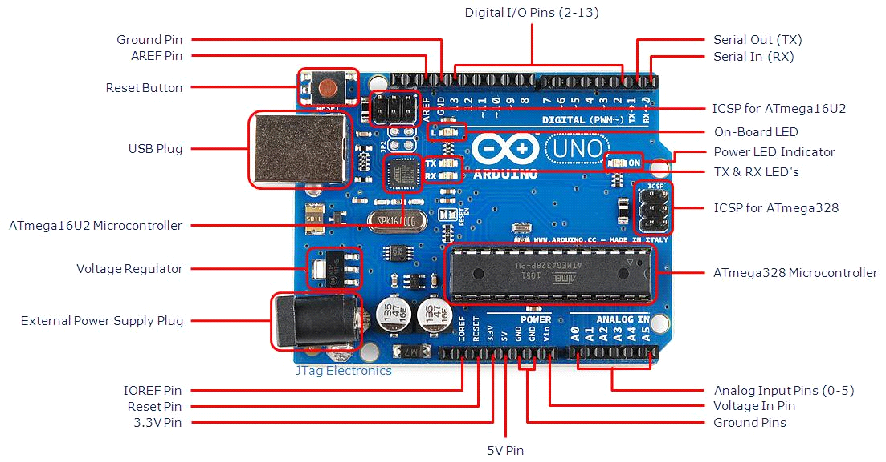fig 3.1 ArduinoUno R3 Board

- USB Plug & External Power Supply Plug

Every Arduino board needs a way to be connected to a power source. The Arduino Uno can be powered from a USB cable coming from your computer or a wall power supply that is terminated in a barrel jack. The power source is selected automatically. The USB connection is also how you will load code onto your Arduino board. Please on my other post on how to program with Arduino can be found in Installing and Programming Arduino.
NOTE: The board can operate on an external supply of 6 to 20 volts. If supplied with less than 7V,
however, the 5V pin may supply less than five volts and the board may be unstable.If using more than 12V, the voltage regulator may overheat and damage the board. The recommended range is 7 to 12 volts
.
- Voltage Regulator
The voltage regulator is not actually something you can (or should) interact with on the Arduino. But it is potentially useful to know that it is there and what it’s for. The voltage regulator does exactly what it says – it controls the amount of voltage that is let into the Arduino board. Think of it as a kind of gatekeeper; it will turn away an extra voltage that might harm the circuit. Of course,it has its limits, so don’t hook up your Arduino to anything greater than 20 volts.

- Power Pins
Voltage In Pin – The input voltage to the Arduino board when it’s using an external power source(as opposed to 5 volts from the USB connection or other regulated power source). You can supply voltage through this pin, or, if supplying voltage via the power jack, access it through this pin.
5V Pin – This pin outputs a regulated 5V from the regulator on the board. The board can be supplied with power either from the DC power jack (7 – 12V), the USB connector (5V), or the VIN pin of the board (7-12V). Supplying voltage via the 5V or 3.3V pins bypasses the regulator, and can damage your board. It’s not recommended.3.3V Pin – A 3.3 volt supply generated by the on-board regulator. Maximum current draw is 50 mA.

- Ground Pins
There are several GND pins on the Arduino, any of which can be used to ground your circuit.

- IOREF Pin
This pin on the Arduino board provides the voltage reference with which the microcontroller operates. A properly configured shield can read the IOREF pin voltage and select the appropriate power source or enable voltage translators on the outputs for working with the 5V or 3.3V.

- Input and Output Pins
Each of the 14 digital pins on the Uno can be used as an input or output. They operate at 5 volts. These pins can be used for both digital input (like telling if a button is pushed) and digital output (like powering an LED). Each pin can provide or receive a maximum of 40 mA and has an internal pull-up resistor (disconnected by default) of 20-5k Ohms. In addition, some pins have specialized functions.

- Serial Out (TX) & Serial In (RX)
Used to receive (RX) and transmit (TX) TTL serial data. These pins are connected to the corresponding pins of the ATmega8U2 USB-to-TTL Serial chip.

- External Interrupts
Pins 2 and 3 can be configured to trigger an interrupt on a low value, a rising or falling edge, or a change in value.
PWM – You may have noticed the tilde (~) next to some of the digital pins (3, 5, 6, 9, 10, and 11). These pins act as normal digital pins, but can also be used for something called Pulse-Width Modulation (PWM). Think of these pins as being able to simulate analog output (like fading an LED in and out).
SPI – Pins 10 (SS), 11 (MOSI), 12 (MISO), 13 (SCK). SPI stands for Serial Peripheral Interface. These pins support SPI communication using the SPI library.
Analog Input Pins – Labeled A0 through A5, each of which provide 10 bits of resolution (i.e. 1024 different values). These pins can read the signal from an analog sensor (like a temperature sensor) and convert it into a digital value that we can read. By default they measure from ground to 5 volts, though is it possible to change the upper end of their range using the AREF Pin (Stands for Analog Reference. Most of the time you can leave this pin alone). Additionally, some pins have specialized functionality:
TWI – Pins A4 or SDA pin and A5 or SCL pin. Support TWI communication using the Wire library.
- Reset Pin
Bring this line LOW to reset the microcontroller.Typically used to add a reset button to shields which block the one on the board.

- LED Indicators
Power LED Indicator – Just beneath and to the right of the word “UNO” on your circuit board, there’s a tiny LED next to the word ‘ON’. This LED should light up whenever you plug your Arduino into a power source. If this light doesn’t turn on, there’s a good chance something is wrong. Time to re-check your circuit!
On-Board LED – There is a built-in LED connected to digital pin 13. When the pin is HIGH value, the LED is on, when the pin is LOW, it’s off. This useful to quickly check if the board has no problem as some boards has a pre-loaded simple blinking LED program in it.
TX & RX LEDs – These LEDs will give us some nice visual indications whenever our Arduino is receiving or transmitting data (like when we’re loading a new program ontotheboard).
Reset Button:Pushing the reset button temporarily connect the reset pin to ground and restart any code that is loaded on the Arduino. This can be very useful if your code doesn’t repeat, but you want to test it multiple times.
Solar panel:
A 12V solar panel is a renewable energy source designed to convert sunlight into electrical power. It consists of photovoltaic (PV) cells made from semiconductor materials, typically monocrystalline or polycrystalline silicon, that generate DC electricity when exposed to sunlight.
Key Features:
- Voltage Output: 12V DC (nominal)
- Power Rating: Varies (e.g., 10W, 20W, 50W, etc.) based on application
- Current Output: Typically between 0.5A to 5A, depending on wattage
- Construction: Weather-resistant with tempered glass and an aluminum frame for durability
- Efficiency: Higher in monocrystalline panels, slightly lower in polycrystalline panels
- Applications: Used in IoT projects, battery charging, LED lighting, small home appliances, and embedded systems

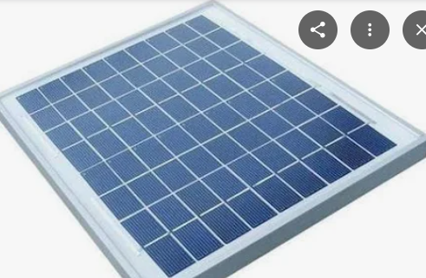
- LCD
LCD (Liquid Crystal Display) screen is an electronic display module and find a wide range of applications. A 16x2 LCD display is very basic module and is very commonly used in various devices and circuits. These modules are preferred over seven segments and other multi segment LEDs. The reasons being: LCDs are economical; easily programmable; have no limitation of displaying special & even custom characters (unlike in seven segments), animationsand so on.
3.6.1 Introduction of LCD
The most commonly used Character based LCDs are based on Hitachi's HD44780 controller or other which are compatible with HD44580.
A 16x2 LCD means it can display 16 characters per line and there are 2 such lines. In this LCD each character is displayed in 5x7 pixel matrix. This LCD has two registers, namely, Command and Data.
The command register stores the command instructions given to the LCD. A command is an instruction given to LCD to do a predefined task like initializing it, clearing its screen, setting the cursor position, controlling display etc. The data register stores the data to be displayed on the LCD. The data is the ASCII value of the character to be displayed on the LCD.

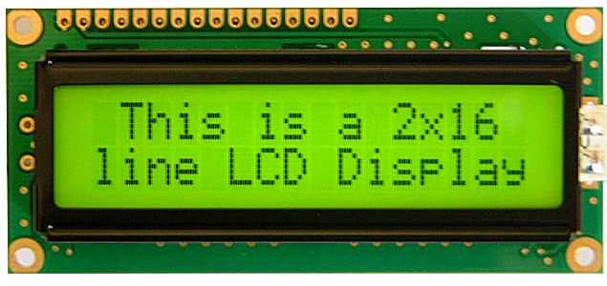
Fig3.17: 16x2 LCD display
3.6.2Pin Description of LCD
Most LCDs with 1 controller has 14 Pins and LCDs with 2 controller has 16 Pins (two pins are extra in both for back-light LED connections). Pin description is shown in the table below.

Pin Configuration table for a 16X2 LCD character display:-
Pin Number | Symbol | Function
1 | Vss | Ground Terminal
2 | Vcc | Positive Supply
3 | Vdd | Contrast adjustment
4 | RS | Register Select; 0→Instruction Register, 1→Data Register
5 | R/W | Read/write Signal; 1→Read, 0→ Write
6 | E | Enable; Falling edge
7 | DB0 | Bi-directional data bus, data transfer is performed once, thru DB0 to DB7, in the case of interface data length is 8-bits; and twice, through DB4 to DB7 in the case of interface data length is 4-bits. Upper four bits first then lower four bits.
8 | DB1
9 | DB2
10 | DB3
11 | DB4
12 | DB5
13 | DB6
14 | DB7
15 | LED-(K) | Back light LED cathode terminal
16 | LED+(A) | Back Light LED anode terminal
Table3.1: Pin Description of LCD

3.6.3 Data/Signals/Execution of LCD
LCD accepts two types of signals, one is data, and another is control. These signals are recognized by the LCD module from status of the RS pin. Now data can be read also from the LCD display, by pulling the R/W pin high. As soon as the E pin is pulsed, LCD display reads data at the falling edge of the pulse and executes it, same for the case of transmission.
LCD display takes a time of 39-43µS to place a character or execute a command. Except for clearing display and to seek cursor to home position it takes 1.53ms to 1.64ms. Any attempt to send any data before this interval may lead to failure to read data or execution of the current data in some devices. Some devices compensate the speed by storing the incoming data to some temporary registers.

3.6.4 Commands and Instruction set
Only the instruction register (IR) and the data register (DR) of the LCD can be controlled by the MCU. Before starting the internal operation of the LCD, control information is temporarily stored into these registers to allow interfacing with various MCUs, which operate at different speeds, or various peripheral control devices. The internal operation of the LCD is determined by signals sent from the MCU. These signals, which include register selection signal (RS), read/write signal (R/W), and the data bus (DB0 to DB7), make up the LCD instructions.
There are four categories of instructions that:
- Designate LCD functions, such as display format, data length, etc.
- Set internal RAM addresses
- Perform data transfer with internal RAM
- Perform miscellaneous functions
Although looking at the table you can make your own commands and test them. Below is a brief list of useful commands which are used frequently while working on the LCD.

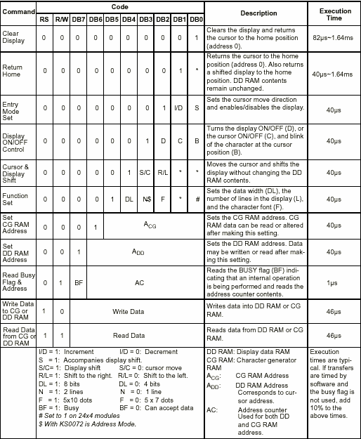Table3.2: Showing various LCD Command Description

3.6.5 List of Commands
No. | Instruction | Hex | Decimal
1 | Function Set: 8-bit, 1 Line, 5x7 Dots | 0x30 | 48
2 | Function Set: 8-bit, 2 Line, 5x7 Dots | 0x38 | 56
3 | Function Set: 4-bit, 1 Line, 5x7 Dots | 0x20 | 32
4 | Function Set: 4-bit, 2 Line, 5x7 Dots | 0x28 | 40
5 | Entry Mode | 0x06 | 6
6 | Display off Cursor off  (clearing display without clearing DDRAM content) | 0x08 | 8
7 | Display on Cursor on | 0x0E | 14
8 | Display on Cursor off | 0x0C | 12
9 | Display on Cursor blinking | 0x0F | 15
10 | Shift entire display left | 0x18 | 24
12 | Shift entire display right | 0x1C | 30
13 | Move cursor left by one character | 0x10 | 16
14 | Move cursor right by one character | 0x14 | 20
15 | Clear Display (also clear DDRAM content) | 0x01 | 1
16 | Set DDRAM address or coursor position on display | 0x80+add* | 128+add*
17 | Set CGRAM address or set pointer to CGRAM location | 0x40+add** | 64+add**
Table3.3: Frequently Used Commands and Instructions forLCD
* CGRAM address from 0x00 to 0x3F, 0x00 to 0x07 for char1 and so on.

3.6.6 Liquid crystal displays interfacing with Controller
The LCD standard requires 3 control lines and 8 I/O lines for the data bus.

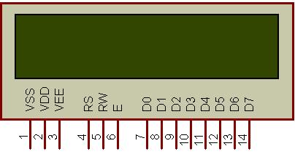
Fig3.18: Pins of LCD
• 8 data pins D7:D0
Bi-directional data/command pins
Alphanumeric characters are sent in ASCII format.
• RS: Register Select
RS = 0 -> Command Register is selected
RS = 1 -> Data Register is selected
• R/W: Read or Write
0 -> Write,
1 -> Read
• E: Enable (Latch data)
Used to latch the data present on the data pins. A high-to-low edge is needed to latch the data.

- GSM
Global System for Mobile Communications (GSM) modems are specialized types of modems that operate over subscription based wireless networks, similar to a mobile phone. A GSM modem accepts a Subscriber Identity Module (SIM) card, and basically acts like a mobile phone for a computer. Such a modem can even be a dedicated mobile phone that the computer uses for GSM network capabilities.
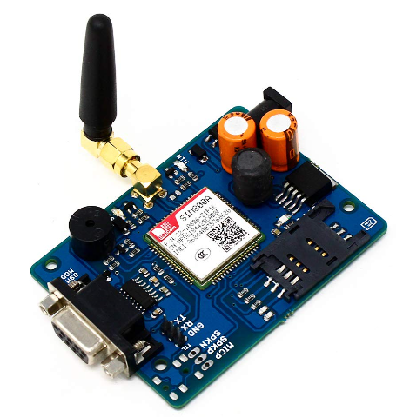
Traditional modems are attached to computers to allow dial-up connections to other computer systems. A GSM modem operates in a similar fashion, except that it sends and receive data through radio waves rather than a telephone line. This type of modem may be an external device connected via a Universal Serial Bus (USB) cable or a serial cable. More commonly, however, it is a small device that plugs directly into the USB port or card slot on a computer or laptop.
It is widely used mobile communication system in the world. GSM is an open and digital cellular technology used for transmitting mobile voice and data services operates at the 850MHz, 900MHz, 1800MHz and 1900MHz frequency bands.

Features

- Improved spectrum efficiency
- International roaming
- Compatibility with integrated services digital network (ISDN)
- Support for new services.
- SIM phonebook management
- Fixed dialing number (FDN)
- Real time clock with alarm management

GSM Modem:

A GSM modem is a wireless modem that works with a GSM wireless network. A wireless modem behaves like a dial-up modem. The main difference between them is that a dial-up modem sends and receives data through a fixed telephone line while a wireless modem sends and receives data through radio waves.
A GSM modem can be an external device or a PC Card / PCMCIA Card. Typically, an external GSM modem is connected to a computer through a serial cable or a USB cable. A GSM modem in the form of a PC Card / PCMCIA Card is designed for use with a laptop computer. It should be inserted into one of the PC Card / PCMCIA Card slots of a laptop computer. Like a GSM mobile phone, a GSM modem requires a SIM card from a wireless carrier in order to operate.
As mentioned in earlier sections of this SMS tutorial, computers use AT commands to control modems. Both GSM modems and dial-up modems support a common set of standard AT commands. You can use a GSM modem just like a dial-up modem.
In addition to the standard AT commands, GSM modems support an extended set of AT commands. These extended AT commands are defined in the GSM standards. With the extended AT commands, you can do things like:
- Reading, writing and deleting SMS messages.
- Sending SMS messages.
- Monitoring the signal strength.
- Monitoring the charging status and charge level of the battery.
- Reading, writing and searching phone book entries.
The number of SMS messages that can be processed by a GSM modem per minute is very low ,only about six to ten SMS messages per minute.

GSM Modem Application

The GSM Network

GSM provides recommendations, not requirements. The GSM specifications define the functions and interface requirements in detail
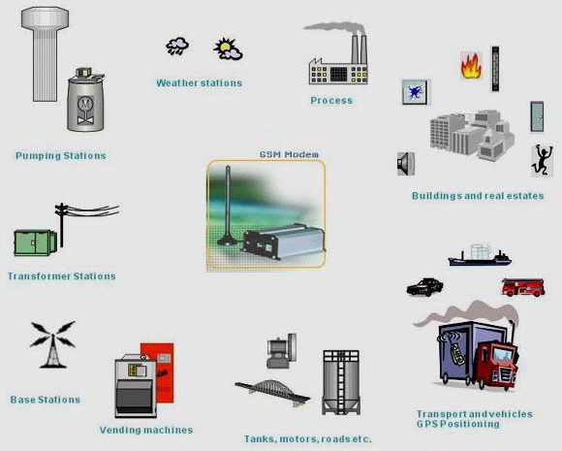
GSM Network
but do not address the hardware. The reason for this is to limit the designers as little as possible but still to make it possible for the operators to buy equipment from different suppliers. The GSM network is divided into three major systems: the switching system (SS), the base station system (BSS), and the operation and support system (OSS).

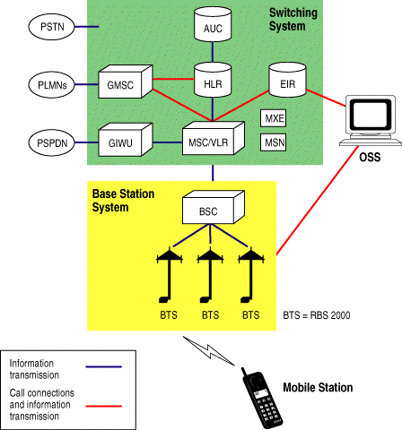
Block diagram of GSM system
- ULTRASONIC SENSOR
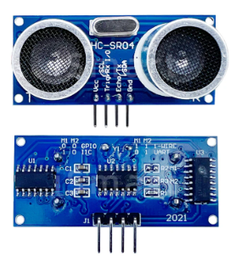
An Ultrasonic sensor is a device that can measure the distance to an object by using sound waves. It measures distance by sending out a sound wave at a specific frequency and listening for that sound wave to bounce back. By recording the elapsed time between the sound wave being generated and the sound wave bouncing back, it is possible to calculate the distance between the sonar sensor and the object.

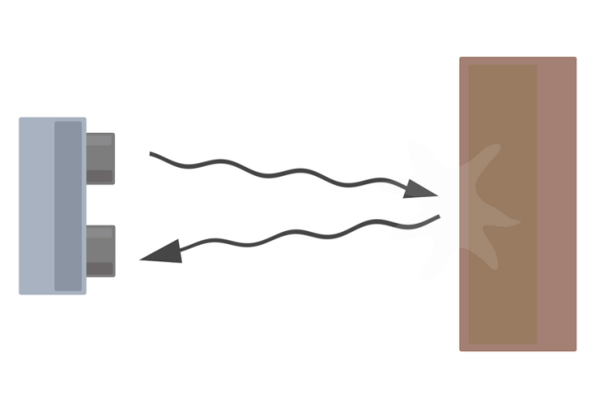
Diagram of the basic ultrasonic sensor operation

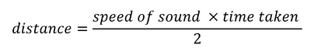
Since it is known that sound travels through air at about 344 m/s (1129 ft/s), you can take the time for the sound wave to return and multiply it by 344 meters (or 1129 feet) to find the total round-trip distance of the sound wave. Round-trip means that the sound wave traveled 2 times the distance to the object before it was detected by the sensor; it includes the 'trip' from the sonar sensor to the object AND the 'trip' from the object to the Ultrasonic sensor (after the sound wave bounced off the object). To find the distance to the object, simply divide the round-trip distance in half.
NOTE: The accuracy of Ultrasonic sensor can be affected by the temperature and humidity of the air it is being used in. However, for these tutorials and almost any project you will be using these sensors in, this change in accuracy will be negligible.
It is important to understand that some objects might not be detected by ultrasonic sensors. This is because some objects are shaped or positioned in such a way that the sound wave bounces off the object, but are deflected away from the Ultrasonic sensor. It is also possible for the object to be too small to reflect enough of the sound wave back to the sensor to be detected. Other objects can absorb the sound wave all together (cloth, carpeting, etc), which means that there is no way for the sensor to detect them accurately. These are important factors to consider when designing and programming a robot using an ultrasonic sensor.
Advancements in camera module technology have led to significant improvements in image quality, allowing users to capture high-resolution photos and videos with smartphones and other devices. Additionally, features like computational photography and AI-powered image processing have further enhanced the capabilities of camera modules, enabling functions such as portrait mode, night mode, and augmented reality experiences.
- WIFI

The ESP8266 is a low-cost Wi-Fi chip with full TCP/IP stack and MCU (microcontroller unit) capability produced by Shanghai-based Chinese manufacturer, Espressif Systems.
The chip first came to the attention of western makers in August 2014 with the ESP-01 module, made by a third-party manufacturer, AI-Thinker. This small module allows microcontrollers to connect to a Wi-Fi network and make simple TCP/IP connections using Hayes-style commands. However, at the time there was almost no English-language documentation on the chip and the commands it accepted. The very low price and the fact that there were very few external components on the module which suggested that it could eventually be very inexpensive in volume, attracted many hackers to explore the module, chip, and the software on it, as well as to translate the Chinese documentation.
The ESP8285 is an ESP8266 with 1 MiB of built-in flash, allowing for single-chip devices capable of connecting to Wi-Fi
Features
- 32-bit RISC CPU: Tensilica Xtensa L106 running at 80 MHz*
- 64 KiB of instruction RAM, 96 KiB of data RAM
- External QSPI flash: 512 KiB to 4 MiB* (up to 16 MiB is supported)
- IEEE 802.11 b/g/n Wi-Fi
- Integrated TR switch, balun, LNA, power amplifier and matching network
- WEP or WPA/WPA2 authentication, or open networks
- 16 GPIO pins
- SPI
- I²C
- I²S interfaces with DMA (sharing pins with GPIO)
- UART on dedicated pins, plus a transmit-only UART can be enabled on GPIO2
- 10-bit ADC
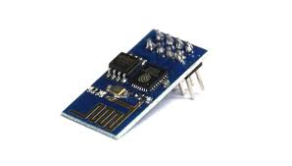

- REGULATED POWER SUPPLY
All digital circuits require regulated power supply. In this article we are going to learn how to get a regulated positive supply from the mains supply.

STEP DOWN
TRANSFORMER
BRIDGE
RECTIFIER
FILTER
CIRCUIT
REGULATOR SECTION

shows the basic block diagram of a fixed regulated power supply
TRANSFORMER
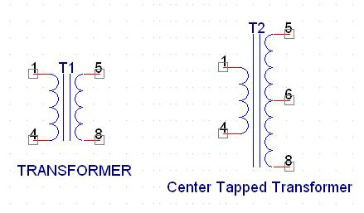
Types of transformer

A transformer consists of two coils also called as “WINDINGS” namely PRIMARY & SECONDARY.
They are linked together through inductively coupled electrical conductors also called as CORE. A changing current in the primary causes a change in the Magnetic Field in the core & this in turn induces an alternating voltage in the secondary coil. If load is applied to the secondary then an alternating current will flow through the load. If we consider an ideal condition then all the energy from the primary circuit will be transferred to the secondary circuit through the magnetic field.
So 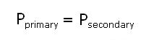
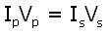

The secondary voltage of the transformer depends on the number of turns
in the Primary as well as in the secondary.
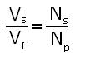
Rectifier
A rectifier is a device that converts an AC signal into DC signal. For rectification purpose we use a diode, a diode is a device that allows current to pass only in one direction i.e. when the anode of the diode is positive with respect to the cathode also called as forward biased condition & blocks current in the reversed biased condition.

Rectifier can be classified as follows:
1) Half Wave rectifier.
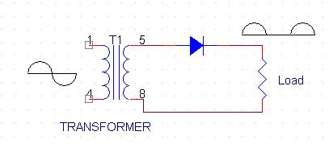
Half wave rectifier

This is the simplest type of rectifier as you can see in the diagram a half wave rectifier consists of only one diode. When an AC signal is applied to it during the positive half cycle the diode is forward biased & current flows through it. But during the negative half cycle diode is reverse biased & no current flows through it. Since only one half of the input reaches the output, it is very inefficient to be used in power supplies.

2) Full wave rectifier.
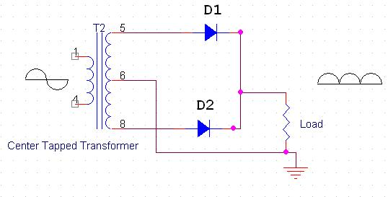
Full wave rectifier

Half wave rectifier is quite simple but it is very inefficient, for greater efficiency we would like to use both the half cycles of the AC signal. This can be achieved by using a center tapped transformer i.e. we would have to double the size of secondary winding & provide connection to the center. So during the positive half cycle diode D1 conducts & D2 is in reverse biased condition. During the negative half cycle diode D2 conducts & D1 is reverse biased. Thus we get both the half cycles across the load.
One of the disadvantages of Full Wave Rectifier design is the necessity of using a center tapped transformer, thus increasing the size & cost of the circuit. This can be avoided by using the Full Wave Bridge Rectifier.
3) Bridge Rectifier.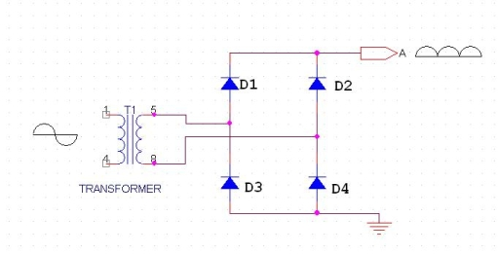
Bridge rectifier
As the name suggests it converts the full wave i.e. both the positive & the negative half cycle into DC thus it is much more efficient than Half Wave Rectifier & that too without using a center tapped transformer thus much more cost effective than Full Wave Rectifier.
Full Bridge Wave Rectifier consists of four diodes namely D1, D2, D3 and D4. During the positive half cycle diodes D1 & D4 conduct whereas in the negative half cycle diodes D2 & D3 conduct thus the diodes keep switching the transformer connections so we get positive half cycles in the output.
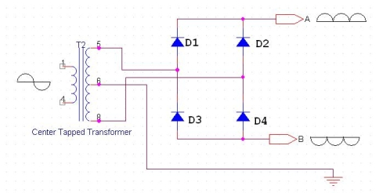

Bridge rectifier with center tapped
If we use a center tapped transformer for a bridge rectifier we can get both positive & negative half cycles which can thus be used for generating fixed positive & fixed negative voltages.
FILTER CAPACITOR
Even though half wave & full wave rectifier give DC output, none of them provides a constant output voltage. For this we require to smoothen the waveform received from the rectifier. This can be done by using a capacitor at the output of the rectifier this capacitor is also called as “FILTER CAPACITOR” or “SMOOTHING CAPACITOR” or “RESERVOIR CAPACITOR”. Even after using this capacitor a small amount of ripple will remain.
We place the Filter Capacitor at the output of the rectifier the capacitor will charge to the peak voltage during each half cycle then will discharge its stored energy slowly through the load while the rectified voltage drops to zero, thus trying to keep the voltage as constant as possible.
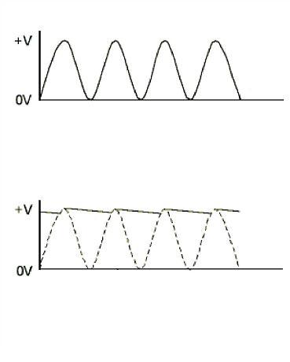
output waveforms

If we go on increasing the value of the filter capacitor then the Ripple will decrease. But then the costing will increase. The value of the Filter capacitor depends on the current consumed by the circuit, the frequency of the waveform & the accepted ripple.
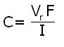

Where,
Vr= accepted ripple voltage.( should not be more than 10% of the voltage)
I= current consumed by the circuit in Amperes.
F= frequency of the waveform. A half wave rectifier has only one peak in one cycle so F=25hz
Whereas a full wave rectifier has Two peaks in one cycle so F=100hz.
VOLTAGE REGULATOR
A Voltage regulator is a device which converts varying input voltage into a constant regulated output voltage. Voltage regulator can be of two types
1) Linear Voltage Regulator
Also called as Resistive Voltage regulator because they dissipate the excessive voltage resistively as heat.
2) Switching Regulators.
They regulate the output voltage by switching the Current ON/OFF very rapidly. Since their output is either ON or OFF it dissipates very low power thus achieving higher efficiency as compared to linear voltage regulators. But they are more complex & generate high noise due to their switching action. For low level of output power switching regulators tend to be costly but for higher output wattage they are much cheaper than linear regulators.
The most commonly available Linear Positive Voltage Regulators are the 78XX series where the XX indicates the output voltage. And 79XX series is for Negative Voltage Regulators.
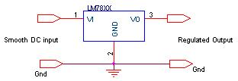
Switching regulator

After filtering the rectifier output the signal is given to a voltage regulator. The maximum input voltage that can be applied at the input is 35V.Normally there is a 2-3 Volts drop across the regulator so the input voltage should be at least 2-3 Volts higher than the output voltage. If the input voltage gets below the Vmin of the regulator due to the ripple voltage or due to any other reason the voltage regulator will not be able to produce the correct regulated voltage.

3 Circuit diagram:
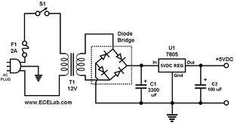
Circuit Diagram of power supply

IC 7805:
7805 is an integrated three-terminal positive fixed linear voltage regulator. It supports an input voltage of 10 volts to 35 volts and output voltage of 5 volts. It has a current rating of 1 amp although lower current models are available. Its output voltage is fixed at 5.0V. The 7805 also has a built-in current limiter as a safety feature. 7805 is manufactured by many companies, including National Semiconductors and Fairchild Semiconductors.
The 7805 will automatically reduce output current if it gets too hot. The last two digits represent the voltage; for instance, the 7812 is a 12-volt regulator. The 78xx series of regulators is designed to work in complement with the 79xx series of negative voltage regulators in systems that provide both positive and negative regulated voltages, since the 78xx series can't regulate negative voltages in such a system.
The 7805 & 78 is one of the most common and well-known of the 78xx series regulators, as it's small component count and medium-power regulated 5V make it useful for powering TTL devices.
Table Specifications of IC7805
SPECIFICATIONS | IC 7805
V_{out} | 5V
V_{ein} - V_{out} Difference | 5V - 20V
Operation Ambient Temp | 0 - 125°C
Output I_{max} | 1A

CHAPTER 6
SOFTWARE TOOLS
- Arduino ide
- Embedded c programming
- Windows OS

6.1 DESCRIPTION OF TOOLS
1. Arduino IDE:
Arduino IDE Software. You can get different versions of Arduino IDE from the Download page on the Arduino Official website. You must select your software, which is compatible with your operating system (Windows, IOS, or Linux). After your file download is complete, unzip the file.
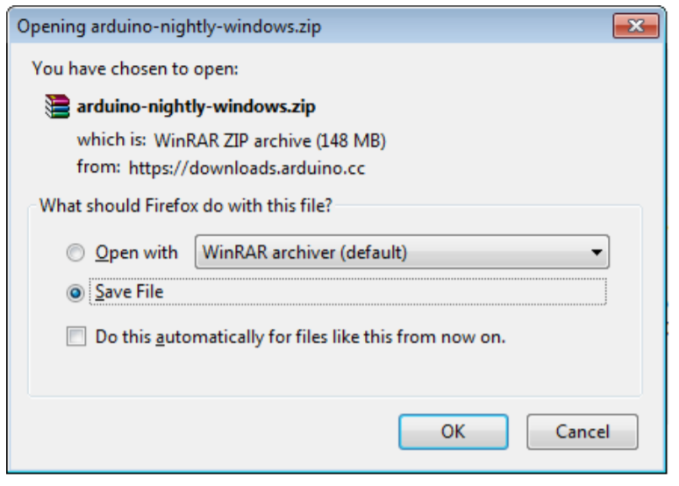
Launch Arduino IDE. After your Arduino IDE software is downloaded, you need to unzip the folder. Inside the folder, you can find the application icon with an infinity label (application.exe). Doubleclick the icon to start the IDE.
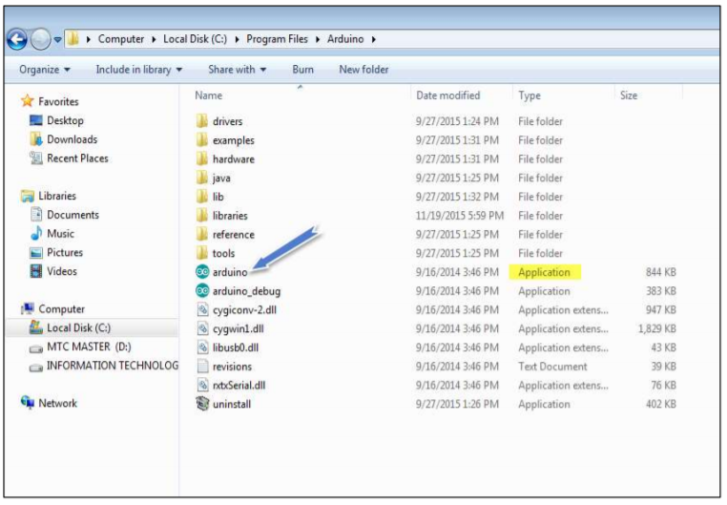
Open your first project. Once the software starts, you have two options:
• Create a new project.
• Open an existing project example.
To create a new project, select File --> New
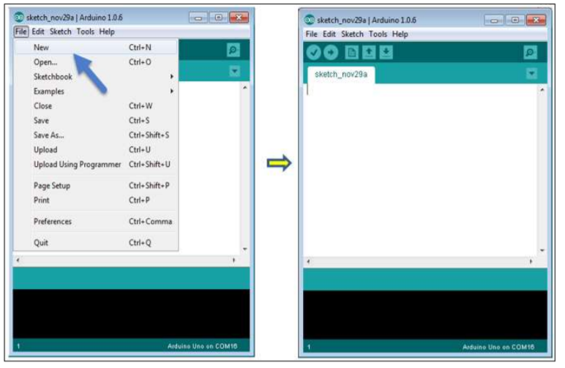
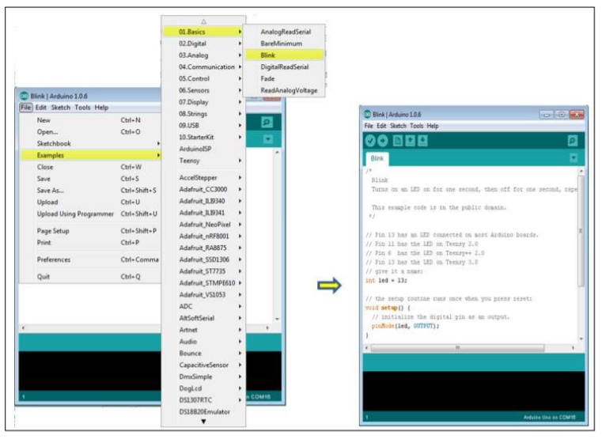
Here, we are selecting just one of the examples with the name Blink. It turns the LED on and off with some time delay. You can select any other example from the list
Select your serial port. Select the serial device of the Arduino board. Go to Tools -> Serial Port menu. This is likely to be COM3 or higher (COM1 and COM2 are usually reserved for hardware serial ports). To find out, you can disconnect your Arduino board and re-open the menu, the entry that disappears should be of the Arduino board. Reconnect the board and select that serial port.
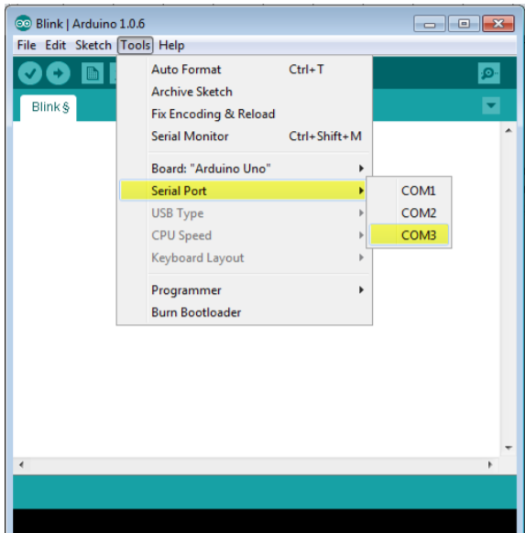
Before explaining how we can upload our program to the board, we must demonstrate the function of each symbol appearing in the Arduino IDE toolbar.
- Used to check if there is any compilation error.
- Used to upload a program to the Arduino board.
- Shortcut used to create a new sketch.
- Used to directly open one of the example sketch.
- Used to save your sketch.
- Serial monitor used to receive serial data from the board and send the serial data to the board.
Now, simply click the "Upload" button in the environment.
Wait a few seconds; you will see the RX and TX LEDs on the board, flashing. If the upload is successful, the message "Done uploading" will appear in the status bar.
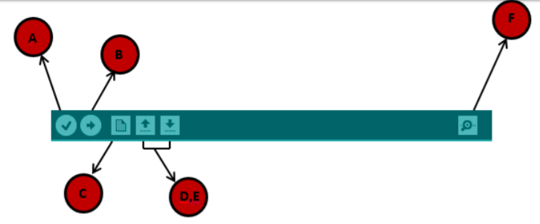
In this chapter, we will study in depth, the Arduino program structure and we will learn more new terminologies used in the Arduino world. The Arduino software is open-source. The source code for the Java environment is released under the GPL and the C/C++ microcontroller libraries are under the LGPL. Sketch: The first new terminology is the Arduino program called “sketch”. Structure Arduino programs can be divided in three main parts: Structure, Values (variables and constants), and Functions. In this tutorial, we will learn about the Arduino software program, step by step, and how we can write the program without any syntax or compilation error. Let us start with the Structure. Software structure consist of two main functions:
•Setup( ) function
•Loop( ) function
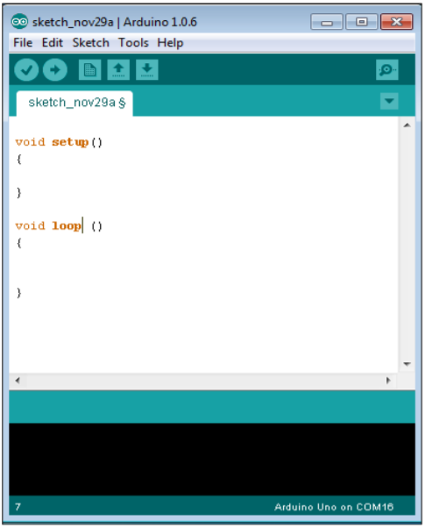
Data types in C refers to an extensive system used for declaring variables or functions of different types. The type of a variable determines how much space it occupies in the storage and how the bit pattern stored is interpreted. The following table provides all the data types that you will use during Arduino programming.

CHAPTER 7
RESULTS AND DISCUSSION

CHAPTER 8
CONCLUSION
The Smart Waste Management System utilizing IoT technology provides an efficient and automated solution to modern urban waste management challenges. By integrating ultrasonic sensors, an Arduino Uno, a GSM module, GPS, Wi-Fi connectivity, and an LCD display, the system enables real-time monitoring of waste bin levels and improves the efficiency of waste collection processes.
The ultrasonic sensors continuously monitor the fill level of waste bins, allowing accurate detection of bin status. When the waste level reaches a predefined threshold, the system sends instant alerts along with the bin’s GPS location to municipal authorities through the GSM module. This ensures timely waste collection and helps prevent overflow conditions, maintaining cleanliness in urban environments.
Wi-Fi-based remote monitoring allows authorities to track multiple bins in real time, reducing the need for manual inspection. This leads to optimized collection routes, reduced operational costs, and minimized fuel consumption. The LCD display provides on-site status updates, making the system easy to monitor and maintain.
Overall, this system enhances urban waste management efficiency by reducing unnecessary collection trips, improving response time, and supporting smarter decision-making. The proposed solution contributes to cleaner cities and more sustainable urban infrastructure through the effective use of IoT and automation technologies.

FUTURE SCOPE:
The solar powered Smart Waste Management System can be further enhanced with advanced technologies to improve efficiency and sustainability. Future developments may include AI-based predictive analysis to optimize waste collection schedules and machine learning algorithms to analyze waste generation patterns. Solar-powered smart bins can enhance energy efficiency, reducing reliance on external power sources. Integration with mobile applications can allow citizens to report waste-related issues and track bin statuses in real-time. Additionally, robotic waste segregation systems can automate recycling processes, promoting environmental sustainability. Expanding the system to cover larger urban areas can further optimize waste management, reducing pollution and enhancing smart city initiatives.

REFERENCES
- Pires, I.; Souza, G.; Junior, J. An Analysis of the Relation between Garbage Pickers and Women’s Health Risk. Acta Sci. Agric. 2020, 4, 12–16. [Google Scholar]
- Liu, J.; Balatti, P.; Ellis, K.; Hadjivelichkov, D.; Stoyanov, D.; Ajoudani, A.; Kanoulas, D. Garbage collection and sorting with a mobile manipulator using deep learning and whole-body control. In Proceedings of the 2020 IEEE-RAS 20th International Conference on Humanoid Robots (Humanoids), Munich, Germany, 19–21 July 2021; pp. 408–414. [Google Scholar]
- Waste Management Indicators. Available online: https://ec.europa.eu/eurostat/statistics-explained/index.php?title=Waste_management_indicators (accessed on 5 July 2022).
- Lagakos, D. Urban-rural gaps in the developing world: Does internal migration offer opportunities? J. Econ. Perspect. 2020, 34, 174–192. [Google Scholar] [CrossRef]
- Nañez Alonso, S.L.; Reier Forradellas, R.F.; Pi Morell, O.; Jorge-Vazquez, J. Digitalization, circular economy and environmental sustainability: The application of Artificial Intelligence in the efficient self-management of waste. Sustainability 2021, 13, 2092. [Google Scholar] [CrossRef]
- Bagri, V.; Sharma, L.; Patil, B.; Dhage, S.N. Survey of Automated Waste Segregation Methods. In Advances in Computer, Communication and Computational Sciences; Springer: Berlin/Heidelberg, Germany, 2021; pp. 953–964. [Google Scholar]
- Zhang, Q.; Zhang, X.; Mu, X.; Wang, Z.; Tian, R.; Wang, X.; Liu, X. Recyclable waste image recognition based on deep learning. Resour. Conserv. Recycl. 2021, 171, 105636. [Google Scholar] [CrossRef]
- Rahman, M.W.; Islam, R.; Hasan, A.; Bithi, N.I.; Hasan, M.M.; Rahman, M.M. Intelligent waste management system using deep learning with IoT. J. King Saud Univ.-Comput. Inf. Sci. 2020, 34, 2072–2087. [Google Scholar] [CrossRef]
- Ramsurrun, N.; Suddul, G.; Armoogum, S.; Foogooa, R. Recyclable Waste Classification Using Computer Vision And Deep Learning. In Proceedings of the 2021 Zooming Innovation in Consumer Technologies Conference (ZINC), Novi Sad, Serbia, 26–27 May 2021; pp. 11–15. [Google Scholar]
- Mao, W.L.; Chen, W.C.; Wang, C.T.; Lin, Y.H. Recycling waste classification using optimized convolutional neural network. Resour. Conserv. Recycl. 2021, 164, 105132. [Google Scholar] [CrossRef]
- Altikat, A.; Gulbe, A.; Altikat, S. Intelligent solid waste classification using deep convolutional neural networks. Int. J. Environ. Sci. Technol. 2022, 19, 1285–1292. [Google Scholar] [CrossRef]
- The FUSON Website. Available online: https://www.fuzon.io/insight/top-iotstatistics/ (accessed on 5 July 2022).
- The STATISTA Website. Available online: https://www.statista.com/topics/2637/internet-of-things/ (accessed on 5 July 2022).
- Sheng, T.J.; Islam, M.S.; Misran, N.; Baharuddin, M.H.; Arshad, H.; Islam, M.R.; Chowdhury, M.E.; Rmili, H.; Islam, M.T. An internet of things based smart waste management system using LoRa and tensorflow deep learning model. IEEE Access 2020, 8, 148793–148811. [Google Scholar] [CrossRef]
- Esmaeilian, B.; Wang, B.; Lewis, K.; Duarte, F.; Ratti, C.; Behdad, S. The future of waste management in smart and sustainable cities: A review and concept paper. Waste Manag. 2018, 81, 177–195. [Google Scholar] [CrossRef]
- Catarinucci, L.; Colella, R.; Consalvo, S.I.; Patrono, L.; Rollo, C.; Sergi, I. IoT-aware waste management system based on cloud services and ultra-low-power RFID sensor-tags. IEEE Sens. J. 2020, 20, 14873–14881. [Google Scholar] [CrossRef]
- Livani, E.; Nguyen, R.; Denzinger, J.; Ruhe, G.; Banack, S. A hybrid machine learning method and its application in municipal waste prediction. In Industrial Conference on Data Mining; Springer: Berlin/Heidelberg, Germany, 2013; pp. 166–180. [Google Scholar]
- Yigitcanlar, T.; Cugurullo, F. The sustainability of artificial intelligence: An urbanistic viewpoint from the lens of smart and sustainable cities. Sustainability 2020, 12, 8548. [Google Scholar] [CrossRef]
- Belli, L.; Cilfone, A.; Davoli, L.; Ferrari, G.; Adorni, P.; Di Nocera, F.; Dall’Olio, A.; Pellegrini, C.; Mordacci, M.; Bertolotti, E. IoT-enabled smart sustainable cities: Challenges and approaches. Smart Cities 2020, 3, 1039–1071. [Google Scholar] [CrossRef]
- Davis, D.R.; Dingel, J.I. A spatial knowledge economy. Am. Econ. Rev. 2019, 109, 153–170. [Google Scholar] [CrossRef]
- Davis, D.R.; Dingel, J.I. The comparative advantage of cities. J. Int. Econ. 2020, 123, 103291. [Google Scholar] [CrossRef]
- Klimanova, O.; Illarionova, O.; Grunewald, K.; Bukvareva, E. Green infrastructure, urbanization, and ecosystem services: The main challenges for Russia’s largest cities. Land 2021, 10, 1292. [Google Scholar] [CrossRef]
- Kuddus, M.A.; Tynan, E.; McBryde, E. Urbanization: A problem for the rich and the poor? Public Health Rev. 2020, 41, 1–4. [Google Scholar] [CrossRef]
- Anierobi, C.; Obasi, C.O. Urbanization and Rural-Urban Migration: Toward Involving the Church in Addressing Pro-Poor Urban Housing Challenges in Enugu, Nigeria. SAGE Open 2021, 11, 21582440211040123. [Google Scholar] [CrossRef]
- Blair, J.; Mataraarachchi, S. A Review of Landfills, Waste and the Nearly Forgotten Nexus with Climate Change. Environments 2021, 8, 73. [Google Scholar] [CrossRef]
- Wang, Y.S. The challenges and strategies of food security under rapid urbanization in China. Sustainability 2019, 11, 542. [Google Scholar] [CrossRef]
- Arfanuzzaman, M.; Dahiya, B. Sustainable urbanization in Southeast Asia and beyond: Challenges of population growth, land use change, and environmental health. Growth Chang. 2019, 50, 725–744. [Google Scholar] [CrossRef]
- Ravichandran, C.; Venkatesan, G. Toward sustainable solid waste management–challenges and opportunities. Handb. Adv. Approaches Towards Pollut. Prev. Control 2021, 2, 67–103. [Google Scholar]
- Niinimäki, K.; Peters, G.; Dahlbo, H.; Perry, P.; Rissanen, T.; Gwilt, A. The environmental price of fast fashion. Nat. Rev. Earth Environ. 2020, 1, 189–200. [Google Scholar] [CrossRef]
- Rahimi, A.; García, J.M. Chemical recycling of waste plastics for new materials production. Nat. Rev. Chem. 2017, 1, 1–11. [Google Scholar] [CrossRef]

