SOC DETECTION &
INVESTIGATION LAB
Windows 11 • Sysmon • Splunk Enterprise • Wireshark • MITRE ATT&CK

Prepared by
Akhil Dawar

Document Control | Value
Document | SOC Detection & Investigation Lab
Version | FINAL v1.2
Environment | CYBER-LAB - Windows 11 virtual machine
Classification | Controlled cybersecurity training / portfolio project
Primary telemetry | Microsoft Sysmon Operational logs
Analytics | Splunk Enterprise
Network analysis | Wireshark
Evidence inventory | 34 screenshots across all upload batches

CONTROLLED LAB NOTICE
All suspicious-looking activity was intentionally generated in an isolated training environment. The report demonstrates detection and investigation methodology and does not represent a real compromise.

Table of Contents
Section | Contents | Page
1 | Executive Summary / Incident Overview | 3
2 | Investigation Scope & Environment | 3
3 | Detection and Investigation Methodology | 3
4 | Incident Timeline | 4
5 | Technical Findings & Evidence | 5
6 | Process-Chain Analysis | 7
7 | Network / DNS Analysis | 8
8 | MITRE ATT&CK Mapping | 10
9 | Indicators of Compromise / Observables | 12
10 | Analyst Assessment | 12
11 | Containment & Remediation Recommendations | 13
12 | Conclusion | 13
13 | Evidence Appendix - Complete Screenshot Set | 15

PORTFOLIO POSITIONING
This document is structured as a SOC investigation case study rather than a tool walkthrough. It prioritises evidence, correlation, analyst judgement, reproducibility and defensible scoping.
INVESTIGATION LENS
Endpoint telemetry | Process ancestry | DNS/network context | ATT&CK mapping | Incident reporting

1. Executive Summary / Incident Overview
This project demonstrates an end-to-end Security Operations Center (SOC) workflow on a Windows 11 endpoint. Microsoft Sysmon generated high-value endpoint telemetry; Splunk Enterprise provided ingestion, detection and event correlation; and Wireshark validated packet-level DNS, HTTP and ICMP activity.
The controlled investigation identified PowerShell and Windows Command Shell execution, current-user discovery, network configuration and connection discovery, PowerShell web/DNS activity, and a controlled TCP/4444 scenario. The analysis moved beyond isolated event searches by reconstructing process ancestry and correlating Sysmon events with ParentProcessId, ProcessId and ProcessGuid.
Executive field | Assessment
Disposition | Expected / controlled lab activity
Production analogue | Would warrant triage if unexpected on a business endpoint
Primary evidence | Sysmon Event IDs 1, 3 and 22 ingested into Splunk
Strongest correlation | PowerShell -> cmd.exe -> whoami.exe; PowerShell process -> DNS query
Analytical outcome | Detection, process correlation, ATT&CK mapping and defensible reporting completed
Key analytical principle
A technique match or suspicious command is not proof of compromise. The report distinguishes observed telemetry from interpretation and explicitly identifies benign test infrastructure.

2. Investigation Scope & Environment
Component | Implementation | Purpose
Endpoint | Windows 11 VM - CYBER-LAB | Controlled source of process and network telemetry
Virtualisation | VMware Workstation | Isolation and recovery snapshots
Endpoint telemetry | Microsoft Sysmon | Process creation, DNS and network visibility
SIEM | Splunk Enterprise | Search, detection, correlation and reporting
Packet analysis | Wireshark | Independent DNS, HTTP and ICMP validation
Framework | MITRE ATT&CK Enterprise | Behavioural mapping and detection context
Scope was intentionally restricted to a single controlled endpoint. example.com was used as a benign demonstration domain. The TCP/4444 scenario used loopback traffic (127.0.0.1), allowing non-standard-port telemetry to be generated without connecting to a malicious external service.

3. Detection and Investigation Methodology
- Validate host connectivity and packet visibility with command-line tests and Wireshark.
- Confirm Sysmon event generation locally and ingest Microsoft-Windows-Sysmon/Operational into Splunk.
- Build reusable Splunk detections for PowerShell execution, system/network discovery, PowerShell spawning CMD, and non-standard-port activity.
- Generate controlled activity and inspect Image, CommandLine, ParentImage, ParentCommandLine, ProcessId, ParentProcessId and ProcessGuid.
- Use time-window, process-tree and ProcessGuid correlation to connect related events.
- Map supported behaviours to MITRE ATT&CK and preserve screenshots as evidence.

3.1 Core telemetry
Sysmon Event ID | Data type | Analytical use
1 | Process Creation | Executable, command line, process ancestry, PID and ProcessGuid
3 | Network Connection | Process-associated connection and destination port
22 | DNS Query | Process-associated name resolution

3.2 Detection Logic & Reproducible SPL
The following searches capture the principal detection and correlation logic used in the lab. They are included as readable text so the investigation can be reproduced without relying solely on screenshots.
Detection / Pivot | Representative SPL
PowerShell process creation | index=* source="WinEventLog:Microsoft-Windows-Sysmon/Operational" "<EventID>1</EventID>" "powershell.exe"
PowerShell -> Windows Command Shell | index=* source="WinEventLog:Microsoft-Windows-Sysmon/Operational" "<EventID>1</EventID>" "cmd.exe" "ParentImage" "powershell.exe"
Discovery activity | index=* source="WinEventLog:Microsoft-Windows-Sysmon/Operational" "<EventID>1</EventID>" ("whoami.exe" OR "ipconfig.exe" OR "netstat.exe")
Controlled TCP/4444 scenario | index=* source="WinEventLog:Microsoft-Windows-Sysmon/Operational" "<EventID>3</EventID>" "4444"
PowerShell web/DNS pivot | index=* source="WinEventLog:Microsoft-Windows-Sysmon/Operational" ("Invoke-WebRequest" OR "example.com")
Analyst note: these searches are intentionally transparent and lab-focused. In production they should be adapted to the organisation's field extractions, baselines, allow-lists and risk model.

4. Incident Timeline
The timeline below represents the strongest correlated discovery sequence from the controlled incident exercise. The PowerShell web/DNS test and TCP/4444 test were separate controlled scenarios and are analysed in Section 7 rather than being presented as one continuous intrusion.
Time | Observed activity | SOC interpretation
01:22:41 | whoami.exe | System owner/user discovery; PowerShell parent PID 5016
01:24:01 | ipconfig.exe /all | System network configuration discovery; same PowerShell parent PID 5016
01:24:34 | NETSTAT.EXE -ano | System network connections discovery; same PowerShell parent PID 5016
01:26:07 | cmd.exe /c "echo INCIDENT-LAB-01 && whoami" | PowerShell spawned Windows Command Shell
01:26:07 | whoami.exe | cmd.exe child; completes PowerShell -> CMD -> whoami chain
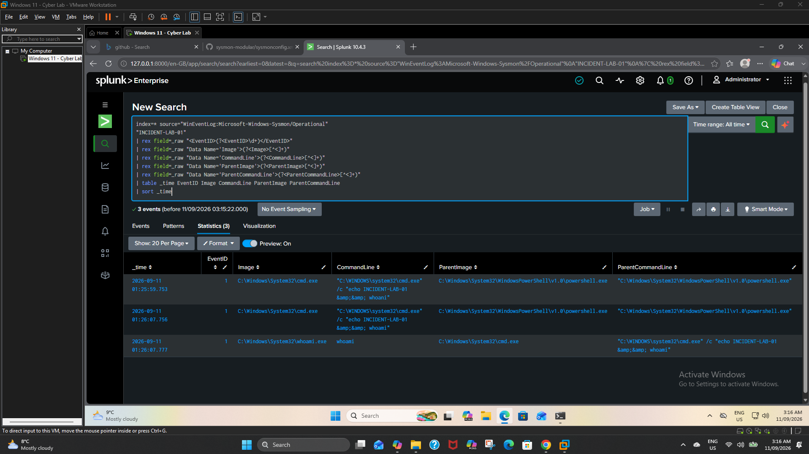
Figure 1. Splunk reconstruction of the INCIDENT-LAB-01 process chain.

5. Technical Findings & Evidence

5.1 PowerShell execution
Sysmon Event ID 1 and Splunk searches identified PowerShell process creation and command-line activity. PowerShell is a legitimate administrative platform; therefore, execution alone is not treated as malicious. Its value comes from command-line context, parent/child relationships and associated network activity.
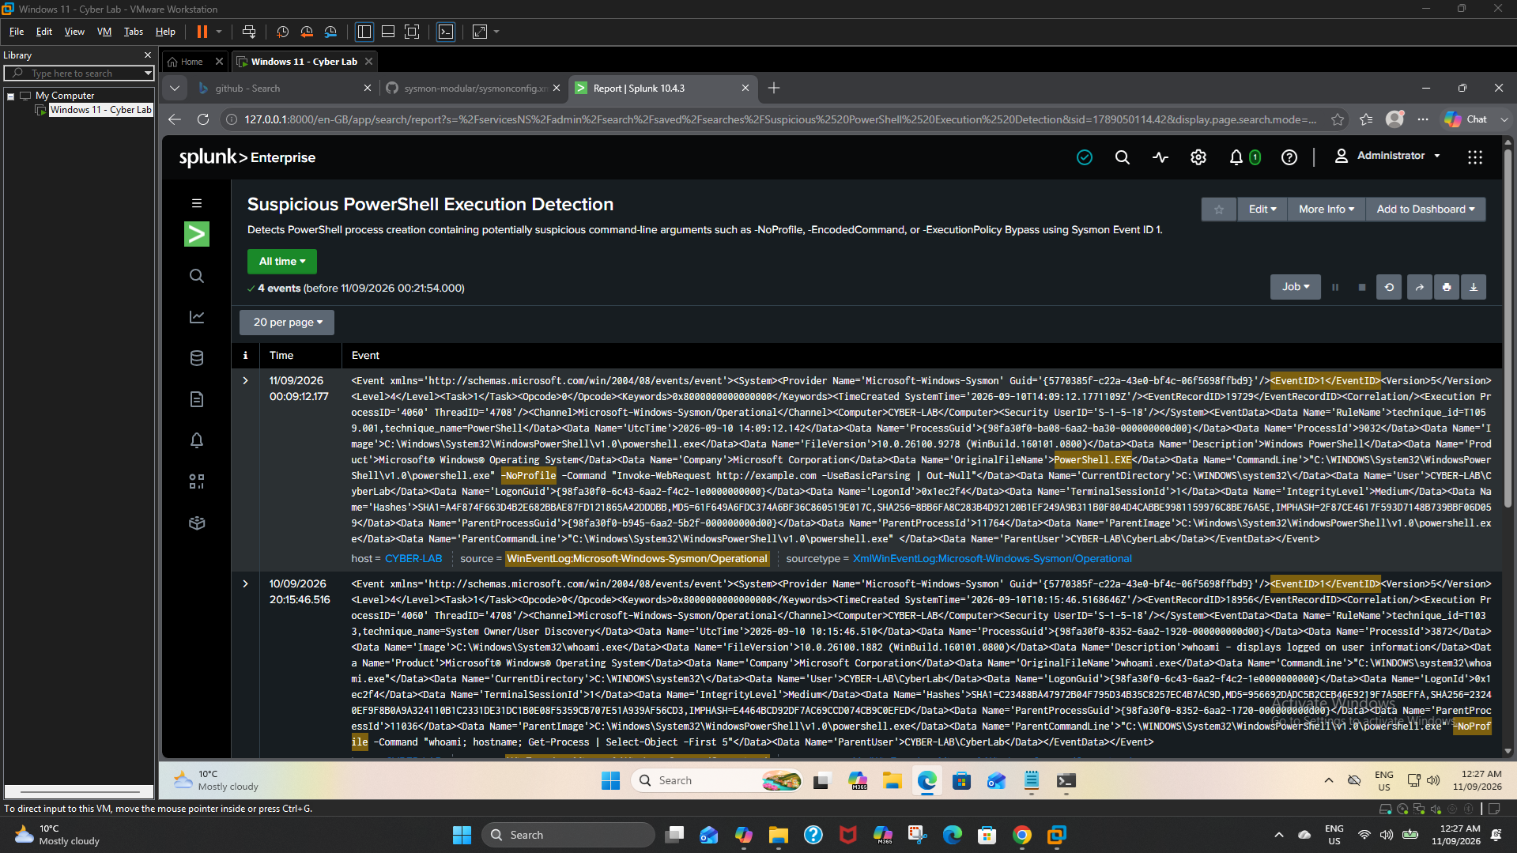
Figure 2. Reusable Splunk detection/report for PowerShell execution.

5.2 Discovery activity
The controlled sequence included whoami, ipconfig /all and netstat -ano. These commands map to distinct Discovery behaviours and occurred within a short time window with shared PowerShell ancestry, which makes the cluster more analytically meaningful than an isolated command.
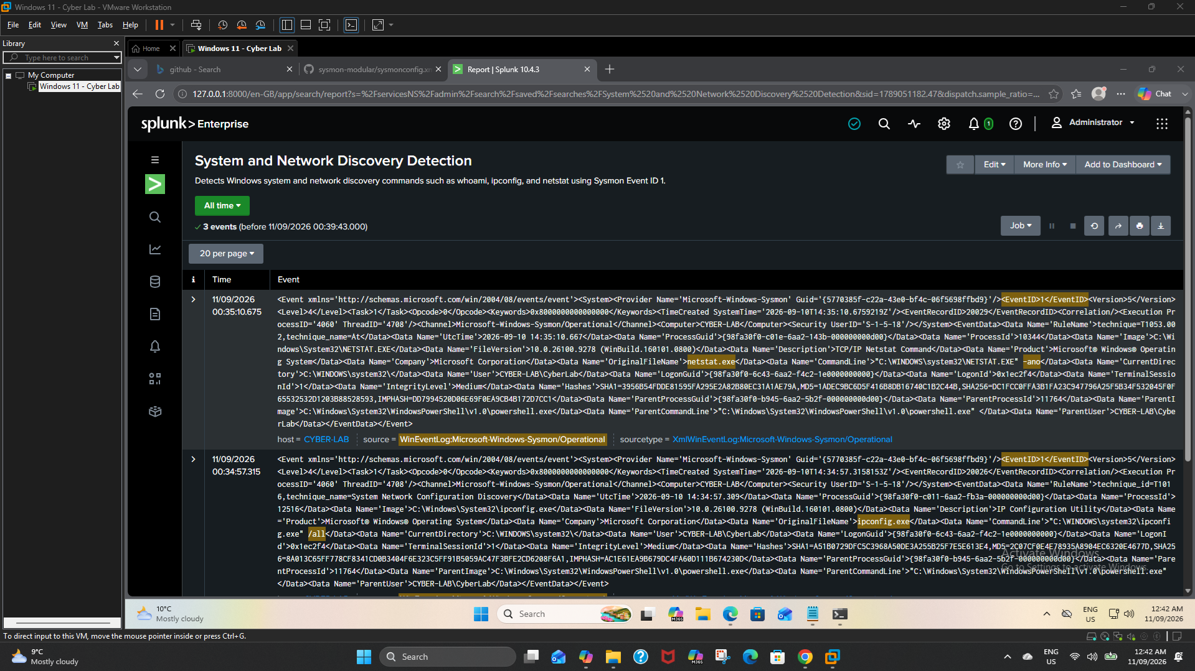
Figure 3. Splunk discovery detection covering user and network enumeration.

5.3 PowerShell spawning Windows Command Shell
cmd.exe was observed with PowerShell as its parent. The controlled command contained the marker INCIDENT-LAB-01 and launched whoami.exe, providing a clear process chain for investigation.
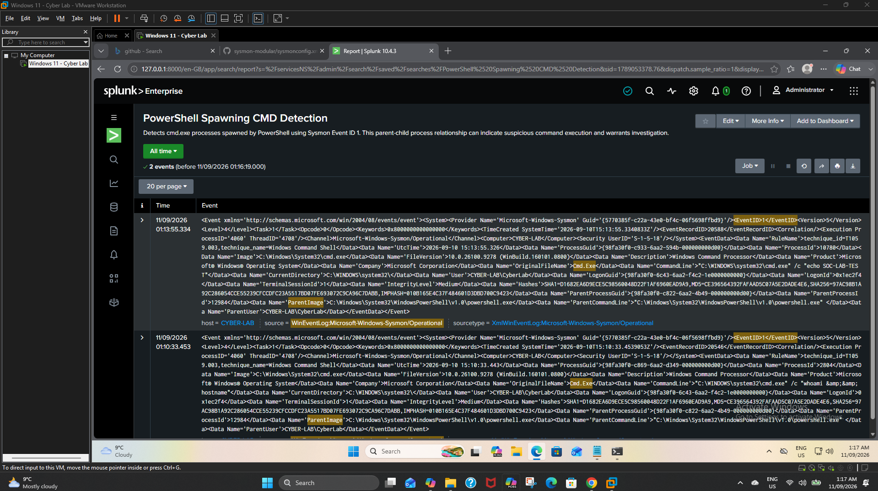
Figure 4. Detection of PowerShell spawning cmd.exe.

5.4 Controlled non-standard-port scenario
Sysmon Event ID 3 captured PowerShell-associated TCP activity involving destination port 4444. Because the destination was 127.0.0.1, this is evidence of the lab detection scenario rather than evidence of external command-and-control.
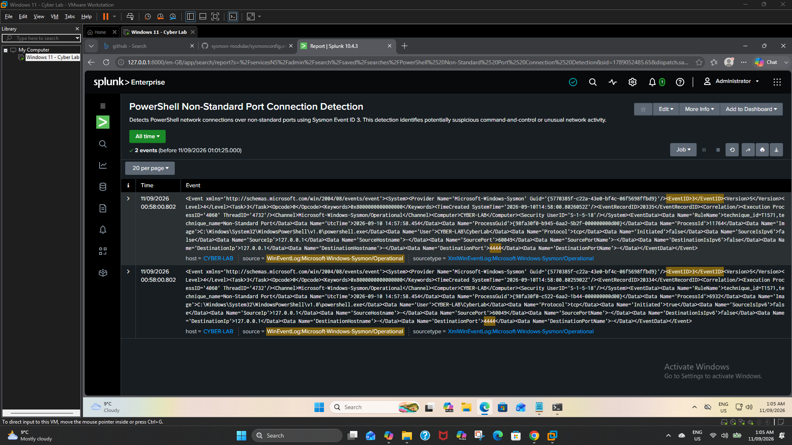
Figure 5. Splunk detection for the controlled TCP/4444 scenario.

6. Process-Chain Analysis
Process ancestry was the core correlation method. ParentImage and ParentProcessId showed that whoami, ipconfig and netstat shared the same PowerShell parent PID 5016 during the discovery sequence. A later event chain showed PowerShell spawning cmd.exe, followed by cmd.exe spawning whoami.exe.

Field | Why it matters
ParentImage | Identifies the executable that launched the child process
ParentProcessId | Connects multiple child processes to the same parent context
ProcessId | Useful short-lived identifier for a running process instance
ProcessGuid | Sysmon identifier used to correlate the same process across event types
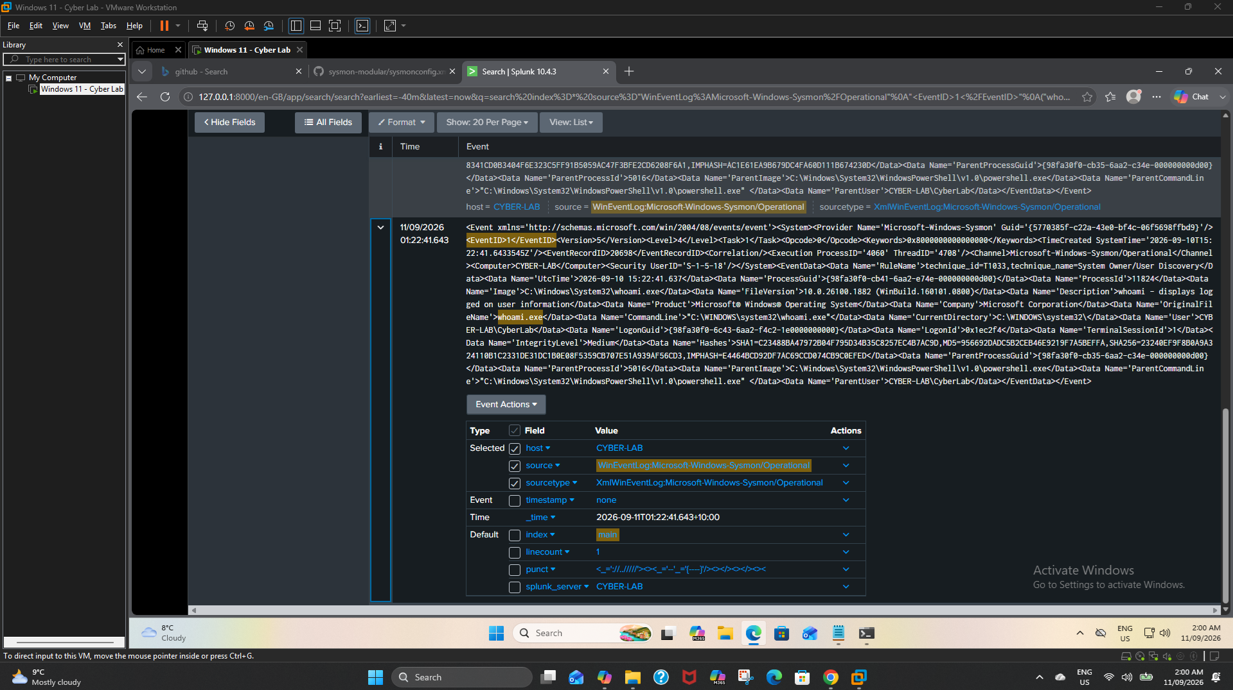
Figure 6. ParentProcessId evidence supporting common PowerShell ancestry.

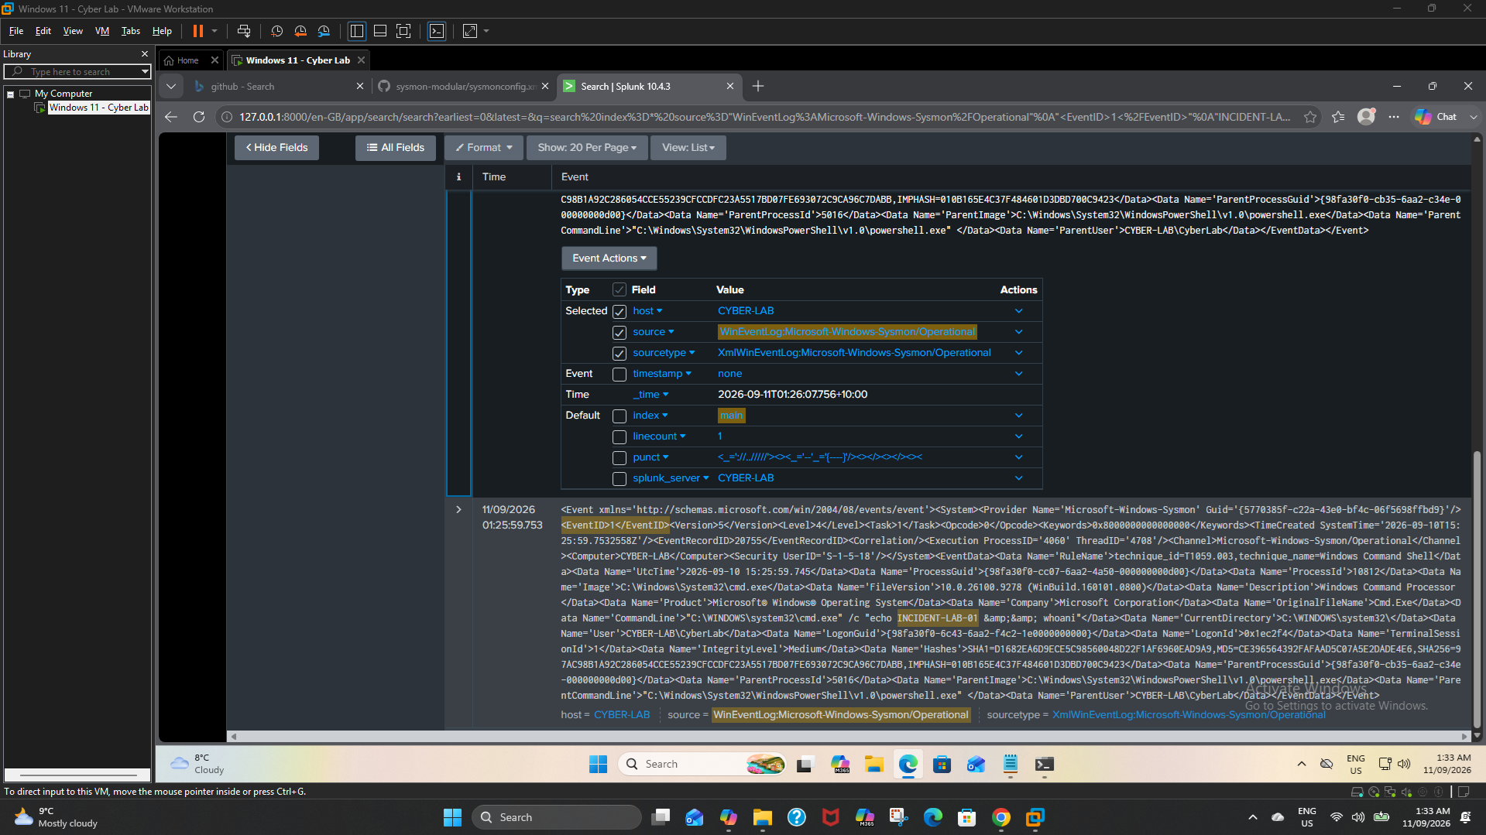
Figure 7. Raw process-chain evidence supporting PowerShell -> cmd.exe -> whoami.exe.

7. Network / DNS Analysis

7.1 Packet-level validation
Wireshark independently validated DNS, HTTP and ICMP visibility. This provided a network perspective alongside endpoint telemetry and demonstrated the ability to interpret both packet-level and host-level evidence.
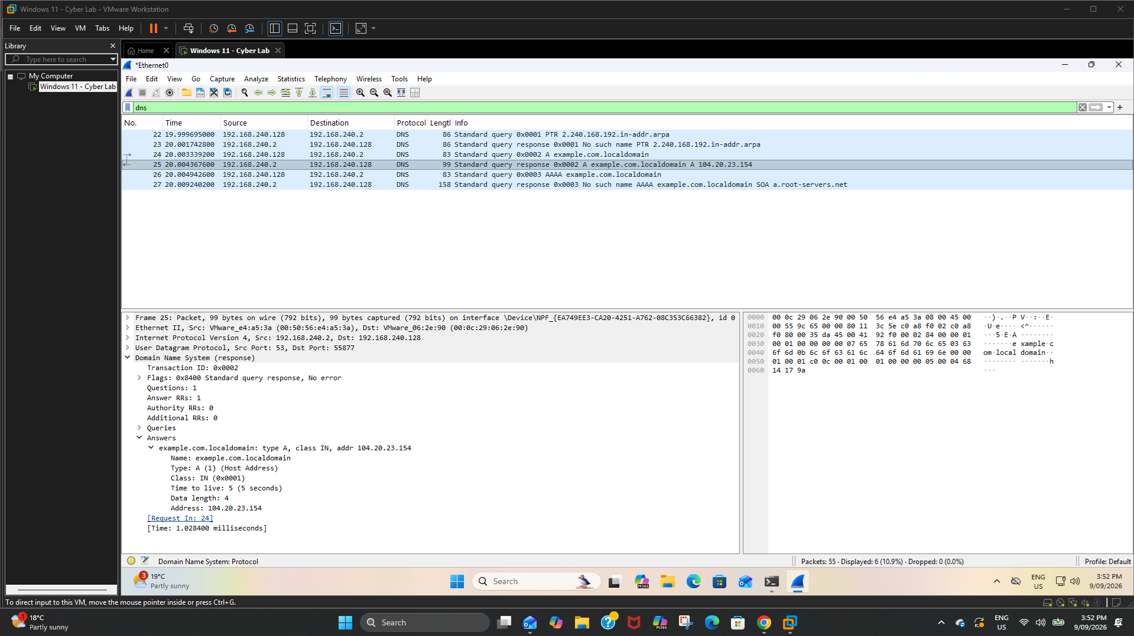
Figure 8. Wireshark DNS analysis from the controlled lab.

7.2 PowerShell web and DNS correlation
A controlled PowerShell Invoke-WebRequest request to http://example.com generated process-creation and DNS telemetry. The investigation extracted the PowerShell ProcessGuid/ProcessId and pivoted across Sysmon events to associate that exact process instance with Event ID 22 DNS activity for example.com.
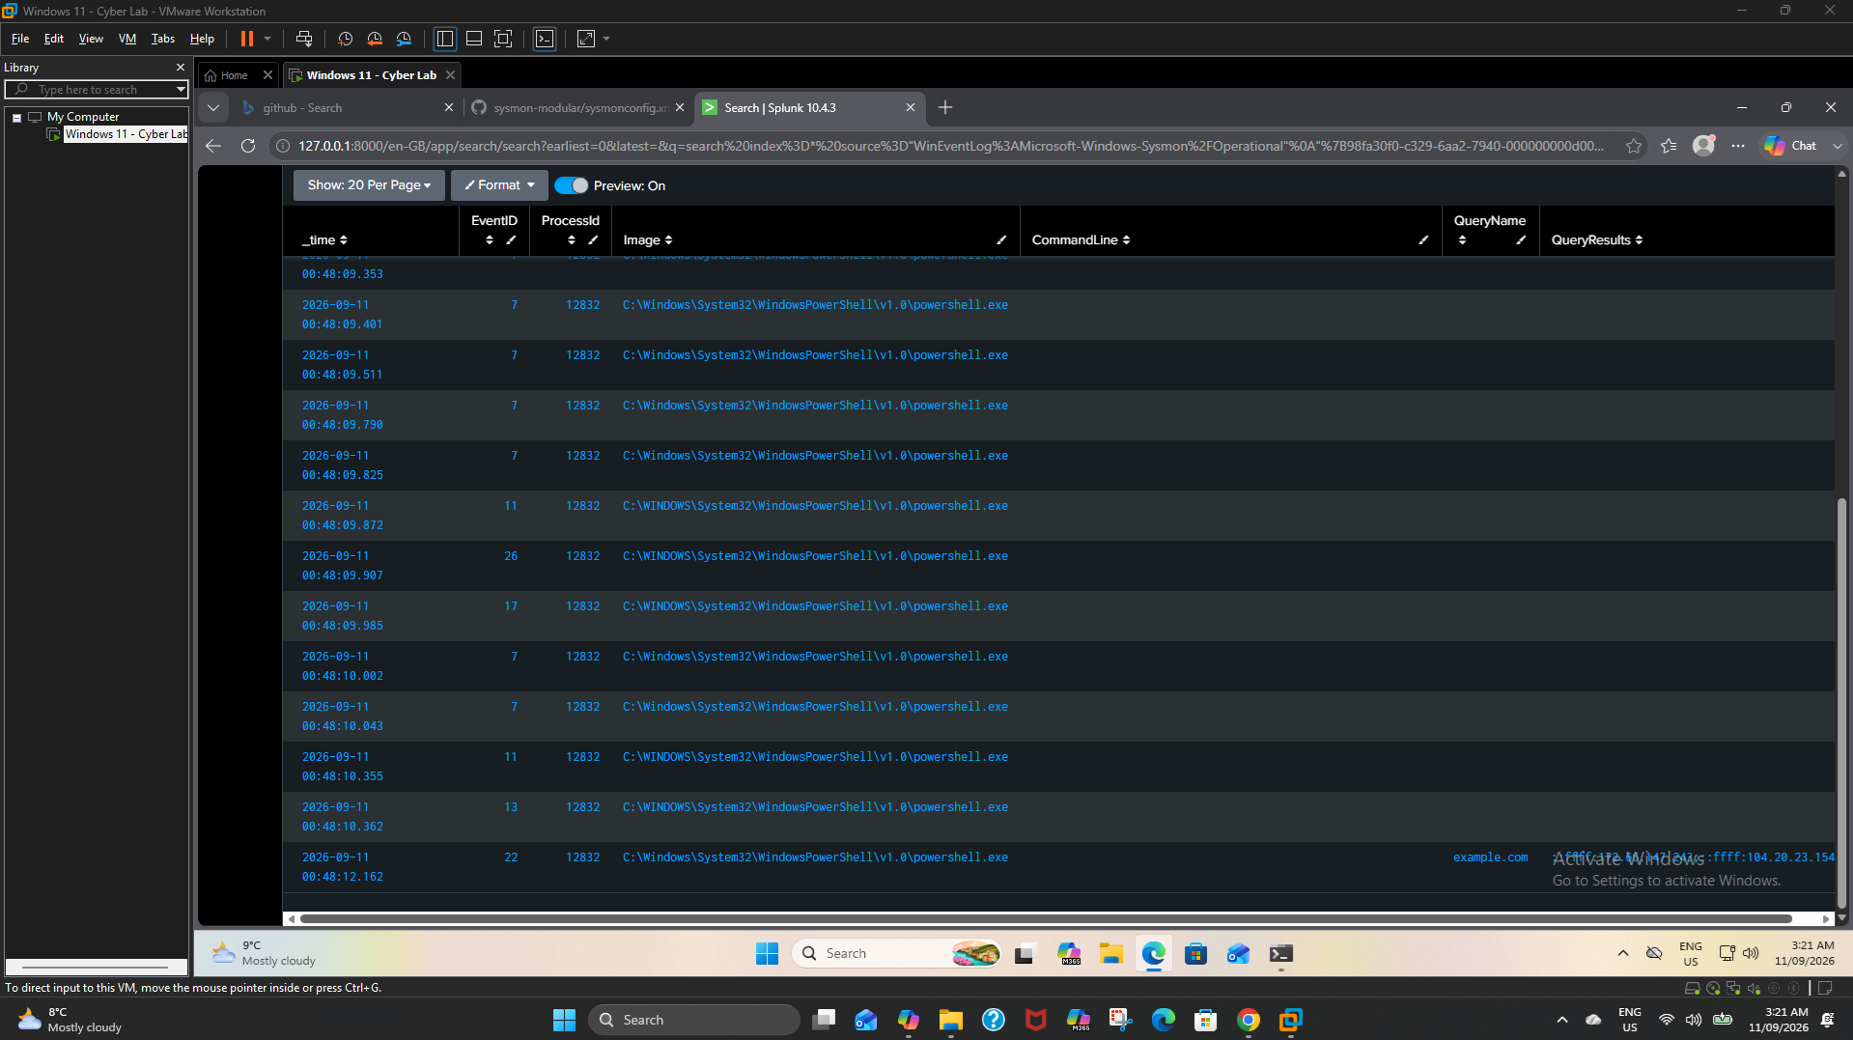
Figure 9. ProcessGuid/ProcessId correlation linking PowerShell execution and DNS activity.

7.3 TCP/4444 context
Port 4444 is often scrutinised, but a port number alone does not establish MITRE ATT&CK T1571. T1571 specifically concerns protocol/port pairings that are atypical for the protocol. In this lab, the TCP/4444 loopback activity is retained as a controlled detection scenario aligned to the concept of non-standard-port monitoring, not as proof of C2.

8. MITRE ATT&CK Mapping
The mapping below was quality-checked against the current MITRE ATT&CK Enterprise technique pages. The report distinguishes direct behavioural mappings from a lab scenario that merely demonstrates a related detection concept.
Technique | Name | Evidence | Assessment
T1059.001 | PowerShell | powershell.exe process creation and command-line activity | Direct behavioural mapping
T1059.003 | Windows Command Shell | cmd.exe spawned from PowerShell | Direct behavioural mapping
T1033 | System Owner/User Discovery | whoami.exe | Direct behavioural mapping
T1016 | System Network Configuration Discovery | ipconfig.exe /all | Direct behavioural mapping
T1049 | System Network Connections Discovery | netstat.exe -ano | Direct behavioural mapping
T1571 | Non-Standard Port | Controlled TCP/4444 loopback scenario | Detection scenario / concept alignment; not proof of C2
ATT&CK accuracy note
MITRE currently identifies whoami under T1033, ipconfig under T1016, and netstat under T1049. T1571 requires a non-standard protocol/port pairing; the lab screenshot is therefore described conservatively as a detection scenario.

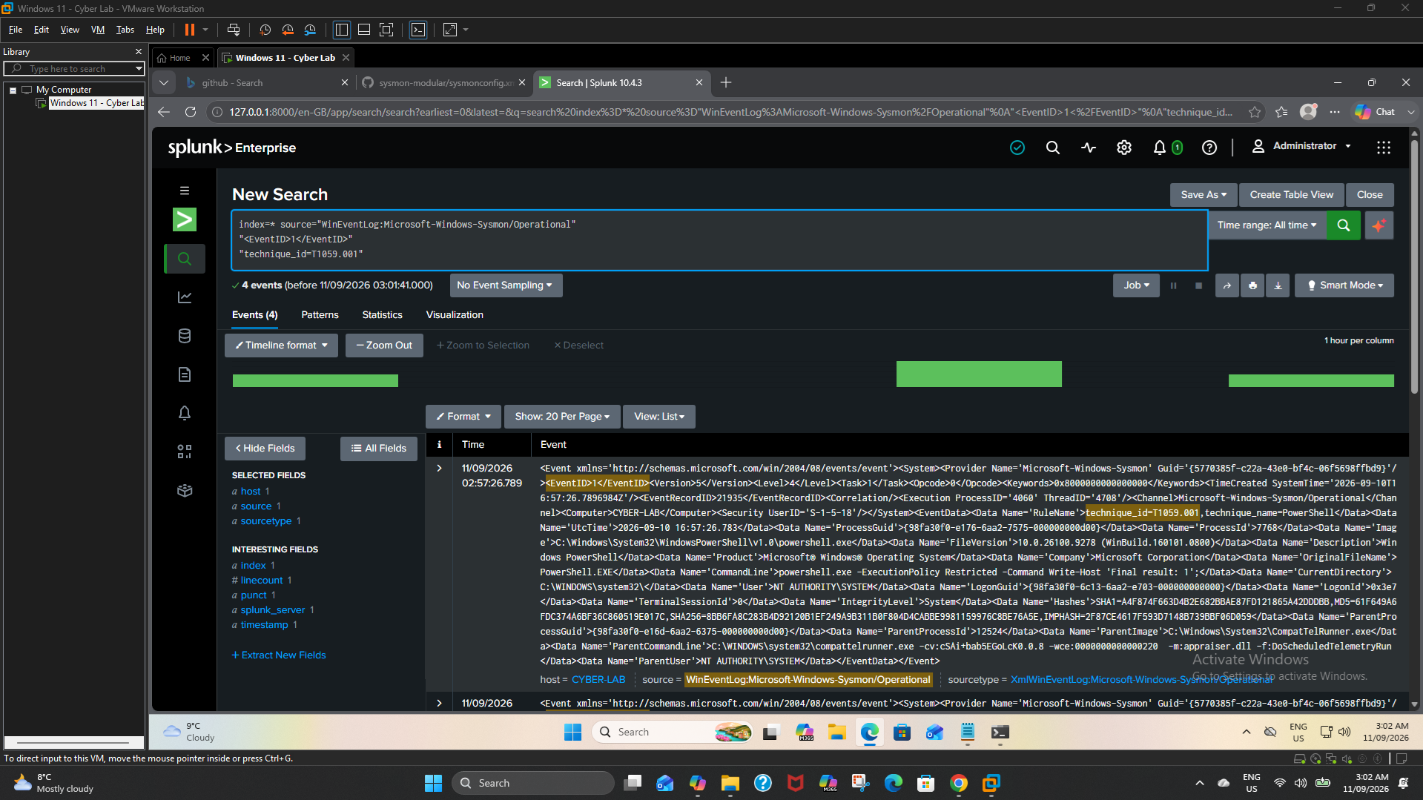
Figure 10. T1059.001 - PowerShell evidence.

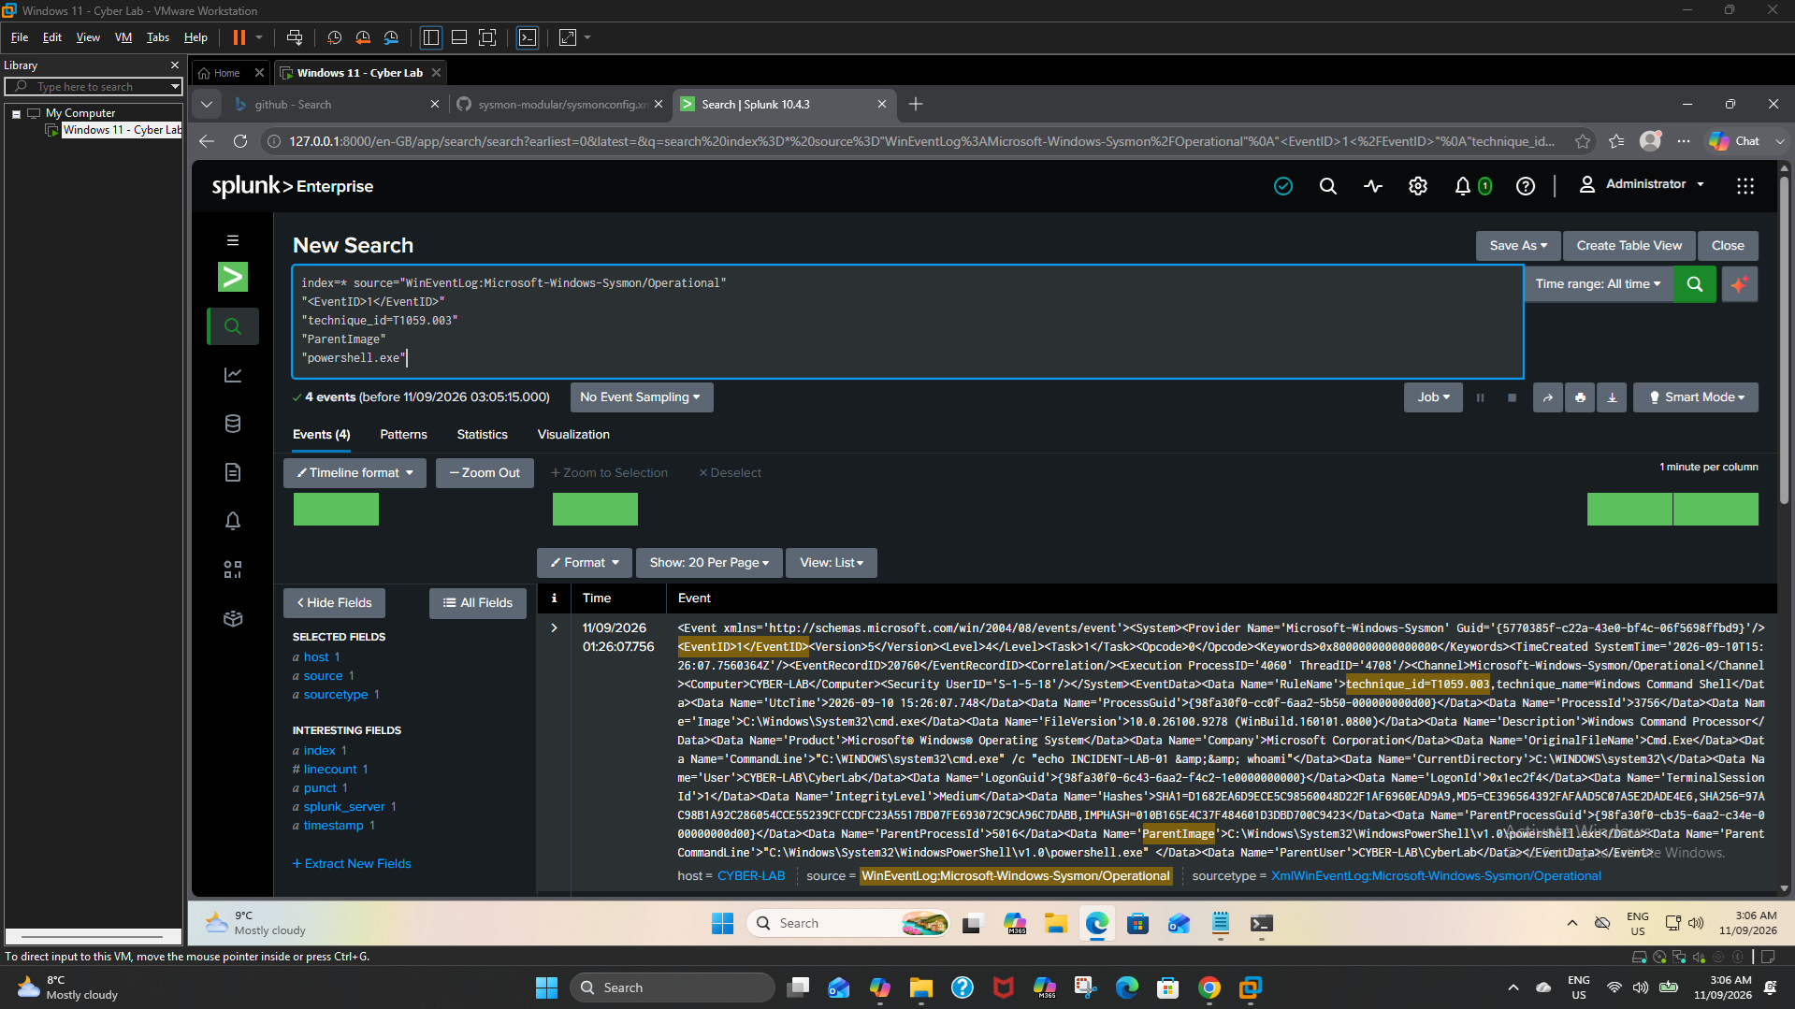
Figure 11. T1059.003 - Windows Command Shell evidence.

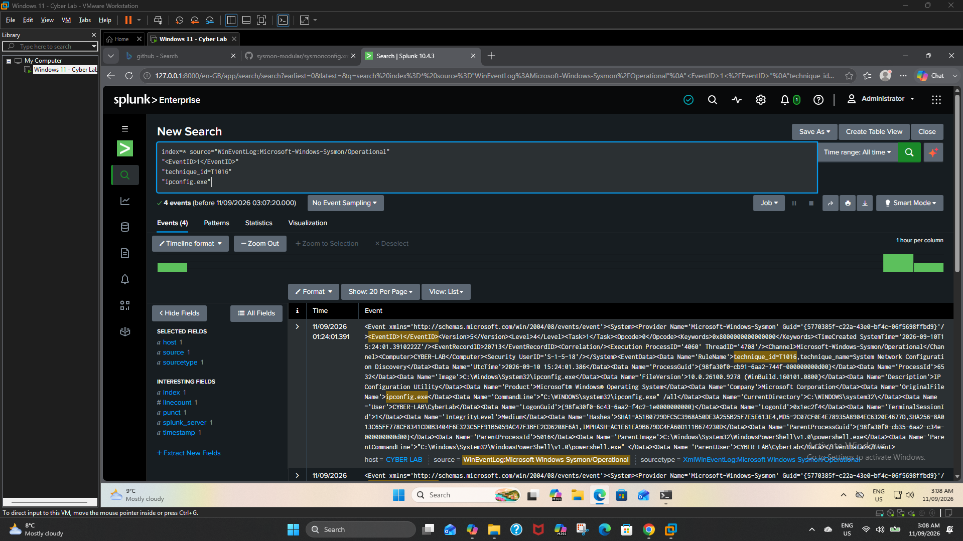
Figure 12. T1016 - System Network Configuration Discovery evidence.

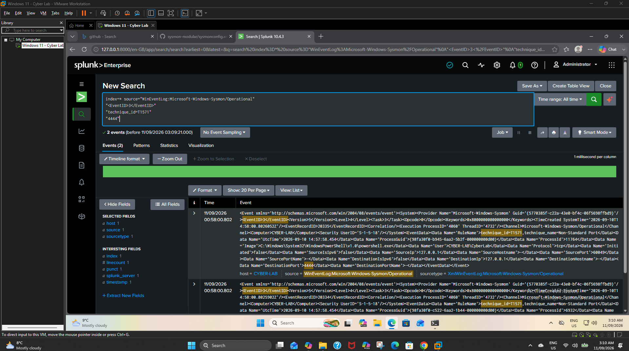
Figure 13. Lab rule labelled T1571; interpreted conservatively in this report.

8.1 Reference basis
- MITRE ATT&CK T1059.001 - Command and Scripting Interpreter: PowerShell.
- MITRE ATT&CK T1059.003 - Command and Scripting Interpreter: Windows Command Shell.
- MITRE ATT&CK T1033 - System Owner/User Discovery (includes whoami).
- MITRE ATT&CK T1016 - System Network Configuration Discovery (includes ipconfig).
- MITRE ATT&CK T1049 - System Network Connections Discovery (includes netstat).
- MITRE ATT&CK T1571 - Non-Standard Port.

9. Indicators of Compromise / Observables
Because this is a controlled lab, these items are more accurately described as observables and investigation pivots rather than confirmed Indicators of Compromise (IOCs).
Type | Observable | Context
Host | CYBER-LAB | Controlled Windows 11 endpoint
User | CYBER-LAB\CyberLab | Lab account context
Processes | powershell.exe; cmd.exe; whoami.exe; ipconfig.exe; NETSTAT.EXE | Execution and discovery pivots
Marker | INCIDENT-LAB-01 | Controlled incident correlation marker
Domain | example.com | Benign demonstration domain
Port | TCP/4444 | Controlled loopback test
Destination | 127.0.0.1 | Loopback address in port scenario
Log source | Microsoft-Windows-Sysmon/Operational | Primary endpoint evidence source
Process IDs and ProcessGuids shown in screenshots are ephemeral correlation identifiers. They are useful inside the investigation but should not be treated as durable threat indicators.

10. Analyst Assessment
Assessment field | Conclusion
Incident status | Controlled lab activity - no real compromise
Evidence confidence | High for process ancestry and DNS/process correlation
Maliciousness confidence | Not applicable; activity was intentionally generated
Production concern | Moderate-to-high triage priority if the same clustered behaviour were unexpected
Primary rationale | Scripting + shell execution + rapid discovery + unusual network context merits investigation

The strongest part of the investigation is not any single command; it is the correlation. Parent-child relationships and ProcessGuid/ProcessId pivots demonstrate that related events can be tied to the same execution context. This reduces the risk of constructing an incident narrative from unrelated events that merely occurred near each other in time.
In production, severity would depend on user intent, asset criticality, destination reputation, persistence, credential access, lateral movement and corroborating telemetry. Dual-use administrative commands should not be classified as malicious without that context.

10.1 Investigation Limitations & Assumptions
- Single Windows 11 virtual endpoint; findings are not representative of an enterprise-wide hunt.
- Telemetry scope centred on Sysmon Operational events ingested into Splunk, supplemented by Wireshark packet captures.
- No production EDR, identity, email, cloud, proxy or threat-intelligence telemetry was available for corroboration.
- All suspicious-looking activity was intentionally generated for training; no real malware or unauthorised compromise was introduced.
- example.com was a benign demonstration destination, and the TCP/4444 test used 127.0.0.1 loopback traffic.
- ATT&CK mappings describe observed behaviour or detection concepts; they do not independently establish malicious intent.

11. Containment & Remediation Recommendations
For an equivalent unexplained event on a production endpoint, a SOC analyst should:
- Validate whether PowerShell, cmd.exe and discovery commands were authorised by the user, administrator or automation platform.
- Review surrounding endpoint, PowerShell, DNS, proxy/firewall and authentication telemetry using the same time window and process ancestry.
- Isolate the endpoint when malicious execution or command-and-control is reasonably suspected and organisational procedure supports containment.
- Preserve relevant evidence before destructive remediation, including command-line, process, network and authentication context.
- Block confirmed malicious domains/IPs and hunt for matching process ancestry, command lines and ATT&CK behaviours across other endpoints.
- Remove persistence or malicious artifacts, patch the root cause, rotate exposed credentials where required, and monitor for recurrence.

12. Conclusion
The SOC Detection & Investigation Lab demonstrates a complete junior-SOC workflow: network validation, Sysmon telemetry collection, Splunk ingestion, detection engineering, process and DNS correlation, ATT&CK mapping, analyst assessment and evidence-based reporting. The project shows the ability to move from raw Windows telemetry to a defensible investigation narrative rather than relying on isolated alerts.

12.1 Skills demonstrated
- Windows 11 / VMware lab administration and recovery snapshots
- Wireshark DNS, HTTP, ICMP and traceroute analysis
- Sysmon process, DNS and network telemetry interpretation
- Splunk Enterprise ingestion, SPL searching and reusable detection reports
- Detection engineering for PowerShell, discovery, process ancestry and network activity
- Parent-child process analysis, PID correlation and Sysmon ProcessGuid correlation
- MITRE ATT&CK behavioural mapping with conservative analytical interpretation
- SOC incident reconstruction, evidence handling and professional reporting

Portfolio takeaway
This project demonstrates practical SOC analysis: telemetry collection, detection logic, correlation, ATT&CK mapping, evidence interpretation and incident reporting.

12.2 Technical References
- MITRE ATT&CK. Enterprise techniques used in this report: T1059.001 PowerShell; T1059.003 Windows Command Shell; T1033 System Owner/User Discovery; T1016 System Network Configuration Discovery; T1049 System Network Connections Discovery; T1571 Non-Standard Port. Accessed September 2026.
- Microsoft Learn. Sysmon documentation and Sysinternals Sysmon event schema, including Process Create (Event ID 1), Network Connect (Event ID 3) and DNS Query (Event ID 22). Accessed September 2026.
- Splunk Documentation. Search Processing Language (SPL), search and reporting concepts used for telemetry investigation and correlation. Accessed September 2026.
- Wireshark Documentation. User Guide and display-filter concepts used for packet-level DNS, HTTP and ICMP validation. Accessed September 2026.
Reference note: product and framework names are used for technical attribution. URLs are intentionally omitted from the body so the portfolio report remains clean; authoritative vendor/framework documentation should be consulted for current syntax and technique definitions.

13. Evidence Appendix - Complete Screenshot Set
All 34 screenshots supplied across every upload batch are retained below. The main body uses selected high-value evidence; this appendix preserves the complete workflow for portfolio verification and interview discussion.

Network & Packet Analysis
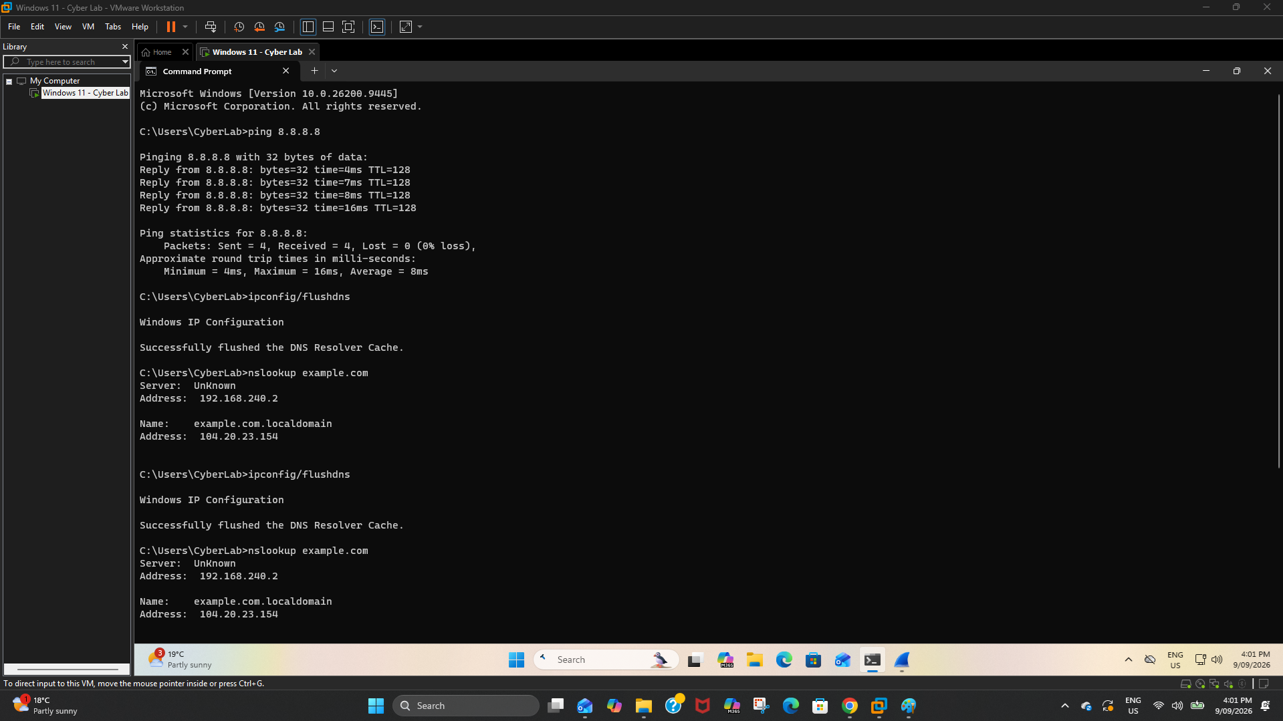
Figure 14. CMD Network Test.

Figure 15. Wireshark DNS Analysis.

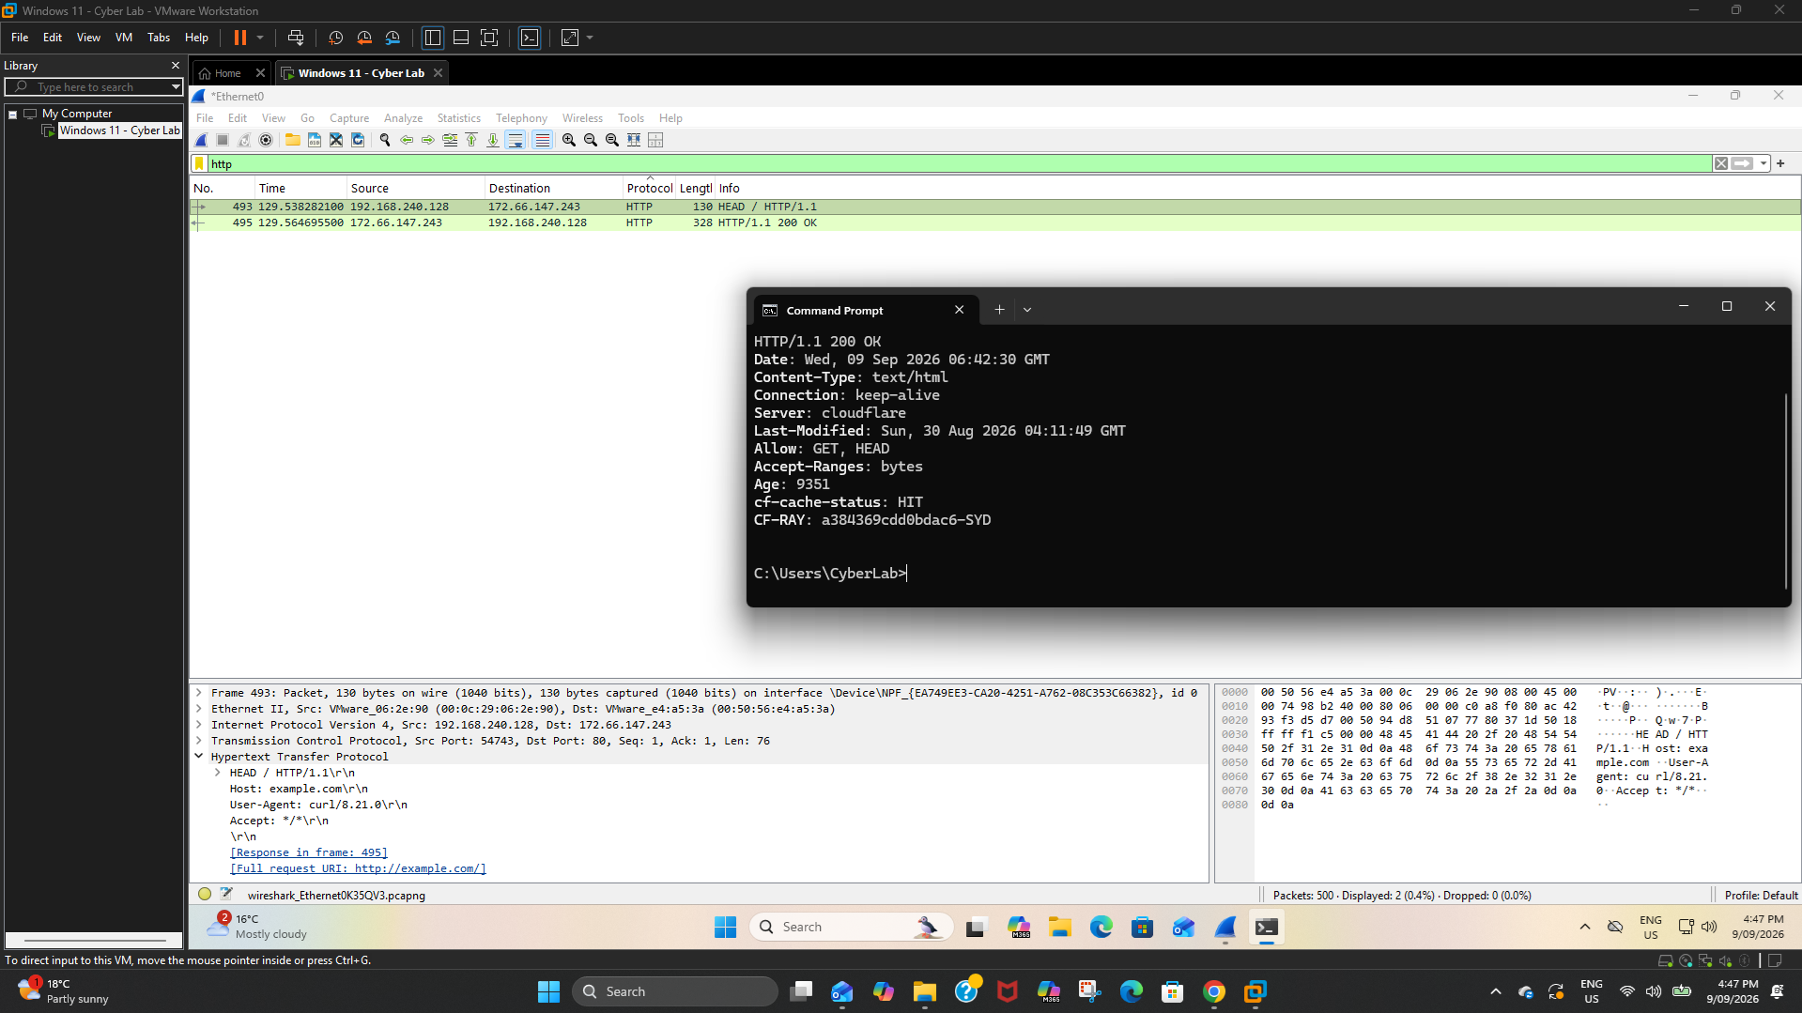
Figure 16. HTTP Request Analysis.

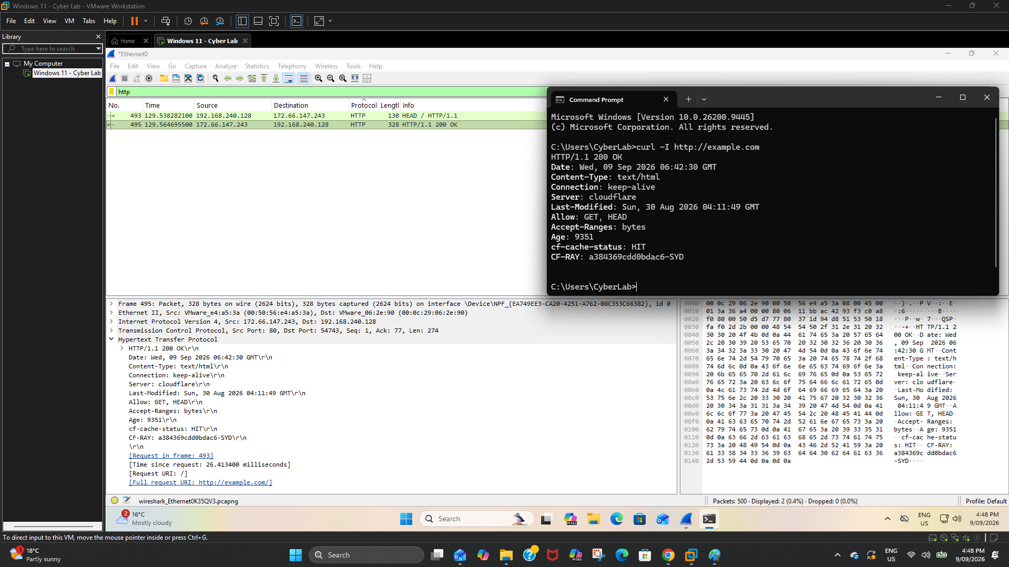
Figure 17. HTTP Response Analysis.

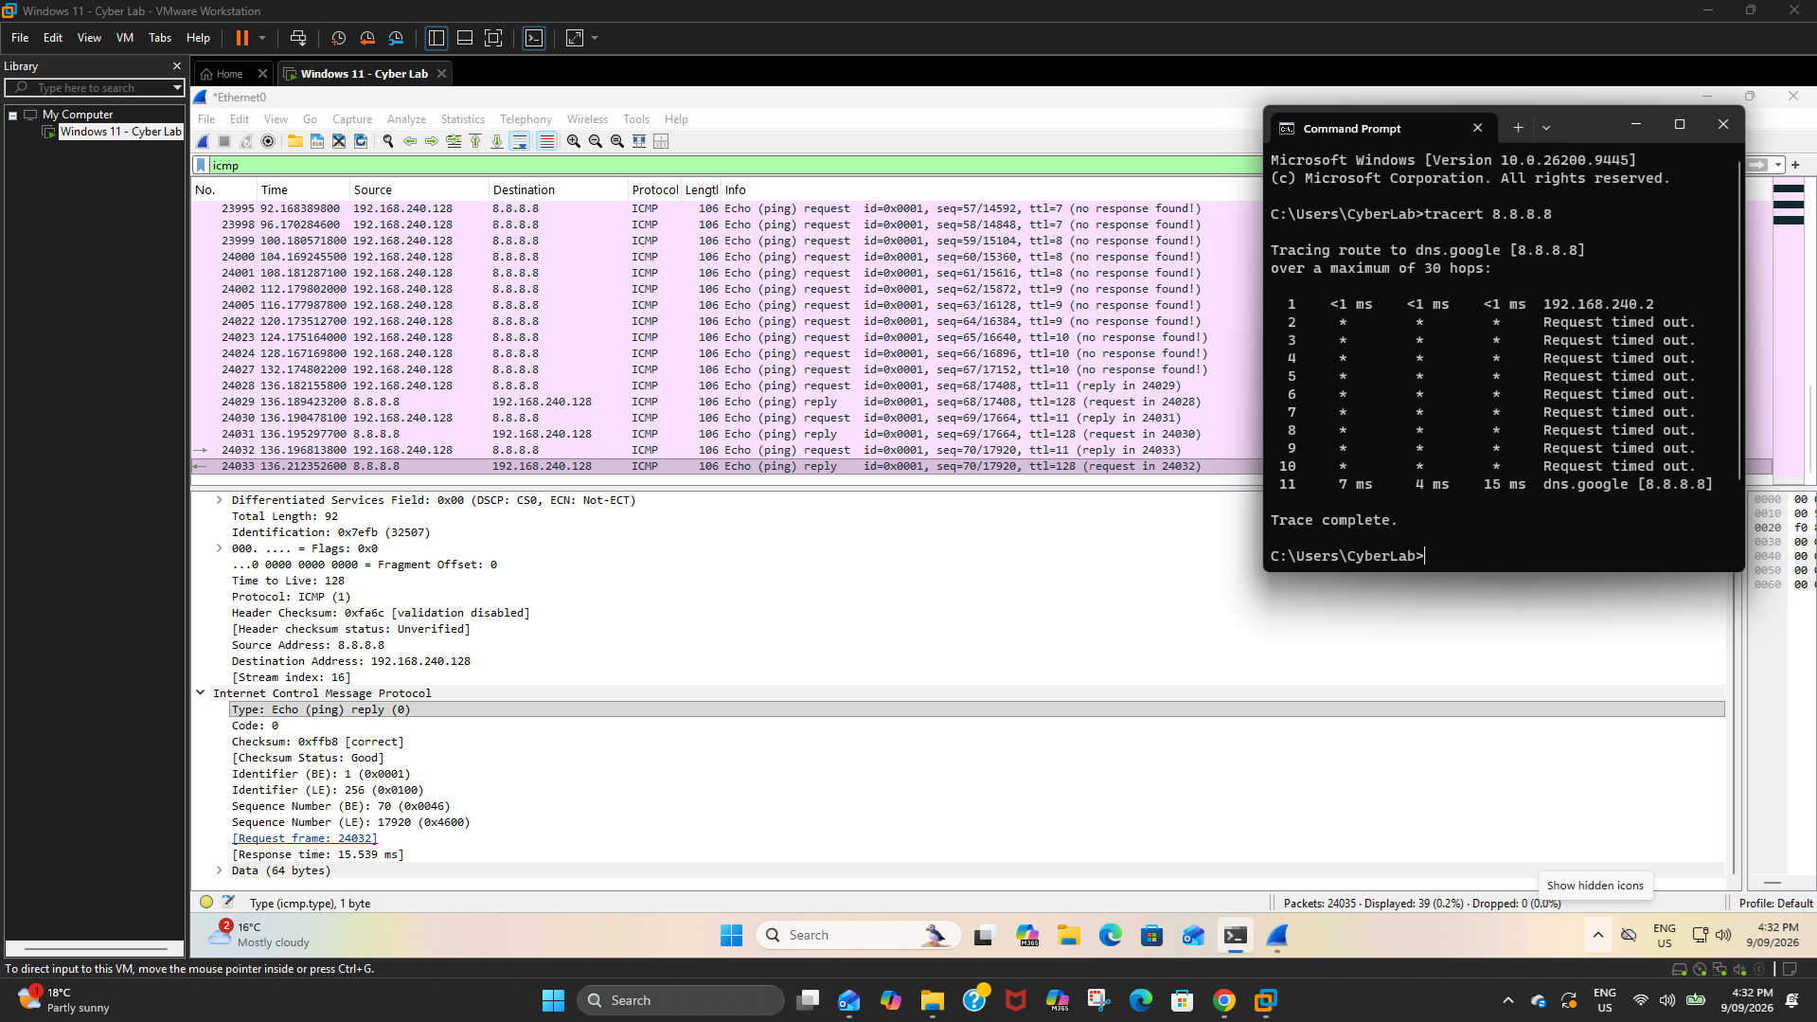
Figure 18. ICMP Echo Reply Analysis.

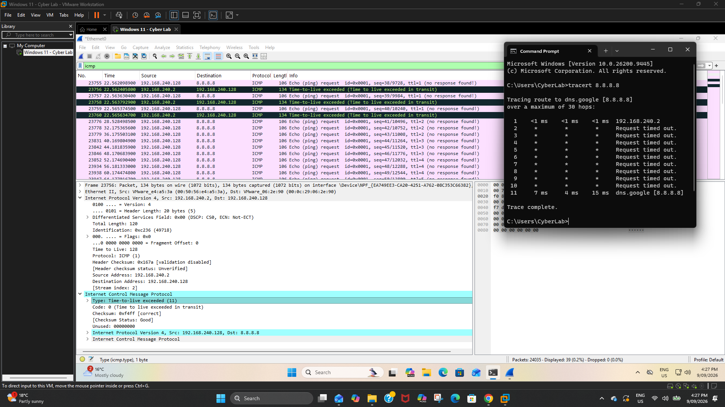
Figure 19. Traceroute ICMP Analysis.

Sysmon Telemetry

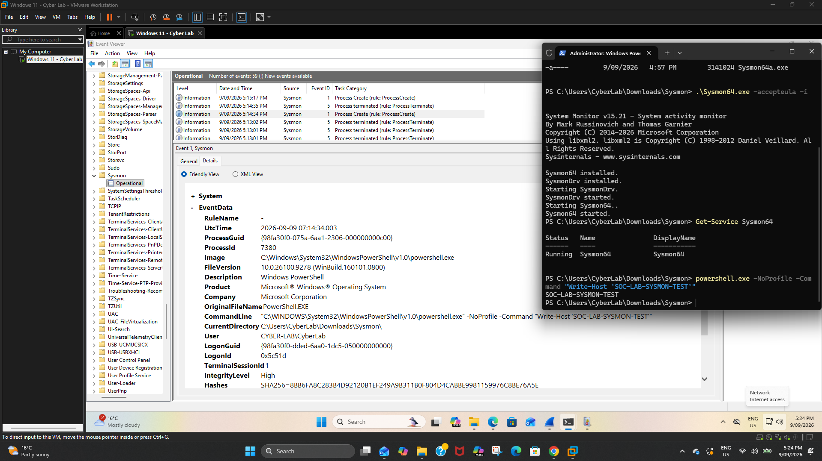
Figure 20. Sysmon PowerShell Detection Evidence.

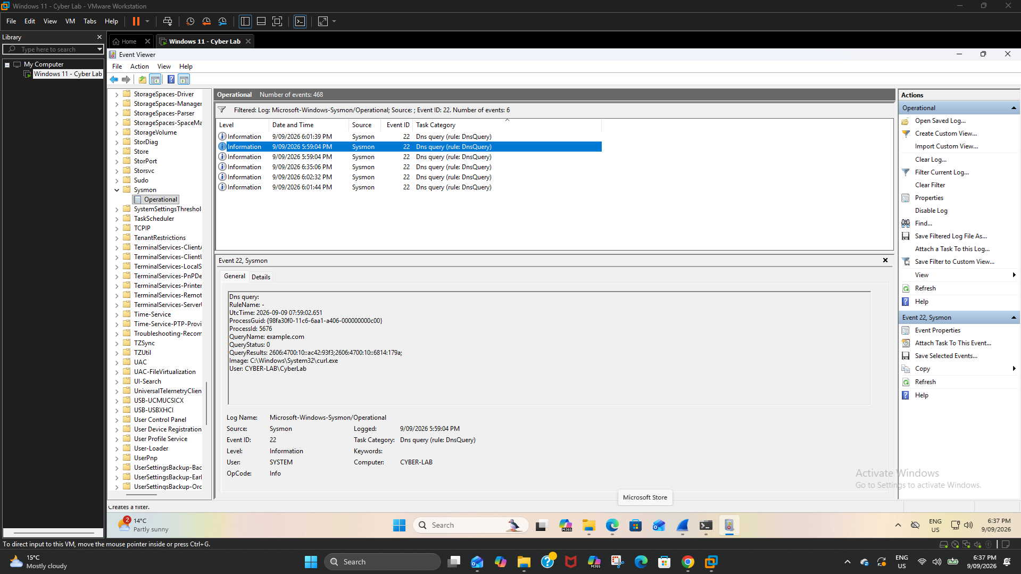
Figure 21. Sysmon Event ID 22 DNS Query.

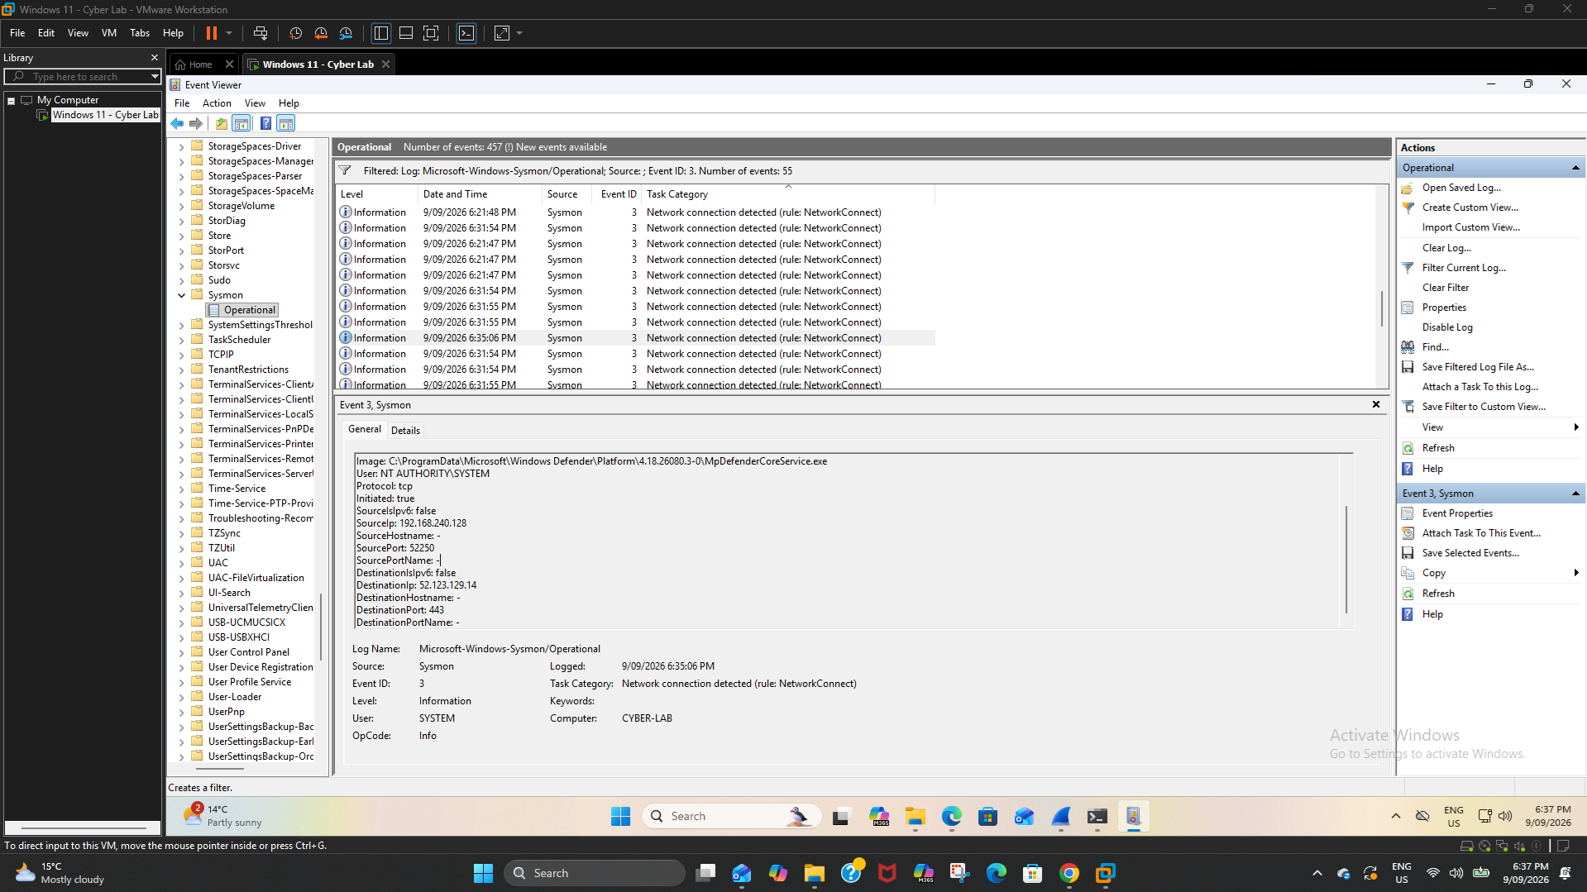
Figure 22. Sysmon Event ID 3 Network Connection.

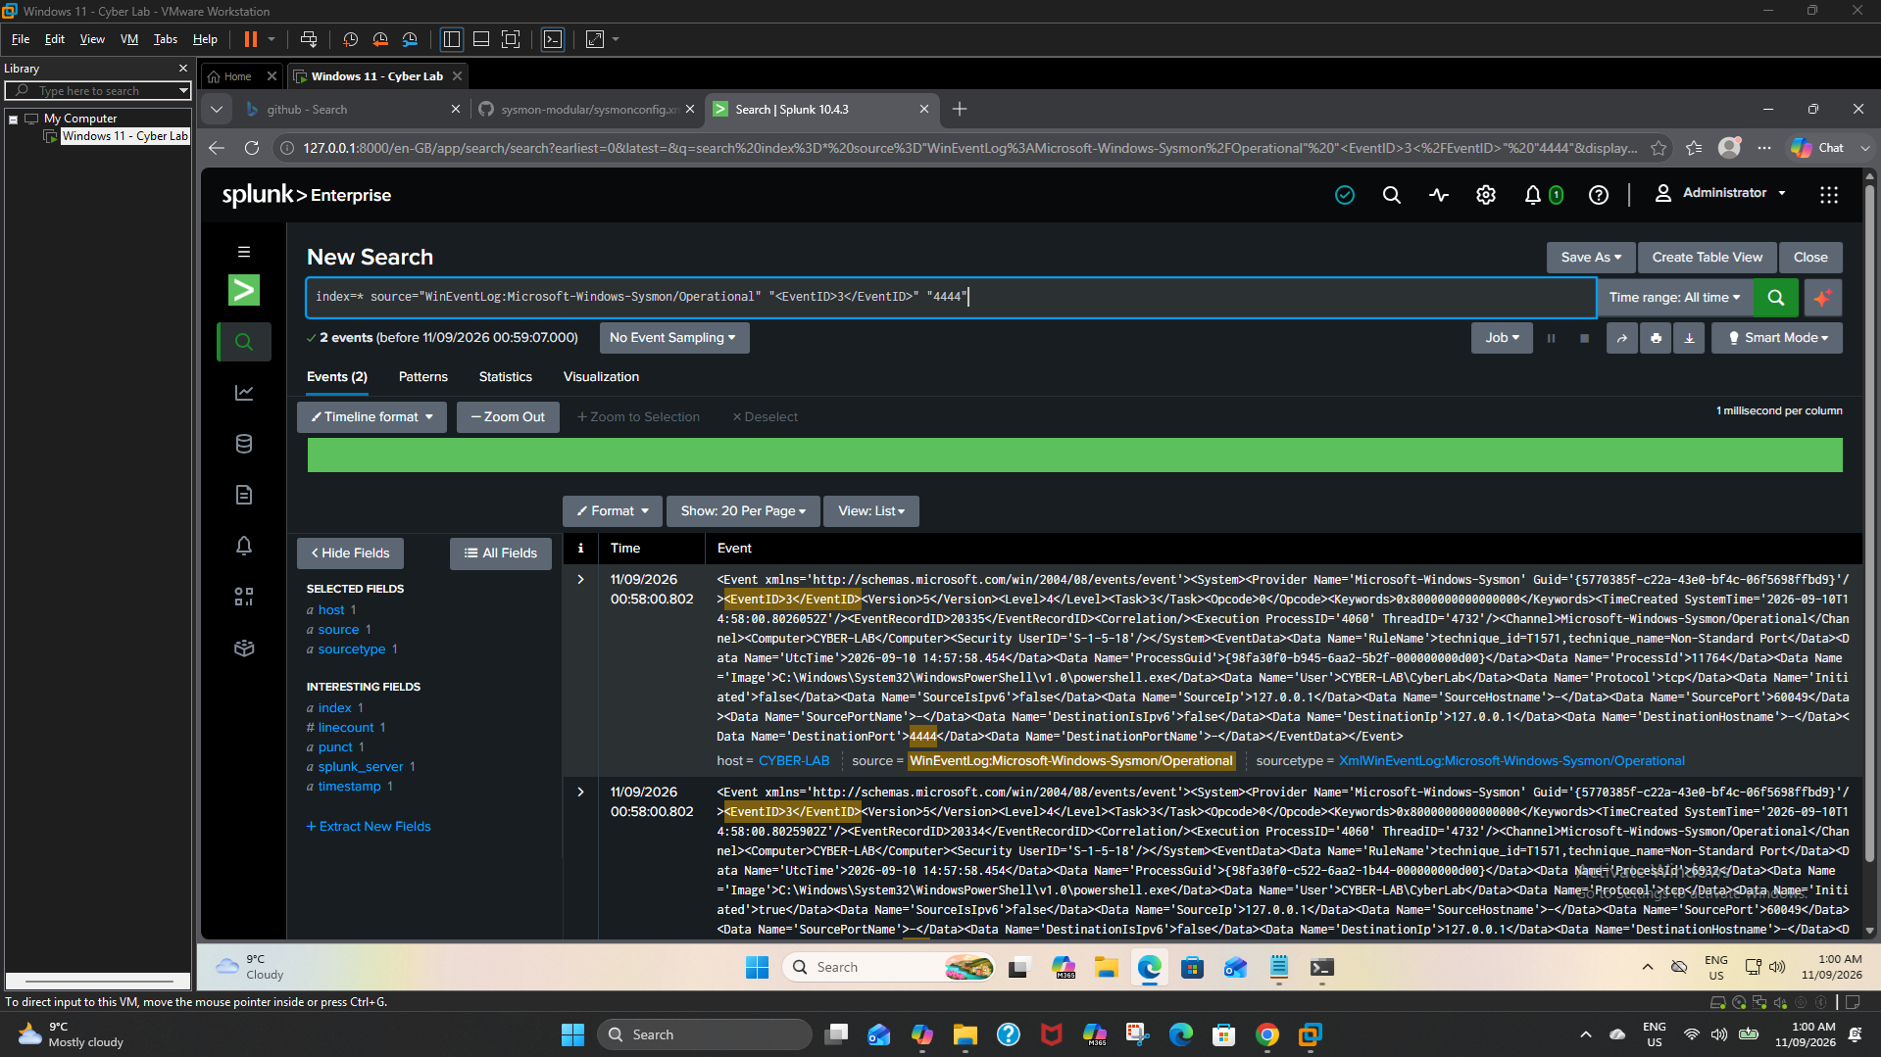
Figure 23. Sysmon Event ID 3 Non-Standard Port 4444.

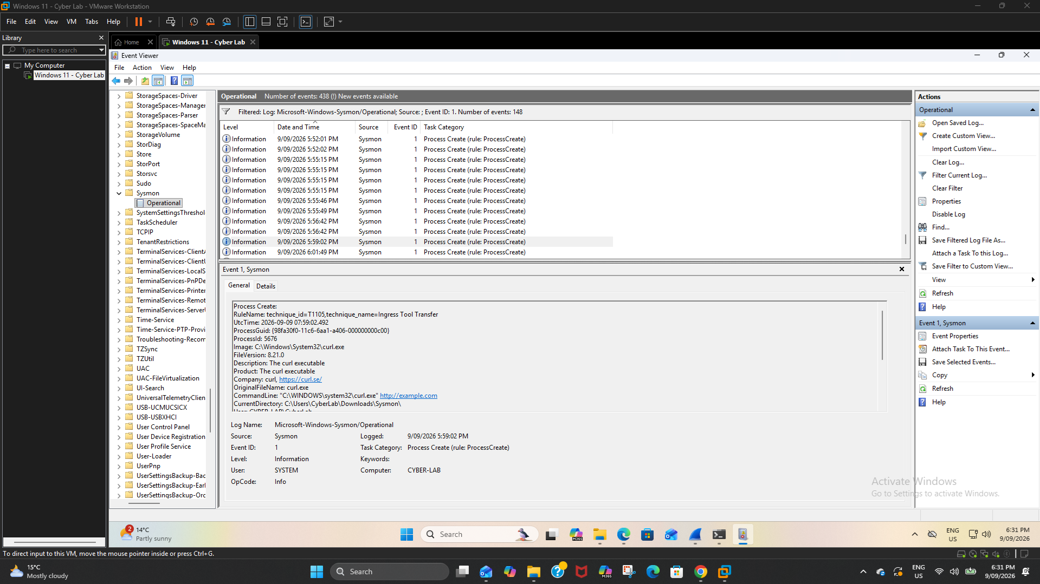
Figure 24. Sysmon MITRE T1105 Curl Detection.

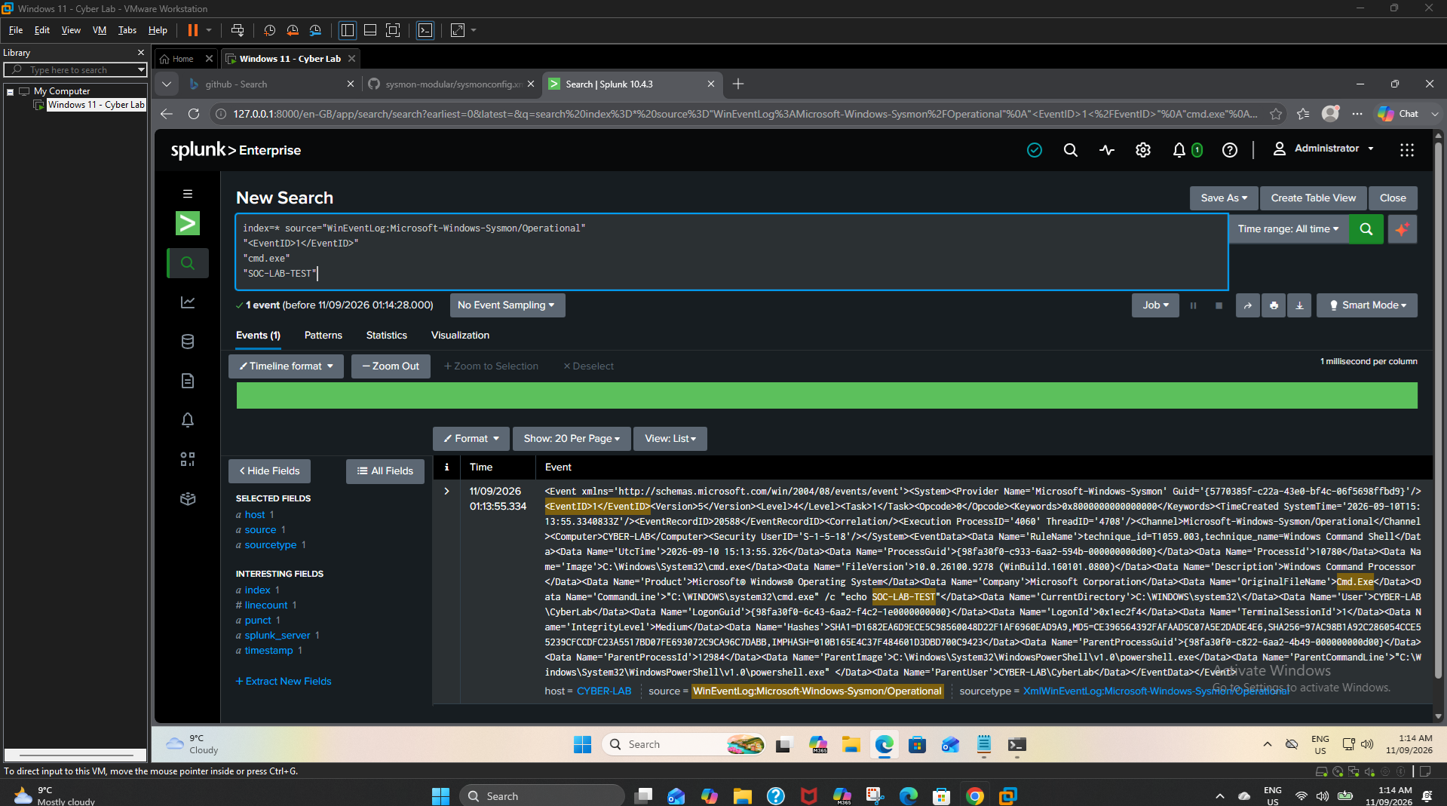
Figure 25. CMD Process Creation - Sysmon Event ID 1.

Splunk Detection & Correlation

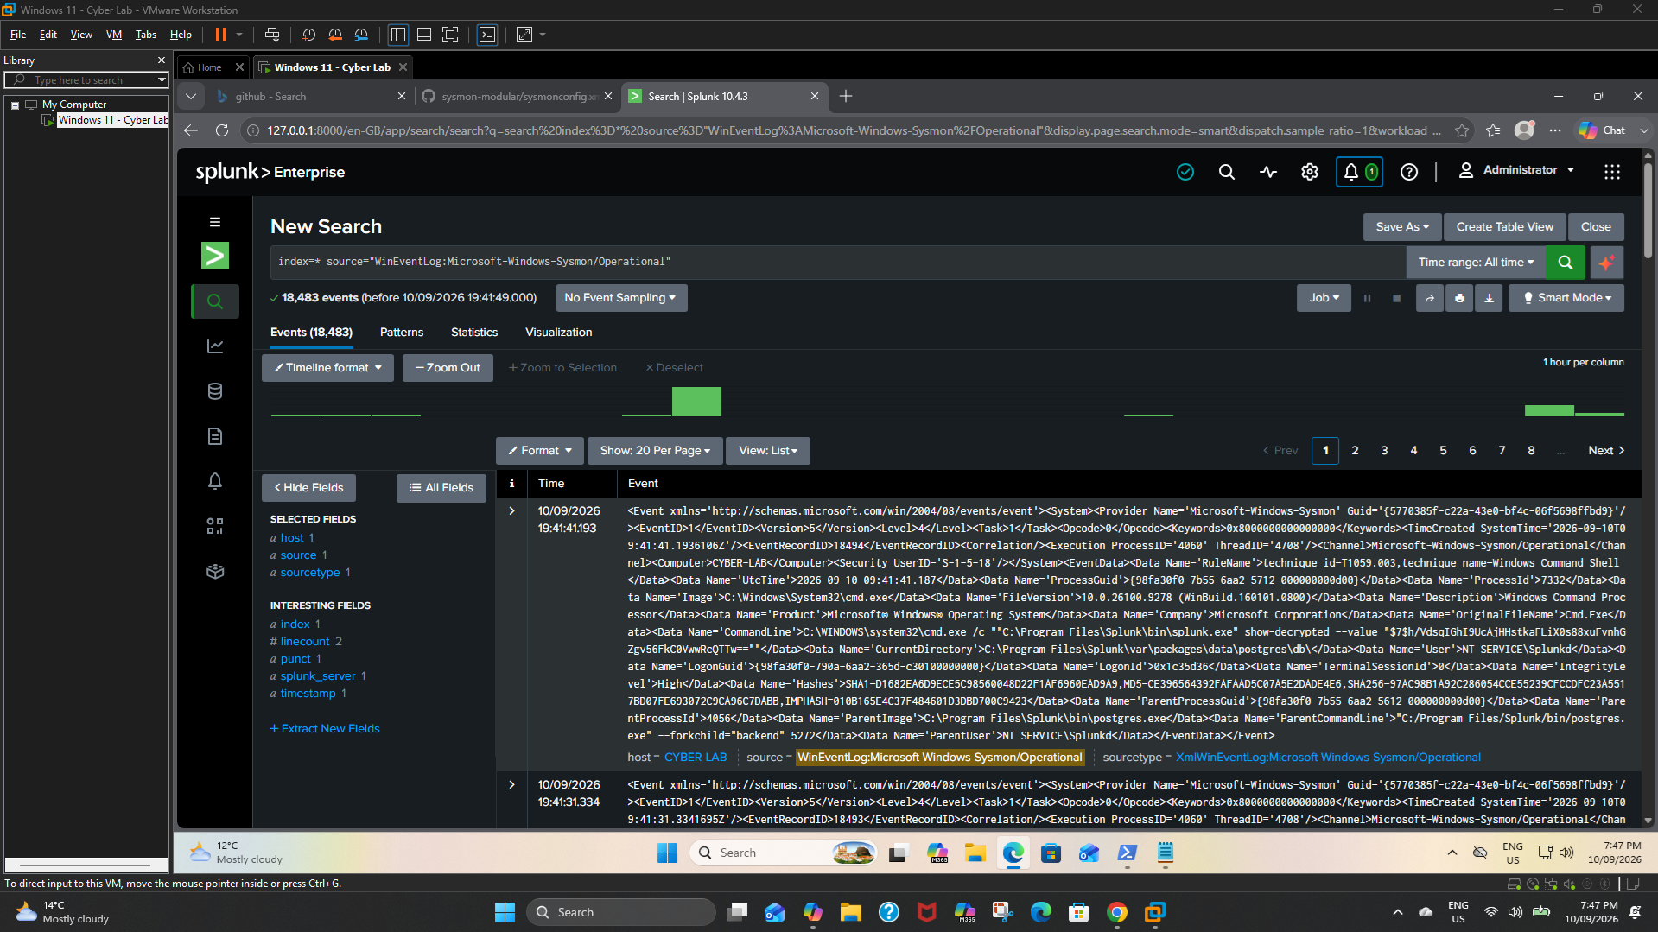
Figure 26. Splunk Sysmon Log Ingestion.

Figure 27. Suspicious PowerShell Detection Report.

Figure 28. System and Network Discovery Detection.

Figure 29. PowerShell Non-Standard Port Detection.

Figure 30. PowerShell Spawning CMD Detection.

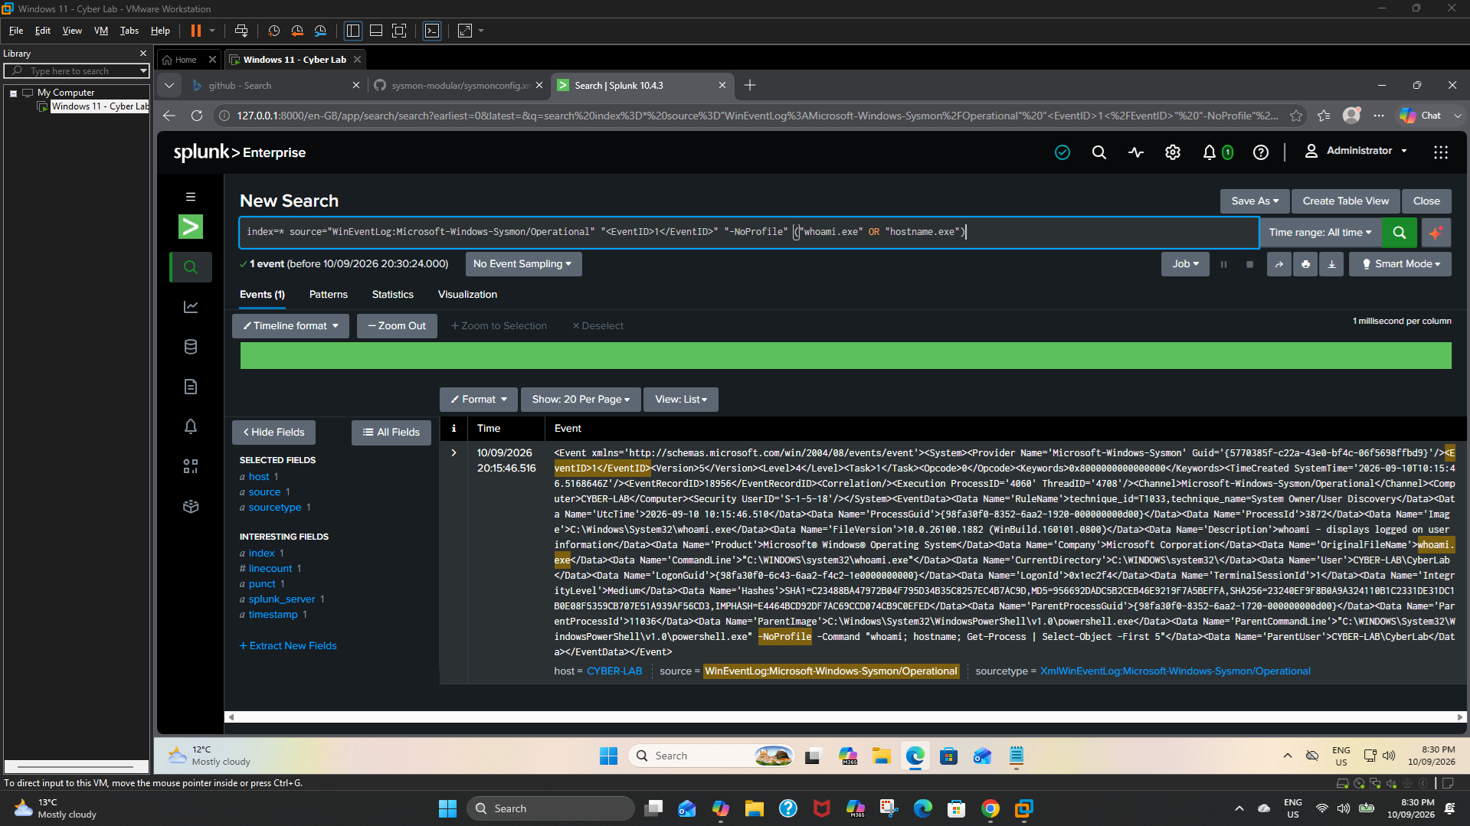
Figure 31. PowerShell Child Process Detection.

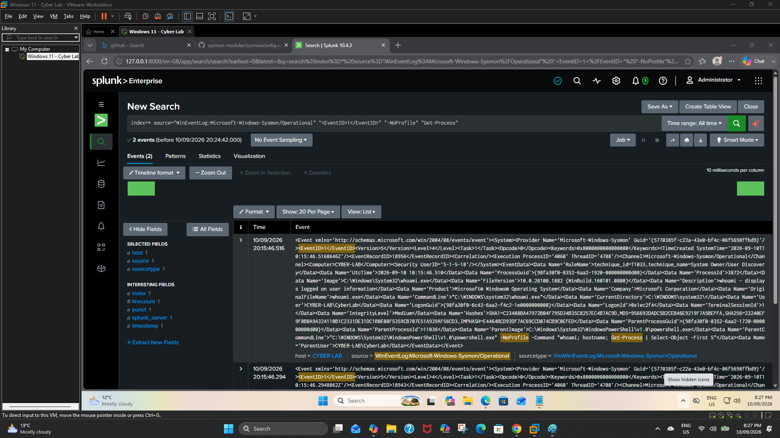
Figure 32. PowerShell Process Investigation.

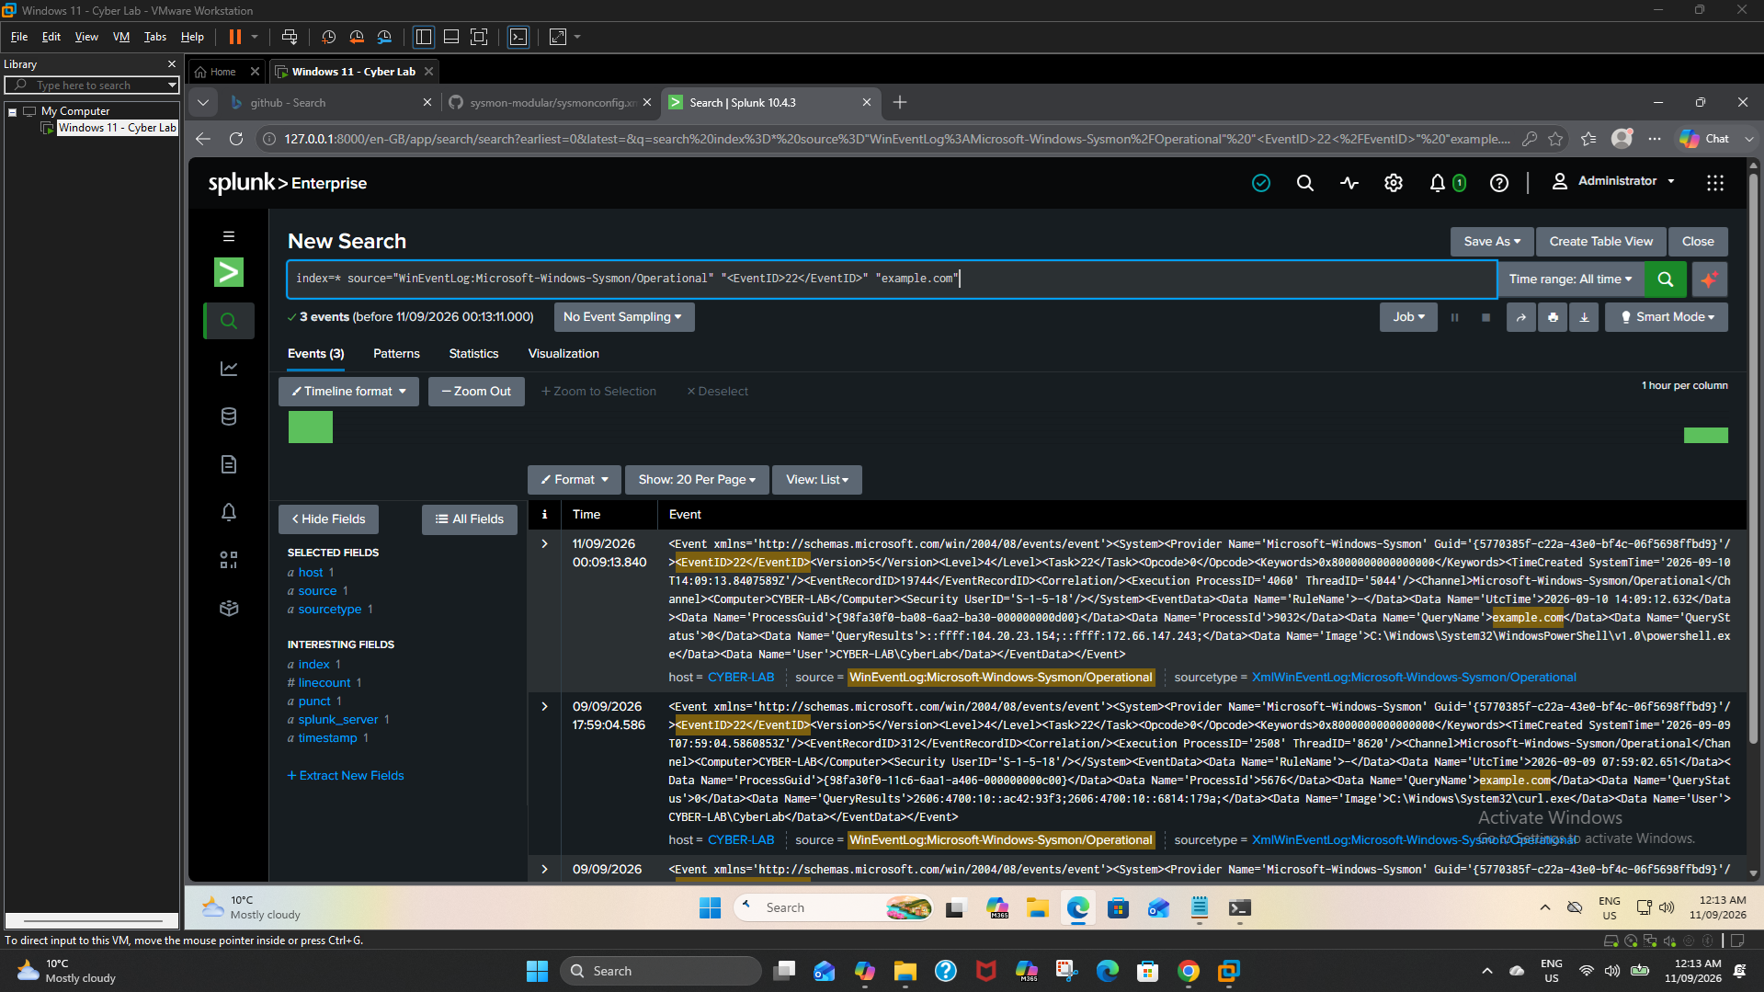
Figure 33. PowerShell DNS Event 22.

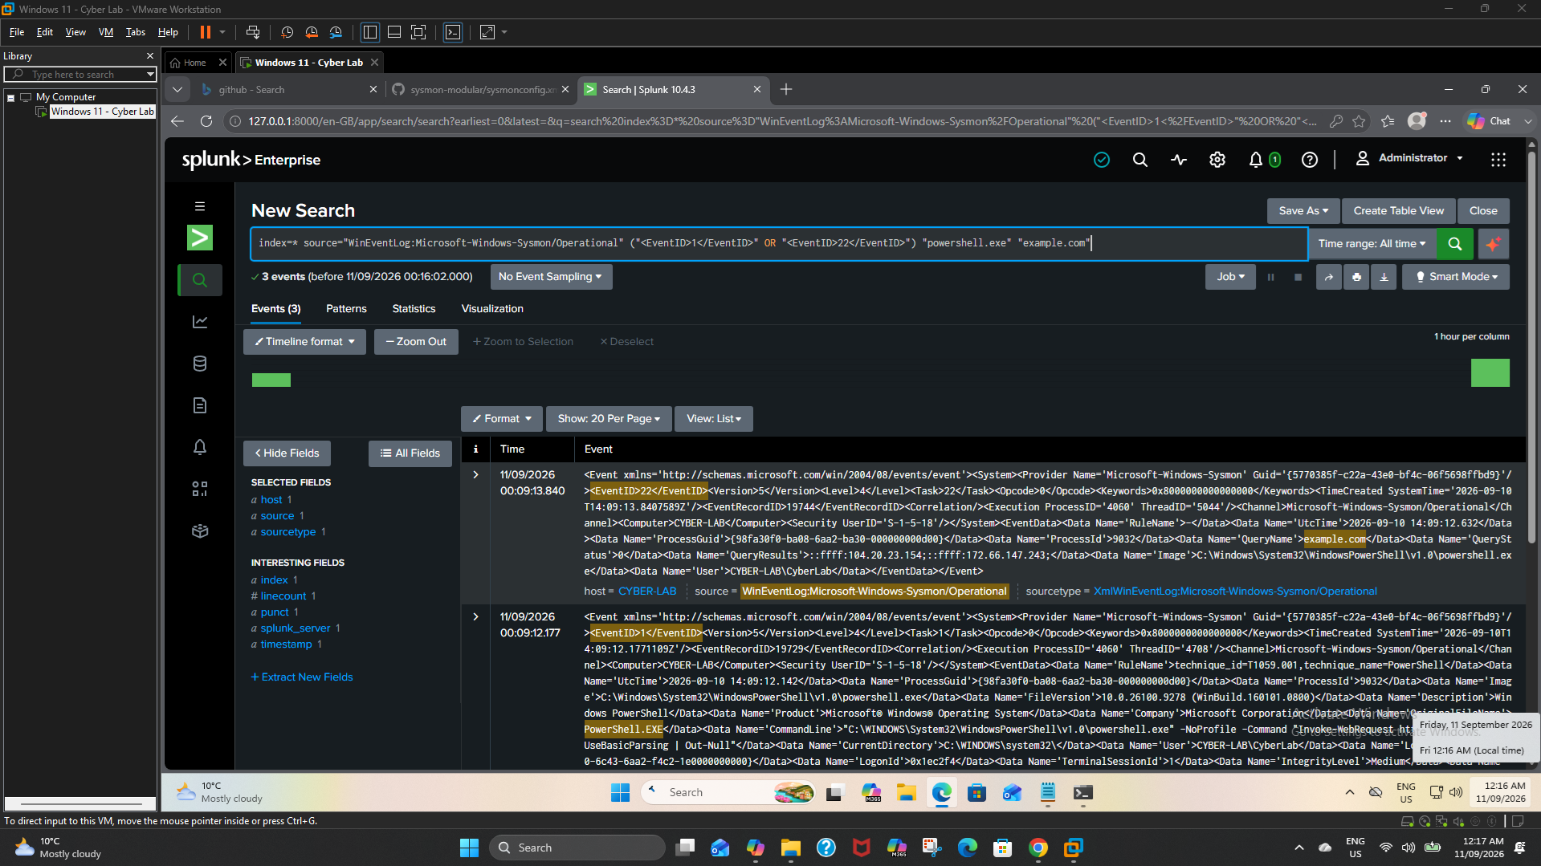
Figure 34. PowerShell DNS Correlation.

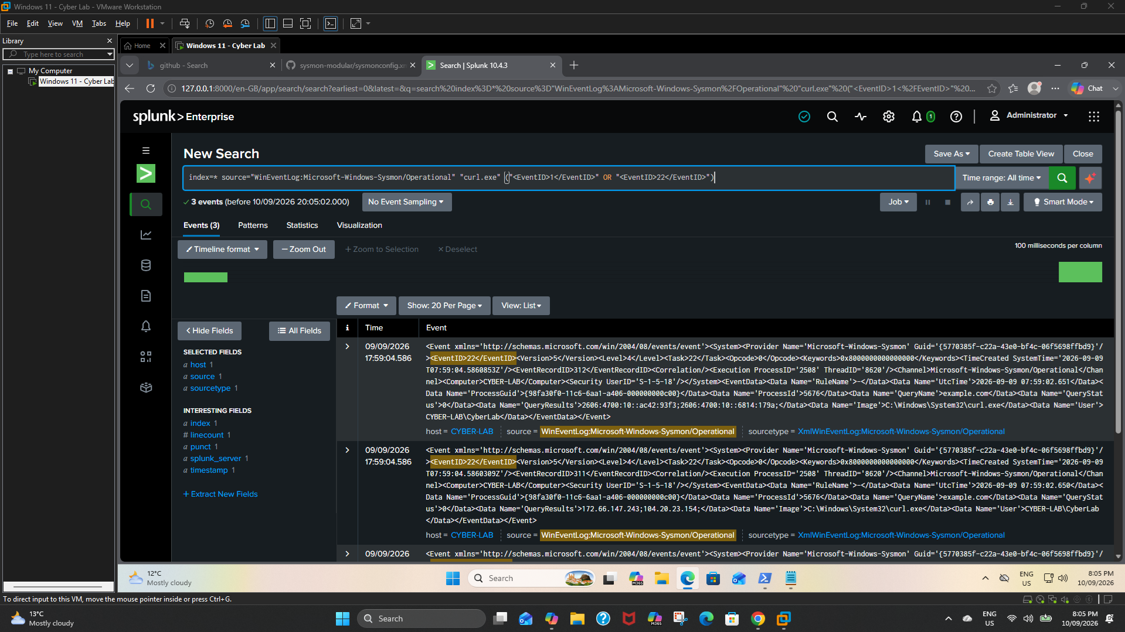
Figure 35. Sysmon Event Correlation.

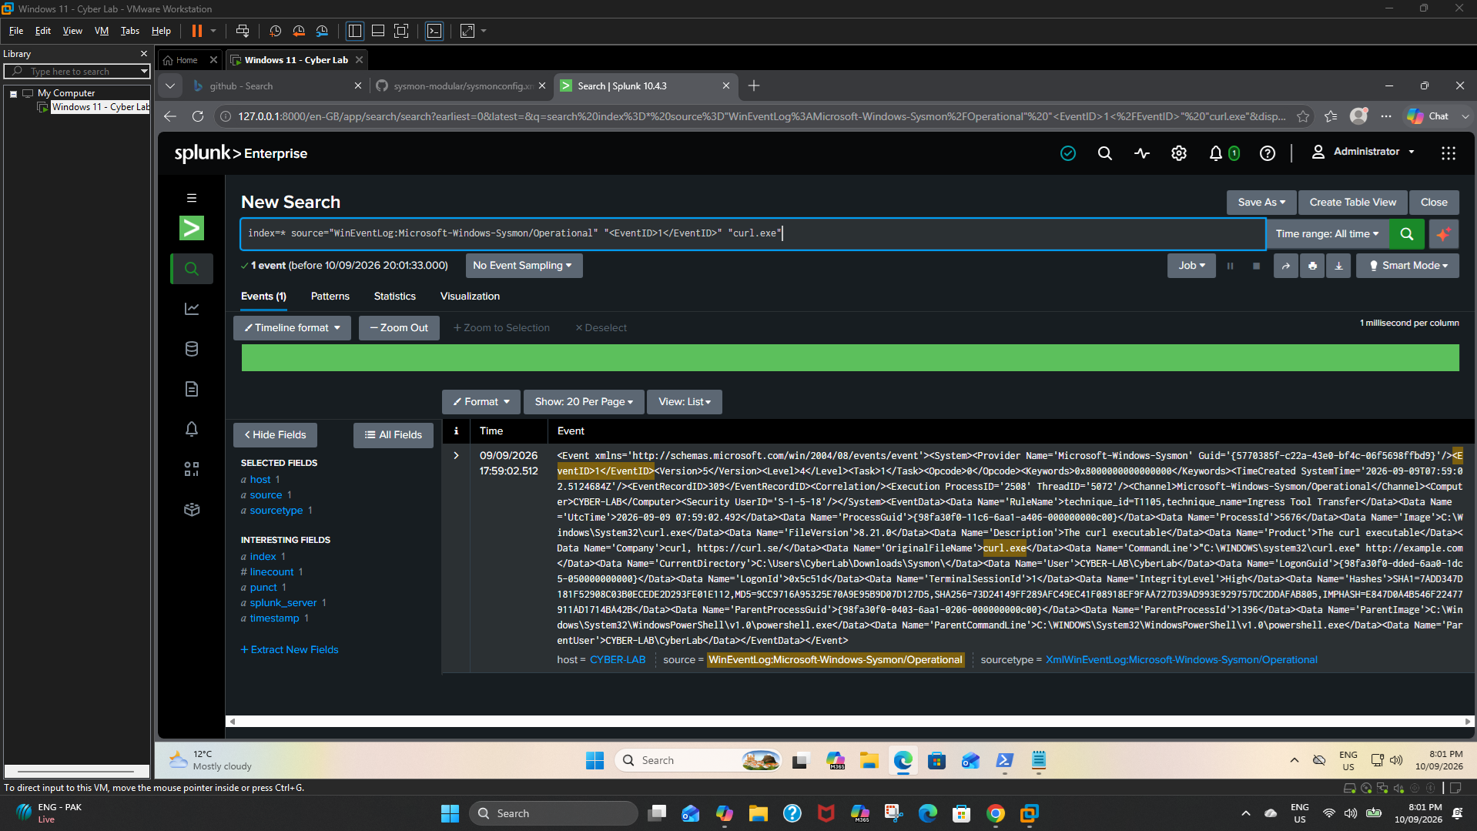
Figure 36. Sysmon Event ID 1 Curl Process.

\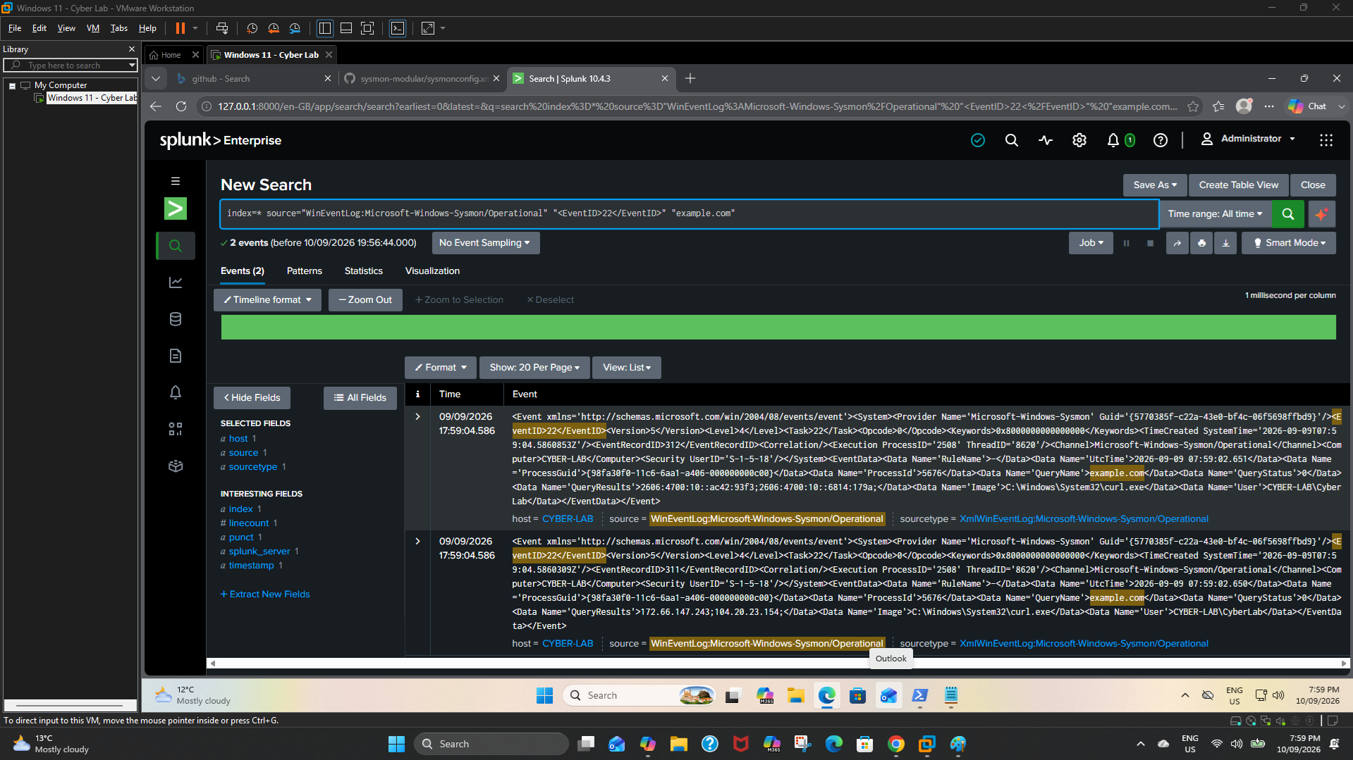
Figure 37. Sysmon DNS Event 22 Curl.

Incident Investigation

Figure 38. Incident Investigation Process Chain.

Figure 39. Incident Process Chain Investigation.

Figure 40. PowerShell PID Correlation.

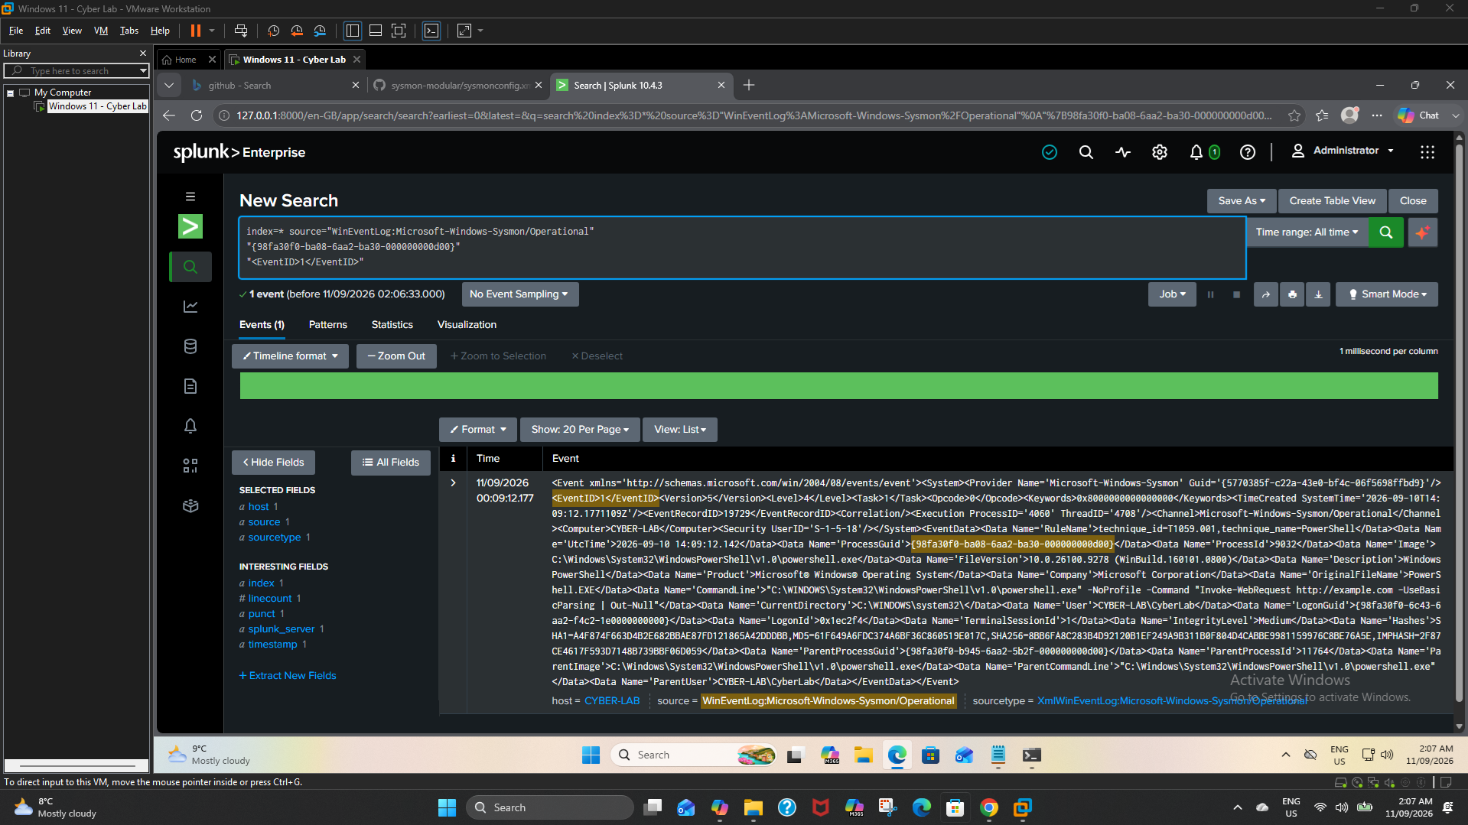
Figure 41. PowerShell ProcessGuid Correlation.

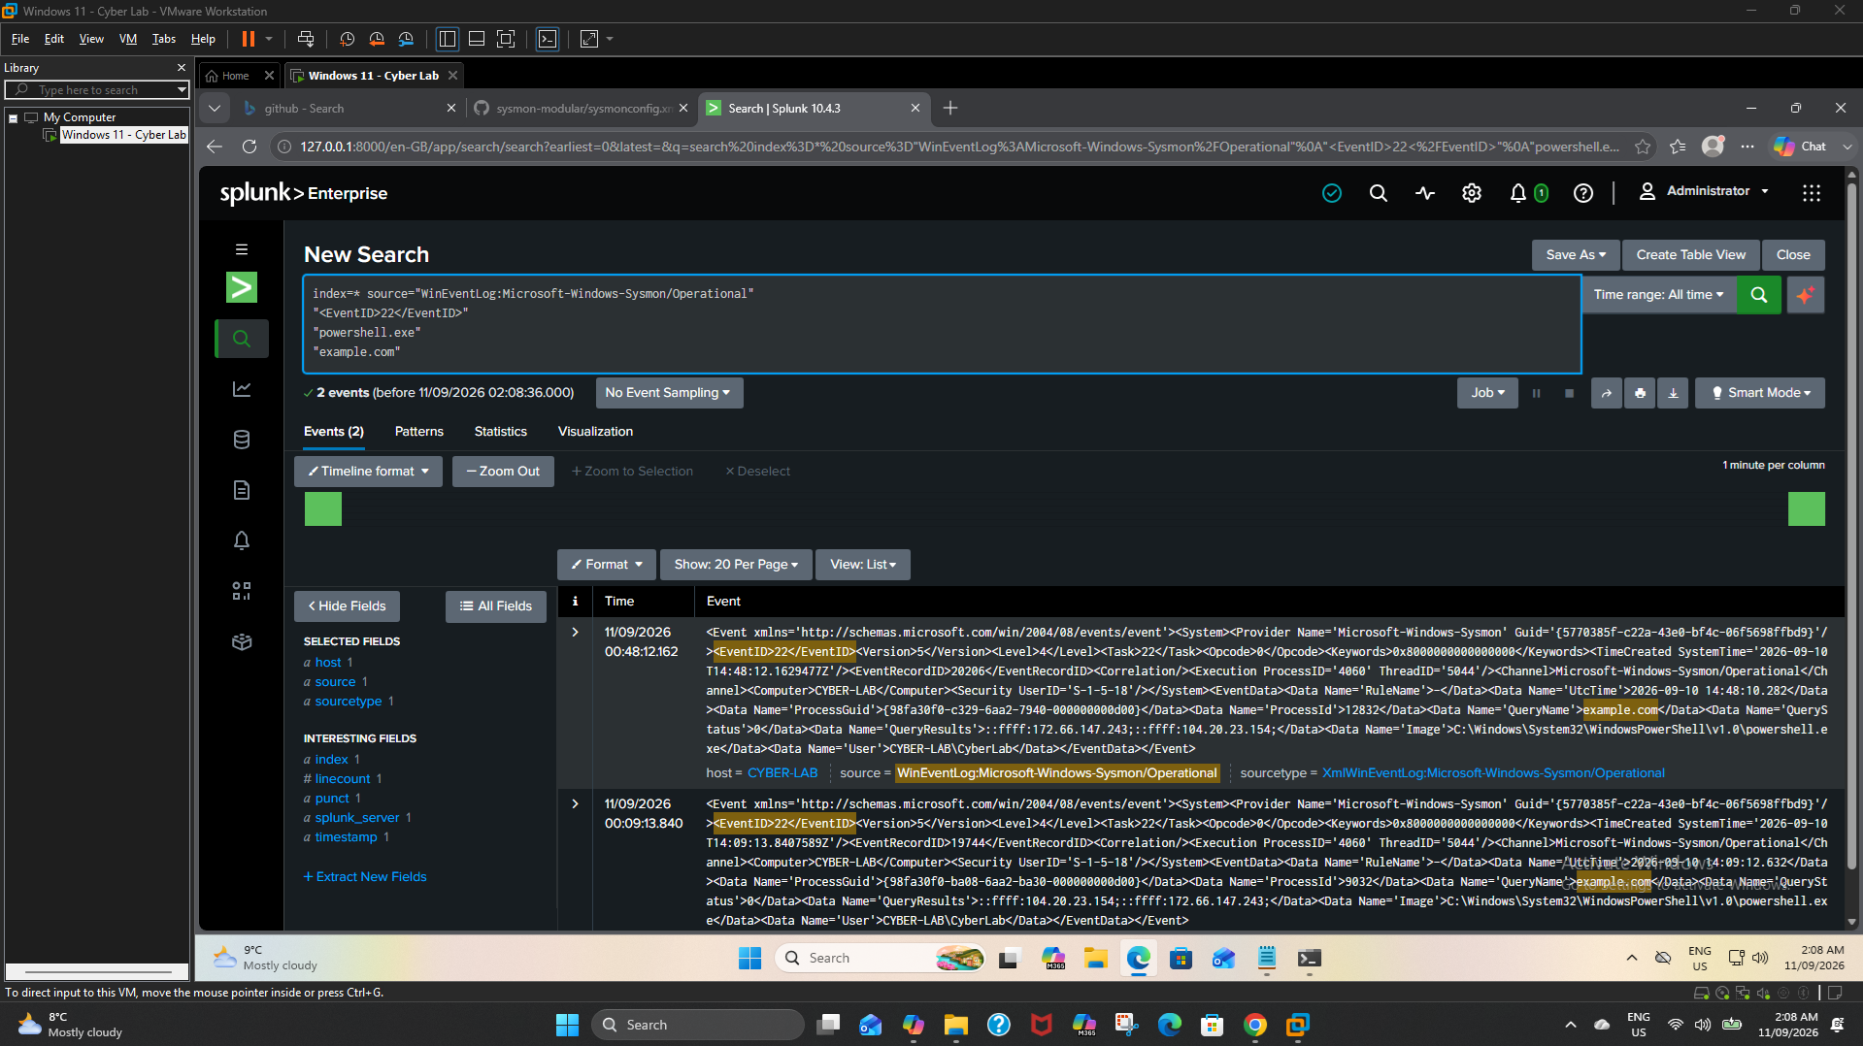
Figure 42. DNS ProcessGuid Correlation.

Figure 43. ProcessGuid DNS Correlation.

MITRE ATT&CK

Figure 44. T1059.001 - PowerShell.

Figure 45. T1059.003 - Windows Command Shell.

Figure 46. T1016 - System Network Configuration Discovery.

Figure 47. T1571 - Non-Standard Port.

Evidence Handling Note
Screenshots are retained in original form. Overlap is intentional where captures document different stages of validation, detection creation, raw-event inspection and correlation. Benign demonstration infrastructure and loopback traffic are explicitly identified to prevent overstatement of the evidence.

