Software Requirements Specification
for
Cyber Incident Reporting Portal
Version 1.0 (Draft)
Prepared by:
Anant Kumar Srivastava
Aditya Mohan
Akhilesh Pathak
Aryan Singh
KIET Group of Institutions, Ghaziabad
Department of Computer Science — Software Engineering Course Project
10 September 2026

Table of Contents
Revision History 4
1. Introduction 5
1.1 Purpose 5
1.2 Document Conventions 5
1.3 Intended Audience and Reading Suggestions 5
1.4 Product Scope 5
1.5 References 6
2. Overall Description 6
2.1 Product Perspective 6
2.2 Product Functions 6
2.3 User Classes and Characteristics 7
2.4 Operating Environment 7
2.5 Design and Implementation Constraints 7
2.6 User Documentation 7
2.7 Assumptions and Dependencies 8
3. External Interface Requirements 8
3.1 User Interfaces 8
3.2 Hardware Interfaces 8
3.3 Software Interfaces 9
3.4 Communications Interfaces 9
4. System Features 9
4.1 User Registration and Authentication 9
4.2 Incident Reporting 10
4.3 Incident Tracking and Status Management 11
4.4 Admin/Analyst Triage and Assignment Dashboard 11
4.5 Notifications 12
4.6 Reports and Analytics 12
5. Other Nonfunctional Requirements 13
5.1 Performance Requirements 13
5.2 Safety Requirements 13
5.3 Security Requirements 13
5.4 Software Quality Attributes 14
5.5 Business Rules 14
6. Other Requirements 15
6.1 Database Requirements 15
6.2 Legal and Compliance Requirements 15
6.3 Internationalization 15
6.4 Future Scope (Out of Scope for v1.0) 15
Appendix A: Glossary 16
Appendix B: Analysis Models 17
Appendix C: To Be Determined List 20

Revision History
Name | Date | Reason For Changes | Version
Anant Kumar Srivastava, Aditya Mohan, Akhilesh Pathak, Aryan Singh | 10-Sep-2026 | Initial draft of the Software Requirements Specification | 1.0

1. Introduction

1.1 Purpose
This Software Requirements Specification (SRS) document describes the functional and non-functional requirements for Version 1.0 of the Cyber Incident Reporting Portal (CIRP). CIRP is a web-based application that allows members of an organization (e.g., students, faculty, or employees) to report cybersecurity incidents — such as phishing attempts, malware infections, unauthorized access, or data breaches — and allows a security team to track, investigate, and resolve them. This document covers the complete scope of the CIRP web application, including the reporting portal used by general users and the administration/analyst dashboard used by the security team. It does not cover any physical security hardware, network monitoring appliances, or third-party SIEM/SOC integrations, as these are outside the scope of this academic project.

1.2 Document Conventions
This document follows the IEEE 830 SRS template. Each functional requirement is uniquely identified using the format REQ-<Feature Code>-<Number> (e.g., REQ-REP-1) and is tagged with a priority of High, Medium, or Low. High-priority requirements are essential for the system to be usable; Medium-priority requirements add significant value; Low-priority requirements are enhancements that may be deferred to a future release. Terms in italics within the body of the document are defined in Appendix A: Glossary. “TBD” is used as a placeholder where information is not yet finalized.

1.3 Intended Audience and Reading Suggestions
This document is intended for the following readers:
- Project guide / evaluator — to assess the completeness and correctness of the requirements.
- Developer (project author) — as the primary reference while designing and implementing the system.
- Testers — to derive test cases directly from the functional requirements in Section 4.
- End users (reporters, security analysts, administrators) — to understand what the system will and will not do.
Readers new to the project should read Sections 1 and 2 first for an overview, then Section 3 and 4 for interface and feature-level detail, and Section 5 for quality and constraint-related requirements. Testers and developers may go directly to Section 4 for the itemized functional requirements.

1.4 Product Scope
Organizations often rely on informal channels — email, verbal reports, or phone calls — to report cybersecurity incidents, which leads to delayed response, lost information, and no central record for audits. The Cyber Incident Reporting Portal addresses this by providing a single, structured, web-based channel through which any user can report a cybersecurity incident in a few minutes, receive a tracking ID, and follow its progress until resolution. For the security team, the portal centralizes incoming reports, supports triage and assignment, and provides basic analytics (e.g., incident counts by type and severity) to support faster, better-informed decisions and simple compliance record-keeping. The v1.0 scope is a single-organization deployment; multi-tenant support and integration with external SIEM/SOC platforms are noted as future scope in Section 6.

1.5 References
- IEEE Std 830-1998, IEEE Recommended Practice for Software Requirements Specifications.
- NIST Special Publication 800-61 Rev. 2, Computer Security Incident Handling Guide.
- OWASP Top 10 (2021), Open Web Application Security Project.
- Project synopsis / proposal document — Cyber Incident Reporting Portal, submitted for the Software Engineering course.

2. Overall Description

2.1 Product Perspective
CIRP is a new, self-contained web application; it is not a component of, or a replacement for, any existing system. It follows a standard three-tier client-server architecture: a browser-based frontend used by all user classes, a backend application server that implements business logic and exposes a REST API, and a relational database that persists users, incidents, categories, and audit data. The system has no dependency on external SIEM/SOC platforms for v1.0; an outbound dependency exists only on an SMTP email service used to deliver notifications (see Section 3.4).

2.2 Product Functions
At a high level, CIRP must let users perform the following functions (detailed in Section 4):
- Register an account and log in securely, with role-based access (Reporter, Security Analyst, Administrator).
- Submit a new incident report with category, description, severity, and optional attachments (e.g., screenshots).
- Automatically receive a unique tracking ID and view the status of previously submitted reports.
- Allow security analysts to view, self-assign or be assigned incidents, add investigation notes, and update status.
- Allow administrators to manage user accounts, incident categories, and view full system/audit logs.
- Send automated email/in-app notifications on status changes and key events.
- Provide a reports and analytics dashboard summarizing incidents by type, severity, and status over time.

2.3 User Classes and Characteristics
- Reporter (General User): Any employee or student with a valid account. Minimal technical expertise assumed. Uses only the incident submission form and their own report history.
- Security Analyst: Technically proficient staff responsible for triaging and investigating assigned incidents. Uses the analyst dashboard, incident detail view, and status-update functions.
- Administrator: Manages user accounts, incident categories, and system configuration. Has the highest privilege level and access to full audit logs.
- Management / Auditor: Read-only access to aggregated reports and analytics for oversight and compliance review; does not handle individual incidents.

2.4 Operating Environment
CIRP is delivered entirely as a web application and imposes no special hardware requirements beyond a standard internet-connected computing device:
- Client: Any modern desktop or laptop web browser with JavaScript enabled (e.g., Google Chrome, Mozilla Firefox, Microsoft Edge, latest two major versions).
- Server: A standard web/application server capable of hosting the chosen backend framework (e.g., a Linux-based host), which is a deployment concern rather than a development deliverable for this course project.
- Database: A relational database management system (e.g., MySQL or PostgreSQL).
As this is a software engineering course project, provisioning and configuring physical server hardware is out of scope; the system is designed to run on any conventional hosting environment that meets the above software requirements.

2.5 Design and Implementation Constraints
- The system must be implementable by a single developer within one academic semester using open-source technologies (no licensed/paid software).
- The client is browser-only for v1.0; no native mobile application is in scope.
- All communication between client and server must use HTTPS.
- Passwords must never be stored in plain text; a standard hashing algorithm (e.g., bcrypt) must be used.
- The system must follow a layered architecture (presentation, business logic, data access) to keep the codebase maintainable and testable.

2.6 User Documentation
The following documentation will be delivered along with the software: a short user manual (PDF) covering account registration, incident submission, and status tracking; in-app tooltips and a FAQ section for common questions; and a brief administrator guide covering user and category management. No printed documentation is planned.

2.7 Assumptions and Dependencies
- It is assumed that users have access to an internet-connected device with a supported web browser.
- It is assumed that the hosting environment provides reliable internet connectivity and uptime; formal Service Level Agreements are outside the scope of this project.
- The notification feature (Section 4.5) depends on an available SMTP email service; if unavailable, notifications will fail gracefully without blocking core reporting functionality.
- The system is designed for a single organization (single tenant) for v1.0; multi-tenant support is not assumed.

3. External Interface Requirements

3.1 User Interfaces
CIRP provides the following logical screens, each following a consistent header/navigation/footer layout with clear error-message standards (inline field validation plus a summary banner for form-level errors):
- Registration and Login pages.
- Incident Report submission form (category, description, severity, date/time of occurrence, optional file attachment).
- “My Reports” dashboard for reporters, listing tracking ID, category, status, and last update.
- Incident detail view, showing full history/timeline of status changes and notes.
- Analyst/Admin dashboard listing all incidents with filter and search by status, category, severity, and date.
- Admin panel for user account and category management.
- Reports and Analytics view with summary charts.
Detailed wireframes and screen-by-screen UI specifications are intended to be documented separately in a UI design specification once available; this SRS defines only the logical characteristics of each screen.

3.2 Hardware Interfaces
Note: Not applicable for this project. CIRP is a purely software application with no dedicated hardware interfaces. It only requires standard end-user computing devices (desktop/laptop with a browser) and a conventional server to host the application and database — both of which are deployment/infrastructure concerns outside the software development scope of this course project, and are therefore not elaborated further in this SRS.

3.3 Software Interfaces
- Operating System: Server-side, any OS capable of hosting the chosen backend runtime (e.g., a Linux distribution).
- Database: A relational database (e.g., MySQL / PostgreSQL), accessed via an ORM or parameterized queries.
- Backend Framework: A server-side web framework (e.g., Node.js/Express, or an equivalent) exposing a REST API consumed by the frontend.
- Frontend: A browser-based client built with standard web technologies (HTML5, CSS3, JavaScript, optionally a frontend framework).
- Email Service: An SMTP-based email provider used for outbound notification messages (see Section 3.4).

3.4 Communications Interfaces
- All client-server communication must use HTTPS to protect data in transit, including login credentials and incident details.
- The frontend and backend communicate through a JSON-based REST API.
- Authenticated sessions are maintained using a token-based mechanism (e.g., JWT) with a defined expiry/timeout.
- Outbound email notifications are sent via SMTP to inform users of status changes on their reported incidents.

4. System Features
This section organizes functional requirements by system feature — the major services the product must provide. Each feature lists its priority, the user-action/system-response sequences that trigger it, and its itemized, uniquely-identified functional requirements.

4.1 User Registration and Authentication

4.1.1 Description and Priority
Allows a new user to create an account and existing users to securely log in and out, with access restricted according to their assigned role (Reporter, Security Analyst, or Administrator). Priority: High.

4.1.2 Stimulus/Response Sequences
- User opens the registration page, submits name/email/password → system creates the account and sends a confirmation.
- User submits valid login credentials → system creates a session and redirects to the appropriate dashboard for their role.
- User submits invalid credentials → system displays an error message without indicating whether the email or password was incorrect.

4.1.3 Functional Requirements
REQ-AUTH-1 (High): The system shall allow a new user to register with a unique email address and a password meeting a minimum complexity policy (e.g., at least 8 characters, one number).
REQ-AUTH-2 (High): The system shall store passwords only in hashed form and never in plain text.
REQ-AUTH-3 (High): The system shall authenticate users via email and password and issue a session token upon success.
REQ-AUTH-4 (High): The system shall restrict access to each screen and API endpoint based on the authenticated user's role.
REQ-AUTH-5 (Medium): The system shall automatically expire a user's session after a configurable period of inactivity.
REQ-AUTH-6 (Low): The system shall provide a “forgot password” flow that emails the user a secure, time-limited reset link.

4.2 Incident Reporting

4.2.1 Description and Priority
Allows an authenticated Reporter to submit a new cybersecurity incident with structured details, and receive a unique tracking ID for later reference. Priority: High.

4.2.2 Stimulus/Response Sequences
- Reporter selects “Report an Incident,” fills the form (category, description, severity, date/time, optional attachment), and submits → system validates input, stores the report, and displays a tracking ID.
- Reporter omits a required field and submits → system highlights the missing field(s) and does not submit the form.

4.2.3 Functional Requirements
REQ-REP-1 (High): The system shall provide an incident report form capturing category, short description, detailed description, severity (Low/Medium/High/Critical), and date/time of occurrence.
REQ-REP-2 (High): The system shall validate that all mandatory fields are completed before allowing submission.
REQ-REP-3 (Medium): The system shall allow the Reporter to optionally attach up to 3 files (e.g., screenshots) of up to 5 MB each as supporting evidence.
REQ-REP-4 (High): Upon successful submission, the system shall generate and display a unique, human-readable tracking ID (e.g., INC-2026-0001).
REQ-REP-5 (Medium): The system shall allow a Reporter to optionally submit a report anonymously, omitting their identity from the record visible to analysts.

4.3 Incident Tracking and Status Management

4.3.1 Description and Priority
Allows a Reporter to view the current status and history of their submitted reports, and allows the security team to progress an incident through a defined status lifecycle. Priority: High.

4.3.2 Stimulus/Response Sequences
- Reporter opens “My Reports” → system lists all reports submitted by that user with current status.
- Reporter selects a tracking ID → system displays the full status timeline and any public analyst notes.
- Analyst updates the status of an assigned incident → system records the change, timestamps it, and triggers a notification.

4.3.3 Functional Requirements
REQ-TRK-1 (High): The system shall maintain a defined incident status lifecycle: Reported → In Review → In Progress → Resolved → Closed.
REQ-TRK-2 (High): The system shall allow a Reporter to search for and view the status of any incident using its tracking ID.
REQ-TRK-3 (High): The system shall record a timestamped history entry every time an incident's status changes.
REQ-TRK-4 (Medium): The system shall allow a Reporter to view analyst notes that have been explicitly marked as visible to the reporter.
REQ-TRK-5 (Medium): The system shall prevent a Reporter from directly changing the status of an incident; only Security Analysts and Administrators may do so.

4.4 Admin/Analyst Triage and Assignment Dashboard

4.4.1 Description and Priority
Provides Security Analysts and Administrators with a consolidated dashboard to view, filter, assign, and act on incoming incident reports. Priority: High.

4.4.2 Stimulus/Response Sequences
- Analyst opens the dashboard → system lists all incidents with filters for status, category, severity, and date range.
- Administrator assigns an unassigned incident to an analyst → system updates the record and notifies the assigned analyst.
- Analyst adds an internal investigation note to an incident → system saves the note against that incident's history.

4.4.3 Functional Requirements
REQ-ADM-1 (High): The system shall display all incidents to Security Analysts and Administrators in a sortable, filterable list (by status, category, severity, date).
REQ-ADM-2 (High): The system shall allow an Administrator to assign an incident to a specific Security Analyst.
REQ-ADM-3 (Medium): The system shall allow a Security Analyst to self-assign an unassigned incident.
REQ-ADM-4 (High): The system shall allow an assigned Security Analyst to add internal notes to an incident, marked as visible only to staff or also to the reporter.
REQ-ADM-5 (Medium): The system shall allow an Administrator to define and edit the list of incident categories (e.g., Phishing, Malware, Unauthorized Access, Data Breach, Denial of Service).
REQ-ADM-6 (Low): The system shall flag an incident as overdue if it remains in “In Review” status for longer than a configurable threshold (e.g., 48 hours).

4.5 Notifications

4.5.1 Description and Priority
Automatically informs users of relevant events, such as status changes on their reported incidents or new assignments for analysts, via email and an in-app notification indicator. Priority: Medium.

4.5.2 Stimulus/Response Sequences
- An incident's status changes → system sends an email and creates an in-app notification for the relevant Reporter and/or assigned Analyst.
- An incident is assigned to an Analyst → system notifies that Analyst.
- The email service is temporarily unavailable → system logs the failure and continues normal operation without blocking the triggering action.

4.5.3 Functional Requirements
REQ-NOT-1 (Medium): The system shall send an email notification to the Reporter whenever the status of their incident changes.
REQ-NOT-2 (Medium): The system shall send an email notification to a Security Analyst when an incident is assigned to them.
REQ-NOT-3 (Low): The system shall display an in-app notification indicator (e.g., a badge count) for unread events.
REQ-NOT-4 (Medium): If the email service is unavailable, the system shall log the failed notification and shall not roll back or block the underlying action (e.g., the status change itself).

4.6 Reports and Analytics

4.6.1 Description and Priority
Provides Administrators and Management with summarized, visual insight into incident volume and trends to support decision-making and basic compliance record-keeping. Priority: Medium.

4.6.2 Stimulus/Response Sequences
- Administrator/Management opens the Analytics view → system displays counts of incidents by category, severity, and status, and a trend of incidents over time.
- Administrator applies a date range filter → system recalculates and redisplays the summary figures.

4.6.3 Functional Requirements
REQ-ANL-1 (Medium): The system shall display the total number of incidents grouped by category and by severity.
REQ-ANL-2 (Medium): The system shall display a chart of incident volume over a selectable date range.
REQ-ANL-3 (Medium): The system shall display the average time-to-resolution across closed incidents.
REQ-ANL-4 (Low): The system shall allow an Administrator to export the current analytics view as a CSV file.

5. Other Nonfunctional Requirements

5.1 Performance Requirements
- The incident submission form shall load within 3 seconds under normal conditions on a broadband connection.
- The system shall support at least 50 concurrent users without a noticeable degradation in response time, consistent with the expected scale of a single-organization academic deployment.
- Search and filter operations on the incident list shall return results within 2 seconds for a dataset of up to 10,000 incidents.
Note: These targets are software design goals for this project; they are not backed by dedicated hardware provisioning or load-testing infrastructure, as procuring such infrastructure is outside the scope of this course project.

5.2 Safety Requirements
As CIRP is a web-based information system rather than a system that controls physical processes or equipment, there are no requirements concerning physical safety, injury, or equipment damage; this subsection is therefore limited to data-safety concerns:
- The system shall take regular automated backups of the incident database to prevent permanent data loss.
- The system shall handle unexpected errors gracefully (e.g., failed form submission) without corrupting previously saved incident data.

5.3 Security Requirements
- All user passwords shall be stored using a strong, salted hashing algorithm (e.g., bcrypt); plain-text storage is prohibited.
- The system shall enforce role-based access control (RBAC) on every screen and API endpoint, per Section 4.1.
- All client-server traffic shall be encrypted using HTTPS/TLS.
- All user input shall be validated and sanitized on the server to prevent SQL injection and cross-site scripting (XSS).
- The system shall log security-relevant events (logins, failed login attempts, status changes, admin actions) to an audit trail accessible only to Administrators.
- Incident data, which may be sensitive, shall be visible only to the reporting user, assigned analysts, and administrators — not to other Reporters.

5.4 Software Quality Attributes
- Usability: A first-time Reporter shall be able to submit an incident report without external help, guided by inline labels and validation messages.
- Reliability: Core reporting and tracking functions shall remain available even if the notification (email) subsystem is temporarily unavailable.
- Maintainability: The codebase shall follow a layered architecture (Section 2.5) so that individual layers can be modified with minimal impact on others.
- Portability: The client shall run unmodified on any of the supported browsers listed in Section 2.4.
- Testability: Each functional requirement in Section 4 shall be written so that it can be verified by at least one corresponding test case.

5.5 Business Rules
The table below states the operating principles that govern who may perform which actions under specific circumstances. These are not functional requirements in themselves, but each implies (and is enforced by) one or more functional requirements referenced in the right-hand column.
Rule ID | Business Rule | Related Requirement(s)
BR-1 | Only an authenticated user holding the Reporter role or higher may submit a new incident report; unauthenticated visitors cannot submit reports. | REQ-AUTH-3, REQ-REP-1
BR-2 | Only the Security Analyst assigned to an incident, or an Administrator, may change that incident's status. | REQ-TRK-5, REQ-ADM-4
BR-3 | An incident's status must follow the defined lifecycle in sequence (Reported → In Review → In Progress → Resolved → Closed); a status may not be skipped. | REQ-TRK-1
BR-4 | Incident categories are drawn only from the fixed list maintained by Administrators; Reporters and Analysts cannot create new categories. | REQ-ADM-5
BR-5 | An incident may be reassigned to a different Security Analyst by an Administrator at any time before it is marked Closed. | REQ-ADM-2
BR-6 | A Reporter who submits an incident anonymously (REQ-REP-5) may not be contacted by an Analyst and does not receive status-change notifications for that report. | REQ-REP-5, REQ-NOT-1
BR-7 | An incident is automatically flagged as overdue if it remains in “In Review” status beyond the configurable threshold (default 48 hours). | REQ-ADM-6
BR-8 | Only Administrators may view the full system audit log; Security Analysts may view only the history of incidents assigned to them. | REQ-ADM-1, Section 5.3

6. Other Requirements

6.1 Database Requirements
The system requires a relational database with, at minimum, the following entities: Users (id, name, email, password hash, role), Incidents (id, tracking ID, reporter, category, description, severity, status, created/updated timestamps), Categories (id, name), Status History (incident id, status, changed by, timestamp), Notes (incident id, author, text, visibility), and Attachments (incident id, file reference). Detailed entity-relationship design is left to the Design phase and is outside the scope of this SRS.

6.2 Legal and Compliance Requirements
The system shall handle reported incident data, including any personal information of reporters, in a manner consistent with the host organization's data privacy policy. As this is an academic project, no formal legal certification is claimed or required.

6.3 Internationalization
Version 1.0 of the system shall support the English language only. Support for additional languages is noted as a possible future enhancement and is not required for this release.

6.4 Future Scope (Out of Scope for v1.0)
- Integration with external SIEM/SOC platforms for automated incident ingestion.
- A dedicated native mobile application.
- Multi-tenant support for multiple organizations on a shared deployment.

Appendix A: Glossary
- CIRP — Cyber Incident Reporting Portal, the system specified in this document.
- Incident — A confirmed or suspected event that may compromise the confidentiality, integrity, or availability of information or systems (e.g., phishing, malware, unauthorized access).
- Reporter — A user who submits an incident report.
- Security Analyst — A user responsible for triaging, investigating, and resolving assigned incidents.
- Administrator — A user with full privileges to manage accounts, categories, and system configuration.
- RBAC — Role-Based Access Control; restricting system access based on a user's assigned role.
- Tracking ID — A unique identifier generated for each submitted incident report, used to look up its status.
- SIEM/SOC — Security Information and Event Management / Security Operations Center; external security platforms referenced only as future-scope integrations.
- Severity — A classification (Low/Medium/High/Critical) indicating the potential impact of a reported incident.
- XSS / SQL Injection — Common web application security vulnerabilities that the system must be designed to prevent (Section 5.3).

Appendix B: Analysis Models

B.1 Context-Level Data Flow Diagram (Level 0)
The diagram below shows CIRP as a single process exchanging data with its external entities: the Reporter, Security Analyst, Administrator, Management/Auditor, and the external Email Notification Service.
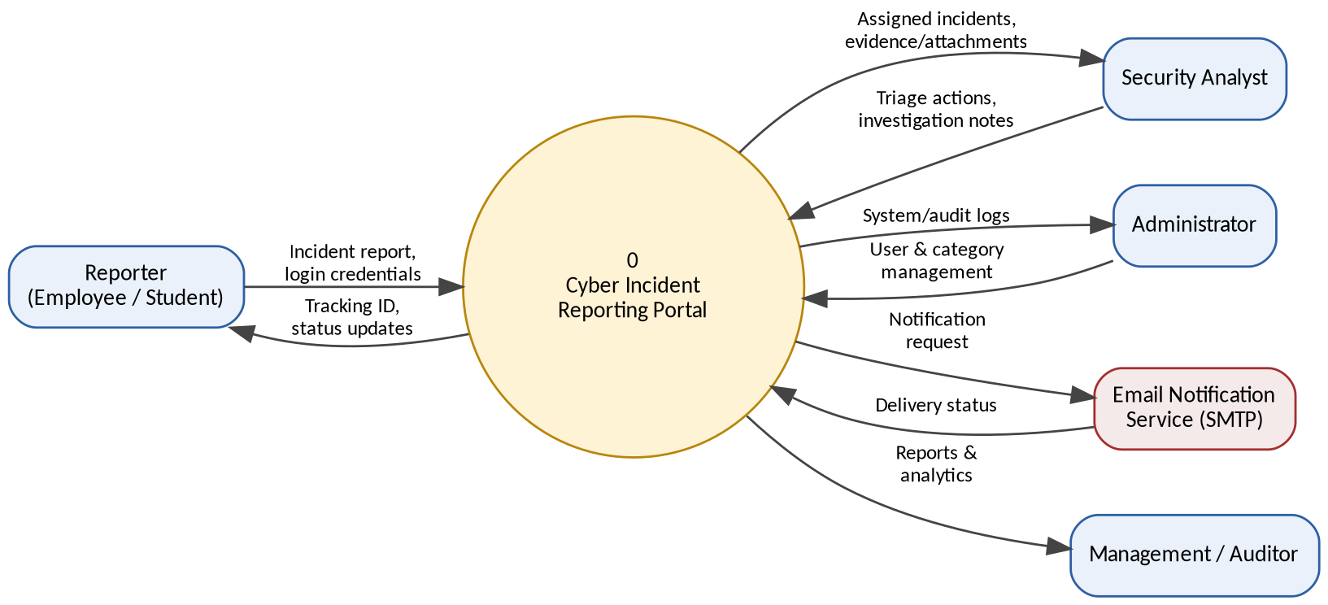
Figure B.1: Context-level (Level 0) Data Flow Diagram for CIRP
Section B.2 (next page) decomposes this single process into its six constituent processes and four data stores as a Level 1 DFD.

B.2 Level 1 Data Flow Diagram
The Level 1 DFD below decomposes Process 0 into its six major processes (1.0–6.0) and shows how they read from and write to the system's four data stores. Every data flow is traceable to a functional requirement in Section 4.
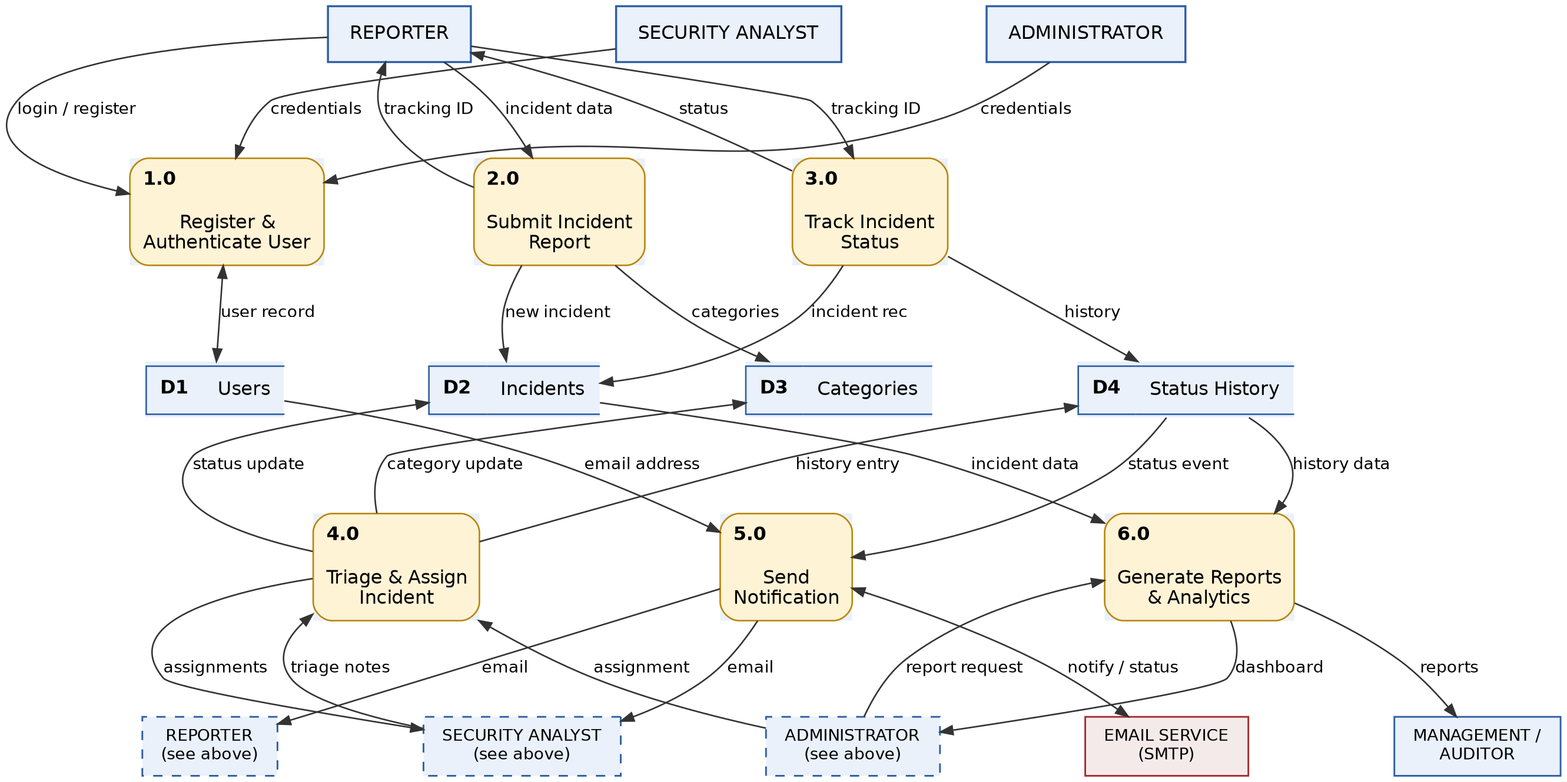
Figure B.2: Level 1 Data Flow Diagram for CIRP
Note: The Reporter, Security Analyst, and Administrator entities are each drawn twice (the second instance labeled “see above,” shown with a dashed border) so that flows to and from Processes 4.0–6.0 do not have to cross back over the top of the diagram. Both instances of a given entity represent the same external entity — this is standard DFD practice for reducing line crossings on a busy diagram.

B.3 Use Case Diagram
The diagram below summarizes the primary use cases available to each user class, corresponding to the functional requirements in Section 4.
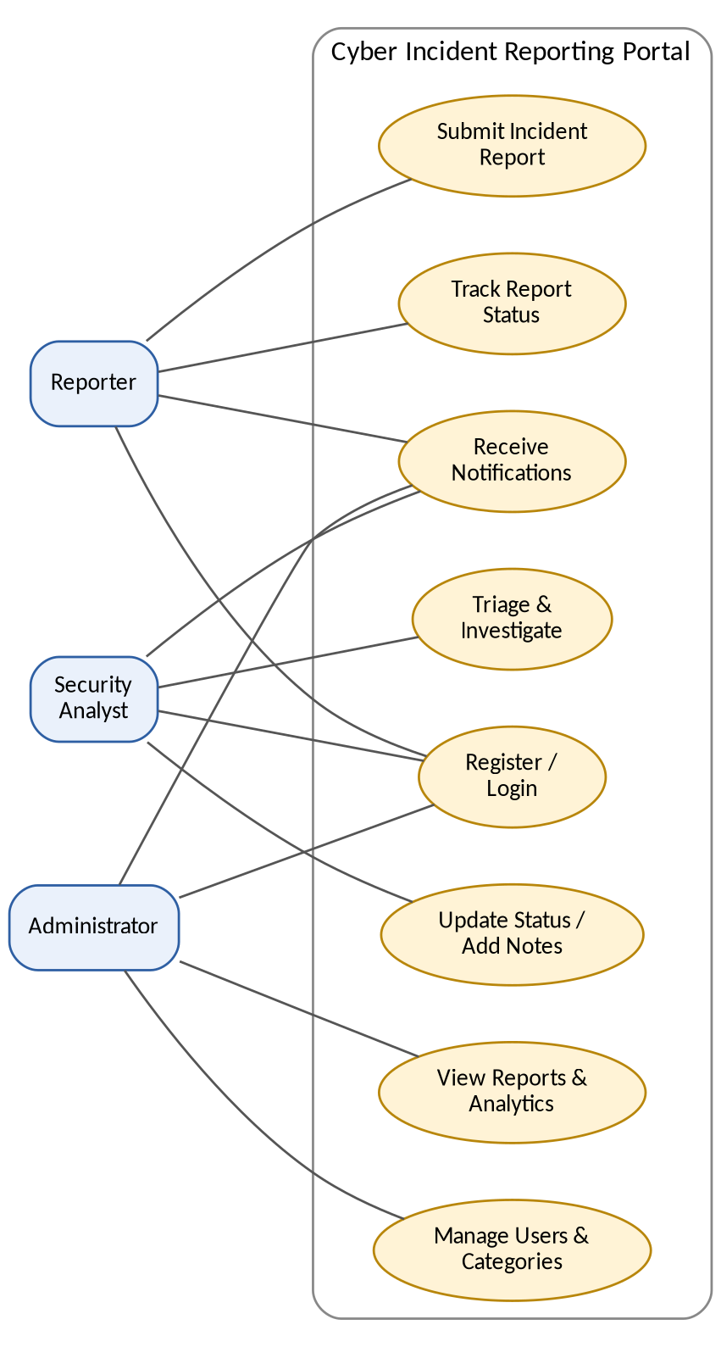
Figure B.3: Use Case Diagram for CIRP
Note: Detailed design artifacts such as a full Entity-Relationship Diagram and sequence diagrams are intended to be produced during the Design phase and are not part of this SRS.

Appendix C: To Be Determined List
# | Item
1 | Exact backend/frontend technology stack to be finalized during the Design phase.
2 | Concurrent-user and dataset-size targets in Section 5.1 to be revisited once actual deployment infrastructure is known.
3 | Overdue-incident threshold (REQ-ADM-6) to be confirmed with the intended host organization.
4 | Specific SMTP provider for the Email Notification Service (Section 3.4) to be selected during implementation.

