## Step

Step 1: Download Tomcat 7 from: <http://www-eu.apache.org/dist/tomcat/tomcat-7/v7.0.69/bin/apache-tomcat-7.0.69-windows-x64.zip>

Step 2: Unzip the archive to C:\T7, make sure T7 is the root folder of tomcat. (T7 could be any other arbitrary name, but do the same changes in the following steps)

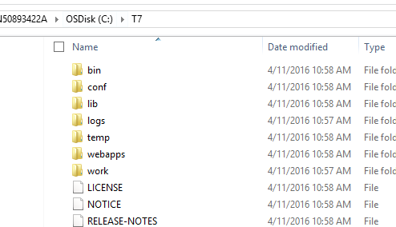

Step 3: Add a new environment variable CATALINA_HOME = C:\T7

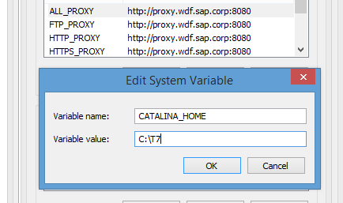

Step 4: Download kie-drools-wb-6.3.0 (Workbench) from <http://download.jboss.org/drools/release/6.3.0.Final/kie-drools-wb-6.3.0.Final-tomcat7.war>, unzip it to C:\T7\webapps\drools-wb (drools-wb will be the app name).

Step 5: Copy all the .jar files in \\cnctul000\TEMP\drools\Workbench\lib to C:\T7\lib. Pay attention that the kie-tomcat-integration-6.3.0.Final.jar is for Workbench 6.3. If you are using other versions, please download the corresponding .jar file.

Step 6: Copy all the .jar files in \\cnctul000\TEMP\drools\Workbench\conf to C:\T7\conf. Remember to make change to resource.ds1.driverProperties.url=jdbc:h2:file:C:/T7/jbpm in resources.properties according to your own tomcat root folder path.

Step 7: Copy \\cnctul000\TEMP\drools\Workbench\setenv.bat to C:\T7\bin. Search “drools-wb” in this file and replace it with your own app name.

Step 8: Add <Valve className="org.kie.integration.tomcat.JACCValve" />

into CATALINA_HOME/conf/server.xml inside Host element.

Step 9: Open a new command line and navigate to C:\T\bin, execute “catalina.bat run” to start the server. Visit <http://localhost:8080/drools-wb> in your browser. For both tomcat and workbench use following account to login:

Username: admin Password: admin

## Troubleshooting

1. If you got errors related to github, just change your network to SAP-Internet and restart the server. This action only need to be done once.

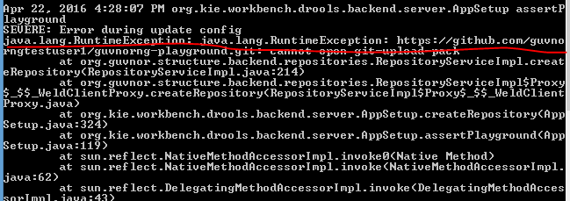

1. If you got warning “WARNING: cannot get this JVM unique ID”, that means tomcat is not able to read the configuration of btm (Bitronix Transaction Manager). Check al the path in setenv.bat in Step 7.

## Further Issues

If you met other issues please check logs in C:\T7\logs.