PRACTICAL 1

*NAME*-*AKHILESH KUMAR*

*CLASS- FYCS*

*ROLL NO-99*

*Introduction and contribution to wikipedia* **wikipedia***:- wikipedia is a free ,multiligual ope collabroative online encyclopedia created and maintained by a community of volunteer contributions using a wiki- based editing system.*

*Launched:-15/01/2001.*

*Creater:-Jimmy wales & larry sanger.*

**Create account**

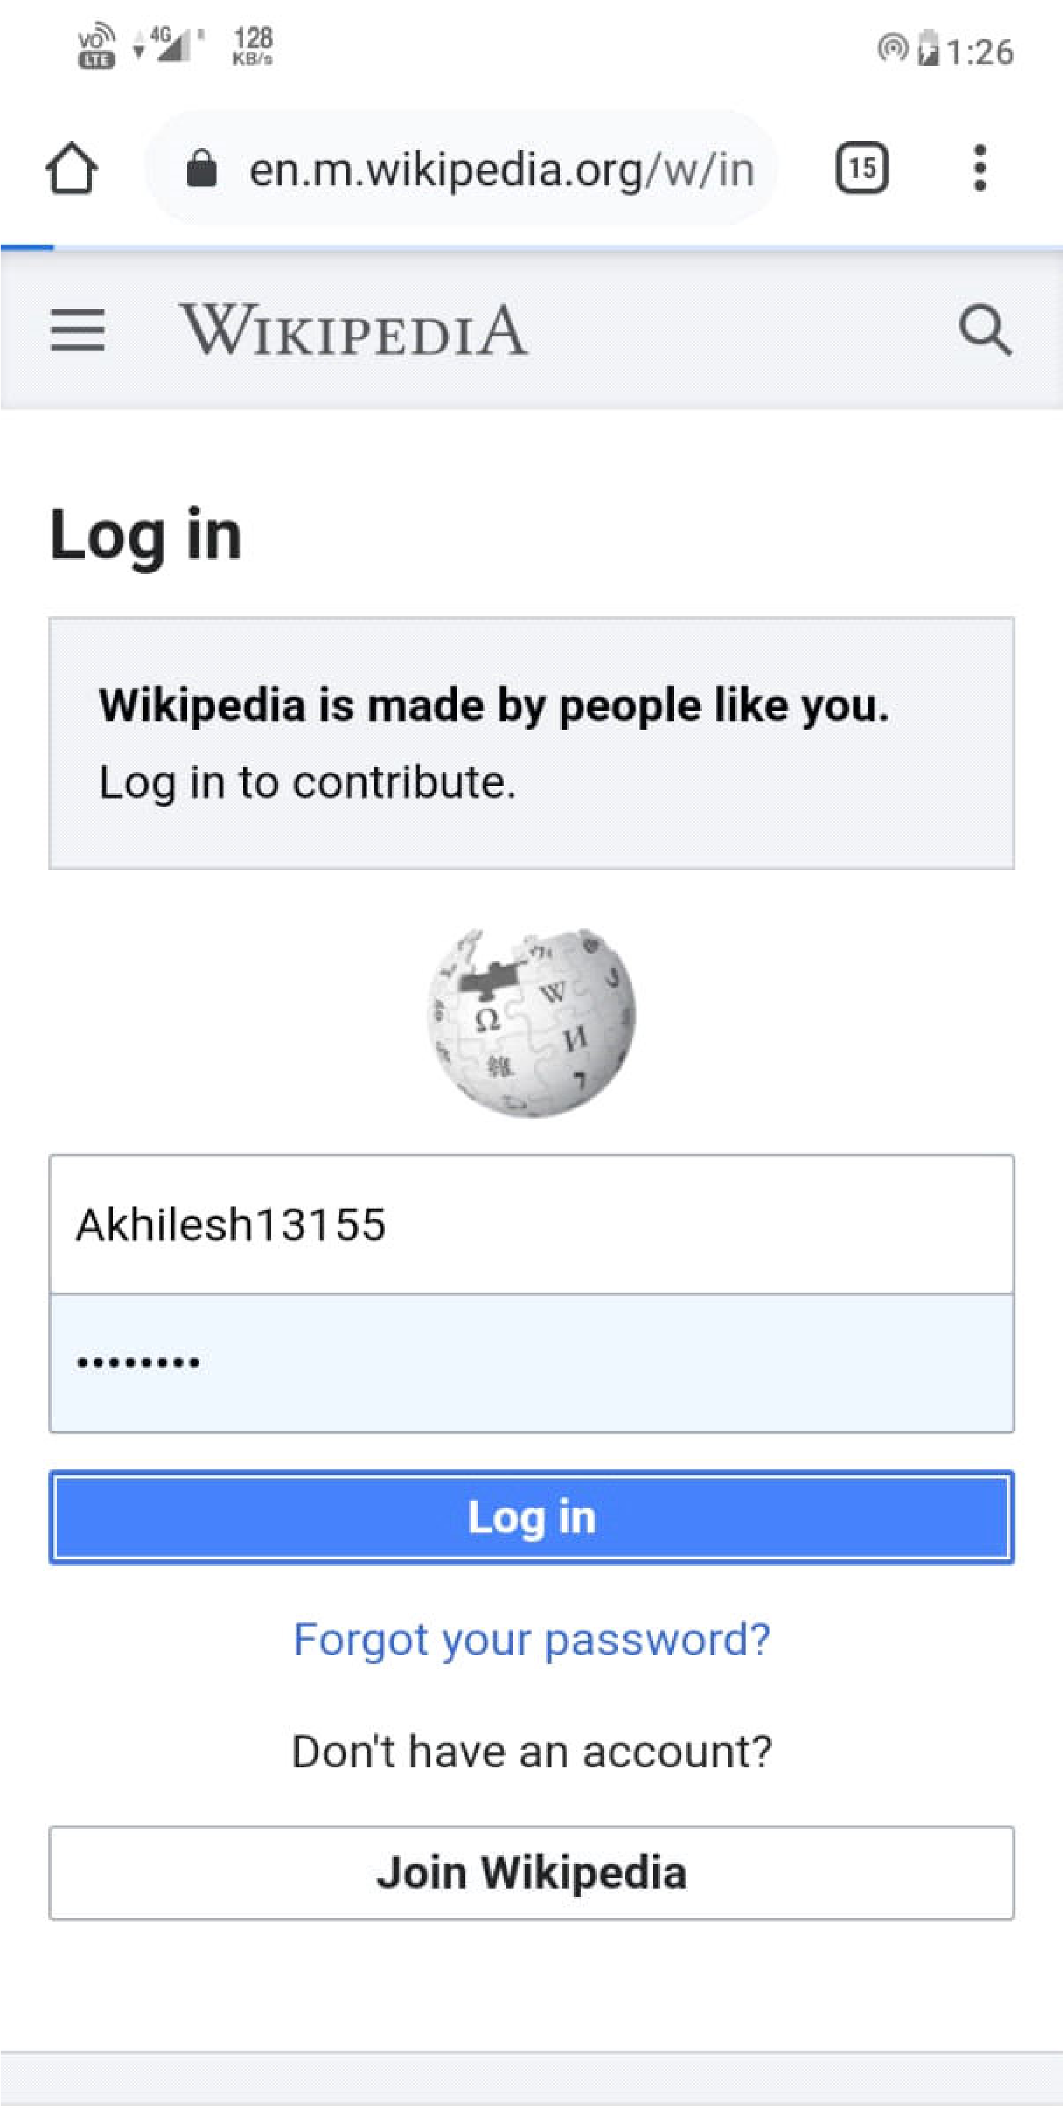

# After creating account successfully page will display like this

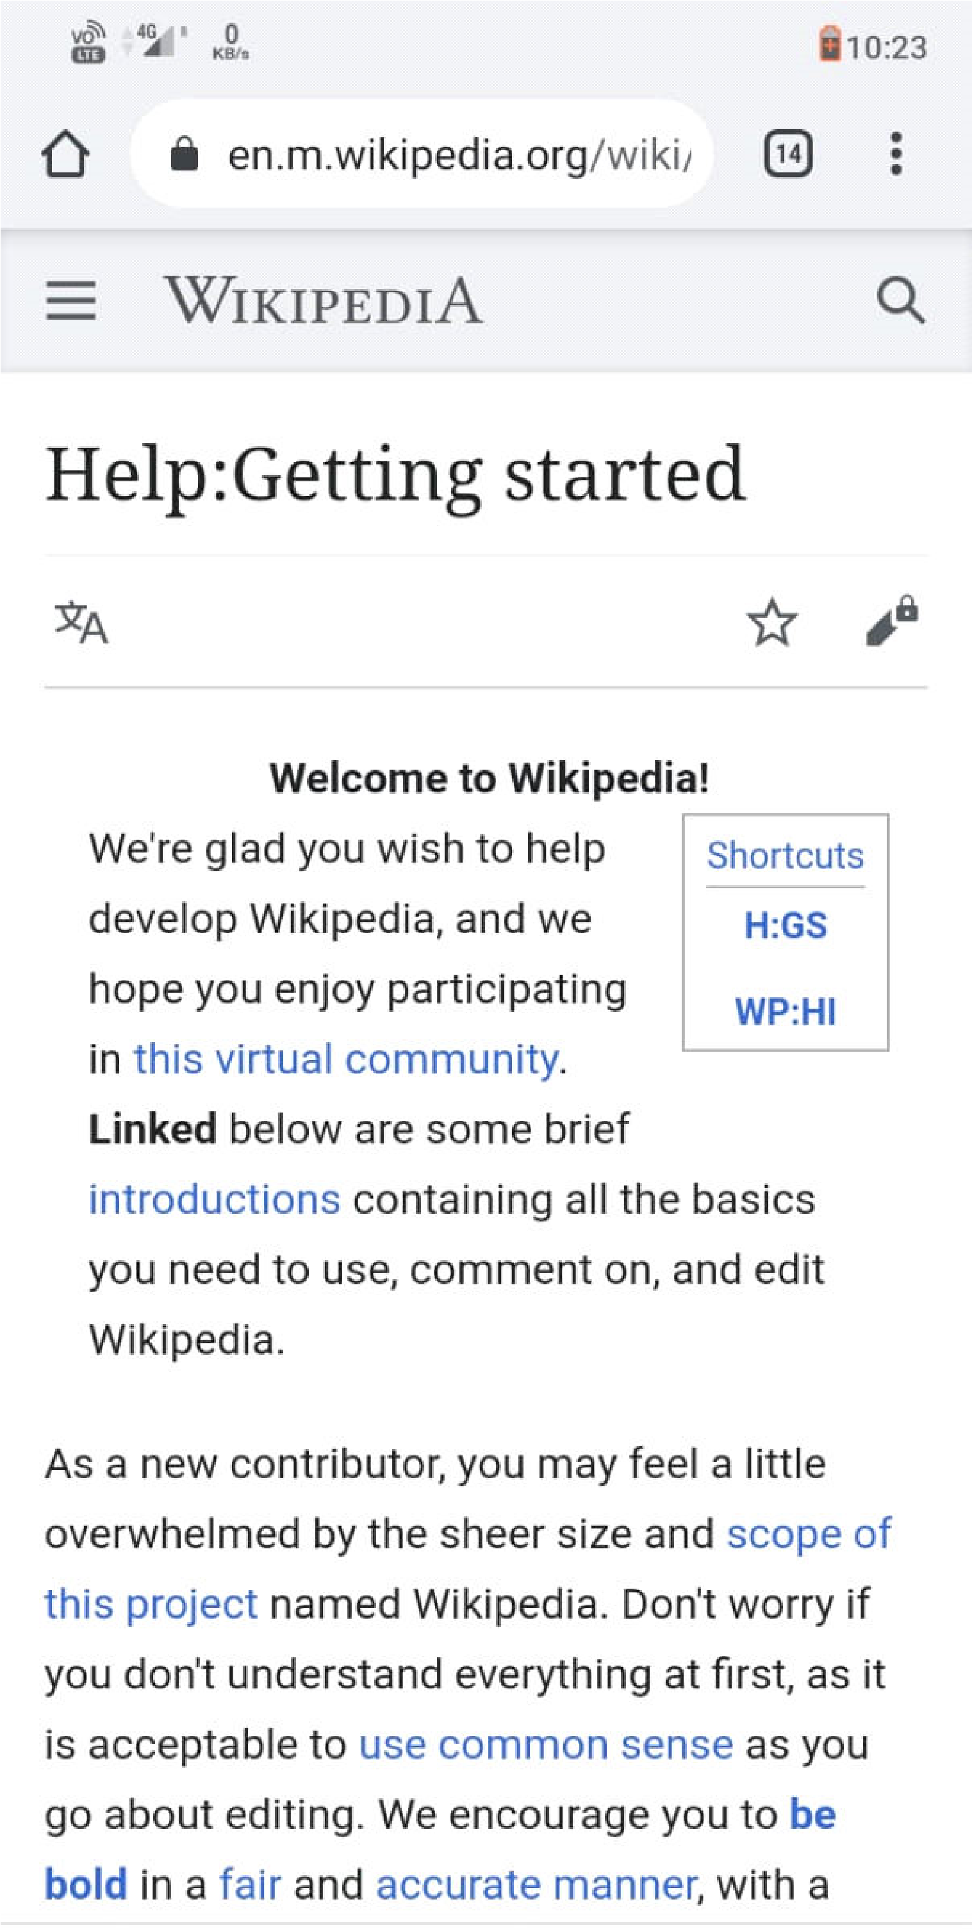

# Click on the source to write anything

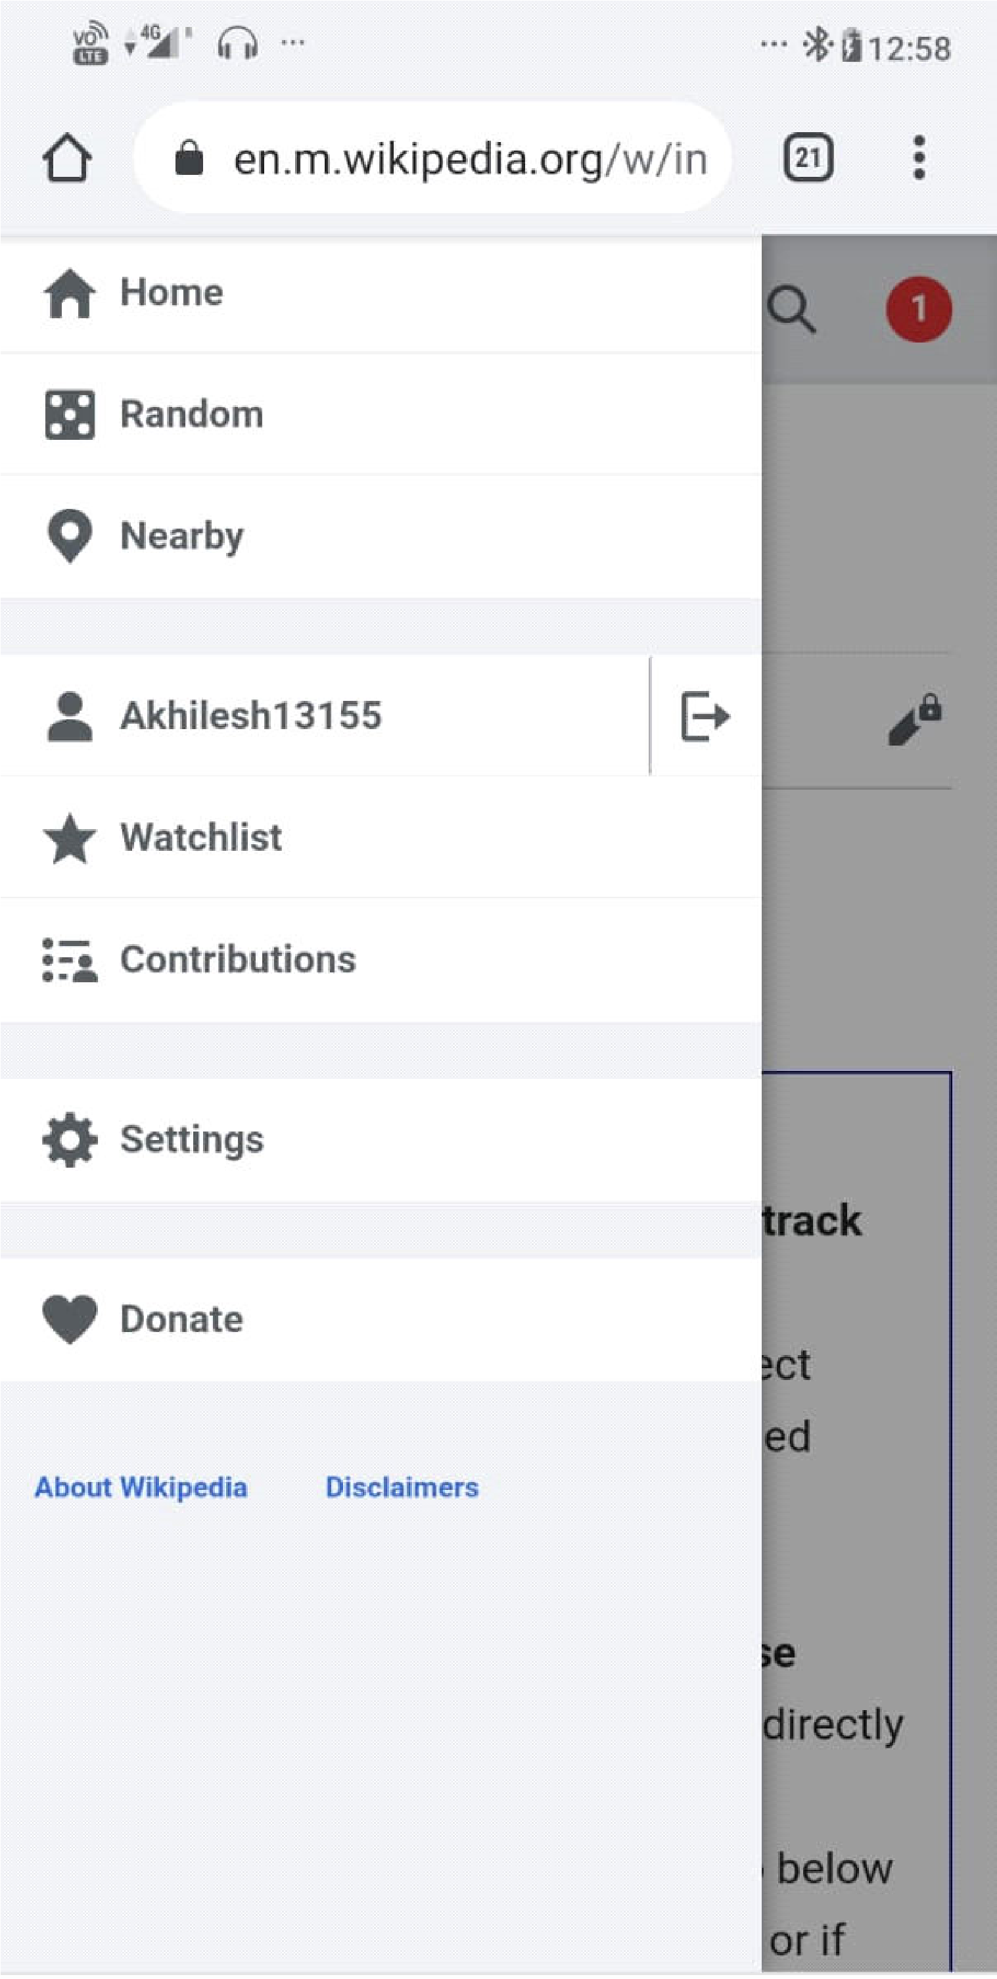

# write anything you want to wright

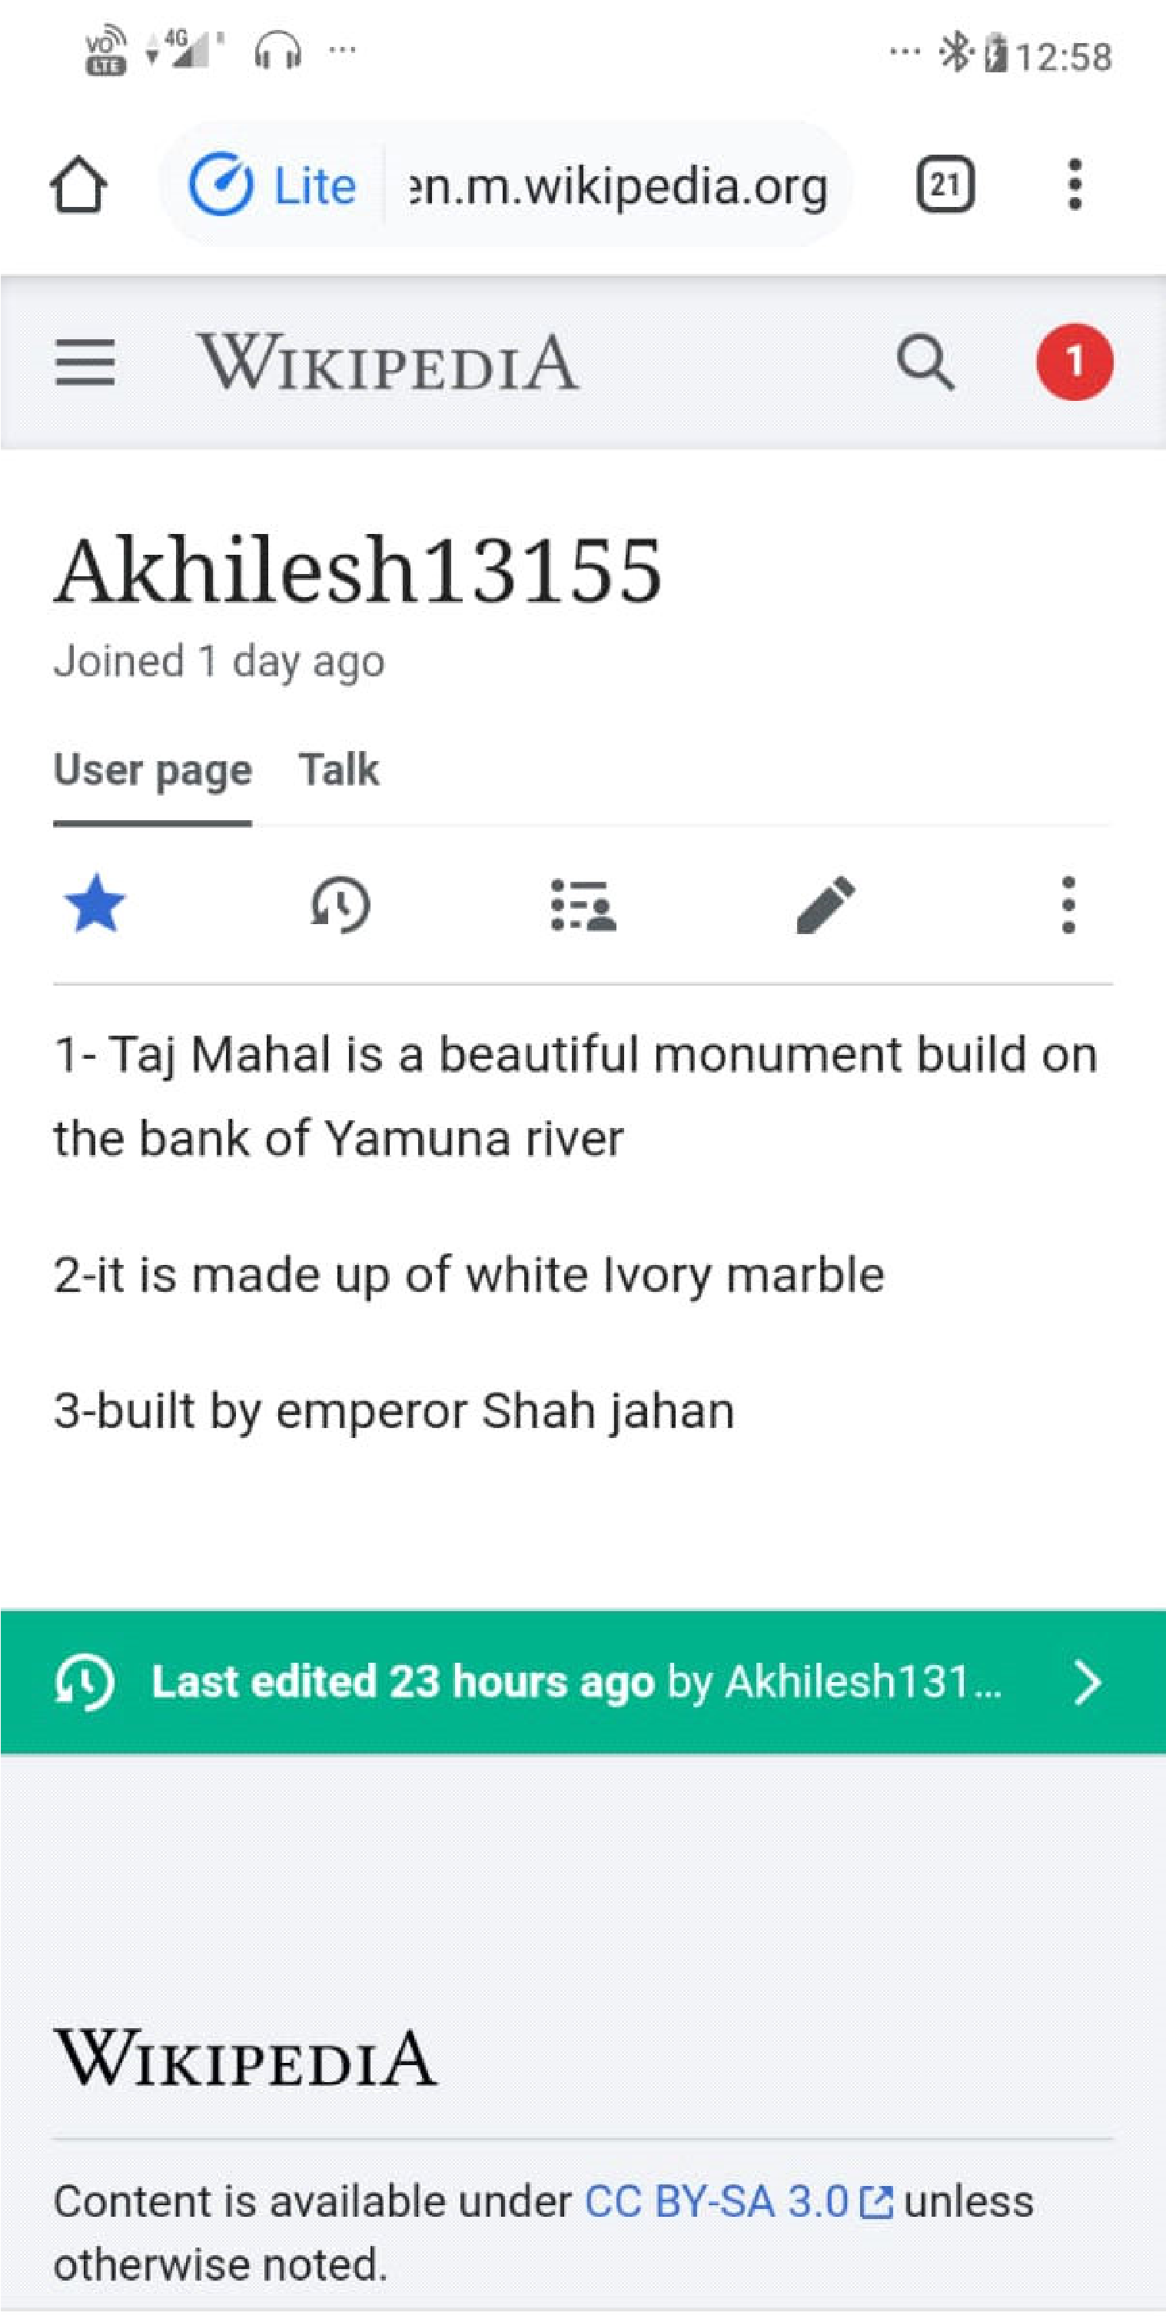

# After writing you can post it

