**Building a Comprehensive End-to-End Testing Suite for "Demowebshop" E-commerce Application Using Cypres**s

**Overview**

This is the documentation of the demo webshop website and this contains the test cases of multiple features for an e-commerce website <https://demowebshop.tricentis.com>. This test suite performs: Home page navigation, Search for products, Viewing product details, Cart management, User Registration, Login/Logout Process, Checkout process.

Note: The Application homepage is referred as homepage in the document

**Test Suites and Cases**

**1. Test Case: Homepage Navigation**

**Objective**

To verify that the homepage of the e-commerce site loads correctly, ensuring that the logo, category navigation menu, and specific categories such as Books and Computers are visible to users.

**Description**

This test case ensures that the homepage displays essential elements like the website logo and the category navigation menu. It verifies the visibility of key categories such as Books and Computers. The test begins by visiting the homepage using cy.visit('https://demowebshop.tricentis.com'). It then checks the visibility of the site logo with cy.get('.header-logo > a'). Next, it verifies the presence of the category navigation menu using cy.get('.block-category-navigation .list'). Finally, it confirms the presence of the "Books" and "Computers" categories within the navigation menu using .contains('Books') and .contains('Computers').

**Steps**

1. Visit the homepage.
2. Verify the logo is visible.
3. Check that the category menu is displayed.
4. Confirm the presence of the "Books" category.
5. Confirm the presence of the "Computers" category.

**Expected Results**

1. The website logo should be visible, ensuring that it is displayed to the user.
2. The category navigation menu should be visible, allowing users to navigate between different product categories.
3. The Books and Computers categories should be visible within the navigation menu.

**Output Obtained**

* The homepage was successfully loaded, with the logo and category navigation menu visible.
* Both Books and Computers categories were confirmed to be present in the category list.

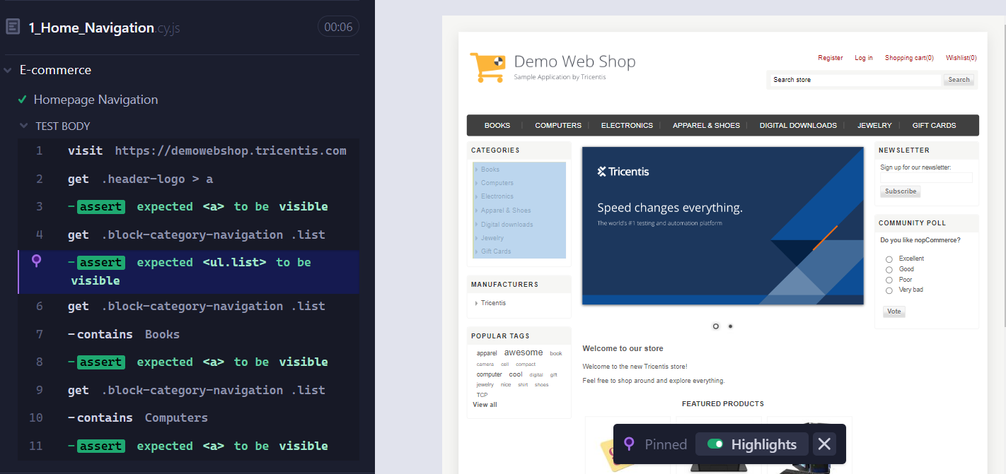

**2. Product Search**

**Objective**

To test the search functionality of the e-commerce site by entering different product name keywords and verifying that the search results. The goal is to ensure that relevant results are displayed for various product searches.

**Description**

This test case validates the ability of the search bar to retrieve and display relevant products based on the keywords entered. The process starts by navigating to the e-commerce homepage using cy.visit('https://demowebshop.tricentis.com') to load the site. Once the homepage is loaded, the search input field is located using cy.get('#small-searchterms'). The keyword "computer" is typed into the search field using the type() command. To execute the search, the search button is clicked using cy.get('form > .button-1').click(). After performing the search, the test verifies that the results contain the term "computer" by checking the presence of this keyword in the product details using cy.get('.details').should('contain.text', 'computer'). In the second part of the test, the keyword "gift card" is entered into the search input field using the type() command. The search is submitted again by clicking the search button. The final step involves verifying that the search results include the keyword "Gift Card", ensuring the search bar accurately returns products related to this query by using cy.get('.details').should('contain.text', 'Gift Card').

**Steps**

1. Visit the homepage.
2. Enter "computer" in the search box.
3. Click the search button to submit the search.
4. Verify that the results contain the keyword "computer".
5. Enter "gift card" in the search box.
6. Click the search button again to submit the search.
7. Verify that the results contain the keyword "Gift Card".

**Expected Results**

1. The search results for the keyword "computer" should include products that contain the term "computer" in their descriptions or titles.
2. The search results for the keyword "gift card" should include products that contain the term "Gift Card" in their descriptions or titles.

**Output Obtained**

* After searching for "computer", the search results successfully displayed products with the term "computer", confirming that the search functionality works for this keyword.
* Similarly, after searching for "gift card", the results included products with "Gift Card", verifying that the search functionality accurately retrieves relevant products for this query as well.

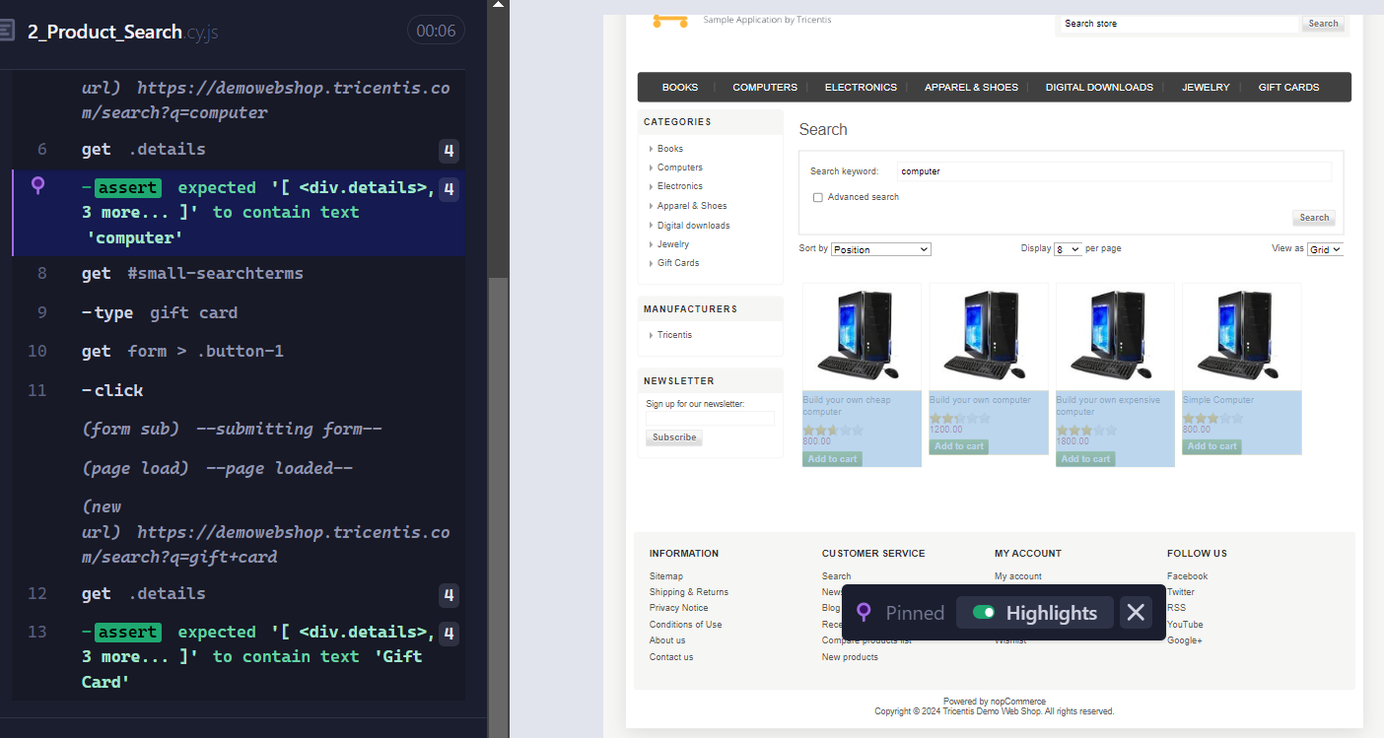

**3. Product Details**

**Objective**

Verify that product details, including title, stock status, and features, are displayed correctly, and ensure that users can successfully add the product to the cart with the desired quantity and selected options.

**Description**

This test case is designed to validate both the display of product details and the functionality of adding a product to the cart. The test begins by navigating to the e-commerce homepage using cy.visit(). The search input field is located using cy.get('#small-searchterms'), where the keyword "computer" is entered. The search is submitted by clicking the search button with cy.get('form > .button-1').click(). From the search results, the product "Build your own cheap computer" is selected by clicking on the product image using cy.get("img[title='Show details for Build your own cheap computer']").click(). On the product details page, the test ensures that the product title is correctly displayed using cy.get('h1').should('contain', 'Build your own cheap computer'). The stock status is confirmed to show "In stock" using cy.get('.stock').should('contain', 'In stock'). Next, the test checks specific product features, starting with the "Fast" option, using cy.get('.attributes').should('contain', 'Fast'). The checkbox for "8 GB" is selected with cy.get('#product_attribute_72_5_18_65').click(). Additional features such as "400 GB," "Image Viewer," and "Office Suite" are verified by locating the appropriate checkboxes and ensuring the selections are applied correctly. The quantity field is then cleared and updated to 2 using cy.get('#addtocart_72_EnteredQuantity').clear().type('2'). The "Add to Cart" button is clicked using cy.get('#add-to-cart-button-72').click(). Finally, the test confirms that the product was successfully added to the cart by checking for the presence of a confirmation message using cy.get('.content').should('contain', 'The product has been added to your cart'). This test ensures that the product details page functions correctly and that users can successfully add items to their shopping cart.

**Steps**

1. Visit the homepage (https://demowebshop.tricentis.com).
2. Search for 'computer' using the search bar.
3. Click on the product 'Build your own cheap computer' from the search results.
4. Verify the product details, including the product title, stock status, and product features.
5. Select product options and set the quantity to 2.
6. Click the 'Add to cart' button to add the product to the shopping cart.
7. Verify that the product has been successfully added to the cart by checking the confirmation message.

**Expected Results**

1. The product title should include 'Build your own cheap computer' and the stock status should show 'In stock'.
2. Product features and selected options (e.g., "Fast", "8 GB", etc.) should display and function correctly.
3. The product should be successfully added to the cart with a confirmation message confirming the action.

**Output Obtained**

* After searching for 'computer', the product 'Build your own cheap computer' was successfully displayed in the search results, and clicking on the product led to the correct product details page.
* The product title was correctly displayed as 'Build your own cheap computer', and the stock status showed 'In stock' as expected.
* The product features, such as 'Fast', '8 GB', '400 GB', 'Image Viewer', and 'Office Suite', were all correctly displayed.
* The quantity was successfully updated to 2, and upon clicking the 'Add to Cart' button, the product was added to the cart.
* The confirmation message, 'The product has been added to your cart', appeared, verifying that the product was successfully added to the cart with the correct options and quantity.

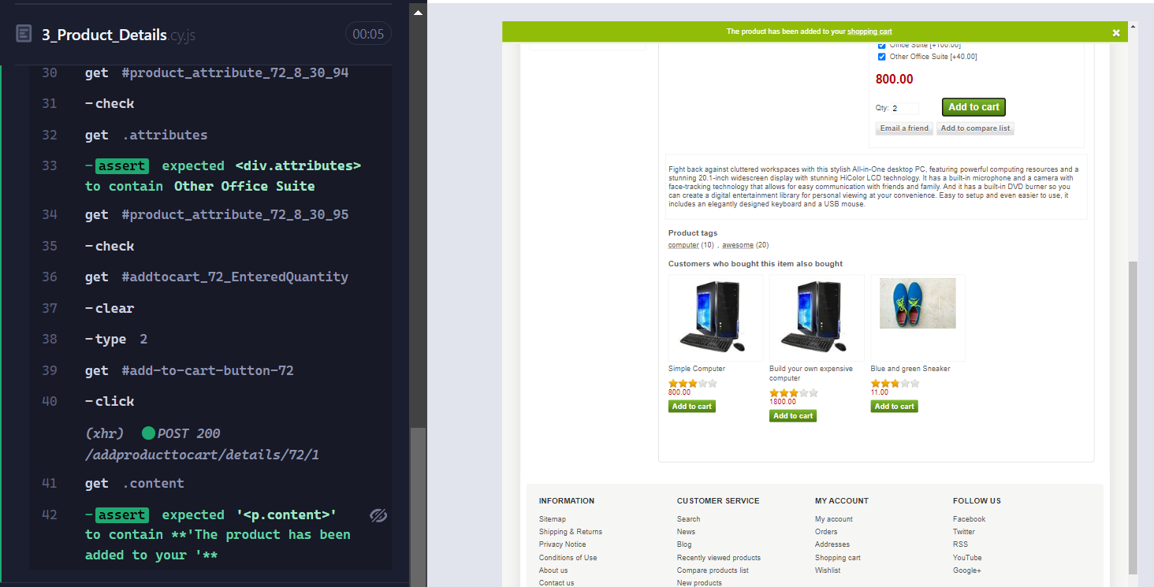

**4. Cart Management**

**Objective**

To test cart management functionalities by adding multiple items to the cart, validating the total number of items and cart value, and then removing specific items to verify the updated totals.

**Description**

This test case involves the process of adding multiple items to the shopping cart, validating the total number of items and the total cart value, and then removing certain items to ensure that the cart reflects these changes accurately. The test begins by navigating to the e-commerce homepage using cy.visit(). After loading the homepage, multiple items are added to the cart by using a custom Cypress command, cy.SearchAndAddItems(), which performs searches based on keywords like "music", "laptop", and "phone" and adds corresponding products to the cart. Once the items have been added, the test navigates to the shopping cart by clicking the cart icon using cy.get('.ico-cart > .cart-label').click(). The total number of items in the cart is validated by summing up the quantities of each product using cy.get('.qty-input').each() and comparing the result to the total cart quantity displayed via cy.get('.cart-qty').invoke('text'). Following this, the total cart value is validated by summing up individual product subtotals using cy.get('.product-subtotal').each() and comparing the sum to the total cart value using cy.get('.product-price > strong').invoke('text'). After validating the totals, the test removes specific items from the cart by selecting the relevant checkboxes and clicking the "Update Cart" button using cy.get('.update-cart-button').click(). The test then revalidates the updated total number of items and the total cart value, ensuring that the cart correctly reflects the removal of items.

**Steps**

1. Visit the homepage.
2. Use the custom command cy.SearchAndAddItems() to add multiple items (e.g., music items, laptop, and phone) to the cart.
3. Navigate to the shopping cart by clicking the cart icon.
4. Validate the total number of items in the cart by comparing the quantities of each item with the displayed total.
5. Validate the total cart value by summing individual product subtotals and comparing it to the displayed cart total.
6. Remove specific items from the cart by selecting checkboxes and updating the cart.
7. Validate the updated total number of items and the total cart value after item removal.

**Expected Results**

1. Cart management is done
2. The total number of items in the cart should match the quantity displayed in the cart icon.
3. The total cart value should match the sum of the individual item subtotals.
4. After removing items, the updated total number of items and the total cart value should reflect the changes accurately.

**Output Obtained**

* Multiple items, including music items, laptop, and phone, were successfully added to the cart using the custom command cy.SearchAndAddItems().
* The total number of items in the cart was validated by summing the item quantities, and it matched the total quantity displayed in the cart icon.
* The total cart value was accurately calculated by summing individual item subtotals, and it matched the displayed total cart value.
* After removing specific items from the cart, the updated total number of items and the total cart value were correctly updated, reflecting the changes made by the user.

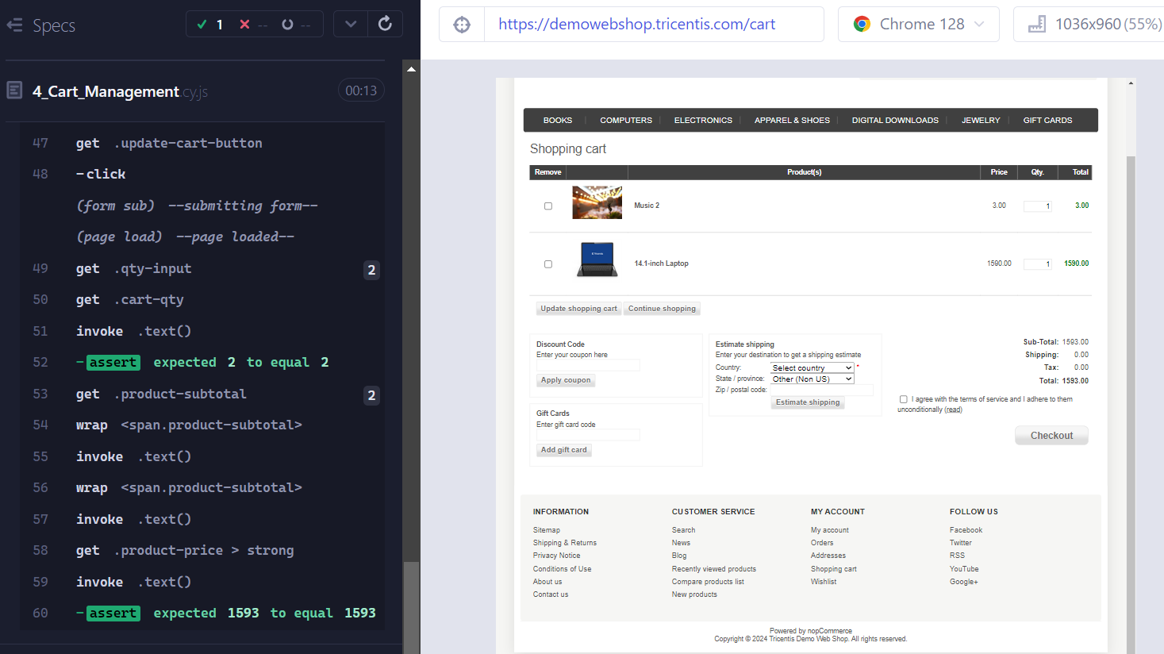

**5.User Registration**

**Objective**

To test the user registration process with various valid and invalid inputs to ensure proper validation and registration handling.

**Description**

This test case verifies the registration process by submitting both valid and invalid details. It ensures that valid registrations are processed successfully and invalid registrations trigger appropriate error messages. The test begins by visiting the registration page using cy.visit(). For valid registration, the test selects the male gender option with cy.get('#gender-male').check(), enters valid first name, last name, email, and password, and submits the form by clicking the register button using cy.get('#register-button').click(). Successful registration is confirmed by checking for a completion message and verifying automatic login. For invalid registration, the test inputs incorrect or incomplete details (such as an invalid email format or mismatched passwords), submits the form, and verifies that appropriate error messages are displayed.

**Steps**

1. Visit the registration page.
2. For valid registration:

* Select the male gender option.
* Enter valid details (first name, last name, email, and password).
* Submit the form.
* Confirm successful registration and automatic login.

1. For invalid registration:

* Visit the registration page again.
* Enter invalid or incomplete details (e.g., incorrect email format, mismatched passwords).
* Submit the form.
* Verify that appropriate error messages are displayed and the registration is not completed.

**Expected Results**

1. **Valid Registration:**

* The user receives a successful registration confirmation message.
* The user is automatically logged in and visible in the account section.

1. **Invalid Registration:**

* Appropriate error messages are displayed for each invalid input.
* The registration process is not completed, and the user is not logged in.

**Output Obtained**

* For valid details, the user was successfully registered, received a confirmation message, and was automatically logged in.
* For invalid details, appropriate error messages were displayed, and the registration process was not completed.

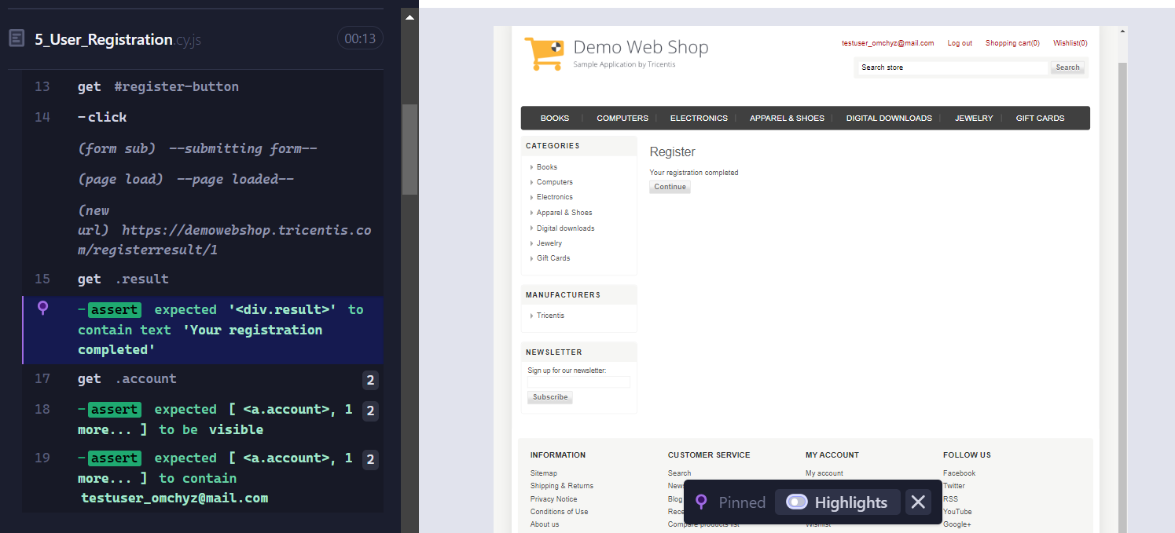

**Test Case: Verifying Validation errors when required fields are left empty**

**Objective**

To verify that the user registration process displays appropriate validation errors when required fields are left empty.

**Description**

This test verifies the registration process when required fields are not filled in. It ensures that the system displays the necessary validation errors for missing fields. The test begins by navigating to the registration page using cy.visit(). Once on the page, the form is submitted without providing any input for the required fields. After submission, the test checks for validation error messages corresponding to the missing fields to confirm that the system correctly handles incomplete registration attempts.

**Steps**

1. Visit the registration page.
2. Attempt to register by leaving all required fields empty.
3. Submit the form.
4. Verify that error messages are displayed for each missing field.

**Expected Results**

* Error messages should be displayed for each required field left empty, confirming the system’s validation process for incomplete form submissions.

**Output Obtained**

* 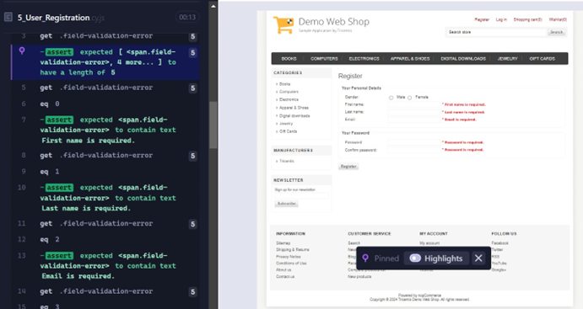Error messages indicating missing fields were successfully displayed, confirming that the system properly handles incomplete registration attempts.

**Test Case: Invalid User Registration with Invalid Email**

**Objective**

To verify that the user registration process displays an appropriate error message when an invalid email format is entered.

**Description**

This test case ensures that the registration process identifies and displays an error for an invalid email format while other fields are correctly filled. The test starts by visiting the registration page using cy.visit(). The form is completed with a valid input for all fields except the email field, which contains an invalid email format. After submitting the form, the test checks for an error message related to the incorrect email format.

**Steps**

1. Visit the registration page.
2. Enter valid details in all required fields except the email field, where an invalid email format is provided.
3. Submit the registration form.
4. Verify that an error message indicating the email format is incorrect is displayed near the email input field.

**Expected Results**

* An appropriate error message should be displayed, indicating that the email address is not in the correct format.

**Output Obtained**

* An error message for the invalid email format was successfully displayed, confirming that the system correctly handles invalid email addresses.

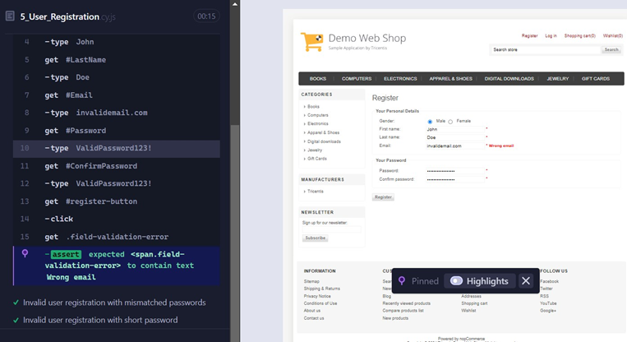

**Test Case: Invalid User Registration with Mismatched Passwords**

**Objective**

To verify that the user registration process displays an appropriate error message when the passwords do not match.

**Description**

This test case ensures that the registration process correctly identifies and displays an error for mismatched passwords while other fields are correctly filled. The test starts by visiting the registration page using cy.visit(). The form is completed with valid details for all required fields except for the password fields, where a valid password is entered in the password field and a different password is entered in the confirm password field. After submitting the form, the test checks that an error message indicating the passwords do not match is displayed.

**Steps**

1. Visit the registration page.
2. Enter valid details in all required fields, including a valid username.
3. Enter a valid password in the password field and a different password in the confirm password field.
4. Submit the registration form.
5. Verify that an error message indicating the passwords do not match is displayed near the confirm password input field.

**Expected Results**

* An appropriate error message should be displayed, indicating that the passwords do not match.

**Output Obtained**

* An error message for mismatched passwords was successfully displayed, confirming that the system correctly handles password mismatches.

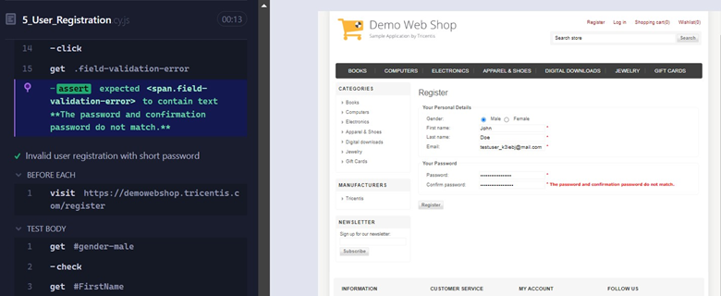

**6. User Login/Logout**

**Objective**

To test the login and logout functionalities to ensure they work correctly with both valid and invalid credentials.

**Description**

This test case verifies the login and logout processes by testing both successful and failed login attempts. It confirms that logging in with valid credentials works as expected, handles invalid login attempts correctly, and ensures that logout functionality operates properly. The test begins by navigating to the login page and performing a successful login with valid credentials. Success is confirmed by checking for visible user account details and logout options. After logging out, it verifies that the login link reappears. The test then attempts to log in with invalid credentials and checks for an appropriate error message. Finally, it tests a successful login again with valid credentials to ensure the login functionality remains consistent.

**Steps**

1. Visit the login page.
2. Login with valid credentials:
   * Click the login link.
   * Enter valid email and password.
   * Submit the form.
   * Verify successful login by checking for user account details and the logout button.
3. Logout:
   * Click the logout link.
   * Verify successful logout by checking that the login link is visible again.
4. Attempt login with invalid credentials:
   * Click the login link.
   * Enter invalid credentials.
   * Submit the form.
   * Verify that an error message indicating the login was unsuccessful is displayed.
5. Re-login with valid credentials:
   * Enter valid email and password.
   * Submit the form.
   * Verify successful login by checking for user account details and the logout button.

**Expected Results**

1. Successful login and logout:

* The user should be able to log in successfully with valid credentials, see account details and the logout button, and log out to see the login link again.

1. Error message for failed login attempt:

* An appropriate error message should be displayed for invalid credentials, indicating the login attempt was unsuccessful.

1. Successful login after failed login attempt:

* After an unsuccessful login attempt with invalid credentials, logging in again with valid credentials should succeed, confirming the login functionality.

**Output Obtained**

* Successful login was achieved with valid credentials, logout was performed successfully, and the login link was visible post-logout.
* An error message was displayed for invalid credentials, confirming proper handling of failed login attempts.
* Re-login with valid credentials was successful, demonstrating consistent login functionality.

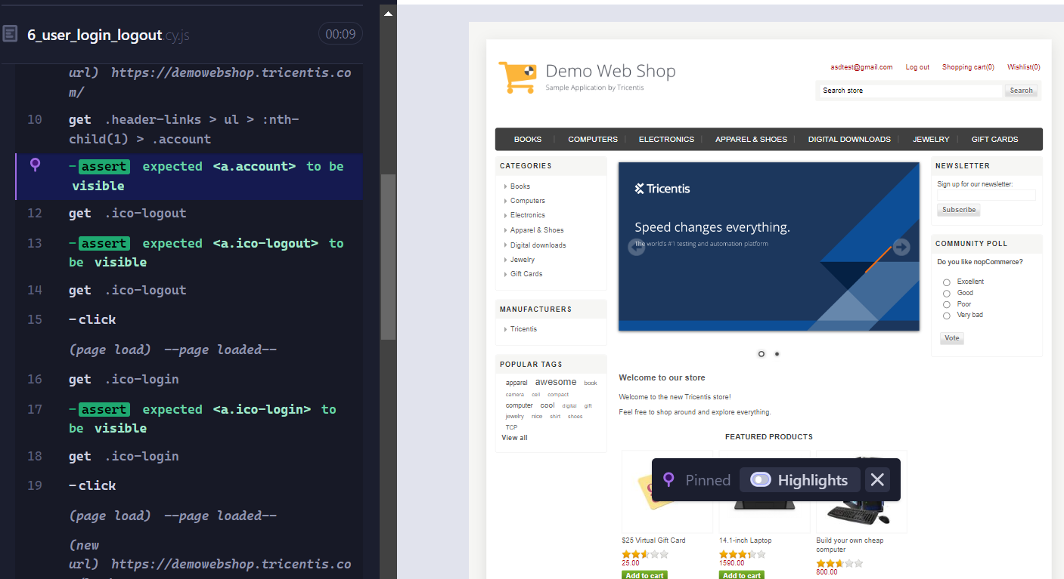

**7. Cart Checkout**

**Objective**

To verify the cart checkout process, including adding items to the cart, logging in, and completing the checkout process to ensure successful order placement and confirmation.

**Description**

This test case covers the entire cart checkout process for an e-commerce site. It starts by navigating to the homepage using cy.visit(). Multiple items are added to the cart by performing searches for different keywords such as "music," "laptop," and "phone" using the cy.SearchAndAddItems() custom command. The login link is then clicked with cy.get('.ico-login').click(), and the user logs in using valid credentials with cy.login('asdtest@gmail.com', '*iWa2_$jfn!aB'). After logging in, the cart is accessed by clicking on the cart icon with cy.get('.ico-cart > .cart-label').click(). The test proceeds by selecting a country from the dropdown using cy.get('#CountryId').select(1), agreeing to the terms of service with cy.get('#termsofservice').check(), and clicking the checkout button using cy.get('#checkout').click(). Subsequent steps include clicking buttons for billing, shipping, payment method, and payment information using their respective selectors. Finally, the order is confirmed by clicking the confirm order button with cy.get('#confirm-order-buttons-container > .button-1').click(). The test concludes by verifying the order confirmation message with cy.get('strong').should('contain', 'Your order has been successfully processed!'), ensuring the order was processed successfully.

**Steps**

1. Visit the homepage (<https://demowebshop.tricentis.com>).
2. Search for "music" and add two items to the cart.
3. Search for "laptop" and add the item to the cart.
4. Search for "phone" and add the item to the cart.
5. Click the login link and log in with valid credentials.
6. Navigate to the cart.
7. Select a country from the dropdown.
8. Check the terms of service checkbox.
9. Click the checkout button.
10. Proceed through the billing, shipping, and payment steps.
11. Confirm the order.
12. Verify the order confirmation message.

**Expected Results**

1. Items are successfully added to the cart.
2. Login with valid credentials is successful.
3. The checkout process completes without errors.
4. An order confirmation message is displayed, indicating successful order placement.

**Output Obtained**

* Items were successfully added to the cart.
* Login with valid credentials was successful.
* The checkout process was completed without errors.
* The confirmation message "Your order has been successfully processed!" was displayed, confirming successful order placement.

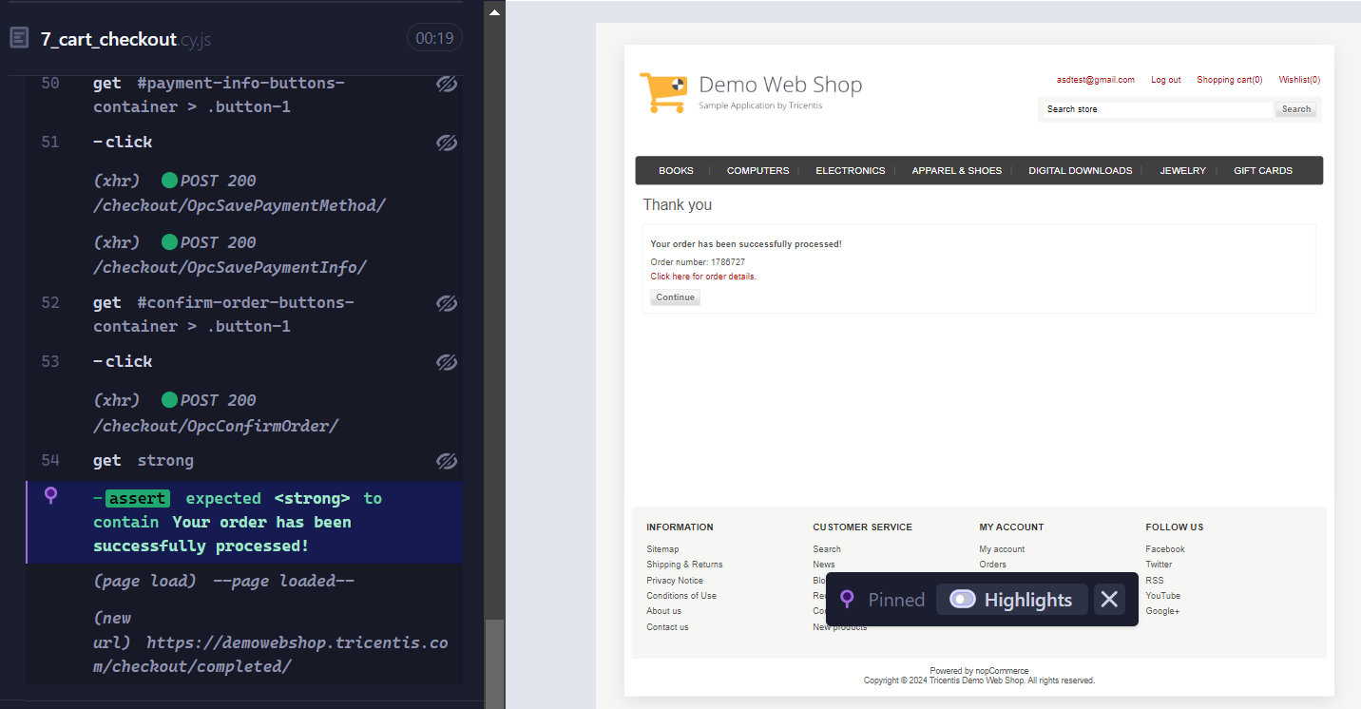

**Mocking and Stubbing**

**Objective**

To use cy.intercept() to mock an API response in Cypress, allowing for isolated and predictable testing of frontend code.

**Test Case: Mock API Response with cy.intercept()**

**Description**

This test case demonstrates how to mock an API response using cy.intercept() in Cypress. By intercepting the API request and providing a mocked response, we can test the frontend code without relying on the actual backend API. The test involves visiting the Demowebshop login page, intercepting the GET request to the login API, and returning a mocked response with a status code of 200 and sample user data.

**Steps**

1. Visit the Demowebshop Login Page.
2. Intercept the GET request to the login API.
3. Return a mocked response with a status code of 200 and specific body content.
4. Click the login button.

**Expected Results**

* Verify that the mocked data is processed correctly.

**Output Obtained**

* The test displayed the mocked user data, it handles the API response as expected.

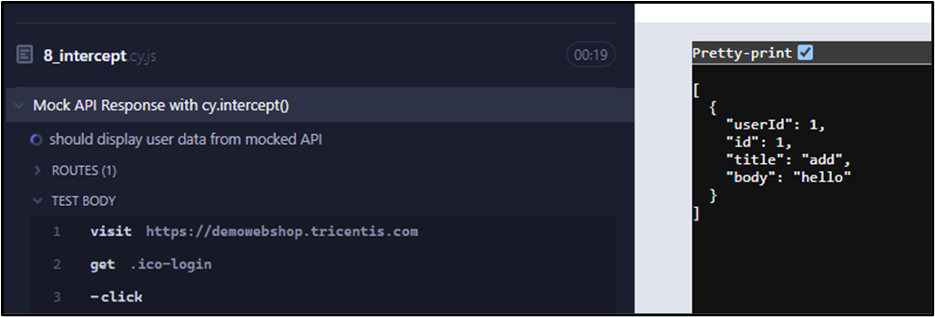

**Data Management**

**Objective**

To verifying of Getting data from the fixtures and do login functionality of the Demowebshop application, ensuring successful user authentication and account access.

**Description**

This test case comprehensively verify of Getting data from the fixtures the login functionality by simulating a user login attempt, validating the login process, and confirming the successful login. It covers various aspects of the login process, including user authentication, authorization, user interface, and error handling. The test ensures that the application correctly authenticates users with valid credentials, grants access to account-related features, displays account-related elements after login and handles invalid credentials and login errors appropriately.

**Steps**

1. Visit the Demowebshop login page and verify its availability.
2. Retrieve valid login credentials (email and password) from the "example" fixture file.
3. Perform login with the retrieved credentials, simulating a user login attempt.
4. Wait for the login process to complete, allowing the application to authenticate the user.
5. Verify the visibility of the account link, confirming successful login and account access.

**Expected Results**

* The login functionality works as expected.
* The user is successfully authenticated and authorized to access their account.
* The application correctly displays account-related elements after login.
* The application handles invalid credentials and login errors appropriately.

**Authentication Login Using Token**

**Objective**

To thoroughly verify the login functionality using a token stored in local storage, ensuring successful user authentication and account access.

**Description**

This test case extensively verifies the login process using a token stored in local storage, encompassing various critical aspects. It begins by storing the token in local storage, containing the user's email and password. Subsequently, it retrieves the token and utilizes it for login authentication. The test ensures that the token is correctly stored, retrieved, and used for successful login, granting the user access to their account. Furthermore, it verifies that the login credentials are accurately authenticated, and the user is successfully logged in. The test also includes logging out from the application.

**Steps**

1. Visit the Demowebshop login page.
2. Set the token in local storage with email and password.
3. Login using the stored token credentials.
4. Verify successful login by checking the account email display.
5. Log out from the application.

**Expected Results**

* The test should successfully login using the token stored in local storage, display the account email, and log out without errors. The token should be correctly stored and retrieved from local storage, and used for successful login authentication. The user should be granted access to their account, and the login credentials should be accurately authenticated.

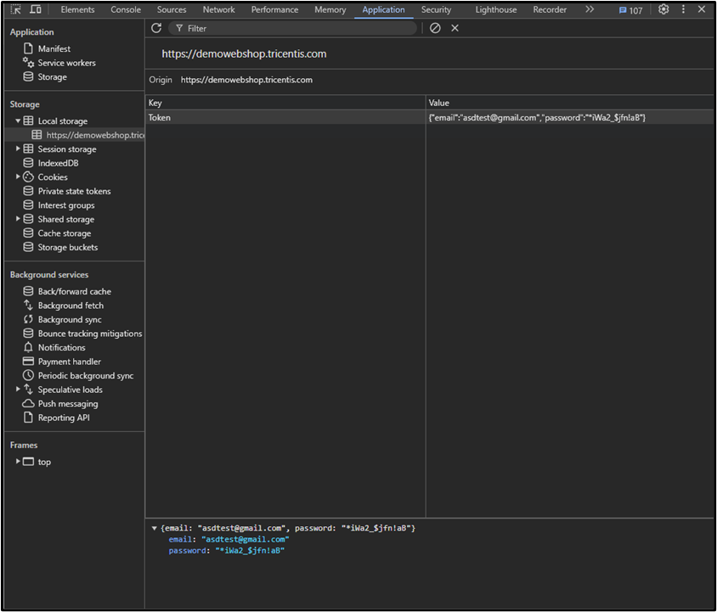



**Visual Testing**

**Objective**

To verify the visual integrity of the Demowebshop login page through screenshot comparison.

**Description**

This test case performs visual testing by capturing a screenshot of the Demowebshop login page and comparing it to a baseline image. The comparison ensures that any unintended visual changes to the page are detected, maintaining the application's visual consistency. The test focuses on the login page's logo area, verifying its layout, spacing, and graphical elements. By using image comparison, the test detects even minor visual regressions, such as layout changes, color scheme modifications, font style or size adjustments, and image distortions.

**Steps**

1. Visit the Demowebshop login page.
2. Capture a screenshot of the login page's logo area.
3. Compare the screenshot to a baseline image using image comparison.

**Expected Results**

* 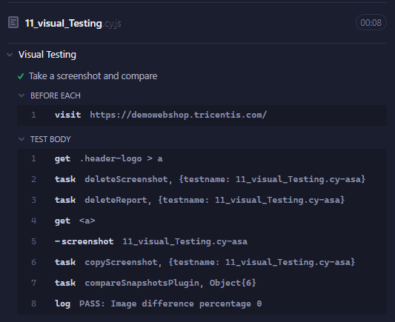The test should successfully compare the screenshot to the baseline image, verifying that the login page's logo area matches the expected visual layout and no visual regressions or unintended changes are detected, with a comparison tolerance level of 1.0.

**Custom Commands**

**Objective**

To verify the login functionality of the Demowebshop e-commerce application using custom commands.

**Description**

This test case verifies the login functionality of the Demowebshop application by utilizing custom Cypress commands. The test visits the application's login page, clicks the login link, and uses the custom login command to authenticate with valid credentials. It then verifies that the user is successfully logged in by checking the account email display and logout button visibility.

**Steps**

1. Visit the Demowebshop application.
2. Click the login link.
3. Use the custom login command to authenticate with valid credentials.
4. Verify the account email display after successful login.
5. Verify the logout button visibility.

**Expected Results**

* The test should successfully log in to the application using the custom login command, display the account email, and show the logout button.

**Output Obtained**

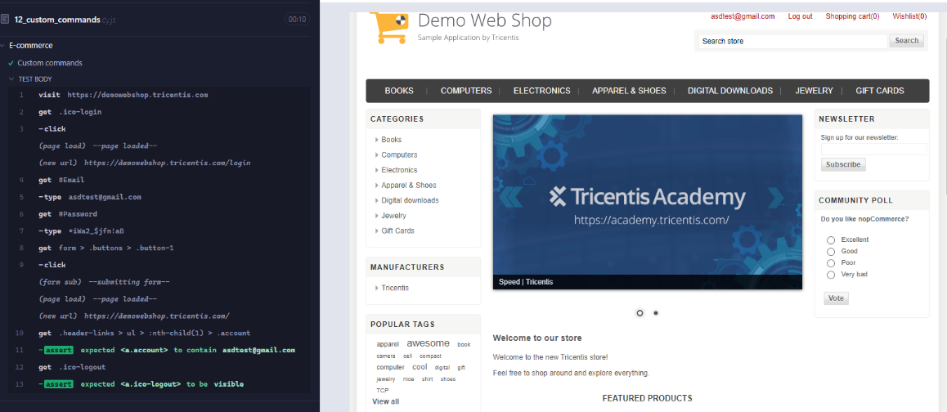

**CI/CD Integration(GitHub Actions)**

**Objective**

To establish a continuous integration and continuous deployment (CI/CD) pipeline using GitHub Actions, automating Cypress tests on each commit or pull request.

**Description**

This pipeline integrates Cypress testing with GitHub Actions, automating test execution on each code commit or pull request. It ensures timely detection of bugs and maintains code quality by running Cypress tests in a continuous integration environment.

**Steps**

1. Create a new YAML file in the .github/workflows directory.
2. Define the workflow, specifying the event trigger (push, pull request).
3. Install dependencies and checkout code.
4. Run Cypress tests using the cypress/run command.
5. Report test results using GitHub Actions' built-in reporting features.

**Expected Results**

* The pipeline should successfully:
* Automate Cypress test execution on each commit or pull request.
* Report test results, including pass/fail status and error messages.
* Display test results in the GitHub Actions workflow interface.
* Fail the workflow if any Cypress tests fail.

**Output**

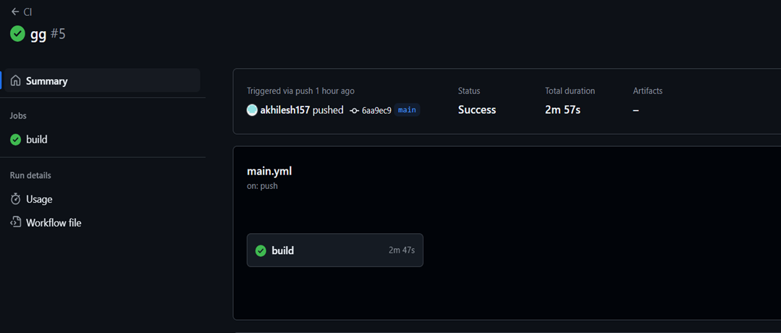

**Reporting and Debugging**

**Objective**

To generate detailed and insightful test reports using Cypress and Mochawesome, enabling thorough analysis and debugging of test execution results.

**Description**

This process involves configuring Cypress to utilize the Mochawesome reporter, which produces comprehensive test reports in HTML or JSON format. These reports provide a clear and detailed summary of test execution, facilitating the identification of issues and debugging.

**npm install --save-dev mochawesome mochawesome-report-generator cypress-mochawesome-reporter**

We need to configure the Cypress configuration file to get the HTML reports

**Steps**

1. Configure Cypress to use the Mochawesome reporter for generating test reports.
2. Run tests to generate reports in the desired format (HTML or JSON).
3. Review the reports to analyze test results, identify issues, and debug as necessary.

**Expected Results**

* Test suite and case names
* Test results (pass/fail/skip)
* Error messages and stack traces
* Screenshots and videos (optional)
* Test execution time and duration

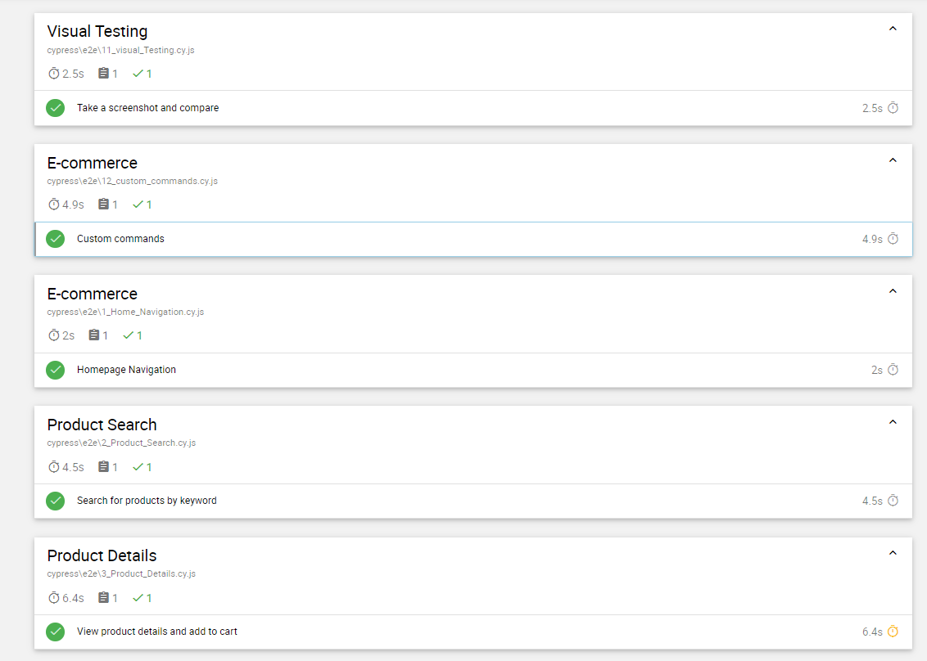**Output Obtained**

**Challenges:**

* Secure Authentication
* Test Data Management
* CI/CD Integration
* Managing Long and Repetitive Code
* Debugging Failed Test Cases

**Overcome:**

* **Manage Dynamic Content:** Implemented effective waits and retries to handle dynamic content variations.
* **Streamline Code:** Applied custom commands to minimize repetitive code and improve maintainability.
* **Secure Authentication and Test Data Management:** Used fixtures to ensure consistent test data handling and secure token storage.
* **CI/CD Integration:** Automated testing and deployment through GitHub Actions, ensuring smooth integration with the CI/CD pipeline.
* **Enhance Debugging and Reporting:** Captured visual evidence of application states during test execution and generated HTML reports to aid in debugging.

**Future Aspects**

* **Expanding Test Coverage:**

Incorporate additional user scenarios and edge cases as the application evolves.

* **Improved Test Data Management:**

Develop more test data and more complex fixtures to simulate various scenarios.

* **Parallel Test Execution:**

Utilize parallel test execution to reduce test run times and speed up the execution

**Conclusion**

The "Comprehensive End-to-End Testing Suite for MyShop" project successfully achieved its objective of ensuring the functionality, performance, and reliability of the e-commerce application through robust Cypress testing. Key accomplishments include:

* **Comprehensive Test Coverage**: Developed a wide range of tests encompassing critical user scenarios such as homepage navigation, product search, product details, cart management, user registration, login/logout functionality, and checkout processes.
* **Advanced Testing Features**: Implemented custom commands, mocking and stubbing of API responses, handling of authentication, data management using fixtures, and integrated visual testing tools to enhance test effectiveness and coverage.
* **CI/CD Integration**: Set up a CI/CD pipeline using GitHub Actions or Jenkins to automate the execution of Cypress tests on each commit or pull request, ensuring continuous integration and timely detection of issues.
* **Effective Reporting and Debugging**: Configured Cypress to generate detailed test reports and utilized built-in debugging tools like screenshots and video recordings to diagnose and resolve test failures effectively.