WEBSITE + MAP SPECIFICATION

01 / Landing Page / Overview
  - Use this with its matching PNG and implementation prompt. It requires real functional work, not just CSS.

Purpose and target user
Keep the user’s actual finished landing page rather than replacing it Primary user: Food Safety Operations Director for a regional U.S. grocery retailer. Expected codebase: E:\VulneraSafe_AI, Python offline + validated versioned artifacts → existing React/TypeScript/Vite static site.

Functional and analytical requirements
Explain purpose, three pathogens, vulnerable groups, One Health sources and one prominent route into the analytical workspace. Preserve the existing high-quality white/navy/teal look.

Exact source classes and availability rules
Real project-wide audited counts; source-status summaries; genuine data vintage only. No pretend live recall cards or invented impact metrics.

User interactions Kiro must implement
Overview → pathogen intelligence and vulnerable communities; visible provenance; responsive navigation.

Required new science / dependencies
No new risk model; supports storytelling and verified summary artifacts.

Design direction
Static hero, clean metric blocks, slim One Health explanation and links to all scientific capabilities. Match the existing landing page: navy→teal gradient hero, spacious white sections, refined typography, accessible controls; prefer one substantial visual at a time.

Scientific safety and claims guardrails
Navigation changes route; keyboard access; keep observed/predicted/simulated distinctions; clear external-data staleness.

Artifact contract + implementation process
Inspect existing schemas and paths before deciding filenames. Add a schema-checked versioned artifact (OBSERVED/PREDICTED/SIMULATED) with pathogen, geography, period, dataset provenance, generated_at and missingness. Run the relevant offline Python analysis or reuse validated existing artifacts; include missing-data status. Integrate typed frontend fetch and real map interactions. Update manifest/checksums. Run project tests and npm production build. No remote Python at GitHub Pages runtime.

Definition of done / browser review
1) A browser route exists and loads using artifacts from the current repository. 2) Controls alter visible measured values and maps rather than decorative text. 3) Data gaps are labeled unavailable. 4) Existing code/tests remain working. 5) Report source counts, generated artifact, tests, build output and actual local route. 6) STOP for user review before the next screen.

Matching approved visual reference
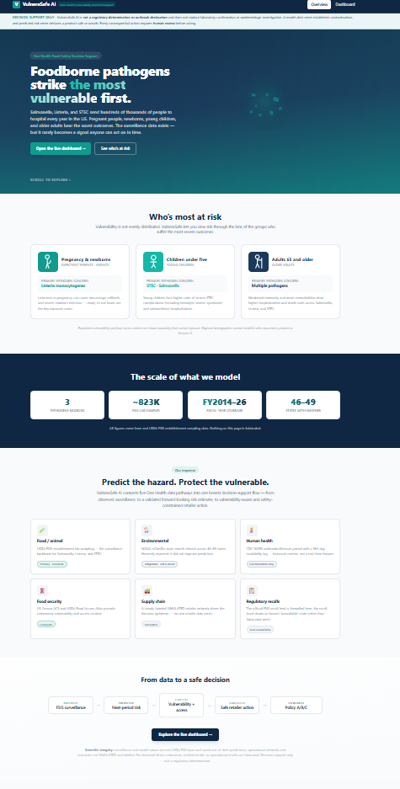
VISUAL CONCEPT ONLY — values, status badges, locations, product claims and alerts in mockups are not project observations.
Styling reference only. This does NOT authorize use of invented percentages, live disease claims, unverified recalls, fictional suppliers, or unsupported countrywide data.

