WEBSITE + MAP SPECIFICATION

02 / Risk Dashboard / Decision Overview
  - Use this with its matching PNG and implementation prompt. It requires real functional work, not just CSS.

Purpose and target user
Provide a compact executive overview for the Food Safety Operations Director Primary user: Food Safety Operations Director for a regional U.S. grocery retailer. Expected codebase: E:\VulneraSafe_AI, Python offline + validated versioned artifacts → existing React/TypeScript/Vite static site.

Functional and analytical requirements
Pathogen selector, current state-period surveillance risk map, historical trend with intervals, model-status badge and top-K queue. Change horizon for monthly Salmonella versus quarterly Listeria/STEC.

Exact source classes and availability rules
Validated FSIS v2 model predictions, actual observed routine positivity, uncertainty, time/region coverage, rank and source freshness.

User interactions Kiro must implement
Select pathogen, state and forecast period; map selection filters trend, queue and evidence; switch predicted versus observed.

Required new science / dependencies
S01/S04/S10/S08; must compare baseline vs full before claiming new early warning.

Design direction
One state map + one trend chart + queue, not a collage of maps; clear small-page navigation. Match the existing landing page: navy→teal gradient hero, spacious white sections, refined typography, accessible controls; prefer one substantial visual at a time.

Scientific safety and claims guardrails
No model-specific alert if evidence/uncertainty missing. Never present predictive probability as contamination rate or human illness incidence.

Artifact contract + implementation process
Inspect existing schemas and paths before deciding filenames. Add a schema-checked versioned artifact (OBSERVED/PREDICTED/SIMULATED) with pathogen, geography, period, dataset provenance, generated_at and missingness. Run the relevant offline Python analysis or reuse validated existing artifacts; include missing-data status. Integrate typed frontend fetch and real map interactions. Update manifest/checksums. Run project tests and npm production build. No remote Python at GitHub Pages runtime.

Definition of done / browser review
1) A browser route exists and loads using artifacts from the current repository. 2) Controls alter visible measured values and maps rather than decorative text. 3) Data gaps are labeled unavailable. 4) Existing code/tests remain working. 5) Report source counts, generated artifact, tests, build output and actual local route. 6) STOP for user review before the next screen.

Matching approved visual reference
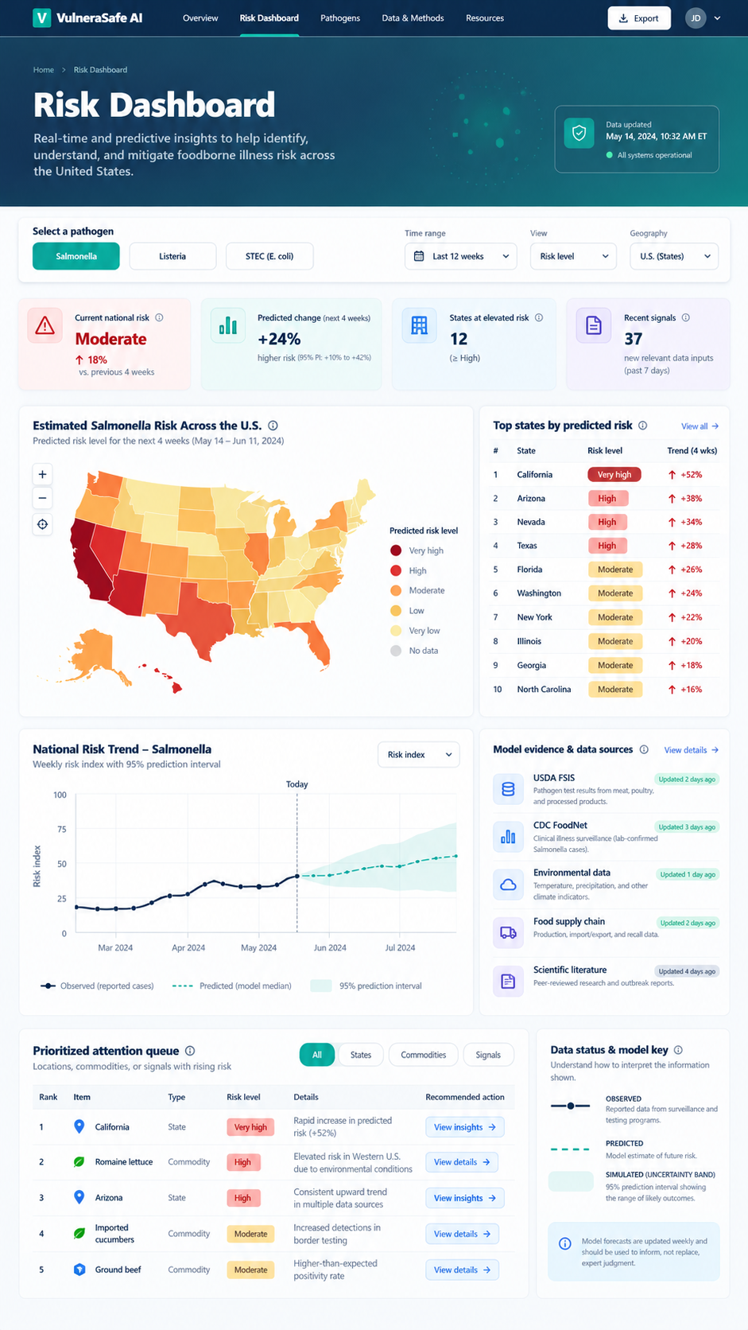
VISUAL CONCEPT ONLY — values, status badges, locations, product claims and alerts in mockups are not project observations.
Styling reference only. This does NOT authorize use of invented percentages, live disease claims, unverified recalls, fictional suppliers, or unsupported countrywide data.

