WEBSITE + MAP SPECIFICATION

03 / Three-Pathogen Explorer
  - Use this with its matching PNG and implementation prompt. It requires real functional work, not just CSS.

Purpose and target user
Make all three pathogens first-class scientific modules, not three labels on one Salmonella analysis Primary user: Food Safety Operations Director for a regional U.S. grocery retailer. Expected codebase: E:\VulneraSafe_AI, Python offline + validated versioned artifacts → existing React/TypeScript/Vite static site.

Functional and analytical requirements
Salmonella product/source and Campylobacter experiments; Listeria production_alternative and RTE-source patterns; STEC raw-beef programs, PCR coverage and uncertainty. Per-pathogen tab has real observed trends and its own evaluation report.

Exact source classes and availability rules
FSIS raw program tables for all three; product_type when present; sample_source_name, project_code; historical assay fields; predictions; feasibility/metrics.

User interactions Kiro must implement
Switch three pathogen tabs; compare product/program distribution; drill into state and product/assay coverage; show unavailable assay fields explicitly.

Required new science / dependencies
S01, S02, S14, S15, S16; feature ablations must use chronological split and same target.

Design direction
A focused product/program breakdown with 2–3 analytical charts and a model evidence card. Match the existing landing page: navy→teal gradient hero, spacious white sections, refined typography, accessible controls; prefer one substantial visual at a time.

Scientific safety and claims guardrails
No cross-pathogen metric leakage; Listeria/STEC rare-events uncertainty; no invented serotypes or human case estimates.

Artifact contract + implementation process
Inspect existing schemas and paths before deciding filenames. Add a schema-checked versioned artifact (OBSERVED/PREDICTED/SIMULATED) with pathogen, geography, period, dataset provenance, generated_at and missingness. Run the relevant offline Python analysis or reuse validated existing artifacts; include missing-data status. Integrate typed frontend fetch and real map interactions. Update manifest/checksums. Run project tests and npm production build. No remote Python at GitHub Pages runtime.

Definition of done / browser review
1) A browser route exists and loads using artifacts from the current repository. 2) Controls alter visible measured values and maps rather than decorative text. 3) Data gaps are labeled unavailable. 4) Existing code/tests remain working. 5) Report source counts, generated artifact, tests, build output and actual local route. 6) STOP for user review before the next screen.

Matching approved visual reference
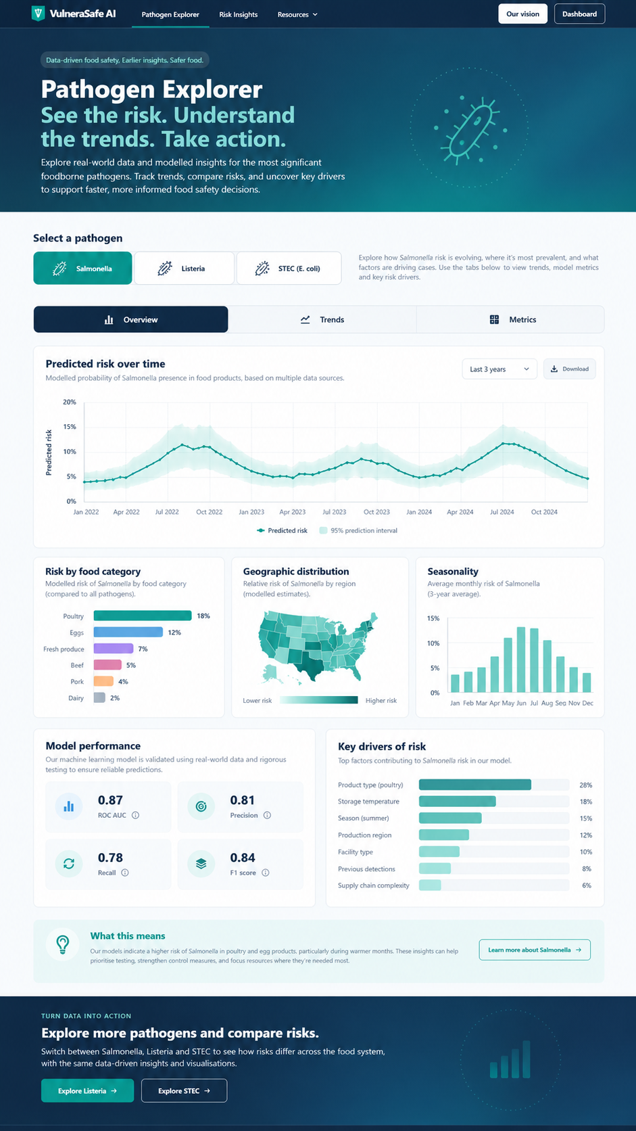
VISUAL CONCEPT ONLY — values, status badges, locations, product claims and alerts in mockups are not project observations.
Styling reference only. This does NOT authorize use of invented percentages, live disease claims, unverified recalls, fictional suppliers, or unsupported countrywide data.

