WEBSITE + MAP SPECIFICATION

04 / Multi-Map Explorer
  - Use this with its matching PNG and implementation prompt. It requires real functional work, not just CSS.

Purpose and target user
Make several scientifically distinct maps, not cosmetic color variants Primary user: Food Safety Operations Director for a regional U.S. grocery retailer. Expected codebase: E:\VulneraSafe_AI, Python offline + validated versioned artifacts → existing React/TypeScript/Vite static site.

Functional and analytical requirements
Map layers: state-level forecast; observed testing positivity; persistent versus emerging; county/tract demographic and food access; sampling-evidence sufficiency; confirmed establishment coordinates (if found); SIMULATED stores/allocation.

Exact source classes and availability rules
FSIS + forecast artifacts + ACS/Food Access Atlas + confirmed geocodes + simulated network; NOAA context optional.

User interactions Kiro must implement
Map layer switch, synchronized selection, geography disclosure, period/pathogen filters, dual-map compare and export; empty states.

Required new science / dependencies
S04/S06/S10/S11/S07/S09; aggregation logic must be explicit.

Design direction
Large map first, contextual panel second; layer mini-cards below; maps can be interactive MapLibre choropleths. Match the existing landing page: navy→teal gradient hero, spacious white sections, refined typography, accessible controls; prefer one substantial visual at a time.

Scientific safety and claims guardrails
Do not paint state risk into counties as county prediction. Avoid global map for US-only dataset. No individual illness mapping.

Artifact contract + implementation process
Inspect existing schemas and paths before deciding filenames. Add a schema-checked versioned artifact (OBSERVED/PREDICTED/SIMULATED) with pathogen, geography, period, dataset provenance, generated_at and missingness. Run the relevant offline Python analysis or reuse validated existing artifacts; include missing-data status. Integrate typed frontend fetch and real map interactions. Update manifest/checksums. Run project tests and npm production build. No remote Python at GitHub Pages runtime.

Definition of done / browser review
1) A browser route exists and loads using artifacts from the current repository. 2) Controls alter visible measured values and maps rather than decorative text. 3) Data gaps are labeled unavailable. 4) Existing code/tests remain working. 5) Report source counts, generated artifact, tests, build output and actual local route. 6) STOP for user review before the next screen.

Matching approved visual reference
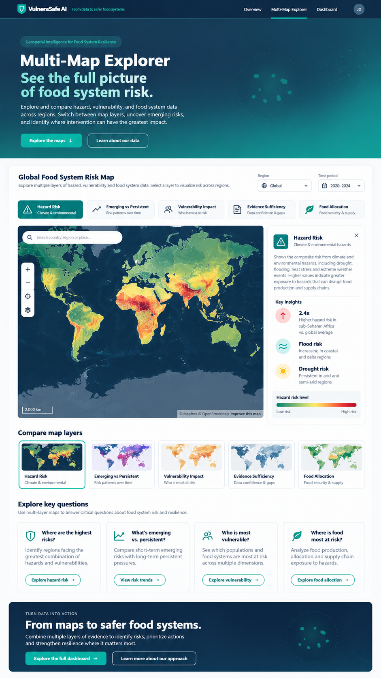
VISUAL CONCEPT ONLY — values, status badges, locations, product claims and alerts in mockups are not project observations.
Styling reference only. This does NOT authorize use of invented percentages, live disease claims, unverified recalls, fictional suppliers, or unsupported countrywide data.

