WEBSITE + MAP SPECIFICATION

05 / Vulnerable Communities / Population Lenses
  - Use this with its matching PNG and implementation prompt. It requires real functional work, not just CSS.

Purpose and target user
Connect hazard evidence to downstream consequences without changing pathogen predictions Primary user: Food Safety Operations Director for a regional U.S. grocery retailer. Expected codebase: E:\VulneraSafe_AI, Python offline + validated versioned artifacts → existing React/TypeScript/Vite static site.

Functional and analytical requirements
Pregnancy/newborn; children under 5; age 65+; community population and food-access patterns; county/tract map; separate hazard and vulnerability panels.

Exact source classes and availability rules
ACS 2022 counties (~3,222), Food Access Atlas 2019 (~72,531 tracts), validated state-level pathogen outputs.

User interactions Kiro must implement
Choose lens, region/county/tract, food-access overlay; compare raw hazard vs consequence-aware priority; open data provenance.

Required new science / dependencies
S06/S07; derive under-5 age bands properly, verify 65+; pregnancy counts unavailable unless separately verified.

Design direction
County map plus explanatory cards, simple rankings and data-vintage note; preserve established white/navy/teal styling. Match the existing landing page: navy→teal gradient hero, spacious white sections, refined typography, accessible controls; prefer one substantial visual at a time.

Scientific safety and claims guardrails
Never invent pregnant residents, county infection probabilities, or infer who consumed contaminated products.

Artifact contract + implementation process
Inspect existing schemas and paths before deciding filenames. Add a schema-checked versioned artifact (OBSERVED/PREDICTED/SIMULATED) with pathogen, geography, period, dataset provenance, generated_at and missingness. Run the relevant offline Python analysis or reuse validated existing artifacts; include missing-data status. Integrate typed frontend fetch and real map interactions. Update manifest/checksums. Run project tests and npm production build. No remote Python at GitHub Pages runtime.

Definition of done / browser review
1) A browser route exists and loads using artifacts from the current repository. 2) Controls alter visible measured values and maps rather than decorative text. 3) Data gaps are labeled unavailable. 4) Existing code/tests remain working. 5) Report source counts, generated artifact, tests, build output and actual local route. 6) STOP for user review before the next screen.

Matching approved visual reference
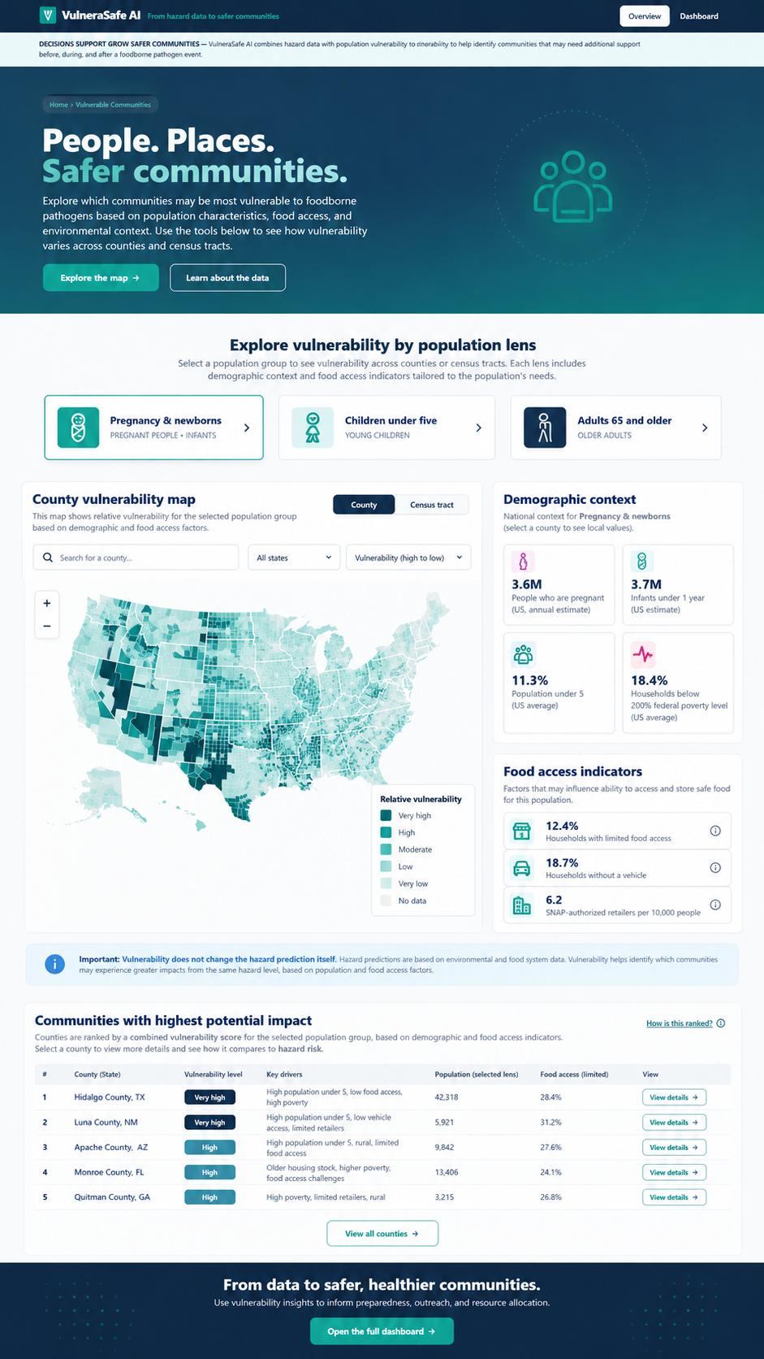
VISUAL CONCEPT ONLY — values, status badges, locations, product claims and alerts in mockups are not project observations.
Styling reference only. This does NOT authorize use of invented percentages, live disease claims, unverified recalls, fictional suppliers, or unsupported countrywide data.

