WEBSITE + MAP SPECIFICATION

06 / Establishment / Supplier Surveillance Monitor
  - Use this with its matching PNG and implementation prompt. It requires real functional work, not just CSS.

Purpose and target user
Use individual sampled facilities for historical risk context; do not assume facilities are retailer suppliers Primary user: Food Safety Operations Director for a regional U.S. grocery retailer. Expected codebase: E:\VulneraSafe_AI, Python offline + validated versioned artifacts → existing React/TypeScript/Vite static site.

Functional and analytical requirements
Establishment history for Salmonella, Listeria, STEC; counts, smoothed historical positivity, credible interval, product/sampling-program breakdown, persistence and evidence sufficiency.

Exact source classes and availability rules
FSIS establishment_id / state / collection_date / project_code / sample_source_name; verified directory metadata only where joinable.

User interactions Kiro must implement
Search/filter facility, pathogen, commodity, program, sample support, years; select facility to view trend and samples/positives.

Required new science / dependencies
S03/S11/S16/S14/S15; test whether past results predict future ones without sampling-intensity confounding.

Design direction
Searchable sortable establishment table plus U.S. map only where real positions exist; detail drawer. Match the existing landing page: navy→teal gradient hero, spacious white sections, refined typography, accessible controls; prefer one substantial visual at a time.

Scientific safety and claims guardrails
Use “FSIS-sampled establishment”, not “our retailer supplier”; location of processor does not establish where product was sold.

Artifact contract + implementation process
Inspect existing schemas and paths before deciding filenames. Add a schema-checked versioned artifact (OBSERVED/PREDICTED/SIMULATED) with pathogen, geography, period, dataset provenance, generated_at and missingness. Run the relevant offline Python analysis or reuse validated existing artifacts; include missing-data status. Integrate typed frontend fetch and real map interactions. Update manifest/checksums. Run project tests and npm production build. No remote Python at GitHub Pages runtime.

Definition of done / browser review
1) A browser route exists and loads using artifacts from the current repository. 2) Controls alter visible measured values and maps rather than decorative text. 3) Data gaps are labeled unavailable. 4) Existing code/tests remain working. 5) Report source counts, generated artifact, tests, build output and actual local route. 6) STOP for user review before the next screen.

Matching approved visual reference
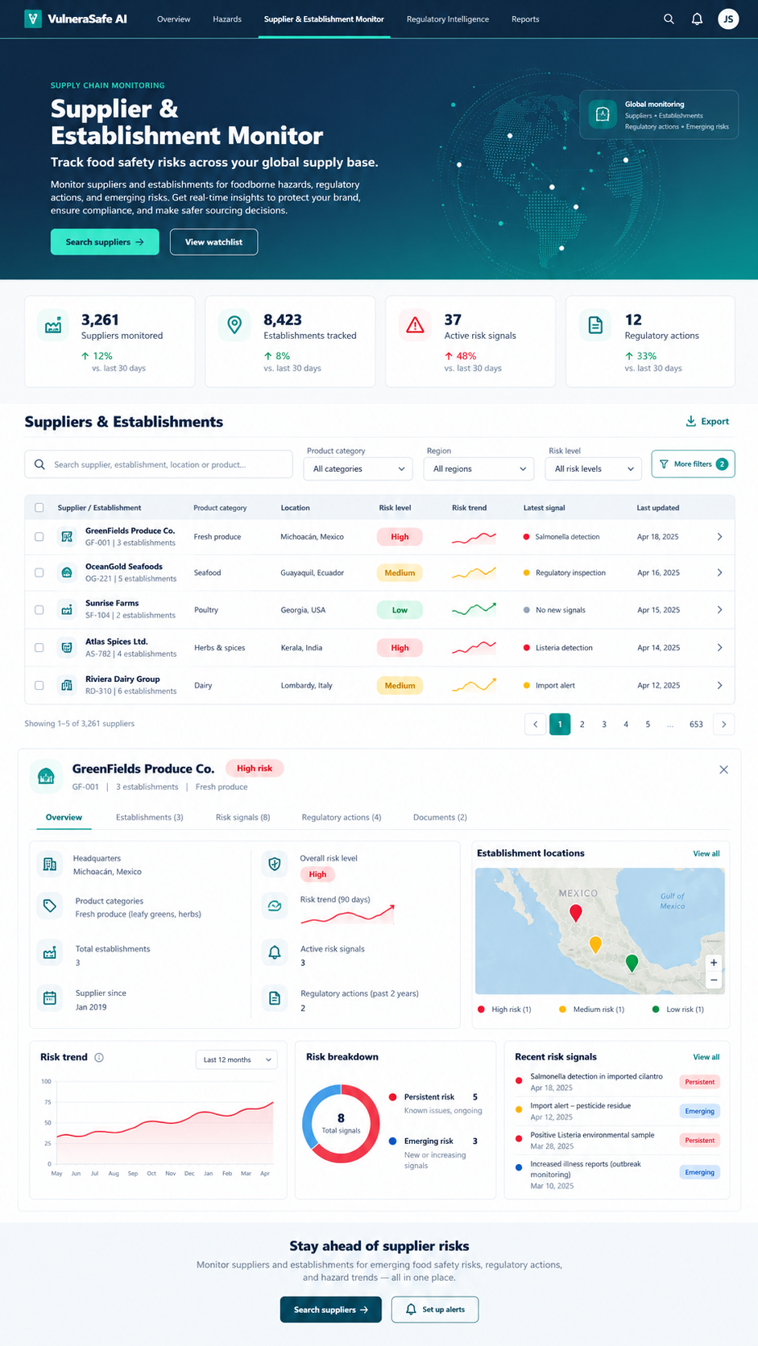
VISUAL CONCEPT ONLY — values, status badges, locations, product claims and alerts in mockups are not project observations.
Styling reference only. This does NOT authorize use of invented percentages, live disease claims, unverified recalls, fictional suppliers, or unsupported countrywide data.

