WEBSITE + MAP SPECIFICATION

07 / Scenario Builder / Policy A-B-C
  - Use this with its matching PNG and implementation prompt. It requires real functional work, not just CSS.

Purpose and target user
Turn risk information into quantitative simulated retailer choices Primary user: Food Safety Operations Director for a regional U.S. grocery retailer. Expected codebase: E:\VulneraSafe_AI, Python offline + validated versioned artifacts → existing React/TypeScript/Vite static site.

Functional and analytical requirements
Scenarios: Listeria recalled RTE lot; Salmonella limited testing; STEC compliant shortage; policies A baseline, B model-aware, C safety+access-aware.

Exact source classes and availability rules
Real risk/evidence artifacts combined with separately SIMULATED lot/store/warehouse/transport/demand inputs and OR-Tools outputs.

User interactions Kiro must implement
Change inspection budget, supply, delay, access weight; run valid precomputed simulations or actual client-side solver logic; policy comparison table and map.

Required new science / dependencies
S07/S08/S09; all allocations must obey hard recall isolation safety constraints.

Design direction
Controls left, policy comparison right, optional full scenario map via navigation; concise results. Match the existing landing page: navy→teal gradient hero, spacious white sections, refined typography, accessible controls; prefer one substantial visual at a time.

Scientific safety and claims guardrails
Do not claim fewer observed infections; use simulated metrics and show assumptions; enforce hard constraints under all policies.

Artifact contract + implementation process
Inspect existing schemas and paths before deciding filenames. Add a schema-checked versioned artifact (OBSERVED/PREDICTED/SIMULATED) with pathogen, geography, period, dataset provenance, generated_at and missingness. Run the relevant offline Python analysis or reuse validated existing artifacts; include missing-data status. Integrate typed frontend fetch and real map interactions. Update manifest/checksums. Run project tests and npm production build. No remote Python at GitHub Pages runtime.

Definition of done / browser review
1) A browser route exists and loads using artifacts from the current repository. 2) Controls alter visible measured values and maps rather than decorative text. 3) Data gaps are labeled unavailable. 4) Existing code/tests remain working. 5) Report source counts, generated artifact, tests, build output and actual local route. 6) STOP for user review before the next screen.

Matching approved visual reference
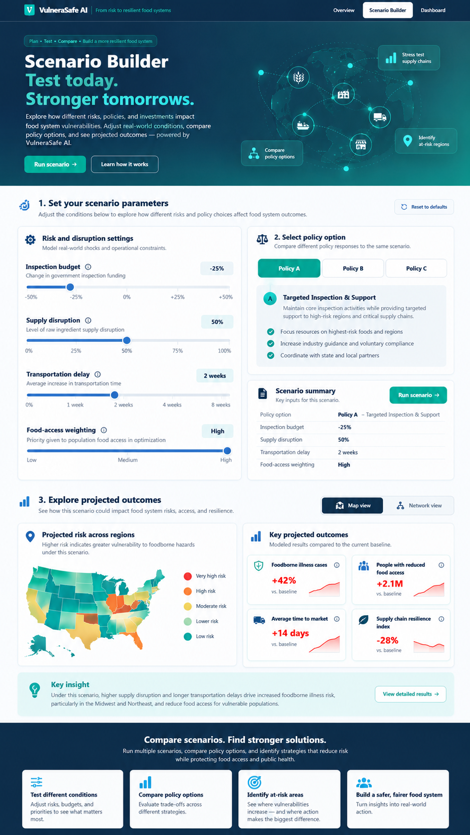
VISUAL CONCEPT ONLY — values, status badges, locations, product claims and alerts in mockups are not project observations.
Styling reference only. This does NOT authorize use of invented percentages, live disease claims, unverified recalls, fictional suppliers, or unsupported countrywide data.

