WEBSITE + MAP SPECIFICATION

08 / Actions and Review Queue
  - Use this with its matching PNG and implementation prompt. It requires real functional work, not just CSS.

Purpose and target user
Translate supported surveillance evidence and official safety controls into human-review workflow Primary user: Food Safety Operations Director for a regional U.S. grocery retailer. Expected codebase: E:\VulneraSafe_AI, Python offline + validated versioned artifacts → existing React/TypeScript/Vite static site.

Functional and analytical requirements
Ranked supplier documentation requests, additional product tests, historical evidence reviews, simulated lot isolation and replacement allocation.

Exact source classes and availability rules
Predictions+CI, provenance, optimizer actions, regulatory artifacts (unavailable if no real recall feed).

User interactions Kiro must implement
Filter by pathogen, evidence, consequence, action type; select action → evidence drawer; mark review acknowledgment as local UI state only.

Required new science / dependencies
S08/S09/S10; enforce evidence+uncertainty on all MODEL recommendations.

Design direction
Focused action queue with clear regulatory vs model vs simulated labels and evidence tabs. Match the existing landing page: navy→teal gradient hero, spacious white sections, refined typography, accessible controls; prefer one substantial visual at a time.

Scientific safety and claims guardrails
Never show illustrative recalls as verified or provide unsafe automatic distribution approval.

Artifact contract + implementation process
Inspect existing schemas and paths before deciding filenames. Add a schema-checked versioned artifact (OBSERVED/PREDICTED/SIMULATED) with pathogen, geography, period, dataset provenance, generated_at and missingness. Run the relevant offline Python analysis or reuse validated existing artifacts; include missing-data status. Integrate typed frontend fetch and real map interactions. Update manifest/checksums. Run project tests and npm production build. No remote Python at GitHub Pages runtime.

Definition of done / browser review
1) A browser route exists and loads using artifacts from the current repository. 2) Controls alter visible measured values and maps rather than decorative text. 3) Data gaps are labeled unavailable. 4) Existing code/tests remain working. 5) Report source counts, generated artifact, tests, build output and actual local route. 6) STOP for user review before the next screen.

Matching approved visual reference
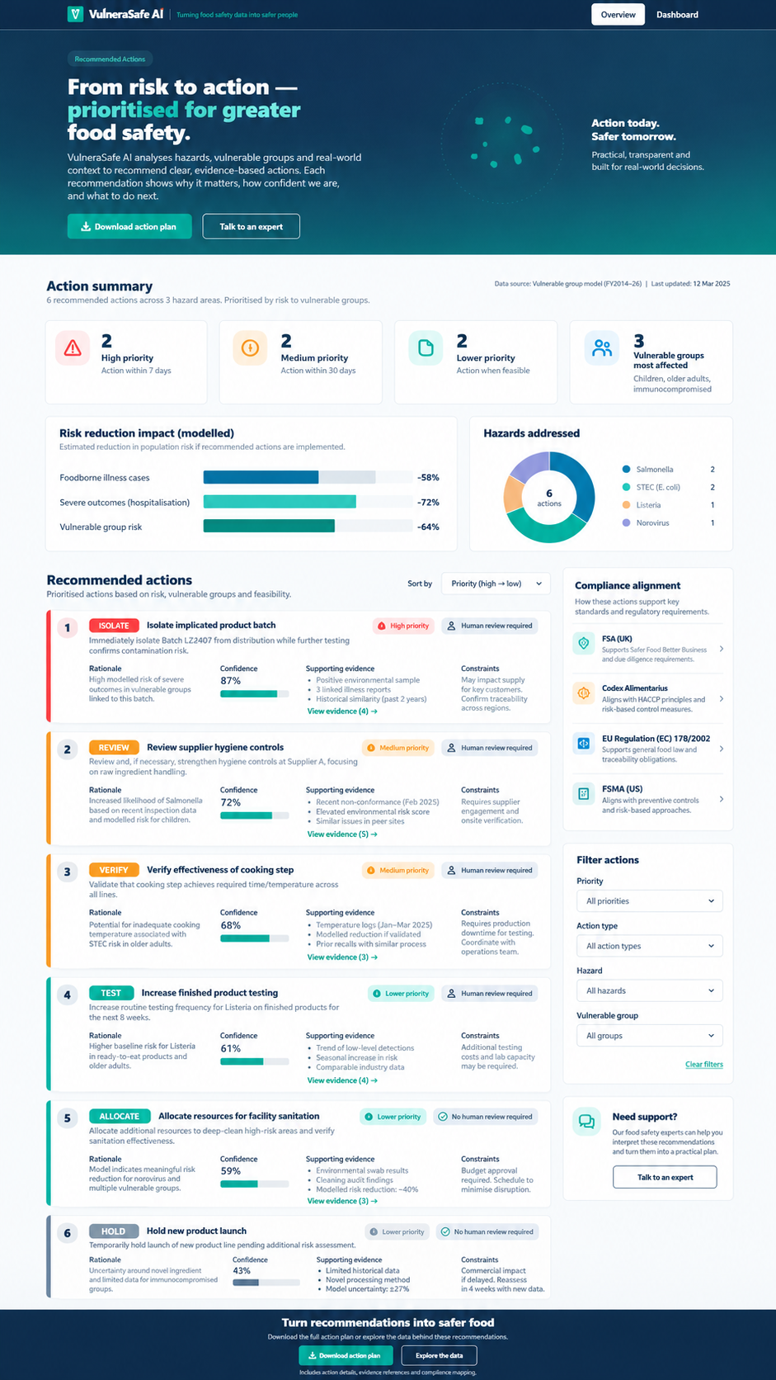
VISUAL CONCEPT ONLY — values, status badges, locations, product claims and alerts in mockups are not project observations.
Styling reference only. This does NOT authorize use of invented percentages, live disease claims, unverified recalls, fictional suppliers, or unsupported countrywide data.

