WEBSITE + MAP SPECIFICATION

09 / One Health Evidence & Connections
  - Use this with its matching PNG and implementation prompt. It requires real functional work, not just CSS.

Purpose and target user
Show actual food, environment, human outbreak, and food-access data without implying causality Primary user: Food Safety Operations Director for a regional U.S. grocery retailer. Expected codebase: E:\VulneraSafe_AI, Python offline + validated versioned artifacts → existing React/TypeScript/Vite static site.

Functional and analytical requirements
FSIS testing, NOAA nClimDiv, CDC NORS 365-day-lagged outbreaks, ACS/Food Access data; cross-plots, delay diagram, ablations and model evidence.

Exact source classes and availability rules
Real NORS history, 46–49 state NOAA coverage and missingness, FSIS seasonality, lag provenance and metrics.

User interactions Kiro must implement
Choose pathogen/state/period, see aligned timelines, compare sources, view reporting-lag disclaimer, inspect signed ablation deltas.

Required new science / dependencies
S05/S13/S12; CDC is corroboration only; NOAA did not improve forecasts; keep that visible.

Design direction
One dual-series comparison and one environmental context graph, source status cards. Match the existing landing page: navy→teal gradient hero, spacious white sections, refined typography, accessible controls; prefer one substantial visual at a time.

Scientific safety and claims guardrails
No FSIS–CDC strain linkage, no pathogen exposure causality, no realtime CDC claim.

Artifact contract + implementation process
Inspect existing schemas and paths before deciding filenames. Add a schema-checked versioned artifact (OBSERVED/PREDICTED/SIMULATED) with pathogen, geography, period, dataset provenance, generated_at and missingness. Run the relevant offline Python analysis or reuse validated existing artifacts; include missing-data status. Integrate typed frontend fetch and real map interactions. Update manifest/checksums. Run project tests and npm production build. No remote Python at GitHub Pages runtime.

Definition of done / browser review
1) A browser route exists and loads using artifacts from the current repository. 2) Controls alter visible measured values and maps rather than decorative text. 3) Data gaps are labeled unavailable. 4) Existing code/tests remain working. 5) Report source counts, generated artifact, tests, build output and actual local route. 6) STOP for user review before the next screen.

Matching approved visual reference
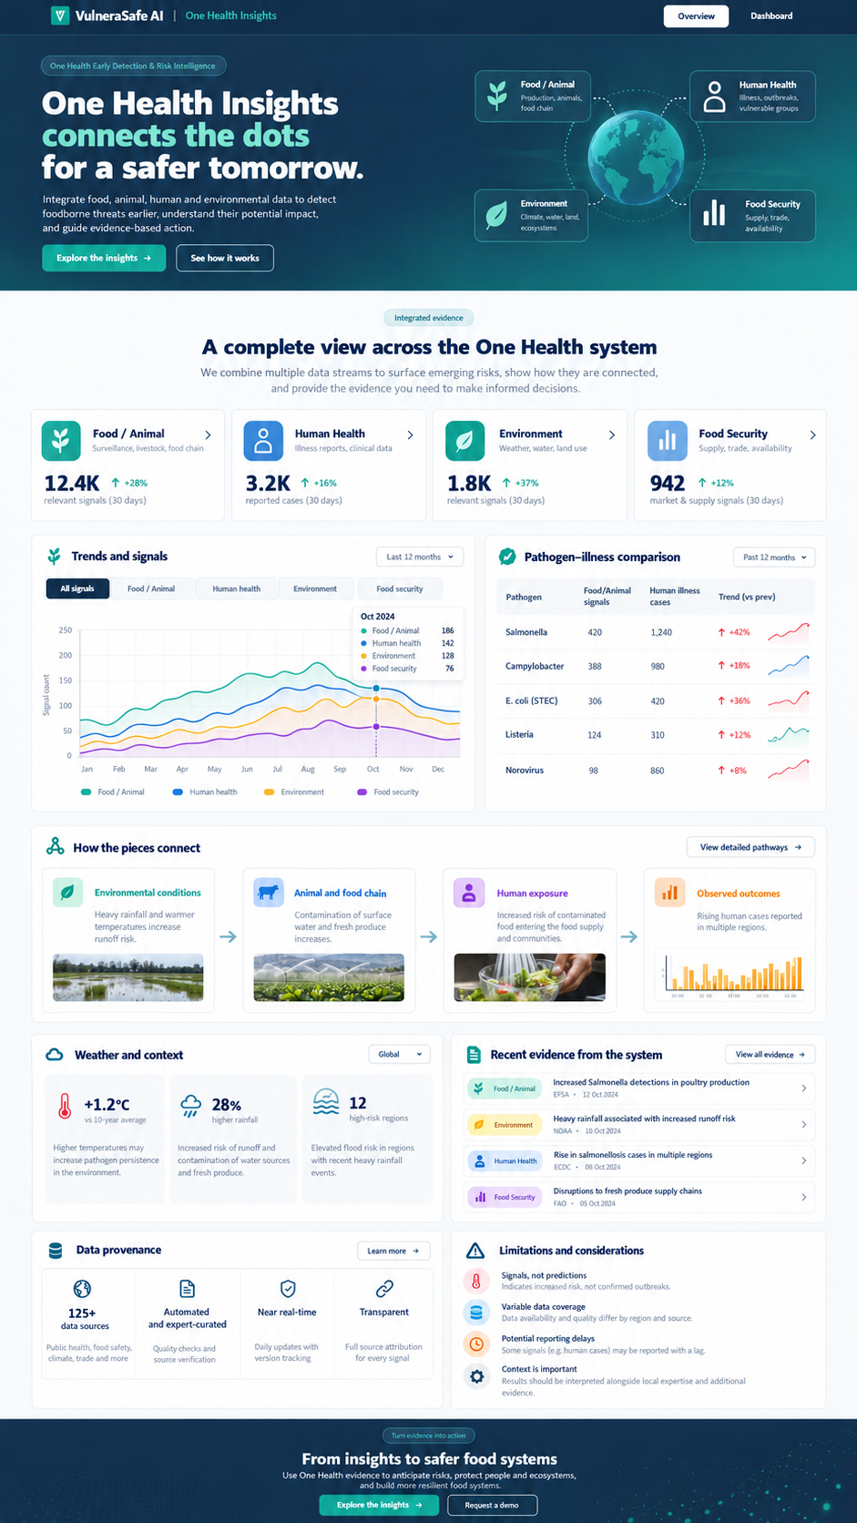
VISUAL CONCEPT ONLY — values, status badges, locations, product claims and alerts in mockups are not project observations.
Styling reference only. This does NOT authorize use of invented percentages, live disease claims, unverified recalls, fictional suppliers, or unsupported countrywide data.

