WEBSITE + MAP SPECIFICATION

10 / Full-Screen Pathogen Surveillance Map
  - Use this with its matching PNG and implementation prompt. It requires real functional work, not just CSS.

Purpose and target user
Dedicated geographic analysis surface for all three pathogens Primary user: Food Safety Operations Director for a regional U.S. grocery retailer. Expected codebase: E:\VulneraSafe_AI, Python offline + validated versioned artifacts → existing React/TypeScript/Vite static site.

Functional and analytical requirements
State-period observed positivity and next-period high-tail risk separately, uncertainty and lower-sample disclosure, temporal replay.

Exact source classes and availability rules
State model predictions, counts, training-derived threshold and CI; preserve separate monthly/quarterly units.

User interactions Kiro must implement
Region click, pathogen/metric/period filters, replay slider and evidence pane; consistent legend units.

Required new science / dependencies
S01/S04/S10/S12; calibration and time-local evaluation.

Design direction
Mostly map with small floating filter bar, linked trend detail, compact right-side data pane. Match the existing landing page: navy→teal gradient hero, spacious white sections, refined typography, accessible controls; prefer one substantial visual at a time.

Scientific safety and claims guardrails
Only state geography for predictive estimates unless a separate validated county forecast exists.

Artifact contract + implementation process
Inspect existing schemas and paths before deciding filenames. Add a schema-checked versioned artifact (OBSERVED/PREDICTED/SIMULATED) with pathogen, geography, period, dataset provenance, generated_at and missingness. Run the relevant offline Python analysis or reuse validated existing artifacts; include missing-data status. Integrate typed frontend fetch and real map interactions. Update manifest/checksums. Run project tests and npm production build. No remote Python at GitHub Pages runtime.

Definition of done / browser review
1) A browser route exists and loads using artifacts from the current repository. 2) Controls alter visible measured values and maps rather than decorative text. 3) Data gaps are labeled unavailable. 4) Existing code/tests remain working. 5) Report source counts, generated artifact, tests, build output and actual local route. 6) STOP for user review before the next screen.

Matching approved visual reference
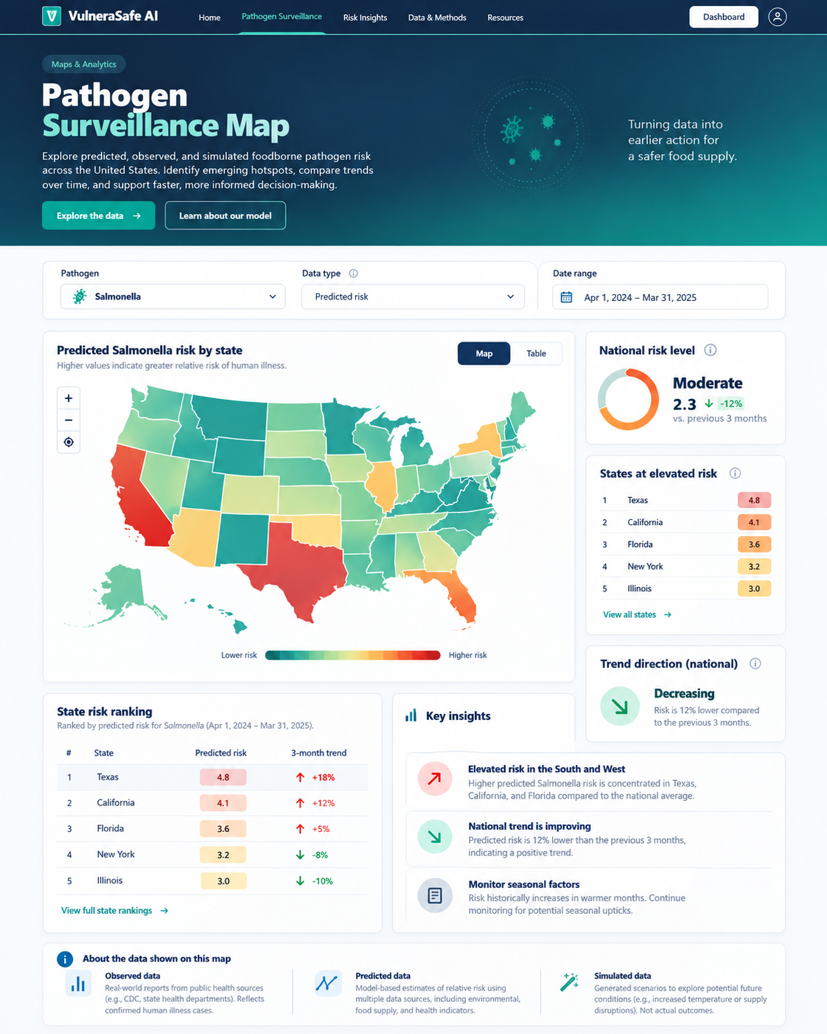
VISUAL CONCEPT ONLY — values, status badges, locations, product claims and alerts in mockups are not project observations.
Styling reference only. This does NOT authorize use of invented percentages, live disease claims, unverified recalls, fictional suppliers, or unsupported countrywide data.

