WEBSITE + MAP SPECIFICATION

11 / Full-Screen County / Tract Vulnerability Map
  - Use this with its matching PNG and implementation prompt. It requires real functional work, not just CSS.

Purpose and target user
Geographic distribution of community context and food-access constraints Primary user: Food Safety Operations Director for a regional U.S. grocery retailer. Expected codebase: E:\VulneraSafe_AI, Python offline + validated versioned artifacts → existing React/TypeScript/Vite static site.

Functional and analytical requirements
Population 65+, under-5 once verified, low-income and low-access, tract/county boundaries, state hazard displayed as separate indicator not downscaled.

Exact source classes and availability rules
ACS county profiles; Atlas tract indicators; state-level model as separate legend/summary.

User interactions Kiro must implement
Filter lens, county, tract, access indicator, map hover; compare counts versus proportions and vintage.

Required new science / dependencies
S06/S07; FIPS crosswalk with missing-join audit.

Design direction
Large county map, separate selected-county profile and source dates. Match the existing landing page: navy→teal gradient hero, spacious white sections, refined typography, accessible controls; prefer one substantial visual at a time.

Scientific safety and claims guardrails
Never label tract vulnerability as observed infection or forecast; no ungrounded pregnancy estimates.

Artifact contract + implementation process
Inspect existing schemas and paths before deciding filenames. Add a schema-checked versioned artifact (OBSERVED/PREDICTED/SIMULATED) with pathogen, geography, period, dataset provenance, generated_at and missingness. Run the relevant offline Python analysis or reuse validated existing artifacts; include missing-data status. Integrate typed frontend fetch and real map interactions. Update manifest/checksums. Run project tests and npm production build. No remote Python at GitHub Pages runtime.

Definition of done / browser review
1) A browser route exists and loads using artifacts from the current repository. 2) Controls alter visible measured values and maps rather than decorative text. 3) Data gaps are labeled unavailable. 4) Existing code/tests remain working. 5) Report source counts, generated artifact, tests, build output and actual local route. 6) STOP for user review before the next screen.

Matching approved visual reference
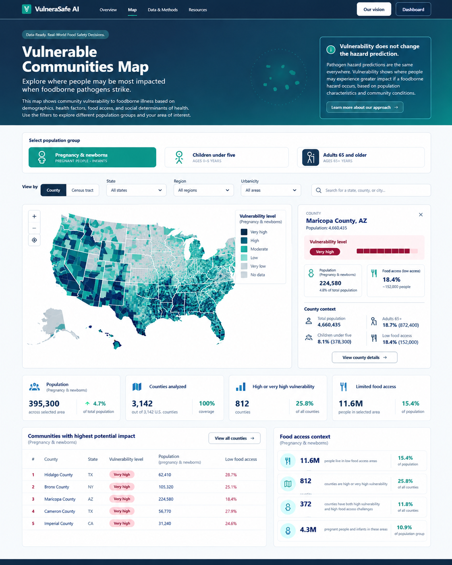
VISUAL CONCEPT ONLY — values, status badges, locations, product claims and alerts in mockups are not project observations.
Styling reference only. This does NOT authorize use of invented percentages, live disease claims, unverified recalls, fictional suppliers, or unsupported countrywide data.

