WEBSITE + MAP SPECIFICATION

12 / Full-Screen Establishment Surveillance Map
  - Use this with its matching PNG and implementation prompt. It requires real functional work, not just CSS.

Purpose and target user
Locate FSIS-sampled facilities where reliable geocoding permits and explore surveillance history Primary user: Food Safety Operations Director for a regional U.S. grocery retailer. Expected codebase: E:\VulneraSafe_AI, Python offline + validated versioned artifacts → existing React/TypeScript/Vite static site.

Functional and analytical requirements
Verified establishment identifiers and address/geocode join; sample volume, positivity, EB confidence and historical patterns; fallback aggregate state counts for unresolved geocodes.

Exact source classes and availability rules
FSIS establishments + official directory/metadata if actually downloaded and valid; no inferred supplier network.

User interactions Kiro must implement
Map search, cluster points, filter pathogen/program/category, select facility and view history; export source-backed rows.

Required new science / dependencies
S03/S11/S16; geographic validation for every point.

Design direction
U.S. point map plus searchable table and facility detail. Match the existing landing page: navy→teal gradient hero, spacious white sections, refined typography, accessible controls; prefer one substantial visual at a time.

Scientific safety and claims guardrails
No invented global suppliers; facility addresses are not retail shipments or consumer locations.

Artifact contract + implementation process
Inspect existing schemas and paths before deciding filenames. Add a schema-checked versioned artifact (OBSERVED/PREDICTED/SIMULATED) with pathogen, geography, period, dataset provenance, generated_at and missingness. Run the relevant offline Python analysis or reuse validated existing artifacts; include missing-data status. Integrate typed frontend fetch and real map interactions. Update manifest/checksums. Run project tests and npm production build. No remote Python at GitHub Pages runtime.

Definition of done / browser review
1) A browser route exists and loads using artifacts from the current repository. 2) Controls alter visible measured values and maps rather than decorative text. 3) Data gaps are labeled unavailable. 4) Existing code/tests remain working. 5) Report source counts, generated artifact, tests, build output and actual local route. 6) STOP for user review before the next screen.

Matching approved visual reference
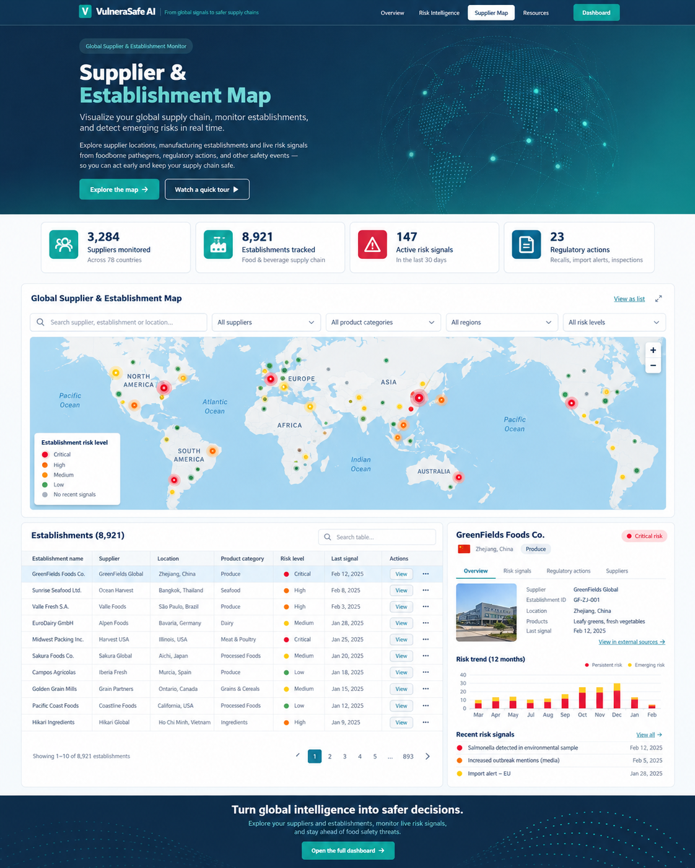
VISUAL CONCEPT ONLY — values, status badges, locations, product claims and alerts in mockups are not project observations.
Styling reference only. This does NOT authorize use of invented percentages, live disease claims, unverified recalls, fictional suppliers, or unsupported countrywide data.

