WEBSITE + MAP SPECIFICATION

13 / Full-Screen Simulated Food Allocation Map
  - Use this with its matching PNG and implementation prompt. It requires real functional work, not just CSS.

Purpose and target user
Show how retailer decisions can preserve safe food access during disruptions Primary user: Food Safety Operations Director for a regional U.S. grocery retailer. Expected codebase: E:\VulneraSafe_AI, Python offline + validated versioned artifacts → existing React/TypeScript/Vite static site.

Functional and analytical requirements
Simulated stores, warehouses, supply routes, compliant product units, high-need service and unmet demand across A/B/C policies.

Exact source classes and availability rules
OR-Tools policy artifacts + SIMULATED network + ACS/Atlas demand/vulnerability context.

User interactions Kiro must implement
Choose scenario/policy/budget; show route flows, unmet need; compare before/after and open assumptions.

Required new science / dependencies
S07/S08; optimizer results, not decorative client-side recomputation.

Design direction
Wide scenario map, policy tabs and compact comparison metric cards. Match the existing landing page: navy→teal gradient hero, spacious white sections, refined typography, accessible controls; prefer one substantial visual at a time.

Scientific safety and claims guardrails
All routes/inventory SIMULATED; no claim that food was delivered or lives saved.

Artifact contract + implementation process
Inspect existing schemas and paths before deciding filenames. Add a schema-checked versioned artifact (OBSERVED/PREDICTED/SIMULATED) with pathogen, geography, period, dataset provenance, generated_at and missingness. Run the relevant offline Python analysis or reuse validated existing artifacts; include missing-data status. Integrate typed frontend fetch and real map interactions. Update manifest/checksums. Run project tests and npm production build. No remote Python at GitHub Pages runtime.

Definition of done / browser review
1) A browser route exists and loads using artifacts from the current repository. 2) Controls alter visible measured values and maps rather than decorative text. 3) Data gaps are labeled unavailable. 4) Existing code/tests remain working. 5) Report source counts, generated artifact, tests, build output and actual local route. 6) STOP for user review before the next screen.

Matching approved visual reference
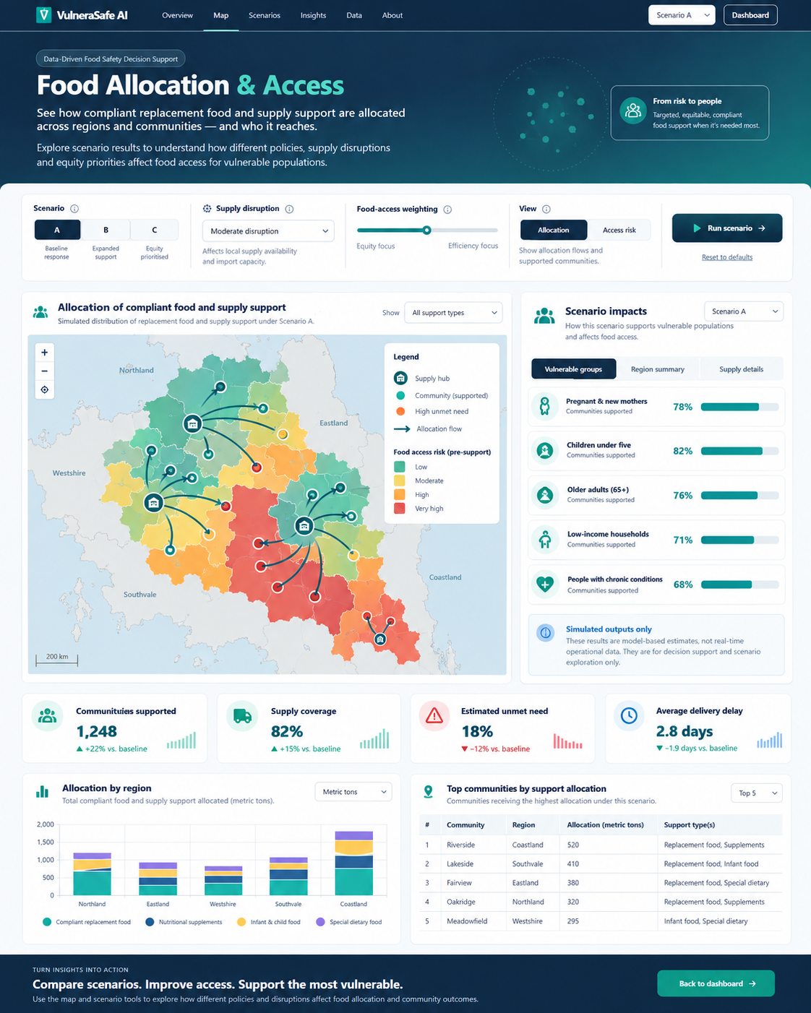
VISUAL CONCEPT ONLY — values, status badges, locations, product claims and alerts in mockups are not project observations.
Styling reference only. This does NOT authorize use of invented percentages, live disease claims, unverified recalls, fictional suppliers, or unsupported countrywide data.

