WEBSITE + MAP SPECIFICATION

14 / Full-Screen Recall Response Scenario Map
  - Use this with its matching PNG and implementation prompt. It requires real functional work, not just CSS.

Purpose and target user
Visualize confirmed regulatory evidence separately from a safe simulated response exercise Primary user: Food Safety Operations Director for a regional U.S. grocery retailer. Expected codebase: E:\VulneraSafe_AI, Python offline + validated versioned artifacts → existing React/TypeScript/Vite static site.

Functional and analytical requirements
If live verified recall feed unavailable, use expressly SIMULATED recall scenario. Lot isolation, affected simulated sites, compliant alternate sources, traced movements.

Exact source classes and availability rules
Official recall only with verifiable source identifier/date and match; synthetic lots/shipments for demo.

User interactions Kiro must implement
Select simulated lot, trace upstream/downstream, show locked recalled inventory, optimize compliant replacement and status.

Required new science / dependencies
S09/S07; verify no recalled lot distributed under any policy.

Design direction
Large network/map plus trace timeline, action panel, evidence badge. Match the existing landing page: navy→teal gradient hero, spacious white sections, refined typography, accessible controls; prefer one substantial visual at a time.

Scientific safety and claims guardrails
Unverified recall placeholder must NEVER say “verified official recall” or appear as a live regulator alert.

Artifact contract + implementation process
Inspect existing schemas and paths before deciding filenames. Add a schema-checked versioned artifact (OBSERVED/PREDICTED/SIMULATED) with pathogen, geography, period, dataset provenance, generated_at and missingness. Run the relevant offline Python analysis or reuse validated existing artifacts; include missing-data status. Integrate typed frontend fetch and real map interactions. Update manifest/checksums. Run project tests and npm production build. No remote Python at GitHub Pages runtime.

Definition of done / browser review
1) A browser route exists and loads using artifacts from the current repository. 2) Controls alter visible measured values and maps rather than decorative text. 3) Data gaps are labeled unavailable. 4) Existing code/tests remain working. 5) Report source counts, generated artifact, tests, build output and actual local route. 6) STOP for user review before the next screen.

Matching approved visual reference
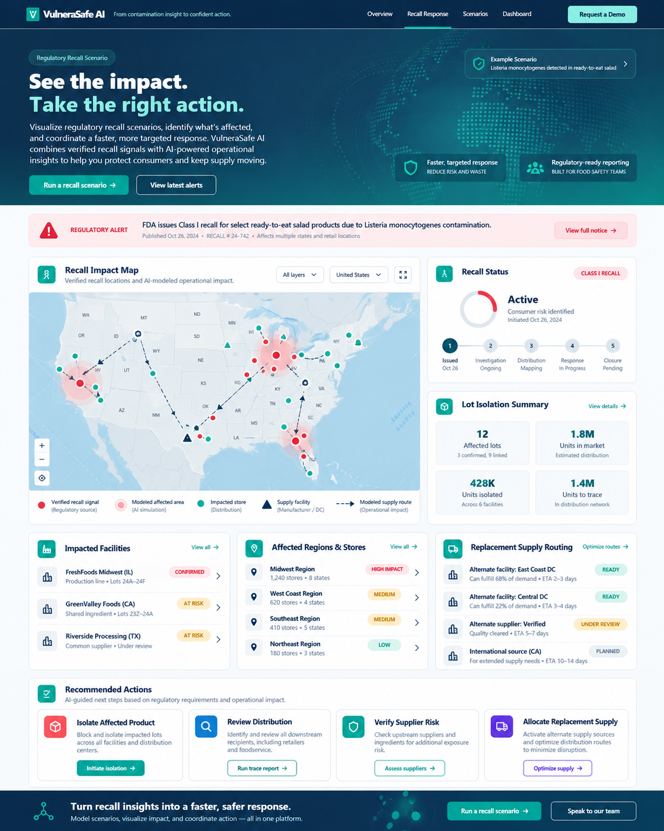
VISUAL CONCEPT ONLY — values, status badges, locations, product claims and alerts in mockups are not project observations.
Styling reference only. This does NOT authorize use of invented percentages, live disease claims, unverified recalls, fictional suppliers, or unsupported countrywide data.

