PROJECT DOCUMENTATION
Global Happiness & Economic Indicators
Hierarchical Clustering of 159 Countries

1. Project Overview

1.1 Introduction
This project applies unsupervised machine learning to group countries into meaningful development tiers using economic and well-being indicators that follow the methodology of the World Happiness Report. Instead of predicting a known label, the goal is to let the data reveal natural groupings using Agglomerative Hierarchical Clustering.

1.2 Problem Statement
Countries differ widely in wealth, health, freedom and happiness, but these dimensions are rarely examined together. The project asks which countries naturally belong together when all of these indicators are considered at once, and what characterises each group?

1.3 Objectives
- Explore and understand the dataset through 12 different visualizations (EDA).
- Preprocess the data: handle missing values, aggregate to country level and scale features.
- Perform Agglomerative Hierarchical Clustering to group countries.
- Validate the clustering with internal metrics and interpret each cluster.

1.4 Tools and Technologies
Category | Tools
Language | Python 3
Data handling | NumPy, Pandas
Visualization | Matplotlib, Seaborn
Hierarchical clustering | SciPy (linkage, dendrogram), scikit-learn (AgglomerativeClustering)
Preprocessing / reduction | StandardScaler, PCA (scikit-learn)
Evaluation | Silhouette, Davies-Bouldin, Calinski-Harabasz
Environment | Jupyter Notebook

2. Dataset Description
The file global_happiness_economic_indicators.csv contains 3,180 rows and 12 columns: yearly observations from 2004 to 2023 for 159 countries across 10 regions. It combines economic indicators (GDP, unemployment, population) with well-being indicators (social support, life expectancy, freedom, generosity, corruption perception, happiness).
Column | Type | Description
Country | Text | Country name
Region | Text | Geographic / economic region
Year | Integer | Year of observation (2004–2023)
GDP_per_capita | Float | GDP per capita in USD
Social_support | Float | Social support index (0–1)
Healthy_life_expectancy | Float | Healthy life expectancy at birth (years)
Freedom_to_make_choices | Float | Freedom to make life choices (0–1)
Generosity | Float | Generosity index
Perceptions_of_corruption | Float | Corruption perception index (0–1; higher = lower perceived corruption)
Unemployment_rate | Float | Unemployment rate (%)
Population_millions | Float | Population in millions
Happiness_score | Float | Overall happiness score (2–8 scale)

Summary statistics (selected)
Feature | Mean | Std | Min | Max
GDP_per_capita | 26,168 | 20,110 | 2,362 | 98,066
Healthy_life_expectancy | 72.4 | 7.1 | 56.4 | 85.0
Unemployment_rate | 7.6 | 2.5 | 1.2 | 14.7
Happiness_score | 5.22 | 1.19 | 2.25 | 7.84

3. Project Workflow at a Glance
The project follows a standard unsupervised-learning pipeline. Each stage is detailed step by step in Section 4.
Stage | Activity | Output
1 | Setup & imports | Configured environment
2 | Load & inspect data | 3,180 × 12 dataframe
3 | Clean data (impute NaNs) | No missing values
4 | Exploratory data analysis | 12 visualizations
5 | Aggregate to country level & scale | 159 × 8 standardized matrix
6 | Dendrogram (Ward linkage) | Hierarchy of merges
7 | Choose k (silhouette) | k = 4 selected
8 | Fit Agglomerative model | Cluster label per country
9 | Evaluate & visualize (PCA) | Metrics + 2-D plot
10 | Profile & interpret clusters | Four development tiers

4. Step-by-Step Implementation

Step 1: Import Libraries and Set Up the Environment
Import the numerical, visualization, clustering and evaluation libraries, set a consistent plot style and fix the random seed for reproducibility.
import numpy as np
import pandas as pd
import matplotlib.pyplot as plt
import seaborn as sns

from scipy.cluster.hierarchy import dendrogram, linkage, fcluster
from sklearn.preprocessing import StandardScaler
from sklearn.cluster import AgglomerativeClustering
from sklearn.decomposition import PCA
from sklearn.metrics import (silhouette_score, davies_bouldin_score,
calinski_harabasz_score)

sns.set_style("whitegrid")
np.random.seed(42)

Step 2: Load the Dataset
Read the CSV file and check its shape, data types and descriptive statistics.
df = pd.read_csv("global_happiness_economic_indicators.csv")
print("Shape:", df.shape) # (3180, 12)
df.info()
df.describe().T
Result: 3,180 rows and 12 columns. Three columns (GDP_per_capita, Generosity, Unemployment_rate) have 3,149 non-null values, which signals missing data.

Step 3: Data Cleaning and Missing-Value Treatment
Check for missing values and duplicates. Each of the three affected columns has 31 missing entries; no duplicate rows exist. Missing values are filled with the median of the same Region, which is more realistic than a single global median because regions differ greatly in income and employment.
print(df.isna().sum())
print("Duplicate rows:", df.duplicated().sum()) # 0

cols_with_na = ["GDP_per_capita", "Generosity", "Unemployment_rate"]
for col in cols_with_na:
df[col] = df.groupby("Region")[col].transform(lambda x: x.fillna(x.median()))
Result: All missing values removed (0 remaining).

Step 4: Exploratory Data Analysis (12 Visualizations)
EDA is performed before clustering to understand distributions, relationships and regional differences.

# | Visualization | Purpose
1 | Histogram + KDE: Happiness Score | Distribution of the target-like indicator
2 | Histogram + KDE: GDP per capita | Spotting skewness
3 | Boxplot: Happiness by Region | Regional comparison and outliers
4 | Scatter: GDP vs Happiness | Wealth–happiness relationship
5 | Correlation heatmap | Linear relationships among all features
6 | Scatter: Social support vs Life expectancy | Relationship coloured by happiness
7 | Line plot: Happiness trend by Region | Change over 2004–2023
8 | Violin plot: Unemployment by Region | Distribution shape per region
9 | Scatter: Freedom vs Corruption perception | Governance-related relationship
10 | Pie chart: Share of records by Region | Data balance
11 | Bubble chart: Generosity vs Happiness | Three extra dimensions (population, GDP)
12 | Pairplot of key indicators | Pairwise overview on a 600-row sample

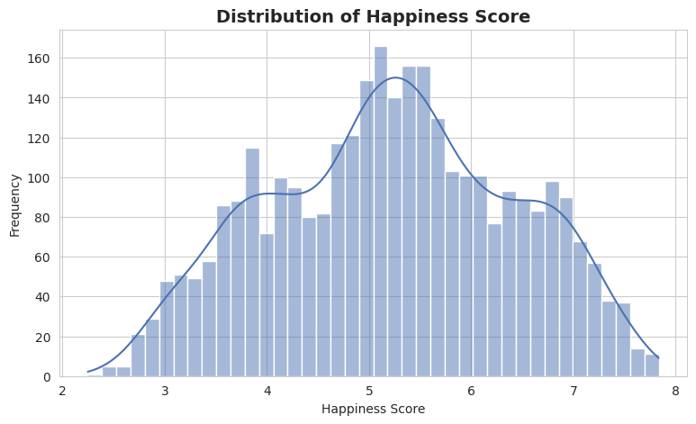
Figure 1: Distribution of Happiness Score
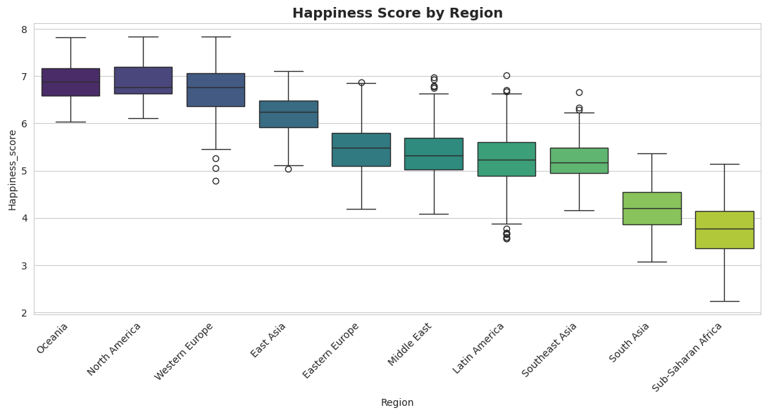
Figure 2: Happiness Score by Region
Observation: Oceania, North America and Western Europe have the highest median happiness (around 6.8–6.9), while South Asia and Sub-Saharan Africa have the lowest.
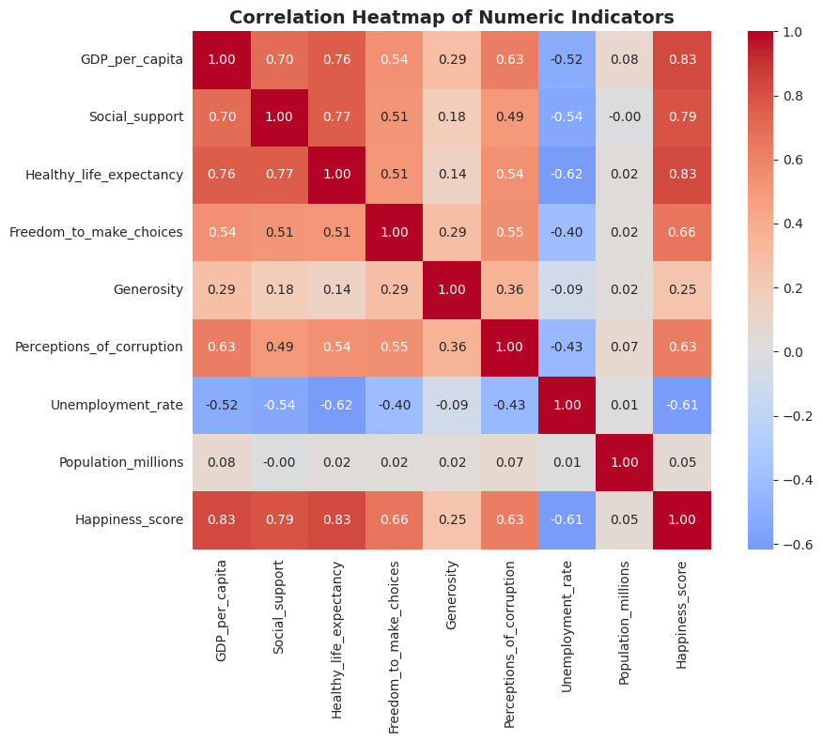
Figure 3: Correlation heatmap of numeric indicators
Key EDA findings:
- Happiness correlates strongly with GDP per capita (0.83), healthy life expectancy (0.83) and social support (0.79).
- Freedom to make choices (0.66) and corruption perception (0.63) show moderate positive correlation with happiness.
- Unemployment is negatively correlated with happiness (−0.61).
- Generosity is only weakly related (0.25), and population is essentially uncorrelated (0.05).

Step 5: Feature Preparation for Clustering
Hierarchical clustering works on one point per object. The 3,180 country-year rows are therefore averaged by country, giving 159 data points. Eight features are used for clustering; Population is kept only for reference because it has no meaningful relationship with the other indicators.
feature_cols = ["GDP_per_capita", "Social_support", "Healthy_life_expectancy",
"Freedom_to_make_choices", "Generosity", "Perceptions_of_corruption",
"Unemployment_rate", "Happiness_score"]

country_df = df.groupby("Country").agg({**{c: "mean" for c in feature_cols},
"Region": "first",
"Population_millions": "mean"}).reset_index()
print(country_df.shape) # (159, 11)
Next, the features are standardized (mean 0, standard deviation 1). This is essential because clustering is distance-based: without scaling, GDP (values in the tens of thousands) would completely dominate indices that range from 0 to 1.
scaler = StandardScaler()
X_scaled = scaler.fit_transform(country_df[feature_cols])

Step 6: Build the Dendrogram (Ward Linkage)
A dendrogram shows how countries are merged step by step. Ward linkage merges the pair of clusters that causes the smallest increase in within-cluster variance, and tends to produce compact, balanced clusters.
Z = linkage(X_scaled, method="ward")

plt.figure(figsize=(16, 7))
dendrogram(Z, labels=country_df["Country"].values, leaf_rotation=90, leaf_font_size=7)
plt.title("Dendrogram — Hierarchical Clustering of Countries (Ward Linkage)")
plt.show()
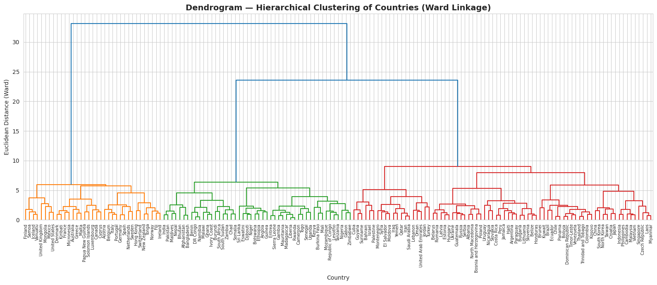
Figure 4: Dendrogram of countries using Ward linkage
The tallest vertical lines show the largest jumps in merge distance. The tree splits first into a high-income group (left) and the remaining countries, which then divide into a low-income group and a large middle group. A further split of the middle group gives the four-cluster solution.

Step 7: Choose the Number of Clusters
Two tools are used together: the dendrogram merge distances and the silhouette score for k = 2 to 8.
sil_scores = {}
for k in range(2, 9):
labels_k = AgglomerativeClustering(n_clusters=k, linkage="ward").fit_predict(X_scaled)
sil_scores[k] = silhouette_score(X_scaled, labels_k)
k | 2 | 3 | 4 | 5 | 6 | 7 | 8
Silhouette | 0.421 | 0.382 | 0.295 | 0.275 | 0.206 | 0.157 | 0.140

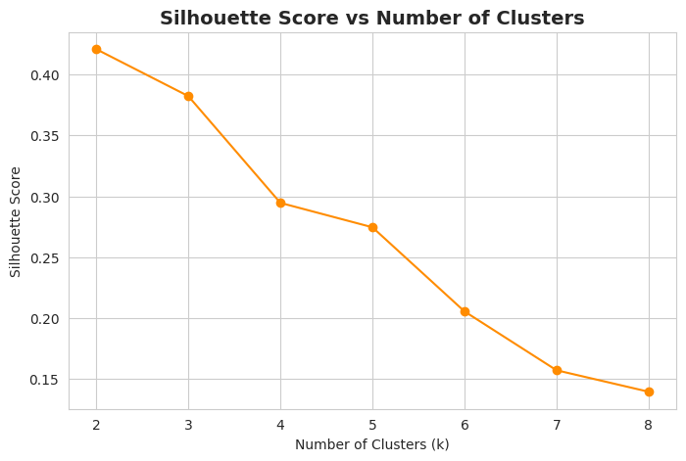
Figure 5: Silhouette score vs number of clusters
Decision: k = 2 has the highest silhouette score (0.421), but it only separates rich from poor countries. k = 4 was chosen as a trade-off between statistical fit and interpretability, giving four distinct development tiers. This is a judgement call and is stated openly in the notebook.

Step 8: Fit the Final Agglomerative Clustering Model
k = 4
hier_model = AgglomerativeClustering(n_clusters=k, linkage="ward")
country_df["Cluster"] = hier_model.fit_predict(X_scaled)
print(country_df["Cluster"].value_counts().sort_index())
Cluster | 0 | 1 | 2 | 3
Countries | 56 | 35 | 48 | 20

Step 9: Evaluate the Clusters
Because there are no true labels, three internal validation metrics are used.
Metric | Value | Meaning
Silhouette Score | 0.295 | Range −1 to 1; higher is better. A moderate value indicates some overlap between clusters.
Davies-Bouldin Index | 1.404 | Lower is better; measures average similarity between clusters.
Calinski-Harabasz Score | 110.6 | Higher is better; ratio of between- to within-cluster dispersion.

Step 10: Visualize Clusters Using PCA
Eight dimensions cannot be plotted directly, so Principal Component Analysis projects the data to two dimensions.
pca = PCA(n_components=2, random_state=42)
pcs = pca.fit_transform(X_scaled)
country_df["PC1"], country_df["PC2"] = pcs[:, 0], pcs[:, 1]
Result: PC1 explains 62.9% and PC2 explains 13.4% of the variance — 76.3% in total — so the 2-D picture is a faithful summary.
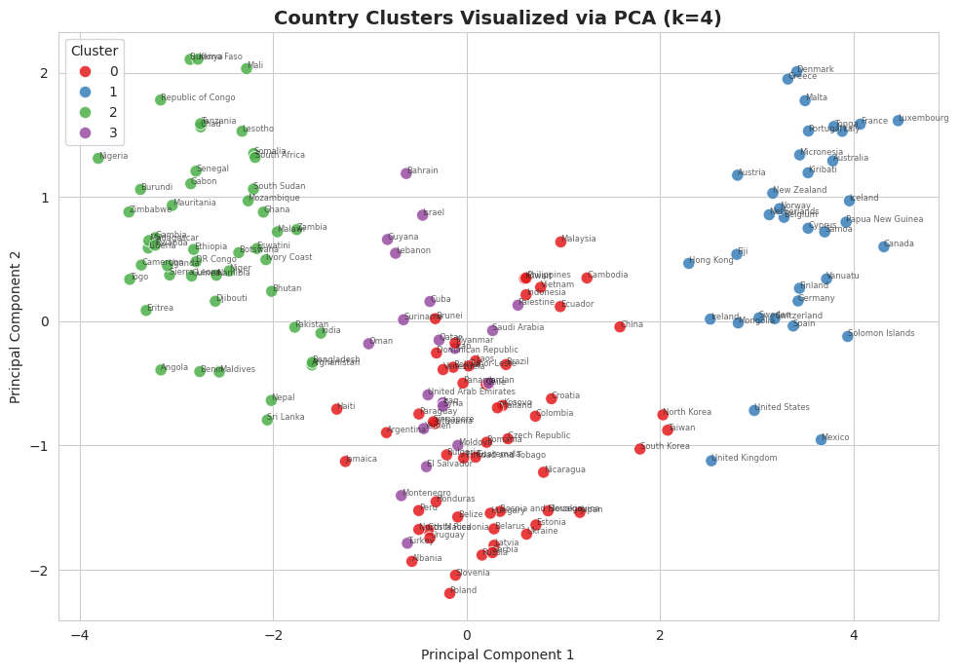
Figure 6: Country clusters projected onto the first two principal components
Cluster 1 (blue) sits at the far right and Cluster 2 (green) at the far left, along PC1, which behaves like an overall development axis. Clusters 0 and 3 occupy the middle and overlap, which is consistent with the moderate silhouette score.
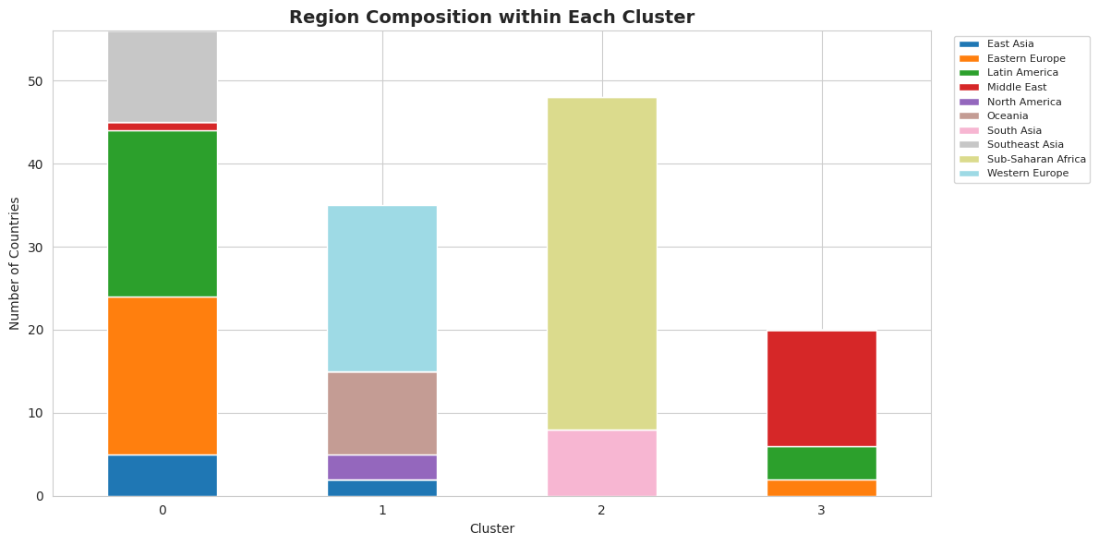
Figure 7: Region composition within each cluster

Step 11: Profile and Interpret the Clusters
Group the original (unscaled) features by cluster and compare mean values.
cluster_profile = country_df.groupby("Cluster")[feature_cols].mean().round(2)
cluster_profile["Num_Countries"] = country_df["Cluster"].value_counts().sort_index()
Cluster | Countries | GDP / capita | Life exp. | Freedom | Corruption idx | Unemp. % | Happiness
0 | 56 | 22,630 | 75.1 | 0.70 | 0.35 | 6.4 | 5.39
1 | 35 | 55,652 | 79.8 | 0.87 | 0.62 | 5.7 | 6.76
2 | 48 | 5,327 | 63.0 | 0.61 | 0.28 | 10.0 | 3.83
3 | 20 | 34,574 | 74.2 | 0.58 | 0.32 | 8.8 | 5.36

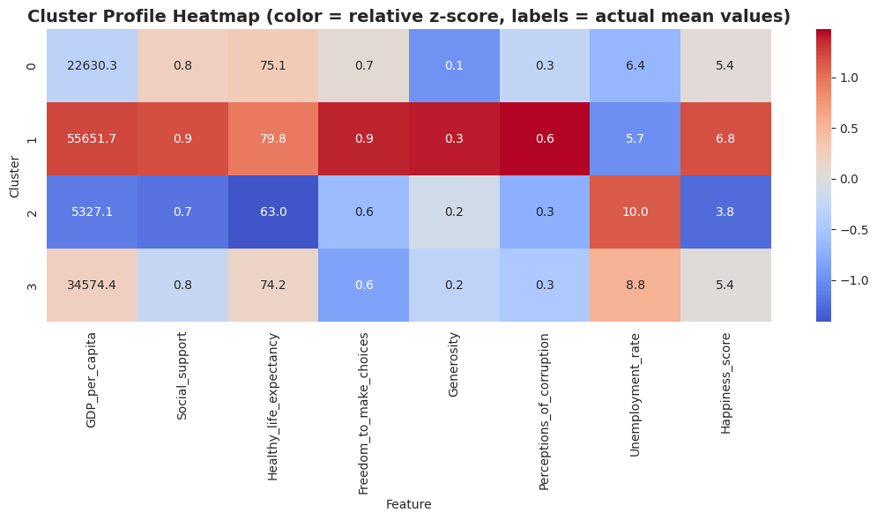
Figure 8: Cluster profile heatmap (colour = relative z-score, labels = actual means)

5. Cluster Interpretation
The names below are interpretive labels based on the actual cluster means and the region composition chart (region counts are read from Figure 7 and are approximate).
Cluster | Label | Characteristics | Typical regions
1 | High-income, high-wellbeing | Highest GDP, life expectancy, freedom, corruption-perception score and happiness (6.76); lowest unemployment among the clusters. | Western Europe, Oceania, North America, part of East Asia
0 | Upper-middle / emerging | Moderate GDP (~$22.6k), life expectancy 75 years, happiness 5.39, relatively low unemployment (6.4%). | Latin America, Eastern Europe, Southeast Asia, East Asia
3 | Wealthy but constrained | GDP well above Cluster 0 (~$34.6k) but the lowest freedom (0.58), low corruption-perception score and higher unemployment (8.8%); happiness no higher than Cluster 0. | Mostly Middle East, plus a few Latin American and Eastern European countries
2 | Lower-income, development challenges | Lowest GDP (~$5.3k), life expectancy 63, happiness 3.83 and highest unemployment (10.0%). | Sub-Saharan Africa and South Asia

Key insight: Cluster 3 shows that high income alone does not guarantee high well-being. Despite a GDP about 53% higher than Cluster 0, its happiness score is essentially the same, held back by lower freedom and higher unemployment.

6. Conclusion, Limitations and Future Work

6.1 Conclusion
- Hierarchical clustering with Ward linkage on standardized, country-level indicators produced four interpretable development tiers.
- EDA confirmed strong links between happiness and GDP, life expectancy and social support, plus clear regional disparities.
- The clusters align well with regional groupings, which supports their meaningfulness.

6.2 Limitations
- The dataset is synthetic, so conclusions about individual countries should not be taken as real-world findings.
- Silhouette score is moderate (0.295) and Clusters 0 and 3 overlap; k = 2 scores higher statistically.
- Averaging over 20 years hides how countries change over time.
- Happiness_score is both a clustering input and an outcome, which pulls clusters toward happiness; a version without it would be a useful robustness check.

6.3 Future Work
- Compare linkage methods (average, complete, single) using cophenetic correlation.
- Cluster at the country-year level to track countries moving between clusters.
- Benchmark against K-Means, DBSCAN or Gaussian Mixture Models.
- Add real indicators (education, internet penetration) from the actual World Happiness Report.

