Travel Review Clustering
using Hierarchical (Agglomerative) Clustering

1. Project Overview
This project applies unsupervised machine learning to a Google reviews dataset. Each row represents one user and contains the average rating that user gave to 24 categories of tourist places such as churches, beaches, museums, restaurants and gyms. The goal is to discover natural groups of users using hierarchical clustering, without any predefined labels.

1.1 Objectives
- Clean and prepare the raw review ratings data.
- Explore rating behaviour using statistics and visualisations.
- Use a dendrogram to decide how many clusters the data supports.
- Build an Agglomerative Clustering model and visualise the clusters.
- Publish the project on GitHub with a clear README.

1.2 Dataset Description
The dataset file is google_review_ratings.csv. It has 5,456 rows and 26 columns; one column (Unnamed: 25) is empty and is dropped, leaving 25 columns.
Column | Description
User | Unique user id (e.g. "User 1")
Category 1 - 24 | Average rating (0 to 5) the user gave to each category
Unnamed: 25 | Empty/redundant column, removed

The 24 categories, in order: churches, resorts, beaches, parks, theatres, museums, malls, zoo, restaurants, pubs/bars, local services, burger/pizza shops, hotels/other lodgings, juice bars, art galleries, dance clubs, swimming pools, gyms, bakeries, beauty & spas, cafes, view points, monuments, gardens.

1.3 Technology Stack
Component | Tool
Language | Python 3
Data handling | pandas, NumPy
Visualisation | Matplotlib, Seaborn
Clustering | SciPy (linkage, dendrogram), scikit-learn (AgglomerativeClustering)
Environment | Jupyter Notebook

2. Environment Setup
- Install Python 3.9 or newer from python.org.
- Create a virtual environment: python -m venv venv, then activate it.
- Install the libraries: pip install pandas numpy matplotlib seaborn scipy scikit-learn jupyter
- Download google_review_ratings.csv and place it in the same folder as the notebook.
- Start Jupyter with: jupyter notebook

3. Step-by-Step Implementation

Step 1: Import Packages
What we do: Import the core libraries and set the default Seaborn theme.
Why: pandas and NumPy handle data, Matplotlib and Seaborn create plots.
import pandas as pd
import numpy as np
import matplotlib.pyplot as plt
import seaborn as sns
sns.set()

Step 2: Read the Data
What we do: Load the CSV into a DataFrame named raw_data and preview the first five rows.
Why: Gives a first look at column names and value formats.
raw_data = pd.read_csv('google_review_ratings.csv')
raw_data.head()

Observation: Columns are named User and Category 1 to Category 24, and a trailing Unnamed: 25 column is present.

Step 3: Check Data Types and Dimensions
What we do: Run raw_data.info() and raw_data.shape.
Why: Confirms data types and size before any cleaning.
raw_data.info()
print(raw_data.shape)

Observation: The data has 5,456 rows and 26 columns. The Category 11 column is read as text (object) instead of numbers, which signals a bad value.

Step 4: Data Manipulation
What we do: Drop the empty column, rename the columns to meaningful names, and fix the invalid value in local_services.
Why: Readable names make later plots interpretable. Non-numeric values would break calculations and clustering.
data = raw_data.drop(['Unnamed: 25'], axis=1)

column_names = ['user_id','churches','resorts','beaches','parks',
'theatres','museums','malls','zoo','restaurants','pubs_bars',
'local_services','burger_pizza_shops','hotels_other_lodgings',
'juice_bars','art_galleries','dance_clubs','swimming_pools',
'gyms','bakeries','beauty_spas','cafes','view_points',
'monuments','gardens']
data.columns = column_names

# find and remove the corrupted row ('2\t2.')
data['local_services'].unique()
data = data.drop(data[data['local_services'] == '2\t2.'].index)
data[['local_services']] = data[['local_services']].apply(pd.to_numeric)
data_manipulated = data.copy(deep=True)

Observation: After this step every column except user_id is numeric (float64).

Step 5: Statistical Summary
What we do: Use describe() on numeric columns and on the categorical user_id column.
Why: Shows the mean, spread, minimum and maximum of each rating, and confirms that user ids are unique (5,456 unique values).
data_manipulated.describe()
data.describe(include='object')

Step 6: Handle Missing Values
What we do: Count missing values per column, then fill them with the column mean.
Why: Missing values can distort distances and break clustering. The notebook found only a couple (for example in local_services and burger_pizza_shops).
missing_values = data_manipulated.isnull().sum()

for col in data_manipulated.select_dtypes('float64','int64').columns:
data_manipulated[col] = data_manipulated[col].fillna(data_manipulated[col].mean())

data_no_missing = data_manipulated.fillna(data_manipulated.mode())
data_no_missing.isnull().sum() # all zeros

Observation: No missing values remain.

Step 7: Exploratory Data Analysis (EDA)
What we do: Study the distribution of every rating, how many users reviewed each category, how many categories each user rated, and the average rating per category.
Why: EDA reveals data quality and behaviour patterns that guide modelling.
data_no_missing.hist(figsize=(18,18))

# which categories were rated by all users?
d = data_no_missing.describe()
rated = d.loc['min'] > 0
rated[rated]

# reviews per category
reviews = data_no_missing[column_names[1:]].astype(bool).sum(axis=0).sort_values()

# categories rated per user
no_of_reviews = data_no_missing[column_names[1:]].astype(bool).sum(axis=1).value_counts()

# average rating per category
avg_rating = data_no_missing[column_names[1:]].mean().sort_values()

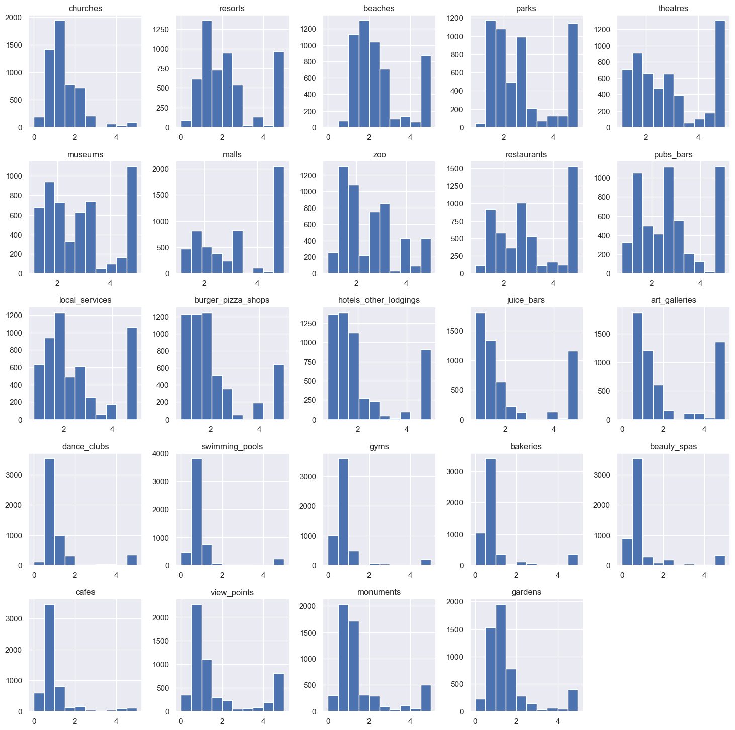
Figure 1: Histograms of ratings for all categories

Findings from EDA:
- Eleven categories (parks, theatres, museums, malls, zoo, restaurants, pubs/bars, local services, burger/pizza shops, hotels/lodgings, juice bars) were rated by every user.
- Categories with the fewest reviews: bakeries (4,410), gyms (4,439), beauty and spas (4,560).
- About 3,725 users rated all 24 categories; the lowest count of categories rated by any user is 15. Users with few ratings are good candidates for a recommender system.
- Lowest average ratings: gyms (0.82), swimming pools (0.95), cafes (0.97), bakeries (0.97).
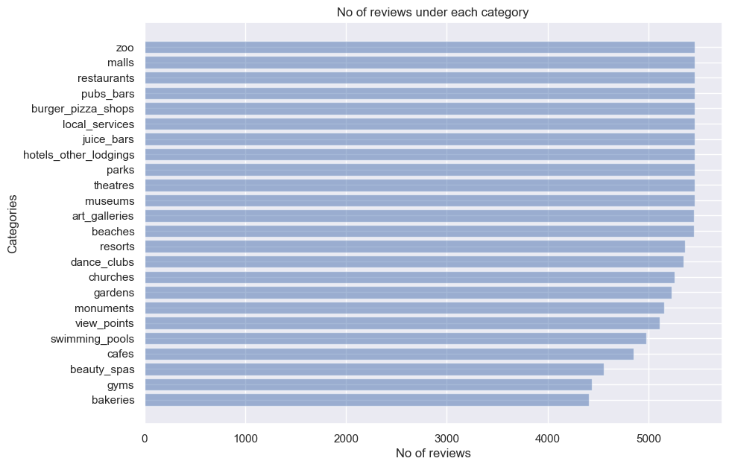
Figure 2: Number of reviews per category
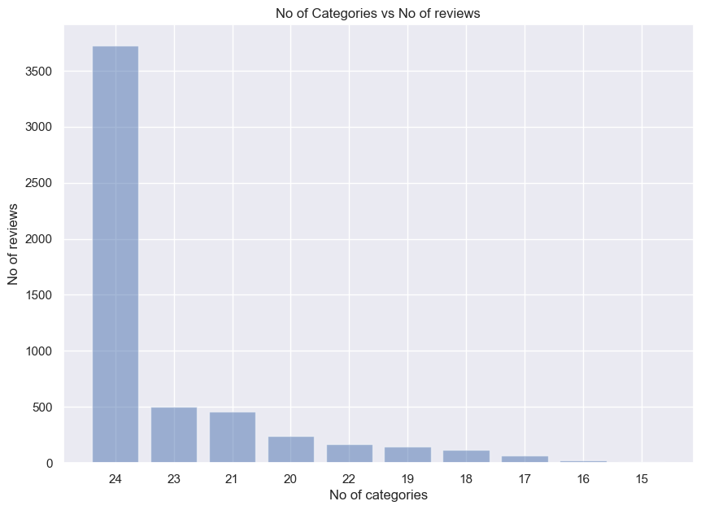
Figure 3: Number of users vs number of categories rated
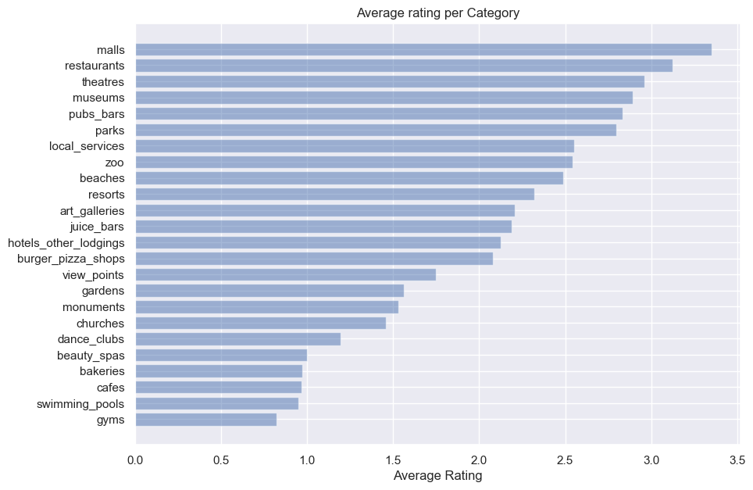
Figure 4: Average rating per category

Step 8: Prepare Final Dataset
What we do: Split the user_id text (for example "User 1") and keep the numeric id part, then drop the original user and user_id columns.
Why: Hierarchical clustering needs a numeric table; the text identifier cannot be used directly.
data_1 = data_no_missing.copy()
new = data_1['user_id'].str.split(' ', n=2, expand=True)
data_1['user'] = new[0]
data_1['id'] = new[1]
data_1 = data_1.drop(['user_id','user'], axis=1)
data_final = data_1.copy(deep=True)

Observation: Note: the id column stays in data_final and is therefore part of the model input (see Section 5 for how to improve this).

Step 9: Build the Linkage Matrix and Dendrogram
What we do: Compute Ward linkage with SciPy and plot the dendrogram.
Why: Ward linkage merges the pair of clusters that causes the smallest increase in within-cluster variance. The dendrogram shows the merge distances and helps choose the number of clusters.
import scipy.cluster.hierarchy as sch
from scipy.cluster.hierarchy import dendrogram, linkage

Z = sch.linkage(data_final, method='ward')

den = sch.dendrogram(Z)
plt.title('Hierarchical Clustering')

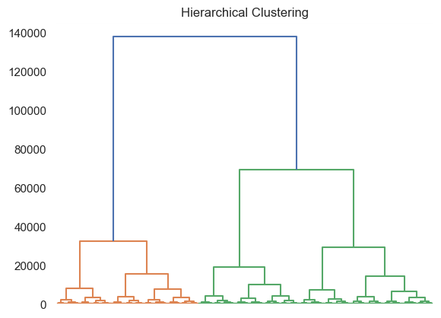
Figure 5: Dendrogram of all users

Step 10: Choose the Cut-off Line
What we do: Define a helper function fd() that draws an annotated dendrogram with a horizontal cut line. The cut line is placed at distance 80,000 and node labels are shown above 30,000.
Why: The number of clusters equals the number of vertical branches crossed by the cut line; a large vertical gap before the cut indicates natural clusters.
def fd(*args, **kwargs):
max_d = kwargs.pop('max_d', None)
if max_d and 'color_threshold' not in kwargs:
kwargs['color_threshold'] = max_d
annotate_above = kwargs.pop('annotate_above', 0)
ddata = dendrogram(*args, **kwargs)
... # annotate merge distances, draw axhline at max_d
return ddata

fd(Z, leaf_rotation=90., show_contracted=True,
annotate_above=30000, max_d=80000)

Observation: The line crosses two branches, so two clusters are chosen.
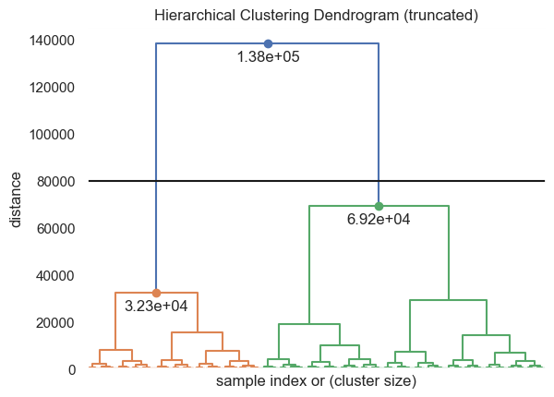
Figure 6: Dendrogram with the cut line at 80,000

Step 11: Fit the Agglomerative Clustering Model
What we do: Create AgglomerativeClustering with 2 clusters, Euclidean distance and Ward linkage, fit it on data_final and attach the cluster labels.
Why: scikit-learn gives each user a cluster label (0 or 1), which can be analysed and plotted.
from sklearn.cluster import AgglomerativeClustering

hc_model = AgglomerativeClustering(n_clusters=2,
metric='euclidean',
linkage='ward')
y_cluster = hc_model.fit_predict(data_final)

data_clustered = data_final.copy()
data_clustered["Cluster"] = y_cluster.astype('object')

Step 12: Visualise the Clusters
What we do: Draw a Seaborn pair plot coloured by cluster, with histograms on the diagonal.
Why: Pairwise scatter plots show how the two clusters separate across the rating dimensions.
sns.pairplot(data_clustered, hue="Cluster", diag_kind="hist")

Observation: The original pair plot is a 25 x 25 grid and was very large (about 28 MB as an embedded image). It was downscaled for GitHub.
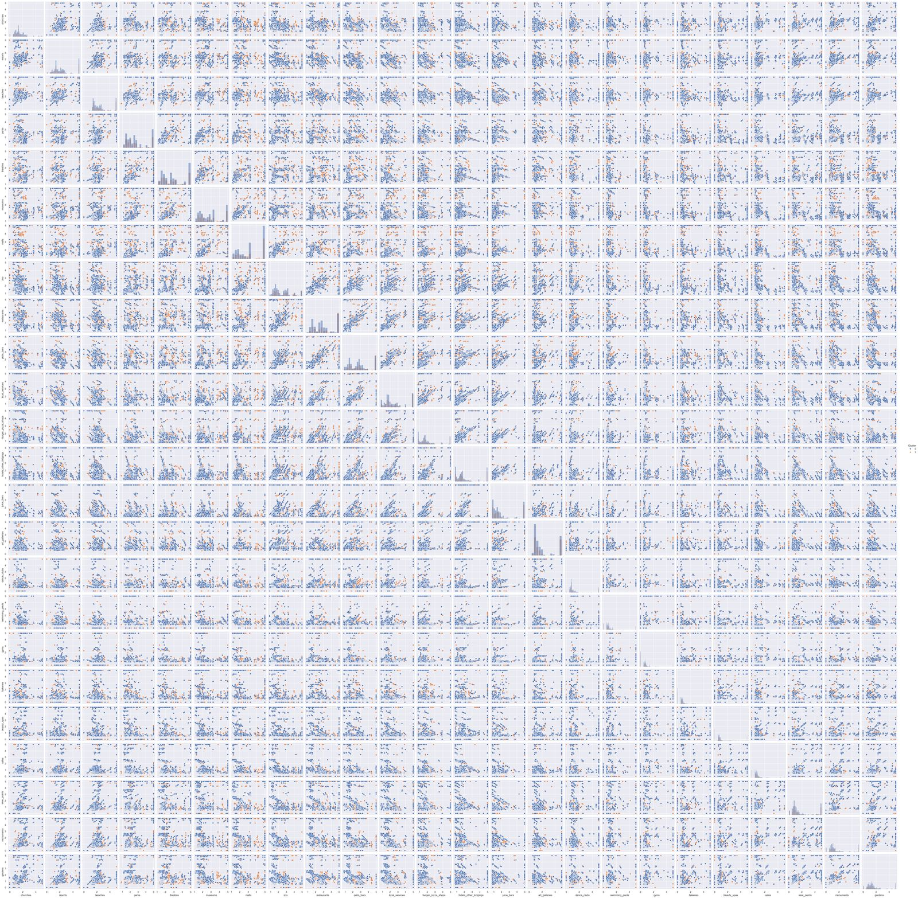
Figure 7: Pair plot of features coloured by cluster

Step 13: Conclusion and Labelling
What we do: Copy the clustered data and rename cluster 1 as Positive and cluster 0 as Negative.
Why: Gives the groups human-readable names.
result = data_clustered.copy()
result.replace({'Cluster': 1}, 'Positive', inplace=True)
result.replace({'Cluster': 0}, 'Negative', inplace=True)
result.head()

Observation: The notebook interprets the two clusters as a positive-review group and a negative-review group.

4. Results Summary
Item | Result
Users clustered | 5,456
Features | 24 category ratings (plus id column)
Method | Agglomerative clustering, Ward linkage, Euclidean distance
Cut-off height | 80,000 on the Ward dendrogram
Number of clusters | 2
Final labels | Positive and Negative

5. Limitations and Suggested Improvements
The notebook is a good baseline. The following points would make the analysis more rigorous, and are worth stating in your report or interviews:
- Exclude the id column. It is an identifier, not a rating, yet it is currently included in the data passed to linkage and the model.
- Scale features. Ratings are all on a similar 0-5 scale, but scaling (StandardScaler) is standard practice before distance-based clustering.
- Validate the Positive/Negative labels. Clustering does not know about sentiment. Compare the mean rating per cluster to confirm which cluster is the higher-rating group before naming it.
- Measure cluster quality. Use the silhouette score or Calinski-Harabasz index and try 3 or 4 clusters.
- Compare algorithms. Try K-Means and DBSCAN.
- Missing values. Only mean imputation is effective; the following mode fill has no effect.

