PROJECT DOCUMENTATION
WFP Global Food Prices 2026
Exploratory Data Analysis & DBSCAN Clustering

1. Project Overview

1.1 Introduction
The World Food Programme (WFP) monitors food prices in markets across food-insecure regions of the world. These prices are an early-warning signal for food crises: sudden increases can indicate supply disruption, currency collapse, or conflict. This project analyses the WFP Global Food Prices dataset for 2026 and applies DBSCAN clustering to group markets that share a similar geographic location and price level.

1.2 Problem Statement
Food prices vary by orders of magnitude across commodities, currencies and countries, and the variation is not a simple linear function of location. The goal is to (a) understand the structure and quality of the data through exploratory analysis, and (b) discover natural groupings of markets in the combined space of latitude, longitude and price level, while automatically flagging markets that do not belong to any dense group (noise).

1.3 Objectives
- Load, inspect and document the WFP global food-price data.
- Assess data quality (missing values, outliers) and clean the data defensibly.
- Perform univariate, categorical, temporal, geographic and multivariate EDA.
- Engineer a market-level feature set and standardise it for distance-based clustering.
- Select DBSCAN hyper-parameters using the k-distance graph and an eps sweep.
- Evaluate the clustering with Silhouette, Calinski-Harabasz and Davies-Bouldin scores.
- Visualise and profile the resulting clusters, and state limitations honestly.

1.4 Why DBSCAN?
Correlation analysis shows that latitude, longitude and month have almost no linear relationship with price, so any structure is local and non-linear. DBSCAN suits this situation because it (1) does not require the number of clusters in advance, (2) finds arbitrarily shaped, density-connected groups, and (3) explicitly labels outliers as noise instead of forcing them into a cluster, unlike k-means, which assumes convex, similarly sized clusters.

1.5 Technology Stack
Library | Purpose
pandas, NumPy | Data loading, cleaning, aggregation, numeric operations
matplotlib, seaborn | All visualisations (bar, box, violin, scatter, heatmap, pairplot)
scikit-learn | StandardScaler, NearestNeighbors, DBSCAN, PCA and evaluation metrics
Jupyter Notebook | Interactive development environment (Python 3 ipykernel)

2. Workflow at a Glance
The project follows a standard data-science pipeline. Each stage maps to a numbered section of the notebook and to a detailed step in Section 4 of this document.
# | Stage | Outcome
1 | Setup | Libraries imported, plot theme configured
2 | Load & inspect | 85,289 rows x 17 columns loaded; types and summary statistics reviewed
3 | Missing-value analysis | 340 missing usdprice; 29 missing location rows (< 0.4%)
4 | Cleaning & outlier check | 85,289 to 84,920 rows; 21.63% IQR outliers retained deliberately
5 | Categorical EDA | Composition by category, country, commodity, currency, market
6 | Price distribution | Heavy right skew confirmed; log1p transform justified
7 | Temporal trends | Monthly global and per-category price movement
8 | Geographic EDA | Markets concentrated in food-insecure regions
9 | Correlation EDA | Only price vs usdprice strongly correlated
10 | Feature engineering | 1,722 market-level profiles; standardised 3-feature matrix
11 | k-distance graph | Elbow-based eps estimate of 1.146
12 | DBSCAN tuning | 8-value eps sweep; eps = 0.712 selected
13 | Evaluation | Silhouette 0.2999 | CH 168.87 | DB 0.5305
14 | Visualisation | Geographic map and PCA projection of clusters
15 | Cluster profiling | 3 clusters (1,636 / 9 / 73 markets) + 4 noise markets
16 | Conclusions | Findings, limitations and next steps

3. Dataset Description

3.1 Source
The data is the WFP Global Food Prices dataset (the file used here is wfp_food_prices_global_2026.csv). WFP publishes this data openly through the Humanitarian Data Exchange (data.humdata.org). Please confirm the current licence and citation requirements on the source page before redistributing the raw file in your repository.

3.2 Size and Coverage
- 85,289 rows and 17 columns (about 11.1 MB in memory).
- 60 countries, 1,730 market names, 541 commodities, 8 food categories, 51 currencies, 103 units.
- 6 reporting dates (monthly snapshots in 2026).
- Largest contributor: Syria (SYR) with 14,380 records; largest category: cereals and tubers (23,425 records).
- Price type: 82,924 Retail records (about 97%) and 2,365 Wholesale records.
- Price flag: 3 values; "actual" is the most frequent (56,521 records, about 66%).

3.3 Data Dictionary
Column | Type | Description
countryiso3 | object | ISO-3 country code
date | object to datetime | Reporting date (monthly)
admin1 / admin2 | object | Sub-national administrative regions
market / market_id | object / int | Market name / unique numeric identifier
latitude / longitude | float | Market coordinates
category | object | Food category (8 categories)
commodity / commodity_id | object / int | Specific commodity (541 unique)
unit | object | Unit of measure (KG, L, ...)
priceflag | object | Whether the price is actual or aggregate
pricetype | object | Retail or Wholesale
currency | object | Local currency code
price | float | Price in local currency
usdprice | float | Price converted to USD (main analysis variable)

4. Step-by-Step Implementation
This section walks through the entire notebook in execution order. Each step lists the objective, what was done, the key code, and the insight obtained.

Step 1: Environment Setup and Imports
Objective: Prepare a reproducible environment and consistent plotting style.
What was done
- Imported pandas, NumPy, matplotlib and seaborn for analysis and plotting.
- Imported StandardScaler, DBSCAN, NearestNeighbors, PCA and three clustering metrics from scikit-learn.
- Suppressed warnings, set the seaborn "whitegrid" theme, figure size (10 x 6), DPI (100) and displayed up to 50 columns.
Key code
import numpy as np, pandas as pd
import matplotlib.pyplot as plt, seaborn as sns
from sklearn.preprocessing import StandardScaler
from sklearn.cluster import DBSCAN
from sklearn.neighbors import NearestNeighbors
from sklearn.decomposition import PCA
from sklearn.metrics import (silhouette_score,
calinski_harabasz_score, davies_bouldin_score)

sns.set_theme(style="whitegrid")
plt.rcParams['figure.figsize'] = (10, 6)

Step 2: Load and Inspect the Data
Objective: Understand the structure, data types and basic statistics before any transformation.
What was done
- Loaded the CSV with pd.read_csv and checked the shape.
- Used df.head(), df.info() and df.describe(include="all") to inspect columns, dtypes, null counts and summary statistics.
- Documented every column in a column reference (see Section 3.3).
Key code
df = pd.read_csv('wfp_food_prices_global_2026.csv')
print('Shape:', df.shape) # (85289, 17)
df.head(); df.info(); df.describe(include="all").T

Result / Insight
- Shape is (85289, 17) with 11 object, 4 float and 2 integer columns.
- The date column is stored as text and must be converted to datetime.
- Only usdprice, admin1, admin2, latitude and longitude contain nulls.

Step 3: Data Quality: Missing Values
Objective: Quantify and understand missing data before deciding how to treat it.
What was done
- Counted nulls per column and converted them to percentages of all rows.
- Plotted the missing counts as a bar chart.
Key code
missing = df.isna().sum()
missing = missing[missing > 0].sort_values(ascending=False)
print((missing / len(df) * 100).round(3))

Result / Insight
- usdprice: 340 missing rows (0.399%), most likely a missing exchange rate for that currency and month.
- admin1, admin2, latitude, longitude: the same 29 rows (0.034%), most likely markets without geocoding.
- Decision: because the volume is negligible, the rows are dropped rather than imputed, to avoid injecting bias into price or geography.

Step 4: Data Cleaning
Objective: Produce an analysis-ready dataset.
What was done
- Converted date to datetime and derived a month column.
- Dropped rows with missing latitude, longitude or usdprice, storing the result in df_clean.
Key code
df['date'] = pd.to_datetime(df['date'])
df['month'] = df['date'].dt.month
df_clean = df.dropna(subset=['latitude','longitude','usdprice']).copy()

Result / Insight
- Rows reduced from 85,289 to 84,920 (369 rows removed, about 0.43%).

Step 5: Outlier Assessment
Objective: Decide whether extreme prices are errors or genuine.
What was done
- Computed Q1, Q3 and IQR of usdprice and the upper fence Q3 + 1.5 x IQR.
- Measured the share of records above the fence.
Key code
Q1, Q3 = df_clean['usdprice'].quantile([0.25, 0.75])
upper_fence = Q3 + 1.5 * (Q3 - Q1) # 22.94 USD
(df_clean['usdprice'] > upper_fence).mean()*100 # 21.63 %

Result / Insight
- The upper fence is 22.94 USD and 21.63% of records exceed it.
- Decision: outliers are retained. Price data is naturally right-skewed (rare or luxury commodities, hyper-inflated currencies), so these are not data-entry errors. A log transform is applied instead of deleting them.

Step 6: Univariate and Categorical EDA
Objective: Understand which categories, countries, commodities and currencies dominate the data.
What was done
- Count plot of records by food category.
- Top-15 bar charts for countries, commodities and currencies by record count.
- Pie chart of price flag (actual vs aggregate).
- Top-15 countries by number of unique markets.
Key code
sns.countplot(data=df_clean, y='category',
order=df_clean['category'].value_counts().index)
df_clean['countryiso3'].value_counts().head(15)
df_clean.groupby('countryiso3')['market_id'].nunique()
.sort_values(ascending=False).head(15)

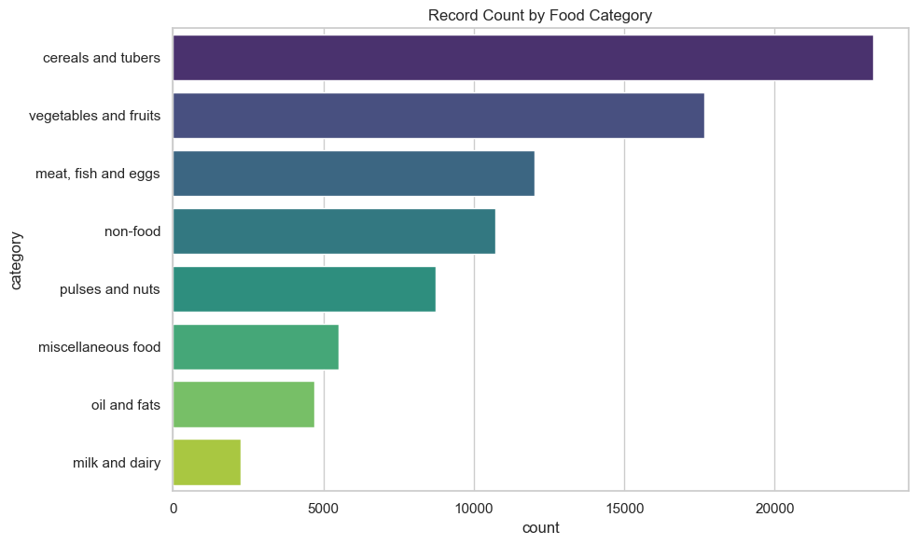
Figure 1: Record count by food category
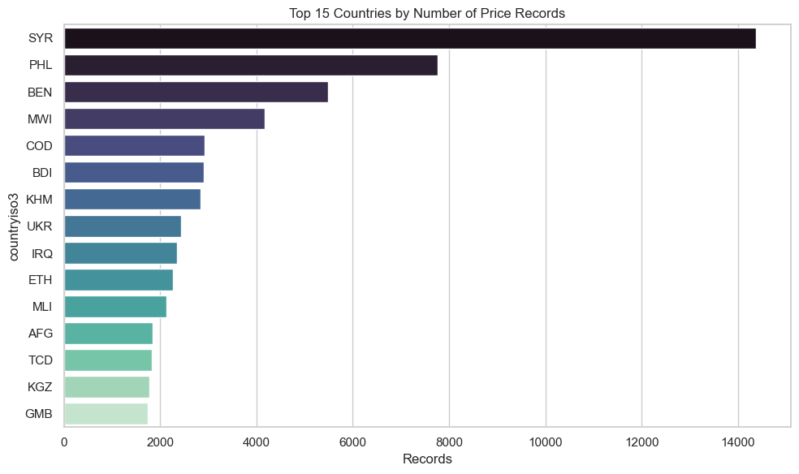
Figure 2: Top 15 countries by number of price records
Result / Insight
- cereals and tubers is the most heavily reported category.
- Reporting volume is very uneven: Syria (SYR) leads by a wide margin, followed by the Philippines (PHL), Benin (BEN) and Malawi (MWI).
- Prices are overwhelmingly Retail (about 97%). About two-thirds of prices are flagged "actual" and the rest are aggregate or other.

Step 7: Price Distribution Analysis
Objective: Study the shape of usdprice and justify a transformation.
What was done
- Histogram of raw usdprice (clipped at the 99th percentile).
- Histogram with KDE of log(1 + usdprice).
- Box plot of usdprice by category on a log axis, and violin plot of log price by Retail vs Wholesale.
- Top-15 countries by mean usdprice (minimum 50 records for reliability).
Key code
np.log1p(df_clean['usdprice'])
sns.boxplot(data=df_clean, x='usdprice', y='category',
showfliers=False); ax.set_xscale('log')
grp = df_clean.groupby('countryiso3')['usdprice']
.agg(['mean','count']); grp = grp[grp['count']>=50]

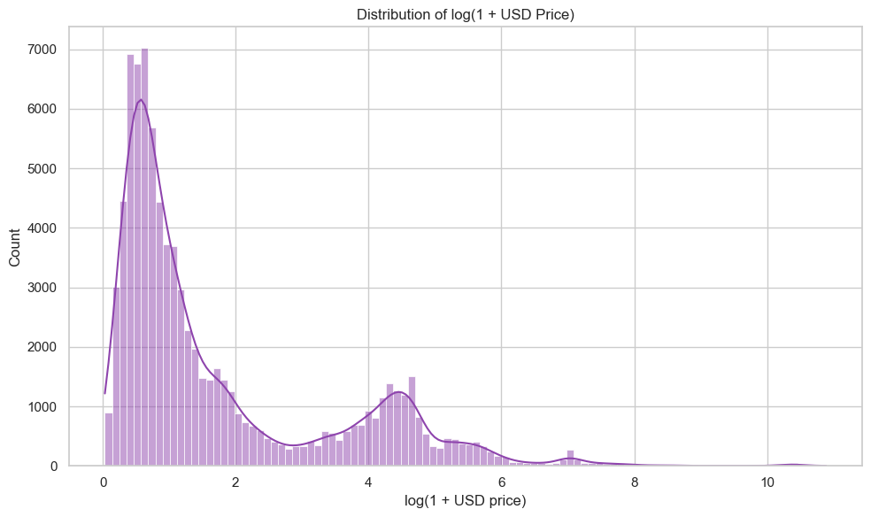
Figure 3: Distribution of log(1 + USD price)
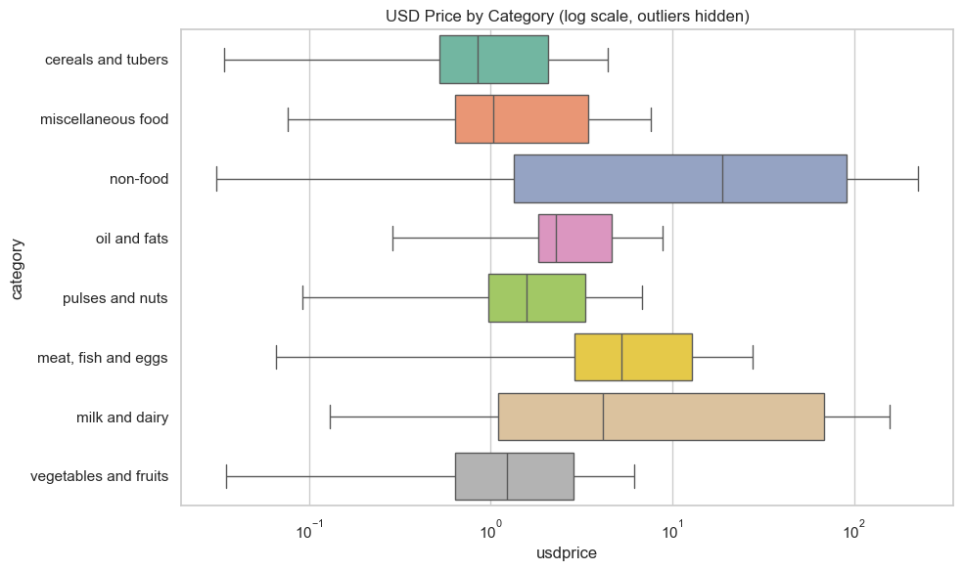
Figure 4: USD price by category (log scale, outliers hidden)
Result / Insight
- Raw usdprice is extremely right-skewed; log1p yields an approximately unimodal, near-symmetric distribution.
- This justifies log1p(usdprice) as the price feature for clustering.
- Price levels differ clearly by category and between price types.

Step 8: Temporal Trends
Objective: See how prices moved month to month in 2026.
What was done
- Plotted the average global usdprice per month.
- Plotted the average usdprice per month for each category on a log scale.
Key code
monthly = df_clean.groupby('month')['usdprice'].mean()
for cat in df_clean['category'].unique():
sub = df_clean[df_clean['category']==cat].groupby('month')['usdprice'].mean()
ax.plot(sub.index, sub.values, marker="o", label=cat)

Result / Insight
- The global average is fairly stable across the year because many currencies and countries are averaged together; individual categories show more movement. The dataset covers only one year, so this is a short-horizon view.

Step 9: Geographic EDA
Objective: Understand where markets are and how price varies in space.
What was done
- Scatter map of a random 8,000-record sample, coloured by category.
- Scatter map coloured by log(1 + usdprice).
- Histograms of latitude and longitude.
Key code
sample = df_clean.sample(min(8000, len(df_clean)), random_state=42)
ax.scatter(sample['longitude'], sample['latitude'],
c=np.log1p(sample['usdprice']), cmap='plasma')

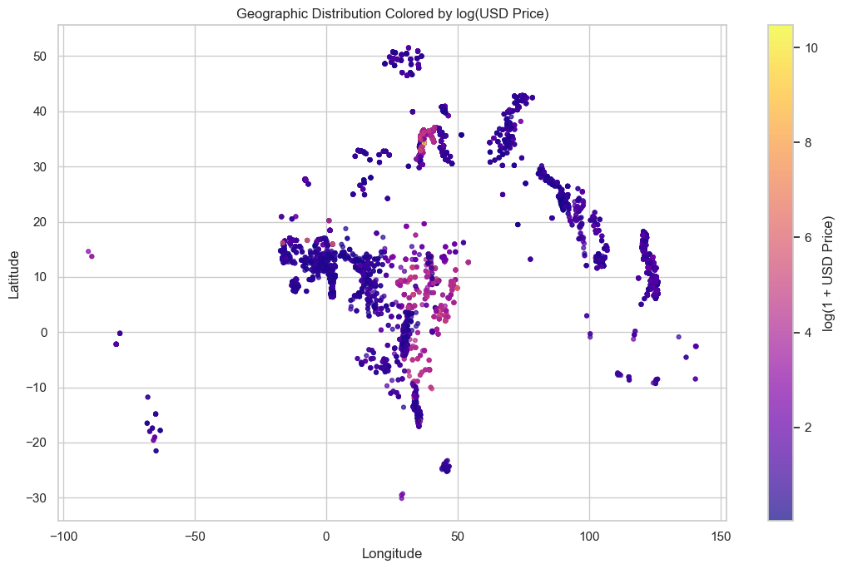
Figure 5: Markets coloured by log(1 + USD price)
Result / Insight
- Monitored markets concentrate in Sub-Saharan Africa, South and South-East Asia and the Middle East, reflecting WFP operational focus.
- Regions of visibly higher price exist, which is the kind of local structure DBSCAN can detect.

Step 10: Multivariate and Correlation EDA
Objective: Test for linear relationships among numeric variables.
What was done
- Correlation heatmap of latitude, longitude, price, usdprice and month.
- Pairplot of latitude, longitude and log price on a 3,000-row sample.
Key code
num_cols = ['latitude','longitude','price','usdprice','month']
sns.heatmap(df_clean[num_cols].corr(), annot=True,
cmap='coolwarm', center=0)

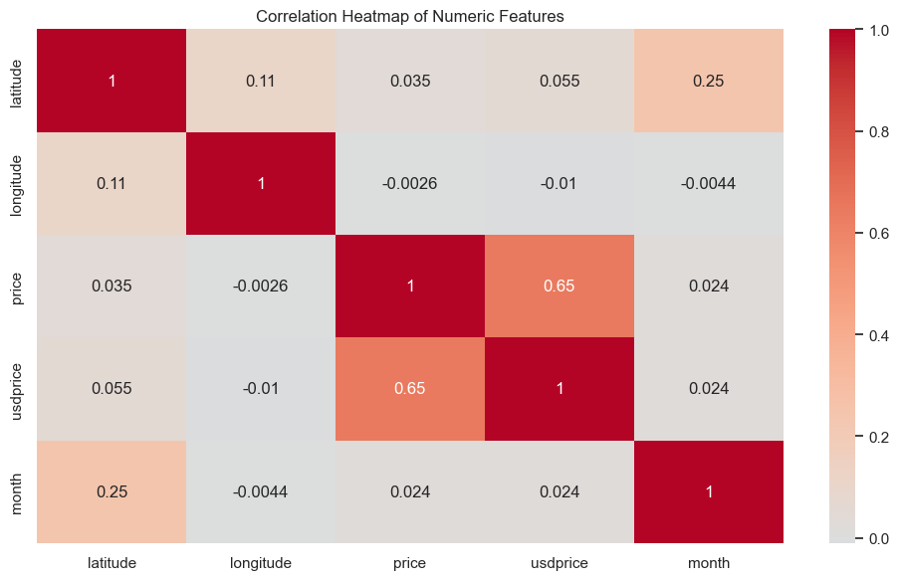
Figure 6: Correlation heatmap of numeric features
Result / Insight
- Only price and usdprice are strongly correlated (expected). Coordinates and month have essentially no linear relationship with price, so price structure is local and non-linear, which motivates a density-based method.

Step 11: Feature Engineering for Clustering
Objective: Convert the transaction-level data into one geo-economic profile per market, then scale it.
What was done
- Created log_usdprice = log1p(usdprice).
- Grouped by market_id and aggregated: first latitude, longitude, country and market name; mean log_usdprice; count of records.
- Selected three clustering features: latitude, longitude, log_usdprice.
- Standardised them with StandardScaler (mean 0, standard deviation 1) because DBSCAN is distance-based and the features have very different scales.
Key code
cluster_df = (df_clean.assign(log_usdprice=np.log1p(df_clean["usdprice"]))
.groupby('market_id')
.agg(latitude=('latitude','first'), longitude=('longitude','first'),
countryiso3=('countryiso3','first'), market=('market','first'),
log_usdprice=('log_usdprice','mean'), n_records=('usdprice','size'))
.reset_index())

features = ['latitude','longitude','log_usdprice']
X_scaled = StandardScaler().fit_transform(cluster_df[features].values)

Result / Insight
- 1,722 markets are available for clustering; the scaled matrix has shape (1722, 3).
- After scaling, every feature has mean approximately 0 and standard deviation approximately 1.

Step 12: Choosing eps with the k-distance Graph
Objective: Estimate a sensible neighbourhood radius (eps) for DBSCAN.
What was done
- Set min_samples = 2 x number of features = 6 (common rule of thumb).
- Fitted NearestNeighbors with k = 6 and sorted each point's distance to its 6th neighbour.
- Plotted the sorted distances and estimated the elbow programmatically as the steepest jump in the last 20% of the curve.
Key code
min_pts = 2 * X_scaled.shape[1] # 6
nbrs = NearestNeighbors(n_neighbors=min_pts).fit(X_scaled)
k_distances = np.sort(nbrs.kneighbors(X_scaled)[0][:, -1])

diffs = np.diff(k_distances)
start = int(0.8 * len(diffs))
eps_guess = k_distances[np.argmax(diffs[start:]) + start] # 1.1460

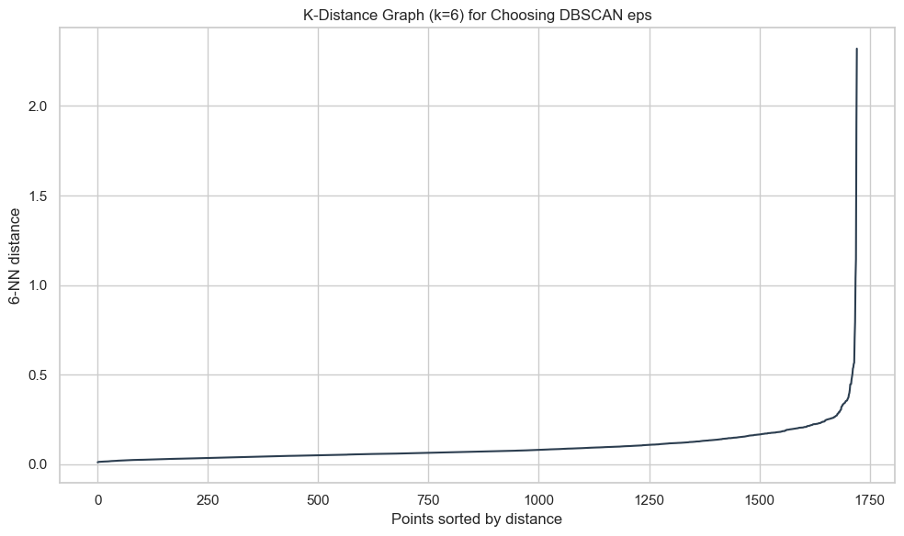
Figure 7: k-distance graph (k = 6)
Result / Insight
- The elbow heuristic suggests eps of about 1.146. Because an elbow near the extreme tail can over-merge clusters, this value is used as an upper anchor and a range of smaller values is tested next.

Step 13: Running and Tuning DBSCAN
Objective: Select the final eps using clustering-quality metrics.
What was done
- Generated 8 candidate eps values between 0.35 x and 1.30 x of the elbow estimate.
- For each eps, ran DBSCAN and recorded number of clusters, noise percentage, Silhouette, Calinski-Harabasz and Davies-Bouldin (metrics computed on non-noise points only).
- Selection rule: keep configurations with at least 3 clusters and less than 25% noise, then choose the highest Silhouette score.
Key code
eps_candidates = sorted(set(round(x,3) for x in
np.linspace(eps_guess*0.35, eps_guess*1.3, 8)))
for eps in eps_candidates:
labels = DBSCAN(eps=eps, min_samples=min_pts).fit(X_scaled).labels_
... # clusters, noise %, silhouette, CH, DB

ok = results_df[(results_df.n_clusters>=3) & (results_df.noise_pct<25)]
best_eps = ok.loc[ok['silhouette'].idxmax(), 'eps'] # 0.712
final_db = DBSCAN(eps=best_eps, min_samples=min_pts).fit(X_scaled)

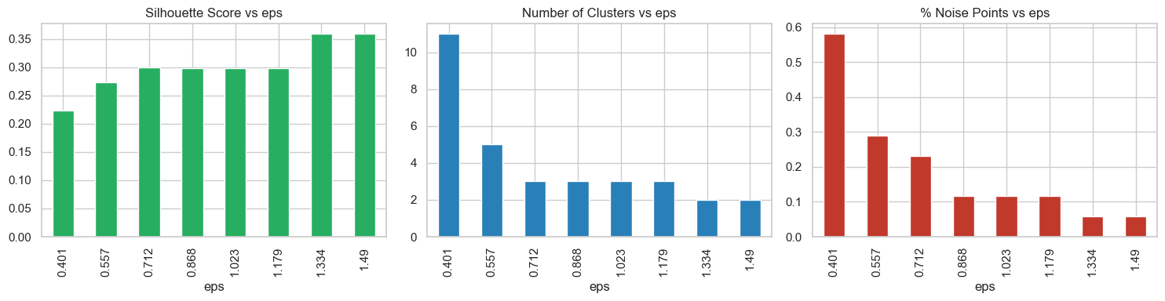
Figure 8: Silhouette, number of clusters and noise % versus eps
Result / Insight
- The tuning table below summarises the sweep. eps = 0.712 gives the best Silhouette (0.2999) among configurations with at least 3 clusters and low noise.
eps | Clusters | Noise % | Silhouette | Calinski-H. | Davies-B. | Chosen
0.401 | 11 | 0.58 | 0.2236 | 549.69 | 0.5311
0.557 | 5 | 0.29 | 0.2731 | 248.09 | 0.6557
0.712 | 3 | 0.23 | 0.2999 | 168.87 | 0.5305 | Yes
0.868 | 3 | 0.12 | 0.2991 | 172.42 | 0.5752
1.023 | 3 | 0.12 | 0.2991 | 172.42 | 0.5752
1.179 | 3 | 0.12 | 0.2991 | 172.42 | 0.5752
1.334 | 2 | 0.06 | 0.3592 | 40.23 | 0.7010
1.490 | 2 | 0.06 | 0.3592 | 40.23 | 0.7010

Step 14: Cluster Evaluation
Objective: Quantify the quality of the final model.
What was done
- Computed Silhouette, Calinski-Harabasz and Davies-Bouldin on non-noise points.
Key code
mask = cluster_df['cluster'] != -1
silhouette_score(X_scaled[mask], cluster_df.loc[mask,'cluster'])
calinski_harabasz_score(...); davies_bouldin_score(...)

Metric | Value | Interpretation
eps / min_samples | 0.712 / 6 | Final DBSCAN parameters
Clusters found | 3 | Excluding noise
Noise points | 4 (0.23%) | Markets not belonging to any dense group
Silhouette score | 0.2999 | Reasonable but not strong separation (range -1 to 1)
Calinski-Harabasz | 168.87 | Higher is better; best compared across eps values
Davies-Bouldin | 0.5305 | Below 1 is generally acceptable; lower is better

Step 15: Cluster Visualisation
Objective: Show where clusters sit geographically and how separated they are in feature space.
What was done
- Plotted markets on a longitude-latitude scatter, coloured by cluster, with noise in grey.
- Projected the 3-D scaled feature space to 2-D using PCA and plotted the clusters.
Key code
pca = PCA(n_components=2, random_state=42)
X_pca = pca.fit_transform(X_scaled)
cluster_df[['pca1','pca2']] = X_pca

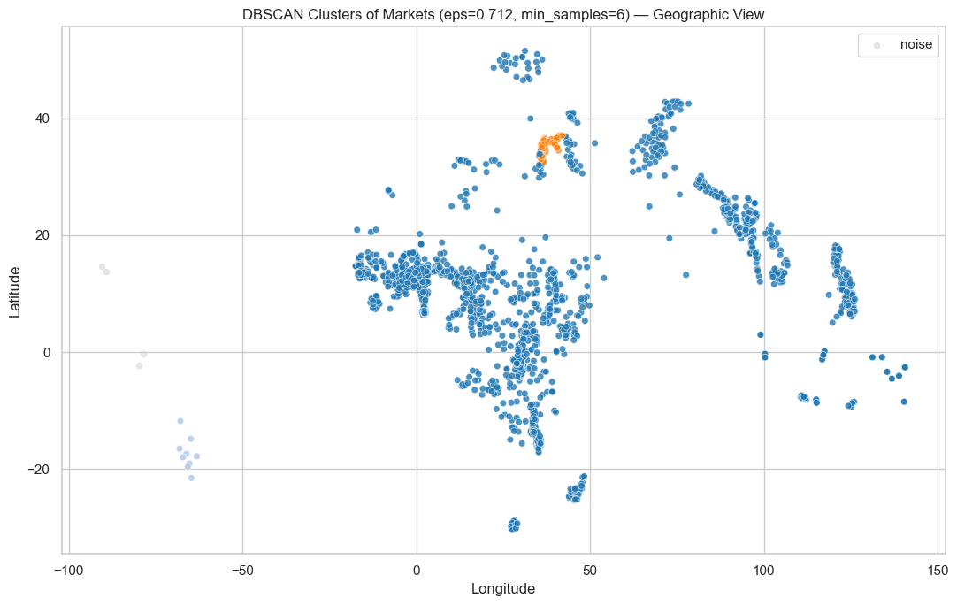
Figure 9: DBSCAN clusters, geographic view
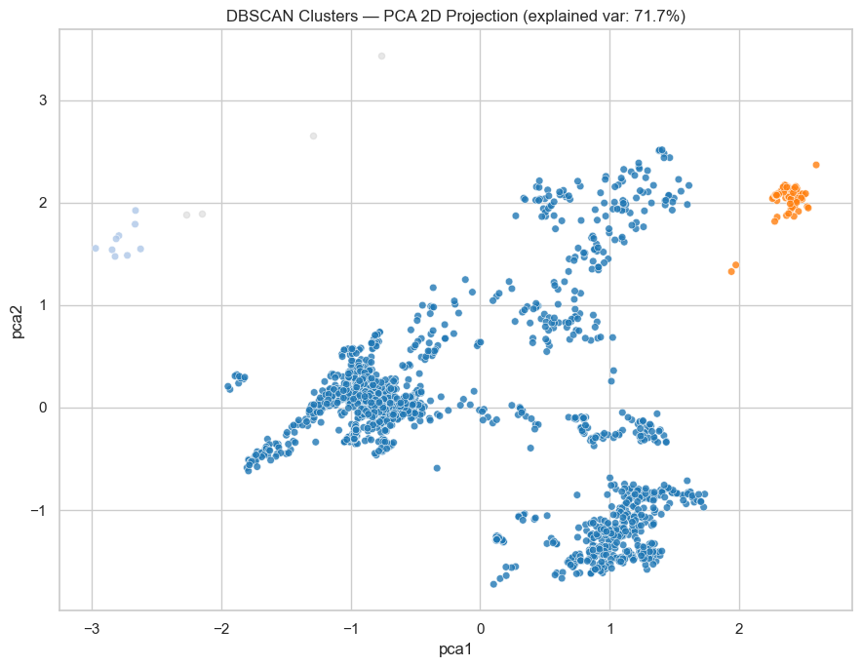
Figure 10: DBSCAN clusters, PCA 2-D projection
Result / Insight
- The map shows where each cluster is; the PCA view shows how separated the clusters are in the full standardised feature space. The two views complement each other.

Step 16: Cluster Profiling
Objective: Interpret what each cluster represents.
What was done
- Counted markets per cluster, plotted price distribution per cluster (log scale) and number of countries per cluster.
- Built a profile table with markets, countries, mean latitude and longitude, and mean USD price per cluster.
Key code
summary = (cluster_df[cluster_df['cluster']!=-1]
.assign(mean_usdprice=lambda d: np.expm1(d['log_usdprice']))
.groupby('cluster')
.agg(n_markets=('market_id','size'), n_countries=('countryiso3','nunique'),
avg_latitude=('latitude','mean'), avg_longitude=('longitude','mean'),
avg_usdprice=('mean_usdprice','mean')).round(2))

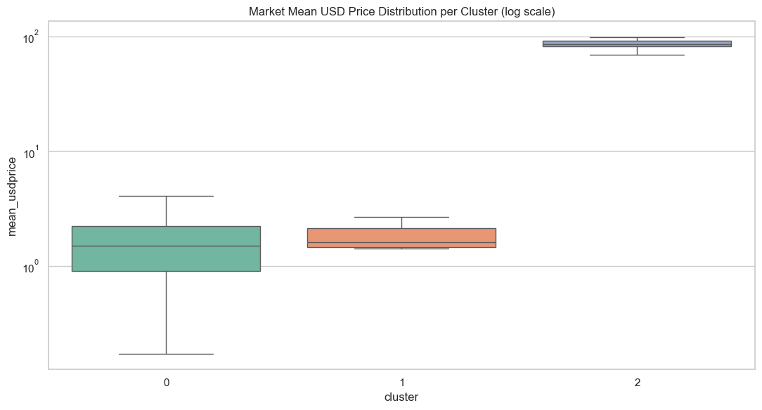
Figure 11: Market mean USD price per cluster (log scale)
Cluster | Markets | Countries | Avg lat. | Avg long. | Avg USD price
0 | 1,636 | 54 | 9.63 | 40.50 | 6.86
1 | 9 | 1 | -17.38 | -65.91 | 1.95
2 | 73 | 1 | 34.68 | 37.29 | 84.71
Noise | 4 | - | - | - | -

Interpretation: Cluster 0 is a very large, continuous belt covering 54 countries (about 95% of markets) with a moderate price level. Cluster 1 is a small group of 9 markets in a single country whose coordinates correspond to Bolivia, with the lowest average USD price. Cluster 2 is a group of 73 markets in a single country whose coordinates correspond to Syria, with a very high average USD price (consistent with Syria's heavily depreciated local currency). The 4 noise markets are isolated points far from any dense group.

Step 17: Conclusions
Objective: Summarise what was learned.
Result / Insight
- The dataset is very clean (below 0.4% missing); cleaning meant dropping a few hundred unusable rows.
- Prices are extremely right-skewed and span orders of magnitude, so log1p is essential for visualisation and modelling.
- Reporting effort and market locations concentrate in crisis-monitored, food-insecure regions.
- Price level shows real but non-linear geographic structure, which a density-based method can capture.
- The final DBSCAN model (eps 0.712, min_samples 6) yields 3 clusters and 4 noise markets with Silhouette 0.2999 and Davies-Bouldin 0.5305: moderate, realistic separation for geo-economic data.

5. Limitations and Future Work

5.1 Limitations
- Unbalanced clusters. One cluster holds about 95% of markets and the other two are single-country clusters. DBSCAN is mainly isolating Syria (very high USD prices) and a Bolivian group, rather than revealing many fine-grained regimes.
- Mixed commodity basket. A market's feature is the mean log price over every commodity it reports. Different markets report different commodities and 103 different units (KG, L, etc.), so the mean partly reflects the basket and unit, not only the cost of living.
- Currency effects. usdprice depends on exchange-rate conversion; hyper-inflated or officially mis-priced currencies (such as Syria's) strongly influence cluster 2.
- Short time span. The data covers six monthly snapshots of one year, so trends and seasonality cannot be established.
- Moderate cluster quality. A Silhouette of about 0.30 shows reasonable but not crisp separation. Metrics also exclude noise points and are not directly comparable across different numbers of clusters.
- Euclidean distance on degrees. Latitude and longitude are treated as planar coordinates after scaling. A haversine metric would be more geographically accurate.

5.2 Future Work
- Cluster within a single commodity (for example wheat flour or rice) or per category to remove basket effects, or use price relative to the national median.
- Use a haversine distance for location and test HDBSCAN, which does not need a single global eps.
- Add economic indicators such as inflation, currency volatility or conflict data.
- Track month-to-month cluster membership to flag emerging regional price shocks.
- Build an interactive map (Folium, Plotly) and a Streamlit dashboard.

6. How to Reproduce

6.1 Requirements
python >= 3.9
numpy
pandas
matplotlib
seaborn
scikit-learn
jupyter

6.2 Run Locally
git clone https://github.com/<your-username>/wfp-food-prices-dbscan.git
cd wfp-food-prices-dbscan
python -m venv venv
source venv/bin/activate # Windows: venv\Scripts\activate
pip install -r requirements.txt
jupyter notebook notebooks/WFP_Food_Prices_EDA_DBSCAN.ipynb

Place wfp_food_prices_global_2026.csv in the same folder the notebook reads from (or update the path in the load cell, Step 2). Run all cells from top to bottom.

