For Update Any Time for any Chnages
akhil@Akhilesh MINGW64 ~/OneDrive/Desktop/Home/My_Project Creation/learning-track/learning-track (main)
$ git add .

akhil@Akhilesh MINGW64 ~/OneDrive/Desktop/Home/My_Project Creation/learning-track/learning-track (main)
$ git commit -m "cross Changesss in SecurityConfig"

akhil@Akhilesh MINGW64 ~/OneDrive/Desktop/Home/My_Project Creation/learning-track/learning-track (main)
$ git push origin main
Part1: -Project-Creation

Step 1: Create Spring Boot Project
Go to:
https://start.spring.io
Select:
Project: Maven
Language: Java
Spring Boot: 3.5.x
Java: 21
Group: com.learningtrack
Artifact: learning-track
Name: learning-track
Dependencies:
Spring Web
Spring Data JPA
MySQL Driver
Lombok
Validation
Spring Boot DevTools
Download and open in Eclipse.
Part2: -Backend
Step 1
Create Database
CREATE DATABASE working_track;
Step 2
application.properties
spring.application.name=learning-track
spring.datasource.url=jdbc:mysql://localhost:3306/working_track
spring.datasource.username=root
spring.datasource.password=root
spring.datasource.driver-class-name=com.mysql.cj.jdbc.Driver

spring.jpa.hibernate.ddl-auto=update
spring.jpa.show-sql=true

server.port=8080
Step 3
Src Code
Copy and Paste SourceCode and Replace application.properties
Step 4
Pom.xml
Replace Pom.xml
Part 3:Postman

Step 1
Test register
POST http://localhost:8080/api/auth/register
{
"name":"Akhilesh Kumar",
"email":"akhilesh@gmail.com",
"password":"123456",
"role":"ADMIN"
}

Step 2
Test Login
POST http://localhost:8080/api/auth/login
{
"email":"akhilesh@gmail.com",
"password":"123456"
}
Copy and Paste Token inside Authorization
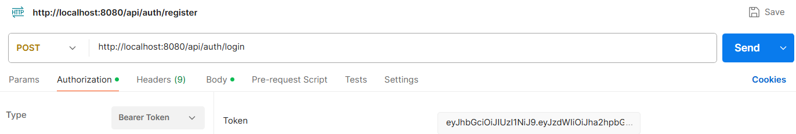
Step 3
Send Tpoic
POST http://localhost:8080/api/topics
{
"title":"Microservice",
"category":"Spring Boot",
"status":"COMPLETED",
"priority":"HIGH",
"progress":100,
"notes":"Completed Successfully"
}
--------------------------------------------------------------------------------------------------------------
Part4 -frontend
Step 1
Create Project
ng new working_track
Step 2
Src Code
Replace Src Code

Step 3
Install Bootstrap
Open the Angular project.
cd learning-track-ui
Install Bootstrap.
npm install bootstrap

Step 4 Open angular.json
Locate
learning-track-ui
angular.json
Find
"styles": [
"src/styles.css"
]
Replace with
"styles": [
"node_modules/bootstrap/dist/css/bootstrap.min.css",
"src/styles.css"
]

Step 5
Restart Angular
Ctrl + C
Then
ng serve
Open
http://localhost:4200
Nothing changes yet because we haven't used Bootstrap classes.
Excellent! 🎉 Your backend is now in a very good state.
✅ Completed
- Phase 1 - Project Setup
- Phase 2 - Enterprise Refactoring
- Phase 3 - Advanced CRUD
- Phase 4 - Dashboard
- Phase 5 - Spring Security + JWT
- Phase 6 - Global Exception Handling
Now let's move to DevOps, which is one of the most important skills for a Senior Java Developer.

Part5 - Dockerizes
🚀 Phase 7 - Dockerize the Spring Boot Application Goal
Step1:
Replace 4 Files
.dockerignore
docker-compose
Dockerfile
Jenkinsfile
Step2:
Build the Project
mvn clean package// mvn clean package -DskipTests
Step3:
Update Dockerfile
Replace The Name of jar inside Docker file after Build

Step 4:
Update application.properties
Replace database URL
Current
spring.datasource.url=jdbc:mysql://localhost:3306/learning_track
with
spring.datasource.url=jdbc:mysql://mysql:3306/learning_track

Step 5
Update docker-compose.yml
replace the new name of project and some changes in file
Mainly 3 Place Change (2 similar and one diffrent)
container_name: workingtrack-mysql(Line no.9 Chnage it not same with old)
container_name: workingtrack-app(Line no.27 Chnage it not same with old)

Step 5 .1
No Changes Need in .dockerignore

Step 6:
Confirm Database is Runninn in Windows PowerShell
PS C:\WINDOWS\system32> Get-Service *mysql*

Status Name DisplayName
------ ---- -----------
Running MySQL80 MySQL80

PS C:\WINDOWS\system32> Stop-Service MySQL80
WARNING: Waiting for service 'MySQL80 (MySQL80)' to stop...
PS C:\WINDOWS\system32> Stop-Service MySQL80
PS C:\WINDOWS\system32>
Note: You can Aslo Stop Using (Window+R) and Use services.msc and CLickin Ok and then Stop Mysql80 and If required then Start from here

Why Used I don’t Know :PS C:\WINDOWS\system32> netstat -ano | findstr :3306

Step 7:
Verify Wthere this Project is there or not
PS C:\WINDOWS\system32> docker ps -a
Step 8: Make sure the JAR exists
Before building the Docker image, run:
mvn clean package -DskipTests

Step 9:
Open Docker and open Console and whtch the folder location of your file
cd "C:\Users\akhil\OneDrive\Desktop\Home\My_Project Creation\working-track\working-track\working_track"

Step 10 Build Docker Image
Open Terminal
docker build -t learning-track .

Step 11
Check image
docker images
Expected
learning-track

Step 12 Run Docker Compose
docker compose up --build
or
docker-compose up –build
depending on your Docker version.
Expected
Creating learningtrack-mysql
Creating learningtrack-app
Started Successfully

If Error Getting Then Foellow Below
✘ Container learningtrack-mysql Error response from daemon: Conflict. The container name "/learningtr... 0.1s
Error response from daemon: Conflict. The container name "/learningtrack-mysql" is already in use by container "55453893385fb77914aab6bc05a457d4388046485d78a71408b56c349a757bca". You have to remove (or rename) that container to be able to reuse that name.

Your new docker-compose.yml is trying to create another container with the same name, which Docker doesn't allow.

Option 1 (Recommended): Remove the old container
Step 1: See all containers
docker ps -a
You should see something like:
CONTAINER ID IMAGE NAME
55453893385f mysql:8.0 learningtrack-mysql

Step 2: Stop it
docker stop learningtrack-mysql

Step 3: Remove it
docker rm learningtrack-mysql

Step 4: Start your new project
docker-compose up --build

If It’s Continie Running then (Ctr+c) for Cancel or Check the logs Run:docker-compose up or Similmpy Try to Check before Doing this docker ps -a if List Get the fine

Step 8 Verify Containers
docker ps
Expected
learningtrack-app
learningtrack-mysql
or
docker ps -a

Step 9 Test APIs
Open Postman
POST
/api/auth/login
Works ✅
POST
/api/auth/register
Works ✅
GET
/api/topics
Works ✅
Everything should behave exactly as before, but now the application is running inside Docker.
If Not Working! Then Follow Below – If Postman Not Reached
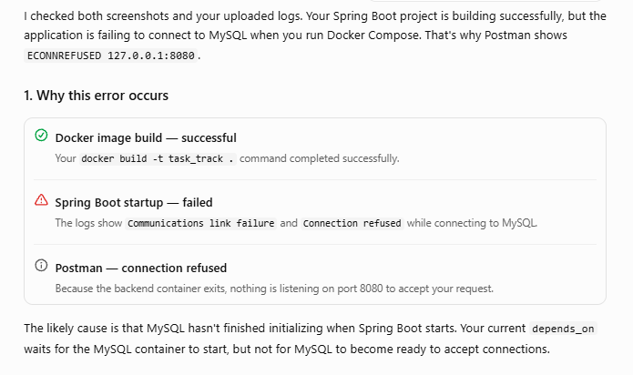
2. Fix your docker-compose.yml
services:
mysql:
image: mysql:8.0
container_name: task_track-mysql
restart: always
environment:
MYSQL_ROOT_PASSWORD: root
MYSQL_DATABASE: task_track
ports:
- "3306:3306"
volumes:
- mysql_data:/var/lib/mysql
healthcheck:
test: ["CMD", "mysqladmin", "ping", "-h", "localhost", "-uroot", "-proot"]
interval: 10s
timeout: 5s
retries: 12
start_period: 30s

learning-track:
build: .
container_name: task_track-app
restart: on-failure
depends_on:
mysql:
condition: service_healthy
ports:
- "8080:8080"
environment:
SPRING_DATASOURCE_URL: jdbc:mysql://mysql:3306/task_track
SPRING_DATASOURCE_USERNAME: root
SPRING_DATASOURCE_PASSWORD: root

volumes:
mysql_data:

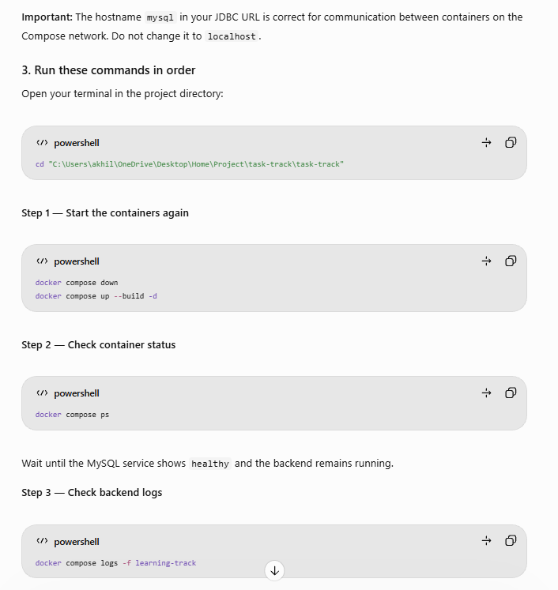
3. Run these commands in order
cd "C:\Users\akhil\OneDrive\Desktop\Home\Project\task-track\task-track"
docker compose down
docker compose up --build -d
docker compose ps
docker compose logs -f learning-track
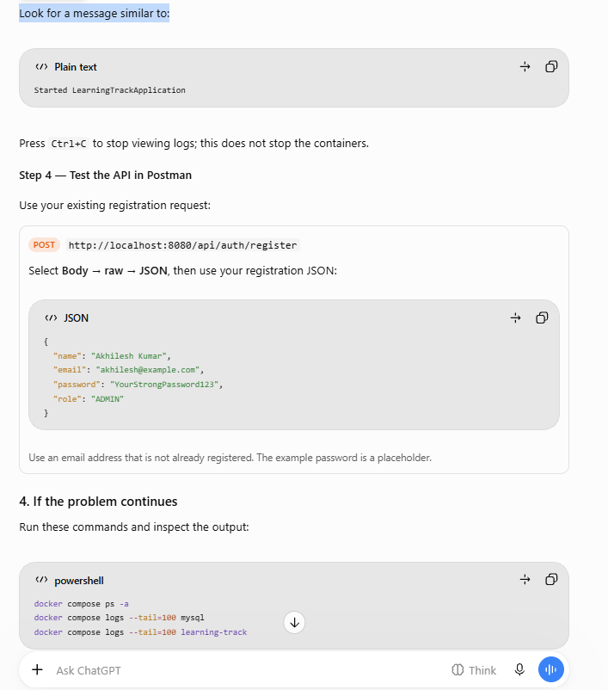
Part6 - Jenkins CI/CD Pipeline
Excellent! You're making good progress. Based on our roadmap, here's the updated status:
- ✅ Phase 1 - Spring Boot Setup
- ✅ Phase 2 - Enterprise Refactoring
- ✅ Phase 3 - CRUD + Search + Pagination
- ✅ Phase 4 - Dashboard + Progress Tracking
- ✅ Phase 5 - Spring Security + JWT Authentication
- ✅ Phase 6 - Docker
- ✅ Phase 7 - Docker Compose + Docker Image + Container Verification + API Testing
Next is:
Phase 8 - Jenkins CI/CD Pipeline
Goal: Automatically build your project whenever code is pushed to GitHub.
GitHub
│
Webhook
│
Jenkins
│
Maven Build
│
Run Tests
│
Build Docker Image
│
Application Ready

url:http://localhost:8081/login?from=%2Fjob%2Fworking-track%2F
User:akhilesh
Password:@A25197348abc
Step 1 - Install Jenkins
Windows
Download Jenkins:
https://www.jenkins.io/download/
Install Jenkins.
During installation:
- Install as Windows Service ✅
- Install JDK if prompted
- Install Suggested Plugins ✅
Open
http://localhost:8080
Unlock Jenkins.
Password location:
C:\ProgramData\Jenkins\.jenkins\secrets\initialAdminPassword
Create Admin User.

Step 2 - Install Required Plugins
Go to
Manage Jenkins
↓
Plugins
Install:
- Git
- Pipeline
- Docker Pipeline
- Maven Integration
- GitHub
Restart Jenkins.

Step 3 - Configure JDK
Manage Jenkins
↓
Tools
↓
JDK
Add
JDK 21
(or JDK 17 if your project uses Java 17)

Step 4 - Configure Maven
Manage Jenkins
↓
Tools
↓
Maven
Add
Maven 3.9

Step 7 - Create Jenkinsfile
Create a file in the project root.
learning-track
│
├── Jenkinsfile
├── Dockerfile
├── pom.xml
└── docker-compose.yml
Paste the following:
Copy & paste Prvoise use and Change Two Places
bat(Line No. 27 & url Line no.15)
Baisically Replace:<your-username> with your GitHub username.
https://github.com/akhileshkumar4953/working-track.git
follow Below
Step 5.1 Create Repository and Push the Code
1.Create new Repository
2.Go Inside folder structure and follow Below Command
---------- git init (Fisrt Time If .git folder is not there)
git status
git add .
git status
git commit -m "Initial commit"
git branch -M main
git branch
git remote add origin https://github.com/akhileshkumar4953/working-track.git
git remote -v
git push -u origin main(Some Time Need Twice Hits)

Repetedly Used If any Changes Update follow below
git add .
git commit -m "cross Changes in SecurityConfig"
git push origin main
Step 5 - Create Pipeline Job
Click
New Item
Name
learning-track
Select
Pipeline
OKStep 6 - Pipeline Configuration
Choose
Pipeline script from SCM
SCM
Git
Repository
https://github.com/<your-username>/learning-track.git
Branch
main
Script Path
Jenkinsfile
Save.
If Below Error Faced:
The key part of the error is:
fatal: unable to access
'https://github.com/akhileshkumar4953/working-track.git/':
Failed to connect to github.com port 443 after 21142 ms:
Could not connect to server
- Go to the job's "Configure" page
- Under Source Code Management → Git → Additional Behaviors, add a behavior "Wipe out repository & force clone"
- Save
- Build

Note:Before Starting Same Build Then Stop Prvouse Running Then Start BuildLike Below
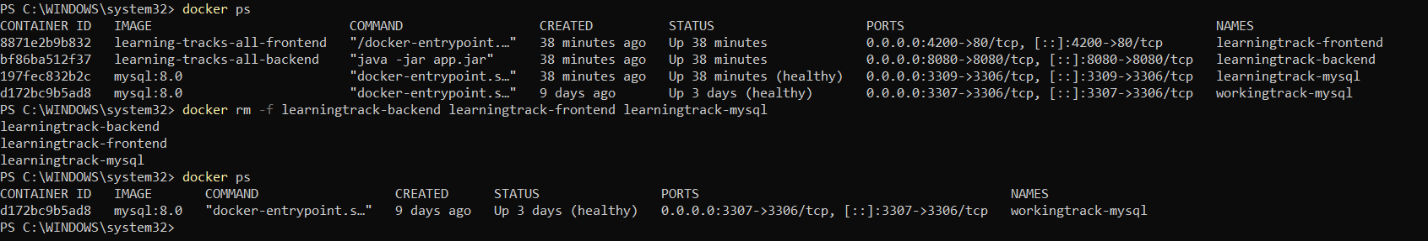
Finally Start Dekstop Docker then clink on build now in jenkind
cd "C:\Users\akhil\OneDrive\Desktop\Home\My_Project Creation\working-track\working-track\working-track"
docker build -t working-track
docker images
docker compose up --build
docker ps
Note:If Everything Working then only click on Build Now Button

Step 9 - Build Job
Open Jenkins.
Click
Build Now
Expected Console Output:
Checking out Git repository
Running mvn clean package
BUILD SUCCESS
Building Docker Image
Successfully built
Finished: SUCCESS

Step 10 - Verify Docker Image
Chnages /working-track/docker-compose.yml with
ports:
- "3307:3306"

Chnages /working-track/src/main/resources/application.properties
Then:
docker compose down
docker compose up –build
PS C:\WINDOWS\system32> docker ps
or
PS C:\WINDOWS\system32> docker ps -a
After 2 days I Open My System and Execute docker compose down
& docker compose up then it’s Working So batter to execute only docker compose up and check It’s Working or not in postman
PS C:\WINDOWS\system32> docker stop d172bc9b5ad8
d172bc9b5ad8
PS C:\WINDOWS\system32> docker ps
CONTAINER ID IMAGE COMMAND CREATED STATUS PORTS NAMES
3b966cc8da1c learning-track-learning-track "java -jar app.jar" 7 days ago Up 32 minutes 0.0.0.0:8080->8080/tcp, [::]:8080->8080/tcp learningtrack-app
55453893385f mysql:8.0 "docker-entrypoint.s…" 8 days ago Up 41 minutes 3306/tcp learningtrack-mysql
PS C:\WINDOWS\system32>
Note:Stop Running MYSQL80 from Service then docker compose up

PS C:\WINDOWS\system32> docker ps -a
CONTAINER ID IMAGE COMMAND CREATED STATUS PORTS NAMESs
0a3643b58530 working-track-working_track "java -jar app.jar" About a minute ago Up 57 seconds 0.0.0.0:8080->8080/tcp, [::]:8080->8080/tcp workingtrack-app
ecb92d073b46 mysql:8.0 "docker-entrypoint.s…" About a minute ago Up About a minute (healthy) 0.0.0.0:3307->3306/tcp, [::]:3307->3306/tcp workingtrack-mysql
3b966cc8da1c learning-track-learning-track "java -jar app.jar" 3 days ago Exited (143) 3 days ago learningtrack-app
55453893385f mysql:8.0 "docker-entrypoint.s…" 3 days ago Up 16 hours 3306/tcp learningtrack-mysql
583ffb654558 mywebapp2:1.0 "catalina.sh run" 6 months ago Exited (255) 4 days ago 8081/tcp, 0.0.0.0:9090->8080/tcp mywebapp2-container
11c0a93a014c akhileshkumar4953/myapp-image:1.0 "catalina.sh run" 6 months ago Created angry_hypatia
70b344ec4521 myapp-image "catalina.sh run" 6 months ago Exited (255) 4 days ago 0.0.0.0:8080->8080/tcp myapp-container
988ebfb1172b mysql "docker-entrypoint.s…" 9 months ago Exited (255) 7 months ago 3306/tcp, 33060/tcp mysqldb
106fbc5bb1cf mysql:latest "docker-entrypoint.s…" 9 months ago Exited (255) 7 months ago 33060/tcp, 0.0.0.0:3307->3306/tcp mysql-container
77d57c2108ac mysql:latest "docker-entrypoint.s…" 9 months ago Exited (1) 9 months ago localhost
dc5fd93051f7 springboot-docker-demo "java -jar springboo…" 9 months ago Exited (143) 9 months ago recursing_stonebraker
f4cb3679af80 springboot-docker-demo "java -jar springboo…" 9 months ago Exited (130) 9 months ago wonderful_carson
be8eef483896 springboot-docker-demo "java -jar springboo…" 9 months ago Exited (130) 9 months ago angry_mayer
1007b4e7951b springboot-docker-demo "java -jar springboo…" 9 months ago Created stupefied_mcnulty
PS C:\WINDOWS\system32>
If Everything Working as expected Also Verifiy above powershell output Then Finally Verify Postman It shouls be work

Step 11 - Enable GitHub Webhook (Optional but Recommended)
In your GitHub repository:
Settings
↓
Webhooks
↓
Add Webhook
Payload URL:
http://YOUR_PC_IP:8080/github-webhook/
Content type:
application/json
Events:
Just the push event
Save.
Now every git push will automatically trigger the Jenkins pipeline.

COntinue From Here After Copletetion of Docker and jenkins file Will Start To Do Same for Angular (Docker & Jenkins ) Then We Will Move To Work On AWS

Perfect. This is exactly the point where enterprise projects introduce Frontend DevOps. We'll do it in the same copy-paste, step-by-step style as we did for the Spring Boot backend.
Project Structure (Recommended)
Learning-Track/
│
├── learning-track/ <-- Spring Boot Backend
│
├── learning-track-ui/ <-- Angular Frontend
│
└── docker-compose.yml <-- Full Stack (Later)

🚀 Phase A.1 – Create Angular .dockerignore
Inside your Angular project (learning-track-ui), create a file named:
.dockerignore
Copy and paste:
node_modules
dist
.angular
.git
.vscode
.idea
coverage
*.log

Expected Structure
learning-track-ui
│
├── .dockerignore
├── package.json
├── angular.json
├── src
└── ...

🚀 Phase A.2 – Create Angular Dockerfile
Inside learning-track-ui
Create
Dockerfile
Copy everything:
# ---------- Stage 1 : Build Angular ----------

FROM node:22-alpine AS build

WORKDIR /app

COPY package*.json ./

RUN npm install

COPY . .

RUN npm run build

# ---------- Stage 2 : Nginx ----------

FROM nginx:alpine

COPY --from=build /app/dist/learning-track-ui/browser /usr/share/nginx/html

COPY nginx.conf /etc/nginx/conf.d/default.conf

EXPOSE 80

CMD ["nginx","-g","daemon off;"]

Why two stages?
Instead of shipping Node.js to production, we:
Node
↓

Build Angular

↓

Static Files

↓

NGINX
This makes the image much smaller and faster.

🚀 Phase A.3 – Create nginx.conf
Inside
learning-track-ui
Create
nginx.conf
Copy everything:
server {

listen 80;

server_name localhost;

root /usr/share/nginx/html;

index index.html;

location / {

try_files $uri $uri/ /index.html;

}

}
This is required because Angular uses client-side routing.
Without this, refreshing:
/dashboard
would give
404 Not Found

🚀 Phase A.4 – Build Angular Docker Image
Open Terminal
cd learning-track-ui
Build
docker build -t learning-track-ui .

Verify
docker images
Expected
REPOSITORY

learning-track-ui

Run
docker run -d -p 4200:80 --name learning-track-ui learning-track-ui
Open
http://localhost:4200
Expected
Angular Login Screen

Stop container
docker stop learning-track-ui
Remove
docker rm learning-track-ui

🚀 Phase A.5 – Angular Jenkinsfile
Inside
learning-track-ui
Create
Jenkinsfile
Copy everything
pipeline {

agent any

tools {

nodejs 'NodeJS22'

}

stages {

stage('Checkout') {

steps {

git branch: 'main',
url: 'https://github.com/akhileshkumar4953/learning-track-ui.git'

}

}

stage('Install Dependencies') {

steps {

bat 'npm install'

}

}

stage('Angular Build') {

steps {

bat 'npm run build'

}

}

stage('Docker Build') {

steps {

bat 'docker build -t learning-track-ui .'

}

}

}

post {

success {

echo 'Angular Build Successful'

}

failure {

echo 'Angular Build Failed'

}

}

}
Note: Replace the GitHub repository URL with your actual Angular repository URL if it differs.

🚀 Phase A.6 – Full Stack docker-compose.yml
Create this file in your project root (the folder containing both learning-track and learning-track-ui).
Learning-Track/
│
├── docker-compose.yml
├── learning-track/
└── learning-track-ui/
Copy everything:
version: '3.8'

services:

mysql:

image: mysql:8.0

container_name: learningtrack-mysql

restart: always

environment:

MYSQL_ROOT_PASSWORD: root

MYSQL_DATABASE: learning_track

ports:

- "3306:3306"

volumes:

- mysql_data:/var/lib/mysql

healthcheck:

test: ["CMD", "mysqladmin", "ping", "-h", "localhost"]

interval: 10s

retries: 10

timeout: 5s

backend:

build: ./learning-track

container_name: learningtrack-backend

depends_on:

mysql:

condition: service_healthy

environment:

SPRING_DATASOURCE_URL: jdbc:mysql://mysql:3306/learning_track

SPRING_DATASOURCE_USERNAME: root

SPRING_DATASOURCE_PASSWORD: root

ports:

- "8080:8080"

frontend:

build: ./learning-track-ui

container_name: learningtrack-frontend

depends_on:

- backend

ports:

- "4200:80"

volumes:

mysql_data:

Run Everything – Continue from here
From the project root:
docker compose up --build
Expected running containers:
learningtrack-mysql

learningtrack-backend

learningtrack-frontend
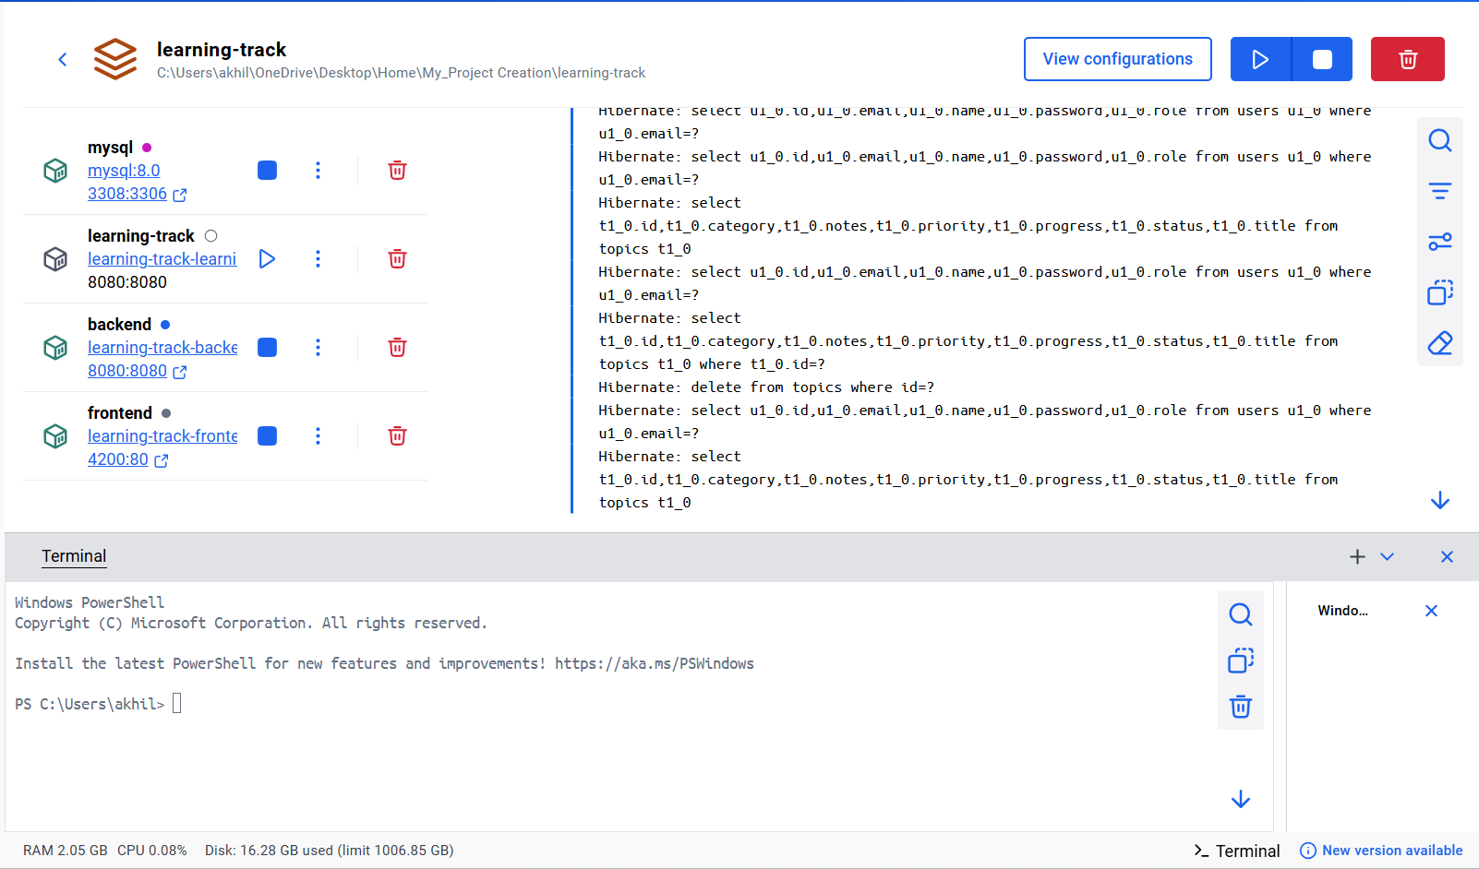
for Stop and Run Again If Need
docker rm -f learningtrack-backend learningtrack-frontend learningtrack-mysql
or
docker compose down
and then run using below Command
docker compose up --build

Then access:
- Angular: http://localhost:4200
- Spring Boot API: http://localhost:8080
If Any Error Then Follow Below To Resolve
target backend: failed to solve: failed to compute cache key: failed to calculate checksum of ref o87tlkkxtmhr6w1p3f4yphqex::ina6omf2h77kbum8wua9uux17: "/target/learning-track-0.0.1-SNAPSHOT.jar": not found
Fixed: Step 1: Build the Spring Boot JAR
Go to:cd "C:\Users\akhil\OneDrive\Desktop\Home\My_Project Creation\learning-track\learning-track"
Run:mvn clean package

Error response from daemon: ports are not available: exposing port TCP 0.0.0.0:3306 -> 127.0.0.1:0: listen tcp 0.0.0.0:3306: bind: Only one usage of each socket address (protocol/network address/port) is normally permitted.
Step 2: Option 1 (Recommended) - Use a different host port
If you already have another MySQL instance running, don't expose your new MySQL on 3306.
In docker-compose.yml, change:
ports:
- "3306:3306"
to:
ports:
- "3307:3306"
or any free port such as 3308:3306.
Then restart:
docker compose down
docker compose up --build
Then access:
- Angular: http://localhost:4200
- Spring Boot API: http://localhost:8080

🚀 Phase A.7 – Full Stack Jenkins Pipeline
Create a new Jenkinsfile in your project root (or use it in a dedicated full-stack repository).
pipeline {

agent any

tools {

jdk 'JDK21'
maven 'Maven3.9'
nodejs 'NodeJS22'

}

stages {

stage('Checkout') {

steps {

git branch: 'main',
url: 'https://github.com/akhileshkumar4953/learning-track.git'

}

}

stage('Build Backend') {

steps {

dir('learning-track') {

bat 'mvn clean package -DskipTests'

}

}

}

stage('Build Frontend') {

steps {

dir('learning-track-ui') {

bat 'npm install'

bat 'npm run build'

}

}

}

stage('Docker Compose Build') {

steps {

bat 'docker compose build'

}

}

}

post {

success {

echo 'Full Stack Build Successful'

}

failure {

echo 'Full Stack Build Failed'

}

}

}

🎯 Expected Final Workflow
After completing all these phases, your development and deployment workflow will look like this:
GitHub
│
▼
Jenkins
│
├── Build Spring Boot
├── Build Angular
├── Create Backend Docker Image
├── Create Frontend Docker Image
└── Build Full Stack
│
▼
Docker Compose
│
├── MySQL
├── Spring Boot
└── Angular (NGINX)
│
▼
http://localhost:4200
This is a production-style setup and provides a strong foundation before moving on to AWS EC2 deployment and automated CI/CD.

Next Phase (Phase 9)
After Jenkins is working, we'll move to AWS EC2 Deployment, where you'll:
- Launch an EC2 instance.
- Install Docker.
- Deploy your learning-track application.
- Access it using the EC2 public IP.
- (Optionally) extend the Jenkins pipeline to automatically deploy to EC2 after a successful build. This will give you a complete CI/CD workflow similar to what is used in many production environments.

