EXP1:   
Aim: Investigation of the impact of device models using SPICE software.   
  
compare between two MOSFET parameters and analyze and document it

IDEAL NMOS model from LT SPICE.

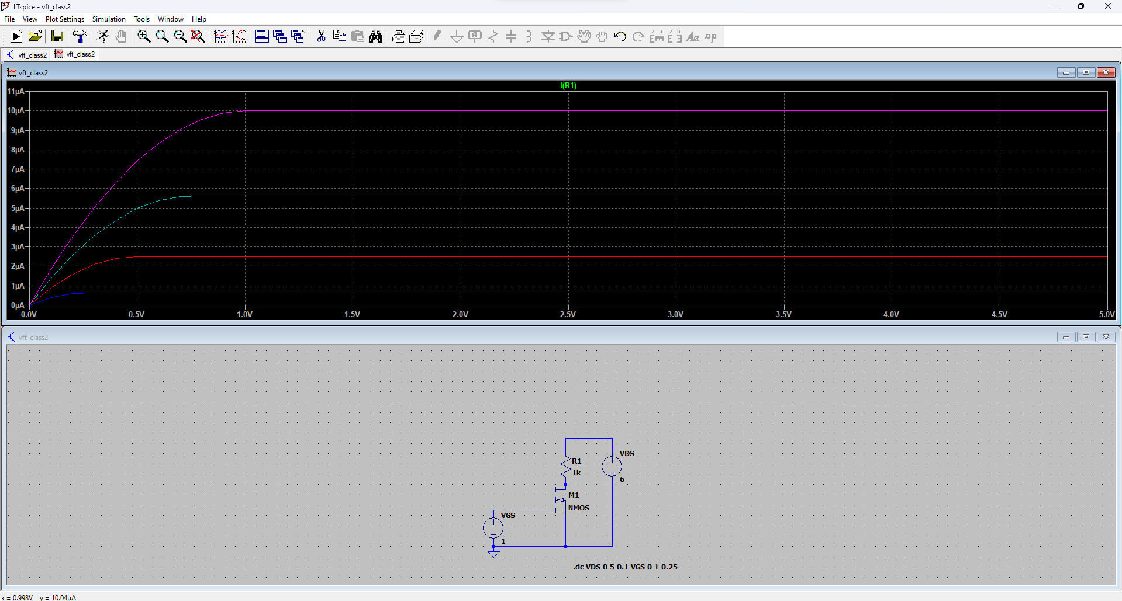

Model 1: BSZ036NE2LS

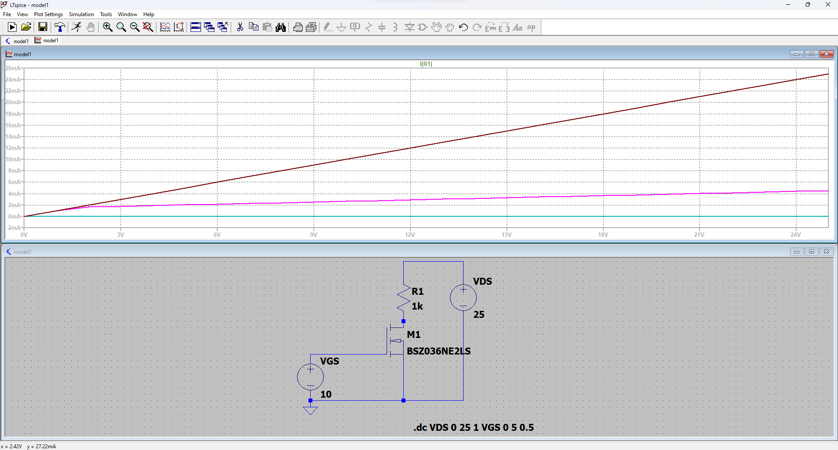

Model 2: BSC020NE2LSI

