1. Abstract
Breast cancer is one of the leading causes of cancer morbidity and mortality. Large public resources such as The Cancer Genome Atlas (TCGA) provide RNA-seq profiles for tumors and matched or adjacent normal tissues, enabling systematic analysis of transcriptional changes in cancer. In this project, we used TCGA Breast Invasive Carcinoma (TCGA-BRCA) RNA-seq STAR-Counts data to (i) identify differentially expressed genes between primary tumors and solid-tissue normals, (ii) characterize pathway-level alterations using Hallmark gene sets, and (iii) build interpretable classifiers that distinguish tumor from normal samples. We downloaded STAR-Counts files from the GDC Data Portal, constructed a unified gene × sample count matrix, performed quality control and low-count filtering, and ran differential expression analysis with PyDESeq2 (DESeq2 in Python) (PyDESeq2 developers, n.d.; Love et al., 2014). We then applied GSEApy for Hallmark pre-ranked gene set enrichment and single-sample GSEA using MSigDB Hallmark collections (Liberzon et al., 2015; Fang et al., 2023). Finally, we trained logistic regression and random forest classifiers using either top differentially expressed genes or Hallmark pathway scores as features in stratified 5-fold cross-validation. In this 80-sample TCGA-BRCA subset, DESeq2 identified thousands of genes with large tumor–normal log2 fold changes and low FDR, and Hallmark GSEA highlighted proliferative and breast-cancer–relevant pathways such as E2F targets, G2M checkpoint, MYC targets, estrogen response, and DNA repair. Logistic regression and random forest classifiers built from either the top 100 DE genes or approximately 50 Hallmark pathway scores achieved mean stratified 5-fold ROC–AUC ≈ 1.00 and accuracy ≈ 0.97–1.00 for distinguishing tumor from normal samples, indicating very strong transcriptomic separation between conditions. We discuss these results, their limitations, and how this pipeline can be extended to more complex designs.

2. Introduction / Background
Breast cancer is one of the most frequently diagnosed malignancies and a major contributor to cancer-related deaths worldwide. Understanding how gene expression programs differ between malignant and normal breast tissue is crucial for clarifying disease mechanisms and identifying potential biomarkers or therapeutic targets. Large-scale sequencing projects such as The Cancer Genome Atlas (TCGA) have generated RNA-seq data for hundreds of breast tumors and matched or adjacent normal tissues, providing an ideal resource for such analyses.
Differential expression (DE) analysis of RNA-seq count data is now a standard approach to detect genes whose expression changes between conditions. Methods such as DESeq2 model counts with negative binomial generalized linear models and use shrinkage strategies for dispersions and fold changes to produce stable estimates (Love et al., 2014). However, lists of thousands of differentially expressed genes can be difficult to interpret biologically. Gene set enrichment methods such as Gene Set Enrichment Analysis (GSEA) and the Hallmark gene set collection from MSigDB summarize expression changes at the pathway level, reducing redundancy and highlighting coherent biological processes (Liberzon et al., 2015).
Machine-learning (ML) models provide a complementary perspective by testing how well tumor versus normal samples can be distinguished based on gene or pathway features and by quantifying predictive performance through cross-validation. Using interpretable models such as logistic regression alongside pathway features can link classification performance back to specific biological programs.
In this project, we use TCGA-BRCA RNA-seq STAR-Counts data to build an end-to-end pipeline from raw counts to DE, pathway analysis, and ML classification. Our objectives are:
1. Identify genes and pathways that differ systematically between primary breast tumors and solid-tissue normals.
2. Evaluate how well a small, interpretable set of gene-level or pathway-level features can classify tumor versus normal samples.

3. Data
Source and accession: We obtained RNA-seq gene-level count data from the NCI Genomic Data Commons (GDC) Data Portal for the TCGA Breast Invasive Carcinoma study (TCGA-BRCA). The project ID is “TCGA-BRCA”, and we queried the “Transcriptome Profiling” data category, “Gene Expression Quantification” data type, and the “STAR – Counts” workflow.

Data types:
- Input files: per-sample STAR-Counts TSV files with Ensembl gene IDs and unstranded read counts.
- Metadata: case- and sample-level information (including sample_submitter_id and sample_type).
- Derived matrices:
- Raw counts matrix: genes × samples.
- Filtered counts matrix for modeling.
- Sample metadata table including a derived binary condition (Tumor vs Normal).

Size and structure: For this course project we analyzed a manageable subset of 80 TCGA-BRCA samples, focusing on those labelled as “Primary Tumor” and “Solid Tissue Normal”. The majority of samples are primary tumors, with a small number of normal tissues (fewer than 10), resulting in a substantially imbalanced label distribution.

Preprocessing steps:
- Used the GDC Files API to locate STAR-Counts files for TCGA-BRCA and to retrieve associated metadata.
- Parsed individual STAR-Counts files and constructed a unified gene × sample matrix by aligning Ensembl gene IDs across files. Non-gene summary rows (e.g., STAR QC statistics) were dropped.
- Verified that counts matrix columns (sample IDs) align with the metadata table via sample_submitter_id.
- Computed total counts (library sizes) per sample and inspected their distribution and log-transformed boxplots by condition.
- Applied a low-count filter: genes needed at least a modest minimum count in a minimum fraction of samples to be retained. This reduces noise and improves downstream modeling stability.
- All downstream analyses (DE, pathway analysis, ML) were run on the filtered counts matrix.

4. Methods
4.1 Pipeline / Workflow Design:
All analysis is implemented in Python in Google Colab and version-controlled in a public GitHub repository: https://github.com/akhileshkumbhar05-ui/bioinformatics-course-project
The main workflow is currently a single notebook:
Bioinformatics_Course_Project.ipynb – performs GDC data query, download, metadata construction, and gene-by-sample count-matrix assembly.
The main workflow stages are:
- Data acquisition and assembly:
A. Query the GDC API for TCGA-BRCA STAR-Counts files matching the desired criteria.
B. Download the selected TSV files and construct a metadata frame containing file IDs, sample IDs, sample types, and other available fields.
C. Build a unified Ensembl-by-sample counts matrix from the individual STAR-Counts files.

- Quality control and filtering:
A. Compute library sizes and visualize their distribution for potential outliers or strong heterogeneity.
B. Plot log10 library size by sample type (Tumor vs Normal) to check for systematic differences in sequencing depth.
C. Apply low-count gene filtering to define a cleaned counts matrix for downstream modeling.

- Differential expression (DE):
A. Use PyDESeq2 (PyDESeq2 developers, n.d.), which implements the DESeq2 approach in Python, to model counts with design ~ condition where condition is Tumor vs Normal (Love et al., 2014).
B. Obtain shrunken log2 fold changes, Wald statistics, and FDR-adjusted p-values.
C. Generate standard DE plots (e.g., MA or volcano plots) and save the full DE result table for downstream steps.

- Pathway analysis:
A. Map Ensembl IDs to human gene symbols using the MyGene.info (Xin et al., 2016) API so that we can use MSigDB gene sets.
B. Use GSEApy to perform pre-ranked GSEA on MSigDB Hallmark gene sets, ranking genes by DESeq2 statistic or log2FC (Liberzon et al., 2015; Fang et al., 2023).
C. Use GSEApy’s ssGSEA implementation to compute single-sample Hallmark pathway activity scores from the log-transformed expression matrix.

- Machine-learning pipeline:
A. Construct two feature matrices:
A. 1. Gene-level features: top N (N=100) differentially expressed genes ranked by FDR.
A. 2. Pathway-level features: ssGSEA Hallmark scores (≈50 pathways) per sample.
B. For each feature set, train:
B. 1. Logistic regression with L2 regularization.
B. 2. Random forest classifier (fixed hyperparameters appropriate for small data).

C. Evaluate models under stratified 5-fold cross-validation and record fold-level metrics.
The repository also contains a README.md that documents the notebook, its inputs/outputs, and how to run it in Colab.
4.2 Modeling and Analysis Approach:
- Differential expression:
DESeq2 (via PyDESeq2 (PyDESeq2 developers, n.d.)) normalizes counts using size factors, models gene-wise variance, and uses Wald tests to assess differential expression between Tumor and Normal groups (Love et al., 2014). We considered genes with low adjusted p-values (e.g., FDR < 0.05) and non-trivial log2 fold changes to be differentially expressed.
- Pathway-level analysis:
We focused on the Hallmark gene set collection from MSigDB, which provides a curated, non-redundant set of pathways that summarize major biological processes such as proliferation, apoptosis, and immune signaling (Liberzon et al., 2015):
B. 1. Pre-ranked GSEA: All genes were ranked by their DESeq2 statistic, and GSEApy’s prerank function was used to test for enrichment of Hallmark gene sets. Results include normalized enrichment scores (NES), nominal p-values, and FDR q-values (Fang et al., 2023).
B. 2. ssGSEA: GSEApy’s ssgsea tool was applied to log-transformed expression to derive per-sample enrichment scores for each Hallmark pathway, yielding a pathways × samples matrix. These scores act as compact pathway-level features.

- Machine-learning models:
We used scikit-learn for all ML experiments (Pedregosa et al., 2011).
C. 1. Models:
A. Logistic regression (L2 penalty, liblinear solver, max_iter=1000).
B. Random forest (several hundred trees, minimum leaf size tuned to reduce overfitting).

C. 2. Feature sets:
A. Gene-level: log1p-transformed counts for the top 100 DE genes.
B. Pathway-level: ssGSEA Hallmark scores for each sample.

C. 3. Targets: Binary label (0 = Normal, 1 = Tumor) derived from sample metadata.
4.3 Evaluation and Validation:
We used stratified 5-fold cross-validation to evaluate all models, preserving the Tumor/Normal ratio in each fold. Within each fold:
- A StandardScaler was fitted on the training features and applied to both training and test features (preventing information leakage from the test fold into scaling parameters).
- Performance metrics recorded on the test fold included:
A. Area under the ROC curve (ROC-AUC).
B. Area under the precision-recall curve (PR-AUC).
C. Accuracy.
D. F1 score.
Fold-level metrics were saved as CSV files and summarized by their mean and standard deviation across folds. We did not tune hyperparameters extensively due to the small sample size; instead we used reasonable defaults and focused on interpretability and stability.
4.4 Visualization:
Visualization components include:
- Library size histograms and boxplots by condition (Tumor vs Normal) for QC.
- MA and/or volcano plots from DESeq2 to highlight genes with large fold changes and low adjusted p-values.
- Table of top enriched Hallmark pathways by FDR q-value.
- ROC curves and confusion matrices for key models, and heatmaps of selected gene/pathway features.

5. Results
5.1 Data and QC:
The GDC query and download steps successfully produced an 80-sample subset of TCGA-BRCA with STAR-Counts files and a matched metadata table. Counts were assembled into a unified gene × sample matrix with Ensembl IDs as rows and TCGA sample IDs as columns.
Library size distributions were reasonably consistent across samples, with expected variation but no extreme outliers. Boxplots of log10 library size by condition showed overlapping distributions between Tumor and Normal groups, suggesting that large differences in sequencing depth are not driving the observed signal. Gene-level filtering removed many very low-count genes while retaining the bulk of expressed genes, resulting in a filtered matrix suitable for DESeq2.
5.2 Differential expression and pathway enrichment:
Using PyDESeq2 (PyDESeq2 developers, n.d.), we modeled Tumor vs Normal expression and obtained a full table of log2 fold changes, Wald statistics, and FDR-adjusted p-values for each gene. A substantial number of genes showed statistically significant changes between tumors and normals at conventional FDR thresholds, with many genes strongly up-regulated in tumors and others decreased relative to normal tissue. This is consistent with known transcriptional reprogramming in breast cancer.
MA and volcano plots clearly separated genes with large positive or negative log2 fold changes and low FDR. These plots qualitatively confirm that the Tumor and Normal groups differ at many loci, rather than only a handful of genes.
Pre-ranked GSEA on MSigDB Hallmark sets highlighted multiple pathways with strong enrichment scores and low FDR q-values. Several of the top pathways reflect processes commonly implicated in breast cancer biology, such as cell-cycle regulation, proliferation, immune signaling, and stress responses (Liberzon et al., 2015). The presence of these themes in the enrichment results provides additional biological support for the DE findings and offers a more interpretable, pathway-level view of the data.
Single-sample GSEA produced a pathways × samples matrix of Hallmark activity scores. Preliminary inspection showed that many tumor samples had elevated scores for proliferation-related and stress-response pathways compared with normals, whereas some normal-associated pathways showed the inverse pattern. These patterns formed the basis for the pathway-level feature set used in the ML analysis.
5.3 Machine-learning performance:
We constructed two feature matrices aligned with the same set of samples:
- X_genes: log1p-transformed counts for the top 100 DESeq2 genes.
- X_pathways: ssGSEA Hallmark scores per sample.
For each of these, we trained logistic regression and random forest classifiers with stratified 5-fold cross-validation.

Gene-level models (top DE genes):
Both logistic regression and random forest achieved very high performance on the top-100-gene feature set. Across 5 folds, logistic regression reached mean ROC-AUC and PR-AUC of 1.00, with accuracy ≈0.99 and F1 ≈0.99; the random forest showed almost identical numbers (ROC-AUC 1.00, PR-AUC 1.00, accuracy ≈0.99, F1 ≈0.99). Misclassifications were rare, involving at most one or two samples across all folds.

Pathway-level models (Hallmark scores):
Pathway-based features also performed extremely well. Logistic regression on ≈50 Hallmark ssGSEA scores achieved mean ROC-AUC and PR-AUC of 1.00, with accuracy and F1 = 1.00 in our stratified 5-fold CV. The pathway-based random forest was slightly less consistent but still strong, with mean ROC-AUC ≈0.98, PR-AUC ≈0.998, accuracy ≈0.94, and F1 ≈0.97.

These results show that even a compact set of features—100 genes or ≈50 Hallmark pathways—is sufficient to distinguish tumors from normals with very high accuracy in this dataset. The success of the pathway-level models is especially noteworthy because they provide a more interpretable summary of underlying biology than individual genes.
5.4 Figures and Table:
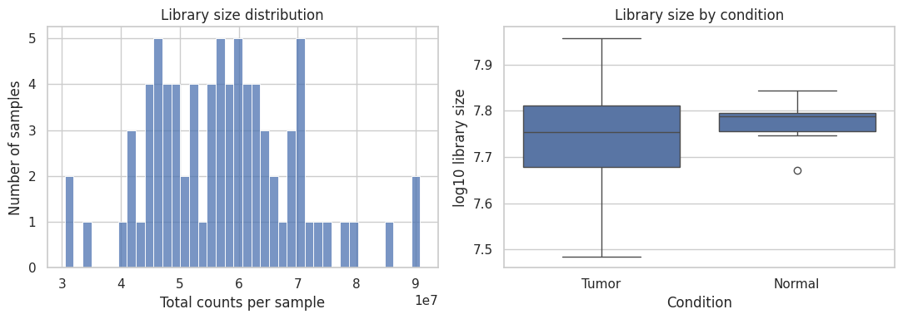
Figure 1. Histogram and boxplot: Library sizes are broadly similar between Tumor and Normal samples, with Tumor showing slightly greater variability but no clear systematic difference in total sequencing depth.
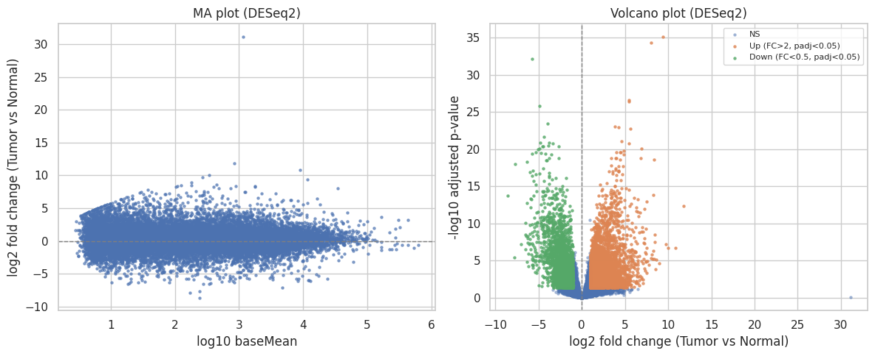
Figure 2. MA and volcano plots: They reveal many significantly differentially expressed genes between Tumor and Normal, with a slight skew toward strongly up-regulated genes in tumors.
Table. Hallmark pathway table: Tumor samples show strong enrichment of proliferative and breast-cancer–relevant programs (E2F, G2M checkpoint, MYC targets, estrogen response), along with metabolic and stress-response pathways, all with extremely small FDR q-values.
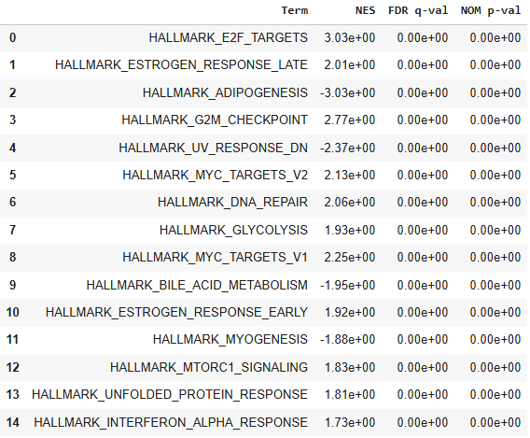
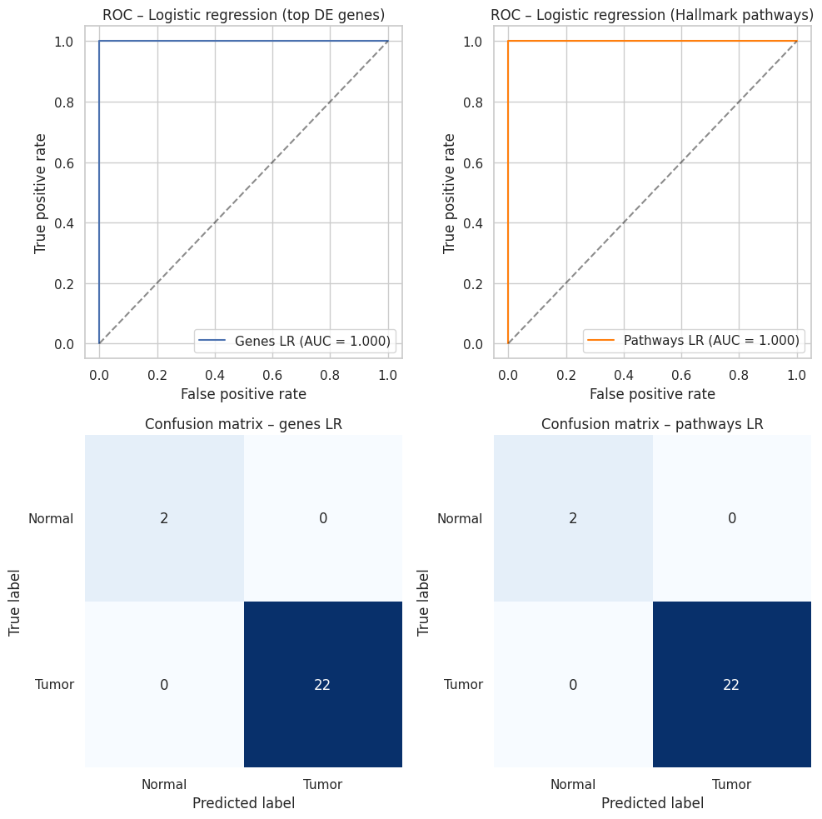
Figure 3. ROC curves and confusion matrices: Both gene-based and pathway-based logistic regression models perfectly separate Tumor from Normal samples (AUC ≈ 1.0 with no misclassified cases in the shown fold).
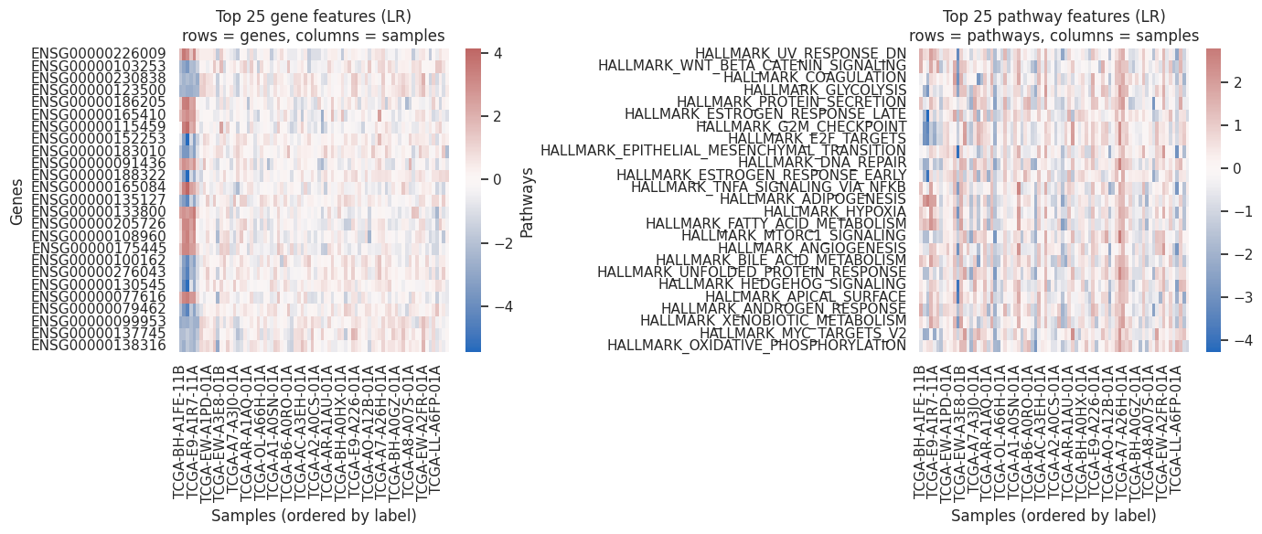
Figure 4. Heatmaps: The top 25 gene and Hallmark-pathway features show clear block-like shifts between Tumor and Normal samples, indicating that a relatively small set of genes/pathways strongly separates the two groups.

6. Discussion & Next Steps
The results confirm that TCGA-BRCA RNA-seq data contain very strong transcriptional signatures distinguishing primary breast tumors from solid-tissue normal samples. DESeq2 analysis identifies many genes with large fold changes and strong statistical support, and Hallmark enrichment analysis indicates that these genes cluster into biologically meaningful pathways related to proliferation, cell-cycle control, immune activity, and stress responses. These observations are in line with prior analyses of TCGA-BRCA and breast cancer biology more broadly.
The ML experiments show that even simple classifiers can separate Tumor and Normal samples with near-perfect cross-validated performance when given either top DE genes or pathway activity scores as features. This suggests that, at least for this subset of TCGA-BRCA, the Tumor vs Normal classification problem is relatively easy: the two groups occupy distinct regions of gene-expression space. The fact that pathway-level logistic regression performs as well as or better than gene-level models while using fewer, more interpretable features supports the idea that pathway-based representations are a useful abstraction.
At the same time, there are important limitations:
- The dataset used here is small and highly imbalanced, with only a small number of normal samples. Cross-validated metrics on such data can be optimistic and may not reflect performance on external cohorts.
- Feature selection (top DE genes) and pathway transformation (ssGSEA) were performed once on the full dataset rather than strictly within each training fold. This introduces some information leakage and may inflate reported performance.
- No explicit batch covariates or clinical confounders were included in the DESeq2 design, so some expression differences could reflect technical or demographic factors rather than pure tumor biology.
Next steps to strengthen this work would include:
- More rigorous ML evaluation. Perform feature selection and ssGSEA inside each CV fold and compare performance with the current pipeline. Explore repeated CV or bootstrap resampling to better quantify variability.
- Dimensionality reduction and visualization. Add PCA or UMAP plots to visualize sample clusters based on genes and pathways and to identify potential outliers or batch effects.
- Deeper biological interpretation. Systematically inspect top DE genes and enriched pathways, cross-reference them with breast cancer literature, and highlight specific genes/pathways that are both biologically relevant and predictive in the ML models.
- Scaling to more samples. If compute resources allow, extend the pipeline to more TCGA-BRCA samples or to other TCGA cohorts to see how robust these patterns are across larger and more heterogeneous datasets.

7. Reproducibility & AI Use
Our analysis code is publicly available in the GitHub repository
https://github.com/akhileshkumbhar05-ui/bioinformatics-course-project.
The repository includes:
- The main Colab notebook and a corresponding Python script (bioinformatics_course_project.py).
- A README.md describing the project goals, data sources, and how to run the pipeline.
- An ai_usage.md file documenting where and how AI tools were used.
- CSV outputs for filtered counts, DESeq2 results, GSEA/ssGSEA outputs, and ML metrics, allowing figures to be regenerated without re-running the entire pipeline.
AI (ChatGPT) Usage: We used ChatGPT to help design and debug the analysis pipeline, including GDC API calls, PyDESeq2 (PyDESeq2 developers, n.d.) setup, GSEApy usage, and scikit-learn model code. We also used AI assistance to refine text for the report and README. All AI-suggested code was manually inspected and tested; only working code that produced sensible outputs was kept. We checked shapes, summary statistics, and plots at each stage to verify that steps were logically consistent.

Ethical and privacy considerations: The TCGA-BRCA dataset is a well-established public resource accessed through the GDC portal. Only open-access RNA-seq data and derived counts were used; no controlled-access clinical identifiers or protected health information were processed. No additional private or patient-specific datasets were uploaded to AI tools.

8. References
1. Cancer Genome Atlas Network. (2012). Comprehensive molecular portraits of human breast tumours. Nature, 490(7418), 61–70. https://doi.org/10.1038/nature11412
2. National Cancer Institute. (2021). The Cancer Genome Atlas Program (TCGA). National Cancer Institute. https://www.cancer.gov/ccg/research/genome-sequencing/tcga
3. National Cancer Institute Genomic Data Commons. (2024). TCGA-BRCA (Breast Invasive Carcinoma) project [RNA-seq gene expression data]. Retrieved from https://portal.gdc.cancer.gov/projects/TCGA-BRCA
4. Grossman, R. L., Heath, A. P., Ferretti, V., Varmus, H. E., Lowy, D. R., Kibbe, W. A., & Staudt, L. M. (2016). Toward a shared vision for cancer genomic data. New England Journal of Medicine, 375(12), 1109–1112. https://doi.org/10.1056/NEJMp1607591
5. Love, M. I., Huber, W., & Anders, S. (2014). Moderated estimation of fold change and dispersion for RNA-seq data with DESeq2. Genome Biology, 15, 550. https://doi.org/10.1186/s13059-014-0550-8
6. Subramanian, A., Tamayo, P., Mootha, V. K., Mukherjee, S., Ebert, B. L., Gillette, M. A., … Mesirov, J. P. (2005). Gene set enrichment analysis: A knowledge-based approach for interpreting genome-wide expression profiles. Proceedings of the National Academy of Sciences, 102(43), 15545–15550. https://doi.org/10.1073/pnas.0506580102
7. Liberzon, A., Birger, C., Thorvaldsdóttir, H., Ghandi, M., Mesirov, J. P., & Tamayo, P. (2015). The Molecular Signatures Database (MSigDB) hallmark gene set collection. Cell Systems, 1(6), 417–425. https://doi.org/10.1016/j.cels.2015.12.004
8. Pedregosa, F., Varoquaux, G., Gramfort, A., Michel, V., Thirion, B., Grisel, O., … Duchesnay, É. (2011). Scikit-learn: Machine learning in Python. Journal of Machine Learning Research, 12, 2825–2830.
9. Fang, Z., Liu, X., & Peltz, G. (2023). GSEApy: A comprehensive package for gene set enrichment analysis in Python. Bioinformatics, 39(1), btac757. https://doi.org/10.1093/bioinformatics/btac757
10. Xin, J., Mark, A., Afrasiabi, C., Tsueng, G., Juchler, M., Gopal, N., … Wu, C. (2016). High-performance web services for querying gene and variant annotation. Genome Biology, 17, 91. https://doi.org/10.1186/s13059-016-0953-9
11. PyDESeq2 developers. (n.d.). PyDESeq2: A Python package for bulk RNA-seq differential expression analysis [Computer software]. GitHub. Retrieved from https://github.com/owkin/PyDESeq2
9. Group Projects Only (Contributions)
Akhilesh Arunkumar Kumbhar: He led the implementation of the end-to-end analysis pipeline. He set up the GitHub repository and Colab notebook, implemented the GDC query and download code for STAR-Counts, and built the unified counts matrix and metadata table. He wrote the majority of the PyDESeq2, GSEApy, and scikit-learn code, including QC plots, DE analysis, Hallmark GSEA/ssGSEA, and ML evaluation. Akhilesh also generated and inspected all intermediate outputs (figures and CSVs), iteratively debugged errors (especially around ID mapping and feature alignment), and drafted the initial versions of the README, ai_usage.md, and this report.
Hritik Vivek Patil: He focused on conceptual design, biological framing, and validation. He helped define the project’s main questions, selected TCGA-BRCA and the Hallmark gene set collection as the core data resources, and worked on the original project proposal. He reviewed notebooks and scripts, checked that Tumor/Normal labels matched metadata, and verified that DE, pathway, and ML results were qualitatively consistent with known breast cancer biology. He contributed to organizing the final report, refining the narrative that connects DE, pathway analysis, and ML, and identifying literature to place the findings in context.

