Visvesvaraya Technological University
Belagavi, Karnataka-590 018

A PROJECT REPORT ON
“HUMAN RESOURCE MANAGEMENT”
Submitted in partial fulfillment of the requirements for the DBMS Laboratory with Mini Project (15CSL58) course of the 5th semester
BACHELOR OF ENGINEERING
IN
COMPUTER SCIENCE AND ENGINEERING

Submitted by:
AKHILESH M.N ARVIND.R
1JS15CS013 1JS15CS023

Under the guidance of

Mr. Mahesh Kumar M R., _{B.E., M.Tech}

Assistant Professor, Dept of CSE, JSSATE, Bengaluru

JSS ACADEMY OF TECHNICAL EDUCATION, BENGALURU
Department of Computer Science and Engineering
2017 - 2018

ABSTRACT
The project Human Resource Database Management System creates software that stores and manages all the data needed to describe the personal and their framework within an organization. It includes definition of various levels of hierarchy in an organization, the salary structure pertaining to every element in this hierarchy, the description of every department functioning in the organization and the overall employ database which integrates elements in all the aforementioned.
It has a database administration that has access to the entire database, in regards with viewing and update of information. The exclusive right is implemented using authorized access. Also viewing all data and editing of personal data can be done by any employee, this also using authorized access. Communication between personnel and administrator has also been provided for.

I

ACKNOWLEDGEMENTS

We express my humble pranamams to his holiness Jagadguru Sri Sri Sri Shivarathri Deshikendra Mahaswamiji who has showered their blessings on us for framing our career successfully.
The completion of any project involves the efforts of many people. We have been lucky enough to have received a lot of help and support from all quarters during the making of this project, so with gratitude, we take this opportunity to acknowledge all those whose guidance and encouragement helped us emerge successful.

We are thankful to the resourceful guidance, timely assistance and graceful gesture of our guide Mr. Mahesh Kumar M R, Assistant Professor, Department of Computer Science and Engineering, who has helped us in every aspect of our project work.
We are also indebted to Dr Prabhudev Jagadeesh, Head of Department of Computer Science and Engineering for the facilities and support extended towards us.

We express our sincere thanks to our beloved principal, Dr. Mrityunjaya V Latte for having supported us in our academic endeavors.

And last but not the least, we would be very pleased to express our heart full thanks to all the teaching and non-teaching staff of CSE department and our friends who have rendered their help, motivation and support.

ARVIND R.
AKHILESH M.N.

II

Table of Contents
Chapter Title Page number

 | Abstract I
Acknowledgment II
List of Figures V
Chapter 1 |  | Preamble 1
 | 1.1 Introduction 1
 | 1.1.1 History Of DBMS 1
1.1.2 MySQL 2
1.1.3 Netbeans 3
1.1.4 Normalization 4
 | 1.2 Objectives 5
 | 1.3 Organization of Report 6
 | 1.4 Summary 6
Chapter 2 | Requirement Specification 7  2.1 Software Specification 7  2.2 Hardware Specification 7  2.3 User Characteristics 7
III
Chapter 3 | System Design and Implementation 9
3.1 Introduction 9
10
11
13
3.2 ER Diagram
3.3 Schema Diagram
Chapter 4 | 3.4 Data Tables  3.5 Pseudo codes for HRM 15  3.5.1 Algorithm for login 15  3.5.2 Algorithm for table display 15  3.5.3 Algorithm for insert 15  3.5.4 Algorithm for update 16  3.5.5 Algorithm for delete 16  3.5.6 Algorithm for jframe transition 16  3.6 Sql tables implemented in database 17  3.7 Sql stored procedures and triggers used 20  Results and Discussions 23
Chapter 5 | Conclusion & Future Enhancement 31
 | References

IV

List of Figures

Figure No. Name of Figure Page No

4.1 Main Page 23

4.2 HR Login 24

4.3 Employee Login 24

4.4 HR Main Page 25

4.5 Employee Main Page 25

4.6 Insertion Main Page 26

4.7 Employee Insertion 27

4.8 Department Updation 28

4.9 Employee Deletion 28

4.10 Employee Display 29

4.11 Table View 29

4.12 Pop up error message 30

4.13 Pop up error message 30

List of Tables

Figure No. Name of Figure Page No

3.1 Position 12

3.2 Department 12

3.3 Qualification 12

3.4 Emplevel 13

3.5 Dependent 13

3.6 Employee 14
V

Chapter 1

Preamble
  - Introduction

The project Human Resource Database Management System creates software that stores and manages all the data needed to describe the personal and their framework within an organization. It includes definition of various levels of hierarchy in an organization, the salary structure pertaining to every element in this hierarchy, the description of every department functioning in the organization and the overall employ database which integrates elements in all the aforementioned.
It has a database administration that has access to the entire database, in regards with viewing and update of information. The exclusive right is implemented using authorized access. Also viewing all data and editing of personal data can be done by any employee, this also using authorized access. Communication between personnel and administrator has also been provided for.
The data can be accessed, manipulated and retrieved very easily. The interface has been made very user friendly. The data is well protected for use and the data processing ie, result of query functions has been made very quick and efficient.

    - History of Database Management System
Following the technology progress in the areas of processors, computer memory, computer storage, and computer networks, the sizes, capabilities, and performance of databases and their respective DBMSs have grown in orders of magnitude. The development of database technology can be divided into three eras based on data model or structure: navigational, SQL/relational, and post-relational.[2] The two main early navigational data models were the hierarchical model, epitomized by IBM's IMS system, and the CODASYL model (network model), implemented in a number of products such as IDMS.
The relational model employs sets of ledger-style tables, each used for a different type of entity. Only in the mid-1980s did computing hardware become powerful enough to allow the wide deployment of relational systems (DBMSs plus applications). By the early 1990s, however, relational systems dominated in all large-scale data processing applications, and as of 2015 they remain dominant: IBM DB2, Oracle, MySQL, and Microsoft SQL Server are the top DBMS. The dominant database language, standardized SQL for the relational model, has influenced database languages for other data models.

    - MySQL
MySQL is an open-source relational database management system (RDBMS). MySQL is written in C and C++. Its SQL parser is written in yacc, but it uses a home-brewed lexical analyzer. MySQL works on many system platforms, including Linux, macOS, Microsoft Windows, NetBSD. MySQL is offered under two different editions: the open source MySQL Community Server and the proprietary Enterprise Server. MySQL Enterprise Server is differentiated by a series of proprietary extensions which install as server plugins, but otherwise shares the version numbering system and is built from the same code base.[1]
Major features that are available in MySQL are a broad subset of ANSI SQL 99,as well as extensions, Cross-platform support, Stored procedures, using a procedural language that closely adheres to SQL/PSM, Triggers, Cursors, Updatable views, Online DDL when using the InnoDB Storage Engine. Many programming languages with language-specific APIs include libraries for accessing MySQL databases. These include MySQL Connector/Net for integration with Microsoft's Visual Studio and the JDBC driver for Java. In addition, an ODBC interface called MySQL Connector/ODBC allows additional programming languages that support the ODBC interface to communicate with a MySQL database, such as ASP or ColdFusion.

    - NetBeans
NetBeans is a software development platform written in Java. The NetBeans Platform allows applications to be developed from a set of modular software components called modules. Applications based on the NetBeans Platform, including the NetBeans integrated development environment (IDE), can be extended by third party developers. The NetBeans IDE is primarily intended for development in Java, but also supports other languages, in particular PHP, C/C++ and HTML5. NetBeans is cross-platform and runs on Microsoft Windows, macOS, Linux, Solaris and other platforms supporting a compatible JVM.
The NetBeans Platform is a framework for simplifying the development of Java Swing desktop applications. The NetBeans IDE bundle for Java SE contains what is needed to start developing NetBeans plugins and NetBeans Platform based applications; no additional SDK is required.[3]
The platform offers reusable services common to desktop applications, allowing developers to focus on the logic specific to their application. Among the features of the platform are User interface management like menus and toolbars, User settings management, Storage management, Window management.
NetBeans IDE is an open-source integrated development environment. NetBeans IDE supports development of all Java application types out of the box.
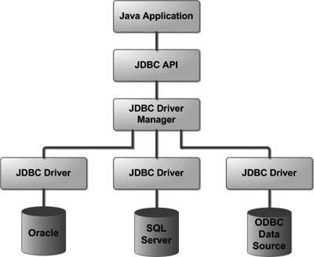
Figure 1.1: Java Application flow

    - Normalization
Normalization is a process of organizing the data in database to avoid data redundancy, insertion anomaly, update anomaly & deletion anomaly. To overcome these anomalies we need to normalize the data. There are 4 basic types of normalizations. They are:
- First normal form(1NF)
- Second normal form(2NF)
- Third normal form(3NF)
- Boyce & Codd normal form (BCNF)
A table is said to be in 2NF if the two conditions stated are satisfied. The table is in First normal form and all the non-prime attribute are dependent on the proper subset of any candidate key of table. The attribute that is not part of any candidate key are known as non-prime attribute.

A table design is said to be in 3NF if the table is in 2NF and Transitive functional dependency of non-prime attribute on any super key are removed.

A table design is said to be in BCNF if there is only one super key.

1.2 OBJECTIVES

The Human Resource Database Management software is very user friendly and appealing. The Human objective of the system is to maintain and retrieve information about the entire personnel framework of the organizational system. The system is fairly simple in design and implementation.
The main objectives of this system can be summarized as follows:

- Design of a hierarchical framework in terms of positions held thus depicting the organizational hierarchy. Update of the structure of the same, as well as addition of new elements.

- Search for all employees, departments, dependent information etc possible. Also department-wise, level-wise and other parameter based search enabled.

- Communication between employee and administrator.

- Computerized payroll generation, manipulation and management.
Easy management of databases of various sections covering key aspects.

1.3 Organization of the Report
Chapter 1 provides the information about the basics of MySql. In Chapter 2, all the requirement specifications are described. Chapter 3 gives the idea of the project and its actual implementation. Chapter 4 discusses about the results of the program. Chapter 5 concludes by giving the direction for future enhancement.
1.4 Summary
The chapter discussed before is an overview about the NetBeans Application and MySQL DBMS and its history. It even includes the Java Application block diagram. The scope of study and objectives of the project are mentioned clearly. The organization of the report is been pictured to increase the readability. Further, coming up chapters depicts the use of various queries to implement various changes like insert, update, delete and also triggers to perform various functions.
Chapter 2
REQUIREMENTS

2.1 SOFTWARE SPECIFICATION

- Operating System: Windows 2000/XP/Vista
- Front End: Java Net Beans
- Rear End: Oracle SQL
- Design Tool: UML

2.2 HARDWARE SPECIFICATION

- Processor: x86 compatible processor with 1.7 GHz Clock Speed
- RAM: 512 MB or greater
- Hard Disk: 20 GB or grater
- Monitor: VGA/SVGA
- Keyboard: 104 keys standard
- Mouse: 2/3 button. Optical/Mechanical.

2.3 USER CHARACTERISTICS

Every user:
- Should be comfortable with basic working of the computer
- Must have been knowledge of English
- Must carry a login ID and password used for authentication
- The GUI is restricted to English
- Login ID and password used for identification of user/administrator. There is no facility for a guest login.

Chapter 3

System Design and Implementation

3.1 Introduction
Systems design is the process or art of defining the architecture, components, modules, interfaces, and data for a system to satisfy specified requirements. One could see it as the application of systems theory to product development.
This Project is implemented using NetBeans, which is proven to be a very efficient tool in the field of Java programming. It is done under Windows10 platform. Stdio.h library is used to create the objects and to translate them. Java programming language is used to implement the entire code. Interface to the program is provided with the help of MySQL.
The Human Resource Database Management software is very user friendly and appealing. The Human objective of the system is to maintain and retrieve information about the entire personnel framework of the organizational system. The system is fairly simple in design and implementation.
Search for all employees, departments, dependent information etc possible. Also department-wise, level-wise and other parameter based search enabled.

3.2 ER Diagram.
An entity–relationship model (ER model) describes inter-related things of interest in a specific domain of knowledge. An ER model is composed of entity types (which classify the things of interest) and specifies relationships that can exist between instances of those entity types.
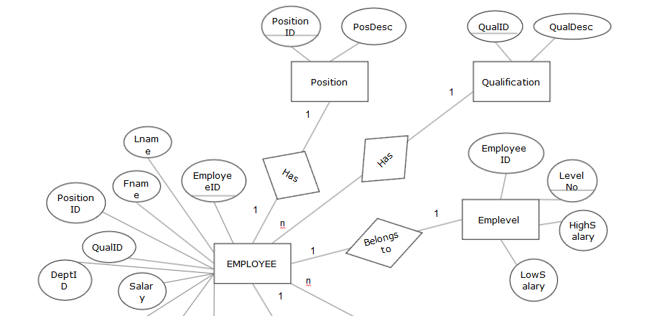
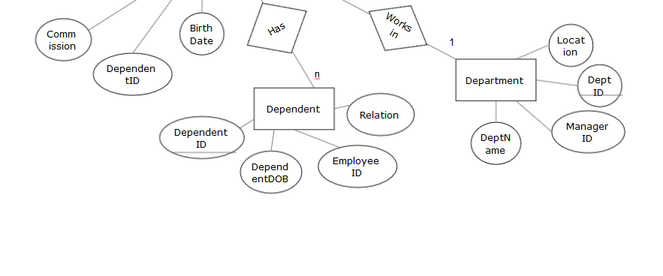
Figure 3.1: Entity Relationship Diagram
In software engineering an ER model is commonly formed to represent things that a business needs to remember in order to perform business processes. Consequently, the ER model becomes an abstract data model that defines a data or information structure that can be implemented in a database, typically a relational database.
Figure 3.1 refers to the Entity Relationship diagram utilized in our project where the employee table holds all the major values that reference from various other tables.
3.3 Schema Diagram.
The database schema of a database system is its structure described in a formal language supported by the database management system (DBMS). The term "schema" refers to the organization of data as a blueprint of how the database is constructed (divided into database tables in the case of relational databases). The formal definition of a database schema is a set of formulas (sentences) called integrity constraints imposed on a database.
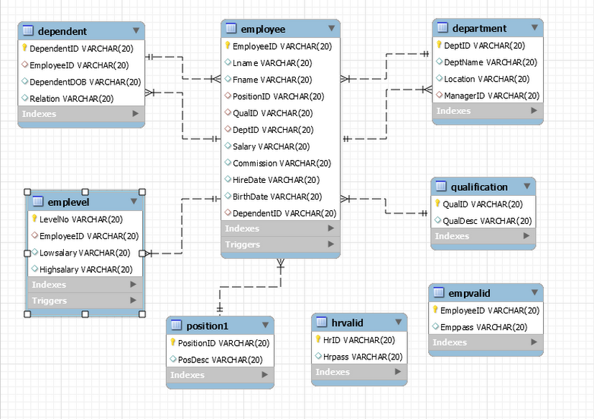
Figure 3.2: Schema Diagram

3.4 Data Tables
Table 3.1: POSITION1
FIELD NAME | DATA TYPE
PositionID | VARCHAR2
PosDesc | VARCHAR2

Table 3.2: DEPARTMENT
FIELD NAME | DATA TYPE
DeptID (Primary key) | VARCHAR2
DeptName | VARCHAR2
Location | VARCHAR2
ManagerID (foreign key from EMPLOYEE) | VARCHAR2

Table 3.3: QUALIFICATION
FIELD NAME | DATA TYPE
QualID (Primary key) | VARCHAR2
QualDesc | VARCHAR2

Table 3.4: EMPLEVEL
FIELD NAME | DATA TYPE
LevelNo (Primary key) | VARCHAR2
EmployeeID (Foreign key from EMPLOYEE) | VARCHAR2
LowSalary | VARCHAR2
HighSalry | VARCHAR2

Table 3.5: DEPENDENT
FIELD NAME | DATA TYPE
EmployeeID (Foreign key from EMPLOYEE) | VARCHAR2
DependentID (Primary key) | VARCHAR2
DependentDOB | VARCHAR2
Relation | VARCHAR2

Table 3.6: EMPLOYEE
FIELD NAME | DATA TYPE
EmployeeID (Primary key) | VARCHAR2
Lname | VARCHAR2
Fname | VARCHAR2
PositionID (Foreign key from POSITION) | VARCHAR2
QualID (Foreign key from QUAL) | VARCHAR2
DeptID (Foreign key from DEPARTMENT) | VARCHAR2
Salary | VARCHAR2
Commission | VARCHAR2
HireDate | VARCHAR2
BirthDate | VARCHAR2
DepID (Foreign key from DEPENDANT) | VARCHAR2

3.5 Pseudo codes for HRM

3.5.1 Algorithm for login

Step 1: BEGIN

Step 2: Enter username and password

Step 3: Verify the credentials entered with that in the login table

Step 4: If Credentials match, then proceed to the Selection page

Else show login failed

Step 5: End if

Step 6: END

    - Algorithm for Table Display
Step1: BEGIN
Step 2: Establish connection with the database using the username and password of the database.
Step 3: Define ArrayList to return all the values from the method passed.
Step 4: Define the select query to retrieve all the values from the DBMS
Step 5: Pass all the values into the ArrayList method.
Step 6: Define DefaultTableModel for the table and use the ArrayList created to display all the values stored in it in the table.
Step 7: END
    - Algorithm for Insert
Step 1: BEGIN
Step 2: Get all the necessary values required for insertion into variable defined in the method.
Step 3: Define the query for insertion as stated.
Step 4: Execute the Query using the executeQuery() method defined.
Step 5: END
    - Algorithm for update
Step 1: BEGIN
Step 2: Get all the necessary values required for updating the values into the variable defined in the method.
Step 3: Define the Query for Updating as stated above.
Step 4: Execute the Query using the executeQuery() method defined.
Step 5: END
    - Algorithm for Delete
Step 1: BEGIN
Step 2: Get the identification number of the entity which is to be deleted into a variable defined in the method.
Step 3:Display the details and ask whether to confirm the deletion process.
Step 3:If yes, define the Query for deleting as stated above.
Step 4: Execute the Query using the executeQuery() method defined by passing the identification number as an argument.
Step 5: END
    - Algorithm for jFrame transition
Step 1: BEGIN
Step 2: Define the object for the class that the transition frame is defined in.
Step 3: use the ‘this’ keyword to point to the current frame object and use the setVisible method and set it to false. This makes the existing jFrame disappear.
Step 4: use the object name from the above created object and use the setVisible method and set it to true. This makes the next Frame appear.
Step 5: END
3.6 Sql tables implemented in database
The below mentioned are all the queries used to perform various tasks in MySQL such as insert, delete, update. A short description of the query is also provided.
CREATE STATEMENTS
Query:create table position1(
PositionID varchar(20) primary key,
PosDesc varchar(20) );
Description: This query is used to create a table called position1 which will store the credentials of all the position details present in the enterprise.
Query:create table department(
DeptID varchar(20) primary key,
DeptName varchar(20),
Location varchar(20),
ManagerID varchar(20) );
Description: This query is used to create a table called department which will store the credentials of all the department details present in the enterprise.
Query:create table qualification(
QualID varchar(20) primary key,
QualDesc varchar(20));
Description: This query is used to create a table called department which will store the credentials of all the qualification details present in the enterprise.
Query:create table emplevel(
LevelNo varchar(20) primary key,
EmployeeID varchar(20),
Lowsalary varchar(20),
Highsalary varchar(20) );
Description: This query is used to create a table called department which will store the credentials of all the emplevel details present in the enterprise.
Query:create table dependent(
DependentID varchar(20) primary key,
EmployeeID varchar(20),
DependentDOB varchar(20),
Relation varchar(20) );
Description: This query is used to create a table called department which will store the credentials of all the dependent details present in the enterprise.
Query:create table employee(
EmployeeID varchar(20) primary key,
Lname varchar(20),
Fname varchar(20),
PositionID varchar(20),
QualID varchar(20),
DeptID varchar(20),
Salary varchar(20),
Commission varchar(20),
HireDate varchar(20),
BirthDate varchar(20),
DependentID varchar(20) );
Description: This query is used to create a table called department which will store the credentials of all the employee details present in the enterprise.
Query:create table empvalid(
EmployeeID varchar(20) primary key,
Emppass varchar(20) );
Query:create table hrvalid(
HrID varchar(20) primary key,
Hrpass varchar(20) );
ALTER STATEMENTS
These alter table queries are being used to add foreign key references from one table to another. Also, the on delete constraints(set null/cascade) are used to update these foreign key values if their respective parent key values are deleted.
- alter table department add foreign key(ManagerID) references employee(EmployeeID) on delete set null;
- alter table dependent add foreign key(EmployeeID) references employee(EmployeeID);
- alter table employee add foreign key(PositionID) references position1(PositionID) on delete set null;
- alter table employee add foreign key(QualID) references qualification(QualID) on delete set null;
- alter table employee add foreign key(DeptID) references department(DeptID) on delete set null;
- alter table emplevel add foreign key(EmployeeID) references employee(EmployeeID);
- alter table employee add foreign key(DependentID) references dependent(DependentID) on delete set null;
3.7 Sql stored procedures and triggers used
TRIGGERS
- Trigger:delimiter $$
create trigger trig1
after update on employee
for each row
begin
declare summ int;
set summ=new.Salary+new.Commission;
update emplevel set Highsalary=((summ-Highsalary)+Highsalary) where new.EmployeeID=EmployeeID;
end$$
Description:This trigger is used to update the highsalary attribute of the emplevel table whenever there is an updation in the employee table.This will add up the salary and commission and update it as the new highsalary value in emplevel table.
- Trigger:delimiter $$
create trigger trig2
before insert on emplevel
for each row
begin
if(new.Lowsalary<10000) then
set new.Lowsalary=10000;
end if;
end $$
Description: This trigger will check if the lowsalary is less than 10000 ,if so, then the lowsalary attribute will be set to 10000 by default in the emplevel table.
STORED PROCEDURES
- delimiter $$
create procedure proc1(in empid int)
select e.EmployeeID,e.Lname,e.Fname,e.HireDate,e.BirthDate,e.Salary,e.Commission,p.PosDesc,
d.DeptName,q.QualDesc,dep.Relation from Employee e,position1 p,department d,qualification q,
dependent dep where e.PositionID=p.PositionID and e.QualID=q.QualID and
e.DependentID=dep.DependentID and e.DeptID=d.DeptID and e.EmployeeID=empid;
Description: This procedure will display all the details regarding a specific employee id.
It refers to all the other tables using the corresponding foreign key values to obtain the required fields. It takes in employee id as the input parameter.
- delimiter $$
create procedure proc2(in did int)
select * from department where DeptId=did;
$$
Description: This procedure will display all the details regarding a specific department id.
It refers to the department table using the input dept id value to obtain the required fields.

Chapter 4
RESULTS AND DISCUSSIONS
The project is compiled and executed on javac. Some screen shots are present here to show the working of the application.
ScreenShots:
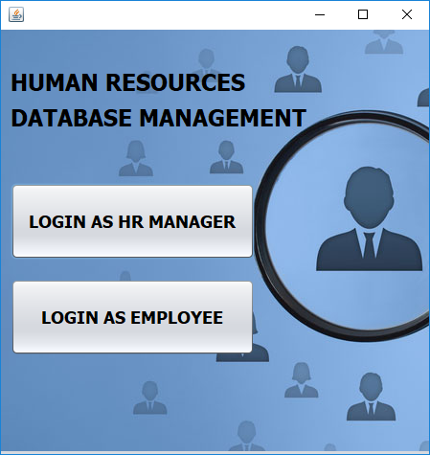
Figure 4.1 refers to the initial bootup of the application:

Figure 4.1:Initial bootup window

Figure 4.2 refers to the login page of the HR manager:
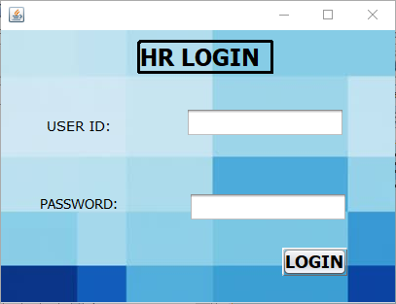

Figure 4.2:Login page
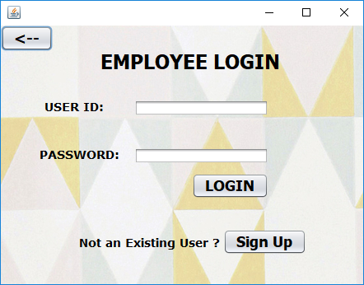
Figure 4.3 refers to login page of employee:

Figure 4.3:Employee Login

Figure 4.4 refers to main page of HR manager:
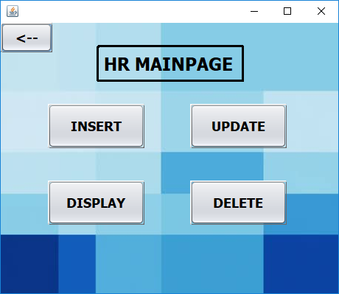

Figure 4.4:HRM main page
Figure 4.5 refers to main page of employee:
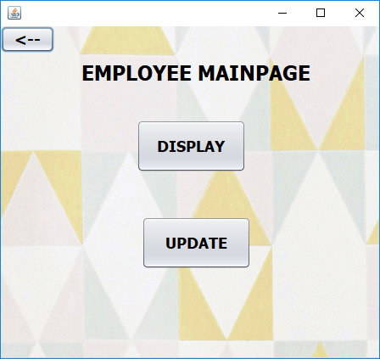

Figure 4.5:Employee main page

Figure 4.6 refers to main page of insertion:

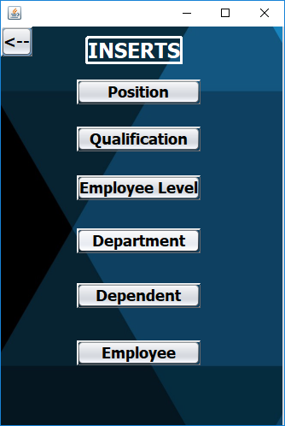

Figure 4.6: insertion mainpage

Figure 4.7 refers to insertion of employee record:
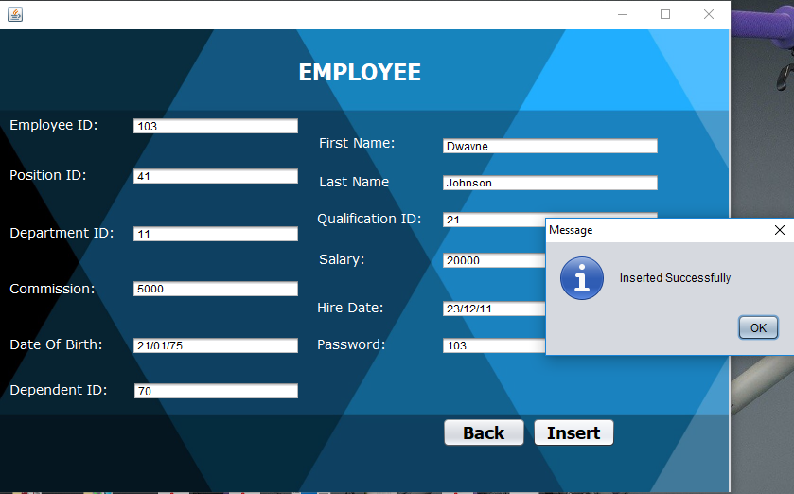
Figure 4.7:Employee insertion

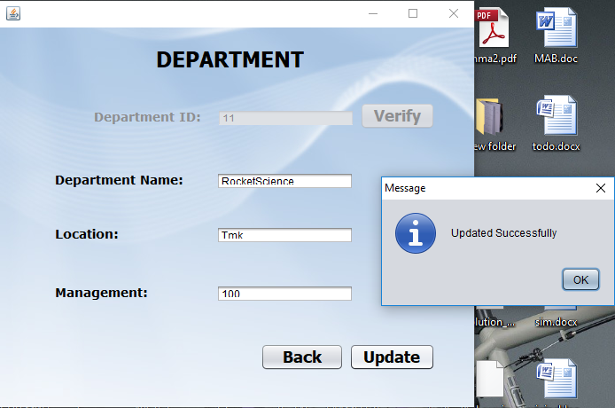
Figure 4.8 refers to updation of department record:
Figure 4.8:Department updation
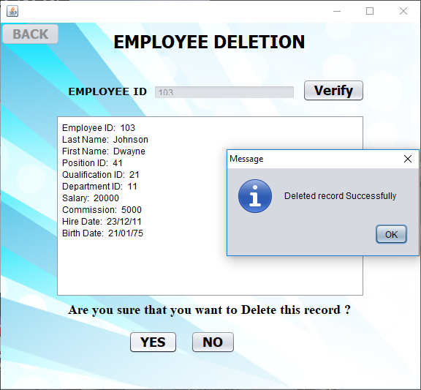
Figure 4.9 refers to deletion of an employee record:

Figure 4.9:Employee deletion
Figure 4.10 refers to display 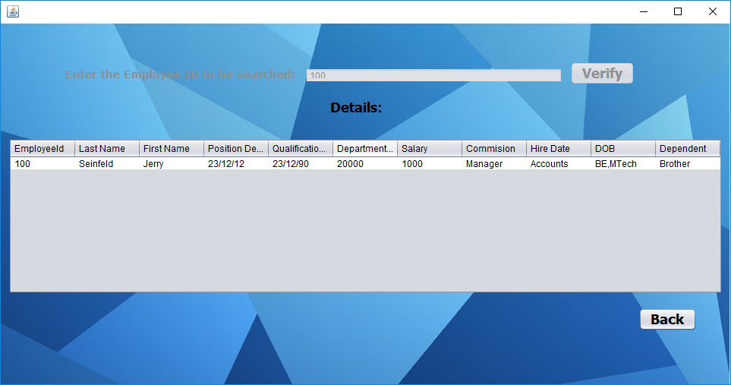
Figure 4.10:Employee display

Figure 4.11 refers to table view:
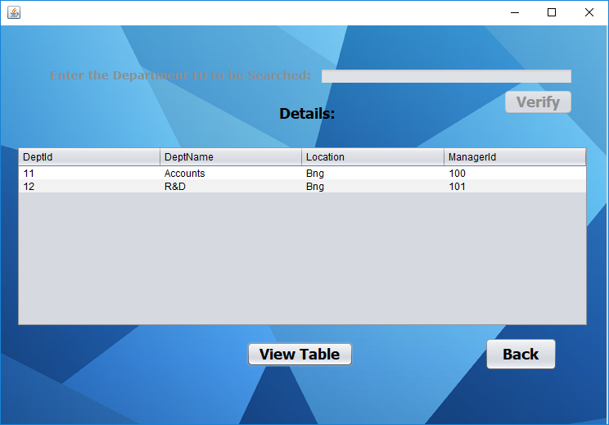
Figure 4.11:Table view

Figure 4.12 refers to a pop-up error message: this message will pop up when the user has entered an existing Identification Number.
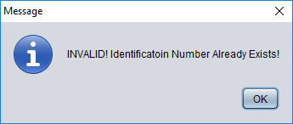

Figure 4.12:Pop-up message
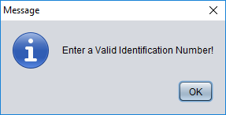
Figure 4.13 refers to a pop-up error message: this message will pop up whenever an invalid identification number is entered.

Figure 4.13:Pop-up message

Chapter 5
Conclusion and Future Enhancement
5.1 Conclusion
Planned approach toward working: The working in the organization will be well planned and organized. The data will be stored efficiency with optimal disk space consumption in data stores which will help in retrieval of information as well as its storage under resource constraints.
Accuracy: The level of accuracy in the proposed system will be higher. All operations would conform to integrity constraints and correctness and it will be ensured that whatever information is received at or sent from the centre is accurate.
Reliability: The reliability of the proposed system will be high due to the above mentioned reasons. This comes from the fact that only the data which conforms accuracy clause would be allowed to commit back to the disk. Other properties like transaction management and rollback during system or power failure etc get automatically taken care of by the SQL systems, which is undoubtedly an excellent choice of the DBMS system. Properties of atomicity, consistency, isolation and data security are intrinsically maintained.

5.2 Future Enhancement

No redundancy: In the proposed system it will be ensured that no repetition of information occurs; neither on a physical storage nor on a logical implementation level. This economizes on resource utilization in terms of storage space. Also even in case of concurrent access no anomalies occur and consistency is maintained. In addition to all this, principles of normalization have been endeavoured to be followed.
Immediate retrieval of information: The main objective of the proposed system is to provide a quick and efficient platform for retrieval of information.queries allowed by the database.
References

[1] ORACLE DATABASE Mysql PL/SQL 101- CHRISTOPHER ALLEN(Oracle press) (1.1.2) (1.1.4)

[2] PROFESSIONAL ORACLE PROGRAMMING- RISK GREENWALD, ROBERT STACKOWIAK, GRAY DODGE, DAVID KLEIN, BEN SHAPIRO, CHISTOPHER G CHELLIAH(Wiley publishers) (1.1.1)

[3]JAVA DATA BASE PROGRAMMING- BRAIN JPSON(Wiley publishers)(1.1.3)

[4] https://stackoverflow.com/questions/26236028/jdbc-connect-to-sql-server

[5] https://www.tutorialspoint.com/jdbc/

