HPC LAB

ASSIGNMENT NO.1

Name: Akhilesh Kumar Pal

Prn No.2019BTECS00097

Batch:B3

Q1) Write a program to print Hello World using OpenMp

code:

#include <stdio.h>

#include <omp.h>

int main()

{

#pragma omp parallel

{

int ID = omp_get_thread_num();

printf("Hello from thread %d\n",ID);

}

return 0;

}

output:

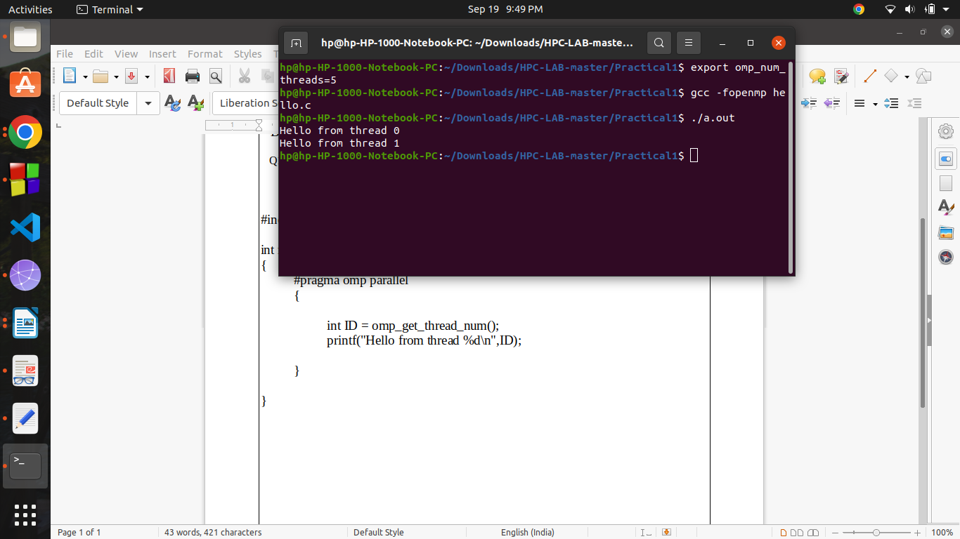

Q 2) Write a program to print the sum of squares of numbers from 1 to hundred using OpenMp.

Code:

#include<omp.h>

#include<stdio.h>

#include<stdlib.h>

#include<iostream>

using namespace std;

static int sum =0;

int main()

{

#pragma omp parallel

{

for(int i=1; i<=100;i++)

{

if(i%4==omp_get_thread_num())

{

printf("thread No. %d Number : %d Square : %d\n", omp_get_thread_num(), i, i * i);

sum+=i*i;

printf("Sum is %d ",sum);

cout<<endl;

}

}

}

return 0;

}

output:

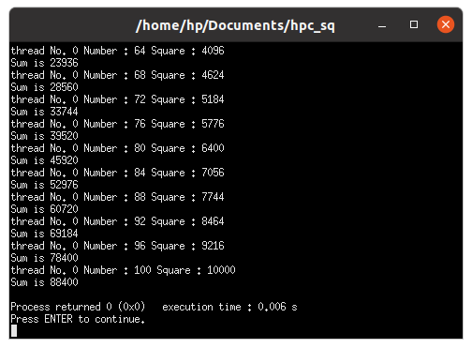

Q3 ) Write a programme to calculate the 5the speedup in parallel and sequential execution

code: parallel execution

#include<omp.h>

#include<stdio.h>

#include<stdlib.h>

#include<bits/stdc++.h>

using namespace std;

int main(){

long long sum = 0;

double getInTime = omp_get_wtime();

#pragma omp parallel for reduction(+ : sum)

for(int i=1;i<=100000000;i++){

sum += (i*i);

}

double getOutTime = omp_get_wtime();

double exptTime = getOutTime - getInTime;

printf("Time Required For Execution in Parallel : %f\n",exptTime);

printf("Answer is : %lld",sum);

return 0;

}

output:

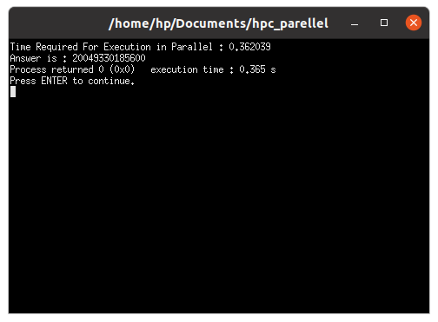

code Sequential Execution:

#include<omp.h>

#include<stdio.h>

#include<stdlib.h>

#include<bits/stdc++.h>

using namespace std;

int main(){

long long sum = 0;

double inTime = omp_get_wtime();

int i;

for(i=1;i<=100000000;i++){

sum += (i*i);

}

double outTime = omp_get_wtime();

double expcTime = outTime - inTime;

printf("Time Required for Execution in Serial : %f\n",expcTime);

printf("Answer is : %lld",sum);

return 0;

}

output:

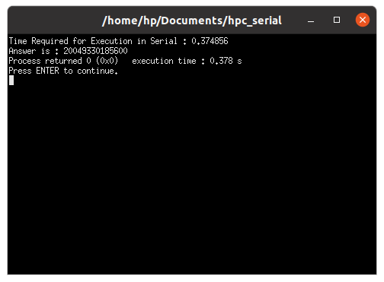

Hence ,

since speedup=sequential execution / parallel execution

so

=0.37486/0.362039

=1.03541331183