**Simson 1/3 rule**

Formula:

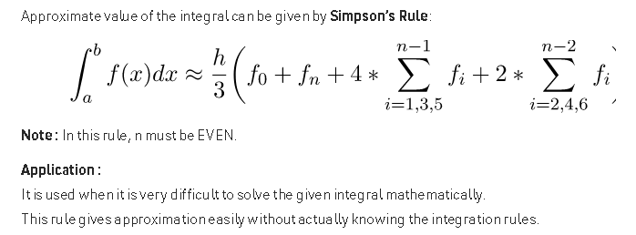

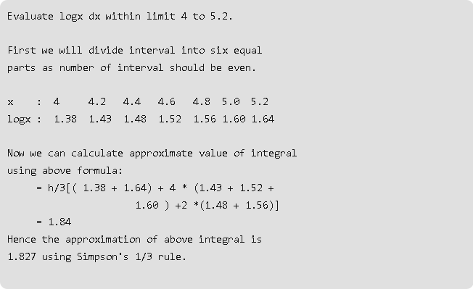

Example:

Lower limit = 4

Upper limit = 5.2

No. Of Interval = 6

Output = 1.827847

**Simson 3/8 rule**

Formula:

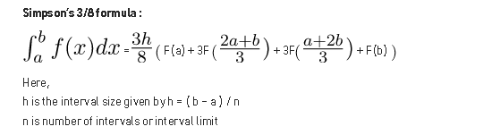

Example :

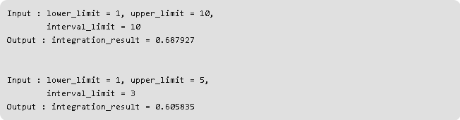

Example :

Lower limit = 1

Upper limit = 10

No. Of Interval = 10

Output = 0.687927