Game Design Document

Fill up the following document

1. Write the title of your project.

CHOR POLICE

1. What is the goal of the game?

The goal of this game is to escape the police and collect keys which are at different places in the grid and open the treasure to win the game.

1. Write a brief story of your game.

There is a thief who wants to become rich and wants to steal treasure which is hidden in a maze.There are two guards who are protecting it .The thief has to collect all the three keys in the maze to open the door of the treasure and then collect the treasure to finish the game

1. Which are the playing characters of this game?

* Playing characters are the ones who respond to the user based on the input from the user.
* Cars, monkeys, dinos, wizards, etc., are the playing characters in the game.

|  |  |  |
| --- | --- | --- |
| Number | Character Name | What can this character do? |
| 1 | The Thief | He can move around the maze using arrow keys |
| 2 |  |  |
| 3 |  |  |
| 4 |  |  |
| 5 |  |  |
| 6 |  |  |
| 7 |  |  |
| 8 |  |  |

1. Which are the Non-Playing Characters of this game?

* Non-Playing characters are the ones that don't have an action or behavior when the user interacts with the game.
* Hurdles, stones, bananas, coins, etc., are non-playing characters in the game.

|  |  |  |
| --- | --- | --- |
| Number | Character Name | What can this character do? |
| 1 | The police | They move around a specific place to try to catch the robber |
| 2 |  |  |
| 3 |  |  |
| 4 |  |  |
| 5 |  |  |
| 6 |  |  |
| 7 |  |  |
| 8 |  |  |

Draw your imagination of this game. What does this game look like?

* Draw the game either on your computer or on paper.
* Add images of the game scenes to show each of the playing and non-playing characters at least once.

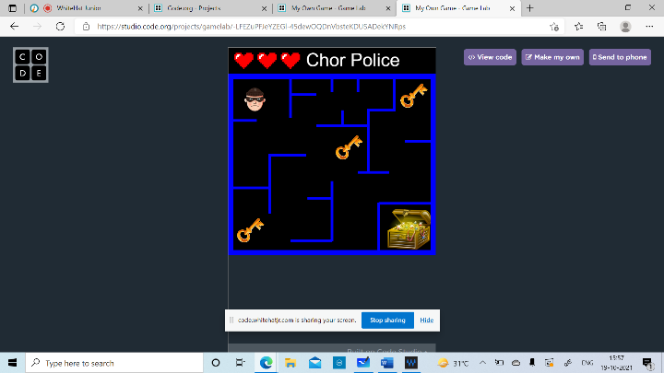

How do you plan to make your game engaging?

There are only three lives given to the player and the guards move fast to prevent the robber reach the treasure.