1. I would like to remove the highlighted part.

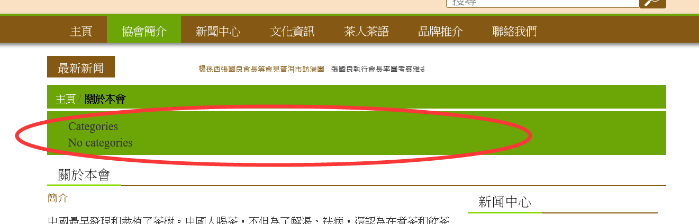

Sourcesoft: Done.

1. When click “關於本會”, which is under “協會簡介”, it comes out the page pic 1. But when I clicked the highlighted “協會簡介”, it comes out pic 2, totally dunno where the “關於理事會” comes from, cos I can’t find it in the existing Page, Post or Category.

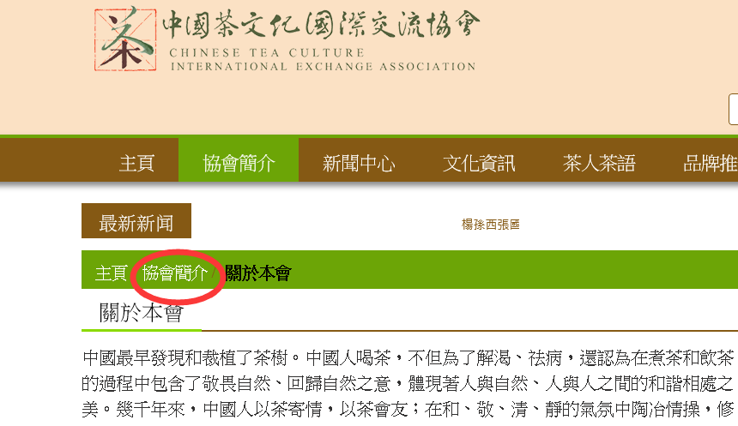

Pic 1

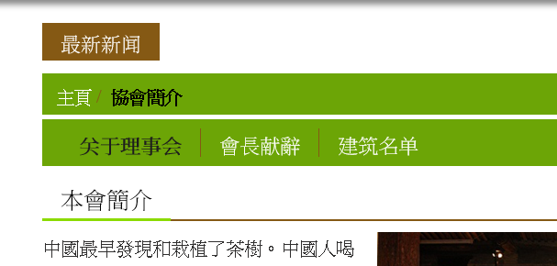

Pic 2

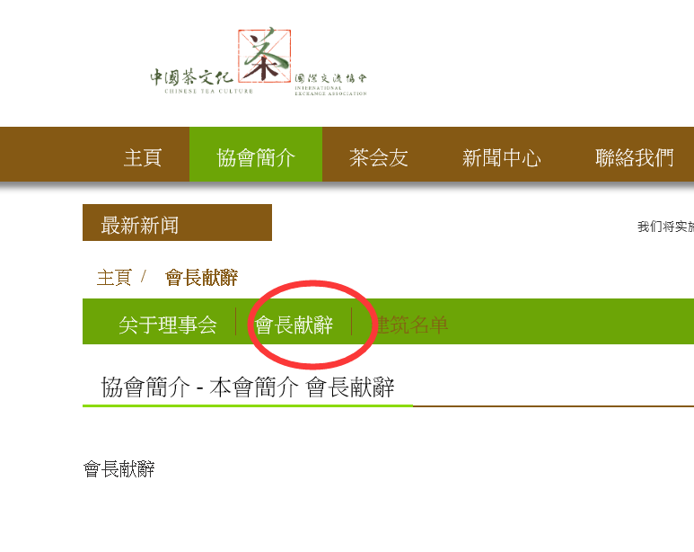

Pic 3  
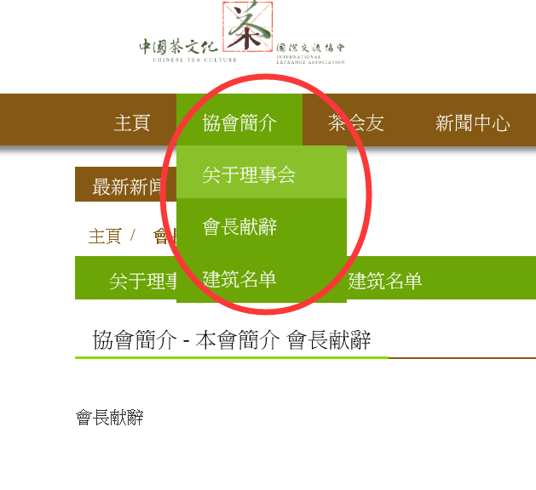

Pic 4 when comes to “關於理事會”, the menu name changed as well. It should be “關於本會” instead of “關於理事會”. But when I back to the home page, then found the “關於理事會” disappeared again.

Sourcesoft: At the moment we are not able to see the pic 2 and pic 3 as well as pic 4. Kindly please check and share revised screen and let us know if you have any query.

Also we have checked you have added the more menu so menu is down. So please confirm is it ok for you?.