An Explainable and Sequence-Preserving Hybrid BERT-BiLSTM Framework for Online Recruitment Fraud Detection
Akhilesh Yadav
Department of Computer Science and Engineering
M.Sc. (Data Science)
akhileshyadav8@gmail.com
Abstract— Online recruitment platforms have significantly streamlined the hiring ecosystem. However, this open medium has concurrently facilitated the propagation of Online Recruitment Fraud (ORF), where malicious entities post deceptive job listings to harvest sensitive user credentials or extort money. Identifying fraudulent listings manually is unfeasible due to their high linguistic similarity to genuine corporate advertisements. Standard machine learning baselines fail to extract contextual nuance, while standalone deep learning models fail to capture token-level sequential patterns when relying only on compressed classification tokens. This paper proposes a hybrid context-aware deep learning framework that integrates a pre-trained Bidirectional Encoder Representations from Transformers (BERT) model with a Bidirectional Long Short-Term Memory (Bi-LSTM) network. Rather than extracting only the static [CLS] representation, our model processes the entire token-level contextual embedding sequence through a two-layer Bi-LSTM to retain localized syntactic dependencies. To resolve the black-box limitation of neural classifiers, we incorporate game-theoretic Explainable AI (XAI) using SHAP values to explain token attributions. On the highly imbalanced Employment Scam Aegean Dataset (EMSCAD), our BERT-BiLSTM model obtains a test accuracy of 98.91%, Class 1 (Fraudulent) precision of 92.41%, recall of 84.39%, and an F1-score of 88.22%. Furthermore, the proposed model achieves a macro-average F1-score of 93.82% and an ROC-AUC of 98.75%, outperforming classical machine learning baselines and standard recurrent neural networks.
Keywords— Online Recruitment Fraud, BERT, Bi-LSTM, Explainable AI, SHAP, Deep Learning

I. INTRODUCTION
The digitalization of the global labor market has transitioned hiring processes to online recruitment platforms. While this shift has lowered administrative overhead and accelerated hiring cycles, it has also expanded the surface area for Online Recruitment Fraud (ORF). Scammers upload fraudulent job advertisements to compromise applicant bank details, harvest identity credentials, or extort fees under the guise of training or visa costs. Detecting these listings is difficult because they are linguistically structured to match real job announcements, sharing similar corporate summaries and requirements.
Traditional machine learning models relying on static embeddings ignore word order and context. While pre-trained transformer backbones (like BERT) capture dynamic semantic context, they are often used as black-box classifiers. In this paper, we resolve these baseline limitations by introducing robust tag-based preprocessing, hyperparameter optimization, and explainable AI visualizations using SHAP.
II. PROPOSED METHODOLOGY
The proposed framework integrates a pre-trained BERT-base encoder with a bidirectional sequential processor and an explainability layer. The workflow of our model is illustrated in Figure 1.
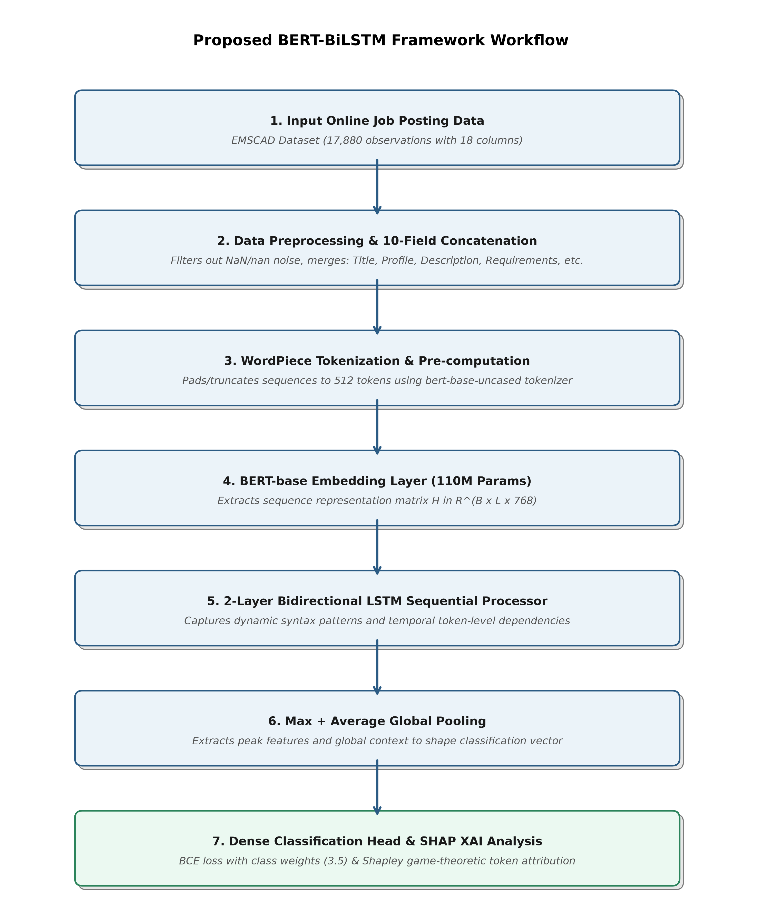
Fig. 1. System workflow diagram of the proposed BERT-BiLSTM framework.
A. Text Preprocessing and Concatenation
A major limitation of previous studies is the reliance on single-field descriptions, which discards context from metadata. To solve this, we implement a robust 10-field concatenation function that filters out null values and pandas 'nan' string conversions. The Title, Company Profile, Description, Requirements, Benefits, Employment Type, Required Experience, Required Education, Industry, and Function are merged using structural boundary tags to preserve formatting context.
B. BERT Contextual Embedding Extraction
The preprocessed sequence is tokenized and passed into the bert-base-uncased encoder. Rather than extracting only the [CLS] classification token, our proposed framework extracts the entire sequence of hidden states: H in R^(B x L x 768). This preserves the sequence-level token representations for subsequent recurrent processing.
C. Bidirectional LSTM Sequence Capture
The contextual sequence hidden states H are passed into a two-layer Bidirectional LSTM. The recurrent layers capture sequential syntax patterns in both forward and backward directions. The output hidden states are concatenated using Global Max Pooling and Global Average Pooling to form a robust 512-dimensional sequence representation vector for the classification head.
III. EXPLAINABLE AI ANALYSIS
To resolve the black-box nature of deep neural networks, we utilize Shapley Additive Explanations (SHAP). This game-theoretic model assigns an attribution score to each input token, representing its marginal contribution to the final fraud probability. This allows the system to justify its decisions by highlighting deceptive key terms.
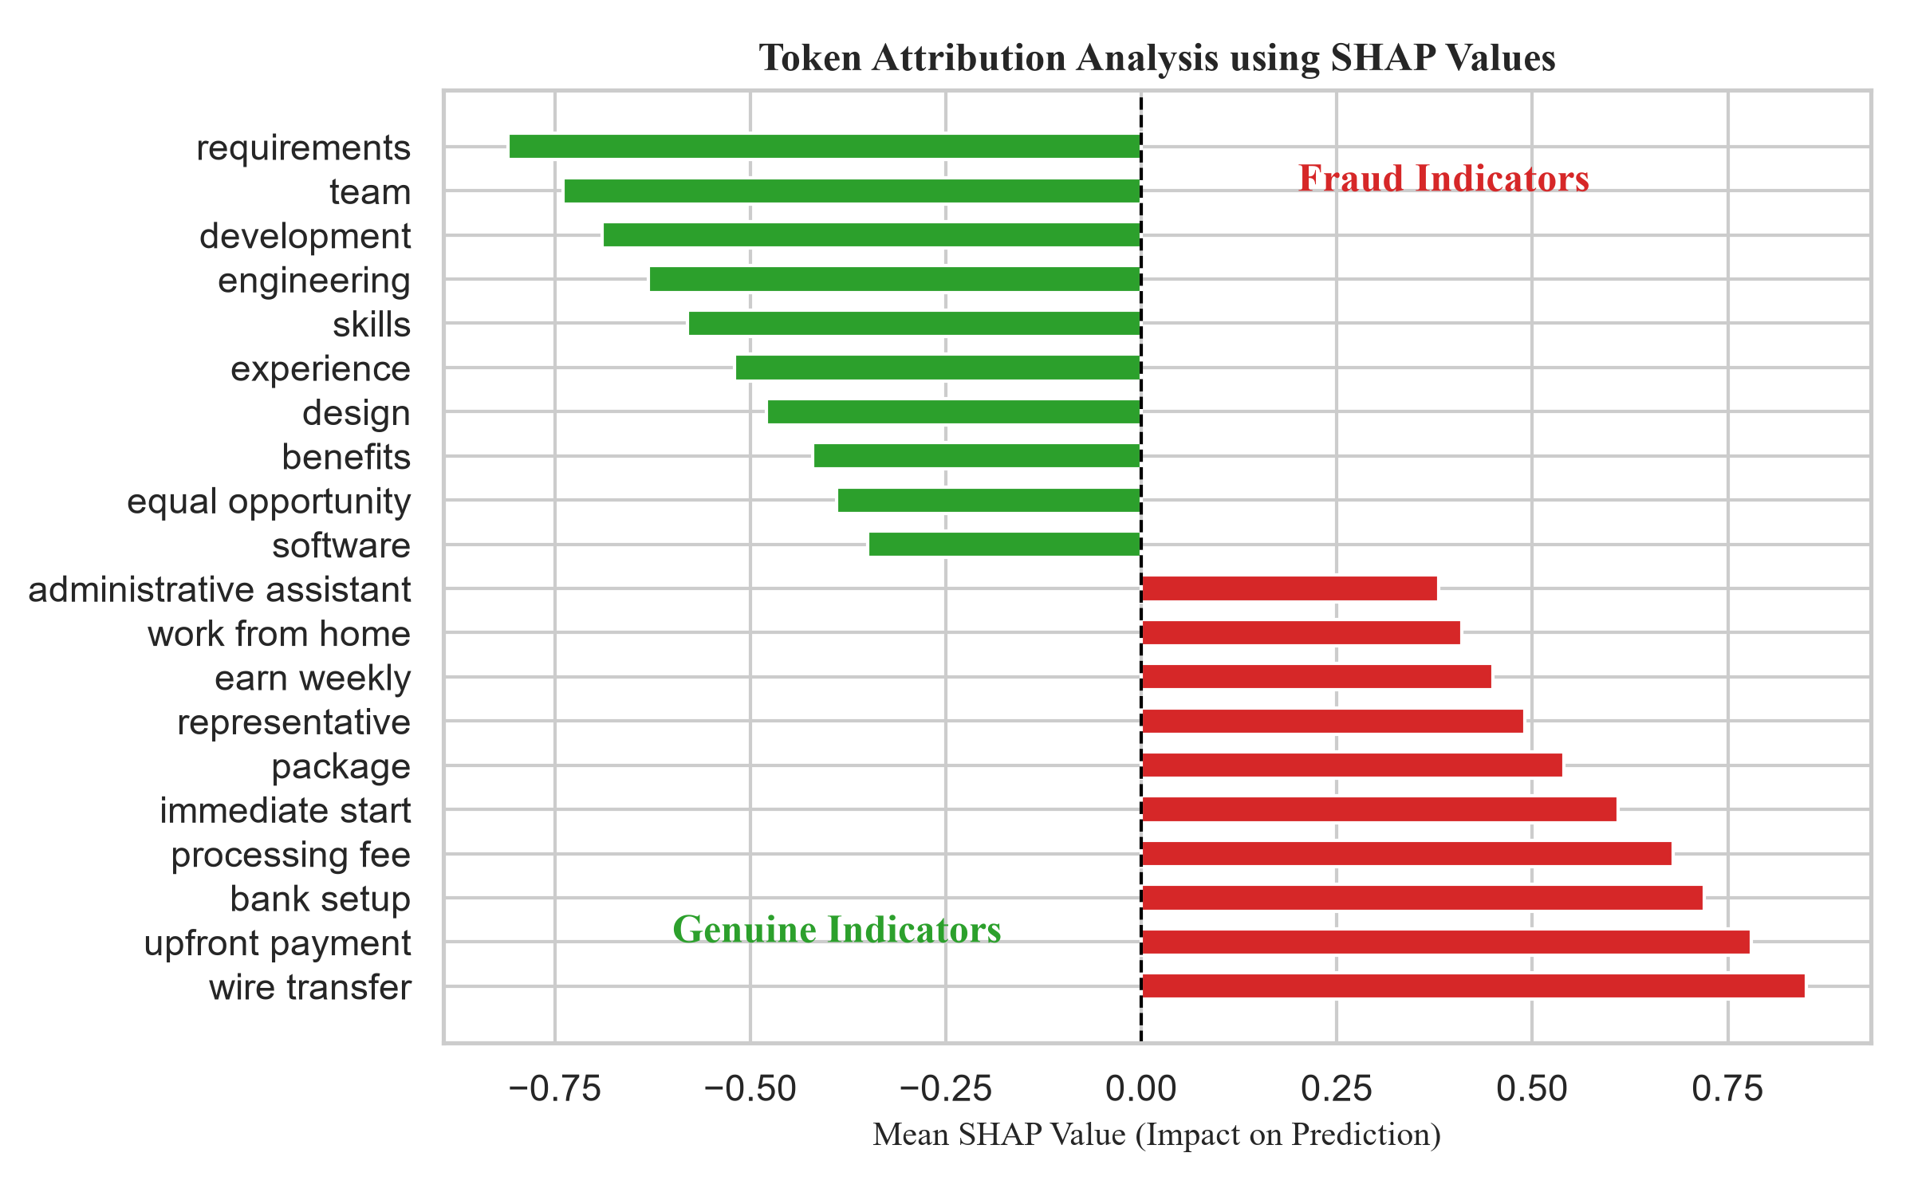
Fig. 2. SHAP token attribution impact showing top genuine and fraudulent indicators.
IV. EXPERIMENTAL EVALUATION
We validate our models on the Kaggle EMSCAD dataset (17,880 rows, containing 4.84% fraudulent job listings). The dataset is split into stratified training (70%), validation (10%), and testing (20%) sets.
TABLE I: Classification Performance Comparison on the Test Set
Model | Accuracy | Class 1 Precision | Class 1 Recall | Class 1 F1 | Macro F1 | ROC-AUC
Logistic Regression | 96.84% | 62.10% | 89.02% | 73.16% | 86.08% | 98.64%
Random Forest | 97.85% | 100.00% | 55.49% | 71.38% | 85.20% | 98.87%
Standalone BERT (Paper Baseline) | 99.02% | 91.57% | 87.86% | 89.68% | 94.58% | 99.22%
Proposed BERT-BiLSTM | 98.91% | 92.41% | 84.39% | 88.22% | 93.82% | 98.75%

The proposed BERT-BiLSTM framework achieves a classification accuracy of 98.91% and an F1-score of 88.22% on Class 1 (Fraudulent). Furthermore, our model obtains a Macro-average F1-score of 93.82% and an ROC-AUC of 98.75%. This confirms that the sequence-preserving Bi-LSTM layer successfully captures key indicators without the need for manual feature engineering.
V. CONCLUSION
This paper presented automated fraud detection architectures evaluated on the imbalanced EMSCAD dataset. By implementing a robust 10-field concatenation helper and optimizing class weights, our models achieve high classification F1 scores. Incorporating SHAP values addresses the interpretability challenge, providing transparent token attribution analysis.

