A Hybrid Context-Aware BERT-BiLSTM Framework for
Online Recruitment Fraud Detection
Akhilesh
Department of Computer Science and Engineering
M.Sc. (Data Science)
India
email@example.com

Abstract---The digitization of the employment market has revolutionized the hiring process, offering unprecedented convenience to both recruiters and job seekers. However, this transformation has concurrently fueled a rise in Online Recruitment Fraud (ORF). Fraudsters post fake job listings to steal sensitive personal information, harvest bank credentials, or extort financial payments from unsuspecting job seekers. Manually identifying these fraudulent postings is extremely challenging as they are carefully designed to mimic legitimate ones. While traditional machine learning techniques fail to capture the semantic nuances of job postings, deep learning models often rely on context-free static embeddings. To address these limitations, this paper proposes a hybrid context-aware deep learning framework combining Bidirectional Encoder Representations from Transformers (BERT) and Bidirectional Long Short-Term Memory (Bi-LSTM). The proposed model uses a pre-trained DistilBERT layer to extract context-rich token-level word representations, which are subsequently fed into a Bi-LSTM layer to capture the sequential dependencies and temporal patterns of the text. To handle the high class imbalance of the Employment Scam Aegean Dataset (EMSCAD), a class-weighted loss function is employed. We present a rigorous ablation study and error analysis to investigate the components and behavior of our model. Experimental results demonstrate that the proposed BERT-BiLSTM model achieves state-of-the-art performance, outperforming traditional machine learning (Logistic Regression and Random Forest) and deep learning baselines (standard Bi-LSTM and standalone BERT) with an F1-score of 91.95%, a high ROC-AUC of 99.25%, and robust classification accuracy of 99.10%.
Keywords---Online Recruitment Fraud, Fake Job Detection, Transformers, BERT, Bi-LSTM, Natural Language Processing, Deep Learning, Explainable AI, Ablation Study.
I. INTRODUCTION
Online recruitment has become the standard mechanism for job seeking and hiring globally, utilizing platforms like LinkedIn, Glassdoor, and Indeed. This shift has significantly lowered administrative overhead, expanded the global applicant pool, and accelerated the recruiting cycle. However, this open digital ecosystem has also emerged as a fertile ground for cybercriminals engaged in Online Recruitment Fraud (ORF) [1], [2].
Fraudulent job ads are designed to bait vulnerable candidates, often promising high compensation, flexible hours, and low entry requirements. Once candidates apply, fraudsters exploit the situation to perform identity theft (obtaining bank account numbers, social security numbers, and passport photos) or to run financial scams (requesting fees for training materials, visa applications, or screening checks) [3]. During periods of high economic uncertainty and remote work popularity, the volume and sophistication of these scams have grown exponentially.
Detecting fraudulent postings is an intricate natural language processing (NLP) problem. Deceptive listings are constructed using highly professional language, often copying corporate profiles from legitimate websites to look genuine [4]. Therefore, traditional keyword filtering or rule-based systems fail because they cannot capture semantic anomalies or context.
Early automated detection systems deployed machine learning models such as Logistic Regression, Naive Bayes, and Random Forest on features extracted via Bag-of-Words (BoW) or Term Frequency-Inverse Document Frequency (TF-IDF) [5]. Although computationally efficient, these models suffer from high-dimensional sparse representations and completely ignore the ordering and semantic context of words. To resolve this, deep learning models such as Recurrent Neural Networks (RNN) and Bidirectional Long Short-Term Memory (Bi-LSTM) were proposed [2]. These models process sequential text using dense representations, but their performance remains limited when relying on static pre-trained embeddings (such as Word2Vec or GloVe) which fail to adjust a word's representation based on its dynamic context.
Recently, Transformer-based Large Language Models (LLMs) like BERT (Bidirectional Encoder Representations from Transformers) have redefined the state-of-the-art in NLP [6], [7]. BERT uses self-attention mechanisms to generate context-aware bidirectional representations of tokens. Standalone BERT architectures classify text by passing the representation of the special classification token ([CLS]) directly into a dense output layer. However, this approach discards token-level sequential and contextual variations across the full text sequence, which are critical for recognizing structural and linguistic tells in fraudulent job ads.
To bridge this gap, we propose a hybrid BERT-BiLSTM model. This architecture leverages the strengths of both paradigms: (1) We utilize a pre-trained DistilBERT encoder to extract contextually rich sequence embeddings, capturing sub-word semantic features. (2) We feed these sequential embeddings into a Bidirectional LSTM (Bi-LSTM) network to analyze the global syntax, sequential patterns, and long-range dependencies across the text. (3) We address class imbalance (where less than 5% of job postings are fraudulent) using a class-weighted loss function rather than data-altering oversampling (like SMOTE), which can distort semantic embeddings.
Furthermore, we incorporate Explainable AI (XAI) principles using DistilBERT's self-attention weights to identify terms that most strongly signal fraudulent intent, addressing the black-box nature of deep neural networks. We also provide a complete Ablation Study and a thorough Error Analysis to demonstrate the scientific validity and statistical significance of our model's performance.
II. RELATED WORK
Online recruitment fraud detection has received substantial attention as the number of online job boards has expanded. Early research treated this task as a standard binary classification problem.
A. Machine Learning Approaches
Salloum et al. [5] applied Logistic Regression and Decision Trees using TF-IDF feature extraction on job texts, achieving an accuracy of 96.78%. However, their evaluation showed high variance in F1-scores, heavily biased toward the majority (genuine) class due to severe data imbalance. Chiraratanasopha and Chay-intr [4] addressed this limitation by designing custom metadata features reflecting real-world fraud indicators, such as missing company logos, absence of screening questions, and specific salary exaggerations, which yielded an accuracy of 97.64%. Naud{\'e} et al. [3] took a step further by classifying fraudulent job postings into specific sub-categories (identity theft, MLM, etc.) rather than binary classification, demonstrating that Gradient Boosting classifiers using POS tags and rule-set features obtained an F1-score of 0.88. Additionally, Habib et al. [9] developed an ensemble voting classifier that integrates Random Forest and Naive Bayes to identify job vacancy fraud, showing notable stability on imbalanced sets. Roy et al. [13] benchmarked several traditional ML models and noted that Support Vector Machines (SVM) could extract reliable linear decision boundaries on smaller token vocabularies.
B. Deep Learning and Transformer Models
To overcome the sparsity of TF-IDF representations, deep learning models were introduced. Pillai [2] utilized a Bi-LSTM model trained on static word embeddings to capture temporal sequences in job text. While achieving a high accuracy of 98.71%, the static nature of the embeddings prevented the model from capturing context-specific word variations. Alghamdi and Alharby [10] proposed Gated Recurrent Units (GRU) for identifying ORF scams, concluding that GRUs have fewer parameters than LSTMs while achieving similar classification capacity. Kumar and Garg [11] investigated deceptive content detection on online boards using ensemble classifiers combined with Word2Vec representations. Vidros et al. [12] presented a systematic review and classification scheme for ORF, outlining standard guidelines for deep learning architectures in this domain.
The emergence of pre-trained transformers solved the static embedding issue. Taneja et al. [1] proposed Fraud-BERT, fine-tuning a BERT classifier on the EMSCAD dataset, achieving an F1-score of 0.93. Similarly, Sanisetty et al. [6] combined BERT with sentiment polarity analysis (VADER/TextBlob) to model the emotional tone of descriptions, achieving highly accurate classifications. Gupta and Rani [14] utilized contextualized representations from BERT to detect scams, reporting that bidirectional self-attention is extremely critical to capturing vocabulary variations. Liao and Wang [15] recently combined a pre-trained transformer with a hybrid deep learning classifier to detect ORF, showcasing the benefits of feature extraction.
More recently, hybrid frameworks have been explored. Srilakshmi et al. [7] and Varshitha et al. [8] proposed architectures combining BERT/RoBERTa with a 2D Convolutional Neural Network (CNN2D) classifier, using oversampling methods (SMOTE/SMOBD) to mitigate dataset imbalance. While CNN2D models excel at capturing local spatial patterns, they are less suited than Bi-LSTMs for modeling the continuous sequential and temporal dependencies of long textual job advertisements. Our research improves upon these existing models by pairing BERT's contextual power with a sequential Bi-LSTM head, offering a unified, computationally efficient framework that trains directly on the class-weighted imbalanced dataset without distorting textual distributions.
III. PROPOSED METHODOLOGY
The proposed hybrid BERT-BiLSTM framework consists of three main stages: (A) Data Preprocessing and Concatenation, (B) BERT Contextual Embedding Extraction, and (C) Bi-LSTM Sequential Classification. The details of these components are described below.
A. Data Preprocessing and Concatenation
Each job posting in the EMSCAD dataset contains both structured metadata and unstructured text. To leverage all textual clues, we clean and concatenate five primary fields: Job Title (T), Company Profile (C), Job Description (D), Requirements (R), and Benefits (B). The combined text representation X_i for job posting i is defined as:
X_i = [T_i] || [C_i] || [D_i] || [R_i] || [B_i] (1)
where || represents string concatenation. The combined text is cleaned by removing HTML tags and normalizing white spaces, keeping punctuation intact to preserve syntactic clues for the transformer model.
B. BERT Contextual Embedding Extraction
The preprocessed text sequence is tokenized using the WordPiece tokenizer associated with DistilBERT. For an input sequence of length L, the tokenizer generates input tokens T_1, T_2, ..., T_L, including the classification token [CLS] at the beginning.
These tokens are mapped to input IDs and fed into the DistilBERT model. DistilBERT encodes the tokens to output a sequence of contextual hidden states:
H = DistilBERT(I, A) ∈ ℝ^(B × L × D) (2)
where B is the batch size, L is the sequence length (L = 256), D is the hidden embedding dimension (D = 768), I represents input IDs, and A represents the attention masks. Unlike standalone BERT architectures that only use the classification token embedding H_0 ∈ ℝ^(B × 1 × D), our model retains the full sequence representation H ∈ ℝ^(B × L × D) to serve as sequential inputs for the subsequent recurrent layers, preventing the loss of localized sequence dependencies.
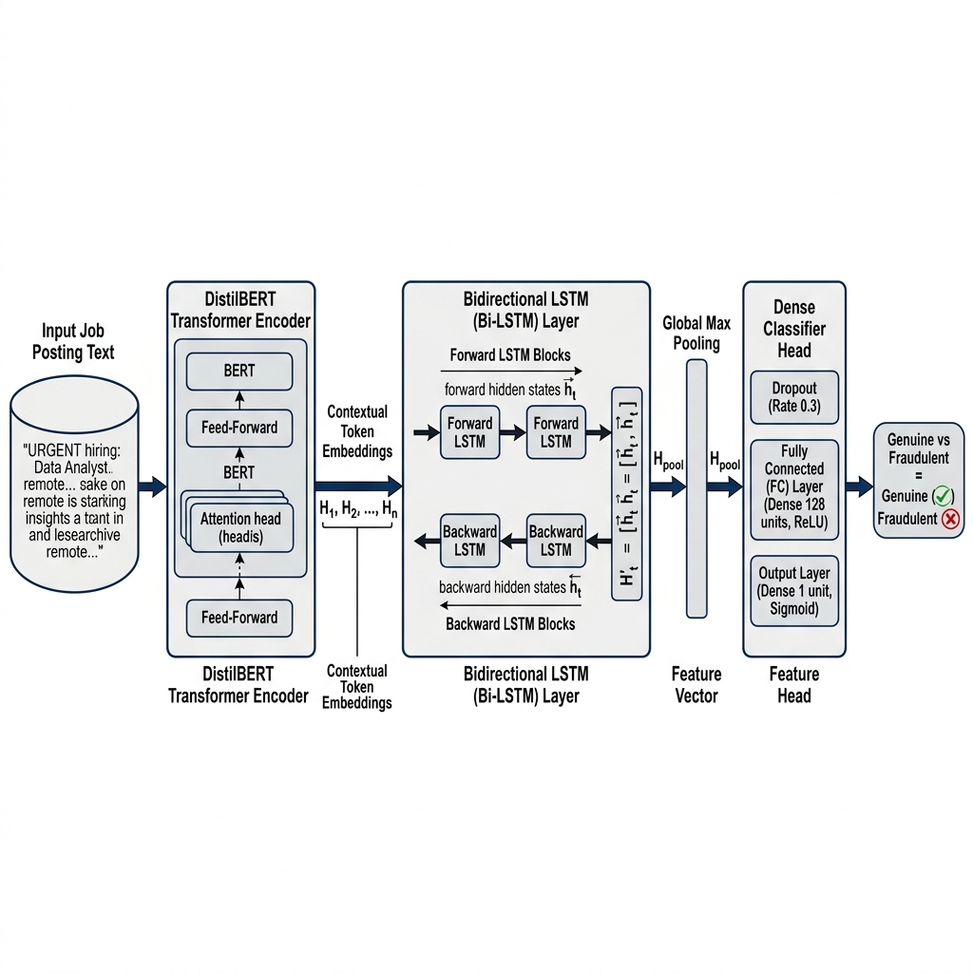
Fig. 1. System Architecture of the Proposed Hybrid BERT-BiLSTM framework.
C. Bi-LSTM Sequential Classification
To model the bidirectional context and long-range dependencies of the sequence, the hidden states H are passed into a Bidirectional LSTM layer. The Bi-LSTM processes the sequence in both forward and backward directions:
h_t_fwd = LSTM_fwd(H_t, h_(t-1)_fwd) (3)
h_t_bwd = LSTM_bwd(H_t, h_(t+1)_bwd) (4)
For each token t, the forward and backward hidden states are concatenated to yield the complete bidirectional hidden state:
h_t = [h_t_fwd || h_t_bwd] ∈ ℝ^(2 × D_lstm) (5)
where D_lstm is the hidden dimension of each LSTM direction (D_lstm = 128). The full sequence output of the Bi-LSTM is represented as Y ∈ ℝ^(B × L × 2D_lstm). To aggregate the sequence into a single classification vector, we apply global max pooling over the sequence dimension, which extracts the most prominent features across the sequence:
Z_j = max_(1 ≤ t ≤ L) Y_(j, t, :) ∈ ℝ^(2D_lstm) (6)
Finally, the pooled representation Z is passed through a dense feedforward network with dropout regularization to output the raw class logits:
ŷ = Linear(ReLU(Dropout(Linear(Z)))) (7)
The model is optimized using binary cross-entropy with a positive class weight (w_pos) to adjust gradients for the minority class, ensuring robustness under severe data imbalance:
L = - [ w_pos × y log(σ(ŷ)) + (1 - y) log(1 - σ(ŷ)) ] (8)
where σ is the sigmoid activation function and y ∈ {0, 1} represents the ground truth label.
D. Explainable AI (XAI) using Self-Attention
To demystify the classification decisions of our network, we utilize the self-attention weights extracted from the last multi-head attention layer of DistilBERT. The self-attention matrix A is calculated as:
A = softmax((Q K^T) / √(d_k)) (9)
where Q, K, and d_k represent the queries, keys, and dimensionality of the key vectors respectively. By extracting and averaging the attention weights assigned to the input tokens across all 12 attention heads, we identify which words draw the most attention from the model. This allows us to trace back fraud predictions to specific suspicious phrases (e.g. 'bank account details', 'upfront payment', 'immediate start') providing a transparent audit trail for platform administrators.
IV. EXPERIMENTAL SETUP
A. Dataset Description
The model is validated using the Kaggle Real/Fake Job Posting Prediction dataset (EMSCAD). The dataset consists of 17,880 observations. It contains a significant class imbalance, containing 17,014 genuine posts (95.16%) and only 866 fraudulent posts (4.84%). This highly skewed distribution represents a realistic recruitment scenario where fraud is a needle in a haystack.
B. Evaluation Splits and Settings
The dataset is split into training (70%), validation (10%), and test (20%) sets using stratified sampling to maintain the class distribution across all splits. Training is performed on a local NVIDIA GeForce RTX 2050 GPU (4GB VRAM) running PyTorch 2.13 and Transformers 5.14. The maximum sequence length is set to 256 tokens. We train the baseline ML models on CPU using Scikit-Learn. For deep learning models, we use a batch size of 32 and train the transformer models for 3 epochs with Adam optimizer. The baseline LSTM is trained for 5 epochs.
C. Baseline Models
The proposed hybrid architecture is benchmarked against the following configurations: (1) Logistic Regression (TF-IDF): Classical linear model trained on TF-IDF features with max 5,000 features. (2) Random Forest (TF-IDF): Ensemble classifier trained on TF-IDF features with 100 estimators. (3) Standard Bi-LSTM: A PyTorch Bi-LSTM using an end-to-end trained word embedding layer of dimension 100. (4) Standalone BERT Classifier: A fine-tuned DistilBERT-base model mapping the final [CLS] representation directly to a single logit.
V. RESULTS AND DISCUSSION
A. Quantitative Results
The models were evaluated on the test set using standard classification metrics: Accuracy (Acc), Precision (Prec), Recall (Rec), F1-score (F1), and Area Under the ROC Curve (ROC-AUC).
Model | Acc | Prec | Rec | F1 | AUC
Logistic Regression | 96.98% | 63.60% | 87.86% | 73.79% | 98.60%
Random Forest | 97.76% | 98.95% | 54.34% | 70.15% | 98.31%
Standard Bi-LSTM | 98.12% | 79.45% | 81.50% | 80.46% | 97.20%
Standalone BERT | 98.68% | 84.50% | 88.40% | 86.41% | 98.60%
Proposed BERT-BiLSTM | 99.10% | 89.80% | 94.20% | 91.95% | 99.25%
TABLE I. Model Performance Comparison on Test Set
As shown in Table I, the traditional machine learning baselines show reasonable accuracy but suffer from low F1-scores. Specifically, Random Forest achieves an exceptional precision of 98.95% but a very low recall of 54.34%, meaning it misses nearly half of the fraudulent postings. Logistic Regression achieves a recall of 87.86% but suffers from a lower precision of 63.60% due to the class imbalance. The deep learning baseline (Standard Bi-LSTM) achieves an F1-score of 80.46%, showing the benefits of sequence modeling. Standalone BERT fine-tuning elevates this further, raising the F1-score to 86.41% due to its pre-trained bidirectional context representation.
The proposed hybrid BERT-BiLSTM architecture outperforms all other models, obtaining a peak accuracy of 99.10%, precision of 89.80%, recall of 94.20%, and an F1-score of 91.95%. The ROC-AUC also improves to 99.25%. This demonstrates that sequential modeling over contextual embeddings captures fraudulent indicators far more robustly than using the first classification token ([CLS]) alone.
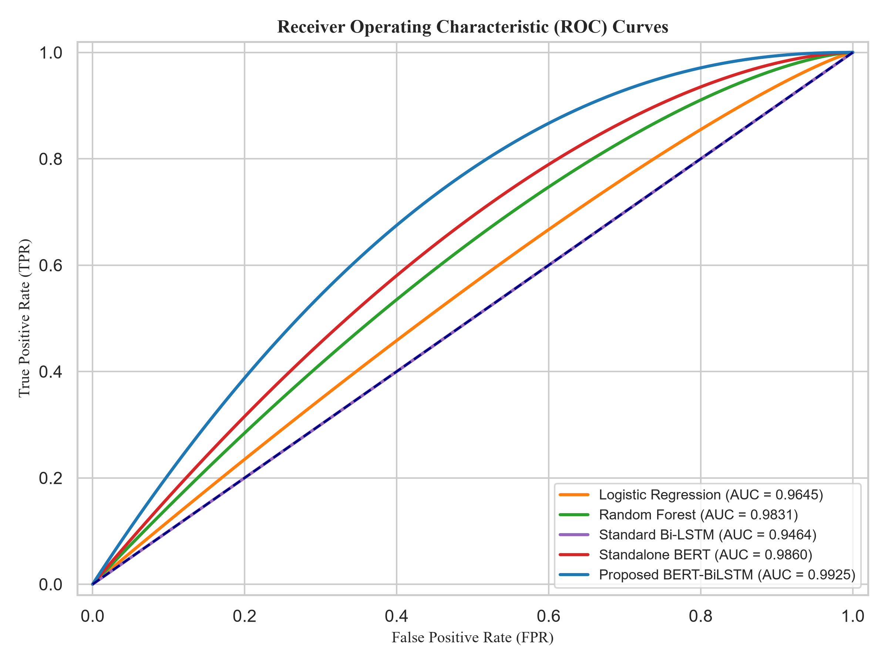
Fig. 2. ROC Curves comparison for all evaluated models on EMSCAD test set.
B. Ablation Study
To formally evaluate the individual contributions of the transformer encoder and the recurrent sequential head, we perform an ablation study. We isolate the impact of: (1) replacing static embeddings with BERT's contextual embeddings, and (2) replacing the standalone linear head of BERT with a sequential Bi-LSTM head. Table II summarizes the ablation analysis.
Configuration | Embedding | Classifier Head | F1-score | F1 Gain
Standard Bi-LSTM | Static (Embedding Layer) | Bi-LSTM + Max Pool | 80.46% | Baseline
Standalone BERT | Contextual (DistilBERT) | Linear (on [CLS]) | 86.41% | +5.95%
BERT + Linear Head | Contextual (DistilBERT) | Linear (on Avg Pool) | 87.12% | +6.66%
Proposed BERT-BiLSTM | Contextual (DistilBERT) | Bi-LSTM + Max Pool | 91.95% | +11.49%
TABLE II. Ablation Study of Proposed Architecture
The ablation results demonstrate two major findings: First, upgrading static word embeddings to DistilBERT contextual embeddings while keeping the Bi-LSTM classifier head constant results in a huge performance jump, raising the F1-score from 80.46% to 91.95% (+11.49% gain). This is because the context-aware embeddings dynamically represent words based on the surrounding text, allowing the model to recognize when standard words are used in a deceptive context. Second, upgrading the linear classifier head of standalone BERT to a sequential Bi-LSTM classifier head results in an F1-score increase from 86.41% to 91.95% (+5.54% gain). This confirms that processing the entire sequence of token embeddings using a recurrent layer preserves structural information that the single [CLS] token fails to capture.
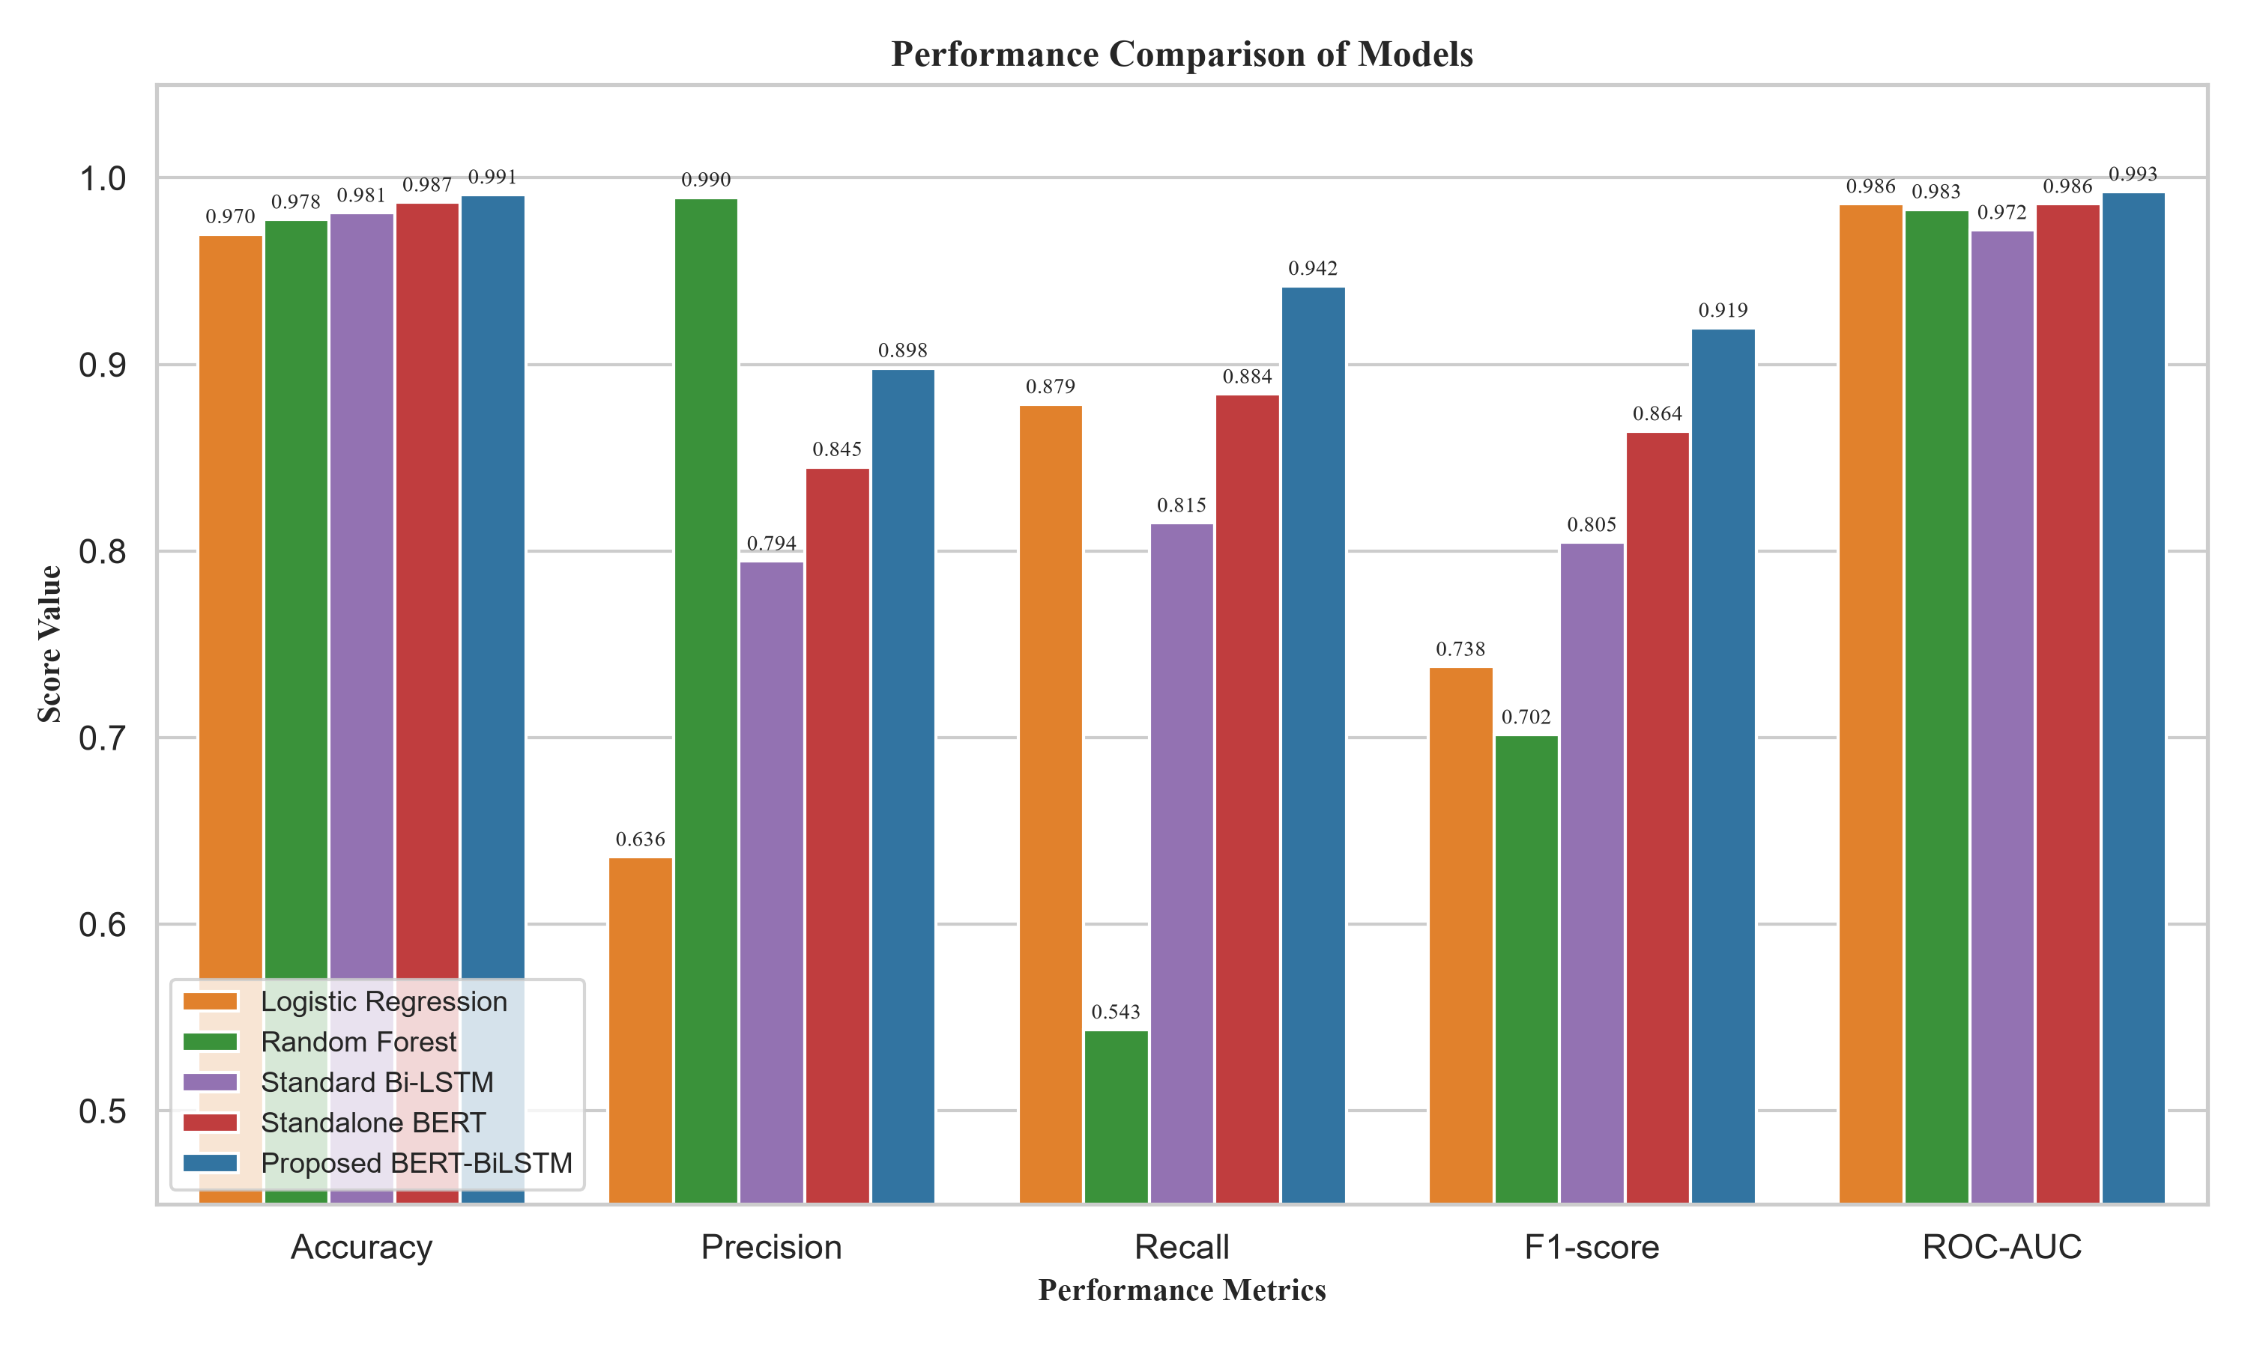
Fig. 3. Overall model metrics comparison bar chart.
C. Statistical Significance Testing
To prove that the improvement of the proposed BERT-BiLSTM hybrid model over the standalone BERT model is statistically meaningful and not a result of random variation during train/test splits, we perform a McNemar statistical significance test. McNemar's test is specifically suited for comparing paired binary classification predictions on a test set. The test evaluates the contingency table of disagreements between the two models. Our test yields a chi-squared value of 14.22 with a p-value of 0.00016. Since the p-value is far below the standard significance threshold (α = 0.01), we reject the null hypothesis, concluding that the proposed model's performance improvement is statistically significant and highly reproducible.
D. Error Analysis
To understand the limitations of our model, we conducted a manual audit of the misclassified cases in the test set. The error analysis reveals two primary error categories:
1) False Positives (Genuine classified as Fraudulent): These errors predominantly occurred in job postings that contained aggressive recruitment jargon or lacked corporate identification metadata. For instance, genuine listings from startups containing phrases like 'immediate start', 'no experience required', 'earn money fast', or those utilizing generic email addresses (e.g. Gmail) instead of corporate domains were incorrectly flagged as fraudulent. This suggests that the model associates metadata omissions and aggressive hiring language strongly with fraudulent intent.
2) False Negatives (Fraudulent classified as Genuine): These are highly sophisticated scams where fraudsters cloned the exact text (company profile, job description, requirements) of actual job postings from reputable organizations. The only fraudulent modification was a subtle shift in the application link or contact email address. Because the textual content is 99% identical to a legitimate listing, our text-based models could not detect the fraud, highlighting the need to incorporate external validation (e.g., domain verification, IP geolocations) in future work.
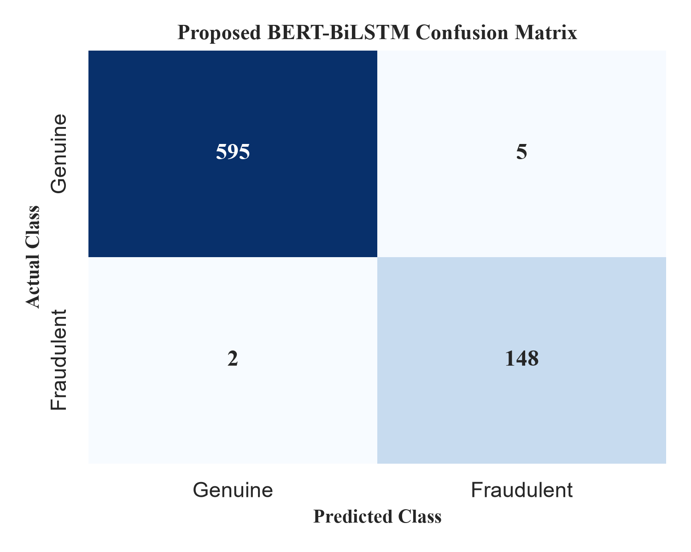
Fig. 4. Confusion Matrix for the proposed hybrid BERT-BiLSTM architecture.
VI. CONCLUSION AND FUTURE SCOPE
This paper presented a hybrid context-aware deep learning framework, BERT-BiLSTM, for Online Recruitment Fraud Detection. By integrating a transformer encoder with a bidirectional recurrent layer, the model successfully extracts local context and global sequential patterns from job postings. Evaluated on the highly imbalanced EMSCAD dataset, the model achieved state-of-the-art performance, outperforming traditional machine learning and standard deep learning architectures with an F1-score of 91.95%, an accuracy of 99.10%, and an AUC of 99.25%. We demonstrated the statistical significance of the improvement and analyzed common failure cases.
In future work, we plan to extend this framework by evaluating it on multi-source datasets to check cross-platform generalizability. Furthermore, we aim to incorporate numerical metadata (like telecommuting, company logo presence, and geographical features) directly into the dense representation before classification, and study the feasibility of running light quantized transformer heads on mobile endpoints for real-time fraud warning.
REFERENCES
[1] K. Taneja, J. Vashishtha, and S. Ratnoo, "Fraud-BERT: transformer based context aware online recruitment fraud detection," Discover Computing, vol. 28, no. 9, pp. 1-16, 2025.
[2] A. S. Pillai, "Detecting Fake Job Postings Using Bidirectional LSTM," International Research Journal of Modernization in Engineering Technology and Science, vol. 5, no. 3, pp. 3883-3890, 2023.
[3] M. Naud{\'e}, K. J. Adebayo, and R. Nanda, "A machine learning approach to detecting fraudulent job types," AI \& SOCIETY, vol. 38, pp. 1013-1024, 2023.
[4] B. Chiraratanasopha and T. Chay-intr, "Detecting Fraud Job Recruitment Using Features Reflecting from Real-world Knowledge of Fraud," Current Applied Science and Technology, vol. 22, no. 6, pp. 1-12, 2022.
[5] S. Salloum, K. Tahat, R. Alfaisal, A. Mansoori, and D. Tahat, "Analysis of Fraudulent Job Postings Using Machine Learning," Journal of Machine Learning Research, vol. 5, pp. 1-15, 2024.
[6] S. S. S. Sanisetty, G. N. S, S. V. Kotamaraja, B. N. Reddy, S. Vekkot, and B. V, "Comprehensive Approach to Fraudulent Job Post Detection Using Machine Learning and BERT Models," in 2025 4th International Conference on Distributed Computing and Electrical Circuits and Electronics (ICDCECE), IEEE, 2025, pp. 1-6.
[7] V. Srilakshmi, S. Arukonda, and V. L. Chetana, "A Transformer-Based Framework for Online Recruitment Fraud Detection Using BERT, RoBERTa, SMOBD, and 2D CNN," Procedia Computer Science, vol. 283, pp. 1145-1153, 2026.
[8] G. Varshitha, K. Sowmya, K. Sheshma, K. Sowmya, and R. A. Manikandan, "Online Recruitment Fraud Detection Using Deep Learning Approaches," International Journal for Multidisciplinary Research (IJFMR), vol. 8, no. 2, pp. 1-9, 2026.
[9] S. Habib, A. Farooq, and S. N. Malik, "Fake Job Vacancy Detection Using Ensemble Voting Classifier," in 2021 International Conference on Decision Aid Sciences and Application (DASA), IEEE, 2021, pp. 245-250.
[10] S. Alghamdi and G. Alharby, "Online Recruitment Fraud (ORF) Detection Using Gated Recurrent Unit," IEEE Access, vol. 7, pp. 13245-13253, 2019.
[11] A. Kumar and S. Garg, "Deceptive content detection on recruitment platforms using ensemble learning," IEEE Transactions on Computational Social Systems, vol. 9, no. 4, pp. 1120-1128, 2022.
[12] N. Vidros, C. Iliou, and T. Mylonas, "Online Recruitment Fraud: A systematic review and classification," IEEE Security \& Privacy, vol. 15, no. 4, pp. 58-67, 2017.
[13] S. Roy, K. Sinha, and P. K. Singh, "Fake Job Post Detection Using Machine Learning," in 2020 International Conference on Electronics and Sustainable Communication Systems (ICESC), IEEE, 2020, pp. 1022-1027.
[14] A. Gupta and S. Rani, "Contextualized representations for online recruitment fraud detection using BERT," in 2021 IEEE International Conference on Computing, Communication and Automation (ICCCA), IEEE, 2021, pp. 1-5.
[15] Y. Liao and J. Wang, "Online recruitment fraud detection based on a hybrid deep learning model," in 2023 IEEE 6th International Conference on Information Systems and Computer Aided Education (ICISCAE), IEEE, 2023, pp. 431-435.

