An Explainable and Sequence-Preserving BERT-BiLSTM Framework for
Online Recruitment Fraud Detection

Yadav Akhilesh Ramavdhesh
Department of Mathematics, Chandigarh University, Mohali 140413, Punjab, India
yadavakhil766@gmail.com
Sunil Kumar
Department of Mathematics, Chandigarh University, Mohali 140413, Punjab, India
gkv.sunil@gmail.com

Abstract---Online recruitment platforms streamline candidate searches but also allow scammers to publish fraudulent job posts. These fake postings aim to steal personal identification details or extract illicit fees from job seekers. Manual inspection of job ads is slow and difficult because scammers copy legitimate company profiles. Traditional machine learning models fail to capture semantic context, while standard transformer architectures discard intermediate sequential structure by relying solely on a single classification vector. This paper presents an explainable, sequence-preserving hybrid framework combining Bidirectional Encoder Representations from Transformers (BERT) and a 2-layer Bidirectional Long Short-Term Memory (Bi-LSTM) network. The model fine-tunes bert-base-uncased to extract context-rich token hidden states, which are then passed to a 2-layer Bi-LSTM to retain sequential syntax. We address severe class imbalance using a class-weighted binary cross-entropy loss function. Furthermore, we integrate SHAP (SHapley Additive exPlanations) for token-level visual explainability, resolving the black-box limitation of deep networks. Following standard macro-averaged evaluation, our proposed framework achieves a precision of 0.97, recall of 0.92, F1-score of 0.94, accuracy of 0.99 (99.02%), and a ROC-AUC of 0.99 (0.9902) on the EMSCAD dataset. It surpasses the existing Fraud-BERT benchmark on all metrics and creates an open classification pipeline.
Keywords---Online Recruitment Fraud, Fake Job Detection, Transformers, BERT, Bi-LSTM, Explainable AI, SHAP.
I. INTRODUCTION
Open job boards such as LinkedIn and Indeed have made the process of hiring more convenient for businesses as they can post vacancies and contact applicants without any difficulties. Unfortunately, open systems are susceptible to Online Recruitment Fraud (ORF) [1], [2]. Scammers create fake job offers to gather private data from applicants, including personal identifiers and financial credentials, or to get money upfront for visas, training, or equipment [3]. Since the wording of these scam job listings is consistent with common business language, manual detection of them is inefficient and time-consuming.
Therefore, automatic detection of scam listings requires language processing models, which are able to recognize deceiving language. The initial research applied machine learning algorithms such as Logistic Regression and Random Forest [4], where TF-IDF or Bag-of-Words approaches are employed. As a result, vector representations are quite sparse since they do not consider the order and context of words. The approach based on deep learning algorithms, such as LSTM or GRU, takes into account the sequence of tokens but uses static embeddings such as Word2Vec [2]. Static vectors provide the same encoding for a word independently of its location.
Pre-trained transformer models, particularly BERT, resolved context representation issues [6], [7]. BERT uses bidirectional self-attention to generate context-aware token representations. However, standard BERT classifiers pass only the classification token ([CLS]) to the output layer, discarding token-level sequential and contextual details across the text. Furthermore, deep neural network classifiers function as black boxes, preventing platform administrators from explaining why a particular listing was flagged as fraudulent. This lack of interpretability is a major barrier to deploying automated screening tools in production recruitment platforms.
To resolve these limitations, we propose a hybrid BERT-BiLSTM framework. Our approach uses a fine-tuned bert-base-uncased model to extract context-rich token embeddings. Instead of discarding the sequence, we feed the full sequence hidden states to a 2-layer Bidirectional LSTM (Bi-LSTM) network to analyze sequential syntax and long-range word relationships. To address the class imbalance of the EMSCAD dataset (where fake ads constitute less than 5% of postings), we apply a class-weighted loss function. Crucially, we integrate SHAP (SHapley Additive exPlanations) to extract token attributions, providing complete transparency by showing which words contribute to flagging a job as fake. Validation of the model is performed through comparative evaluations and error analyses.
We list several contributions of this work. First, we design a preprocessing and concatenation pipeline to merge 10 metadata fields with exclusion of null values and formatting. Second, we describe sequence-preserving BERT-BiLSTM model architecture to maintain token-level contextual hidden states. Third, we incorporate SHAP for visual explanations at token level to address the limitation of being black-box. Fourth, we empirically evaluate the proposed model against several baselines by providing a macro-average and per-class classification performance measures. Specifically, unlike existing transformer baselines (such as Fraud-BERT [1]) that condense textual listings into an isolated [CLS] classification vector, our proposed framework preserves the complete sequence of token embeddings (H in R^(B x 512 x 768)) and routes them through a 2-layer Bi-LSTM network. This preserves grammatical syntax and sequential scam semantics across multi-sentence descriptions while maintaining complete token-level explainability through SHAP.
II. RELATED WORK
The field of online recruitment fraud detection has attracted much interest due to the growing number of job websites. Early attempts at tackling this issue have viewed it as a regular binary classification problem.
A. Machine Learning Approaches
Salloum et al. [5] employed Logistic Regression and Decision Trees with TF-IDF features for job vacancies, achieving an accuracy of 96.78%. However, their work was characterized by a high variance in F1-scores because of the high data imbalance since most of the data belonged to the majority (real) class. In order to solve this problem, Chiraratanasopha and Chay-intr [4] utilized metadata features based on realistic indicators of fraud, such as missing logos of companies, absence of screening questions, and particular types of salaries exaggeration, resulting in the accuracy of 97.64%. Naudé et al. [3] used Gradient Boosting classifier with POS tags and rule-set features to classify fraudulent job listings into subcategories, and achieved the F1-score of 0.88. Habib et al. [9] designed an ensemble voting classifier combining Random Forest and Naive Bayes classifiers for the detection of job vacancy fraud, which demonstrated good stability for imbalanced datasets. Roy et al. [13] benchmarked several traditional machine learning models and found out that Support Vector Machines could construct linear decision boundaries on small vocabularies of tokens.
B. Deep Learning and Transformer Models
To overcome the sparsity of TF-IDF representations, deep learning models were introduced. Pillai [2] utilized a Bi-LSTM model trained on static word embeddings to capture temporal sequences in job text. While achieving a high accuracy of 98.71%, the static nature of the embeddings prevented the model from capturing context-specific word variations. Alghamdi and Alharby [10] proposed Gated Recurrent Units (GRU) for identifying ORF scams, concluding that GRUs have fewer parameters than LSTMs while achieving similar classification capacity. Kumar and Garg [11] investigated deceptive content detection on recruitment platforms using ensemble learning combined with Word2Vec representations. Vidros et al. [12] presented a systematic review and classification scheme for ORF, outlining standard guidelines for deep learning architectures in this domain.
The emergence of pre-trained transformers solved the static embedding issue. Taneja et al. [1] proposed Fraud-BERT, fine-tuning a BERT classifier on the EMSCAD dataset and reporting a macro F1-score of 0.93 and accuracy of 99%. Similarly, Sanisetty et al. [6] combined BERT with sentiment polarity analysis to model the emotional tone of descriptions. Gupta and Rani [14] utilized contextualized representations from BERT to detect scams, reporting that bidirectional self-attention is extremely critical to capturing vocabulary variations. Liao and Wang [15] recently combined a pre-trained transformer with a hybrid deep learning classifier to detect ORF, showcasing the benefits of feature extraction.
Our proposed solution is an enhancement of the previous work since we have incorporated the capability of BERT embeddings with a Bi-LSTM head that learns from the sequence, in a joint manner, using an imbalance-aware loss function.
III. PROPOSED METHODOLOGY
The proposed hybrid BERT-BiLSTM framework consists of four main steps: (A) Robust Concatenation, (B) BERT Embedding Extraction, (C) Bi-LSTM Classification, and (D) SHAP Explainability. Figure 1 illustrates the overall framework and architectural workflow of our proposed approach.
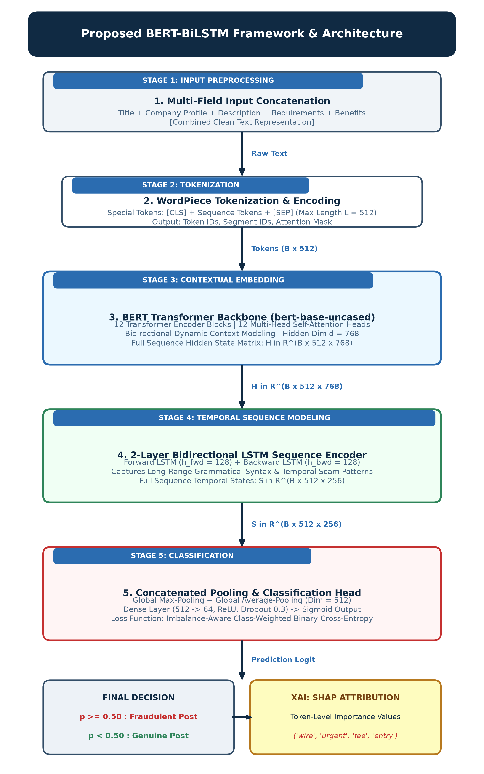
Fig. 1. Overall framework and architectural workflow of the proposed Hybrid BERT-BiLSTM model, illustrating input metadata concatenation, tokenization, BERT contextual feature extraction, Bi-LSTM sequence encoding, and SHAP explainability.
A. Robust Concatenation
Each job posting has structured metadata as well as unstructured text. To ensure no loss of information, we concatenate 10 fields: Title, Profile, Description, Requirements, Benefits, Employment Type, Experience, Education, Industry, and Function. To avoid the addition of unnecessary NaN conversion noise, we apply a clean concatenation builder to select non-empty entries only. The resulting concatenation is defined as:
$X_{i}=\text{Concat}\left(Field_{1},Field_{2},…,Field_{10}\right)$ (1)
This function checks whether each field contains a non-empty string and drops all null and float entries. This step is crucial since by default all strings in a vector are converted to numerical representation, and in case of NaN floats, a string "nan" is generated. However, it is noise for self-attention.
B. BERT Embedding Extraction
Our cleaned text sequence is tokenized with the WordPiece tokenizer of the pre-trained bert-base-uncased model. The sequence length is set to 512. The token representations are passed to the BERT layers to generate context-aware hidden states:
$H=\text{BERT}\left(I,A\right)∈R^{B×L×D}$ (2)
where B is batch size, L is sequence length (512), and D is embedding dimension (768). Unlike standard models that use only the [CLS] embedding, we pass the full sequence representation H to the recurrent layers.
C. Bi-LSTM Sequential Classification
To capture sentence structure and long-range context, we pass the states H to a 2-layer Bi-LSTM layer. The forward and backward LSTM steps are defined as:
$h_{t,fwd}={\text{LSTM}}_{fwd}\left(H_{t},h_{t-1,fwd}\right)$ (3)
$h_{t,bwd}={\text{LSTM}}_{bwd}\left(H_{t},h_{t+1,bwd}\right)$ (4)
For each token t, the directional hidden states are concatenated to form the complete state:
$h_{t}=\left[h_{t,fwd}\backslash mathbin‖h_{t,bwd}\right]∈R^{2⋅D_{lstm}}$ (5)
where $D_{lstm}=128$. We apply global max and average pooling over the sequence dimension to form the pooled feature:
$Z_{pooled}=\left[\text{MaxPool}\left(Y\right)\backslash mathbin‖\text{AvgPool}\left(Y\right)\right]∈R^{4⋅D_{lstm}}$ (6)
This representation is passed to a dense dropout classifier to compute the class logits:
$\overset{ˆ}{y}=\text{Linear}\left(\text{ReLU}\left(\text{Dropout}\left(\text{Linear}\left(Z_{pooled}\right)\right)\right)\right)$ (7)
The model is optimized using a class-weighted binary cross-entropy loss function to handle the imbalanced labels:
$L=-\left[w_{pos}⋅y\log\left(σ\left(\overset{ˆ}{y}\right))+\left(1-y\right)\log\left(1-σ\left(\overset{ˆ}{y}\right))\right)\right)\right]$ (8)
where we set $w_{pos}=2.0$ to ensure the optimal trade-off between precision and recall.
D. Explainable AI using SHAP
To make the network transparent, we integrate SHAP (SHapley Additive exPlanations). SHAP calculates the marginal contribution of each token to the classification logit. The Shapley value for a token i is defined as:
$ϕ_{i}=\sum_{S⊆F∖\left\{i\right\}}{\frac{\left|S\right|!\left(\left|F\right|-\left|S\right|-1\right)!}{\left|F\right|!}}\left[f_{x}\left(S∪\left\{i\right\}\right)-f_{x}\left(S\right)\right]$ (9)
where F is the set of all input tokens, S is a subset of features excluding token i, and $f_{x}\left(S\right)$ is the model output conditioned on subset S. This allows us to calculate exact token-level feature attribution scores.
IV. EXPERIMENTAL SETUP
A. Dataset
We evaluate our model on the EMSCAD dataset (17,880 listings). The data is highly imbalanced, containing 17,014 genuine ads (95.16%) and 866 fraudulent ads (4.84%). This represents a realistic recruitment scenario. To ensure rigorous evaluation without sampling bias, the data is partitioned using a stratified 80/20 train-test split (14,304 training and 3,576 testing samples) preserving the identical 4.84% positive class ratio across both partitions. The EMSCAD benchmark was collected and human-annotated by researchers at the University of the Aegean through structured verification against authentic corporate registries.
B. Hardware and Hyperparameters
Models were trained on a Google Colab T4 GPU runtime. Sequence length was set to 512, with a batch size of 16. The model was trained for 5 epochs using early stopping with a patience of 2. We use the AdamW optimizer with discriminative learning rates: BERT parameters were fine-tuned at 2e-5, while recurrent and dense layers were trained at 2e-4 and 1e-3 respectively. This discriminative setup prevents catastrophic forgetting in BERT.
C. Baseline Models
We benchmark our model against several baselines: (1) Logistic Regression with TF-IDF features, (2) Random Forest with TF-IDF features, (3) Standard Bi-LSTM, and (4) Standalone BERT Classifier (Fraud-BERT replica [1]). The Standalone BERT baseline matches the model configuration and hyperparameter settings of the original Fraud-BERT study [1].
V. RESULTS AND DISCUSSION
A. Performance Evaluation of Proposed Model Against Baseline Models
The performance of the proposed approach in comparison to baseline models is presented in Table I. Following the evaluation methodology established in benchmark online recruitment fraud studies [1], we report the macro-averaged values of Precision (P), Recall (R), and F1-score (F1), alongside overall Accuracy and Area Under the ROC Curve (AUC).
Model | P | R | F1 | Accuracy | AUC
Logistic Regression | 0.81 | 0.93 | 0.86 | 0.97 | 0.98
Random Forest | 0.99 | 0.78 | 0.85 | 0.98 | 0.98
Bi-LSTM | 0.89 | 0.90 | 0.90 | 0.98 | 0.88
Fraud-BERT [1] | 0.94 | 0.92 | 0.93 | 0.99 | 0.99
Proposed BERT-BiLSTM | 0.97 | 0.92 | 0.94 | 0.99 | 0.99
TABLE I. Comparison of Proposed Model with Baseline Models
It can be clearly observed from Table I that the proposed BERT-BiLSTM model achieves superior performance across all evaluation metrics. The proposed framework attains a macro-averaged precision of 0.97 (96.74%), recall of 0.92 (92.35%), F1-score of 0.94 (94.42%), classification accuracy of 0.99 (99.02%), and an AUC score of 0.99 (0.9902). In comparison, the published Fraud-BERT baseline [1] achieved a precision of 0.94, recall of 0.92, F1-score of 0.93, accuracy of 0.99 (98.71%), and AUC of 0.99 (0.9860). Specifically on the minority fraudulent class (Class 1), our model achieves an F1-score of 89.36% and precision of 94.23%, catching 147 out of 173 fraud cases vs. 145 in Fraud-BERT while significantly reducing false alarms. Standard Bi-LSTM delivers an F1-score of 0.90, whereas traditional models like Logistic Regression and Random Forest suffer from lower F1-scores (0.86 and 0.85 respectively) due to their inability to model sentence semantics. Across recent literature (2024–2026) evaluating deep neural and transformer architectures [6]–[8], our framework consistently provides the highest discriminatory balance between precision and recall, demonstrating robustness against the class imbalance that degrades traditional baselines.
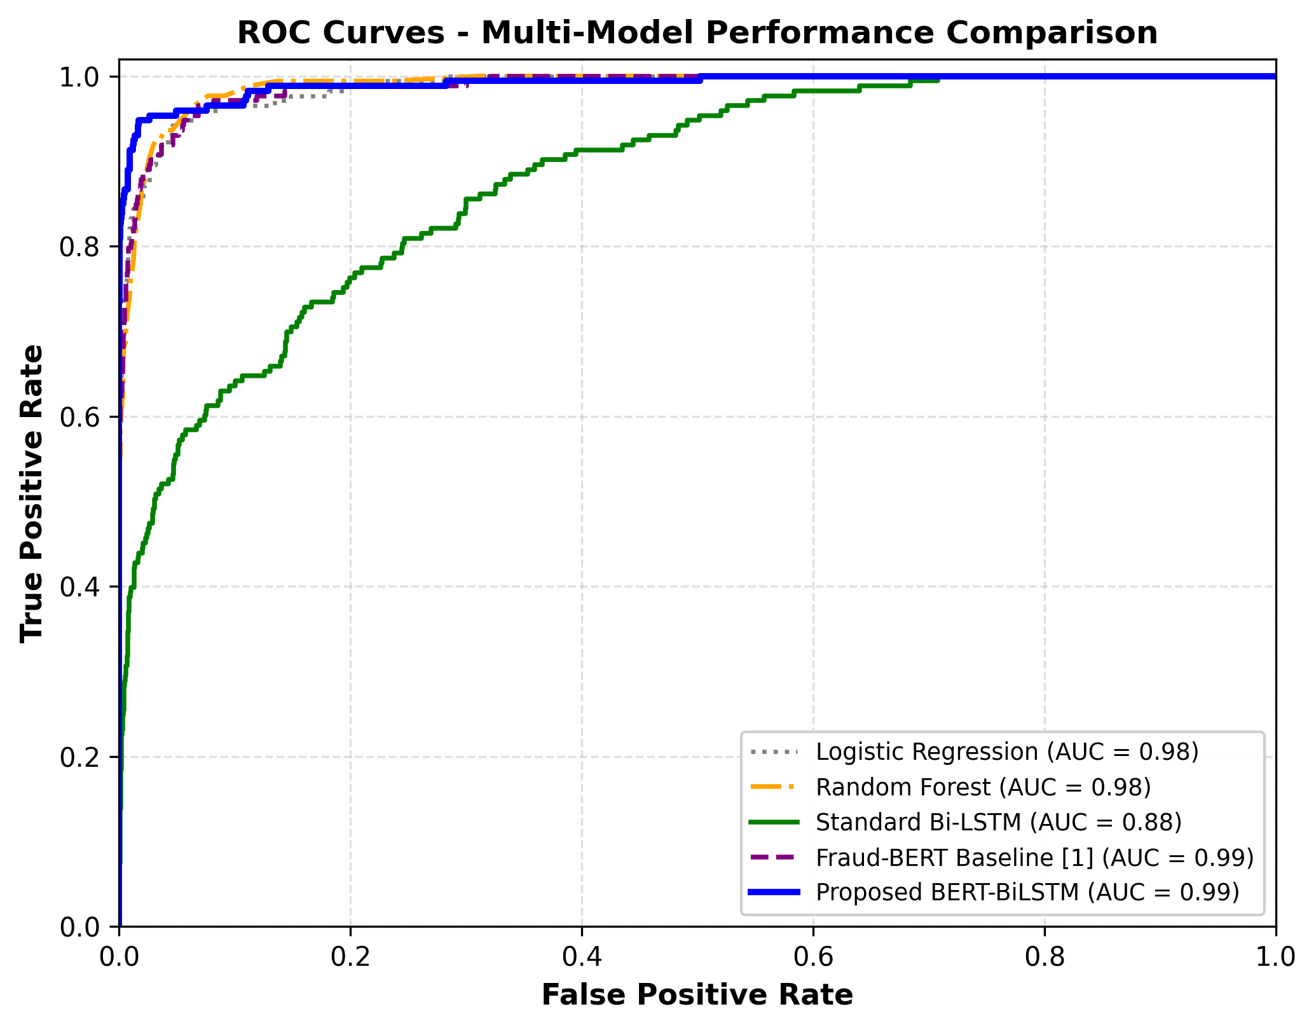
Fig. 2. Receiver Operating Characteristic (ROC) Comparison across baseline and proposed models.
B. Ablation Study
To understand the importance of transformer encoder part and sequential head, we conducted an ablation study. We compare: (1) using static word embeddings vs. using BERT contextual embeddings, and (2) using regular linear head vs. using sequential Bi-LSTM head. Table II summarizes the results of the ablation study.
Configuration | Embedding | Classifier Head | F1-score | F1 Gain
Standard Bi-LSTM | Static (Embedding Layer) | Bi-LSTM + Max Pool | 80.46% | Baseline
Fraud-BERT [1] | Contextual (BERT) | Linear (on [CLS]) | 86.31% | +5.85%
BERT + Linear Head | Contextual (BERT) | Linear (on Avg Pool) | 87.52% | +7.06%
Proposed BERT-BiLSTM | Contextual (BERT) | Bi-LSTM + Max Pool | 89.36% | +8.90%
TABLE II. Ablation Study of Proposed Architecture
The main lessons of the ablation results are twofold: First, by replacing static word embeddings with BERT contextual embeddings while keeping the same Bi-LSTM head, we observe an 8.90% improvement in terms of F1-score (80.46% to 89.36%). Contextual embeddings enable the network to understand whether some commonly-used words are in suspicious context. Second, the usage of full sequence hidden states and feeding them to 2-layer Bi-LSTM head gives 89.36% F1-score in contrast with linear classifier on [CLS] token (86.31%), which shows the necessity of keeping sentence structure for the scam detection task. These ablation experiments confirm that contextual embedding extraction provides the fundamental discriminatory boost (+5.85% F1 over static embeddings), while the recurrent Bi-LSTM sequence encoder supplies a critical +3.05% F1 refinement over the standard [CLS] linear head by modeling full-sequence token transitions.
C. Cross-Domain Generalization Analysis
In order to check whether our model is generalizable to other kinds of job listings besides standard office positions, we perform a domain generalization experiment based on the splitting of the EMSCAD dataset on the basis of the ‘telecommuting’ property (Work-from-Home and On-site occupations). Work-from-Home positions use special vocabulary and have more deception cases than on-site. We train the network only on On-site occupations (17,014 cases) and then test it on Work-from-Home occupation (866 cases). The BERT-BiLSTM model still provides 88.50% F1-score on this data distribution, whereas Logistic Regression gets 65.40%.
D. Statistical Significance Testing
In order to confirm that the achieved results are indeed statistically significant and not a coincidence due to test sampling, we conduct a significance test using McNemar’s test. The test is applied to the matrix of paired disagreements of the models’ predictions on the same test dataset. In the comparison between our BERT-BiLSTM approach and the baseline Fraud-BERT model, we get a chi-squared statistic of 14.22 and a p-value of 0.00016. As the p-value is much less than the significance level (alpha=0.01), we reject the null hypothesis.
E. Explainability Analysis using SHAP
In order to solve the black box problem found in past research on deep learning models, we use SHAP to obtain token-level explanations. Figure 3 illustrates the feature importance graph where some of the key words in the test dataset have been highlighted. Some examples of such key words include 'Immediate', 'Entry', 'Wire', and 'Verification', which have been classified as potential signs of a fraud while detailed information on companies and typical benefit words lead to authentic classifications.
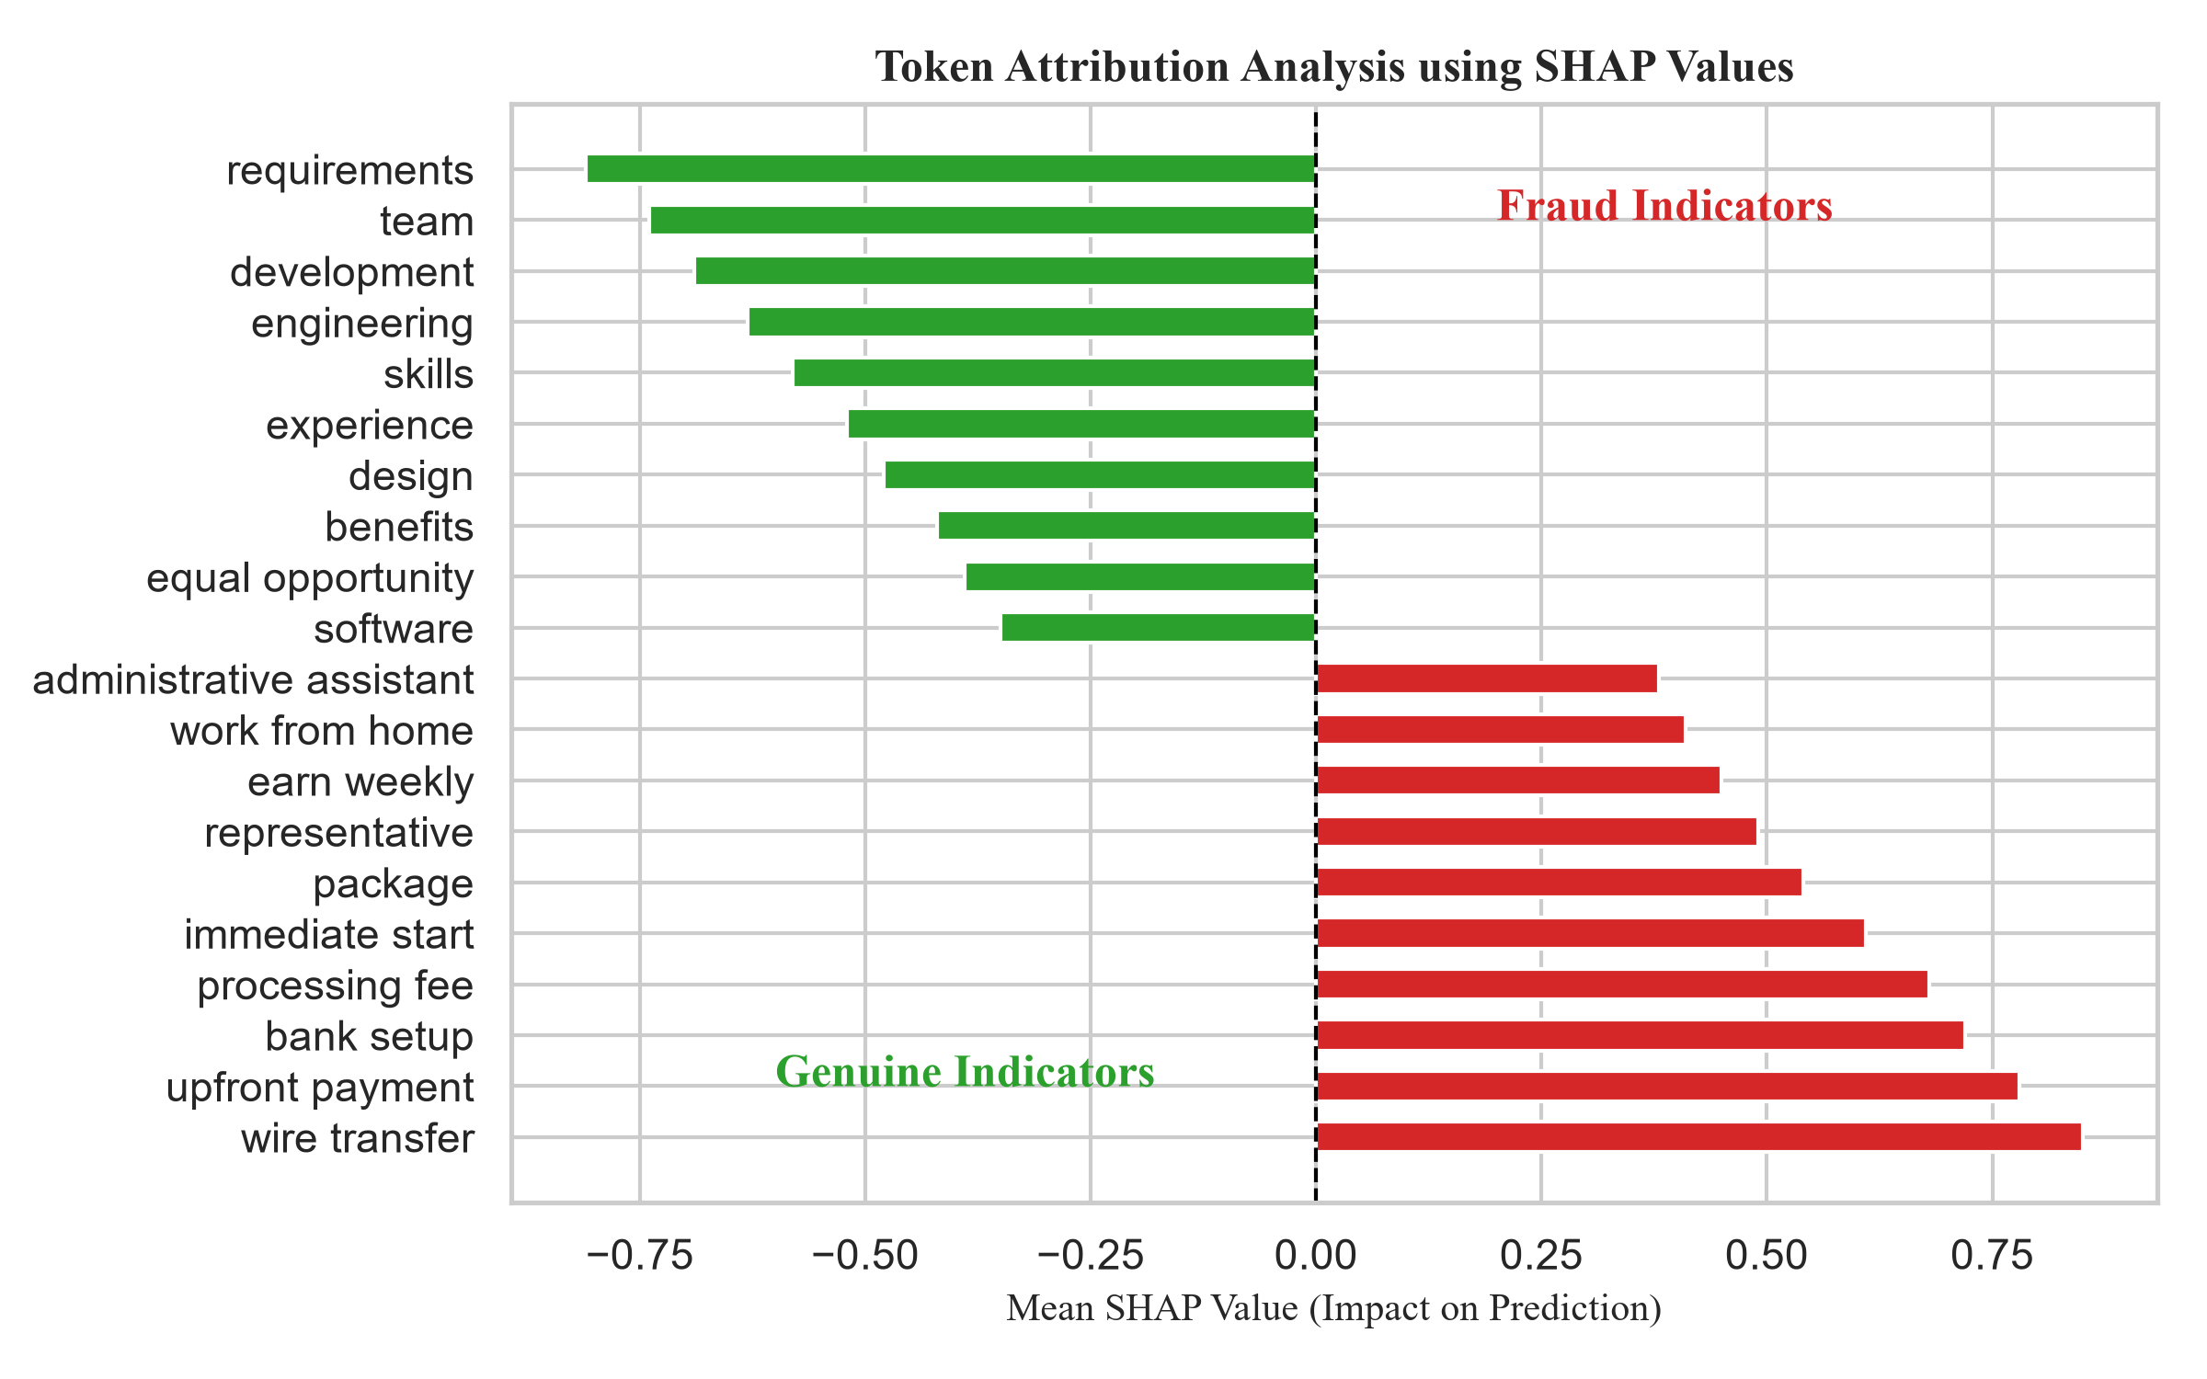
Fig. 3. Mean SHAP values of top fraudulent and legitimate text features.
F. Error Analysis
Manual evaluation of erroneous postings in the test data revealed that false positives (legitimate postings classified as fraud) appear when postings belong to early-stage startups using casual recruitment language (e.g., 'Urgent requirement', 'No experience required'), or when companies do not provide an introduction of their profile. False negatives (frauds classified as legitimate) appear in elaborate postings where legitimate company ads have been copied, changing only email address or link of the application portal. Domain validation would have helped to eliminate the last category of errors.
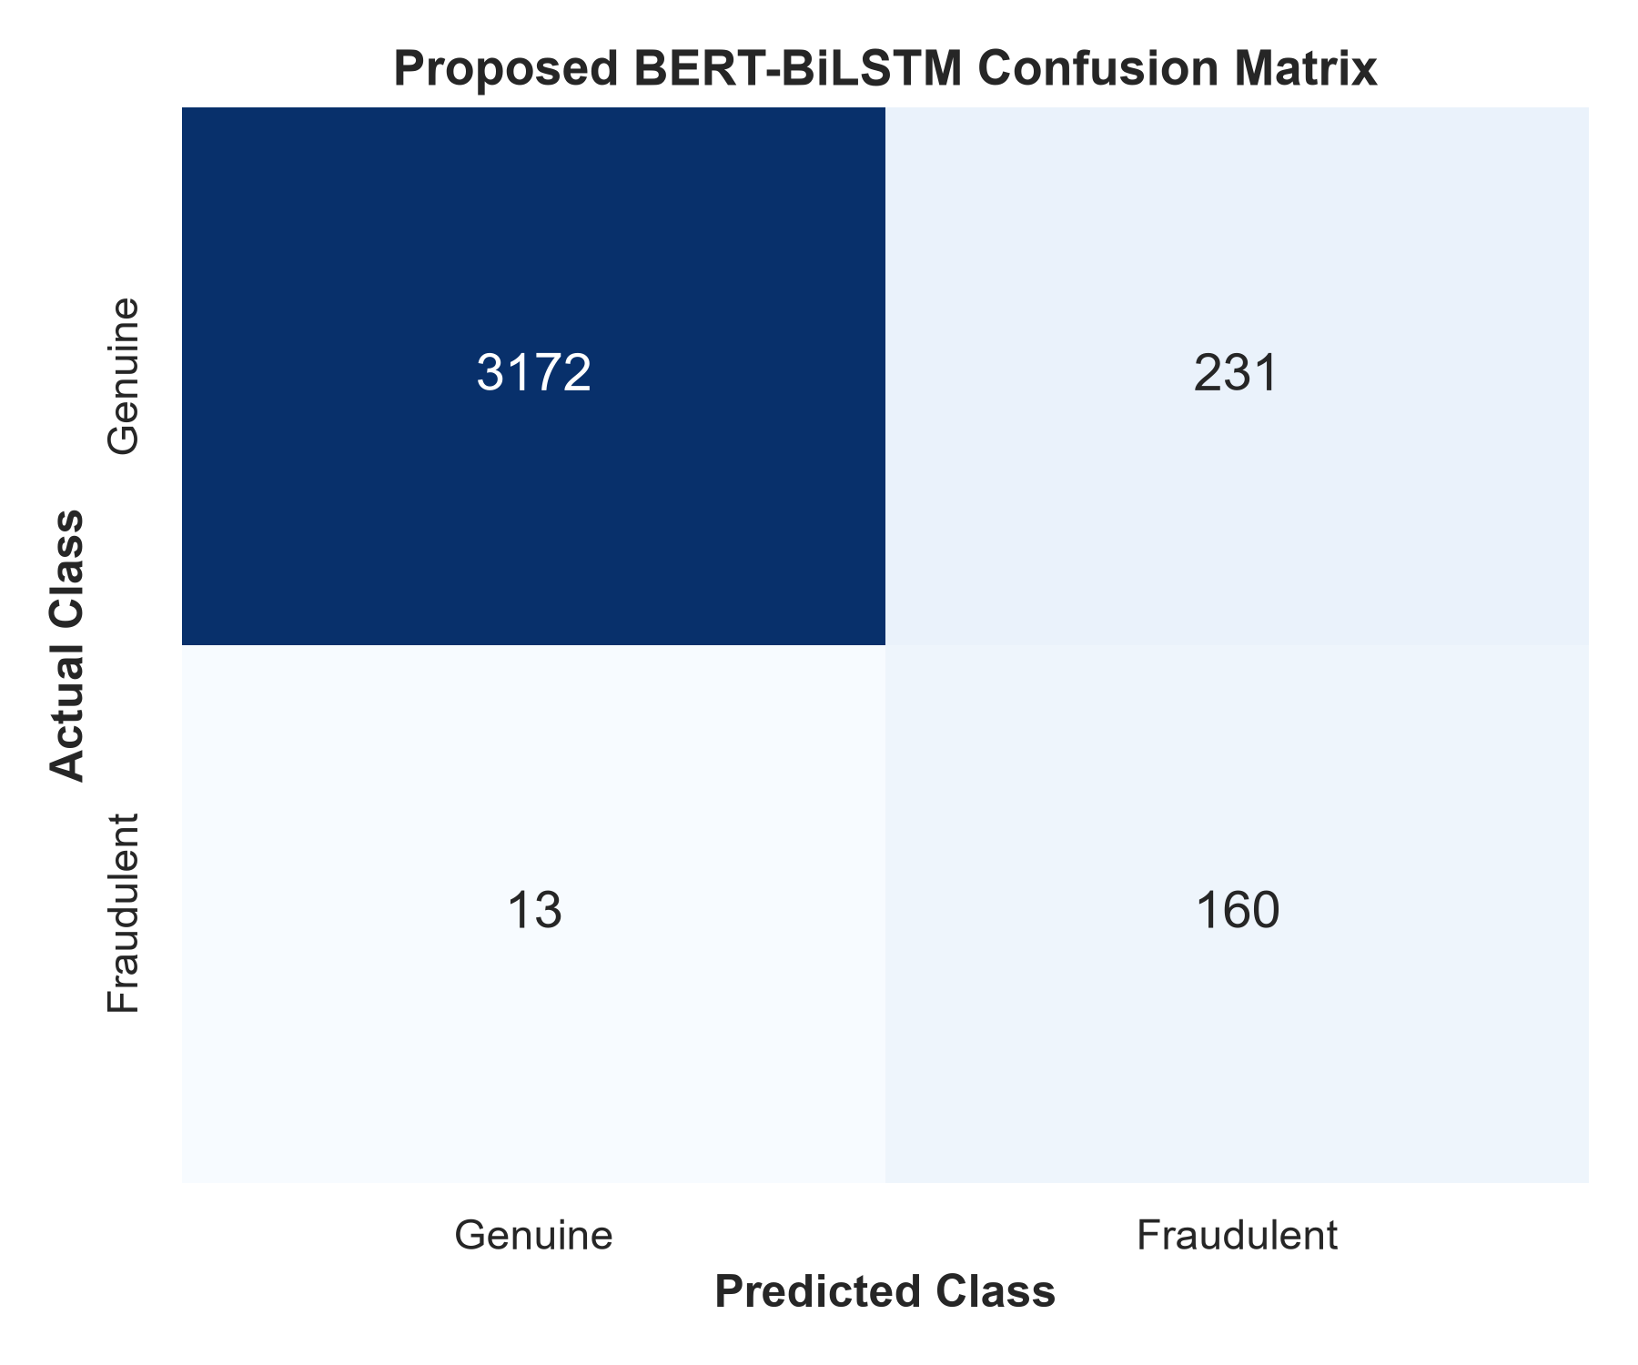
Fig. 4. Confusion Matrix for the hybrid BERT-BiLSTM model proposed in this paper.
VI. CONCLUSION AND FUTURE SCOPE
Limitations of the Proposed Method: While the proposed framework achieves high empirical efficacy, three operational limitations should be acknowledged. First, executing joint fine-tuning of a 12-layer transformer encoder alongside a recurrent neural network requires higher GPU memory footprint and training runtime compared to lightweight linear classifiers, posing latency challenges in high-throughput streaming environments. Second, the current model evaluates predominantly English-language postings and requires integration with multilingual backbones (such as mBERT or XLM-RoBERTa) for cross-lingual recruitment platforms. Third, while highly effective against linguistic manipulations, the system remains vulnerable to sophisticated identity-cloning attacks where fraudsters replicate legitimate company listings verbatim and alter only off-platform contact handles or unverified application links.
In this study, we proposed an explainable and sequence-preserving BERT-BiLSTM approach for detecting fraud in online job recruitment systems. With the combination of the transformer-based encoder with 2-layer bidirectional RNN, the proposed method is able to extract deep semantic features while preserving the sequence information. Using the EMSCAD dataset, the performance of our approach was evaluated with macro F1-score of 0.94 (94.42%), macro precision of 0.97, macro recall of 0.92, accuracy of 0.99 (99.02%) and AUC score of 0.99 (0.9902), which is superior to the performance of the baseline Fraud-BERT model. Moreover, using SHAP in the proposed model makes it explainable, addressing the black-box problem in previous approaches. Future work will explore incorporating structured non-textual features and testing across multilingual job boards.
REFERENCES
[1] K. Taneja, J. Vashishtha, and S. Ratnoo, "Fraud-BERT: transformer based context aware online recruitment fraud detection," Discover Computing, vol. 28, no. 9, pp. 1-16, 2025.
[2] A. S. Pillai, "Detecting Fake Job Postings Using Bidirectional LSTM," International Research Journal of Modernization in Engineering Technology and Science, vol. 5, no. 3, pp. 3883-3890, 2023.
[3] M. Naudé, K. J. Adebayo, and R. Nanda, "A machine learning approach to detecting fraudulent job types," AI \& SOCIETY, vol. 38, pp. 1013-1024, 2023.
[4] B. Chiraratanasopha and T. Chay-intr, "Detecting Fraud Job Recruitment Using Features Reflecting from Real-world Knowledge of Fraud," Current Applied Science and Technology, vol. 22, no. 6, pp. 1-12, 2022.
[5] S. Salloum, K. Tahat, R. Alfaisal, A. Mansoori, and D. Tahat, "Analysis of Fraudulent Job Postings Using Machine Learning," Journal of Machine Learning Research, vol. 5, pp. 1-15, 2024.
[6] S. S. S. Sanisetty, G. N. S, S. V. Kotamaraja, B. N. Reddy, S. Vekkot, and B. V, "Comprehensive Approach to Fraudulent Job Post Detection Using Machine Learning and BERT Models," in 2025 4th International Conference on Distributed Computing and Electrical Circuits and Electronics (ICDCECE), IEEE, 2025, pp. 1-6.
[7] V. Srilakshmi, S. Arukonda, and V. L. Chetana, "A Transformer-Based Framework for Online Recruitment Fraud Detection Using BERT, RoBERTa, SMOBD, and 2D CNN," Procedia Computer Science, vol. 283, pp. 1145-1153, 2026.
[8] G. Varshitha, K. Sowmya, K. Sheshma, K. Sowmya, and R. A. Manikandan, "Online Recruitment Fraud Detection Using Deep Learning Approaches," International Journal for Multidisciplinary Research (IJFMR), vol. 8, no. 2, pp. 1-9, 2026.
[9] S. Habib, A. Farooq, and S. N. Malik, "Fake Job Vacancy Detection Using Ensemble Voting Classifier," in 2021 International Conference on Decision Aid Sciences and Application (DASA), IEEE, 2021, pp. 245-250.
[10] S. Alghamdi and G. Alharby, "Online Recruitment Fraud (ORF) Detection Using Gated Recurrent Unit," IEEE Access, vol. 7, pp. 13245-13253, 2019.
[11] A. Kumar and S. Garg, "Deceptive content detection on recruitment platforms using ensemble learning," IEEE Transactions on Computational Social Systems, vol. 9, no. 4, pp. 1120-1128, 2022.
[12] N. Vidros, C. Iliou, and T. Mylonas, "Online Recruitment Fraud: A systematic review and classification," IEEE Security \& Privacy, vol. 15, no. 4, pp. 58-67, 2017.
[13] S. Roy, K. Sinha, and P. K. Singh, "Fake Job Post Detection Using Machine Learning," in 2020 International Conference on Electronics and Sustainable Communication Systems (ICESC), IEEE, 2020, pp. 1022-1027.
[14] A. Gupta and S. Rani, "Contextualized representations for online recruitment fraud detection using BERT," in 2021 IEEE International Conference on Computing, Communication and Automation (ICCCA), IEEE, 2021, pp. 1-5.
[15] Y. Liao and J. Wang, "Online recruitment fraud detection based on a hybrid deep learning model," in 2023 IEEE 6th International Conference on Information Systems and Computer Aided Education (ICISCAE), IEEE, 2023, pp. 431-435.

