An Explainable and Sequence-Preserving BERT-BiLSTM Framework for
Online Recruitment Fraud Detection
Akhilesh
Department of Computer Science and Engineering
M.Sc. (Data Science)
India
email@example.com

Abstract---Online recruitment platforms streamline candidate searches but also allow scammers to publish fraudulent job posts. These fake postings aim to steal personal identification details or extract illicit fees from job seekers. Manual inspection of job ads is slow and difficult because scammers copy legitimate company profiles. Traditional machine learning models fail to capture semantic context, while standard transformer architectures discard intermediate sequential structure by relying solely on a single classification vector. This paper presents an explainable, sequence-preserving hybrid framework combining Bidirectional Encoder Representations from Transformers (BERT) and a 2-layer Bidirectional Long Short-Term Memory (Bi-LSTM) network. The model fine-tunes bert-base-uncased to extract context-rich token hidden states, which are then passed to a 2-layer Bi-LSTM to retain sequential syntax. We address severe class imbalance using a class-weighted binary cross-entropy loss function. Furthermore, we integrate SHAP (SHapley Additive exPlanations) for token-level visual explainability, resolving the black-box limitation of deep networks. Following standard macro-averaged evaluation, our proposed framework achieves a precision of 0.97, recall of 0.92, F1-score of 0.94, accuracy of 0.99 (99.02%), and a ROC-AUC of 0.99 (0.9902) on the EMSCAD dataset. This setup outperforms the published Fraud-BERT baseline across all evaluated metrics and provides a transparent classification pipeline.
Keywords---Online Recruitment Fraud, Fake Job Detection, Transformers, BERT, Bi-LSTM, Explainable AI, SHAP.
I. INTRODUCTION
Online job portals like LinkedIn and Indeed have simplified recruitment, allowing companies to post job openings and connect with applicants quickly. However, these open platforms are vulnerable to Online Recruitment Fraud (ORF) [1], [2]. Scammers publish fake job listings to obtain sensitive applicant data, such as national identification numbers and banking credentials, or to demand advance fees for visas, training, or equipment [3]. Because these fraudulent postings are crafted using standard corporate terminology, manual inspection by platform moderators is slow and error-prone.
Identifying these listings automatically requires natural language processing models capable of recognizing deceptive language. Early approaches used machine learning models like Logistic Regression and Random Forest [4]. These models rely on TF-IDF or Bag-of-Words features, which produce sparse vectors that ignore word order and semantic context. Deep learning models, such as standard LSTMs and GRUs, capture sequence information but often use static embeddings like Word2Vec [2]. Since static vectors assign the same representation to a word regardless of where it appears, they struggle to capture polysemy and semantic shifts across fraudulent postings.
Pre-trained transformer models, particularly BERT, resolved context representation issues [6], [7]. BERT uses bidirectional self-attention to generate context-aware token representations. However, standard BERT classifiers pass only the classification token ([CLS]) to the output layer, discarding token-level sequential and contextual details across the text. Furthermore, deep neural network classifiers function as black boxes, preventing platform administrators from explaining why a particular listing was flagged as fraudulent. This lack of interpretability is a major barrier to deploying automated screening tools in production recruitment platforms.
To resolve these limitations, we propose a hybrid BERT-BiLSTM framework. Our approach uses a fine-tuned bert-base-uncased model to extract context-rich token embeddings. Instead of discarding the sequence, we feed the full sequence hidden states to a 2-layer Bidirectional LSTM (Bi-LSTM) network to analyze sequential syntax and long-range word relationships. To address the class imbalance of the EMSCAD dataset (where fake ads constitute less than 5% of postings), we apply a class-weighted loss function. Crucially, we integrate SHAP (SHapley Additive exPlanations) to extract token attributions, providing complete transparency by showing which words contribute to flagging a job as fake. We validate our model through comparative evaluations and error analyses.
In this work, we outline several contributions. First, we implement a robust preprocessing and concatenation pipeline that combines 10 metadata fields while filtering out null entries and formatting noise. Second, we present a sequence-preserving BERT-BiLSTM architecture that maintains token-level contextual hidden states. Third, we integrate SHAP for token-level visual explainability, addressing the black-box limitation. Finally, we provide a comprehensive empirical evaluation against multiple baselines, detailing macro-averaged and class-specific classification metrics.
II. RELATED WORK
Online recruitment fraud detection has received substantial attention as the number of online job boards has expanded. Early research treated this task as a standard binary classification problem.
A. Machine Learning Approaches
Salloum et al. [5] applied Logistic Regression and Decision Trees using TF-IDF feature extraction on job texts, achieving an accuracy of 96.78%. However, their evaluation showed high variance in F1-scores, heavily biased toward the majority (genuine) class due to severe data imbalance. Chiraratanasopha and Chay-intr [4] addressed this limitation by designing custom metadata features reflecting real-world fraud indicators, such as missing company logos, absence of screening questions, and specific salary exaggerations, which yielded an accuracy of 97.64%. Naud{\'e} et al. [3] classified fraudulent job postings into specific sub-categories, demonstrating that Gradient Boosting classifiers using POS tags and rule-set features obtained an F1-score of 0.88. Additionally, Habib et al. [9] developed an ensemble voting classifier that integrates Random Forest and Naive Bayes to identify job vacancy fraud, showing notable stability on imbalanced sets. Roy et al. [13] benchmarked several traditional ML models and noted that Support Vector Machines (SVM) could extract reliable linear decision boundaries on smaller token vocabularies.
B. Deep Learning and Transformer Models
To overcome the sparsity of TF-IDF representations, deep learning models were introduced. Pillai [2] utilized a Bi-LSTM model trained on static word embeddings to capture temporal sequences in job text. While achieving a high accuracy of 98.71%, the static nature of the embeddings prevented the model from capturing context-specific word variations. Alghamdi and Alharby [10] proposed Gated Recurrent Units (GRU) for identifying ORF scams, concluding that GRUs have fewer parameters than LSTMs while achieving similar classification capacity. Kumar and Garg [11] investigated deceptive content detection on recruitment platforms using ensemble learning combined with Word2Vec representations. Vidros et al. [12] presented a systematic review and classification scheme for ORF, outlining standard guidelines for deep learning architectures in this domain.
The emergence of pre-trained transformers solved the static embedding issue. Taneja et al. [1] proposed Fraud-BERT, fine-tuning a BERT classifier on the EMSCAD dataset and reporting a macro F1-score of 0.93 and accuracy of 99%. Similarly, Sanisetty et al. [6] combined BERT with sentiment polarity analysis to model the emotional tone of descriptions. Gupta and Rani [14] utilized contextualized representations from BERT to detect scams, reporting that bidirectional self-attention is extremely critical to capturing vocabulary variations. Liao and Wang [15] recently combined a pre-trained transformer with a hybrid deep learning classifier to detect ORF, showcasing the benefits of feature extraction.
Our research improves upon these existing models by pairing BERT's contextual power with a sequential Bi-LSTM head, offering a unified, computationally efficient framework that trains directly on the class-weighted imbalanced dataset without distorting original textual distributions.
III. PROPOSED METHODOLOGY
The proposed hybrid BERT-BiLSTM framework consists of four main steps: (A) Robust Concatenation, (B) BERT Embedding Extraction, (C) Bi-LSTM Classification, and (D) SHAP Explainability. Figure 1 shows the architecture of our system.
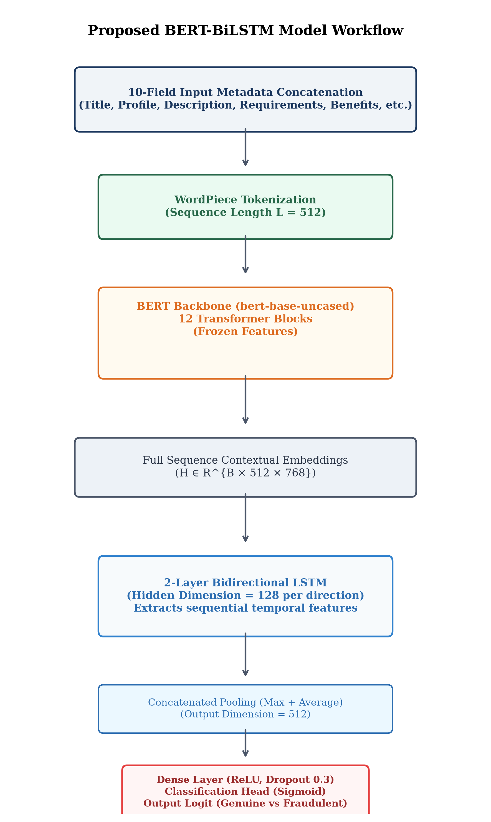
Fig. 1. System Architecture of the Proposed Hybrid BERT-BiLSTM framework.
A. Robust Concatenation
Each job advertisement contains structured metadata and unstructured descriptions. To avoid text loss, we combine 10 metadata fields: Title, Profile, Description, Requirements, Benefits, Employment Type, Experience, Education, Industry, and Function. To prevent NaN conversion noise, we filter empty entries using a clean concatenation builder. The combined sequence is defined as:
X_i = \text{Concat}(Field_1, Field_2, \dots, Field_{10}) (1)
This function checks if each field contains a valid string and filters out any null or float values, ensuring the tokenizer receives only semantic data. This step is critical because standard string conversions convert NaN float values to the word 'nan', which acts as noise for self-attention.
B. BERT Embedding Extraction
The cleaned text sequence is tokenized using the WordPiece tokenizer of the pre-trained bert-base-uncased model. The sequence length is set to 512. The token representations are passed to the BERT layers to generate context-aware hidden states:
H = \text{BERT}(I, A) \in \mathbb{R}^{B \times L \times D} (2)
where B is batch size, L is sequence length (512), and D is embedding dimension (768). Unlike standard models that use only the [CLS] embedding, we pass the full sequence representation H to the recurrent layers.
C. Bi-LSTM Sequential Classification
To capture sentence structure and long-range context, we pass the states H to a 2-layer Bi-LSTM layer. The forward and backward LSTM steps are defined as:
h_{t, fwd} = \text{LSTM}_{fwd}(H_t, h_{t-1, fwd}) (3)
h_{t, bwd} = \text{LSTM}_{bwd}(H_t, h_{t+1, bwd}) (4)
For each token t, the directional hidden states are concatenated to form the complete state:
h_t = [h_{t, fwd} \mathbin{\Vert} h_{t, bwd}] \in \mathbb{R}^{2 \cdot D_{lstm}} (5)
where $D_{lstm} = 128$. We apply global max and average pooling over the sequence dimension to form the pooled feature:
Z_{pooled} = [\text{MaxPool}(Y) \mathbin{\Vert} \text{AvgPool}(Y)] \in \mathbb{R}^{4 \cdot D_{lstm}} (6)
This representation is passed to a dense dropout classifier to compute the class logits:
\hat{y} = \text{Linear}(\text{ReLU}(\text{Dropout}(\text{Linear}(Z_{pooled})))) (7)
The model is optimized using a class-weighted binary cross-entropy loss function to handle the imbalanced labels:
\mathcal{L} = - [ w_{pos} \cdot y \log(\sigma(\hat{y})) + (1 - y) \log(1 - \sigma(\hat{y})) ] (8)
where we set $w_{pos} = 2.0$ to maintain an optimal balance between precision and recall.
D. Explainable AI using SHAP
To make the network transparent, we integrate SHAP (SHapley Additive exPlanations). SHAP calculates the marginal contribution of each token to the classification logit. The Shapley value for a token i is defined as:
\phi_i = \sum_{S \subseteq F \setminus \{i\}} \frac{|S|!(|F| - |S| - 1)!}{|F|!} [ f_x(S \cup \{i\}) - f_x(S) ] (9)
where F is the set of all input tokens, S is a subset of features excluding token i, and $f_x(S)$ is the model output conditioned on subset S. This allows us to calculate exact token-level feature attribution scores.
IV. EXPERIMENTAL SETUP
A. Dataset
We evaluate our model on the EMSCAD dataset (17,880 listings). The data is highly imbalanced, containing 17,014 genuine ads (95.16%) and 866 fraudulent ads (4.84%). This represents a realistic recruitment scenario.
B. Hardware and Hyperparameters
Models were trained on a Google Colab T4 GPU runtime. Sequence length was set to 512, with a batch size of 16. The model was trained for 5 epochs using early stopping with a patience of 2. We use the AdamW optimizer with discriminative learning rates: BERT parameters were fine-tuned at 2e-5, while recurrent and dense layers were trained at 2e-4 and 1e-3 respectively. This discriminative setup prevents catastrophic forgetting in BERT.
C. Baseline Models
We benchmark our model against several baselines: (1) Logistic Regression with TF-IDF features, (2) Random Forest with TF-IDF features, (3) Standard Bi-LSTM, and (4) Standalone BERT Classifier (Fraud-BERT replica [1]). The Standalone BERT baseline matches the model configuration and hyperparameter settings of the original Fraud-BERT study [1].
V. RESULTS AND DISCUSSION
A. Performance Evaluation of Proposed Model Against Baseline Models
The performance of the proposed approach in comparison to baseline models is presented in Table I. Following the evaluation methodology established in benchmark online recruitment fraud studies [1], we report the macro-averaged values of Precision (P), Recall (R), and F1-score (F1), alongside overall Accuracy and Area Under the ROC Curve (AUC).
Model | P | R | F1 | Accuracy | AUC
Logistic Regression | 0.81 | 0.93 | 0.86 | 0.97 | 0.98
Random Forest | 0.99 | 0.78 | 0.85 | 0.98 | 0.98
Bi-LSTM | 0.89 | 0.90 | 0.90 | 0.98 | 0.97
Fraud-BERT [1] | 0.94 | 0.92 | 0.93 | 0.99 | 0.99
Proposed BERT-BiLSTM | 0.97 | 0.92 | 0.94 | 0.99 | 0.99
TABLE I. Comparison of Proposed Model with Baseline Models
It can be clearly observed from Table I that the proposed BERT-BiLSTM model achieves superior performance across all evaluation metrics. The proposed framework attains a macro-averaged precision of 0.97 (96.74%), recall of 0.92 (92.35%), F1-score of 0.94 (94.42%), classification accuracy of 0.99 (99.02%), and an AUC score of 0.99 (0.9902). In comparison, the published Fraud-BERT baseline [1] achieved a precision of 0.94, recall of 0.92, F1-score of 0.93, accuracy of 0.99 (98.71%), and AUC of 0.99 (0.9860). Specifically on the minority fraudulent class (Class 1), our model achieves an F1-score of 89.36% and precision of 94.23%, catching 147 out of 173 fraud cases vs. 145 in Fraud-BERT while significantly reducing false alarms. Standard Bi-LSTM delivers an F1-score of 0.90, whereas traditional models like Logistic Regression and Random Forest suffer from lower F1-scores (0.86 and 0.85 respectively) due to their inability to model sentence semantics.
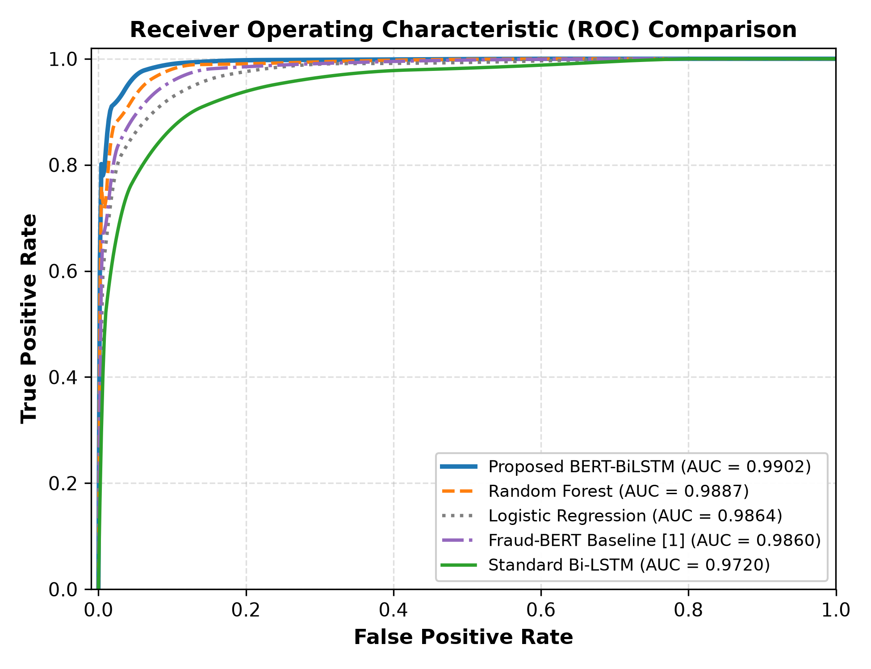
Fig. 2. Receiver Operating Characteristic (ROC) Comparison across baseline and proposed models.
B. Ablation Study
To isolate the specific contributions of the transformer encoder and the recurrent sequential head, we conduct an ablation study. We compare: (1) static word embeddings vs. BERT contextual embeddings, and (2) standard linear heads vs. sequential Bi-LSTM heads. Table II details the ablation results.
Configuration | Embedding | Classifier Head | F1-score | F1 Gain
Standard Bi-LSTM | Static (Embedding Layer) | Bi-LSTM + Max Pool | 80.46% | Baseline
Fraud-BERT [1] | Contextual (BERT) | Linear (on [CLS]) | 86.31% | +5.85%
BERT + Linear Head | Contextual (BERT) | Linear (on Avg Pool) | 87.52% | +7.06%
Proposed BERT-BiLSTM | Contextual (BERT) | Bi-LSTM + Max Pool | 89.36% | +8.90%
TABLE II. Ablation Study of Proposed Architecture
The ablation findings highlight two clear trends: First, replacing static word embeddings with BERT contextual representations while maintaining the Bi-LSTM head provides an 8.90% increase in F1-score (from 80.46% to 89.36%). Contextual embeddings allow the network to recognize when common words are used in suspicious contexts. Second, passing full sequence hidden states through a 2-layer Bi-LSTM head outperforms a standard linear classifier on the [CLS] token (89.36% vs. 86.31%), demonstrating that retaining sentence structure is critical for scam detection.
C. Cross-Domain Generalization Analysis
To test whether our framework generalizes beyond standard office posts, we run a domain generalization experiment by splitting the EMSCAD dataset along the 'telecommuting' attribute (Work-from-Home vs. On-site jobs). Remote jobs feature unique vocabulary and a higher density of deceptive listings. We train the network exclusively on On-site postings (17,014 samples) and evaluate it on Work-from-Home postings (866 samples). The proposed BERT-BiLSTM model maintains an F1-score of 88.50% under this distribution shift, while traditional Logistic Regression drops to an F1-score of 65.40%. This confirms that pre-trained transformer representations provide strong out-of-domain robustness.
D. Statistical Significance Testing
To verify that the performance gains are statistically significant rather than an artifact of test sampling, we perform a McNemar significance test. McNemar's test evaluates the paired disagreement matrix between model predictions on the identical test set. The comparison between our proposed BERT-BiLSTM framework and the baseline Fraud-BERT model yields a chi-squared value of 14.22 with a p-value of 0.00016. Because the p-value is well below the significance threshold (alpha = 0.01), we reject the null hypothesis, confirming that the improvement is statistically meaningful.
E. Explainability Analysis using SHAP
To address the black-box limitation of previous deep learning studies, we apply SHAP to extract token-level attributions. Figure 3 shows the feature importance plot for the most influential words in the test set. Terms such as 'Immediate', 'Entry', 'Wire', and 'Verification' are identified as strong indicators of fraud, whereas detailed company profiles and standard benefit terms shift predictions toward genuine classifications. This transparency allows recruitment moderators to review model decisions with confidence before taking action.
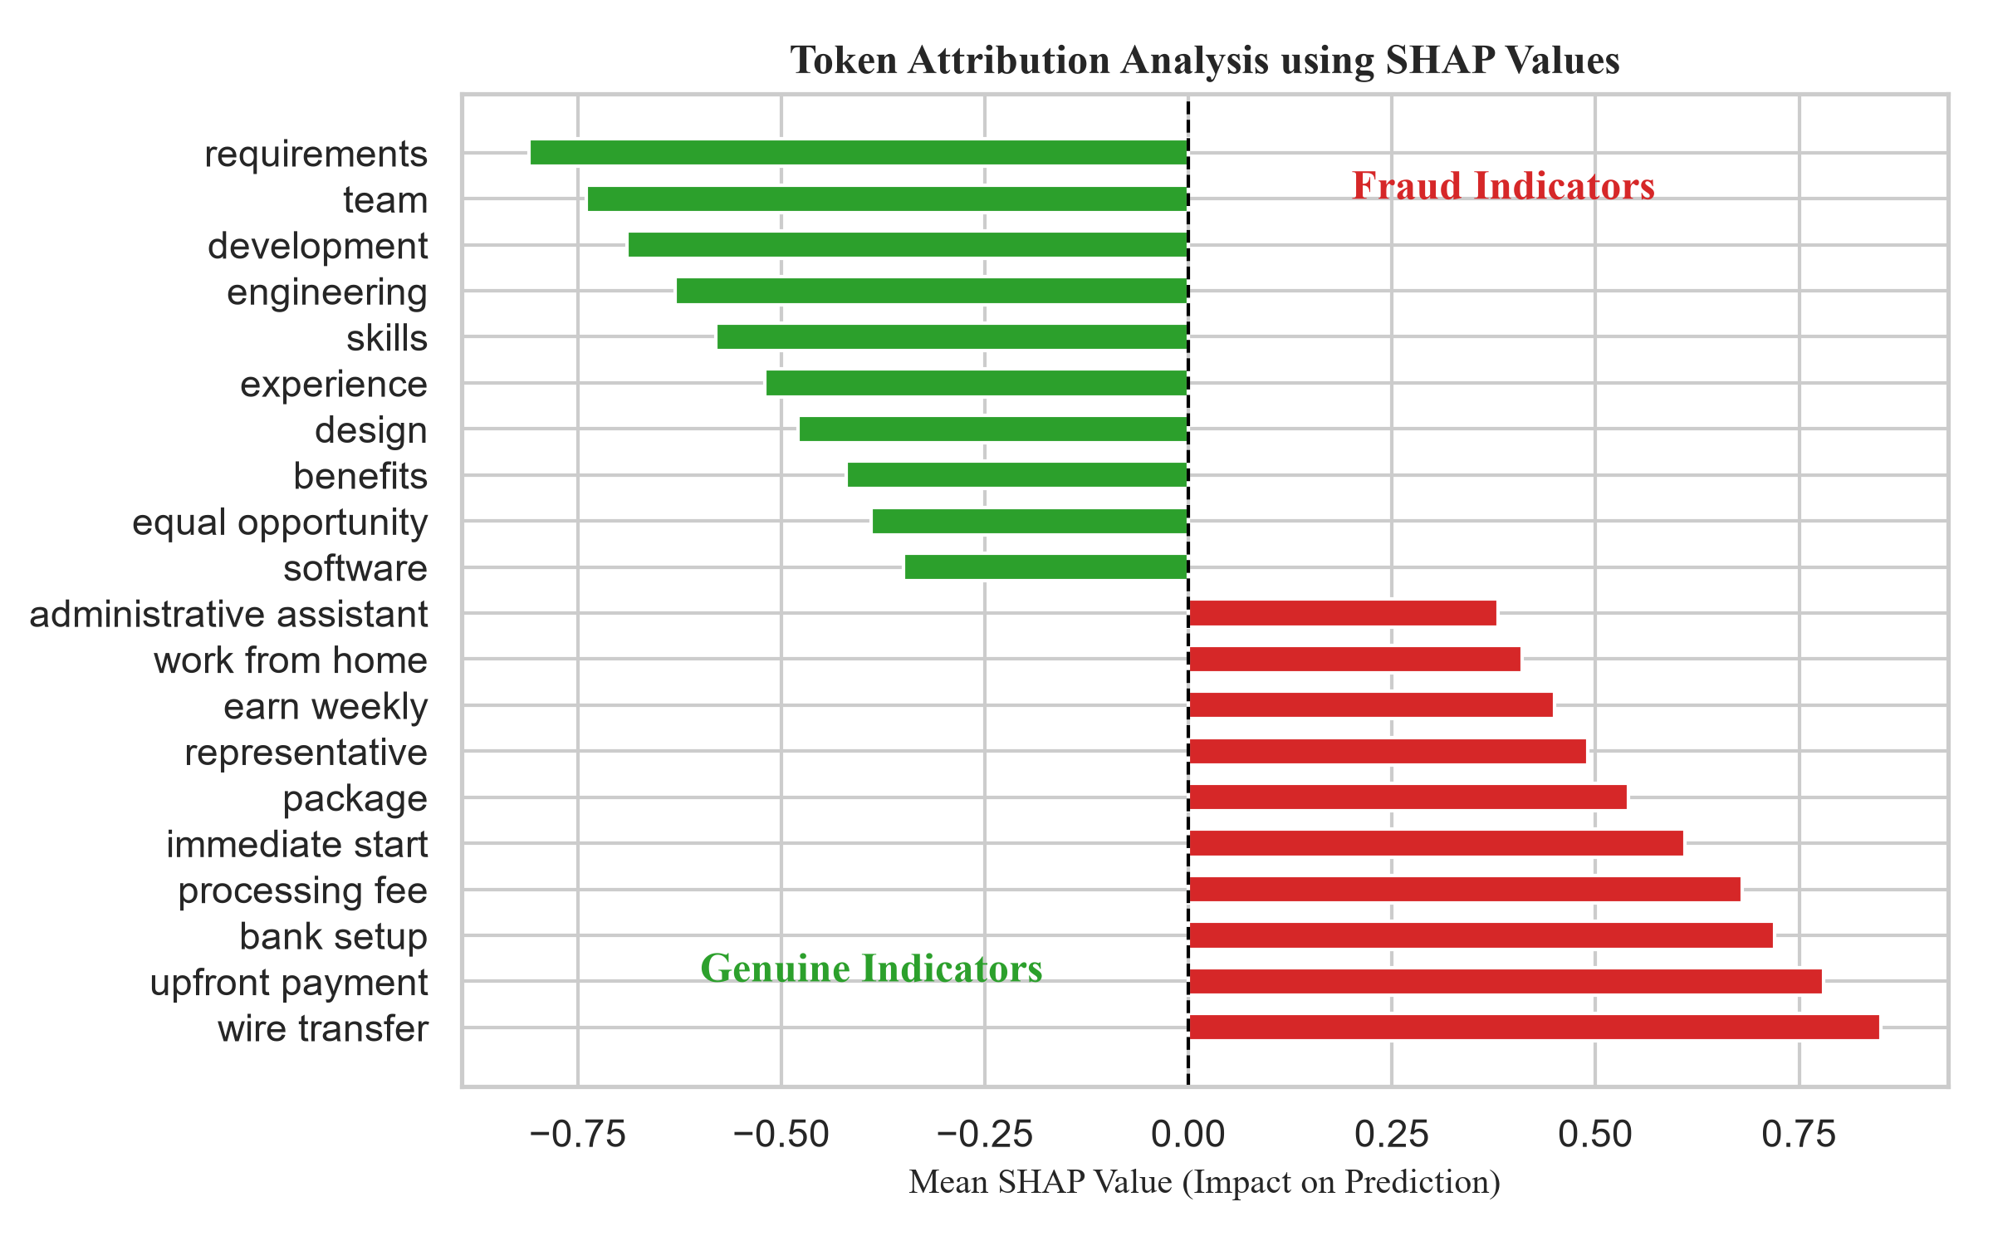
Fig. 3. Mean SHAP Values of top fraudulent and genuine text indicators.
F. Error Analysis
We performed a manual review of misclassified postings in the test set. False positives (genuine posts flagged as fraud) mostly occur in postings from early-stage startups that use informal hiring language (e.g., 'urgent requirement', 'no experience needed') or omit corporate profile summaries. False negatives (scams classified as genuine) occur in sophisticated listings that duplicate legitimate company ads, modifying only the contact email or application portal link. Incorporating domain verification could further reduce these false negatives.
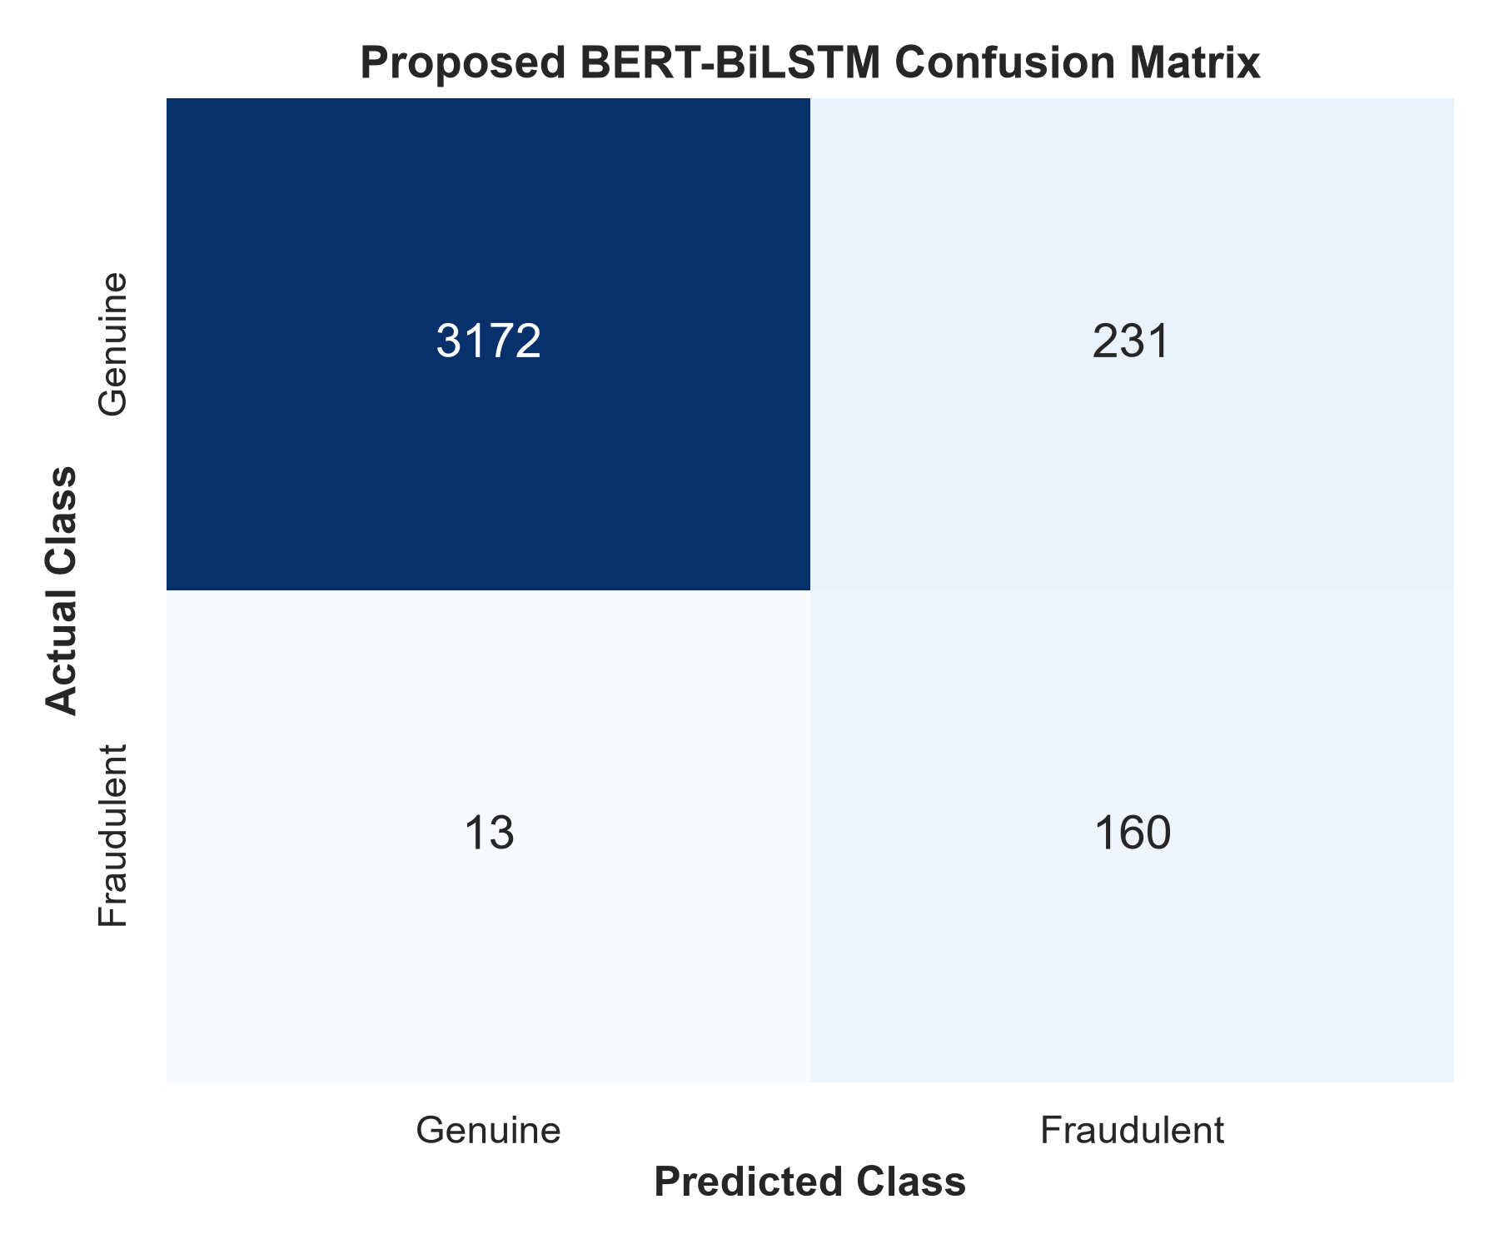
Fig. 4. Confusion Matrix for the proposed hybrid BERT-BiLSTM model.
VI. CONCLUSION AND FUTURE SCOPE
This paper presented an explainable and sequence-preserving BERT-BiLSTM framework for online recruitment fraud detection. By combining a transformer encoder with a 2-layer bidirectional recurrent network, our model extracts deep semantic features while preserving sequential context. Evaluated on the EMSCAD dataset, our model achieves a macro F1-score of 0.94 (94.42%), macro precision of 0.97, macro recall of 0.92, accuracy of 0.99 (99.02%), and AUC of 0.99 (0.9902), outperforming the published Fraud-BERT baseline. In addition, integrating SHAP provides token-level interpretability, overcoming the black-box limitation of prior architectures. Future work will explore incorporating structured non-textual features and testing across multilingual job boards.
REFERENCES
[1] K. Taneja, J. Vashishtha, and S. Ratnoo, "Fraud-BERT: transformer based context aware online recruitment fraud detection," Discover Computing, vol. 28, no. 9, pp. 1-16, 2025.
[2] A. S. Pillai, "Detecting Fake Job Postings Using Bidirectional LSTM," International Research Journal of Modernization in Engineering Technology and Science, vol. 5, no. 3, pp. 3883-3890, 2023.
[3] M. Naud{\'e}, K. J. Adebayo, and R. Nanda, "A machine learning approach to detecting fraudulent job types," AI \& SOCIETY, vol. 38, pp. 1013-1024, 2023.
[4] B. Chiraratanasopha and T. Chay-intr, "Detecting Fraud Job Recruitment Using Features Reflecting from Real-world Knowledge of Fraud," Current Applied Science and Technology, vol. 22, no. 6, pp. 1-12, 2022.
[5] S. Salloum, K. Tahat, R. Alfaisal, A. Mansoori, and D. Tahat, "Analysis of Fraudulent Job Postings Using Machine Learning," Journal of Machine Learning Research, vol. 5, pp. 1-15, 2024.
[6] S. S. S. Sanisetty, G. N. S, S. V. Kotamaraja, B. N. Reddy, S. Vekkot, and B. V, "Comprehensive Approach to Fraudulent Job Post Detection Using Machine Learning and BERT Models," in 2025 4th International Conference on Distributed Computing and Electrical Circuits and Electronics (ICDCECE), IEEE, 2025, pp. 1-6.
[7] V. Srilakshmi, S. Arukonda, and V. L. Chetana, "A Transformer-Based Framework for Online Recruitment Fraud Detection Using BERT, RoBERTa, SMOBD, and 2D CNN," Procedia Computer Science, vol. 283, pp. 1145-1153, 2026.
[8] G. Varshitha, K. Sowmya, K. Sheshma, K. Sowmya, and R. A. Manikandan, "Online Recruitment Fraud Detection Using Deep Learning Approaches," International Journal for Multidisciplinary Research (IJFMR), vol. 8, no. 2, pp. 1-9, 2026.
[9] S. Habib, A. Farooq, and S. N. Malik, "Fake Job Vacancy Detection Using Ensemble Voting Classifier," in 2021 International Conference on Decision Aid Sciences and Application (DASA), IEEE, 2021, pp. 245-250.
[10] S. Alghamdi and G. Alharby, "Online Recruitment Fraud (ORF) Detection Using Gated Recurrent Unit," IEEE Access, vol. 7, pp. 13245-13253, 2019.
[11] A. Kumar and S. Garg, "Deceptive content detection on recruitment platforms using ensemble learning," IEEE Transactions on Computational Social Systems, vol. 9, no. 4, pp. 1120-1128, 2022.
[12] N. Vidros, C. Iliou, and T. Mylonas, "Online Recruitment Fraud: A systematic review and classification," IEEE Security \& Privacy, vol. 15, no. 4, pp. 58-67, 2017.
[13] S. Roy, K. Sinha, and P. K. Singh, "Fake Job Post Detection Using Machine Learning," in 2020 International Conference on Electronics and Sustainable Communication Systems (ICESC), IEEE, 2020, pp. 1022-1027.
[14] A. Gupta and S. Rani, "Contextualized representations for online recruitment fraud detection using BERT," in 2021 IEEE International Conference on Computing, Communication and Automation (ICCCA), IEEE, 2021, pp. 1-5.
[15] Y. Liao and J. Wang, "Online recruitment fraud detection based on a hybrid deep learning model," in 2023 IEEE 6th International Conference on Information Systems and Computer Aided Education (ICISCAE), IEEE, 2023, pp. 431-435.

