ROADIE RANGER
User Guide
A practical, step-by-step guide to signing in and using Roadie Ranger by Text or Voice.
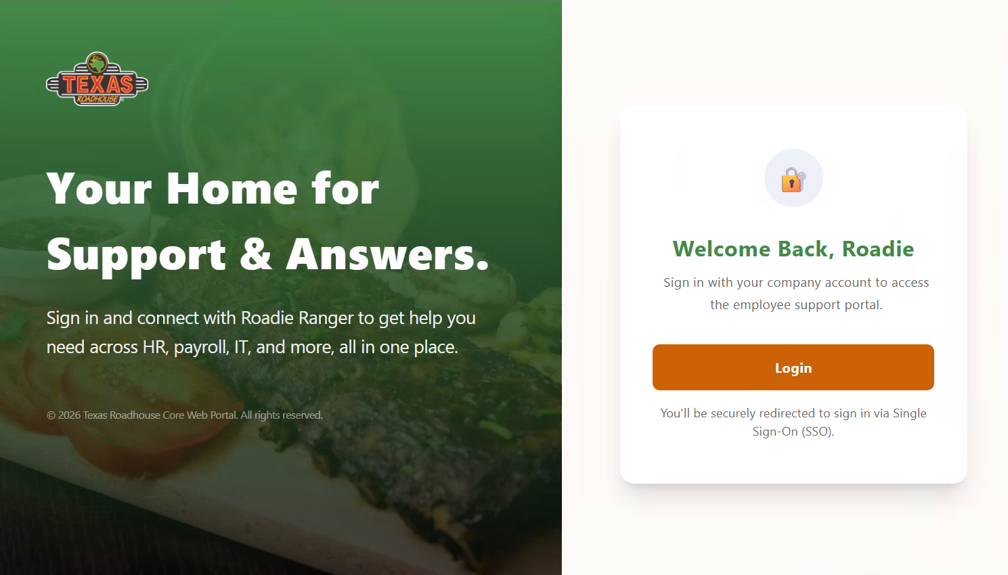
New: updated sign-in screen reference
What this guide covers
Sign in with your Texas Roadhouse work account • Start a Text chat • Use Popular Roadie Inquiries • Switch between Text and Voice • Use Voice Chat • View your profile and sign out • Use the Quick Reference when you need a fast reminder.

Quick Start
If you only need the basics, follow these five steps:
- Open the Roadie Ranger web address and select Login.
- Choose your Texas Roadhouse work account on the account picker.
- Choose Text Mode for typed questions or Voice Mode for spoken questions.
- Ask your question. Roadie Ranger responds in chat; in Voice Mode, the response is also spoken aloud.
- When finished, select your avatar in the top-right corner and choose Logout.

Contents
1. Signing In — Page 3
2. Home Screen Overview — Page 4
3. Using Text Chat — Pages 5–6
4. Switching Between Text and Voice — Page 7
5. Using Voice Chat — Pages 8–9
6. Your Profile and Signing Out — Page 10
7. Quick Reference & Helpful Tips — Page 11
Before you begin
Have your Texas Roadhouse work account available. Roadie Ranger uses your work sign-in, so there is no separate Roadie Ranger password to remember.

1. Signing In
Roadie Ranger uses your Texas Roadhouse work account to sign you in. Follow the steps below.
- Open the Roadie Ranger web address in your browser. You will see the Texas Roadhouse Core Web Portal sign-in screen.
- Select Login (or continue if you are redirected automatically).
- On the Pick an account screen, select your Texas Roadhouse work account. If it is not listed, choose Use another account and enter your Texas Roadhouse email.
Sign-in screen — select Login to continue with your company account.
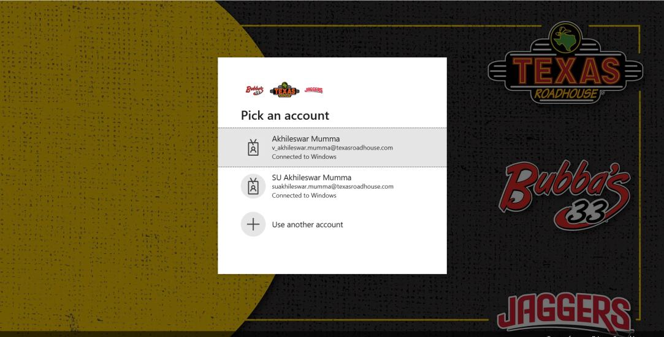
Pick an account — select the Texas Roadhouse work account you normally use.
Tip
If you have more than one Texas Roadhouse account listed (for example, a regular account and an “SU” elevated account), choose the one you normally use for day-to-day work.

Once you select your account, you are signed in automatically and taken to the Roadie Ranger home screen — no additional password entry is needed.

2. Home Screen Overview
After signing in, you land on the Roadie Ranger home screen. This is where every conversation starts.
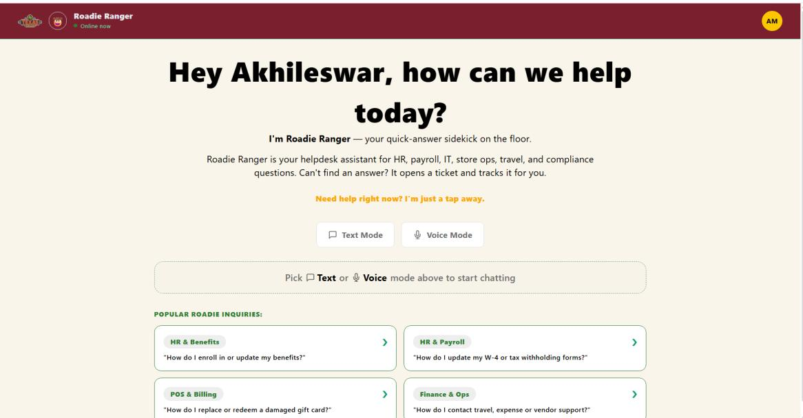
The Roadie Ranger home screen, with Text Mode, Voice Mode, and Popular Roadie Inquiries.
What you see | What it does
Greeting message | Welcomes you by name and explains what Roadie Ranger can help with — HR, payroll, IT, store ops, travel, and compliance questions.
Text Mode button | Starts a typed conversation.
Voice Mode button | Starts a spoken conversation.
Popular Roadie Inquiries cards | Ready-made example questions grouped by topic. Selecting a card jumps into Text Mode with that question already filled in.
Helpful navigation
The Texas Roadhouse logo in the top-left of the header returns you to the home screen from any screen.

3. Using Text Chat

Starting a text conversation
- From the home screen, select Text Mode.
- You will land on an empty chat screen with a message box at the bottom.
- Type your question into the Write a message box.
- Select the send button (arrow icon), or press Enter to submit.
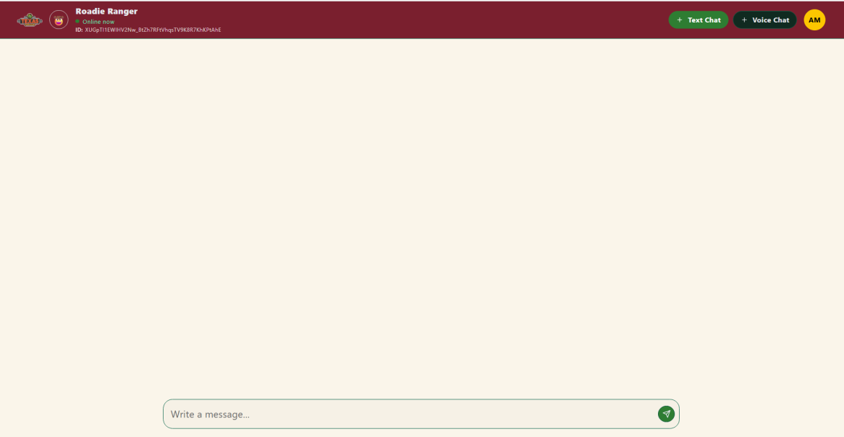
Text Chat screen, ready for your first message.

Using a Popular Roadie Inquiry card
If your question matches an example topic on the home screen, you can skip typing altogether.
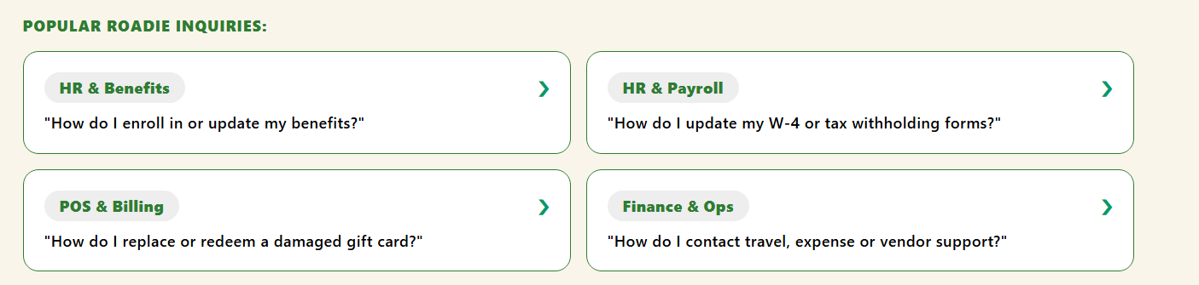
Popular Roadie Inquiries — HR & Benefits, HR & Payroll, POS & Billing, and Finance & Ops.
- From the home screen, select any card under Popular Roadie Inquiries.
- Roadie Ranger automatically switches to Text Mode and drafts that card’s sample question into the message box.
- Review the drafted question. Send it as-is, or edit it before sending.

3. Using Text Chat — Reading a Response
Once you send a question, Roadie Ranger replies directly in the chat window with a clear, formatted answer. Responses may be broken into numbered steps or bullet points.
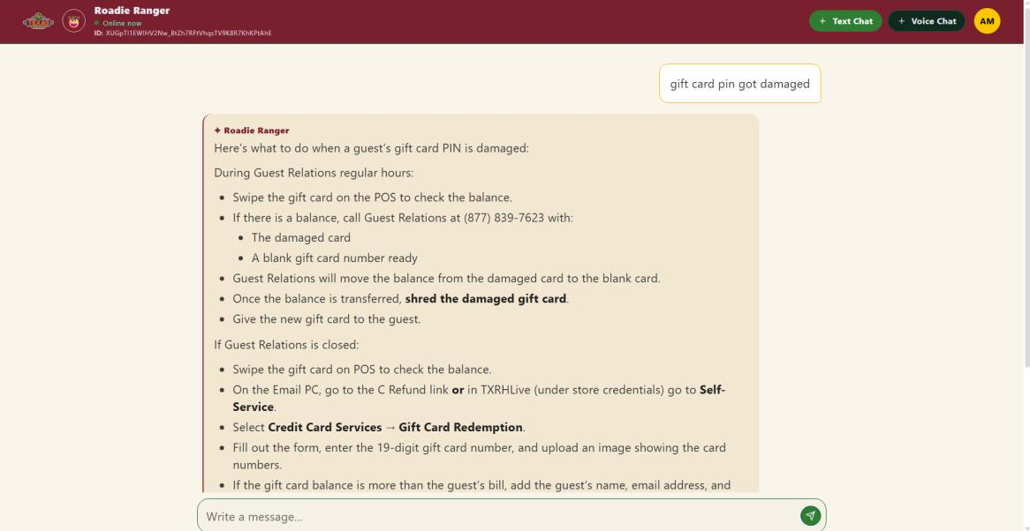
Example: asking about a damaged gift card PIN and receiving step-by-step instructions.
Tip
Long answers may be scrollable. Scroll down within the response area to see the remaining steps if the answer does not fit on one screen.

Good ways to use Text Chat
Ask a specific question: Use the message box to ask the question you need answered.
Review before sending: When a Popular Roadie Inquiry fills the message box, review and edit it if needed.
Follow the formatted response: Use numbered steps or bullet points to work through the answer.
Scroll when needed: If the response is long, continue scrolling to see the rest.

4. Switching Between Text and Voice
You can switch modes at any time using the Text Chat and Voice Chat buttons at the top of the screen.
Important
Switching modes ends your current conversation. Roadie Ranger checks with you first so you have a chance to finish reading or copying anything important.

- While in an active Text or Voice conversation, select the other mode’s button in the top-right.
- A confirmation dialog appears warning that switching will close the current conversation.
- Select Continue to switch modes and start fresh, or Cancel to stay in your current conversation.
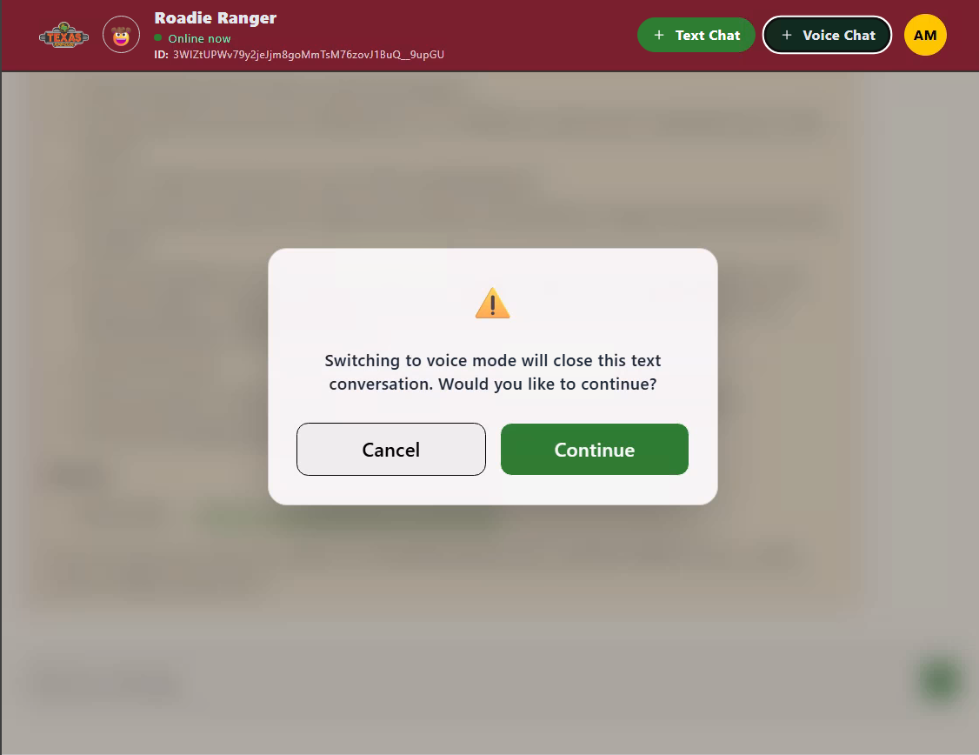
New screenshot — confirmation shown before switching from Text to Voice.
What the warning means
The message shown is: “Switching to voice mode will close this text conversation. Would you like to continue?” The same type of warning appears in reverse when switching from Voice back to Text.

5. Using Voice Chat

Starting a voice conversation
- From the home screen (or from Text Chat), select Voice Mode / Voice Chat.
- The Voice Chat screen opens in an idle state and shows a microphone button at the bottom.
- Select the microphone button and start speaking your question out loud.
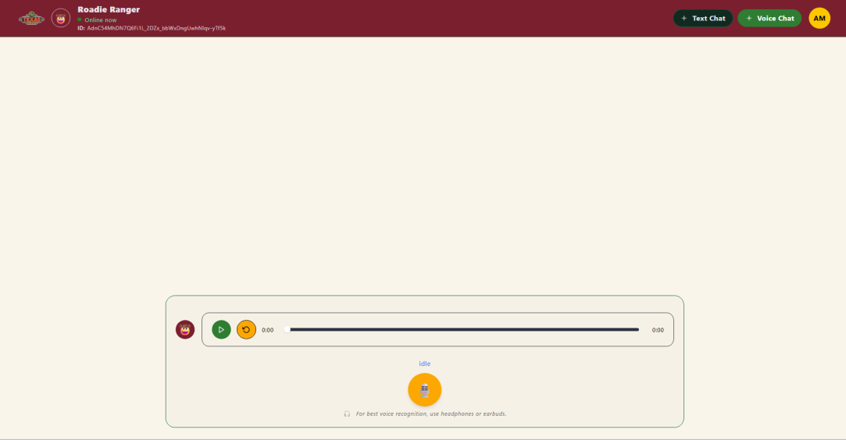
Hold to talk
Voice Chat, idle and ready — select the microphone button to start speaking.
Tip
For the clearest voice recognition, use headphones or earbuds, especially in a noisy store environment.

While Roadie Ranger is replying
After you finish speaking, Roadie Ranger processes your question and replies both out loud and in text, so you can listen or read along.
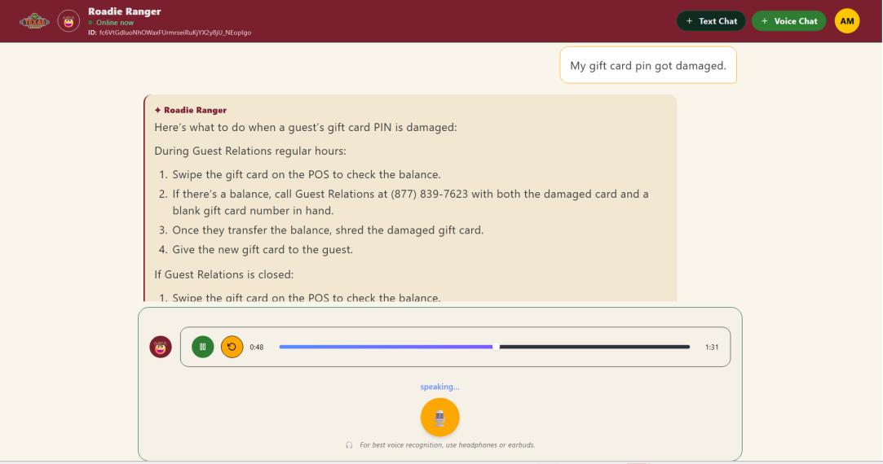
Click to restart playing
Click to pause/play

Roadie Ranger speaking its response, with the audio player showing playback progress.

5. Using Voice Chat — Status & Playback
Status label | What it means
idle | Roadie Ranger is waiting for you to select the microphone and start speaking.
listening / thinking | Your question has been received and Roadie Ranger is working on a response.
speaking… | Roadie Ranger is actively replying — you will see the response text on screen and hear it through the audio player.
Playback controls
Use the play/pause and restart controls beneath the response to replay what Roadie Ranger said. You can also start speaking again at any time to ask a follow-up question.

A simple Voice Chat flow
1. Speak: Select the microphone and ask your question.
2. Listen: Roadie Ranger speaks its response while showing the response text.
3. Replay: Use the playback controls if you want to hear the response again.
4. Follow up: Start speaking again to ask another question.

6. Your Profile and Signing Out
Your profile menu is available from any screen in the top-right corner.
- Select the circular avatar icon showing your initials in the top-right corner.
- A small menu opens showing your name and work email.
- Select Logout to sign out of Roadie Ranger.
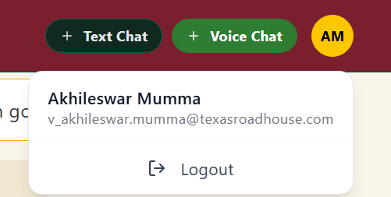
Profile menu opened from within an active Text or Voice conversation.
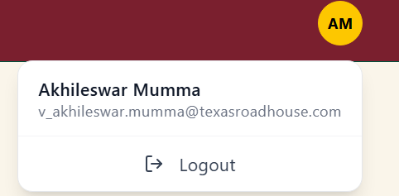
The same profile menu and Logout option are available from the home screen.
Remember
Use the avatar in the top-right to access your account menu. Use the Texas Roadhouse logo in the top-left to return Home.

7. Quick Reference & Helpful Tips
Use this page as a fast reminder when you already know the basics.
I want to… | Do this
Sign in | Select Login, then pick your Texas Roadhouse account.
Ask a typed question | Select Text Mode, type your question, then send.
Ask a quick, common question | Select a Popular Roadie Inquiries card — it auto-fills the question in Text Mode.
Ask a spoken question | Select Voice Mode, then select the microphone and speak.
Switch Text ↔ Voice | Select the other mode’s button, then confirm Continue on the warning dialog.
Replay a voice response | Use the play/restart controls under the response in Voice Chat.
Return to the home screen | Select the Texas Roadhouse logo in the top-left of the header.
View your account / sign out | Select your avatar (initials) in the top-right, then select Logout.

Helpful reminders
Long answer? Scroll within the response area to see the rest.
Voice recognition? Headphones or earbuds can help in noisy store environments.
Switching modes? Switching closes the current conversation, so copy anything important first.
Need more help? Ask Roadie Ranger directly — it can open and track a support ticket if it cannot answer your question.
Need Home? Select the Texas Roadhouse logo in the top-left.
Need to sign out? Open your avatar menu in the top-right and select Logout.
You are ready
Roadie Ranger is designed to give you quick support across HR, payroll, IT, store operations, travel, and compliance questions. Start with Text or Voice, ask a clear question, and follow the response.

