Roadie Ranger
User Guide
A practical, step-by-step guide to signing in and using Roadie Ranger by Text or Voice.

Table of Contents
What This Guide Covers 3
Quick Start 3
1. Signing In 3
2. Home Screen Overview 4
3. Using Text Chat 5
Starting a text conversation 5
Using a Popular Roadie Inquiry card 6
Reading a response 6
4. Switching Between Text and Voice 7
5. Using Voice Chat 8
Starting a voice conversation 8
While Roadie Ranger is replying 9
6. Your Profile and Signing Out 10
7. Quick Reference & Helpful Tips 11

What This Guide Covers
This guide walks you through everything you need to get help from Roadie Ranger — from signing in for the first time to asking questions by text or by voice. Use it start to finish if you're new, or jump straight to the section you need.
- Sign in with your Texas Roadhouse work account
- Start a Text Chat conversation
- Use the Popular Roadie Inquiries shortcuts
- Switch between Text and Voice
- Use Voice Chat
- View your profile and sign out
- Use the Quick Reference page when you just need a fast reminder

Quick Start
Already comfortable with apps like this? Here's everything in five steps:
- Open the Roadie Ranger web address and select Login.
- Choose your Texas Roadhouse work account on the account picker.
- Choose Text Mode for typed questions, or Voice Mode for spoken questions.
- Ask your question. Roadie Ranger replies in chat — and in Voice Mode, it also speaks the answer aloud.
- When you're finished, select your avatar in the top-right corner and choose Logout.
Before you begin
Have your Texas Roadhouse work account ready. Roadie Ranger signs you in with your existing work account, so there's no separate Roadie Ranger password to create or remember.

1. Signing In
Roadie Ranger uses your Texas Roadhouse work account to sign you in — follow the steps below the first time you visit.
- Open the Roadie Ranger web address in your browser. You'll see the welcome screen shown below.
- Select Login.
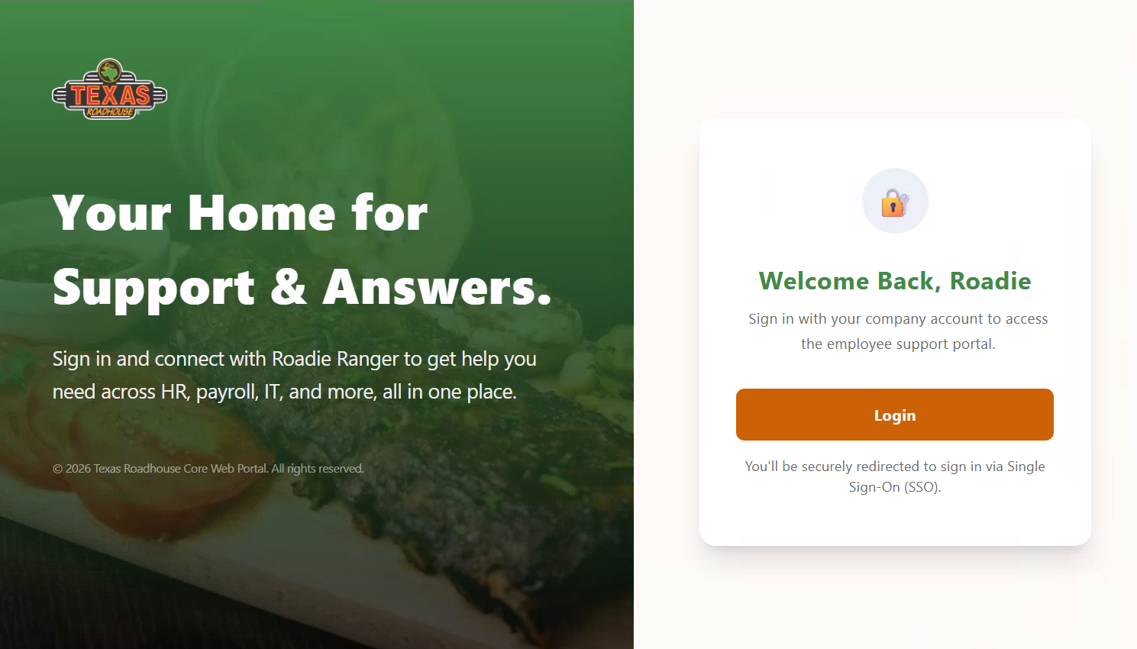
The Roadie Ranger welcome screen — select Login to continue.
- You'll be redirected to a "Pick an account" screen. Select your Texas Roadhouse work account from the list. Don't see it? Choose Use another account and enter your Texas Roadhouse email instead.
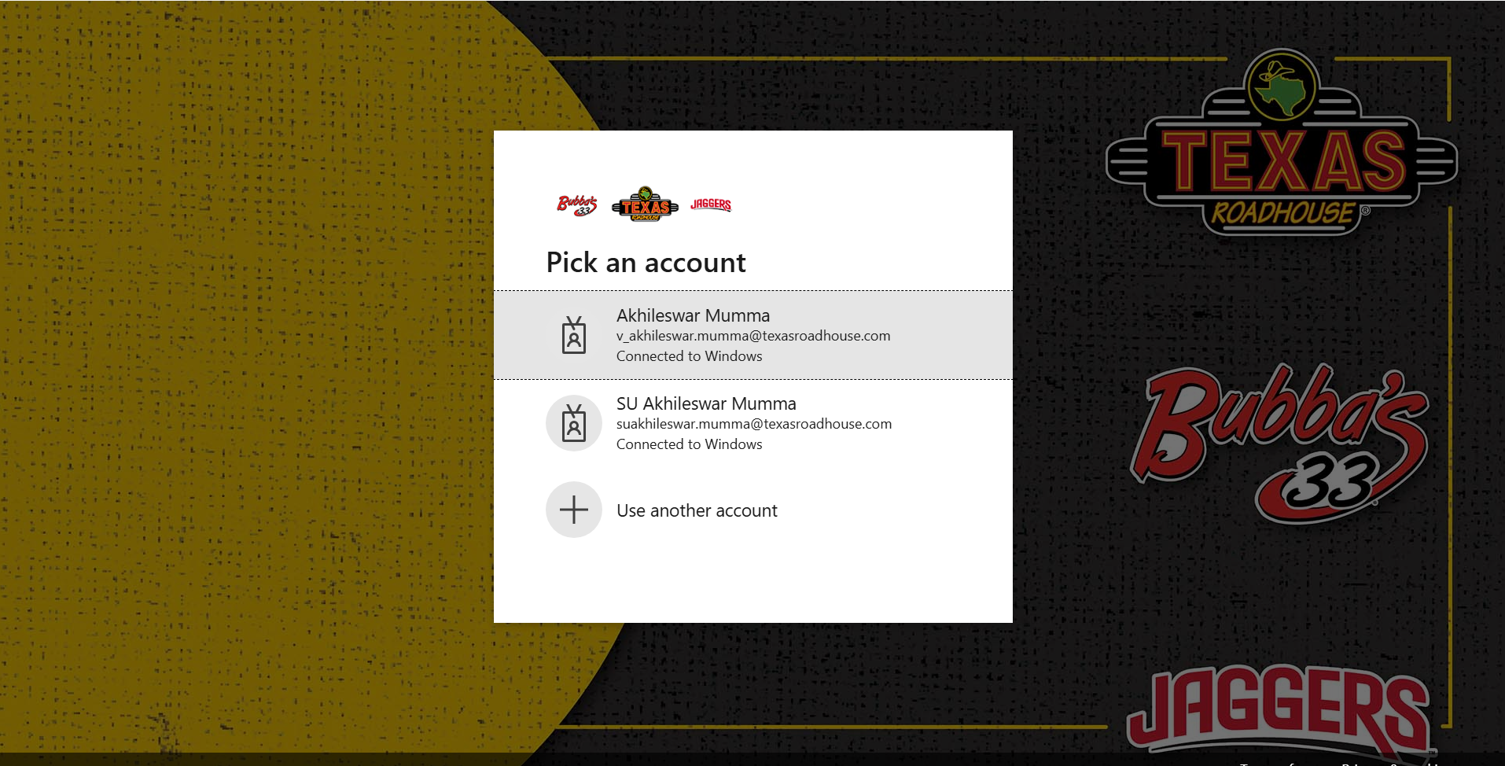
Pick an account — select your Texas Roadhouse work account to continue.
Once you select your account, you're signed in automatically and taken straight to the Roadie Ranger home screen — no extra password entry needed.
Tip
See more than one Texas Roadhouse account listed (for example, a regular account and an "SU" elevated account)? Choose the one you normally use for day-to-day work.

2. Home Screen Overview
After signing in, you'll land on the Roadie Ranger home screen — this is where every conversation starts.
The Roadie Ranger home screen, with Text Mode, Voice Mode, and Popular Roadie Inquiries.
Click to start voice chat

Click to start text chat
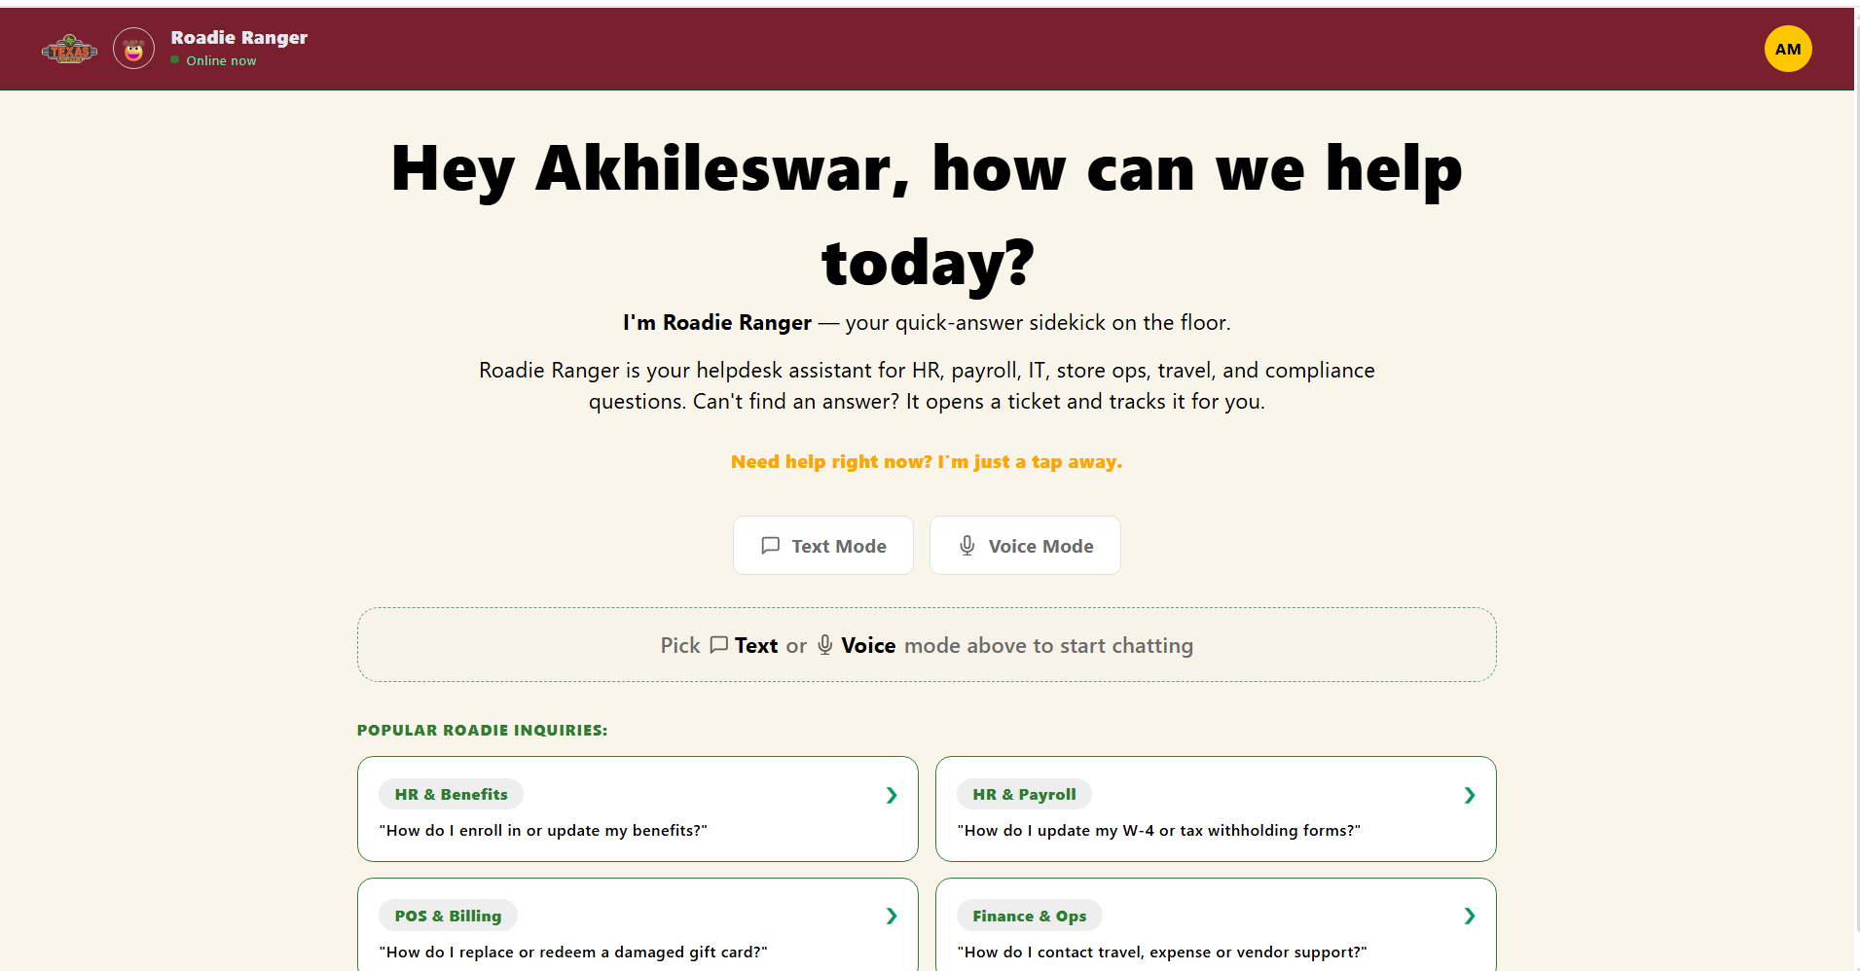
What you see | What it does
Greeting message | Welcomes you by name and explains what Roadie Ranger can help with — HR, payroll, IT, store operations, travel, and compliance questions.
Text Mode button | Starts a typed conversation. See Section 3.
Voice Mode button | Starts a spoken conversation. See Section 5.
Popular Roadie Inquiries cards | Ready-made example questions grouped by topic. Selecting a card jumps into Text Mode with that question already filled in.
Helpful navigation
The Texas Roadhouse logo in the top-left corner of the header returns you to the home screen from any screen, at any time.

The header bar — select the Texas Roadhouse logo to return Home.

3. Using Text Chat

Starting a text conversation
- From the home screen, select Text Mode.
- You'll land on an empty chat screen with a message box at the bottom.
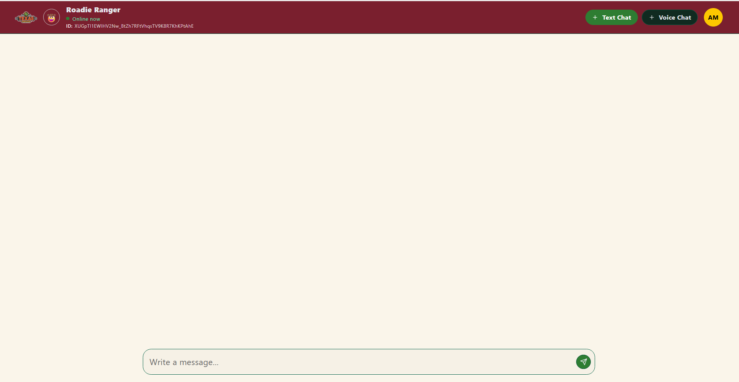
The Text Chat screen, ready for your first message.
- Type your question into the Write a message box.
- Select the send button (the arrow icon), or press Enter, to submit your question.

Using a Popular Roadie Inquiry card
If your question matches one of the example topics on the home screen, you can skip typing altogether:
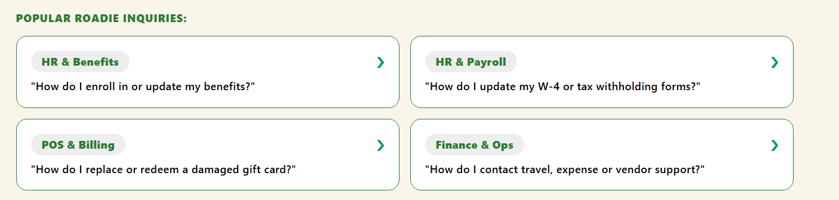
Popular Roadie Inquiries — HR & Benefits, HR & Payroll, POS & Billing, and Finance & Ops.
- From the home screen, select any card under Popular Roadie Inquiries.
- Roadie Ranger automatically switches to Text Mode and drafts that card's sample question into the message box for you.
- Review the drafted question — send it as-is, or edit it first if you'd like to ask something slightly different.

Reading a response
Once you send a question, Roadie Ranger replies directly in the chat window with a clear, formatted answer — often broken into numbered steps or bullet points so it's easy to follow along on the floor.
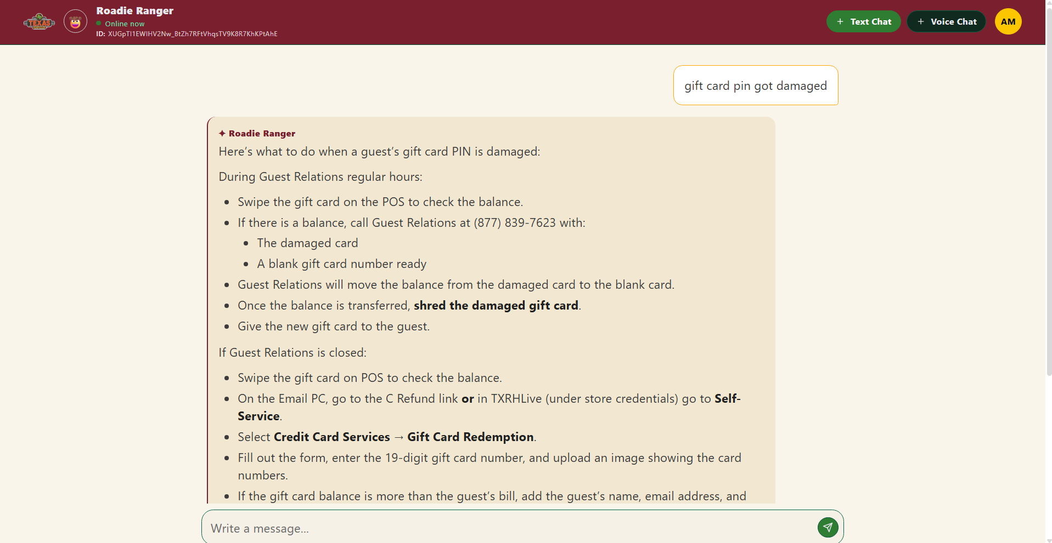
Example: asking about a damaged gift card PIN and receiving step-by-step instructions.
Tip
Long answers may be scrollable. Scroll down within the response area to see the rest of the steps if the answer doesn't fit on one screen.

Good habits for Text Chat
- Ask one clear question at a time — you'll get a more focused answer.
- Review a Popular Roadie Inquiry before sending it, and edit it if your situation is slightly different.
- Work through the response step by step, especially when it includes numbered instructions.
- Scroll down if the answer looks cut off — there may be more below.

4. Switching Between Text and Voice
You can switch modes at any time using the Text Chat and Voice Chat buttons at the top of the screen. Keep in mind that switching modes ends your current conversation, so Roadie Ranger will always check with you first.
Important
Switching modes ends your current conversation. Roadie Ranger checks with you first, so you have a chance to finish reading or copying anything important before it closes.
- While in an active conversation, select the other mode's button in the top-right (for example, select Voice Chat while you're in a text conversation).
- A confirmation dialog appears, warning that switching will close your current conversation.
- Select Continue to switch modes and start fresh, or Cancel to stay in your current conversation.
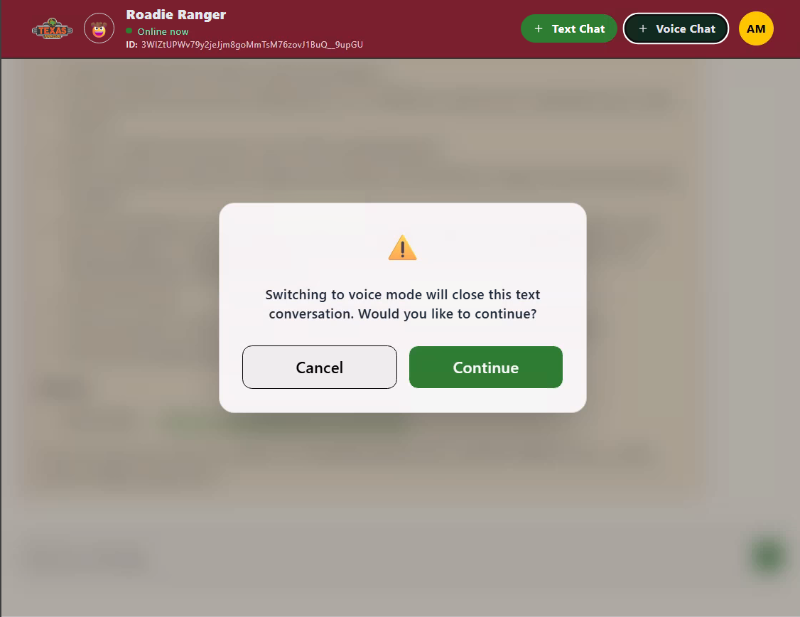
Click to continue in same chat and same mode
Click to start new chat
Confirmation shown before switching from Text to Voice.
What the warning means
The message shown reads “Switching to voice mode will close this text conversation. Would you like to continue?” The same warning appears in reverse when switching from Voice back to Text.

5. Using Voice Chat

Starting a voice conversation
- From the home screen (or from Text Chat), select Voice Mode / Voice Chat.
- The Voice Chat screen opens in an idle state, showing a microphone button at the bottom.
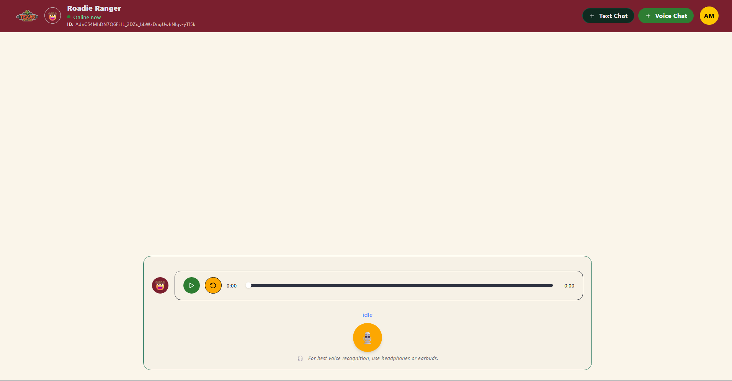
Hold to talk
Voice Chat, idle and ready — select the microphone button to start speaking.
- Select the microphone button and start speaking your question out loud.
Tip
For the clearest voice recognition, use headphones or earbuds — especially in a noisy store environment.

While Roadie Ranger is replying
After you finish speaking, Roadie Ranger processes your question and replies both out loud and in text, so you can listen or read along.
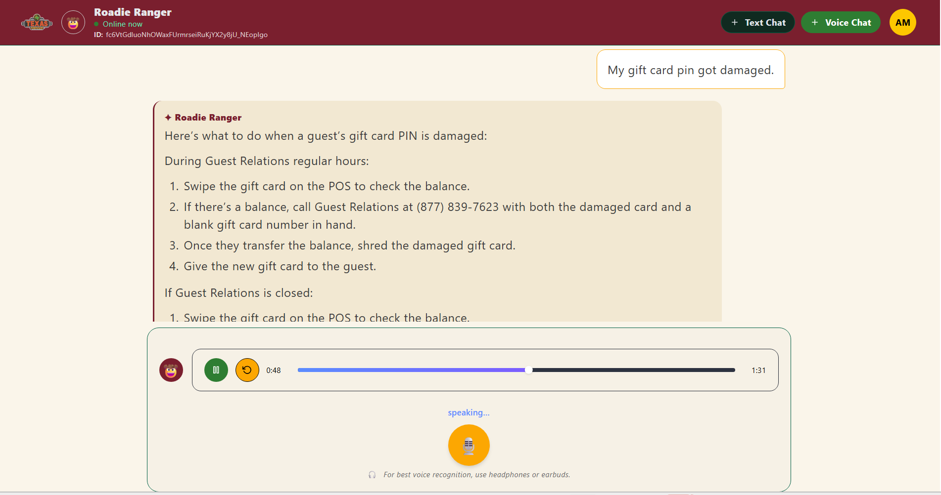
Click to replay
Click to pause / play
Roadie Ranger speaking its response, with the audio player showing playback progress.
Status label | What it means
idle | Roadie Ranger is waiting for you to select the microphone and start speaking.
listening / thinking | Your question has been received and Roadie Ranger is working on a response.
speaking… | Roadie Ranger is actively replying — you'll see the response text on screen and hear it through the audio player.
Playback controls
Use the play/pause and restart controls beneath the response to replay what Roadie Ranger said. You can also start speaking again at any time to ask a follow-up question.

A simple Voice Chat flow
- Speak — select the microphone and ask your question.
- Listen — Roadie Ranger speaks its response while showing the text on screen.
- Replay — use the playback controls if you'd like to hear the response again.
- Follow up — start speaking again to ask another question.

6. Your Profile and Signing Out
Your profile menu is available from any screen, in the top-right corner.
- Select the circular avatar icon (your initials) in the top-right corner of the screen.
- A small menu opens showing your name and work email.
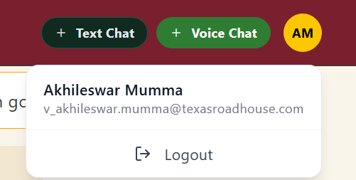
Profile menu, opened from within an active Text or Voice conversation.
- Select Logout to sign out of Roadie Ranger.
The same menu — with the same Logout option — is available from the home screen as well.
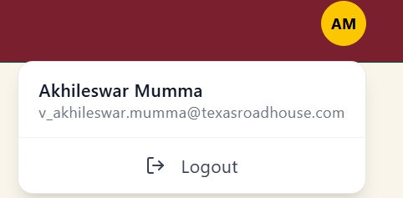
Profile menu, opened from the home screen.
Remember
Use the avatar in the top-right corner to access your account menu. Use the Texas Roadhouse logo in the top-left corner to return to the home screen.

7. Quick Reference & Helpful Tips
Use this page as a fast reminder once you already know the basics.
I want to... | Do this
Sign in | Select Login, then pick your Texas Roadhouse account.
Ask a typed question | Select Text Mode, type your question, then send.
Ask a quick, common question | Select a Popular Roadie Inquiries card — it auto-fills the question in Text Mode.
Ask a spoken question | Select Voice Mode, then select the microphone and speak.
Switch Text ↔ Voice | Select the other mode's button, then confirm Continue on the warning dialog.
Replay a voice response | Use the play/restart controls under the response in Voice Chat.
Return to the home screen | Select the Texas Roadhouse logo in the top-left of the header.
View your account / sign out | Select your avatar (initials) in the top-right, then select Logout.

Helpful reminders
- Long answer? Scroll within the response area to see the rest.
- Voice recognition acting up? Headphones or earbuds help a lot in noisy store environments.
- Switching modes? It closes your current conversation, so copy anything important first.
- Need more help? Ask Roadie Ranger directly — it can open and track a support ticket for you if it can't answer your question.
You're ready
Roadie Ranger is designed to give you quick support across HR, payroll, IT, store operations, travel, and compliance questions. Start with Text or Voice, ask a clear question, and follow the response.

