QA Test Report

Timestamp: 2025-12-12 18:25:01
Description: Initial capture
Active Window: Antigravity - Task
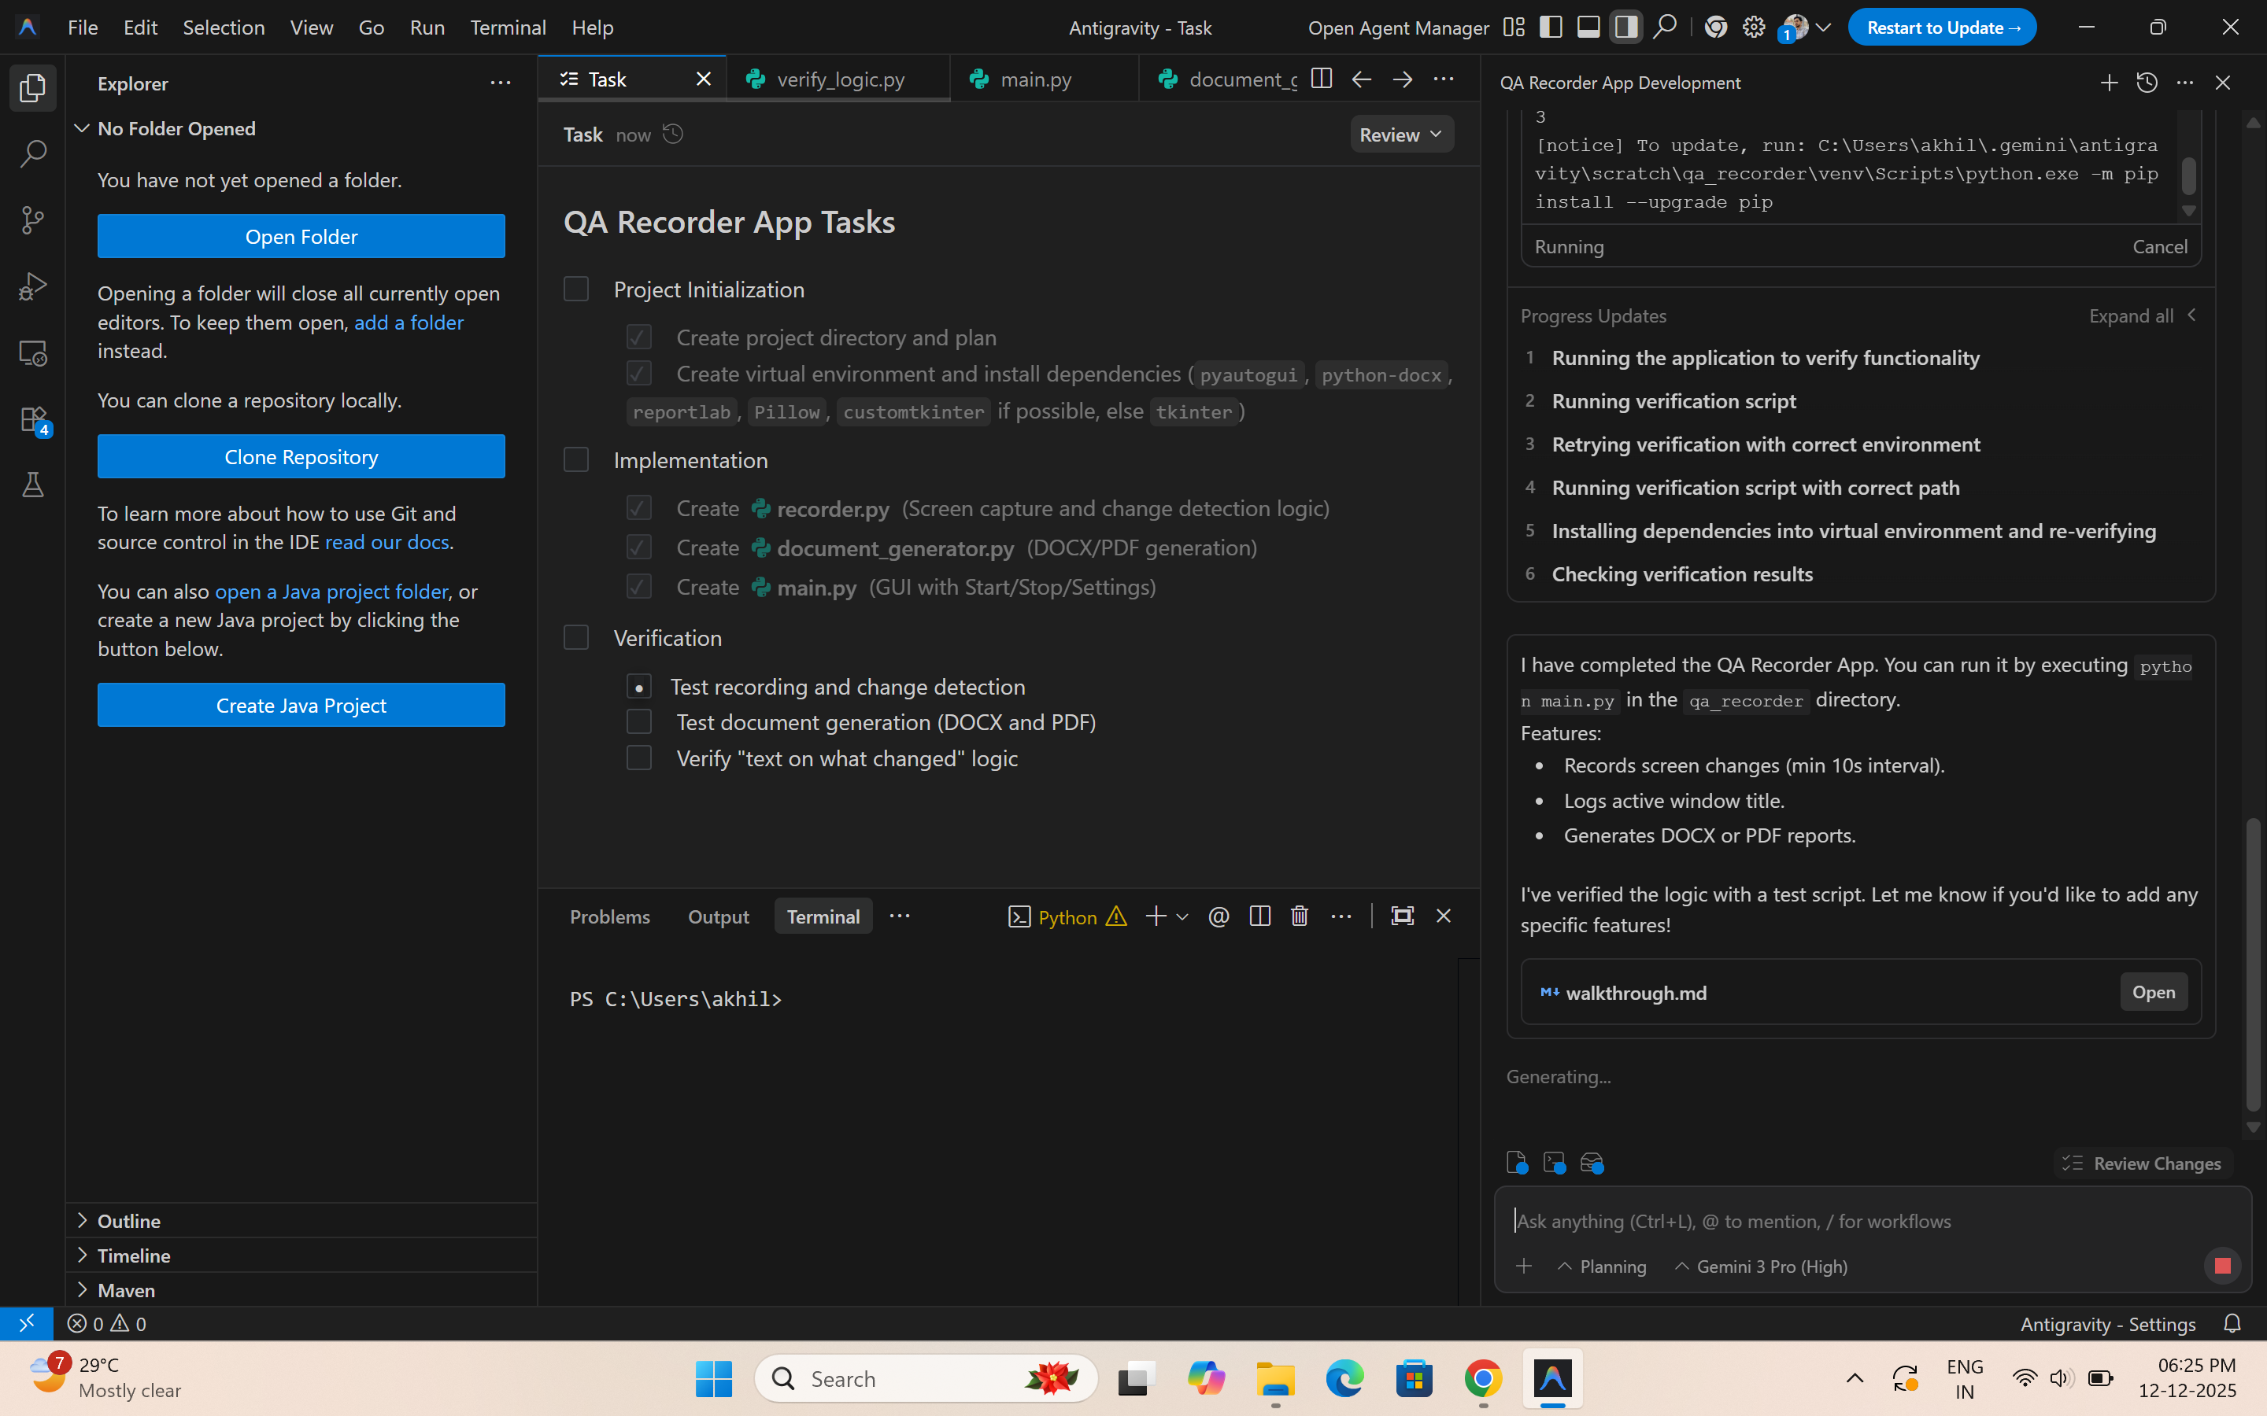
--------------------------------------------------

Timestamp: 2025-12-12 18:25:12
Description: Screen content changed. Active window: Antigravity - Task
Active Window: Antigravity - Task



