Knowledge-Based AI Decision Support Using Enterprise Innovation Data for Digital Transformation and Entrepreneurship Readiness
Akhil Chary Goshamahal
Independent Researcher, New Jersey, USA
Corresponding author: Goshamahalakhil@gmail.com
Article type: Short Communication
Abstract
Digital-transformation decisions require more than accurate prediction: managers also need explicit reasoning, calibrated escalation, and a record of why an intervention was recommended. This Short Communication introduces a compact knowledge-based artificial-intelligence decision-support architecture that combines a probabilistic classifier, training-fold-derived innovation rules, selective human review, and asymmetric decision costs. The experiment links twelve dimensions from the European Innovation Scoreboard 2025 with Eurostat enterprise Digital Intensity Index observations. The resulting panel contains 220 country-year cases from 33 European countries during 2018–2024 and predicts the next-year, country-relative digital-readiness tier. Five-fold country-grouped validation prevents the same country from appearing in both training and test partitions. The hybrid achieved 0.636 accuracy and 0.619 macro-F1, compared with 0.614 and 0.606 for logistic regression. At a confidence threshold of 0.55, 19.1% of cases were referred for review and automated-case accuracy reached 0.702. Under a transparent loss scenario in which overstating readiness costs three times as much as understating it, mean decision cost fell from 0.832 to 0.553; the grouped-bootstrap difference was −0.282 (95% confidence interval −0.527 to −0.082). The results support the feasibility of auditable, human-supervised readiness screening, while not establishing firm-level causality or an audited maturity certification.
Keywords: knowledge-based AI; enterprise innovation data; digital transformation; entrepreneurship readiness; decision support; selective prediction
1. Introduction
Digital transformation is not a single technology purchase. It is a sequence of interdependent decisions about skills, information technology, finance, collaboration, intellectual assets, and market deployment. Innovation indicators can reveal these capabilities, yet a prediction alone does not tell a manager when to trust the output, which evidence triggered it, or when human judgment should override automation. This gap is important for entrepreneurs and public decision makers because an overly optimistic readiness classification can lead to premature platform investment, vendor lock-in, or an innovation program that lacks complementary capabilities.
Knowledge-based systems are well suited to this setting because they can combine statistical learning with explicit domain logic and traceable decision outputs. In high-stakes applications, interpretable structures are preferable to explanations attached after the fact [1]. Confidence must also be operationalized: selective prediction allows a system to abstain and refer uncertain cases to a human reviewer instead of forcing every case through automation [2]. Probability diagnostics remain useful because an apparently accurate classifier may issue confidence values that do not match empirical correctness [3].
This study asks whether a small, reproducible knowledge layer can improve the decision value of next-year digital-readiness forecasts derived from public enterprise-innovation data. Its contribution is threefold. First, it defines a leakage-controlled country-year benchmark that links the European Innovation Scoreboard (EIS) to Eurostat digital-intensity statistics. Second, it integrates transparent low- and high-readiness rules with a probabilistic baseline and preserves a decision trace. Third, it evaluates not only classification performance but also review coverage and a directional decision cost. The intent is decision support—not automated certification—and the scope is deliberately narrow enough for independent replication.
2. Conceptual basis and research proposition
The Oslo Manual treats innovation measurement as a foundation for policy and managerial analysis and emphasizes internationally comparable indicators [4]. The EIS operationalizes this perspective through 32 indicators arranged in 12 dimensions that describe framework conditions, investments, innovation activities, and impacts [5]. Eurostat’s Digital Intensity Index (DII), derived from the harmonized survey of ICT use and e-commerce in enterprises, summarizes the adoption of enterprise digital technologies [6]. These sources are complementary: EIS represents innovation-system capabilities, whereas DII supplies an observed marker of enterprise digital adoption.
A readiness forecast can therefore be expressed as a mapping from current innovation capabilities and current digital intensity to a next-year readiness tier. Pure machine learning may capture broad associations but can violate defensible boundary conditions. A low value for both current digital intensity and the EIS use-of-information-technologies dimension should constrain an optimistic prediction. Conversely, high digital intensity combined with strong innovator activity and linkages supplies convergent evidence for a higher tier. These rules encode transparent sufficiency and constraint conditions without claiming to exhaust domain knowledge.
The research proposition is that integrating such rules with probabilistic forecasts and a reject option reduces decision loss relative to the same probabilistic forecasts alone. The claim concerns out-of-country predictive decision support under an explicitly stated cost scenario; it does not imply that innovation dimensions cause later digital intensity.
3. Knowledge-based decision architecture
Figure 1 summarizes the architecture. The data layer joins current-year innovation dimensions and DII. The probabilistic layer estimates one of three next-year tiers: Emerging, Progressing, or Ready. The knowledge layer applies thresholds estimated only from each training fold. A low-readiness rule caps the prediction at Emerging when both DII and use of information technologies are at or below their training-fold 33rd percentiles. A high-readiness rule raises the prediction to Ready when DII, Innovators, and Linkages are at or above their 67th percentiles. Finally, predictions with maximum probability below 0.55 enter human review. Each record retains the source country-year, class probabilities, original and rule-adjusted predictions, rule flags, review status, and decision cost.
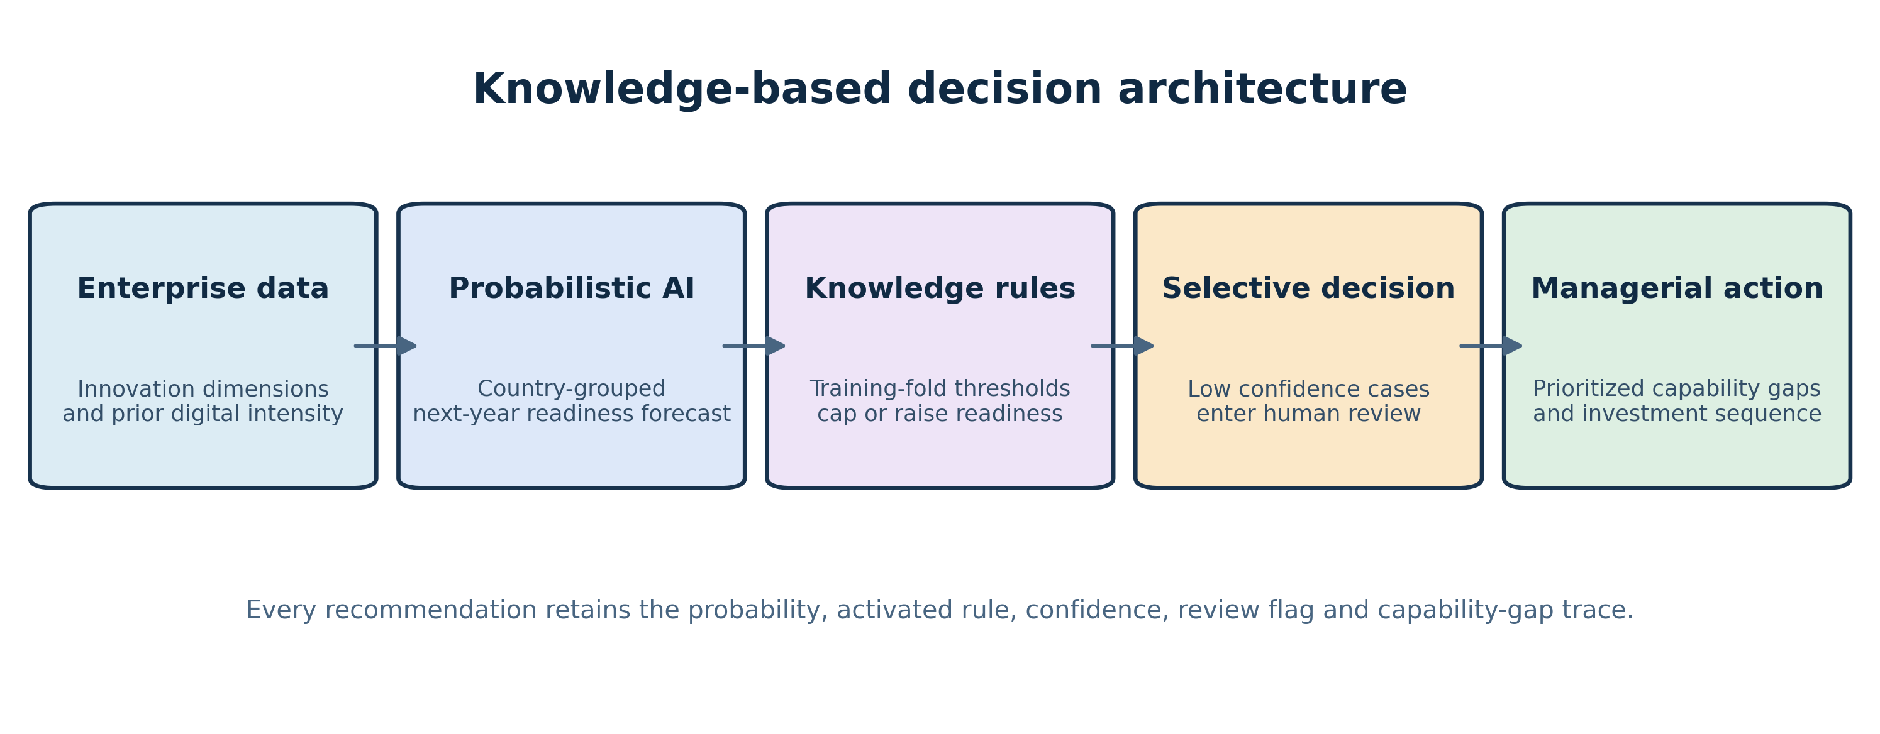
Figure 1. Knowledge-based AI decision architecture and retained audit trace.
4. Materials and methods
4.1 Data and target construction
The code downloads the official EIS 2025 country-and-neighbourhood workbook and the Eurostat isoc_e_dii dataset through its dissemination API. The analysis uses the twelve EIS dimension scores: Human resources, Attractive research systems, Digitalisation, Finance and support, Firm investments, Use of information technologies, Innovators, Linkages, Intellectual assets, Employment impacts, Sales impacts, and Environmental sustainability. Current-year DII is added as a thirteenth predictor. The target is next-year DII for enterprises with at least ten employees.
Because Eurostat revised the DII technology basket over time, absolute scores from different versions are not treated as identical scales. Within each survey year, next-year DII values are ranked and divided into three approximately equal country-relative tiers. The final panel contains 220 observations, 33 countries, and predictor years 2018–2024, with 73 Emerging, 70 Progressing, and 77 Ready cases. This target measures relative national positioning; it is not a firm-level label.
4.2 Models, validation, and decision loss
Three statistical baselines were evaluated: class-weighted multinomial logistic regression, a 500-tree random forest, and sigmoid-calibrated histogram gradient boosting. Median imputation was learned within each training fold, and logistic predictors were standardized within the same pipeline. Five-fold GroupKFold validation assigned each country to one held-out fold, preventing repeated country observations from crossing the train–test boundary [7]. Logistic regression was pre-specified as the probabilistic component because its linear decision structure and class probabilities support an auditable knowledge-rule comparison; the forest and calibrated boosting models were retained as nonlinear benchmarks.
Evaluation reports accuracy, balanced accuracy, macro-F1, multiclass log loss, multiclass Brier score, and ten-bin expected calibration error. Decision cost is directional: understating readiness costs one unit per tier, while overstating it costs three units per tier to represent the greater exposure associated with premature investment. A reviewed case costs 0.35 units, representing analyst effort rather than a monetary estimate. The primary comparison uses 5,000 country-grouped bootstrap resamples; a paired two-sided Wilcoxon test across the five folds is reported as a low-power secondary check. Threshold sensitivity from 0.35 to 0.75 evaluates the review–cost trade-off.
4.3 Reproducibility controls
The entire pipeline is implemented in one Python entry point. It downloads source data, records SHA-256 hashes, builds the panel, performs grouped validation, writes a case-level trace, fits a final reusable artifact, and regenerates both tables and both figures. Random seeds and package versions are fixed. The repository excludes downloaded data but retains source URLs, hashes, derived results, and the code required to recreate them. This design keeps the code base compact while making every numerical claim auditable.
5. Results
Table 1 shows out-of-fold performance. Logistic regression was the strongest statistical classifier by accuracy (0.614) and macro-F1 (0.606), while random forest had the lowest statistical-model decision cost (0.823). The knowledge rules alone achieved 0.564 accuracy. Combining the logistic forecast with the knowledge rules increased accuracy to 0.636 and macro-F1 to 0.619. With the 0.55 review threshold, 19.1% of observations were escalated; accuracy among the remaining automated cases was 0.702. The hybrid’s mean decision cost was 0.553, a reduction of 0.279 relative to logistic regression.
Table 1. Out-of-country predictive and decision performance.
Method | Acc. | Bal. acc. | Macro-F1 | Auto. acc. | Review | Decision cost | Log loss | ECE
Logistic regression | 0.614 | 0.610 | 0.606 | 0.614 | 0.000 | 0.832 | 0.920 | 0.111
Random forest | 0.596 | 0.593 | 0.595 | 0.596 | 0.000 | 0.823 | 0.808 | 0.069
Calibrated HGB | 0.500 | 0.493 | 0.478 | 0.500 | 0.000 | 1.127 | 1.003 | 0.046
Rule-only knowledge system | 0.564 | 0.573 | 0.553 | 0.564 | 0.000 | 0.736 | — | —
Knowledge-based AI | 0.636 | 0.632 | 0.619 | 0.702 | 0.191 | 0.553 | 0.920 | 0.111
Note: Auto. acc. is accuracy among non-reviewed cases. ECE = expected calibration error. Review cost = 0.35; overstatement cost = 3 per tier; understatement cost = 1 per tier.
The knowledge layer activated the low-readiness rule in 53 held-out cases and the high-readiness rule in 23. The country-grouped bootstrap estimated a hybrid-minus-probabilistic cost difference of −0.282 with a 95% interval from −0.527 to −0.082 (Table 2). The interval excludes zero under the scenario assumptions. The five-fold Wilcoxon result was p = 0.0625; with only five fold-level pairs, it should be read as descriptive corroboration rather than a definitive hypothesis test.
Table 2. Knowledge activation, review coverage, and uncertainty evidence.
Evidence | Value | Uncertainty or interpretation
Low-readiness rule activations | 53 | Held-out cases
High-readiness rule activations | 23 | Held-out cases
Human-review rate | 0.1909 | Threshold=0.55
Hybrid minus probabilistic-AI cost | -0.2786 | Grouped bootstrap 95% CI [-0.5269, -0.0819]
Paired fold Wilcoxon p-value | 0.0625 | Statistic=0.000; five country-grouped folds
Figure 2 tests whether the advantage depends on a single review threshold. Across the displayed range, the knowledge-based curve remains below the probabilistic baseline at comparable review coverage. Higher thresholds refer more cases and lower mean cost because the stipulated review cost is less than many automated errors. The default 0.55 threshold is therefore a policy point, not a universally optimal constant; deployments should select it from review capacity and validated organizational costs.
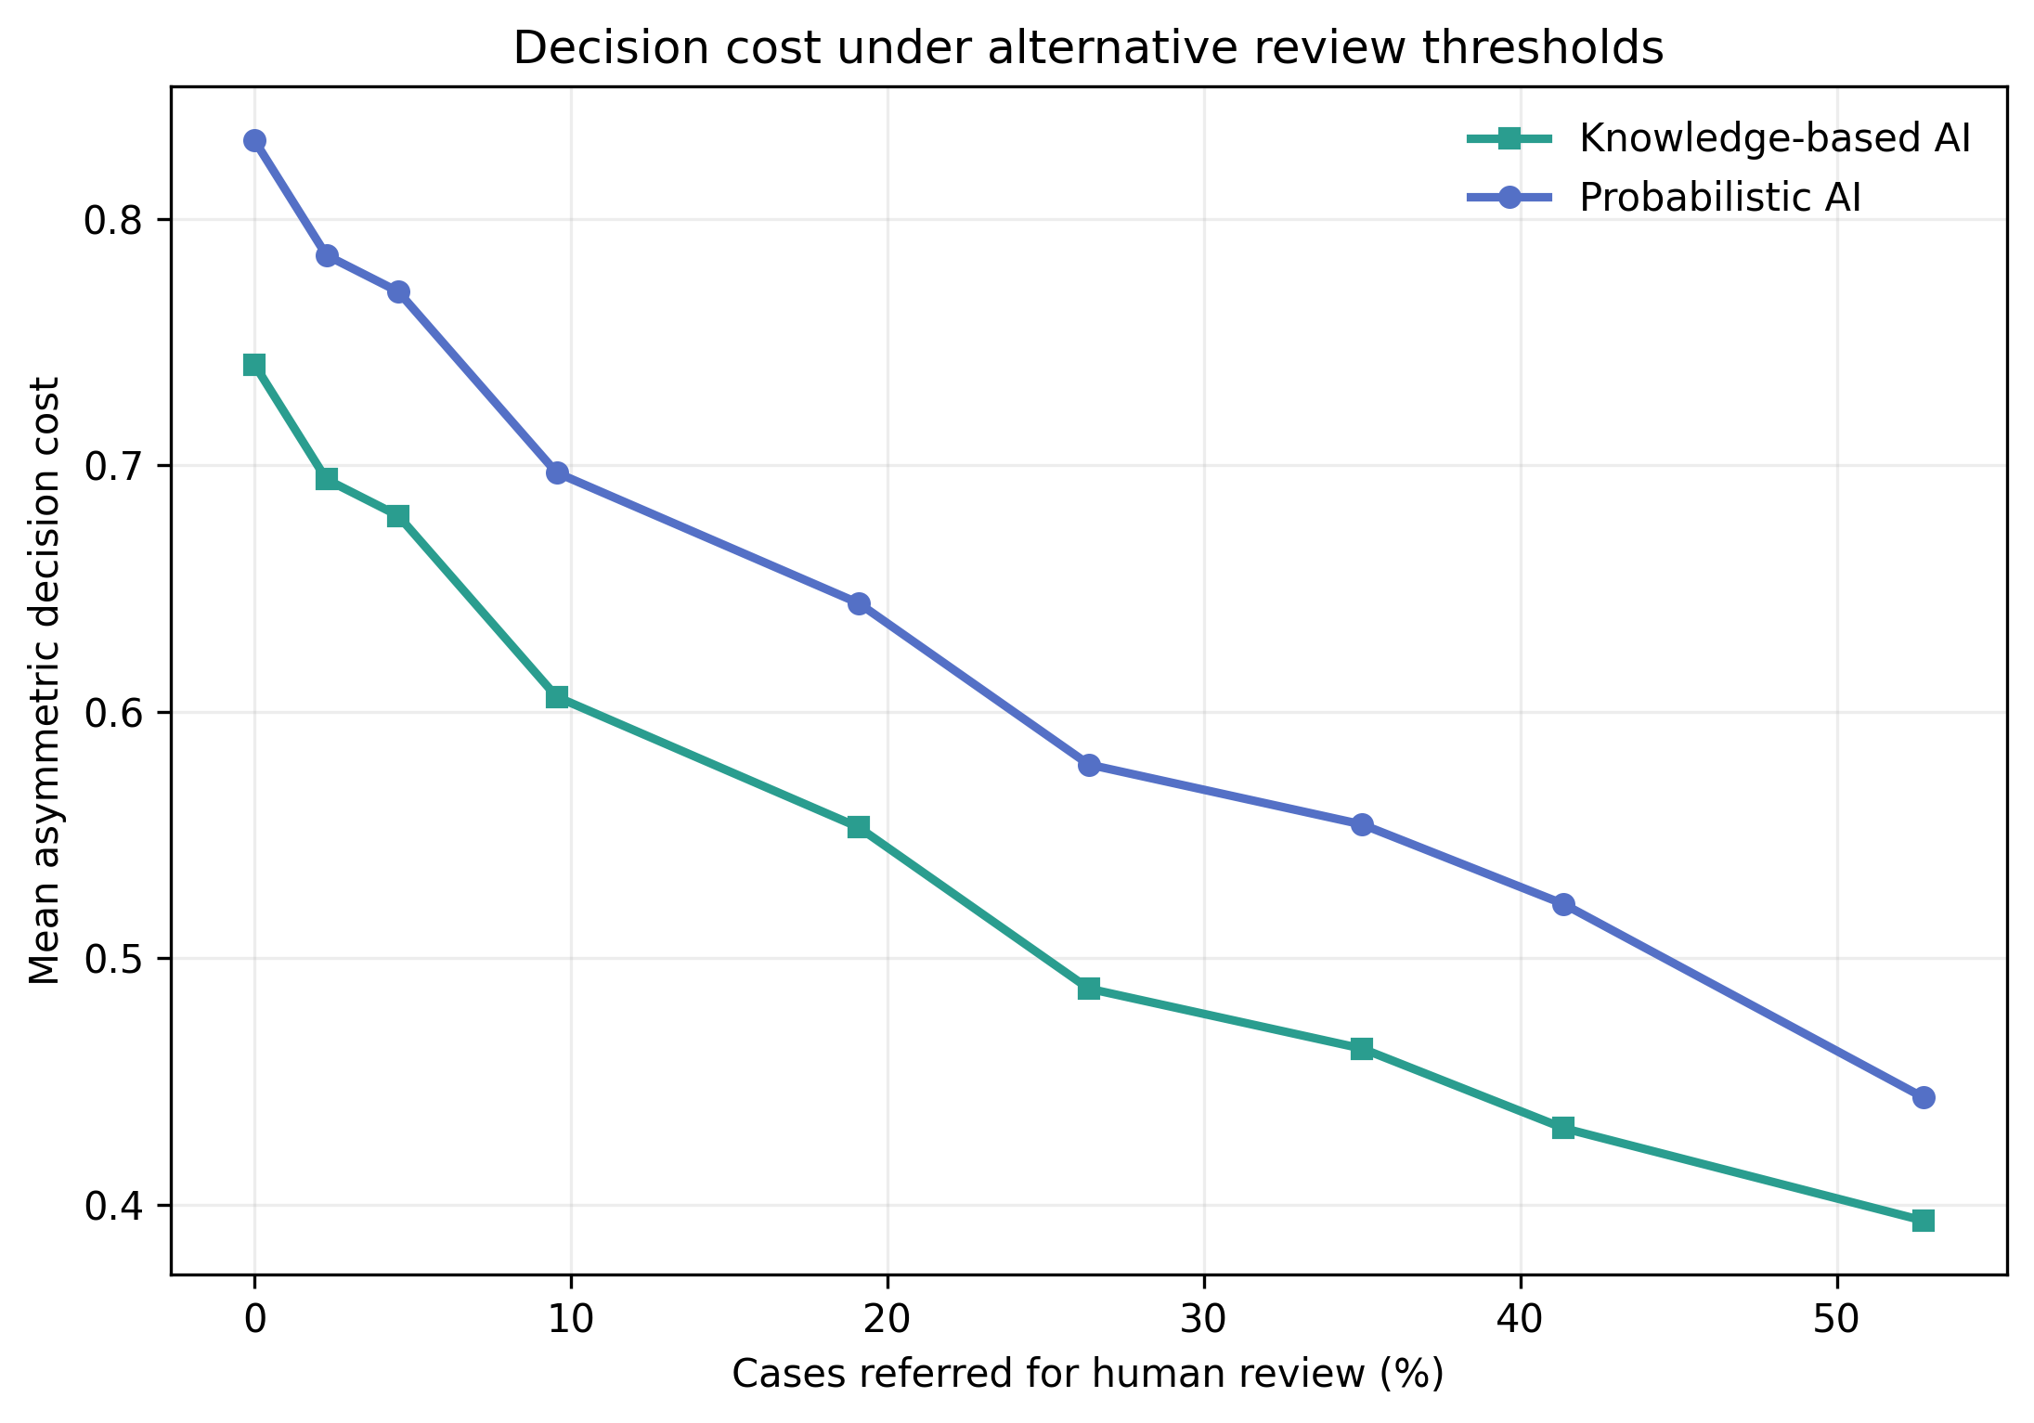
Figure 2. Mean decision cost as confidence-based human review increases.
6. Discussion and implications
The evidence suggests that a modest knowledge layer can improve an otherwise conventional classifier when the objective is decision quality rather than raw prediction alone. The gain is not attributable to a larger opaque model: it comes from explicit boundary conditions, asymmetric consequences, and a review channel. This is consistent with the argument that interpretable models and procedures are particularly valuable when errors have unequal consequences [1]. It also extends the selective-prediction idea from generic risk–coverage analysis to a documented managerial readiness workflow [2].
For digital-transformation governance, the architecture changes the output from a tier into an actionable dossier. A low-readiness rule directs attention to foundational digital adoption and information-technology use before ambitious innovation scaling. A high-readiness rule requires evidence from adoption, innovators, and linkages, preventing a single strong indicator from driving the recommendation. The capability-gap trace can support sequencing: managers can review the weakest dimensions, identify complementary investments, and document why a case was escalated. For entrepreneurship policy, country-level evidence can help prioritize ecosystem support, but it should not be used to rank individual ventures.
The result also illustrates why the evaluation boundary matters. Random row splitting would allow the same country’s repeated observations into training and test data and could overstate generalization. Country grouping asks a harder and more relevant question: can the system transfer to an unseen national context? Similarly, computing rule thresholds inside each training fold avoids using held-out distributional information. These controls strengthen the evidence but do not remove temporal dependence, measurement revision, or unobserved institutional differences.
Several limitations constrain interpretation. The sample is small, European, aggregated, and partly shaped by changing DII questionnaires. Terciles are relative rather than absolute maturity standards. The knowledge rules are parsimonious expert propositions, not a formally elicited ontology. The cost ratio and review cost are scenario values and require stakeholder calibration. The bootstrap interval evaluates the observed panel, while the fold-level test has low power. Future work should use firm-level longitudinal data, prospectively elicit and validate rules with transformation leaders, test external regions, analyze fairness across firm sizes and sectors, and compare capacity-constrained or conformal abstention policies.
7. Conclusion
This Short Communication demonstrates a reproducible knowledge-based AI pipeline for next-year digital-transformation readiness screening from enterprise-innovation data. On 220 observations from 33 countries, explicit rules and selective review improved macro-F1 and reduced scenario-based asymmetric decision cost relative to the probabilistic baseline. The contribution is not a universal readiness score; it is an auditable design pattern that joins data-driven prediction, domain constraints, human oversight, and decision consequences. Its compact public implementation provides a testable foundation for stronger firm-level and prospective studies.
Data and code availability
The experiment uses the European Commission EIS 2025 database [5] and Eurostat dataset isoc_e_dii (DOI: 10.2908/isoc_e_dii) [6]. Code, source URLs, hashes, derived tables, figures, and decision traces are available at https://github.com/akhilgoshamahal/kbs-ai-digital-readiness. The script downloads the source files; redistribution of those source files remains governed by their providers.
Funding
This research received no specific grant from funding agencies in the public, commercial, or not-for-profit sectors.
Declaration of competing interest
The author declares no known competing financial interests or personal relationships that could have appeared to influence the work reported in this paper.
CRediT authorship contribution statement
Akhil Chary Goshamahal: Conceptualization, Methodology, Software, Validation, Formal analysis, Investigation, Data curation, Visualization, Writing—original draft, Writing—review and editing, and Project administration.
Declaration of generative AI and AI-assisted technologies
During preparation of this work, the author used OpenAI Codex to assist with code scaffolding, language editing, and document formatting. The author reviewed and verified the code, analyses, sources, and text and takes full responsibility for the content of the article.
References
[1] C. Rudin, Stop explaining black box machine learning models for high stakes decisions and use interpretable models instead, Nat. Mach. Intell. 1 (2019) 206–215. https://doi.org/10.1038/s42256-019-0048-x.
[2] Y. Geifman, R. El-Yaniv, SelectiveNet: A deep neural network with an integrated reject option, Proc. Mach. Learn. Res. 97 (2019) 2151–2159. https://proceedings.mlr.press/v97/geifman19a.html.
[3] C. Guo, G. Pleiss, Y. Sun, K.Q. Weinberger, On calibration of modern neural networks, Proc. Mach. Learn. Res. 70 (2017) 1321–1330. https://proceedings.mlr.press/v70/guo17a.html.
[4] OECD/Eurostat, Oslo Manual 2018: Guidelines for Collecting, Reporting and Using Data on Innovation, 4th ed., OECD Publishing, Paris/Eurostat, Luxembourg, 2018. https://doi.org/10.1787/9789264304604-en.
[5] European Commission, European Innovation Scoreboard 2025, Directorate-General for Research and Innovation, 2025. https://research-and-innovation.ec.europa.eu/knowledge-publications-tools-and-data/publications/all-publications/european-innovation-scoreboard-2025_en.
[6] Eurostat, Digital intensity by size class of enterprise, dataset isoc_e_dii, 2026. https://doi.org/10.2908/isoc_e_dii.
[7] Scikit-learn developers, GroupKFold: K-fold iterator with non-overlapping groups, scikit-learn documentation, version 1.5.2. https://scikit-learn.org/stable/modules/generated/sklearn.model_selection.GroupKFold.html.
[8] L. Breiman, Random forests, Mach. Learn. 45 (2001) 5–32. https://doi.org/10.1023/A:1010933404324.
[9] J.H. Friedman, Greedy function approximation: A gradient boosting machine, Ann. Stat. 29 (2001) 1189–1232. https://doi.org/10.1214/aos/1013203451.

