- Configure 2 slave machines in Jenkins master.
Steps to be done in slave:
Steps to be done on slave
Step-1 : Create an ec2 –slave-01
Login to slave machine..
switch to root user
sudo dnf install -y java-17-amazon-corretto
Create ssh-keygen
cat id_rsa.pub > authorized_keys
chmod 700 authorized_keys
Steps to be done on master machine:
Login to Master machine
switch to root user.
Prepare Jenkins SSH directory
mkdir -p /var/lib/jenkins/.ssh
cd /var/lib/jenkins/.ssh
Add slave’s SSH key to known_hosts
ssh-keyscan -H SLAVE-NODE-IP-OR-HOSTNAME>>/var/lib/jenkins/.ssh/known_hosts
# ssh-keyscan -H 172.31.38.42 >>/var/lib/jenkins/.ssh/known_hosts
Fix permissions
chown jenkins:jenkins known_hosts
#we need to change the owner as we ran ssh-keyscan command using “root”
user.
# default user of Jenkins will be “jenkins”
chmod 700 known_hosts
# Done !!
Steps on Jenkins GUI
1. Manage Jenkins → Nodes → New Node
2. Name: slave1 → Type: Permanent Agent
3. Remote root directory: /home/ec2-user
a. This path is taken from slave machine
Configure Node
oRemote root directory: /home/ec2-user (or another working
dir on slave)
oLabels: (optional, e.g., Java)
oLaunch method: Launch agent via SSH
oHost: Public IP of Slave
Add Credentials
oKind: SSH Username with private key
oUsername: ec2-user
oPrivate key: Paste your .pem key (from AWS)
oSave

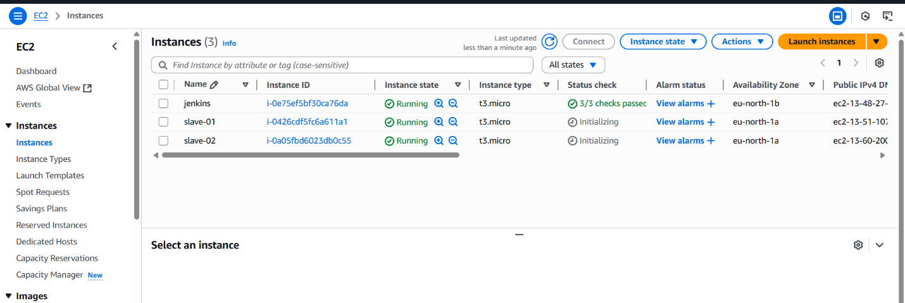
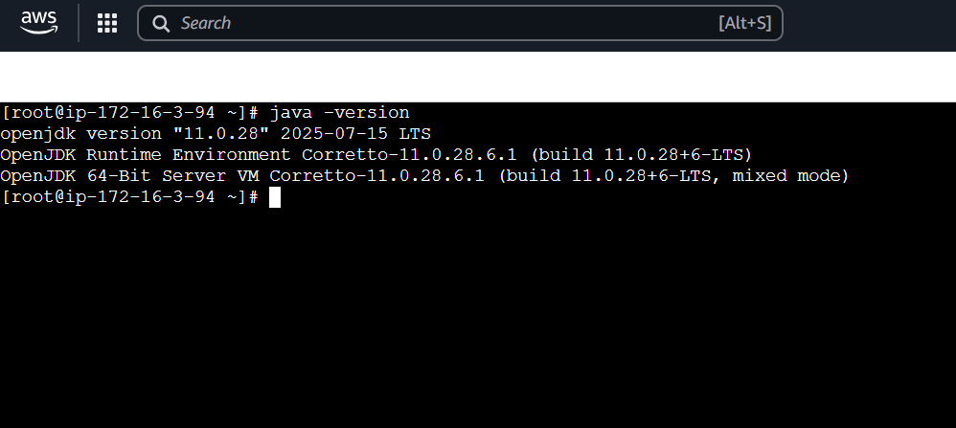
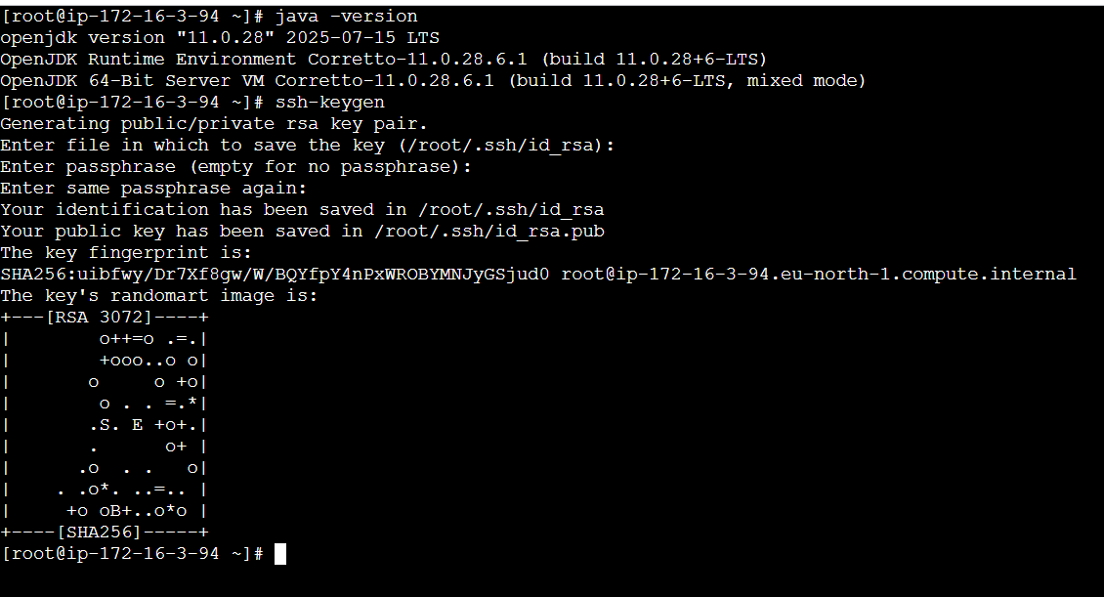
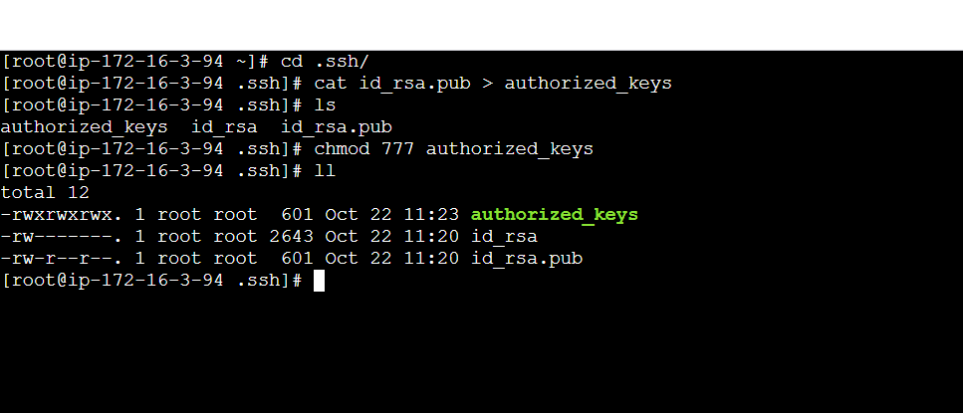
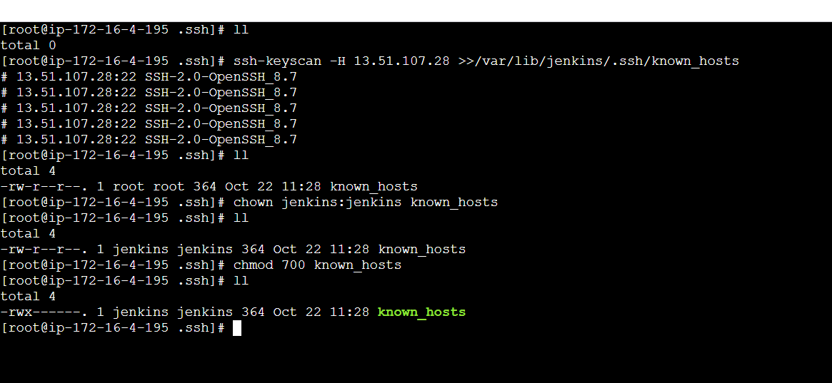
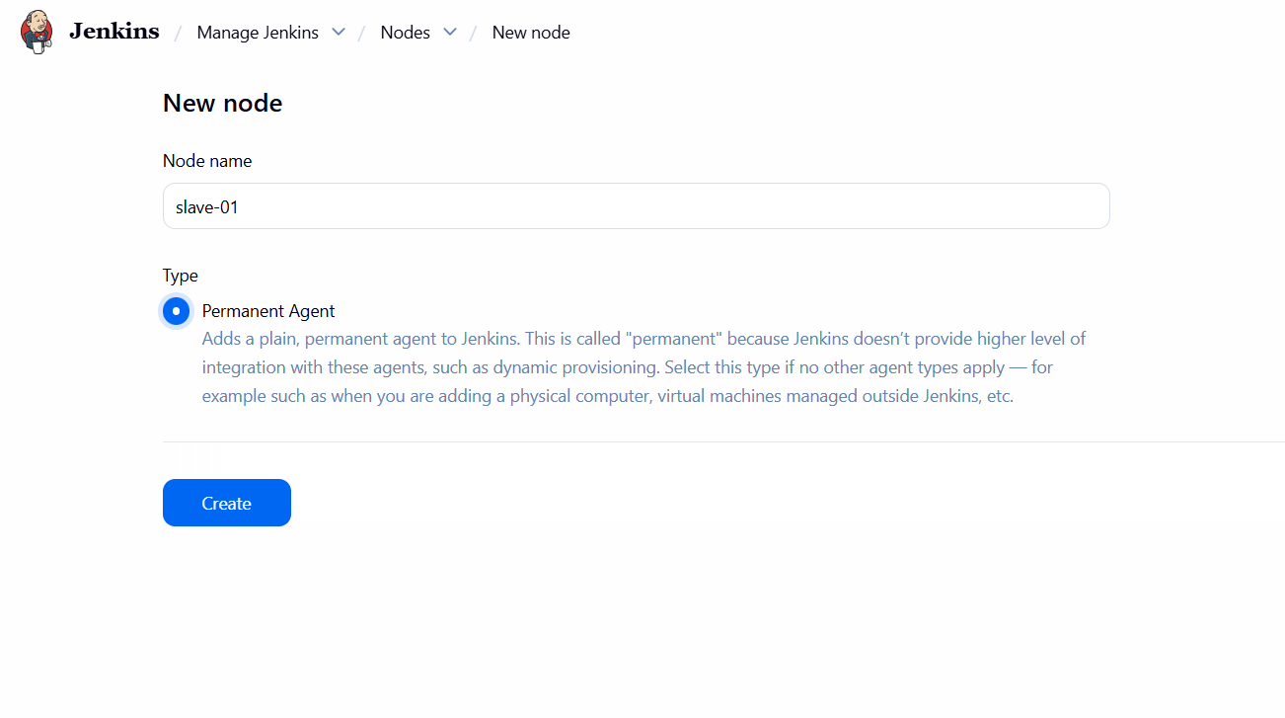
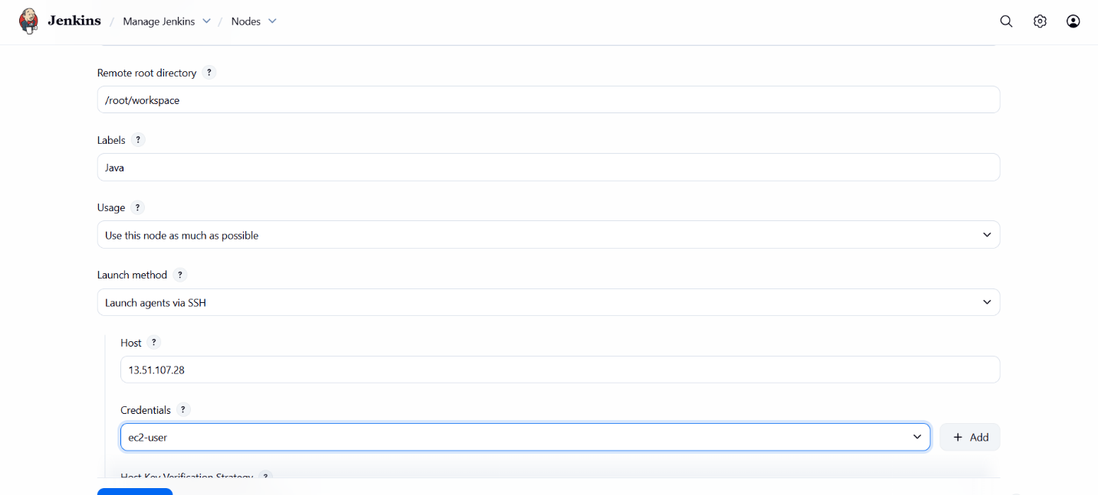
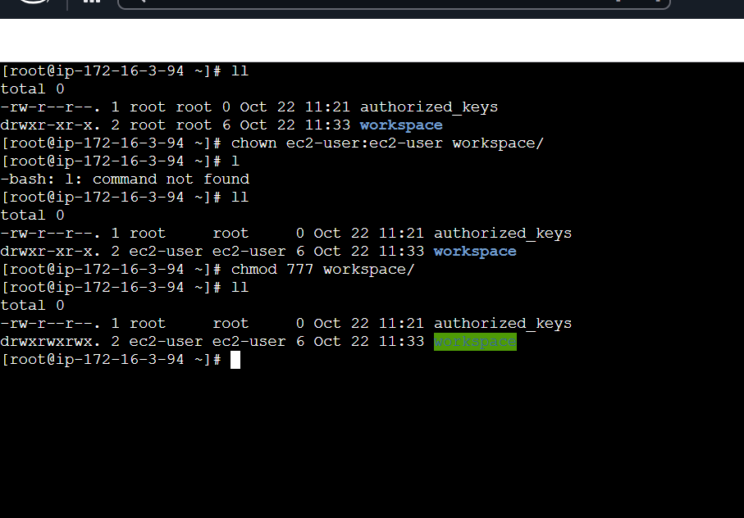
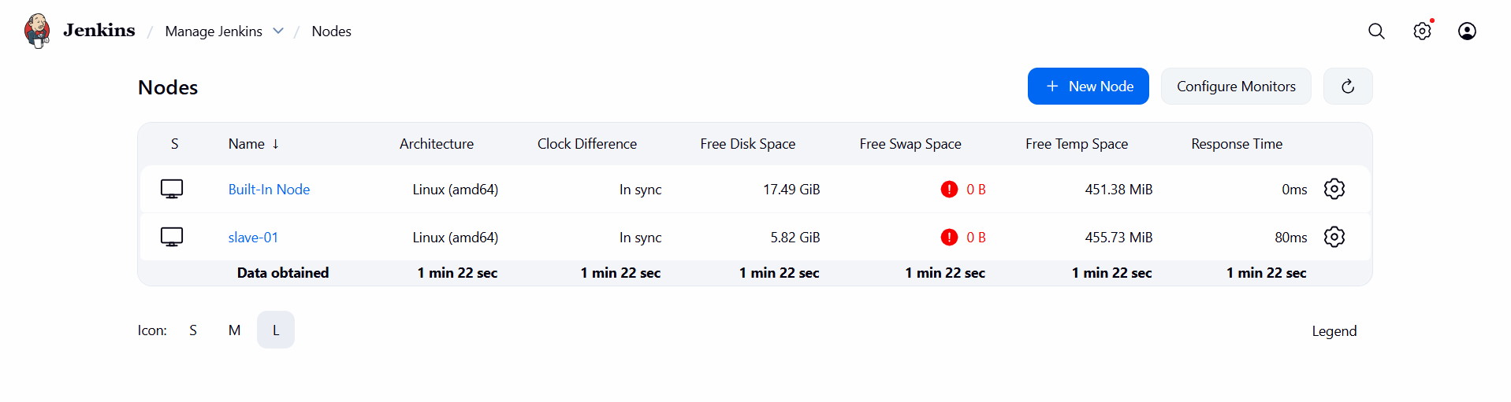
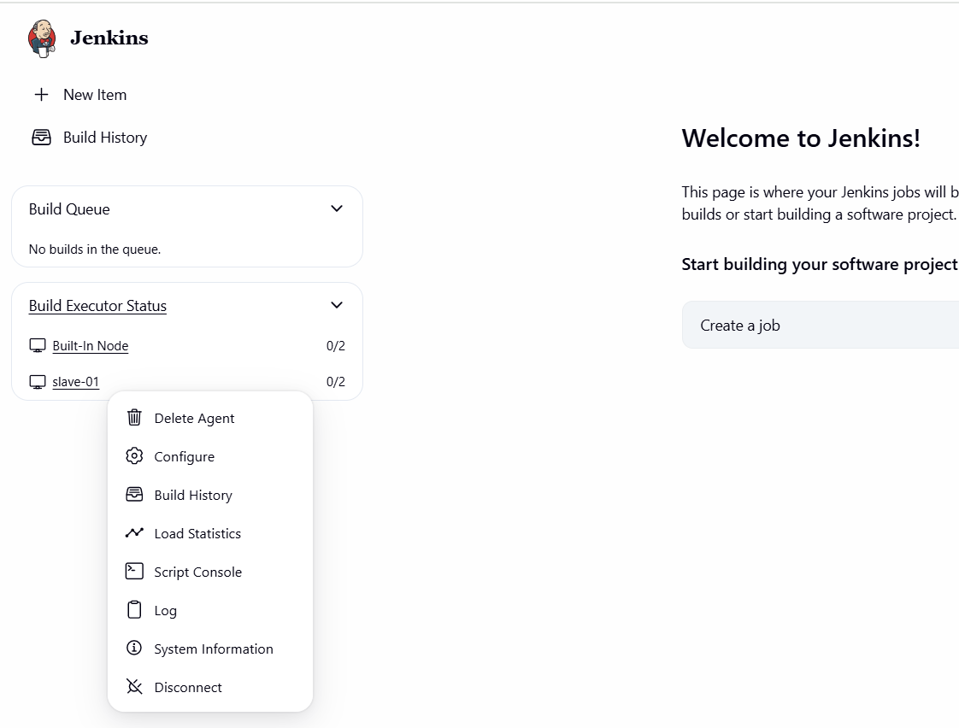
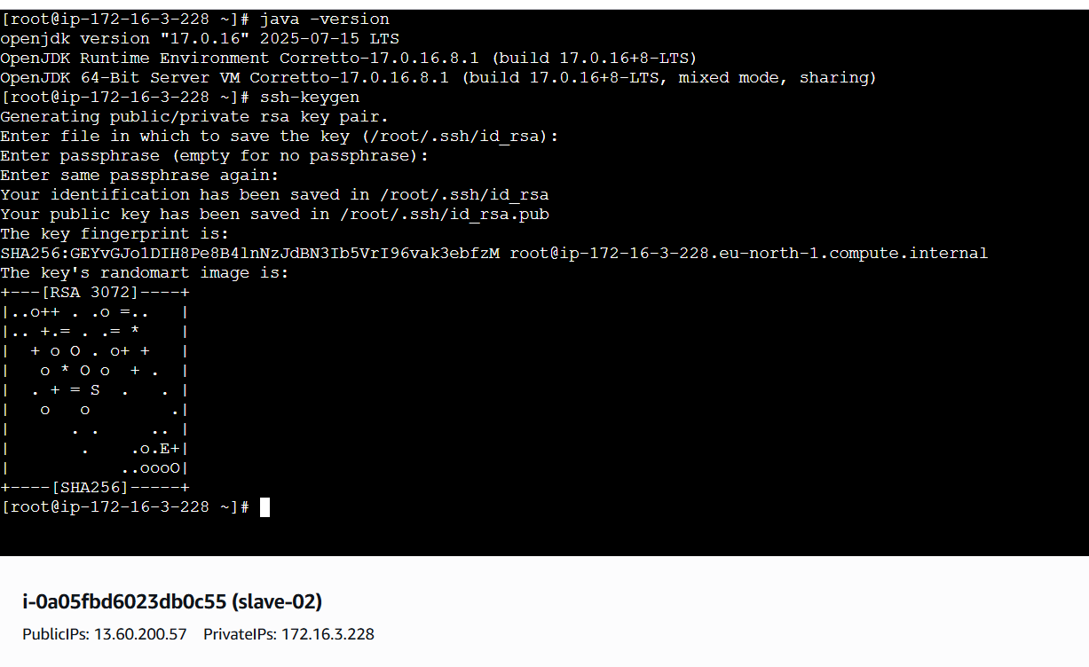
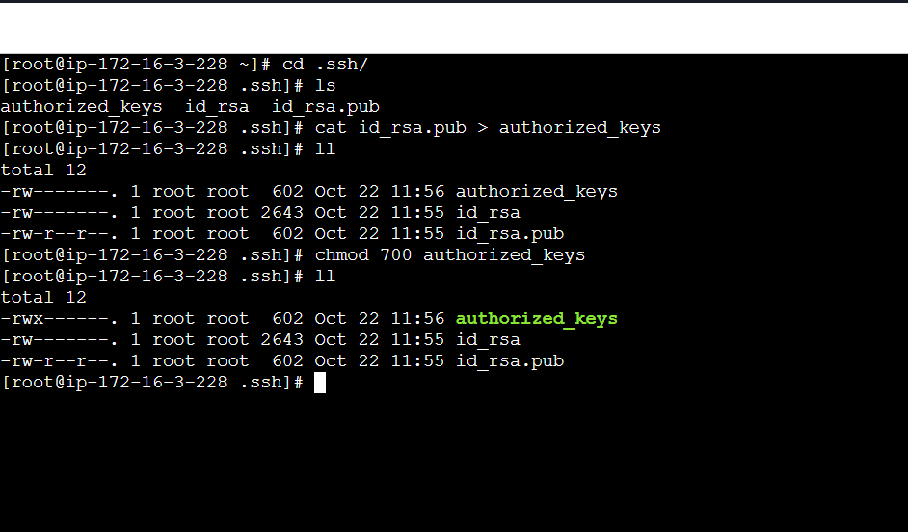

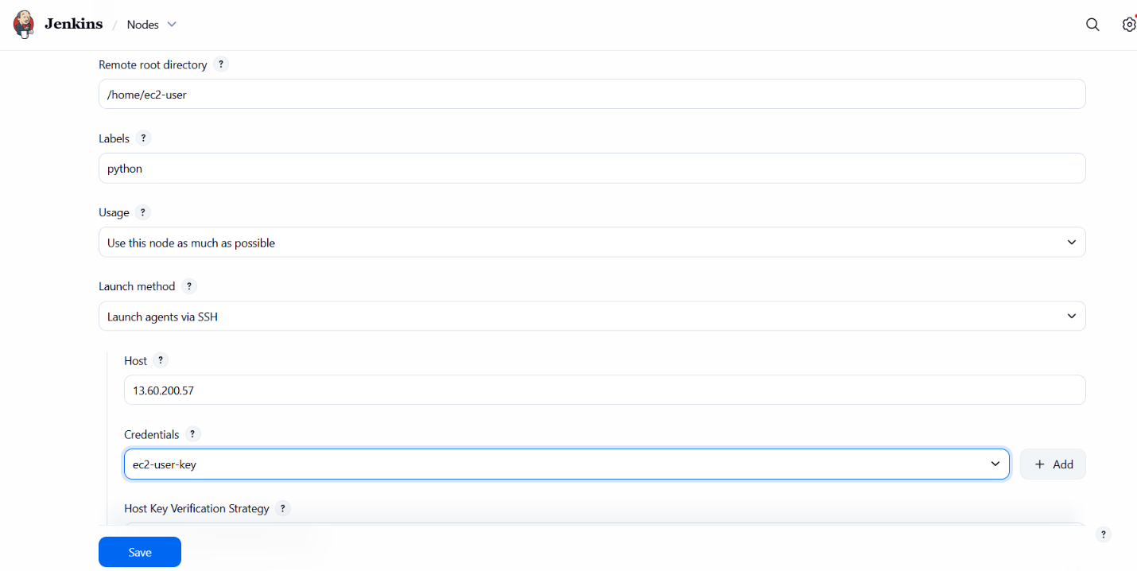
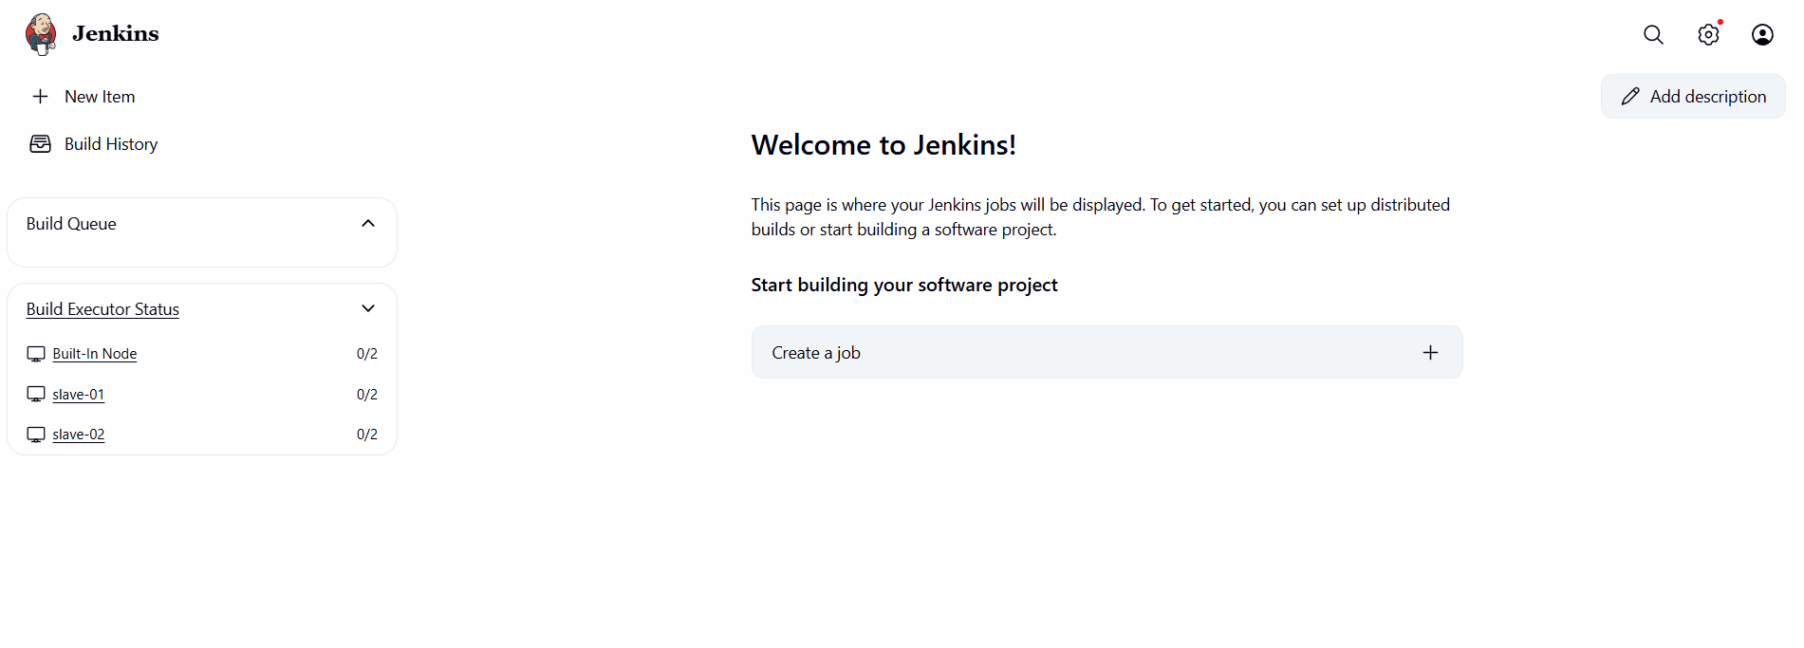
2.Configure webhooks to Jenkins job.
Configure GitHub Webhook
•Go to your GitHub repository → Settings → Webhooks → Add
webhook.
•In the Payload URL, enter:
•http://<your-jenkins-server>:8080/github-webhook/
•Click Add webhook.
•Choose Send me everything
Verify
•Push a commit to your GitHub repo.
•Jenkins job should trigger automatically.
•Check Jenkins logs to confirm webhook was received

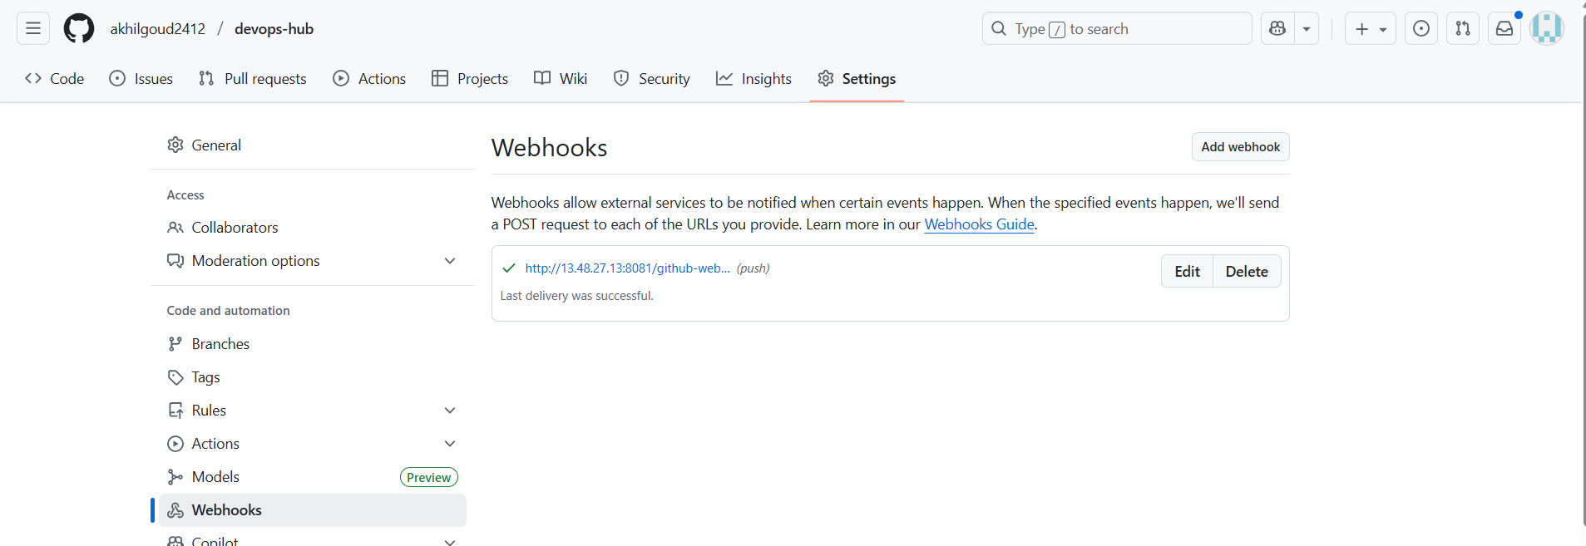
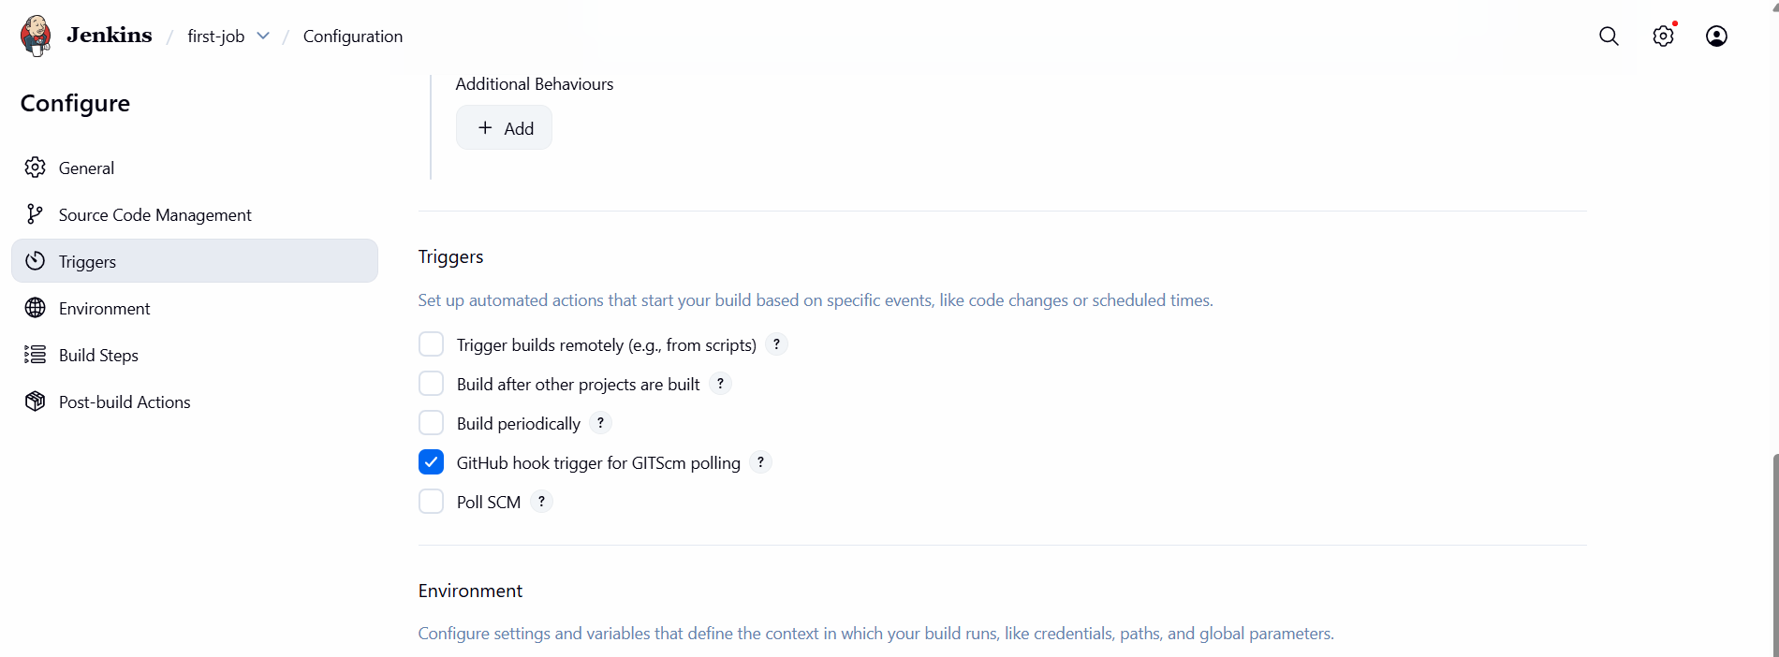
3.Configure poll scm and build periodical options in Jenkins job.
Build Periodically
This option triggers builds whether or not there are
SourceCodeManagement ( scm) changes.
•Go to your Jenkins job → Configure.
•Scroll down to Build Triggers.
•Check Build periodically.
•Enter a cron-style schedule in the Schedule box
Poll SCM
This option tells Jenkins to check the source code repository (Git, SVN,
etc.) at defined intervals. If it detects any change (new commit), it
triggers a build.
•Go to your Jenkins job → Configure.
•Scroll down to Build Triggers.
•Check Poll SCM.
•In the Schedule box, use cron-style syntax

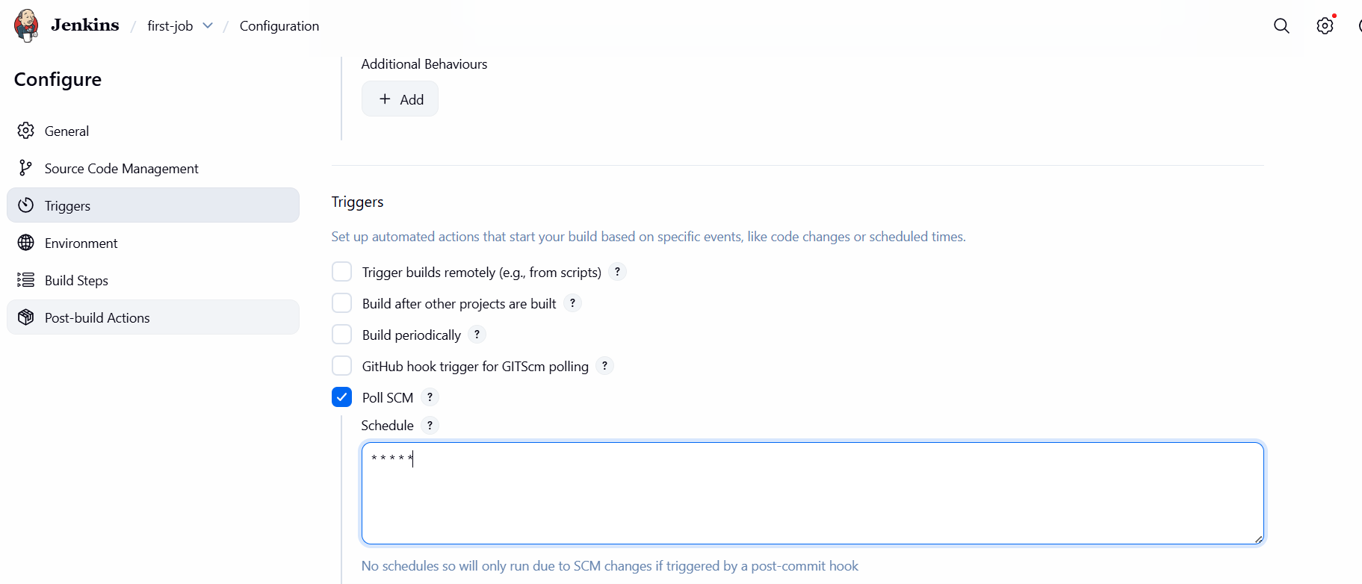
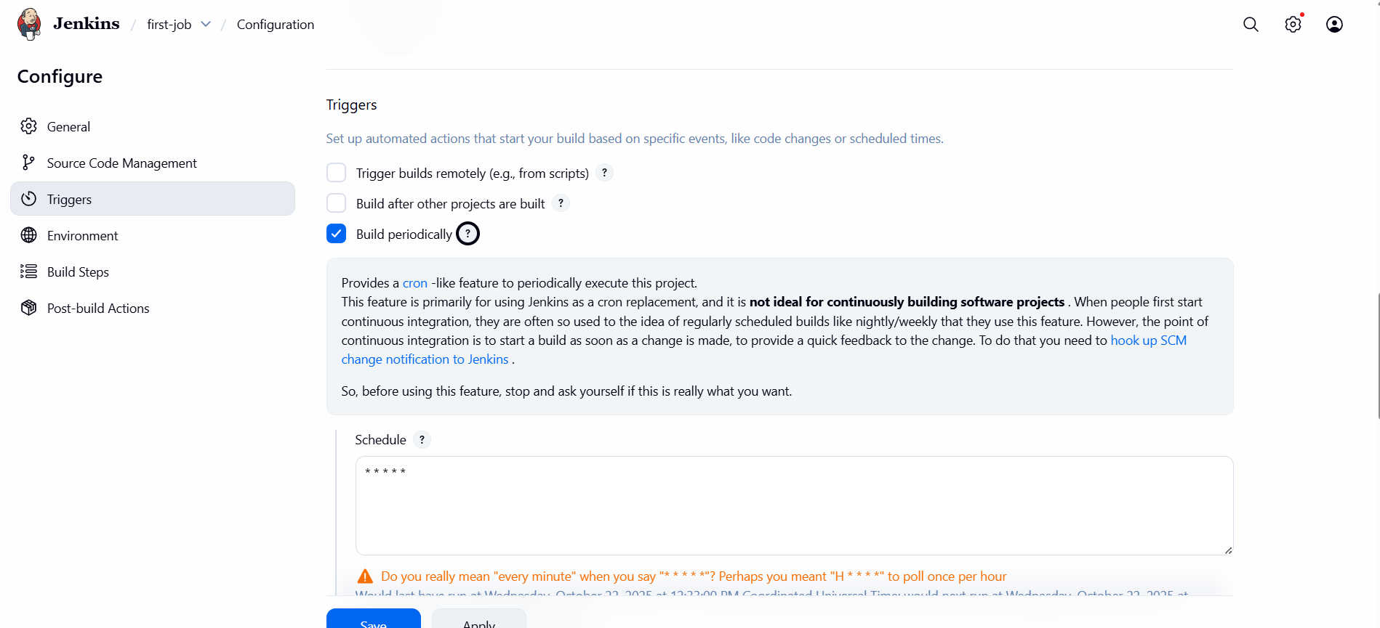
4.Take backup of Jenkins server by using bash script
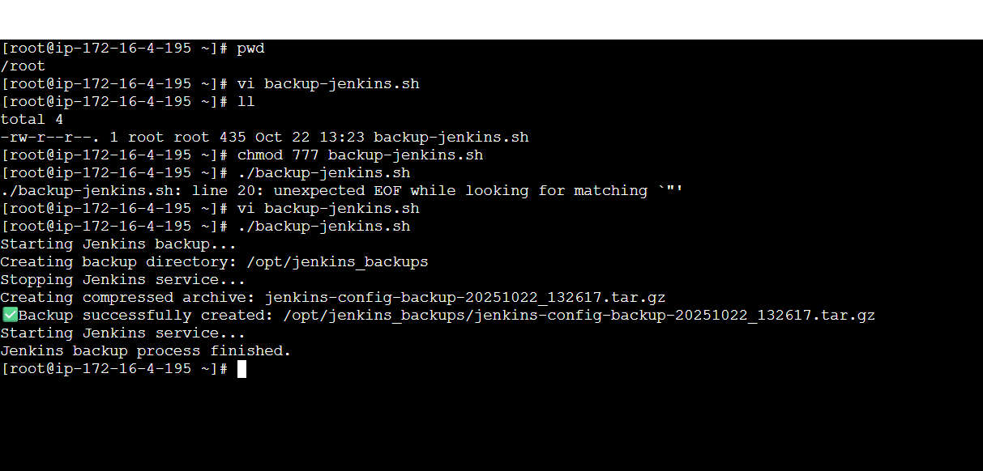
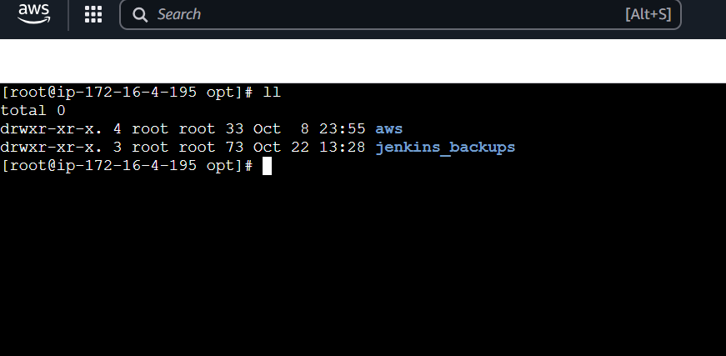
5.Take backup of Jenkins using rethin backup plugin.
1. Go to Manage Jenkins → Manage Plugins.
2. Click the Available tab.
3. Search for ThinBackup.
4. Check the box next to ThinBackup.
5. Click Install without restart
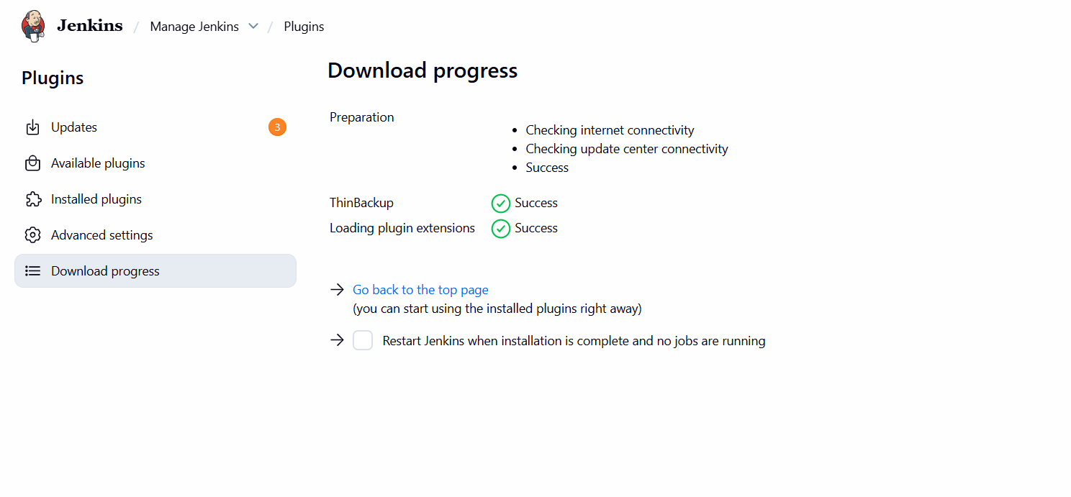

6.Setup a new Jenkins server and dump the backup taken in task4
