- Jenkins-03
- Create one jenkins job using the below code and
create three stages.
stage1: Git clone to download the source code.
stage2: Sonarqube Integration to check the quality of
code
stage3: Slack Integration to send the alerts to slack.
URL: https://github.com/betawins/VProfile-1.git

stage1: Git clone to download the source code.
Step 1: Open Jenkins Dashboard
Go to your Jenkins URL → http://<your-server-ip>:8080/
Step 2: Create a New Job
1. Click on “New Item”
2. Enter a job name → e.g. - VProfile.
3. Select “Freestyle project”.
4. Click OK.
Step 3: Configure Git Repository
1. In the job configuration page:
oScroll to Source Code Management.
oSelect Git.
oIn Repository URL, enter your Git repo link:
https://github.com/betawins/VProfile-1.git
In Branches to build, specify the branch (default: */main or */master)
- Step 4: Save and Build
•Click Save.
•Click Build Now.
•Check the Console Output → It should show Jenkins cloning the
repository.
Now successfully we have created the VProfile job and
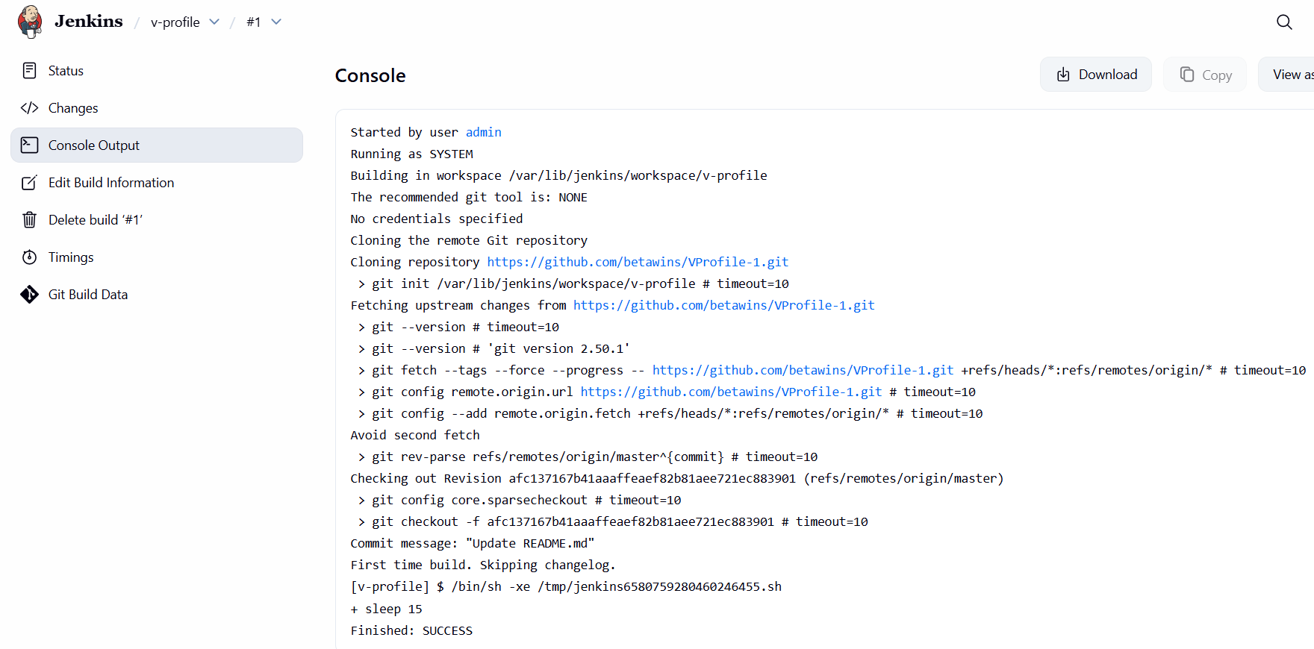
Now successfully we have created the VProfile job and
cloned the source code from git hub using the url

We can check by login to your ssh and incd /var/lib/Jenkins
cd workspace
in workspace we ll see the Vprofile

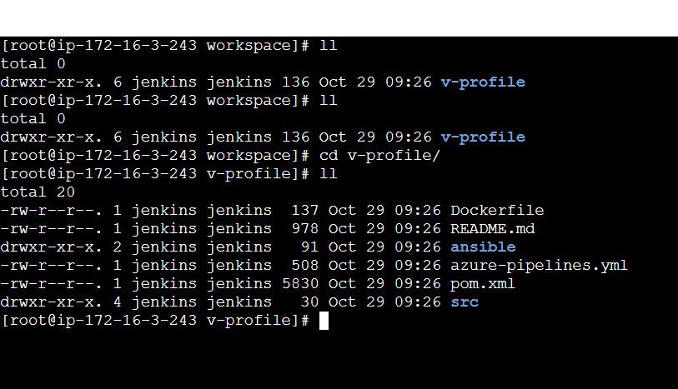

stage2: Sonarqube Integration to check the quality of
code
### Prerequisites
•EC2 instance with Java installed
•Use t2.large with atleast 20gb memory to run sonarqube.
•MySQL Database Server or MySQL RDS instance.

1.Step-by-Step SonarQube Installation on EC2
•Launch EC2 Instance
•Instance type: t2.large
•Storage: 20 GB (minimum)
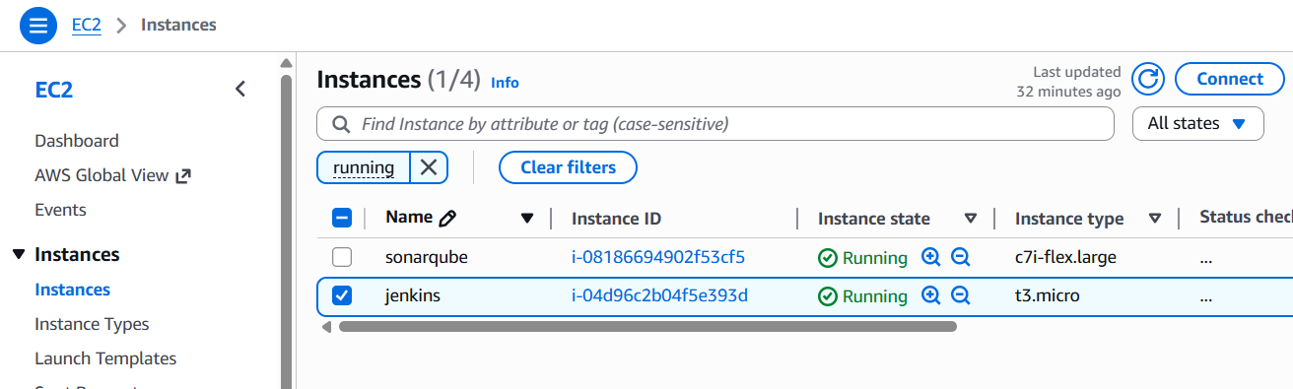
. Install Java
Install java 1.8 version
yum install java-1.8*

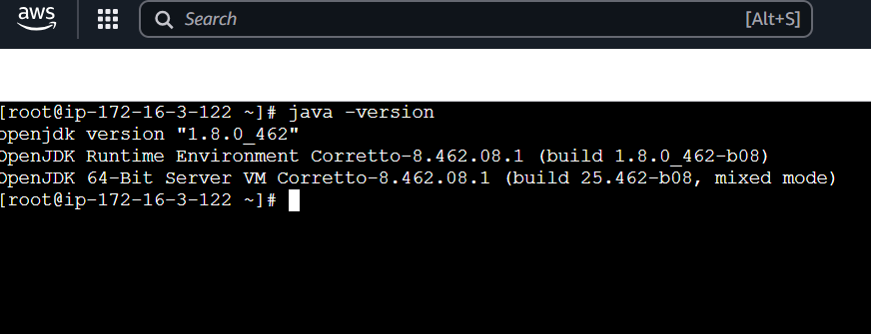
3.Install & Configure MySQL
Add mysql rpm Repository
sudo wget https://dev.mysql.com/get/mysql57-community-release-el7-11.noarch.rpm
sudo yum localinstall -y mysql57-community-release-el7-11.noarch.rpm
sudo rpm --import https://repo.mysql.com/RPM-GPG-KEY-mysql-2022
sudo yum install -y mysql-community-server

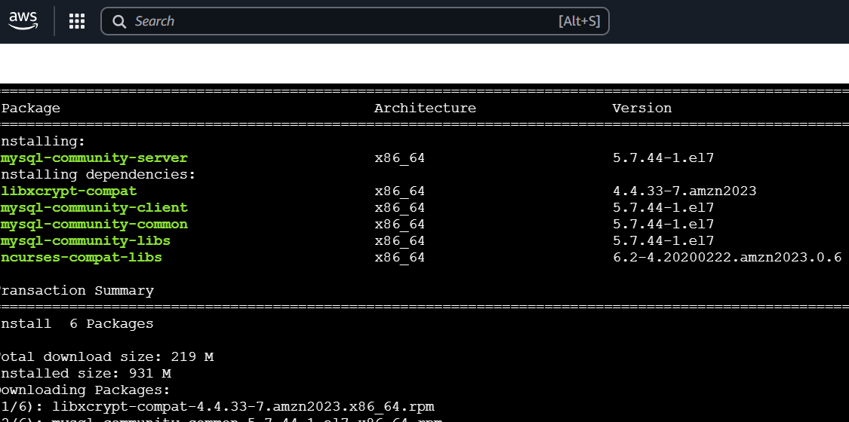
Start MySQL and Enable Start at Boot Time
systemctl start mysqld
systemctl enable mysqld
Check if mysql is running or not
netstat -na | grep 3306

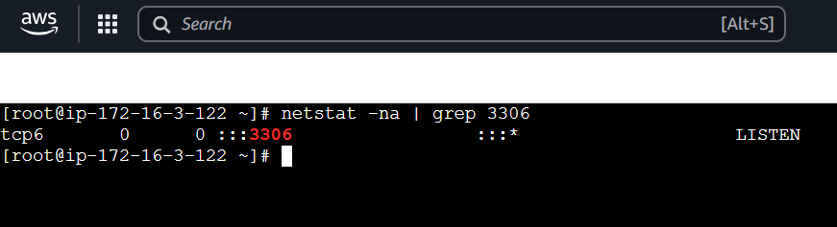
4. Configure MySQL Root Password
Configure the MySQL Root Password
You will see default MySQL root password
grep 'temporary' /var/log/mysqld.log
Login to mysql using the default password
mysql -u root -p
Now replace the default password with a new and strong password
ALTER USER 'root'@'localhost' IDENTIFIED BY 'Admin@123';
flush privileges;
Test Using new password
mysql -u root –p

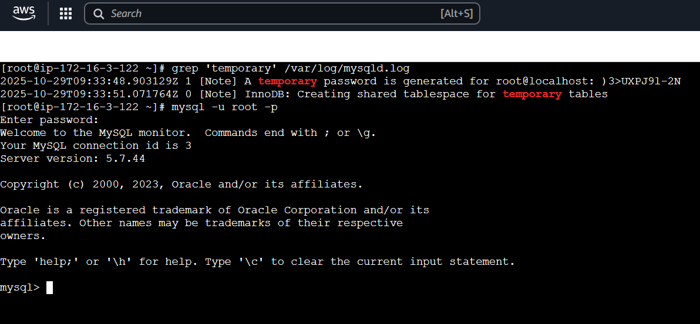
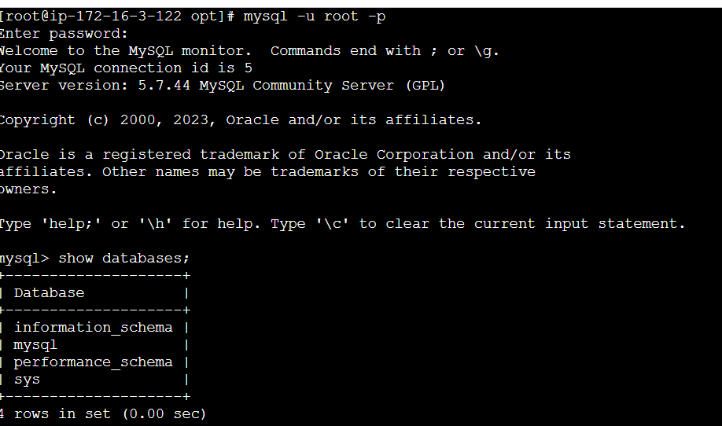
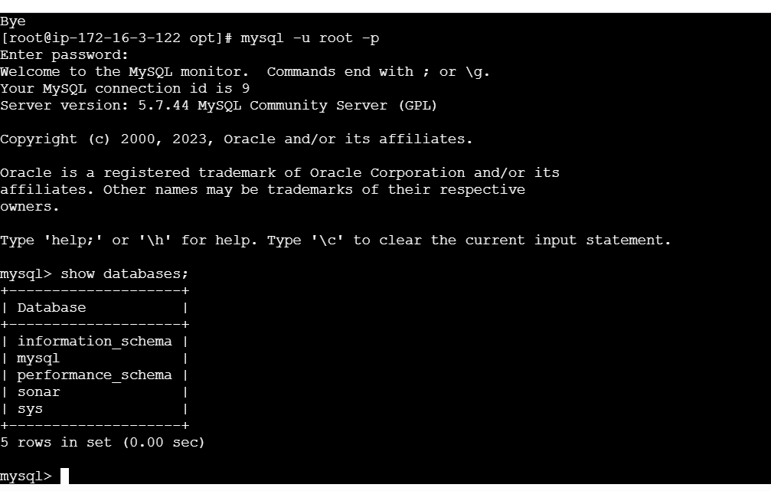
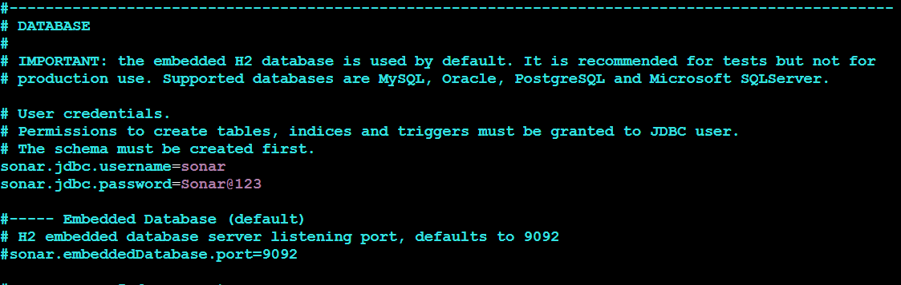
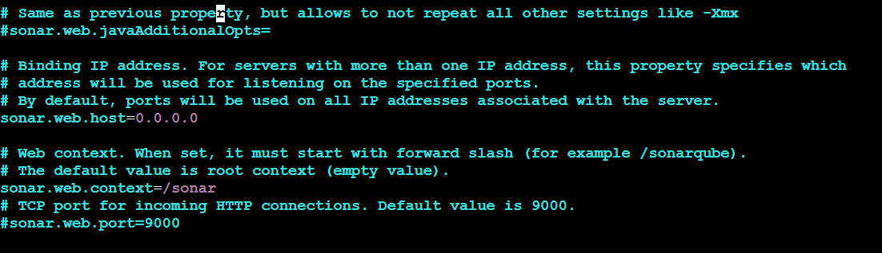
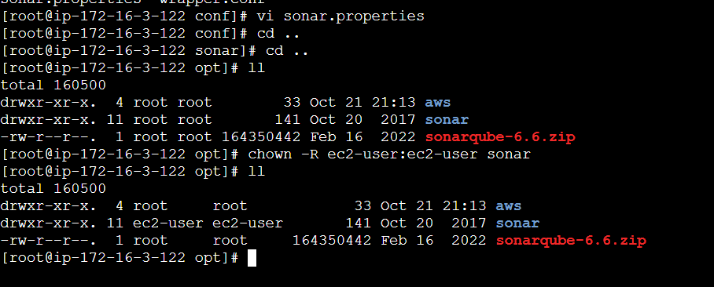
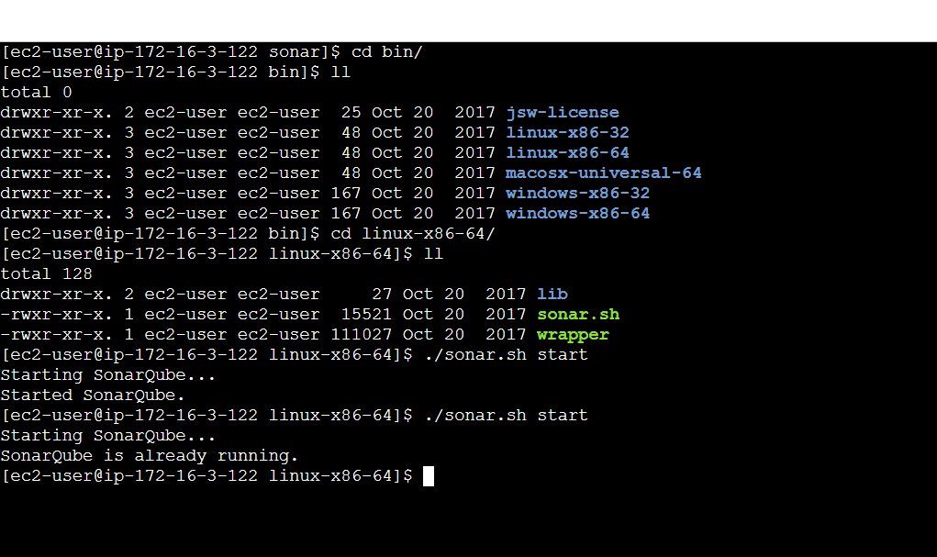
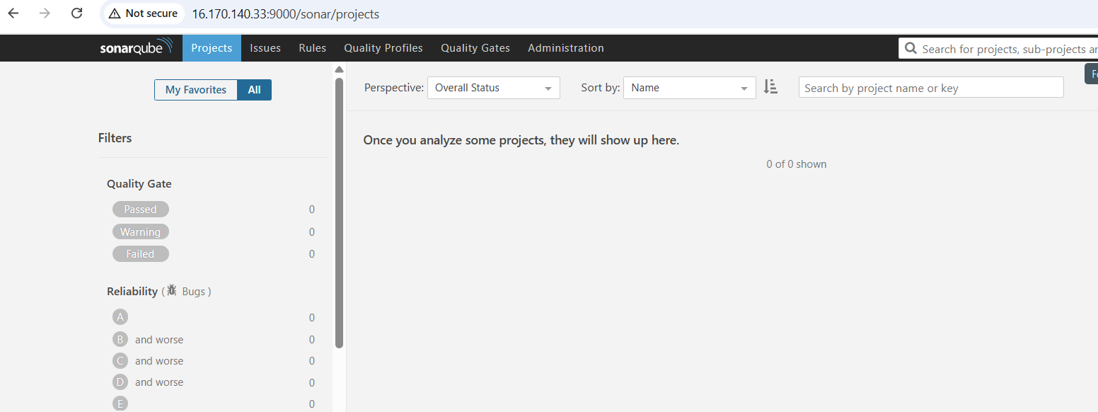
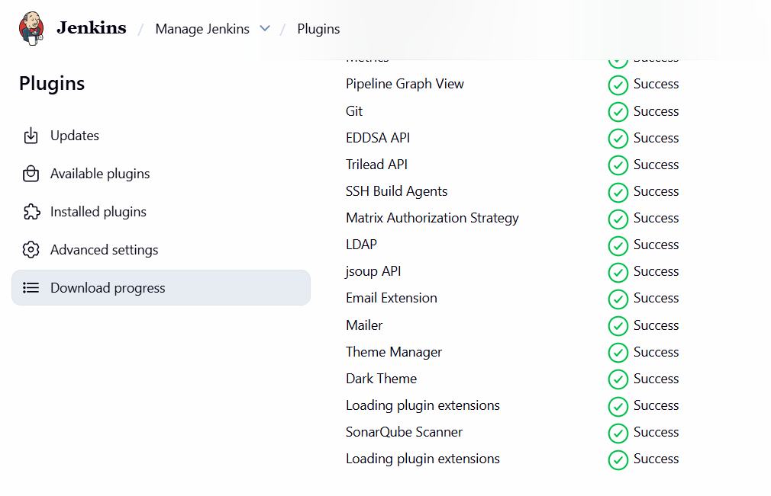
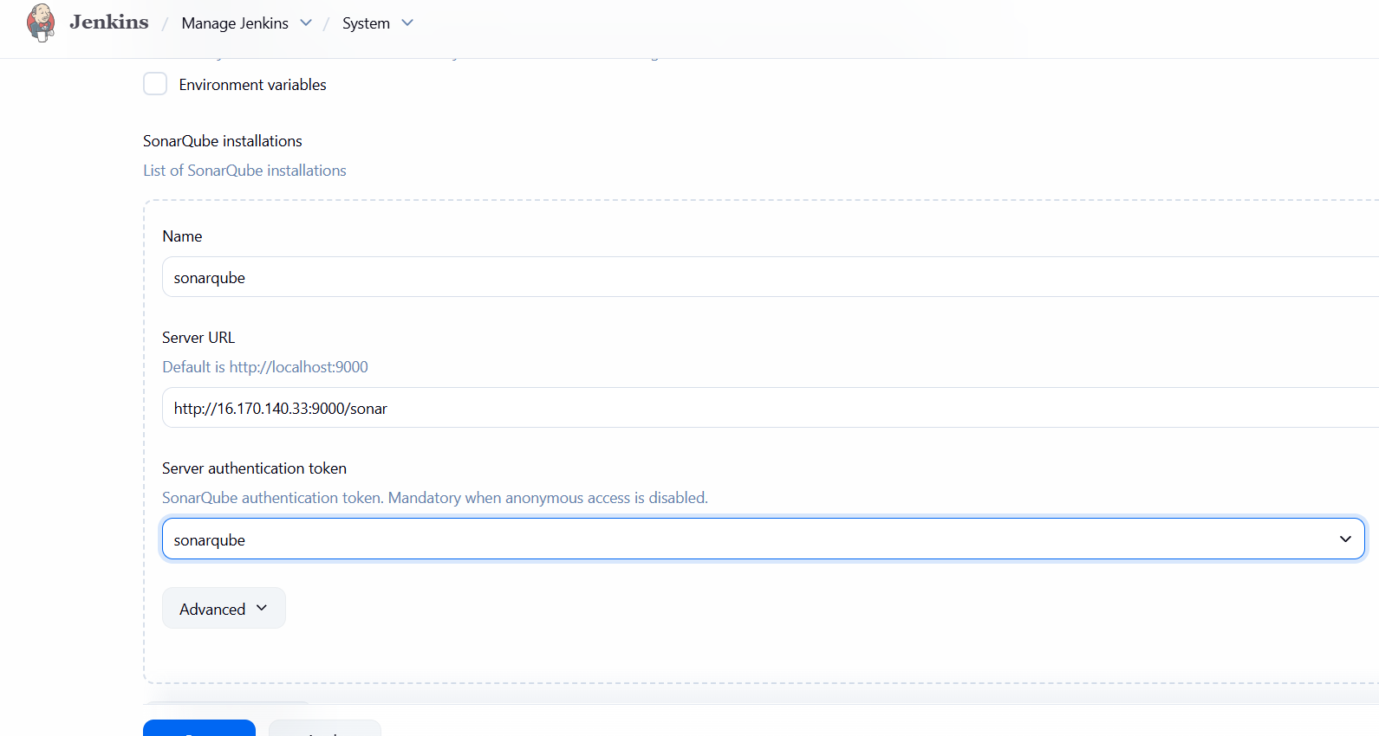
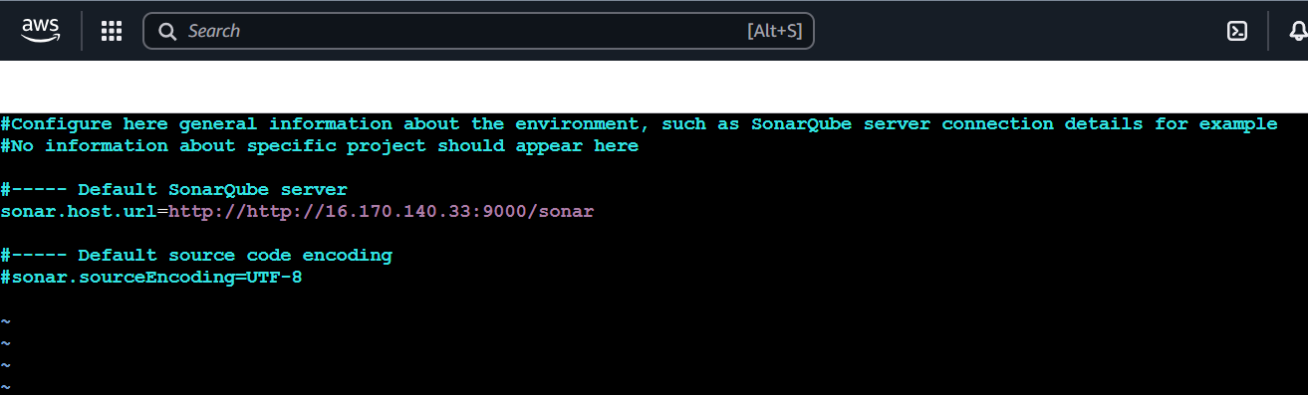
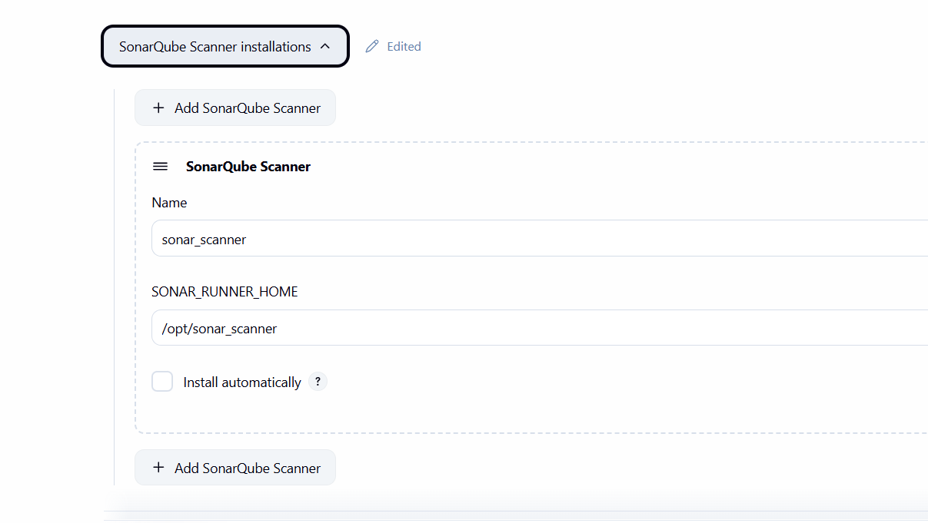
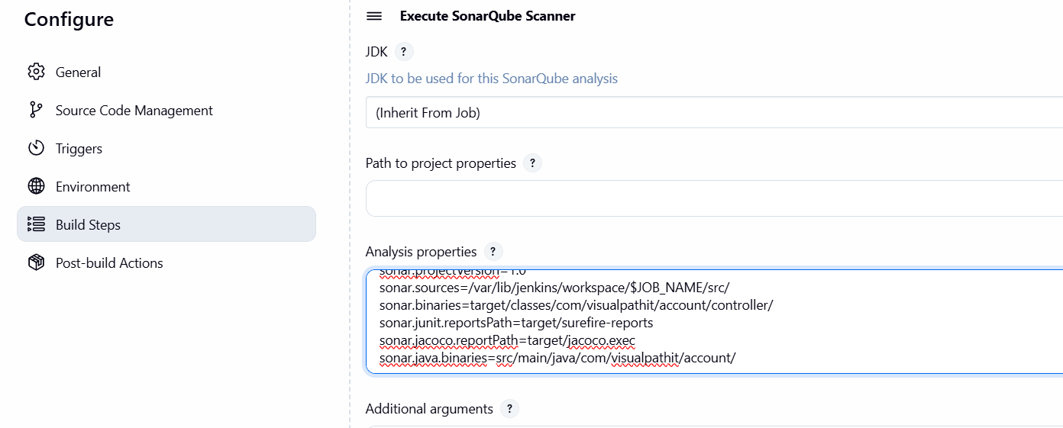
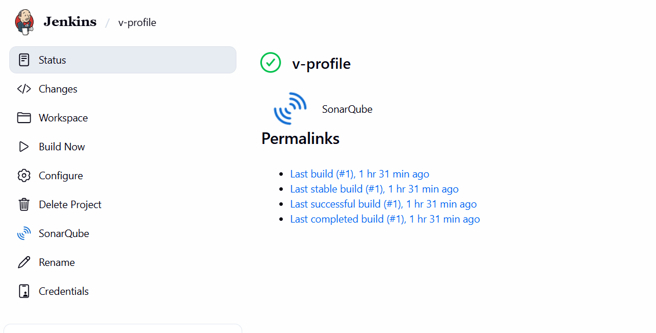
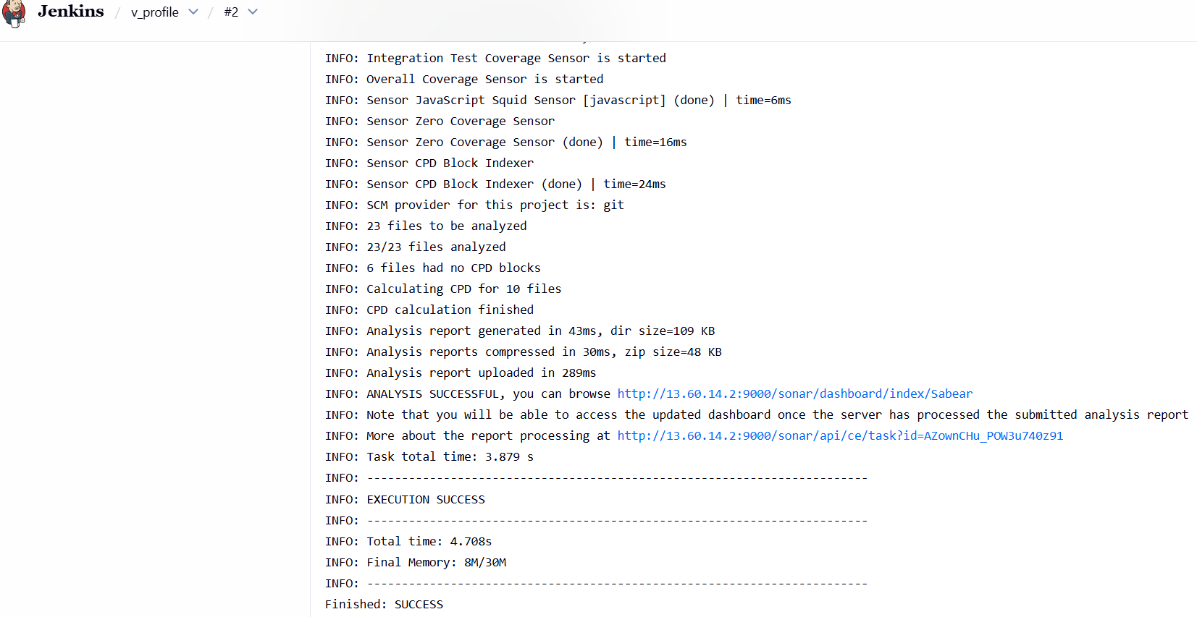
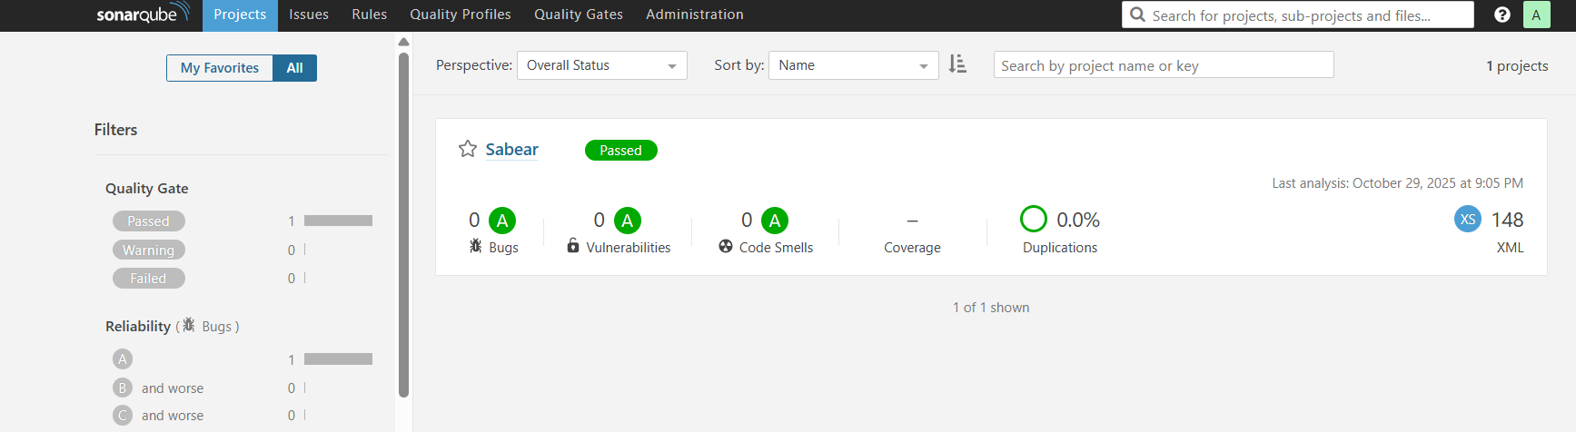
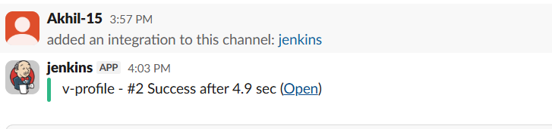
2. Create one jenkins job using the below code and create
three stages. stage1: Git clone to download the source
code. stage2: Sonarqube Integration to check the quality
of code stage3: Slack Integration to send the alerts to
slack. URL: https://github.com/betawins/hiring-app.git
