- Configure VPC peering in cross regions.
- Crete two vpc in two different region or zone
- Create peering connection
- Select the same account and different region
- Provide the acceptor vpc and requestor vpc
- create the peering connection

- 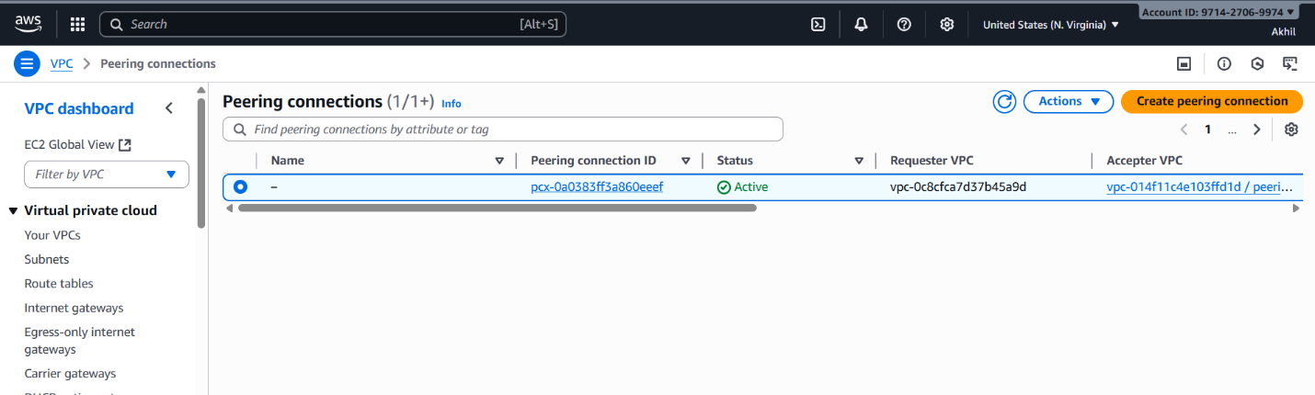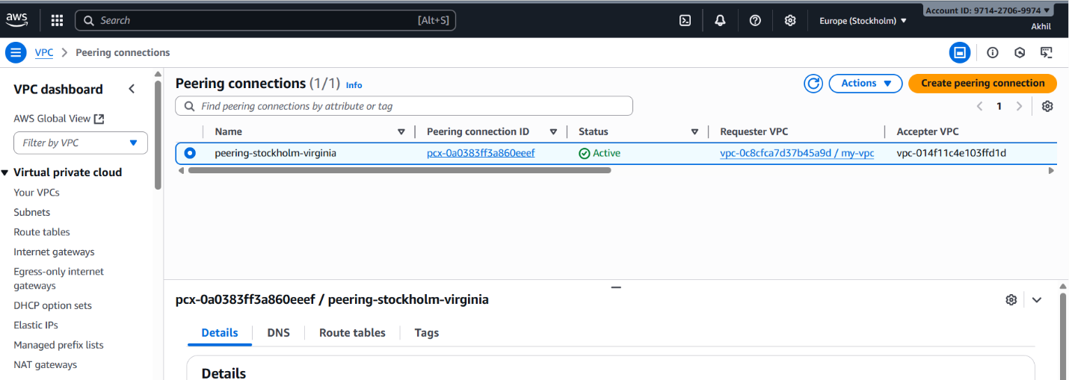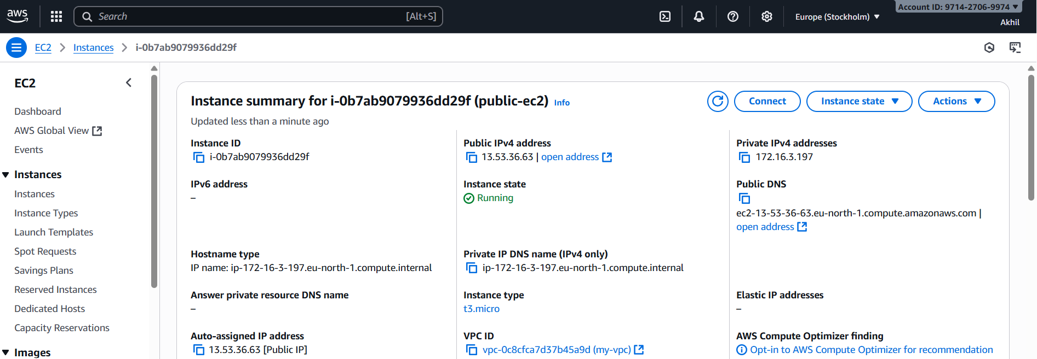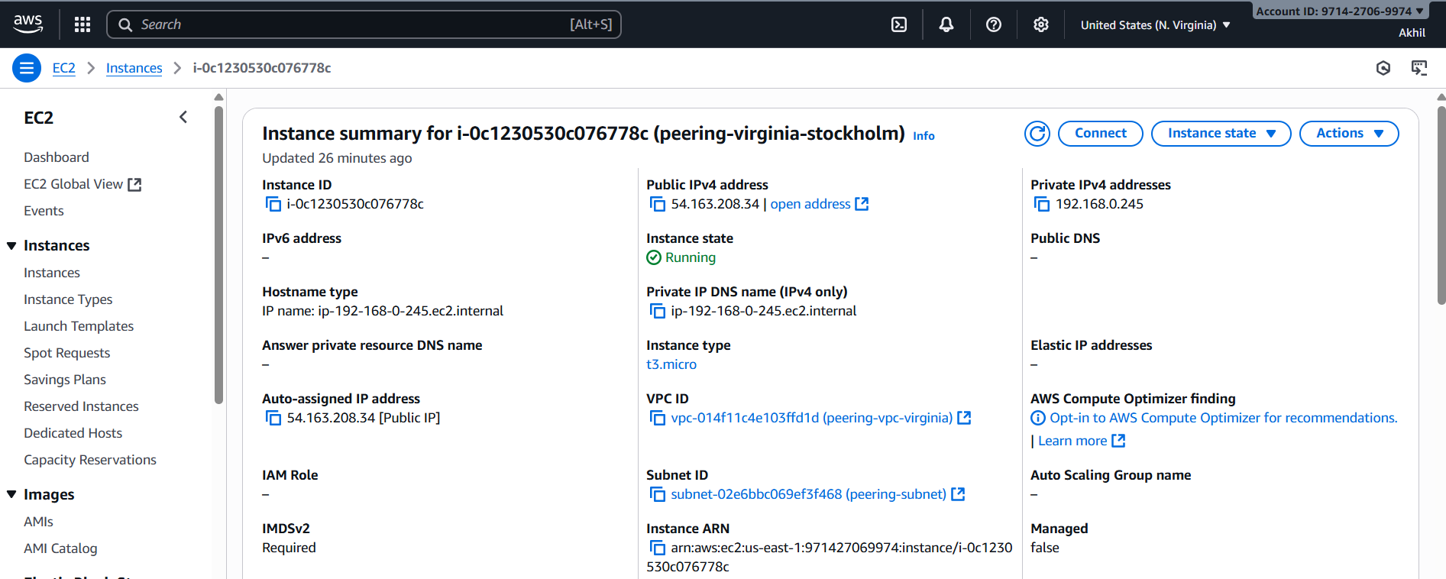

- 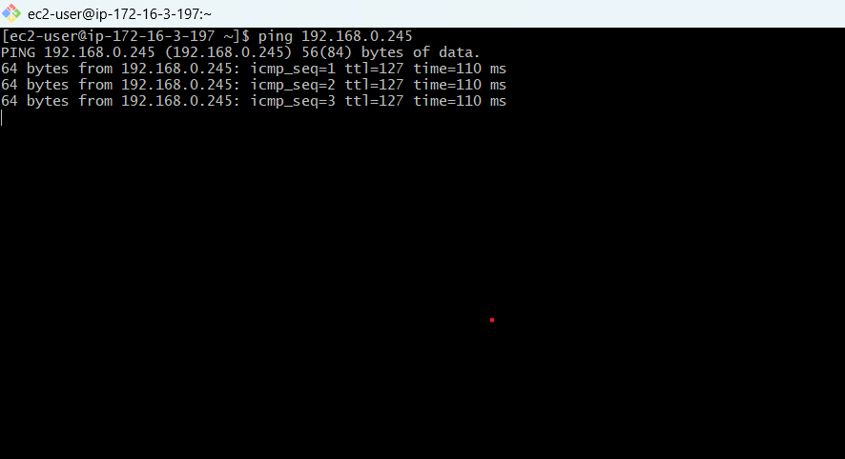

- Purchase one domain from GoDaddy.
- Go to go daddy
- Search for domain find the domain with your estimated price
- Select the time period youwant it for
- Add cart -- checkout – payment
- Domain has been purchased
- You will get the confirmation mail after buiying

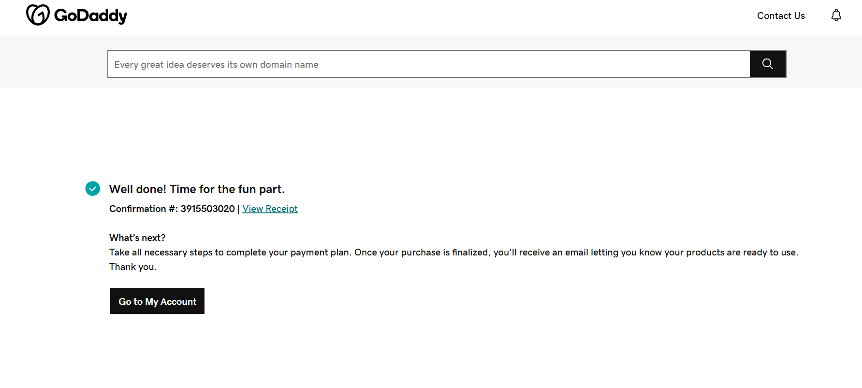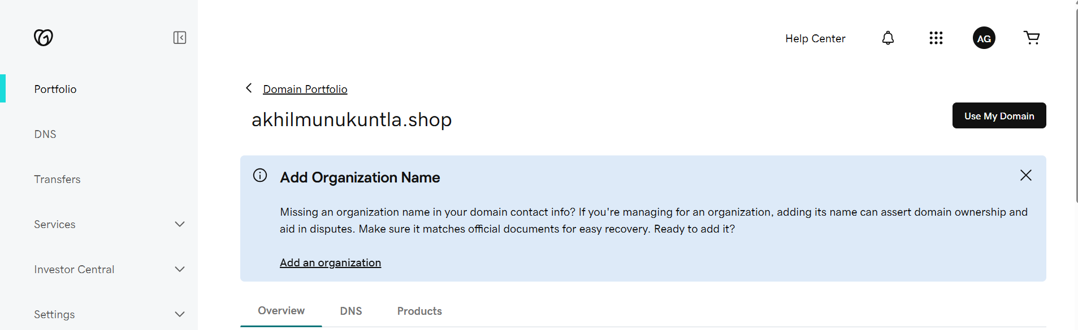
3.Deploy static website in S3
- Go to the s3 bucket
- Properties – enable statis website hosting.
- Give the files names index.html & error.html
- The save the website hosting will be established
- Upload the index.html & error.html files to the bucket make it public access
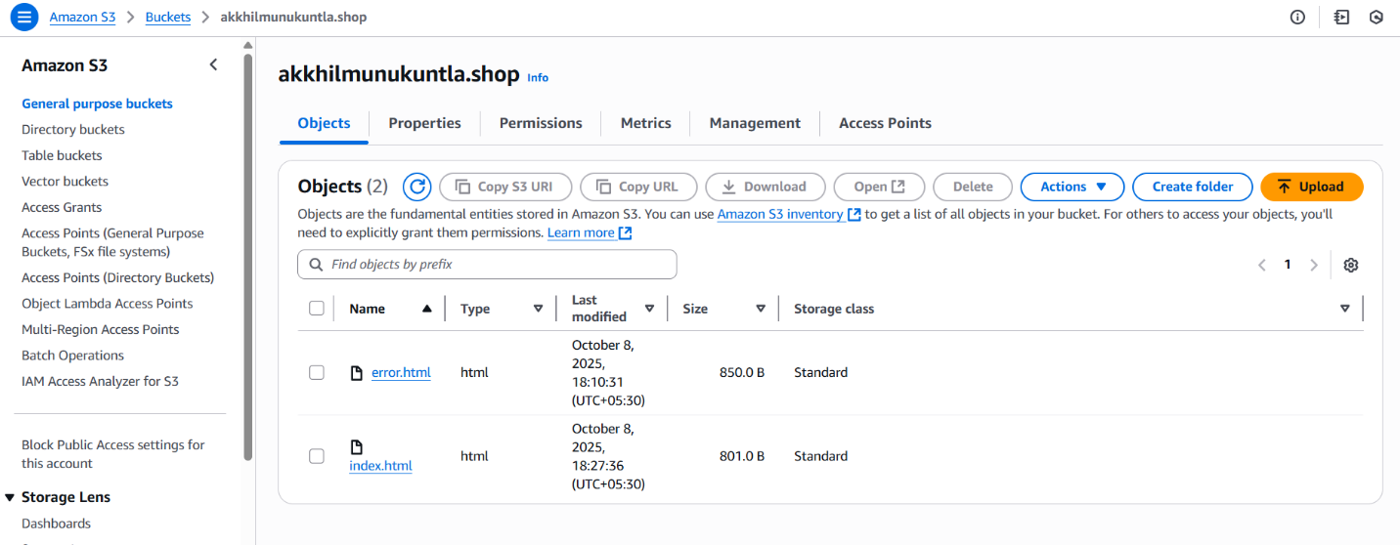
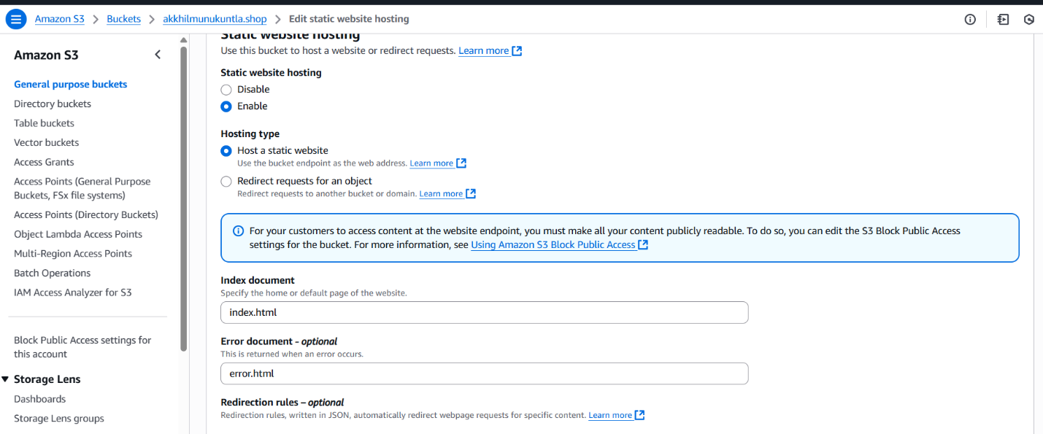
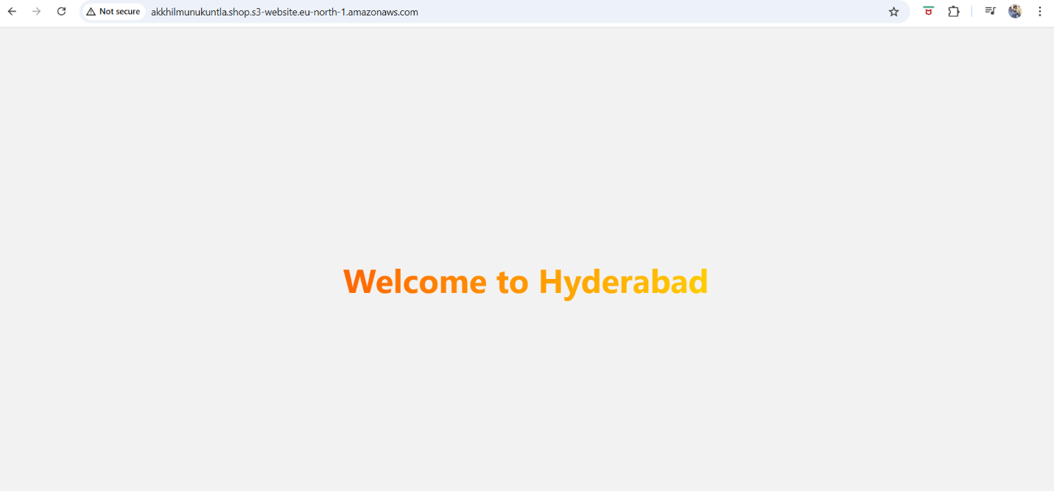
4.Create a CDN and attach one SSL certificate.
- Go to the certificate in aws console
- Provide the domain name that you purchased : parvezdevops.co.in
- Then click on request
- Wait for its validation it might take some time .
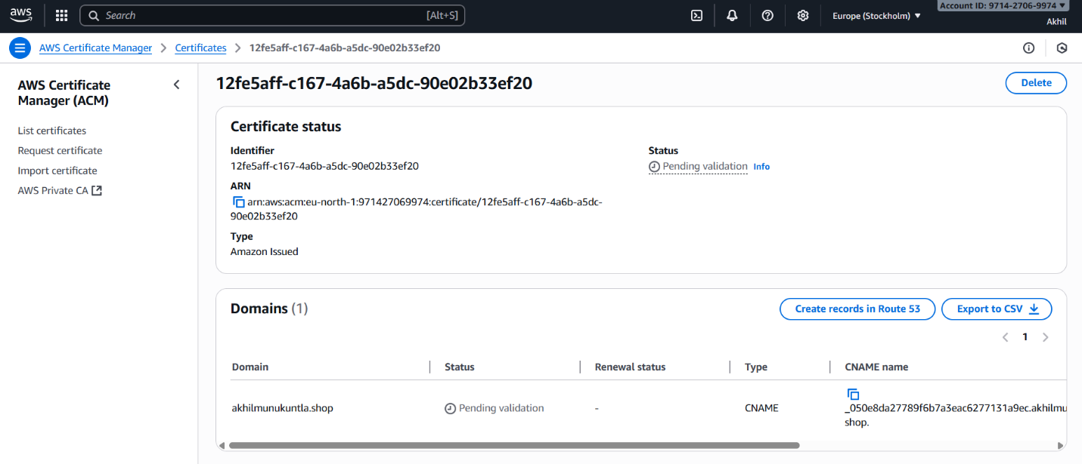
5.Create a Route 53 hosted zone and map the domain with the CDN.
- Go to root 53 in aws console
- Create records to the
- The four websites will be generated go to go daddy.com
- Your domain – name servers -copy the four dns names and add it in the server names

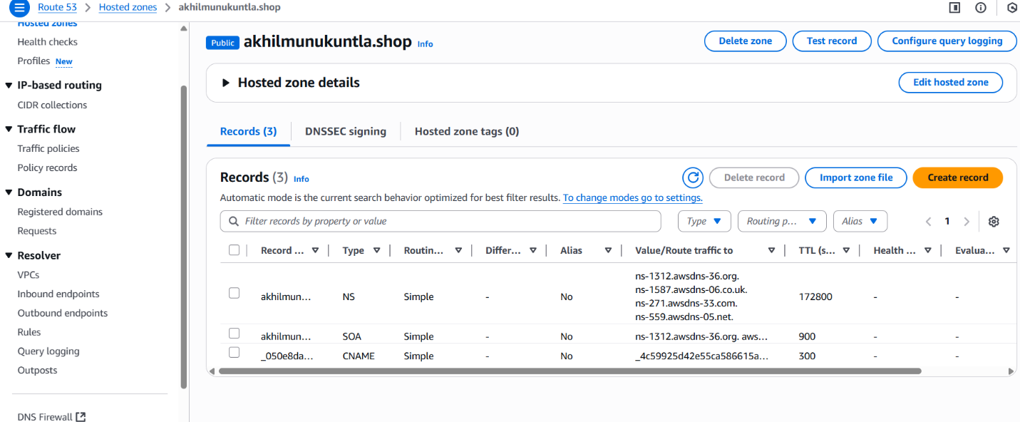

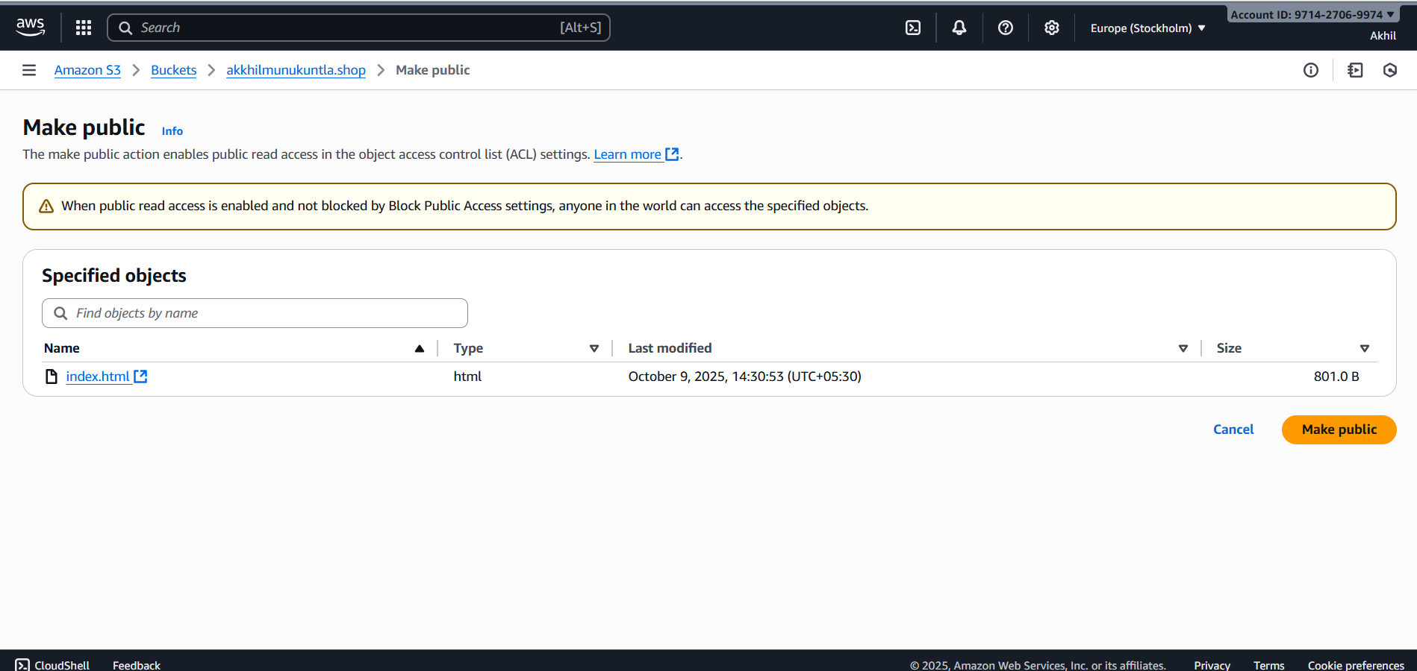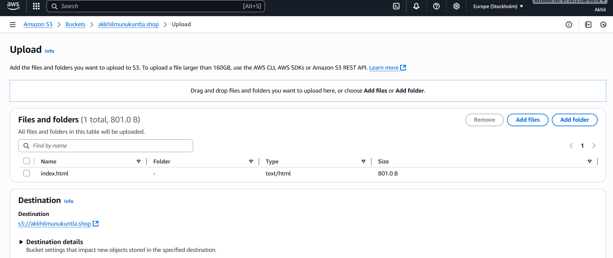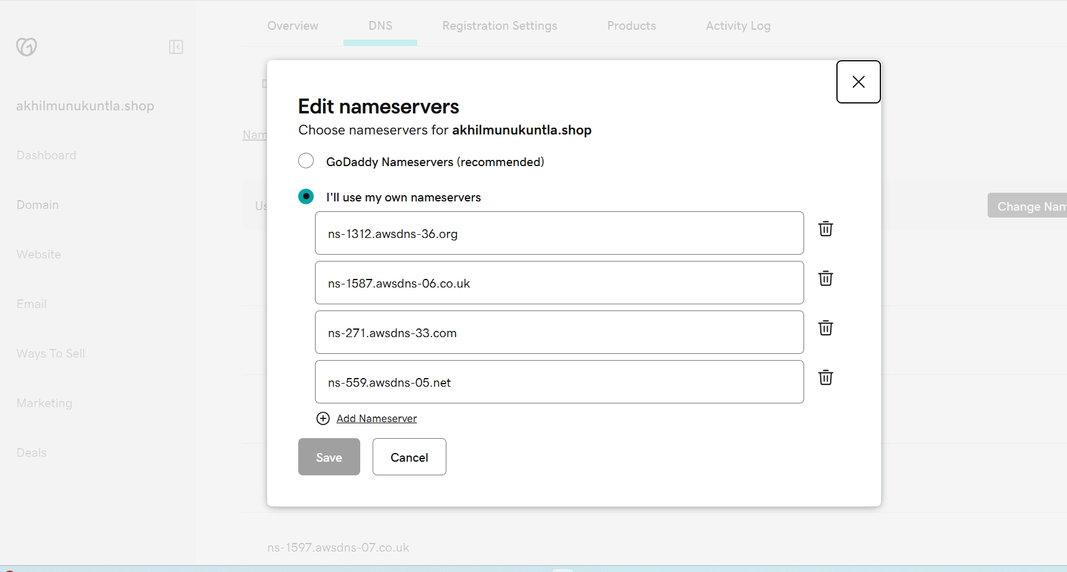

6. Update the index.html in the S3 bucket and ensure the updated file is accessible using the domain name.

- Go to the cloud front distribution.
- And copy the distribution domain name.
- And paste it in the browser.

- 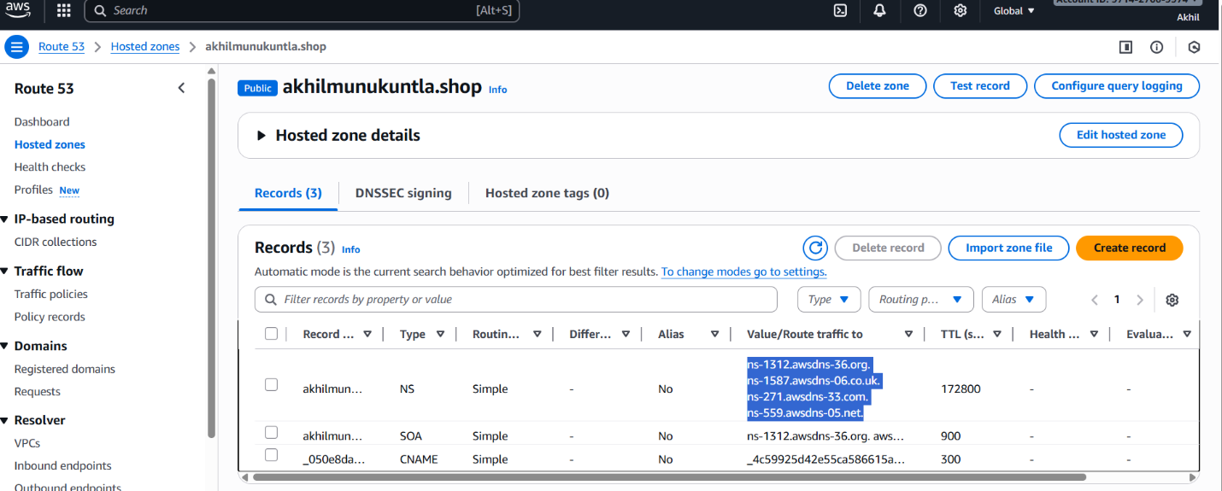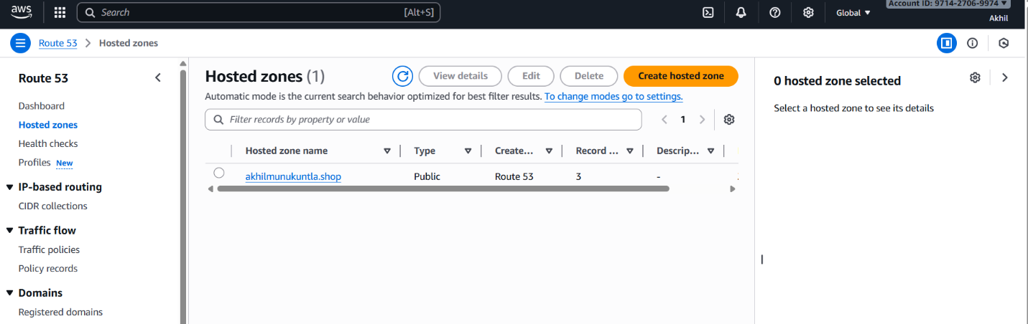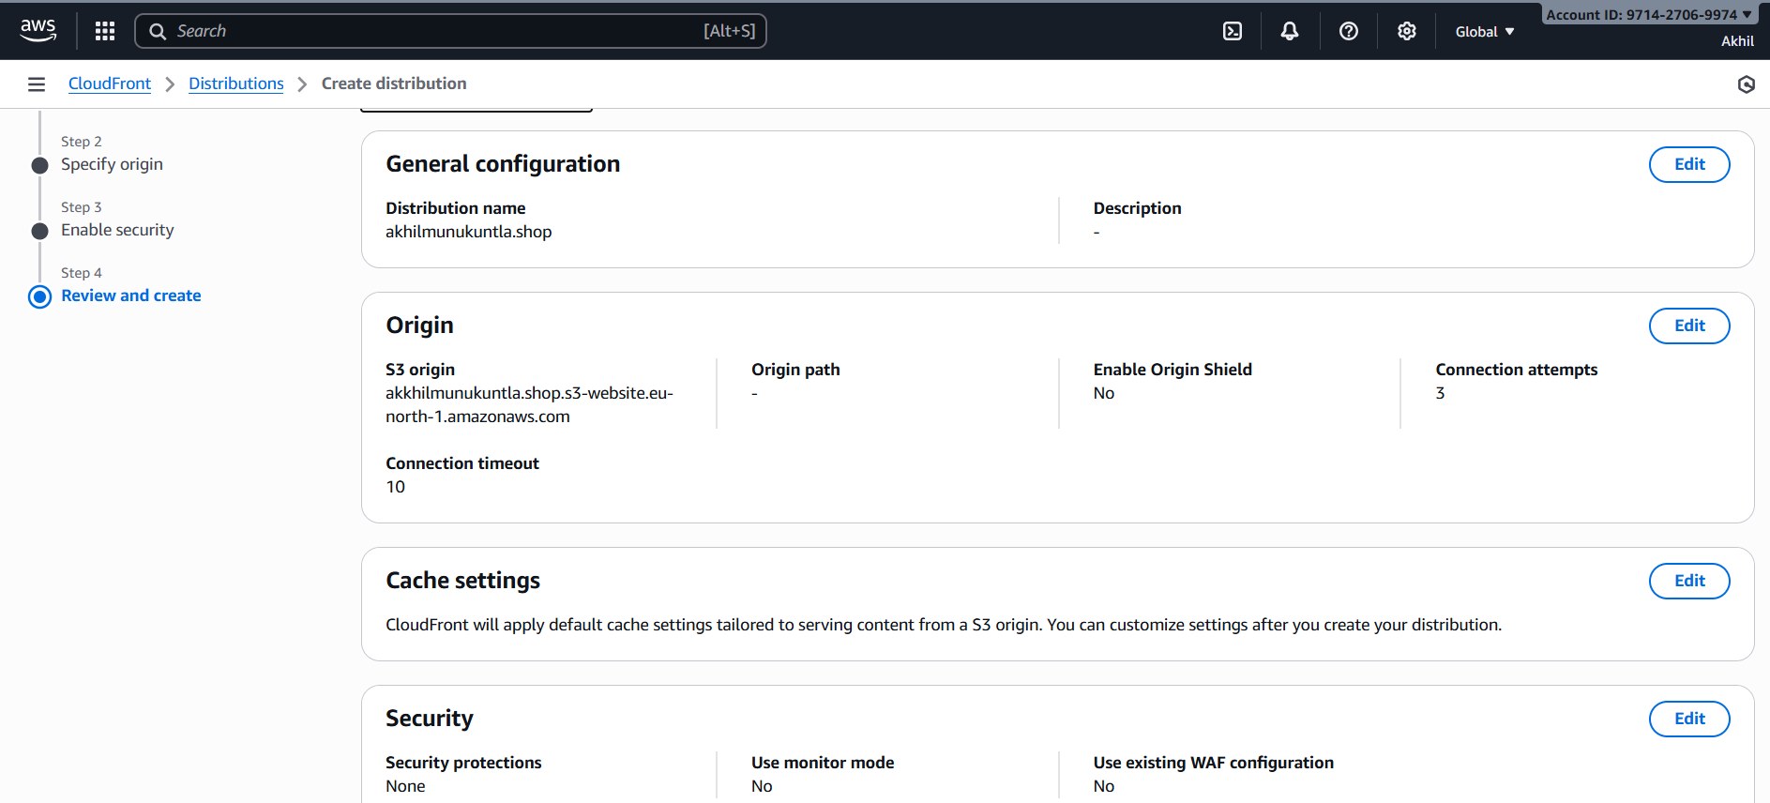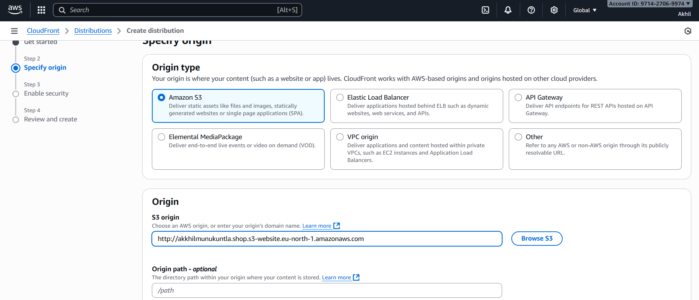
7.Share the domain name in Slack to test the connectivity.

