- Enable cloudtrail monitoring and store the events in s3 and cloudwatch log events.
- Go to cloud trail – create trail
- Create trail work flow
- Give the Name to the trail
- Enable logs and enable
- Create ne role for sns alert and then create trail logs
- Now go to cloud watch log groupsyou find the log created log streams check the logs.
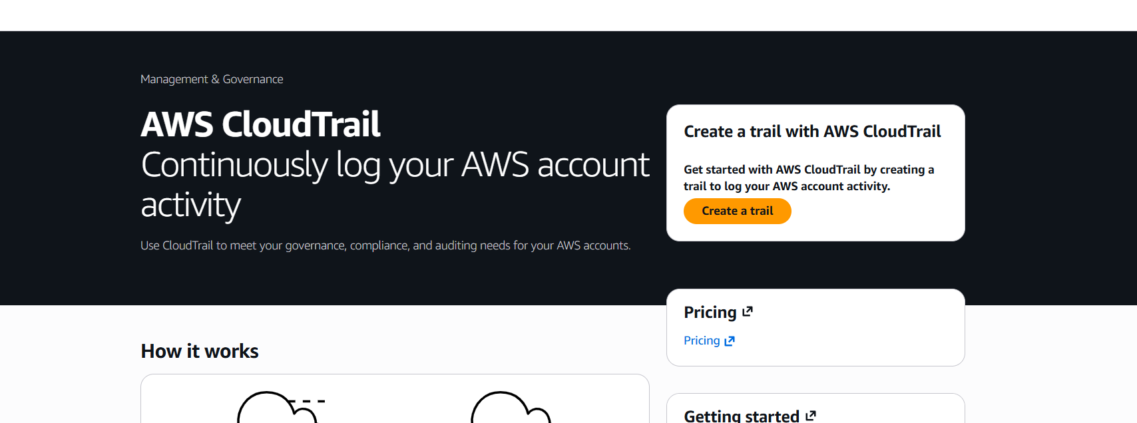
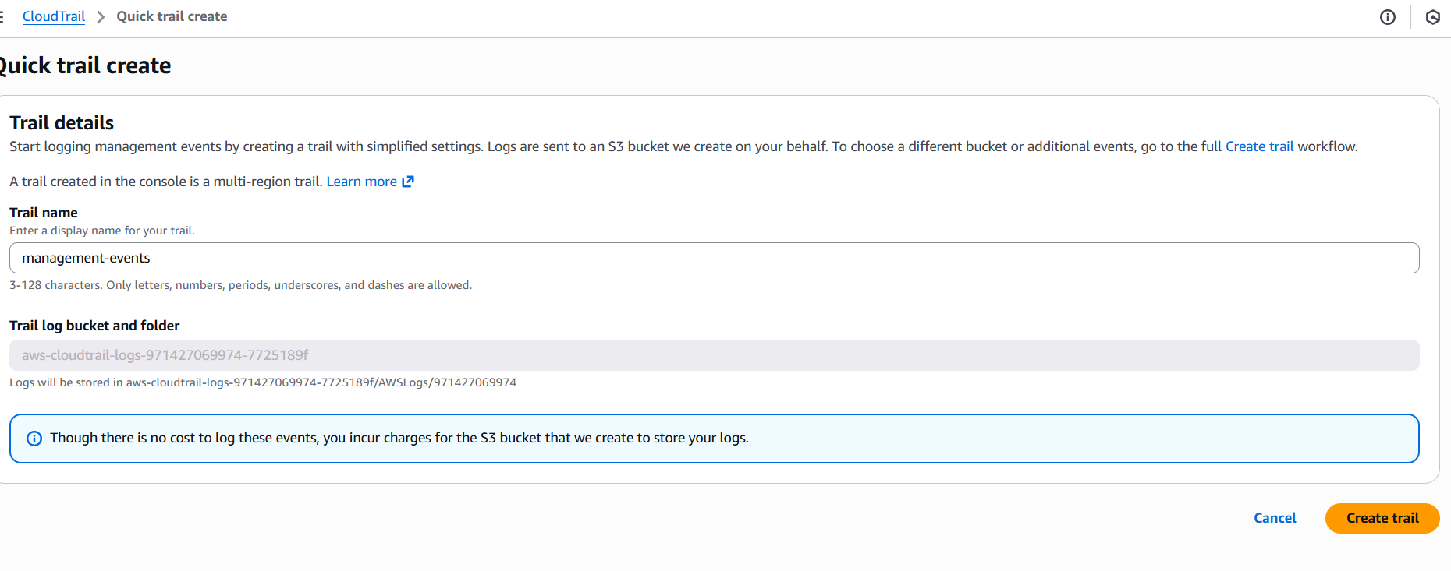
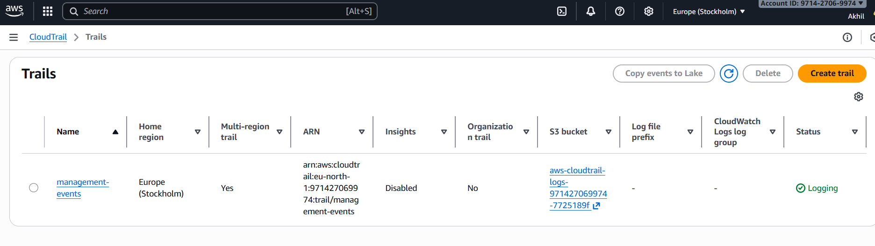
- Enable SNS for cloudtrial to send alert on email.
- Configure the sns for the cloud trail to send the alert to your phone or email
- Got to sns (simple notification service)
- Create subscriptiontopic nameprovide your email address and create the topic
- Confirm the the subscription fro your email then the sns is created successfully
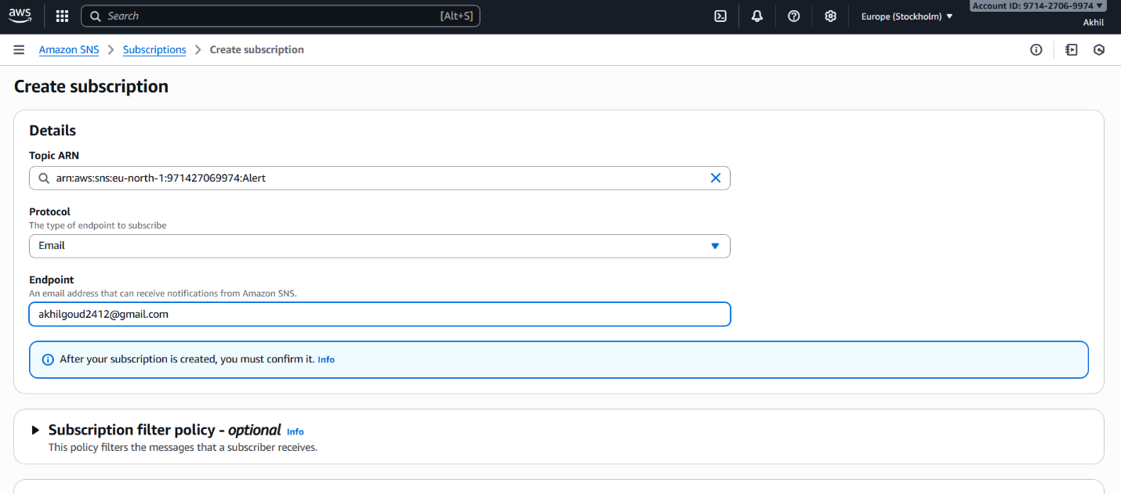
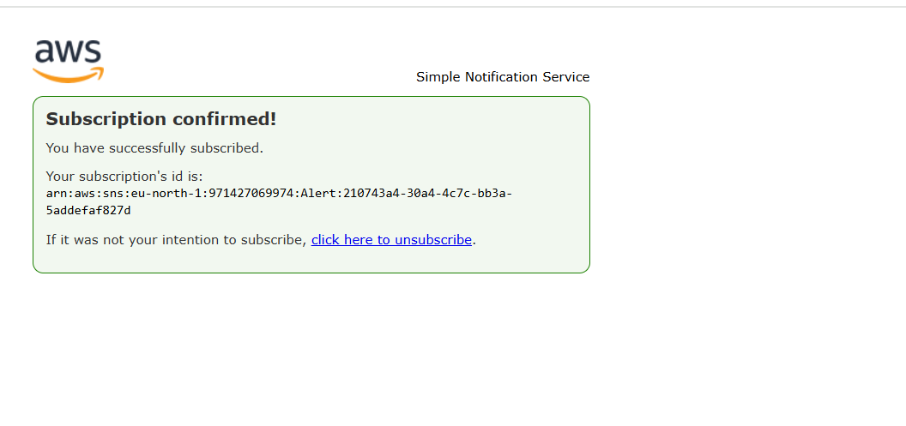
- Configure cloud watch monitoring and record the cpu utilization and other metrics of ec2.
- Launch one ec2 instance
- Go to cloud watchdashboardcreate daash board
- Go to the dash board created add metric graphs select ec2select the graph you want to monitor create widget type graph sleect and create the widget you can monitor cpu utiliation
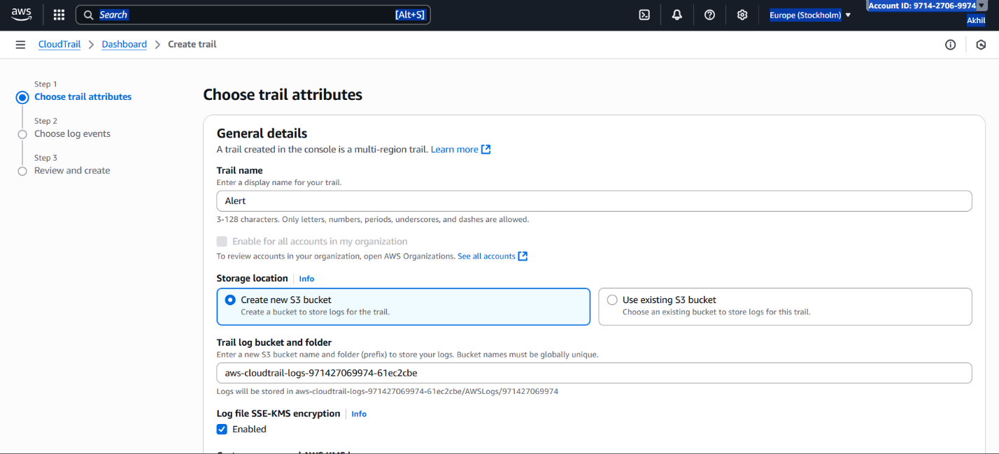
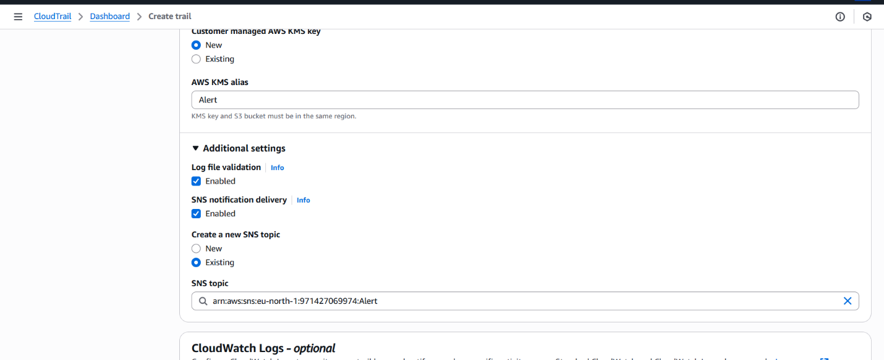
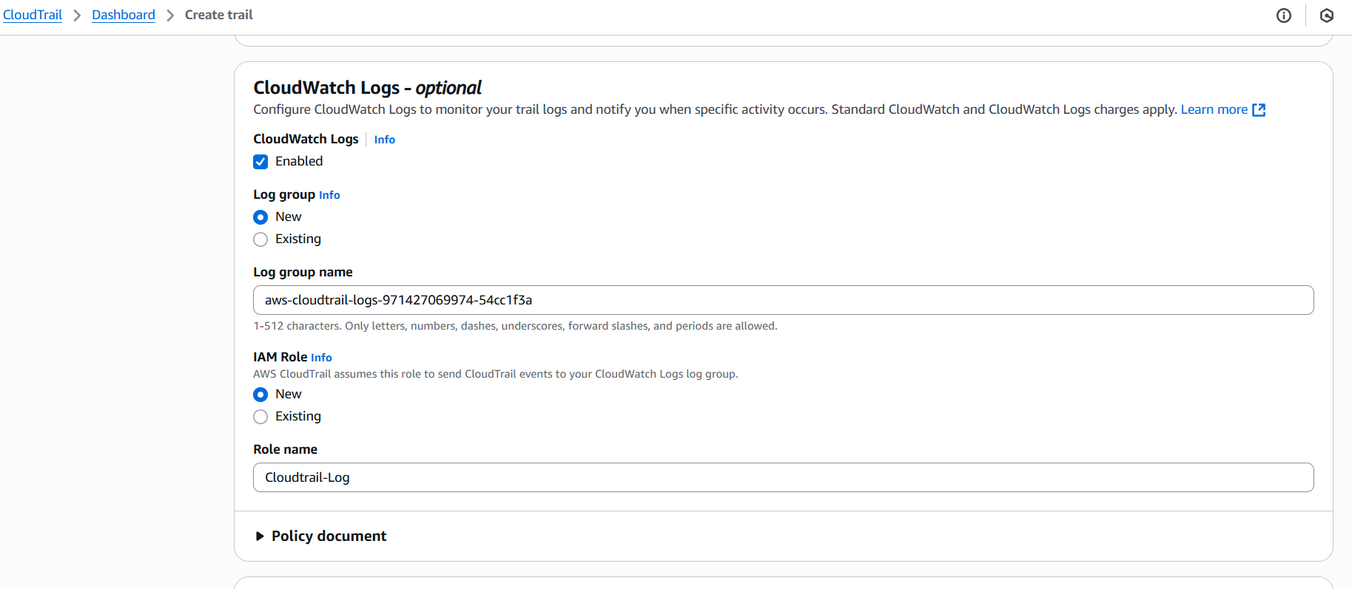
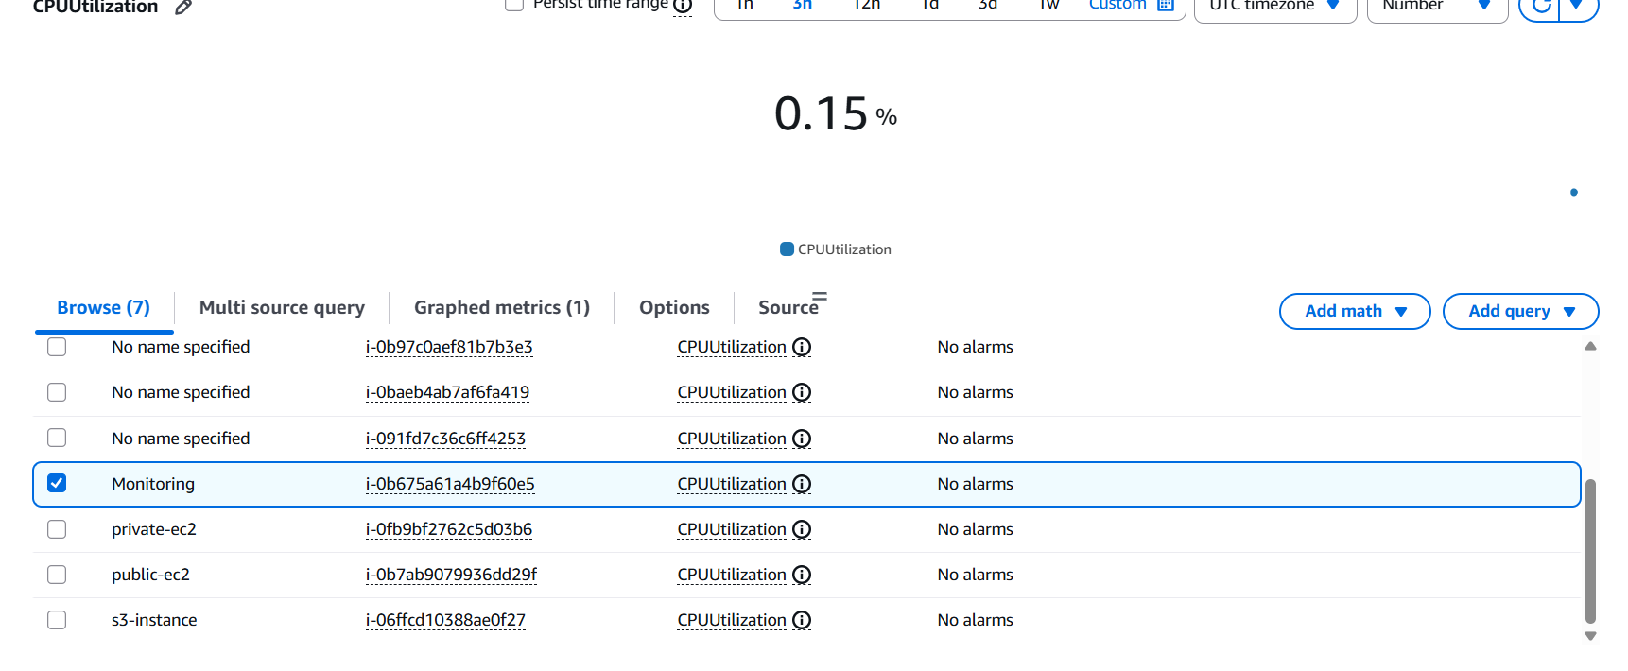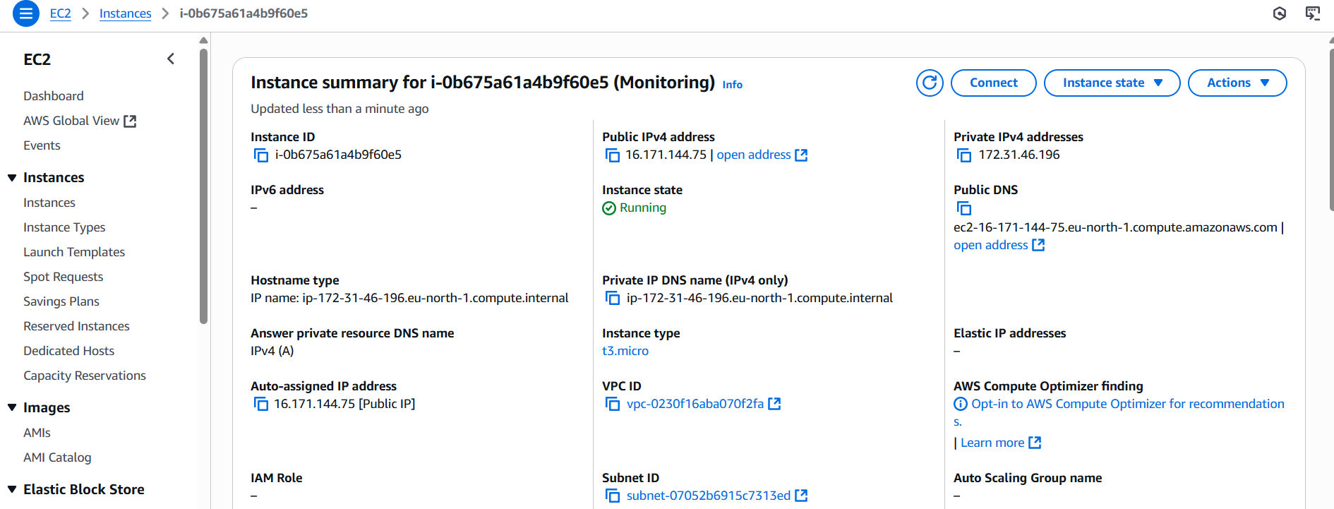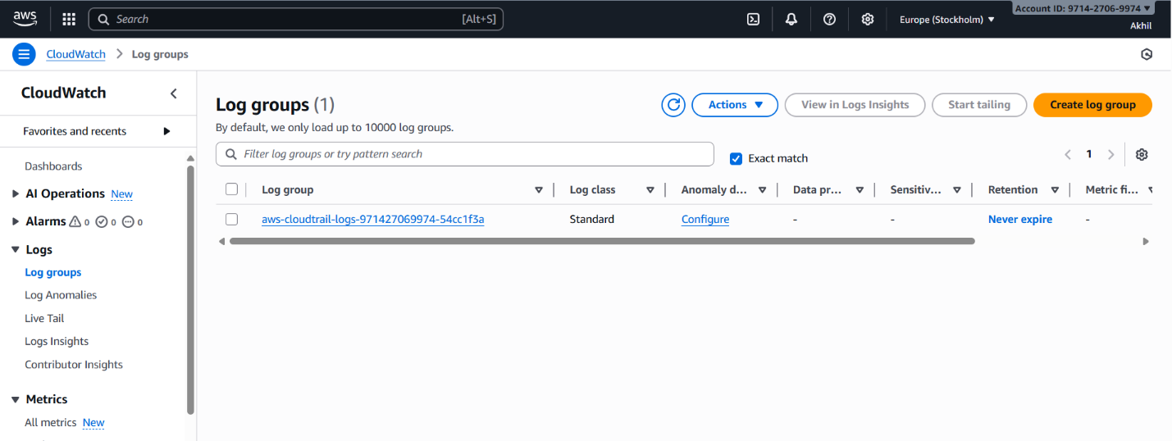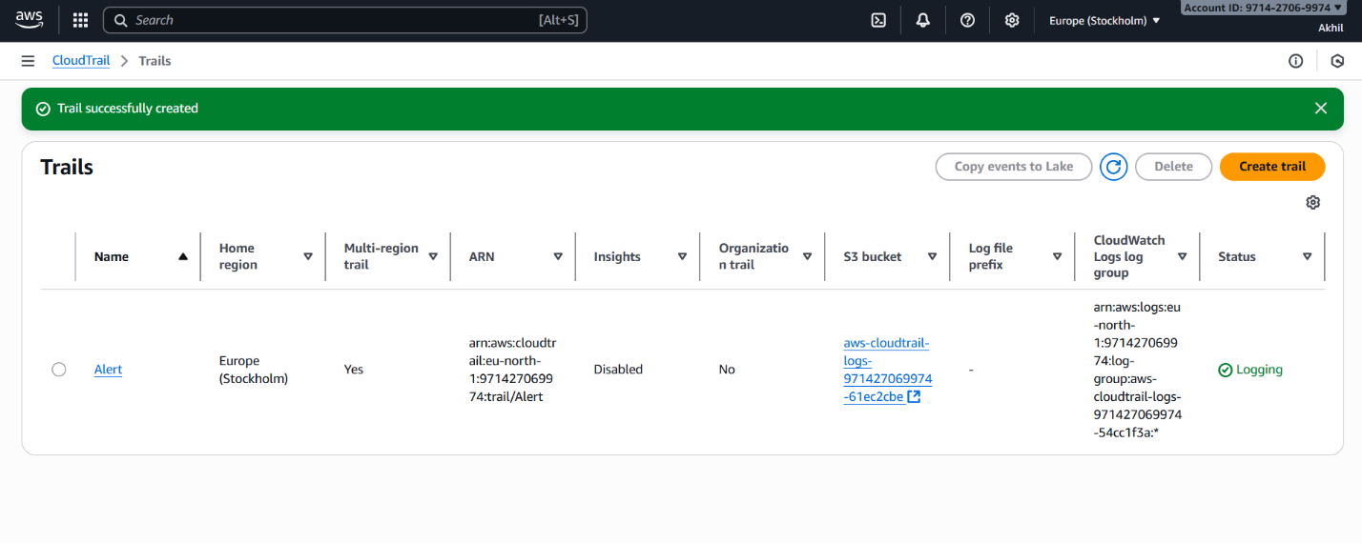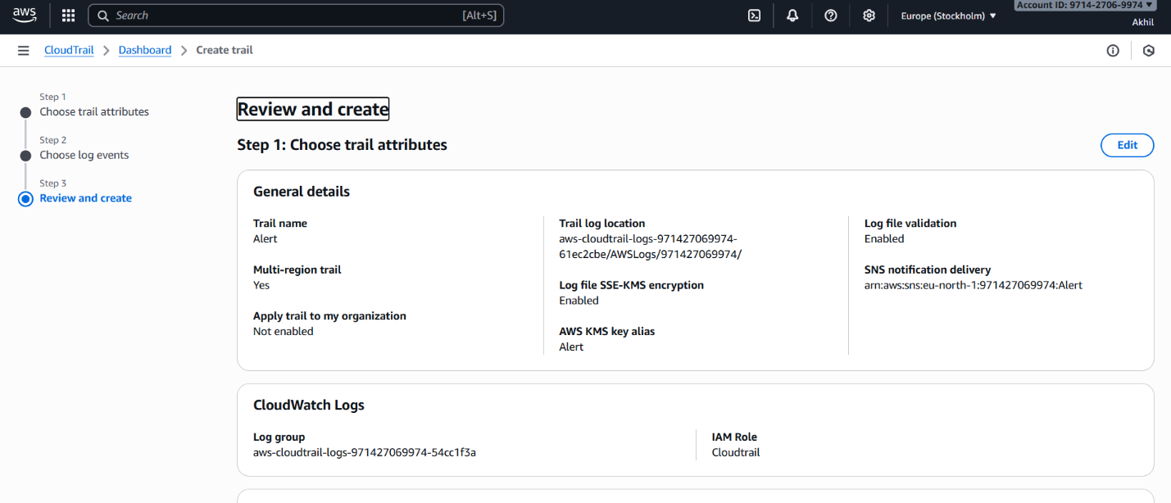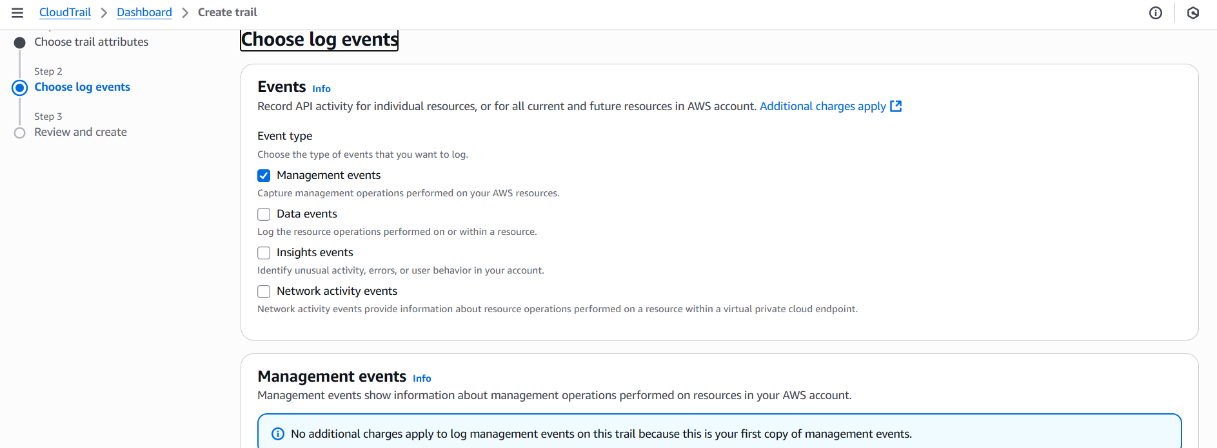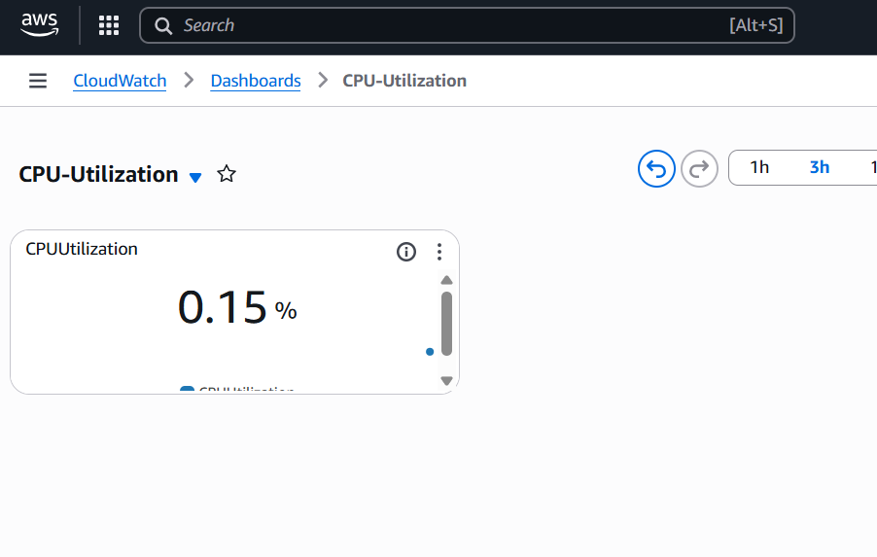
- Create one alarm to send alert to email if the cpu utilization is more than 70 percent.
- Go to cloud watch create alarm
- Select the metricor search with instance idselect spu utilizationgive the parameter greater than 70 select the sns create alarm
- Now check the alarm and email will be sent to your mail id for the usage is more than the 70%
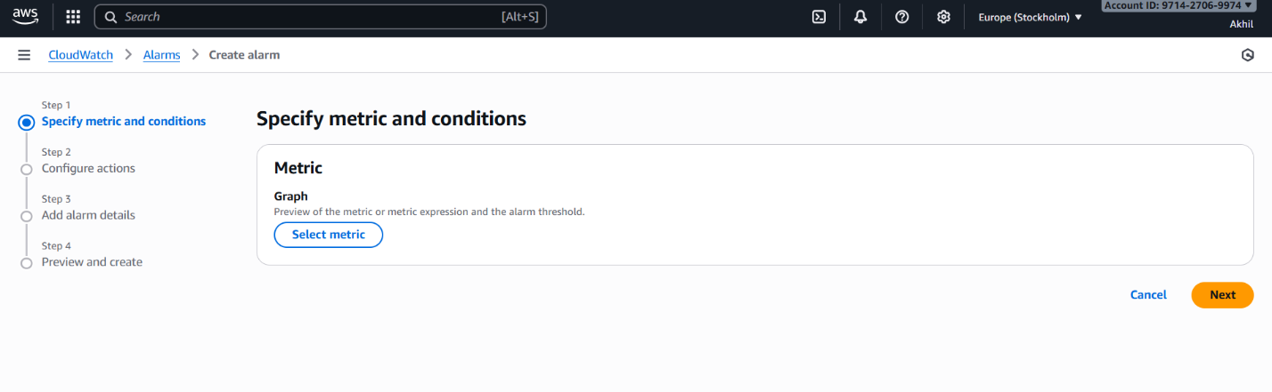
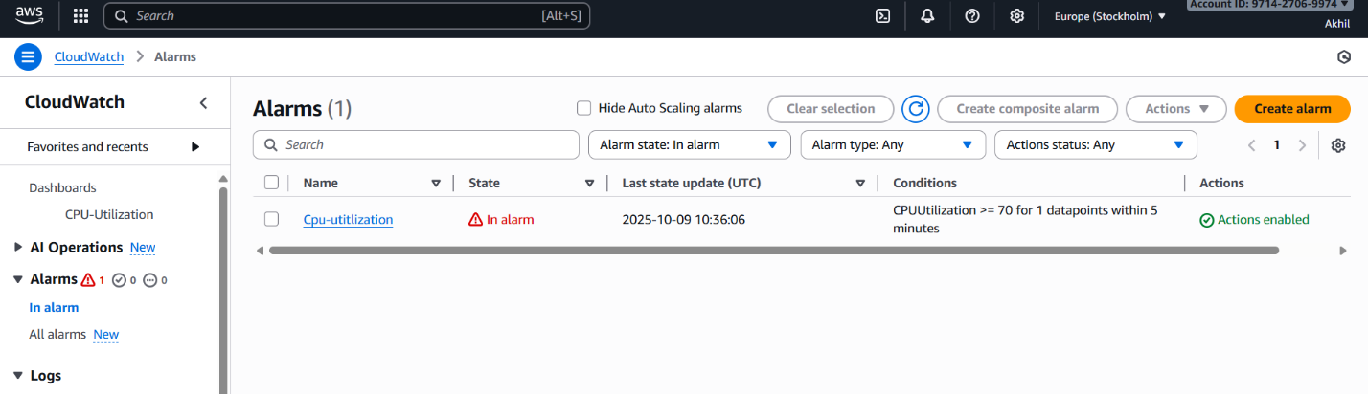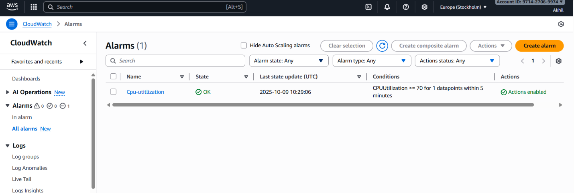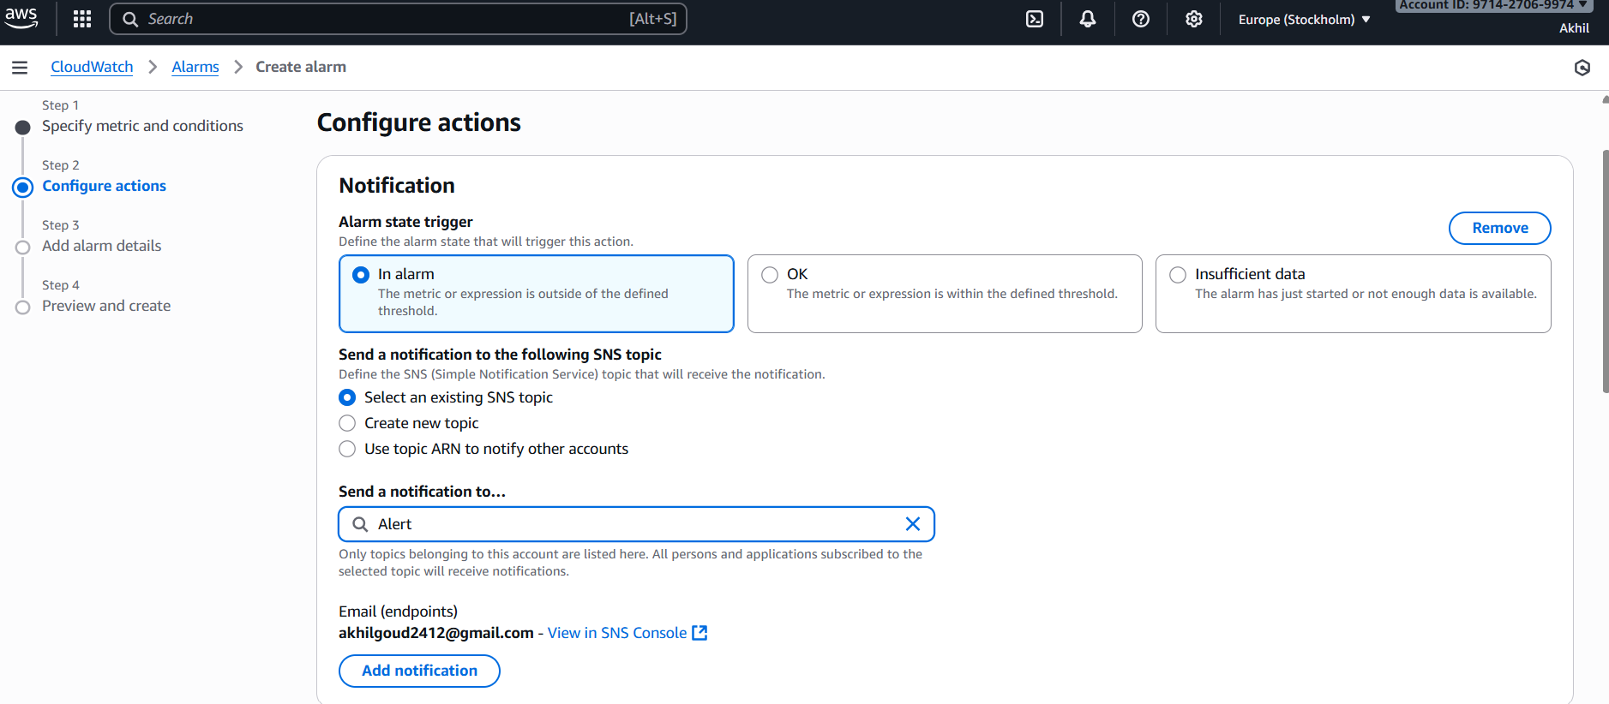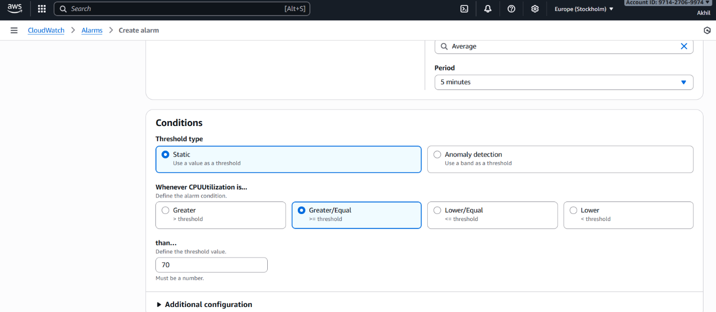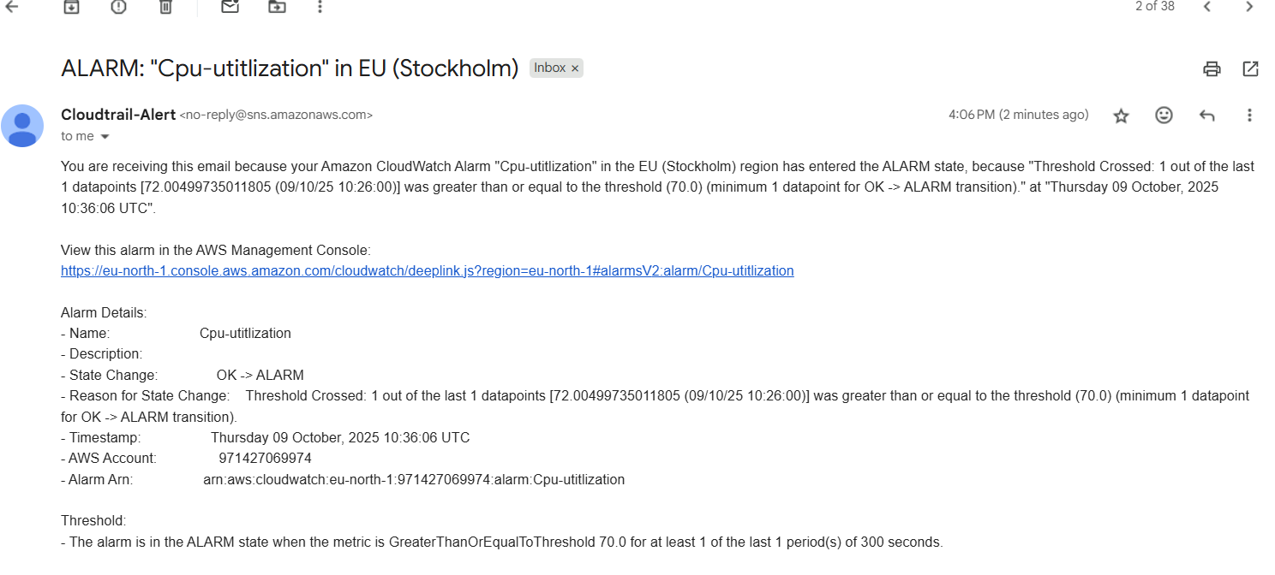
5) Create Dashboard and monitor tomcat service wether it is running or not and send the alert.
- Go to colod watch create dash board create dash boardnameselect metrix tomcatthen create widget
- Create alarm create alarm select the metric select the valuein alarmtomcat is stoped or running
- “ 0” is stopped & “ 1” IS RUNNING
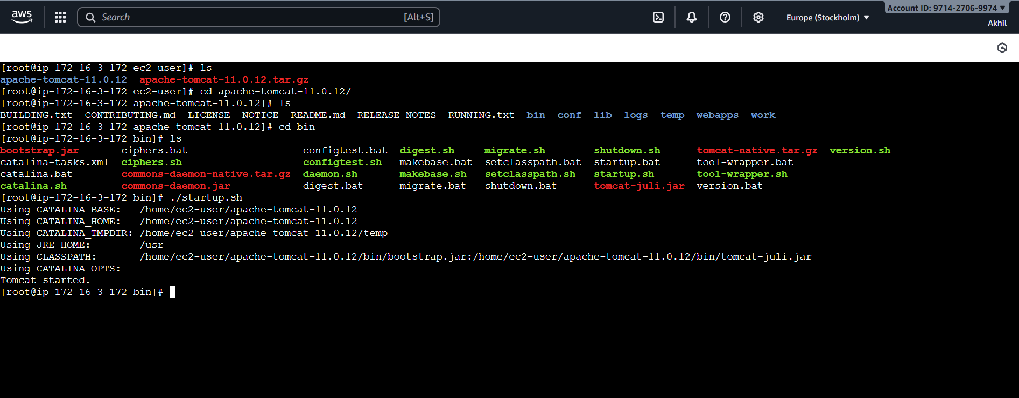
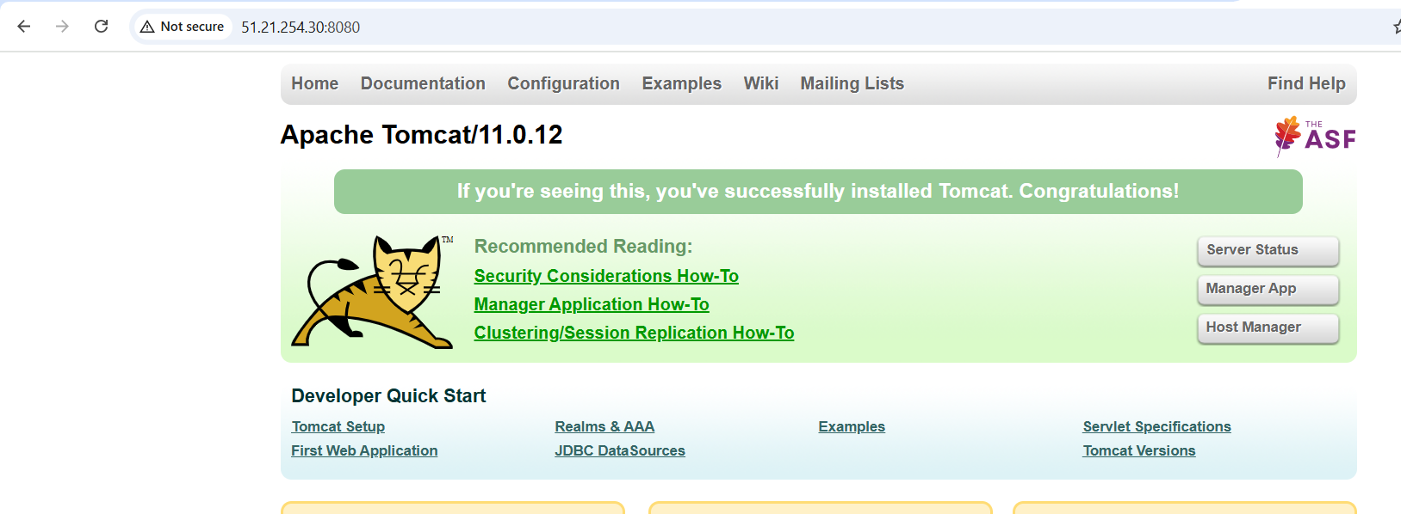
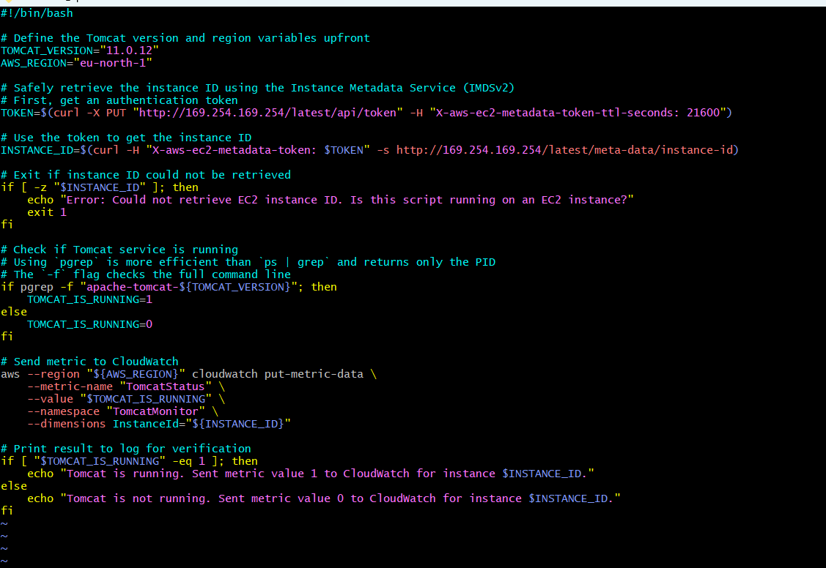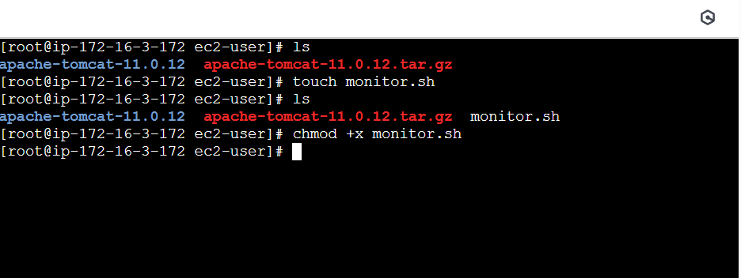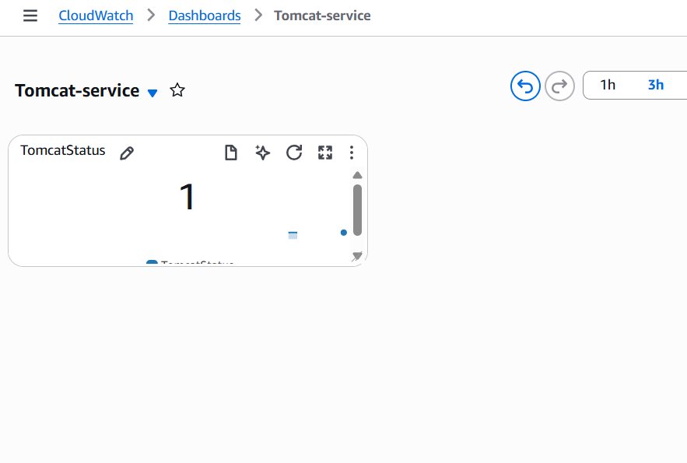
6)Create Dashboard and monitor nginx service to send the alert if nginx is not running.
- Install nginx and start the nginx
- Write a script to check and monitor the nginx service and push metrics to the cloud watch
- create dash board find nginx select you can see the nginx is being monitored
- create cronjob for the script
- script
#!/bin/bash

#set -x

# Get the instance ID
INSTANCE_ID=$(aws ec2 describe-instances --query "Reservations[].Instances[].InstanceId" --output text)

# Function to check NGINX status
checkNginxStatus(){
if systemctl is-active --quiet nginx; then
echo 1
else
echo 0
fi
}

# Get NGINX status
STATUS=$(checkNginxStatus)

# Push metric to CloudWatch
aws --region ap-south-1 cloudwatch put-metric-data \
--metric-name nginx \
--value "$STATUS" \
--namespace nginx \
--dimensions InstanceId=$INSTANCE_ID
