- Create one VPC in N. Virginia region.
- Go to vpc change region to N.virginiacreate vpc nameCIDR -range createvpc
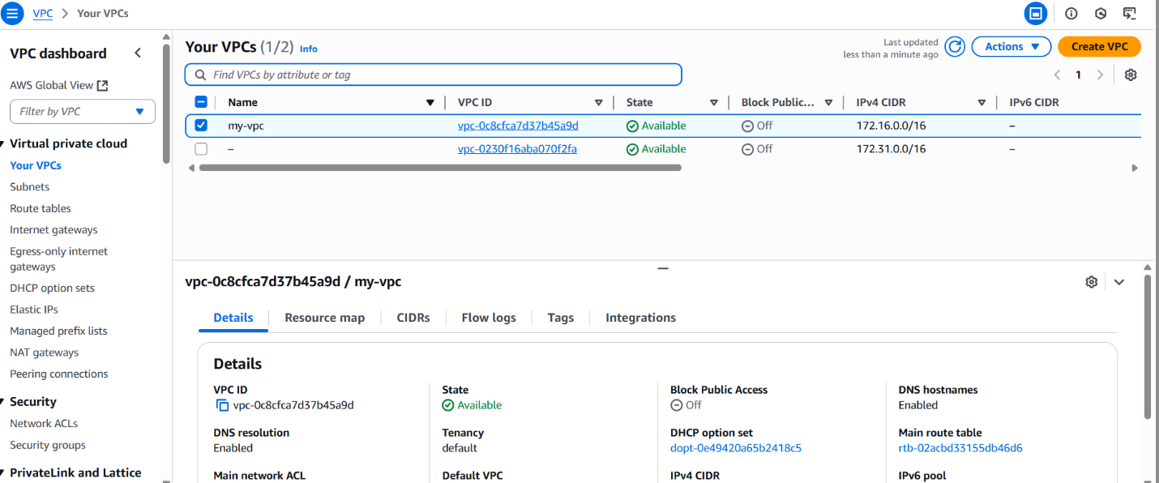
2.Create two subnets: one public subnet and one private subnet.
- Go subnetscreate subnet two subnets give name give cidr blockcreate subnet
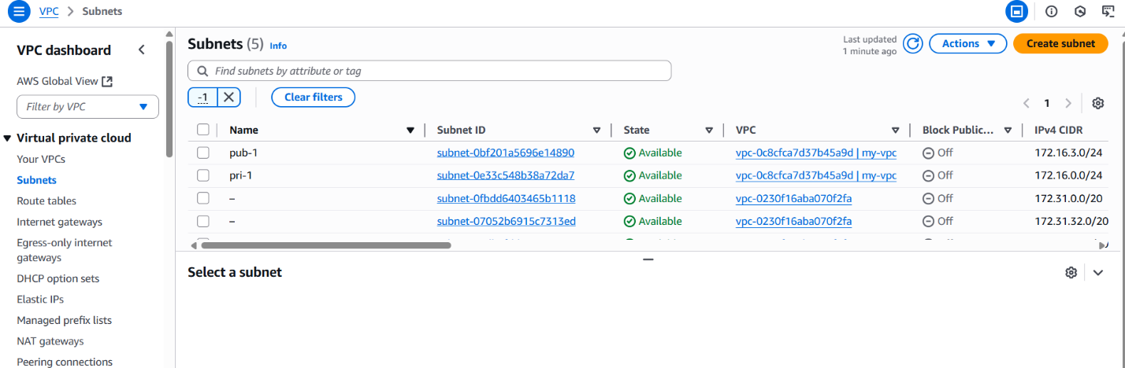
3.Attach an IGW to the VPC.
- Got IGWcreate new IGW or select the existingattach to vpc you have created
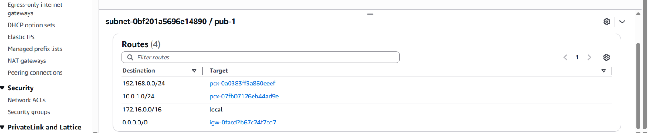
4.Create one public route table (RT) and one private route table.
- Go to route tablescreate RTone name public & other privateattach subnet associationattach public subnet to public rtattach private subnet to private RT
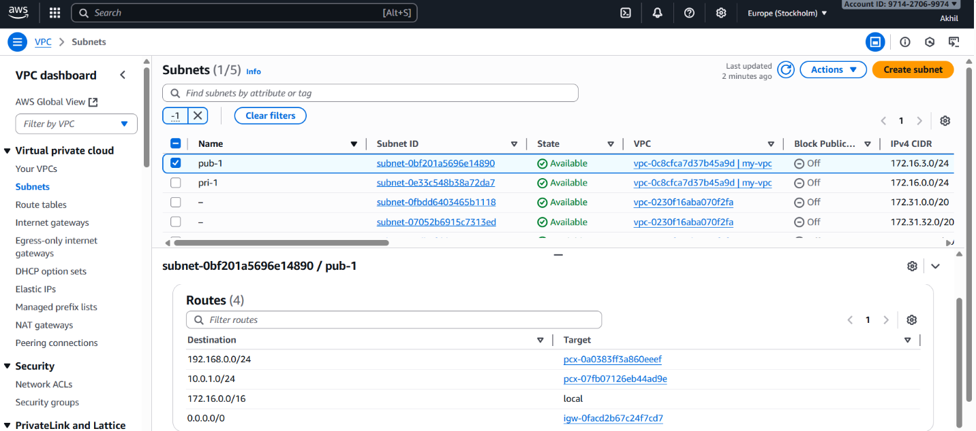
5.Deploy a NAT gateway in the public subnet and attach the NAT gateway to the private subnet.
- Go to nat gatewaycreate natgatewayselect vpcselect private subnetallocte elastic ipcreate nat gateway
- Go to route tablesedit routesadd routenat gatewaysave
- Nat gateway is attached to the pubRT
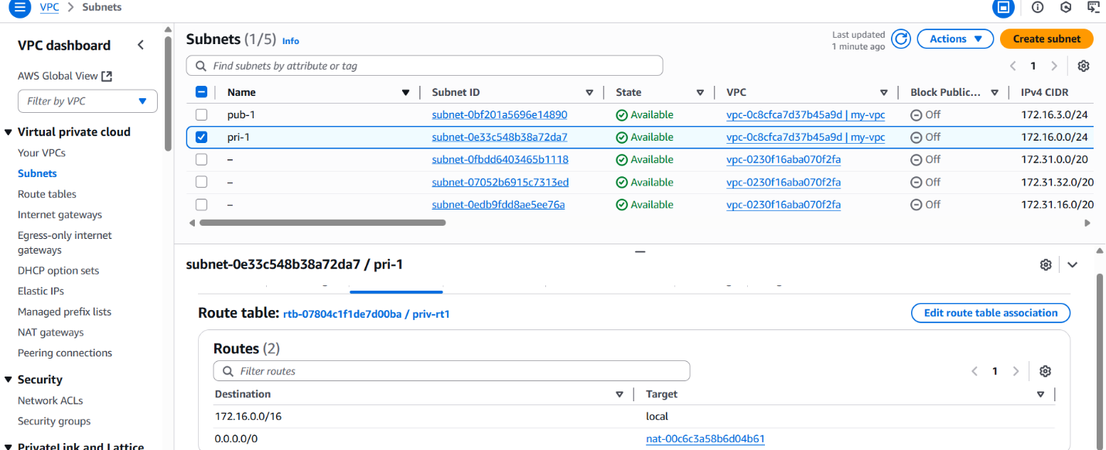
6.Create two instances, one in the public subnet and one in the private subnet.
- Go to ec2 launch ec2 select vpc createdselect publicsubnetuse default security groupkeypair create or selectlaunch public instance

- Go to ec2 launch ec2 select vpc createdselect privatesubnetuse default security groupkeypair create or selectlaunch instance

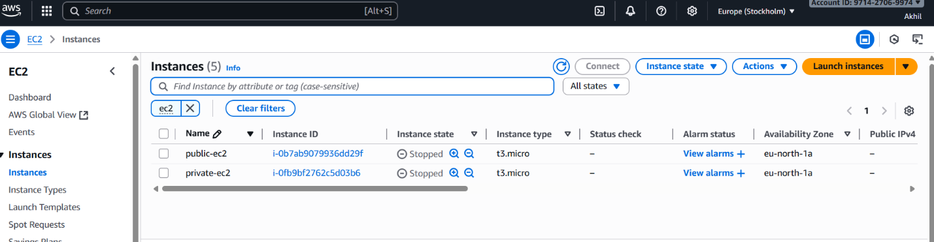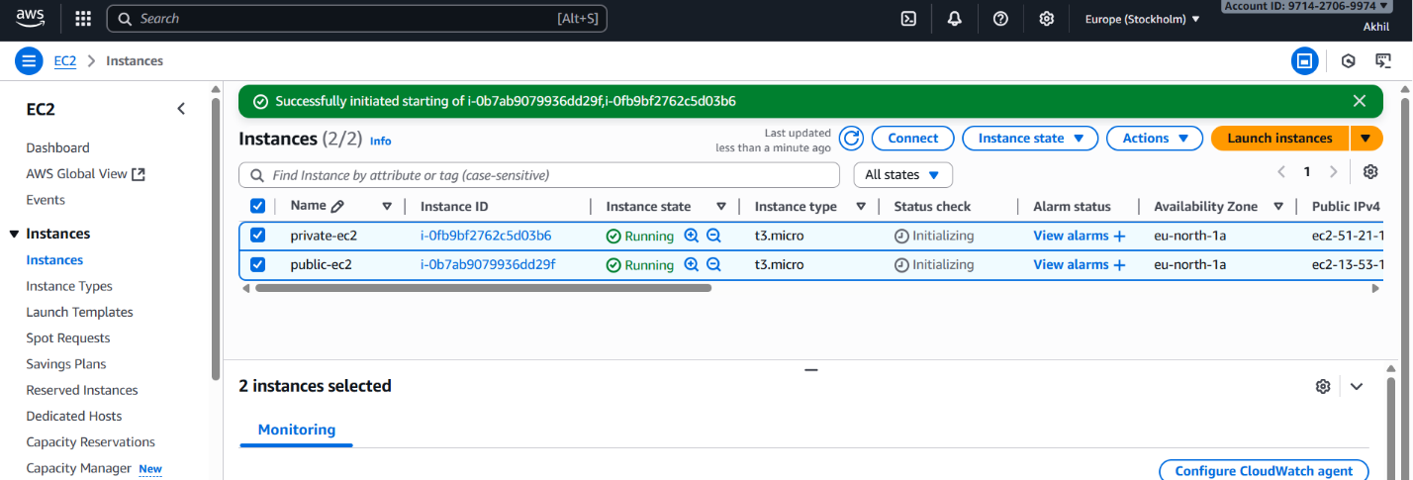
7.Deploy Apache server on both EC2 instances with a sample index.html file.
- Connect to the public ec2 instance
- Install httpd(apache application)
- Yum install httpd
- Systemctl start httpd : start the service
- Deploy the sample index.html go to directory : var/www/html
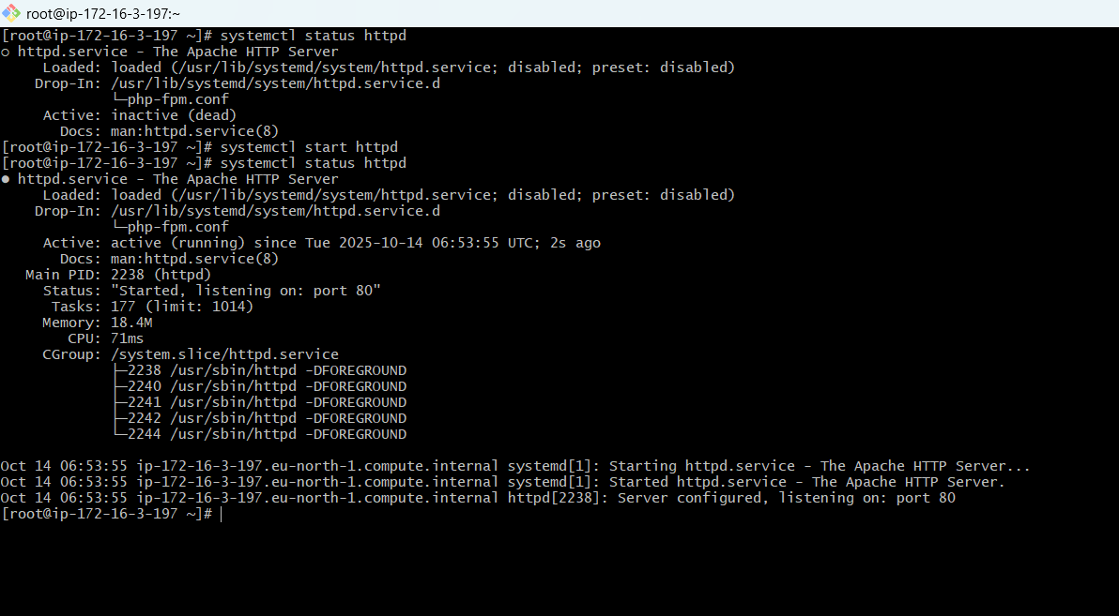
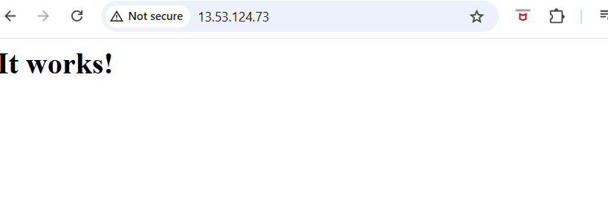
8.Create one application load balancer and attach it to both EC2 instances.
- Go to load balancercreate for applicationnameselect vpcselect subnetsselect security groups reviewcreate load balancer
- Attach target groups-create taret group to your instance
