- Configure Classic Load balancer.
- Open EC2 Dashboard
- Log in to AWS Console
- Open EC2 service
- On the left menu → click Load Balancers
- Click Create Load Balancer

- Configure Load Balancer
- Enter Load Balancer Name → example: my-clb
- Listener Configuration
  - Load Balancer Protocol: HTTP
  - Load Balancer Port: 80
  - Instance Protocol: HTTP
  - Instance Port: 80
- Click Next

- Select VPC & Subnets
- Choose your VPC
- Select at least 2 public subnets (for high availability)
- Click Next

- Configure Security Settings
- If using HTTP, you can skip SSL.
- Click Next

- Assign Security Groups
- Choose one:
- Use existing SG
or
- Create new SG with:
  - Inbound HTTP 80 → 0.0.0.0/0
Click Next

- Configure Health Check
- Set the health check options:
- Setting | - Value
- Ping Protocol | - HTTP
- Ping Port | - 80
- Ping Path | - /
- Response Timeout | - 5 sec
- Interval | - 30 sec
- Unhealthy Threshold | - 2
- Healthy Threshold | - 5
- Click Next

- Add EC2 Instances
- Select the EC2 servers you want the CLB to forward traffic to.
- Click Add to Load Balancer
- Click Next

- Add Tags (Optional)
- Example:
- Key: Environment
- Value: Prod
- Click Review

- Review & Create
- Review all configurations
- Click Create

- Test the Load Balancer
- Select your newly created CLB
- Copy its DNS name
- Paste it in your browser
- You should see the application running from backend instances.

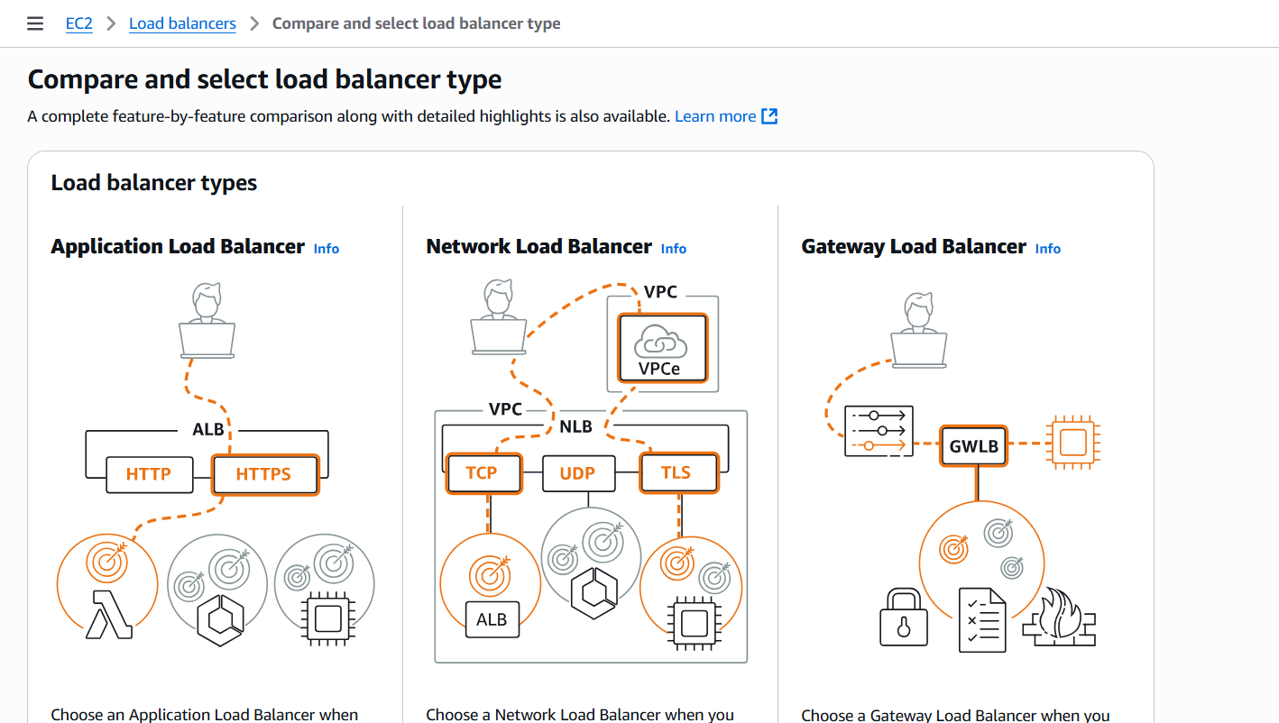

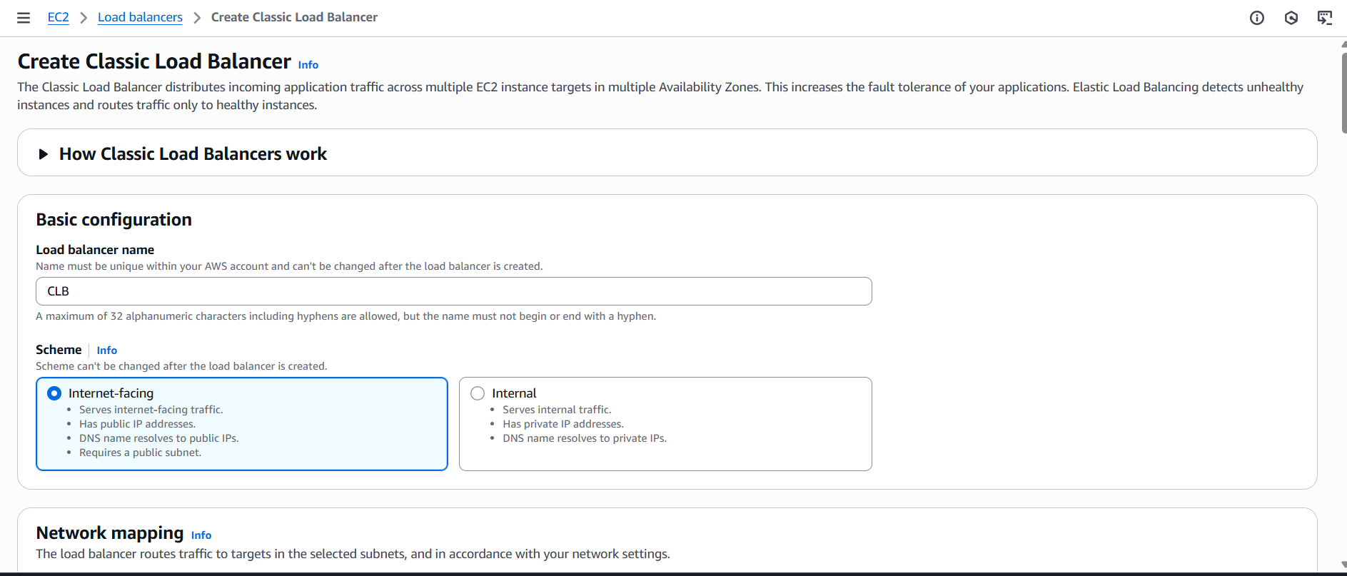
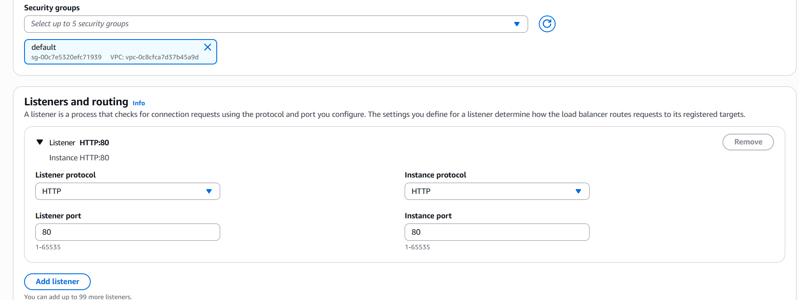
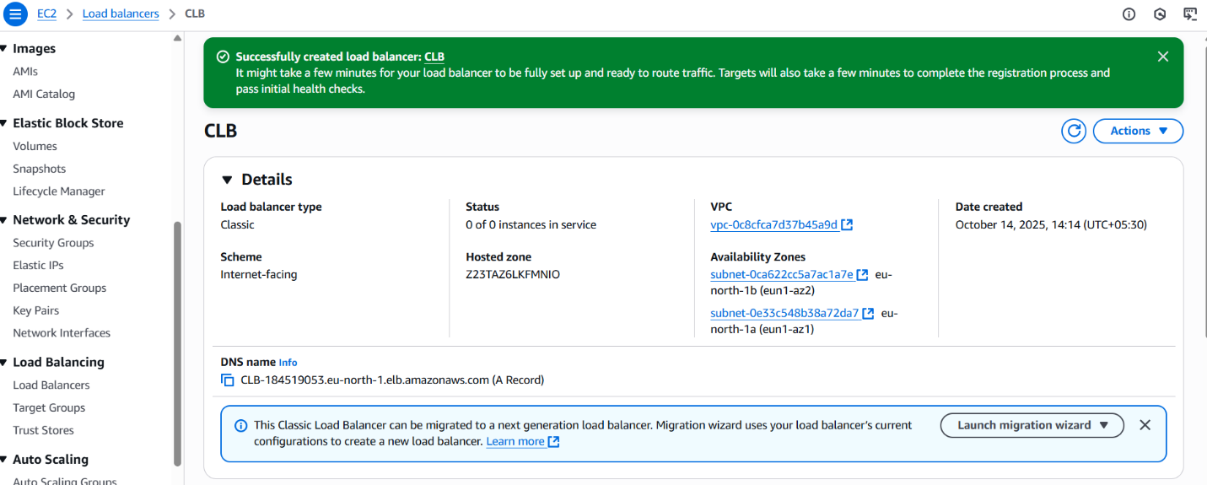
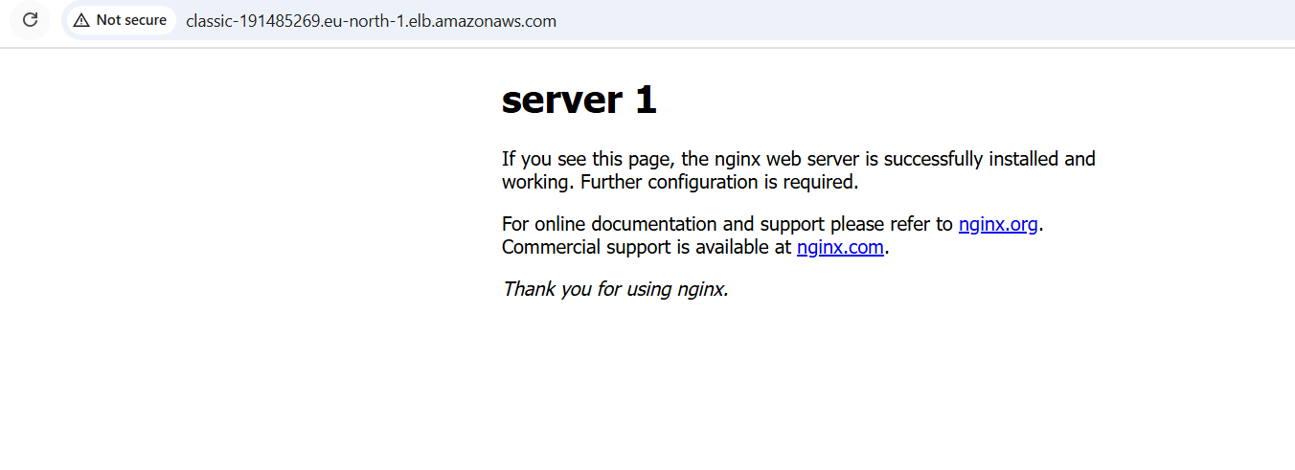
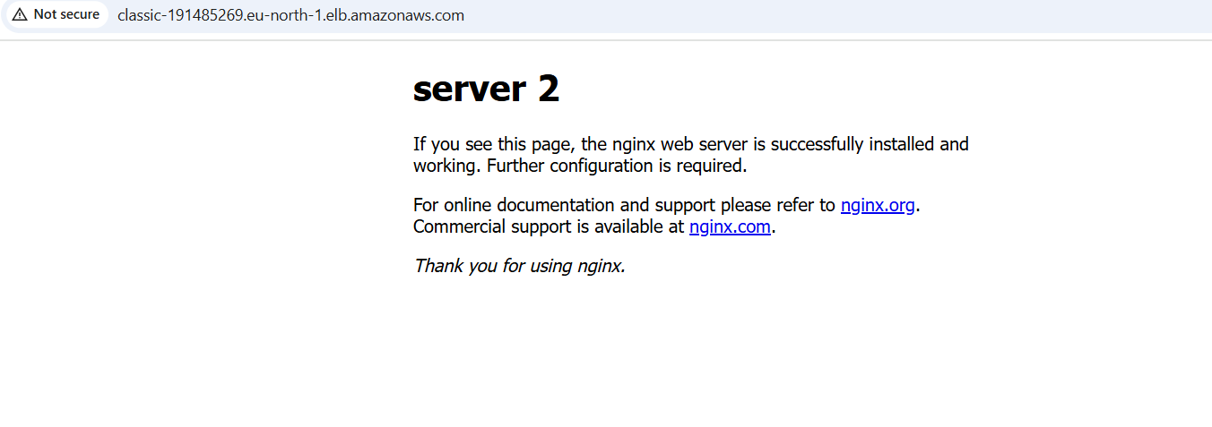
2.Configure Application Load balancer.
- Open EC2 Dashboard
- Log in to AWS Console
- Open EC2 service
- On the left menu → click Load Balancers
- Click Create Load Balancer
- Select Application Load Balancer (ALB)
- Click Create

- 🔵 2. Configure Basic Settings
- Name:
Example: my-alb
- Scheme:
  - Internet-facing (public access)
  - Internal (private-only)
- IP Address Type:
  - IPv4
- Listeners:
  - HTTP : 80
(HTTPS optional later)
- Click Next

- 🔵 3. Select VPC & Subnets
- Choose your VPC
- Select at least 2 public subnets in different AZs
(ALB needs 2 subnets for high availability)
- Click Next

- 🔵 4. Configure Security Groups
- Choose one:
- Use existing security group
OR
- Create a new one with inbound:
- Inbound Rules (for ALB security group)
- HTTP 80 → 0.0.0.0/0
- HTTPS 443 → 0.0.0.0/0 (optional)
- Click Next

- 🔵 5. Configure Target Groups
- Target Group Name:
Example: my-target-group
- Target Type:
  - Instances
  - IP addresses
  - Lambda (select as needed)
- Protocol: HTTP
- Port: 80
- Health Check Settings:
  - Protocol: HTTP
  - Path: /
- Click Next

- 🔵 6. Register Targets (EC2 Instances)
- Select the EC2 instances you want ALB to forward traffic to
- Click Add to registered
- Click Next

- 🔵 7. Review & Create
- Review all settings
- Click Create Load Balancer

- 🔵 8. Test ALB
- Open the ALB details page
- Copy the DNS name of the ALB
Example:
my-alb-123456789.ap-south-1.elb.amazonaws.com
- Paste it in the browser
- You should see your application's output

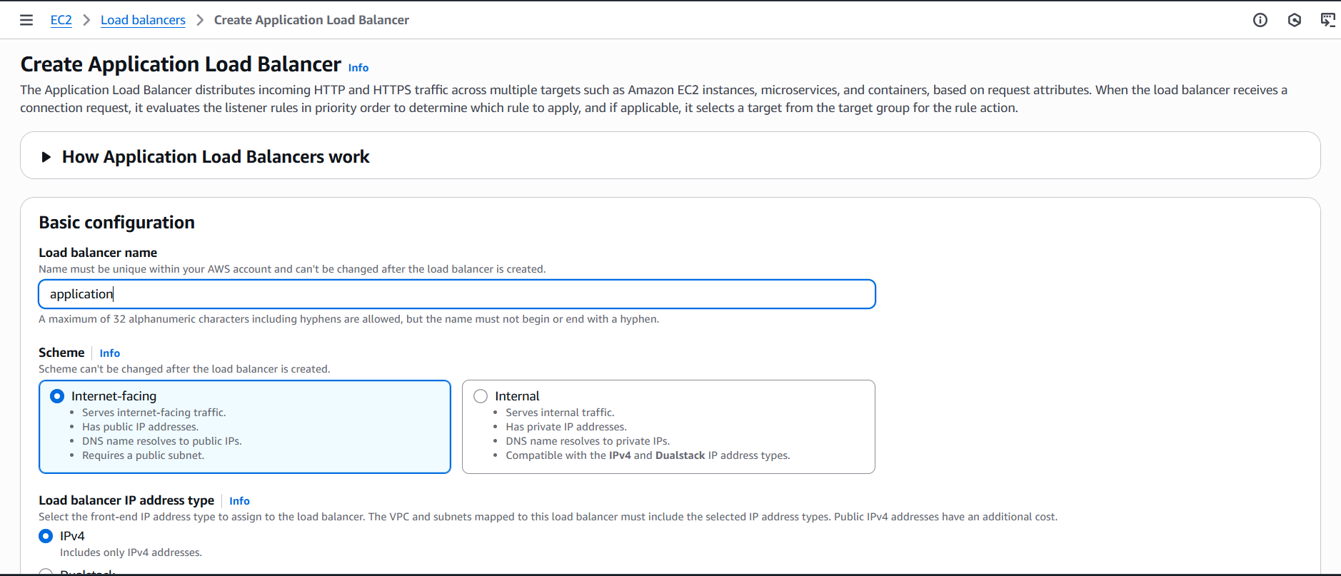
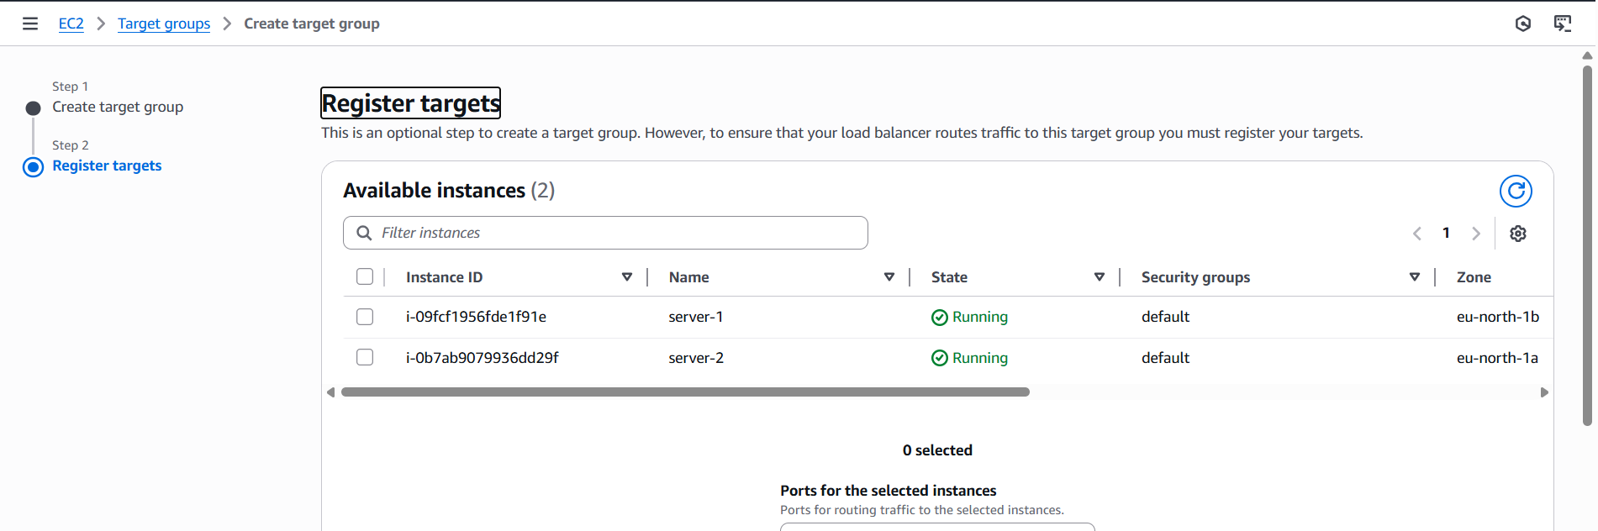

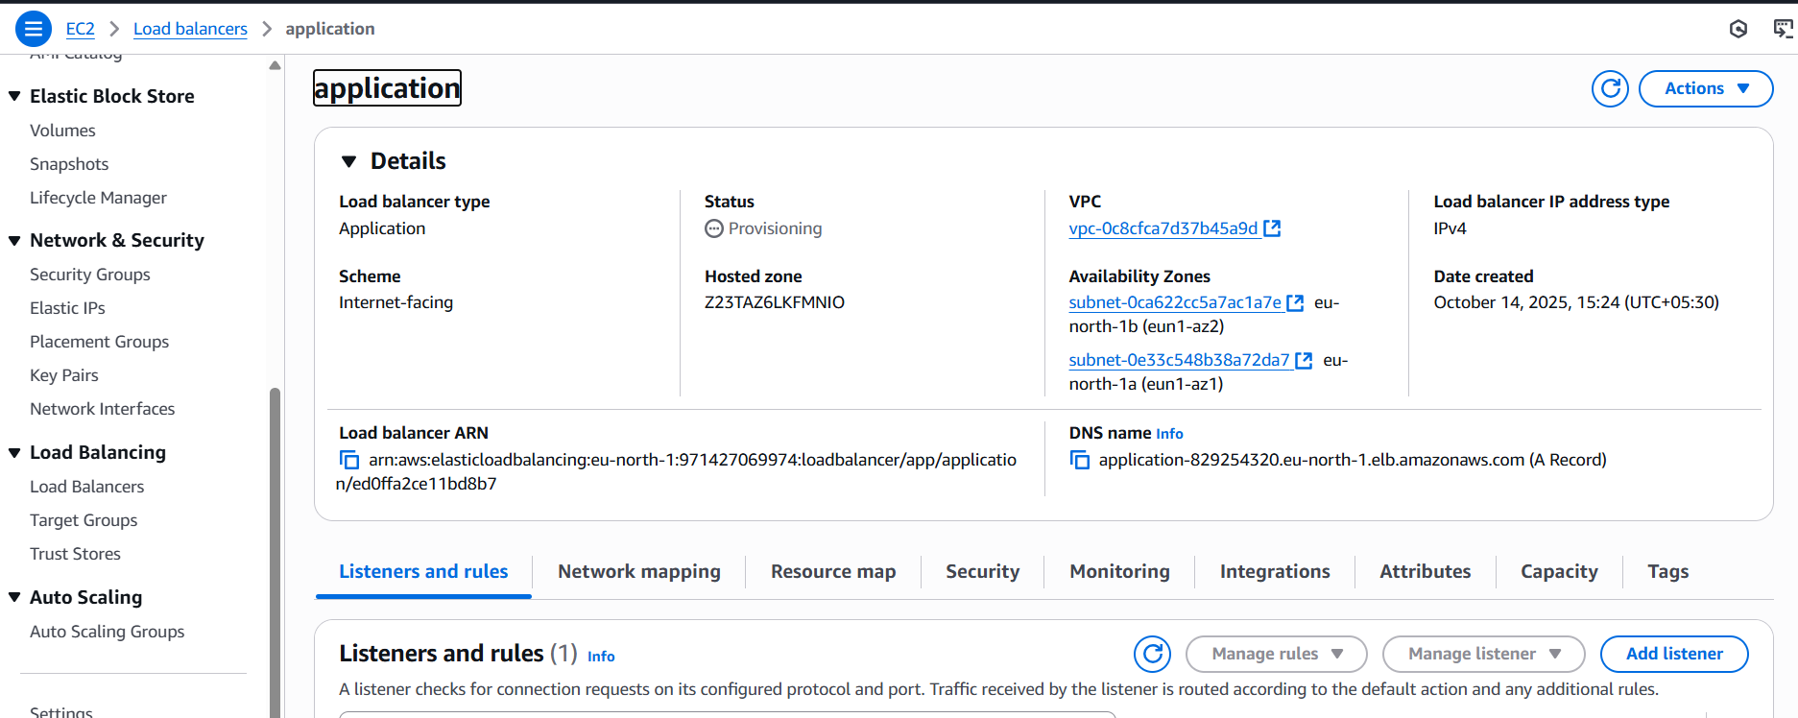
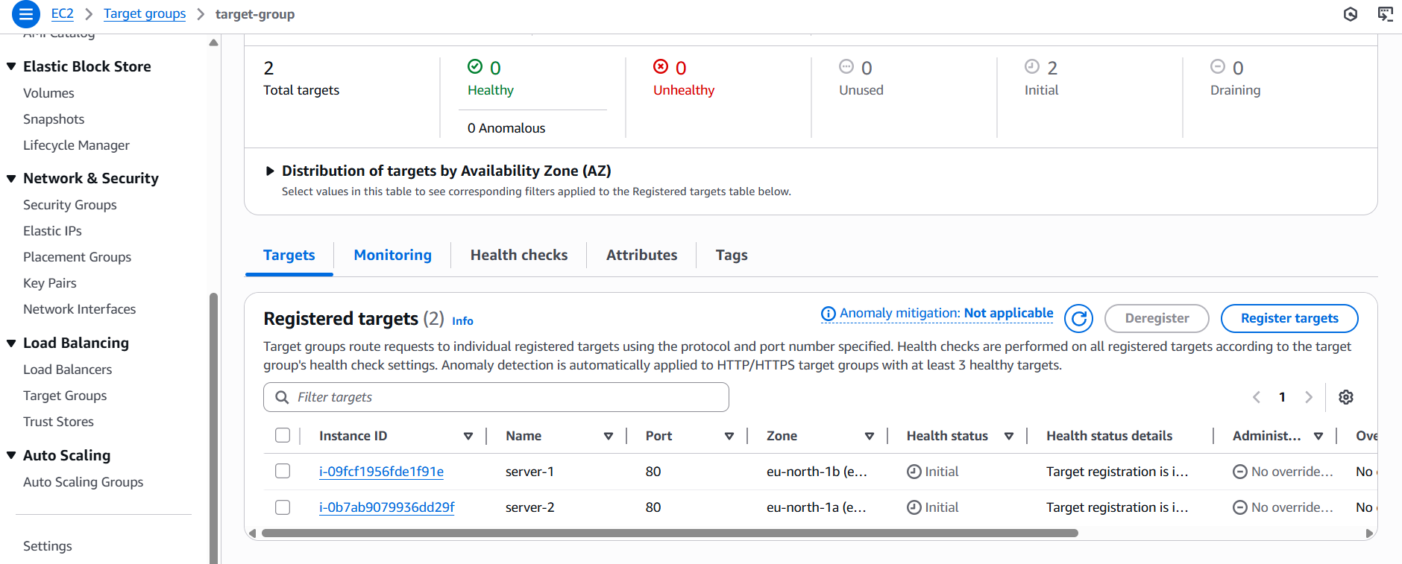
3.Configure Network Load balancer.
- Open EC2 Dashboard
- Log in to AWS Console
- Open EC2
- On the left menu → click Load Balancers
- Click Create Load Balancer
- Select Network Load Balancer (NLB)
- Click Create

- 🔵 2. Configure Basic Load Balancer Settings
- Name:
Example: my-nlb
- Scheme:
  - Internet-facing → public access
  - Internal → inside VPC only
- IP Type:
  - IPv4 or Dualstack (IPv4 & IPv6)
- Listeners:
Default:
  - TCP : 80
(You can add more ports like 443, 22, 8080, etc.)
- Click Next

- 🔵 3. Select VPC & Subnets
- Choose your VPC
- Select at least 2 subnets (public subnets for internet-facing)
- For each subnet, choose Elastic IP (optional)
- Click Next

- 🔵 4. Configure Target Group
- Target Group Name:
Example: my-nlb-target-group
- Target Type:
  - Instance
  - IP
  - Lambda
- Protocol:
  - TCP (default)
(You can also choose TLS or UDP)
- Port: 80
- Health Check:
  - Protocol: TCP (default)
  - If using HTTP app → change to HTTP
  - Health check port: traffic-port
- Click Next

- 🔵 5. Register Targets
- Select EC2 instances you want NLB to forward traffic to
- Click Add to registered
- Click Next

- 🔵 6. Review & Create
- Review all settings
- Click Create Load Balancer

- 🔵 7. Test the NLB
- Open the NLB details page
- Copy the DNS name
Example:
my-nlb-123456.ap-south-1.elb.amazonaws.com
- Paste it in your browser (if HTTP/HTTPS)
- Or use curl to test:

